Supplemental table 1. Demographic information of participants from GSE157239 dataset
 | NCI  (n=8) | AD  (n=8) | Total  (n=16) | P value ^{c}
Female ª | 5 (62.5) | 6 (75) | 11 (68.8) | 0.59
Age at death in years ^{b} | 81.5 (76.0 – 83.8) | 81.5 (75.8 – 84.5) | 81.5 (75.8 – 84.5) | 0.96

Values are n (%), unless indicated otherwise.
ª Data are presented as number (percent)
^{b} Data are shown as median (interquartile range)
^{c} The Mann-Whitney U test or chi-square test was used to determine the P value for comparisons between groups, as appropriate.

Abbreviations: AD, Alzheimer’s dementia; NCI, no cognitive impairment.
Supplemental table 2. Association analysis results of miRNAs with diagnosis and clinical and pathological traits. Here we showed only significantly differentially expressed miRNAs in AD.
 | AD diagnosis |  | CERAD |  | Braak |  | Global cognition  at the last visit |  | Slope of  global cognition
miRNA | Estimate ª | P value ^{c} | Estimate ª | P value ^{c} | Estimate ª | P value ^{c} | beta ^{b} | P value ^{c} | beta ^{b} | P value ^{c}
miR-100 | 1.837 | 0.032* | 0.902 | 0.202 | 0.498 | 0.900 | -0.602 | 0.007** | -0.286 | 0.582
miR-1260 | 0.650 | 0.047* | 0.352 | 0.127 | 0.154 | 0.900 | -0.144 | 0.124 | -0.086 | 0.621
miR-129-3p | -1.816 | 0.009** | -0.760 | 0.113 | -0.624 | 0.620 | 0.809 | < 0.001*** | 0.383 | 0.006**
miR-129-5p | -3.771 | < 0.001*** | -1.208 | 0.007** | -1.023 | 0.048* | 1.432 | < 0.001*** | 0.757 | < 0.001***
miR-132 | -2.787 | < 0.001*** | -0.852 | < 0.001*** | -0.686 | 0.001** | 0.899 | < 0.001*** | 0.334 | < 0.001***
miR-133b | -1.581 | 0.002** | -0.369 | 0.526 | -0.403 | 0.840 | 0.581 | <0.001*** | 0.219 | 0.180
miR-19b | 1.773 | 0.012* | 0.393 | 0.670 | 0.468 | 0.900 | -0.571 | <0.001*** | -0.246 | 0.464
miR-29a | 1.811 | 0.021* | 0.322 | 0.756 | 0.487 | 0.900 | -0.775 | <0.001*** | -0.042 | 0.984
miR-335 | 1.485 | 0.031* | 0.337 | 0.733 | 0.276 | 0.900 | -0.439 | 0.009** | -0.167 | 0.659
miR-33a | 1.192 | 0.032* | 0.274 | 0.736 | 0.342 | 0.900 | -0.012 | 0.969 | -0.086 | 0.894
miR-410 | -1.118 | 0.031* | -0.406 | 0.492 | -0.081 | 0.950 | 0.318 | 0.016* | 0.203 | 0.180
miR-433 | -1.590 | 0.015* | -0.355 | 0.690 | -0.305 | 0.900 | 0.461 | 0.005** | 0.286 | 0.180
miR-504 | -1.942 | 0.032* | -0.622 | 0.492 | -0.701 | 0.774 | 0.492 | 0.016* | 0.270 | 0.542
miR-519a | 1.573 | 0.012* | 0.469 | 0.492 | 0.261 | 0.900 | -0.473 | 0.002** | -0.142 | 0.659
miR-99b | 1.463 | 0.031* | 0.800 | 0.113 | 0.384 | 0.900 | -0.596 | <0.001*** | -0.314 | 0.148

ª Logistic regression coefficient of associations between miRNAs and diagnosis and pathological traits
^{b} Linear regression coefficients of association between miRNAs and cognitive traits.
^{c} Adjusted p value for FDR

Abbreviations: AD, Alzheimer’s dementia; CERAD, Consortium to Establish a Registry for Alzheimer’s Disease; FDR, false discovery rate; miRNAs, microRNAs.
Note: significance stars indicating the p values of the correlations adjustment for multiple comparisons
* P-value ≤ 0.05.
** P-value ≤ 0.01.
*** P-value ≤ 0.001.

Supplemental table 3. Association analysis results of module eigengenes with diagnosis and clinical and pathological traits.
 | AD diagnosis |  | CERAD |  | Braak |  | Global cognition  at the last visit |  | Slope of  global cognition
Module | Estimate ª | P value ^{c} | Estimate ª | P value ^{c} | Estimate ª | P value ^{c} | beta ^{b} | P value ^{c} | beta ^{b} | P value ^{c}
M0 | 4.794 | 0.303 | 1.101 | 0.818 | 3.236 | 0.271 | -0.542 | 0.851 | -0.280 | 0.870
M1 | -5.743 | 0.298 | -0.496 | 0.818 | 0.549 | 0.913 | -0.216 | 0.851 | 0.927 | 0.646
M2 | -0.593 | 0.872 | -1.623 | 0.818 | -0.232 | 0.913 | 1.142 | 0.638 | 0.150 | 0.870
M3 | -19.480 | 0.005** | -8.393 | 0.034* | -7.458 | 0.067 | 5.100 | 0.008** | 3.830 | 0.017*

ª Logistic regression coefficient of associations between miRNAs and diagnosis and pathological traits
^{b} Linear regression coefficients of association between miRNAs and cognitive traits.
^{c} Adjusted p value for FDR

Abbreviations: AD, Alzheimer’s dementia; CERAD, Consortium to Establish a Registry for Alzheimer’s Disease; FDR, false discovery rate; M, module.
Note: significance stars indicating the p values of the correlations adjustment for multiple comparisons
* P-value ≤ 0.05.
** P-value ≤ 0.01.

Supplemental table 4. Enrichment analysis of miRNAs in modules from the ROS/MAP dataset
Biological process | Number of miRNAs  belonging to the pathway | Fold enrichment | P value ª
M1 module
Innate Immunity | 27 | 7.024 | < 0.001
Skeletal Muscle Cell Differentiation | 16 | 7.946 | < 0.001
Brain Development | 19 | 5.766 | < 0.001
Cell Division | 13 | 8.355 | < 0.001
Latent Virus Replication | 13 | 8.355 | < 0.001
Glucose Metabolism | 16 | 6.243 | < 0.001
Adipocyte Differentiation | 19 | 5.063 | < 0.001
T-helper 17 Cell Differentiation | 13 | 7.476 | < 0.001
Osteoclast Differentiation | 11 | 8.585 | < 0.001
Neuron Apoptosis | 11 | 8.012 | < 0.001
Bone Regeneration | 15 | 5.463 | < 0.001
T-Cell Differentiation | 11 | 7.512 | < 0.001
Lipid Metabolism | 18 | 4.370 | < 0.001
Nephrotoxicity | 11 | 7.070 | < 0.001
Neuron Differentiation | 10 | 7.804 | < 0.001
Cardiac Regeneration | 12 | 5.960 | < 0.001
Adipogenesis | 11 | 6.009 | < 0.001
Muscle Development | 11 | 5.723 | < 0.001
Cell Migration | 8 | 7.946 | < 0.001
Smooth Muscle Cell Proliferation | 10 | 6.070 | < 0.001
Osteoblast Differentiation | 11 | 4.807 | < 0.001
Cell Motility | 10 | 5.203 | < 0.001
Hepatic Stellate Cell Differentiation | 5 | 10.926 | < 0.001
Autophagy | 6 | 8.194 | < 0.001
Chondrocyte Development | 8 | 5.827 | < 0.001
Osteoclastogenesis | 5 | 9.105 | 0.002
Cholesterol Homeostasis | 6 | 7.284 | 0.002
Circadian Rhythm | 9 | 4.470 | 0.003
Regulation of Nf-Κb Pathway | 5 | 7.804 | 0.006
Cellular Senescence | 5 | 7.804 | 0.006
Myogensis | 5 | 6.829 | 0.015
Transdifferentiation | 5 | 6.829 | 0.015
Cell Adhesion | 5 | 6.829 | 0.015
Cholesterol Metabolism | 5 | 6.829 | 0.015
Plasma Cell Differentiation | 5 | 6.829 | 0.015
Embryonic Development | 7 | 4.499 | 0.023
Vascular Smooth Muscle Cell Differentiation | 5 | 6.070 | 0.030
Neutrophil Differentiation | 3 | 10.926 | 0.041
Regulation of Wnt Signaling Pathway | 4 | 7.284 | 0.047
M2 module
Embryonic Development | 5 | 6.941 | 0.005
Circadian Rhythm | 5 | 5.364 | 0.020
Chondrocyte Development | 4 | 6.293 | 0.031
DNA Damage Response | 4 | 5.900 | 0.040
M3 module
Muscle Development | 4 | 7.492 | 0.013
Glucose Metabolism | 4 | 5.619 | 0.038
Neuron Apoptosis | 3 | 7.867 | 0.045
Bone Regeneration | 4 | 5.244 | 0.049

ª Adjusted p value for Bonferroni correction

Abbreviations: M, module; MAP, Memory and Aging Project; miRNAs, microRNAs; ROS, Religious Orders Study.

Supplemental table 5. Association analysis results of top 10 candidate hub miRNAs with diagnosis and clinical and pathological traits
 | AD diagnosis |  | CERAD |  | Braak |  | Global cognition  at the last visit |  | Slope of  global cognition
Hub miRNAs | Estimate ª | P value ^{c} | Estimate ª | P value ^{c} | Estimate ª | P value ^{c} | beta ^{b} | P value ^{c} | beta ^{b} | P value ^{c}
miR-103 | -0.258 | 0.845 | 0.087 | 0.910 | -0.103 | 0.778 | 0.027 | 0.853 | 0.100 | 0.573
miR-1260 | 0.650 | 0.008** | 0.352 | 0.012* | 0.154 | 0.450 | -0.144 | 0.035* | -0.086 | 0.297
miR-200a | 0.705 | 0.046* | 0.413 | 0.025* | 0.182 | 0.450 | -0.195 | 0.035* | -0.040 | 0.609
miR-744 | 0.317 | 0.603 | 0.304 | 0.239 | 0.095 | 0.778 | -0.279 | 0.013* | -0.047 | 0.609
miR-107 | -0.214 | 0.845 | 0.031 | 0.910 | -0.170 | 0.778 | 0.095 | 0.571 | 0.107 | 0.573
let-7e | 0.081 | 0.896 | 0.056 | 0.910 | -0.157 | 0.778 | -0.390 | 0.057 | -0.028 | 0.863
miR-2117 | -0.091 | 0.845 | -0.035 | 0.910 | -0.046 | 0.778 | 0.102 | 0.309 | 0.119 | 0.297
miR-433 | -1.590 | 0.002** | -0.355 | 0.258 | -0.305 | 0.450 | 0.461 | 0.001** | 0.286 | 0.033*
miR-221 | -1.084 | 0.046* | -0.368 | 0.303 | -0.429 | 0.450 | 0.256 | 0.114 | 0.150 | 0.416
miR-129-5p | -3.771 | < 0.001*** | -1.208 | < 0.001*** | -1.023 | 0.003** | 1.432 | < 0.001*** | 0.757 | < 0.001***

ª Logistic regression coefficient of associations between miRNAs and diagnosis and pathological traits
^{b} Linear regression coefficients of association between miRNAs and cognitive traits.
^{c} Adjusted p value for FDR

Abbreviations: AD, Alzheimer’s dementia; CERAD, Consortium to Establish a Registry for Alzheimer’s Disease; FDR, false discovery rate; miRNAs, microRNAs.
Note: significance stars indicating the p values of the correlations adjustment for multiple comparisons
* P-value ≤ 0.05.
** P-value ≤ 0.01.
*** P-value ≤ 0.001.
Supplemental table 6. Gene ontology analysis of target genes of five AD-associated hub miRNAs (miR-129-5p, miR-1260, miR-200a, miR-433, and miR-221)
Biological process | Number of target genes belonging to the pathway | Fold enrichment | P value ª
Regulation of transcription, DNA-templated | 111 | 1.991 | < 0.001
Positive regulation of transcription from RNA polymerase II promoter | 122 | 1.800 | < 0.001
Regulation of transcription from RNA polymerase II promoter | 157 | 1.634 | < 0.001
Negative regulation of transcription from RNA polymerase II promoter | 102 | 1.861 | < 0.001
Regulation of alternative mRNA splicing, via spliceosome | 19 | 5.351 | < 0.001
Protein phosphorylation | 63 | 2.119 | < 0.001
Nervous system development | 53 | 2.286 | < 0.001
Chromatin organization | 39 | 2.475 | < 0.001
Regulation of RNA splicing | 16 | 3.561 | 0.010
Neuron migration | 20 | 2.955 | 0.012
Positive regulation of mitotic cell cycle | 10 | 5.462 | 0.016

ª Adjusted p value for Bonferroni correction

Abbreviations: AD, Alzheimer’s dementia; miRNAs, microRNAs; mRNA, messenger RNAs.

Supplemental table 7. kMEs of all miRNAs for the CM2 module in the replication (GEO) dataset
miRNA | kME | P value ª
miR-744 | 0.946 | 1.02 × 10⁻⁶
let-7e | 0.892 | 4.60 × 10⁻⁵
miR-485-3p | 0.887 | 4.60 × 10⁻⁵
miR-769-3p | 0.883 | 4.60 × 10⁻⁵
miR-491-5p | 0.881 | 4.60 × 10⁻⁵
miR-331-3p | 0.863 | 9.46 × 10⁻⁵
miR-107 | 0.850 | 1.51 × 10⁻⁴
miR-129-5p | 0.833 | 2.58 × 10⁻⁴
miR-221 | 0.827 | 2.77 × 10⁻⁴
miR-129-3p | 0.825 | 2.77 × 10⁻⁴
miR-770-5p | 0.823 | 2.77 × 10⁻⁴
miR-708 | 0.807 | 4.55 × 10⁻⁴
miR-487a | 0.753 | 1.99 × 10⁻³
miR-125a-5p | 0.716 | 4.42 × 10⁻³
miR-132 | 0.692 | 6.71 × 10⁻³
miR-103 | 0.684 | 7.36 × 10⁻³
miR-31 | 0.637 | 1.59 × 10⁻²
miR-34a | 0.629 | 1.71 × 10⁻²
miR-99b | 0.608 | 2.24 × 10⁻²
miR-1275 | 0.587 | 2.61 × 10⁻²
miR-140-5p | 0.558 | 3.65 × 10⁻²
miR-543 | 0.529 | 4.97 × 10⁻²
miR-767-5p | 0.497 | 6.82 × 10⁻²
miR-379 | 0.467 | 7.97 × 10⁻²
miR-186 | 0.454 | 8.69 × 10⁻²
miR-548a-3p | 0.450 | 8.69 × 10⁻²
miR-525-5p | 0.448 | 8.69 × 10⁻²
miR-518e | 0.398 | 1.30 × 10⁻¹
miR-603 | 0.391 | 1.34 × 10⁻¹
miR-548h | -0.474 | 7.73 × 10⁻²
miR-370 | -0.485 | 7.20 × 10⁻²
miR-200a | -0.492 | 6.93 × 10⁻²
miR-1246 | -0.592 | 2.53 × 10⁻²
miR-518f | -0.602 | 2.30 × 10⁻²

ª Adjusted p value using FDR

kME and p values represent the correlation and significance levels, respectively, between the miRNA expression levels and module eigengene of the CM2 module.
Abbreviations: CM, consensus module; FDR, false discovery rate; GEO, Gene Expression Omnibus; ME, module eigengene; miRNAs, microRNAs.
Supplemental table 8. kMEs of all miRNAs for the CM3 module in the replication (GEO) dataset
miRNA | kME | P value ª
miR-346 | 0.951 | 2.25 × 10⁻⁷
miR-139-5p | 0.932 | 2.41 × 10⁻⁶
miR-191 | 0.900 | 2.21 × 10⁻⁵
miR-423-3p | 0.878 | 6.29 × 10⁻⁵
miR-361-5p | 0.854 | 1.63 × 10⁻⁴
miR-127-3p | 0.851 | 1.63 × 10⁻⁴
miR-92b | 0.843 | 1.98 × 10⁻⁴
miR-30c | 0.803 | 6.65 × 10⁻⁴
miR-885-5p | 0.800 | 6.65 × 10⁻⁴
miR-423-5p | 0.800 | 6.65 × 10⁻⁴
miR-138 | 0.786 | 8.90 × 10⁻⁴
miR-149 | 0.784 | 8.90 × 10⁻⁴
miR-23b | 0.766 | 1.39 × 10⁻³
miR-324-3p | 0.751 | 1.90 × 10⁻³
miR-197 | 0.726 | 3.17 × 10⁻³
miR-487b | 0.692 | 5.50 × 10⁻³
miR-128 | 0.689 | 5.50 × 10⁻³
miR-30d | 0.689 | 5.50 × 10⁻³
miR-93 | 0.666 | 8.07 × 10⁻³
miR-520d-3p | 0.656 | 9.13 × 10⁻³
miR-1286 | 0.651 | 9.43 × 10⁻³
miR-574-3p | 0.632 | 1.23 × 10⁻²
miR-124 | 0.624 | 1.28 × 10⁻²
miR-185 | 0.624 | 1.28 × 10⁻²
miR-425 | 0.607 | 1.62 × 10⁻²
miR-329 | 0.585 | 2.12 × 10⁻²
miR-22 | 0.539 | 3.59 × 10⁻²
miR-125a-3p | 0.538 | 3.59 × 10⁻²
miR-484 | 0.525 | 4.05 × 10⁻²
miR-154 | 0.381 | 1.49 × 10⁻¹
miR-142-3p | -0.371 | 1.57 × 10⁻¹
miR-190b | -0.427 | 1.05 × 10⁻¹
miR-224 | -0.719 | 3.49 × 10⁻³

ª Adjusted p value using FDR

kME and p values represent the correlation and significance levels, respectively, between the miRNA expression levels and module eigengene of the CM3 module.

Abbreviations: CM, consensus module; FDR, false discovery rate; GEO, Gene Expression Omnibus; ME, module eigengene; miRNAs, microRNAs.

Supplemental table 9. Enrichment analysis of miRNAs in consensus modules from the combined ROS/MAP and GEO datasets
Biological process | Number of miRNAs  belonging to the pathway | Fold enrichment | P value ª
CM1 module
Innate Immunity | 23 | 14.048 | < 0.001
Adipocyte Differentiation | 17 | 10.636 | < 0.001
Latent Virus Replication | 11 | 16.598 | < 0.001
T-Cell Differentiation | 10 | 16.033 | < 0.001
Chondrocyte Development | 9 | 15.391 | < 0.001
Cell Motility | 10 | 12.215 | < 0.001
Cell Division | 9 | 13.581 | < 0.001
Adipogenesis | 9 | 11.543 | < 0.001
Glucose Metabolism | 10 | 9.161 | < 0.001
Circadian Rhythm | 9 | 10.494 | < 0.001
Embryonic Stem Cell Differentiation | 10 | 8.275 | < 0.001
Osteoclastogenesis | 5 | 21.377 | < 0.001
Muscle Development | 8 | 9.772 | < 0.001
Cardiac Regeneration | 8 | 9.328 | < 0.001
Bone Regeneration | 9 | 7.696 | < 0.001
Regulation of Nf-Κb Pathway | 5 | 18.323 | < 0.001
Osteoblast Differentiation | 8 | 8.209 | < 0.001
Smooth Muscle Cell Proliferation | 7 | 9.976 | < 0.001
T-helper 17 Cell Differentiation | 7 | 9.451 | < 0.001
Vascular Smooth Muscle Cell Differentiation | 5 | 14.251 | < 0.001
Neuron Apoptosis | 6 | 10.261 | < 0.001
Skeletal Muscle Cell Differentiation | 7 | 8.161 | < 0.001
DNA Damage Response | 6 | 9.620 | < 0.001
Nephrotoxicity | 6 | 9.054 | < 0.001
Smooth Muscle Cell Differentiation | 3 | 25.652 | 0.002
Neutrophil Differentiation | 3 | 25.652 | 0.002
Plasma Cell Differentiation | 4 | 12.826 | 0.005
Autophagy | 4 | 12.826 | 0.005
Ovarian Follicle Development | 3 | 19.239 | 0.008
Lipid Metabolism | 8 | 4.560 | 0.009
Brain Development | 7 | 4.988 | 0.013
Hepatic Stellate Cell Differentiation | 3 | 15.391 | 0.020
DNA Damage Repair | 5 | 6.751 | 0.023
CM2 module
Glucose Metabolism | 5 | 8.104 | 0.001
Cell Migration | 3 | 12.378 | 0.006
Lipid Metabolism | 5 | 5.043 | 0.010
CM3 module
Regulation of Wnt Signaling Pathway | 4 | 31.053 | < 0.001
Transdifferentiation | 4 | 23.289 | < 0.001
Cholesterol Homeostasis | 4 | 20.702 | < 0.001
Smooth Muscle Cell Proliferation | 5 | 12.939 | < 0.001
Brain Development | 6 | 7.763 | 0.001
Osteoclast Differentiation | 4 | 13.308 | 0.002
Neuron Apoptosis | 4 | 12.421 | 0.003
Glucose Metabolism | 5 | 8.318 | 0.004
Embryonic Development | 4 | 10.960 | 0.006
Neuron Differentiation | 3 | 9.981 | 0.045

ª Adjusted p value for Bonferroni correction

Abbreviations: CM, consensus module; GEO, Gene Expression Omnibus; MAP, Memory and Aging Project; miRNAs, microRNAs; ROS, Religious Orders Study.
Supplemental figure 1. Construction of co-expression network using weighted gene co-expression network analysis
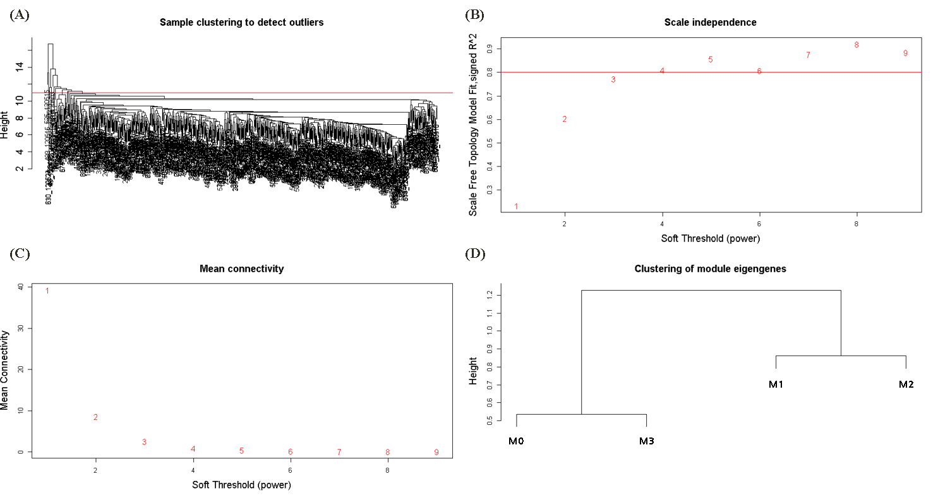
(A) Hierarchical clustering dendrogram of samples in the ROS/MAP dataset. Red line in the dendrogram represents the cutting height to detect outliers. A cutting tree height of 11 was selected, and the number of samples under the red line after clustering was 663. (B) The plot showing the scale-free topology fitting index (y-axis) for different soft-thresholding powers (β) (x-axis). (C) Analysis of mean connectivity (degree, y-axis) for various soft-thresholding powers (x-axis). The soft thresholding power of 4 was chosen to best approximate a scale-free topology because the scale-free topology index reached 0.8 and mean connectivity decreased considerably. (D) Eigengene dendrogram. The dynamic tree cut method was used to merge modules with dissimilarity < 25% when the minimum number of miRNAs in modules was set to 30. The M0 and M3 modules are highly related, while the M1 and M2 modules are also related.

Abbreviations: MAP, Memory and Aging Project; ROS, Religious Orders Study.

Supplemental figure 2. Co-expression network construction of consensus modules
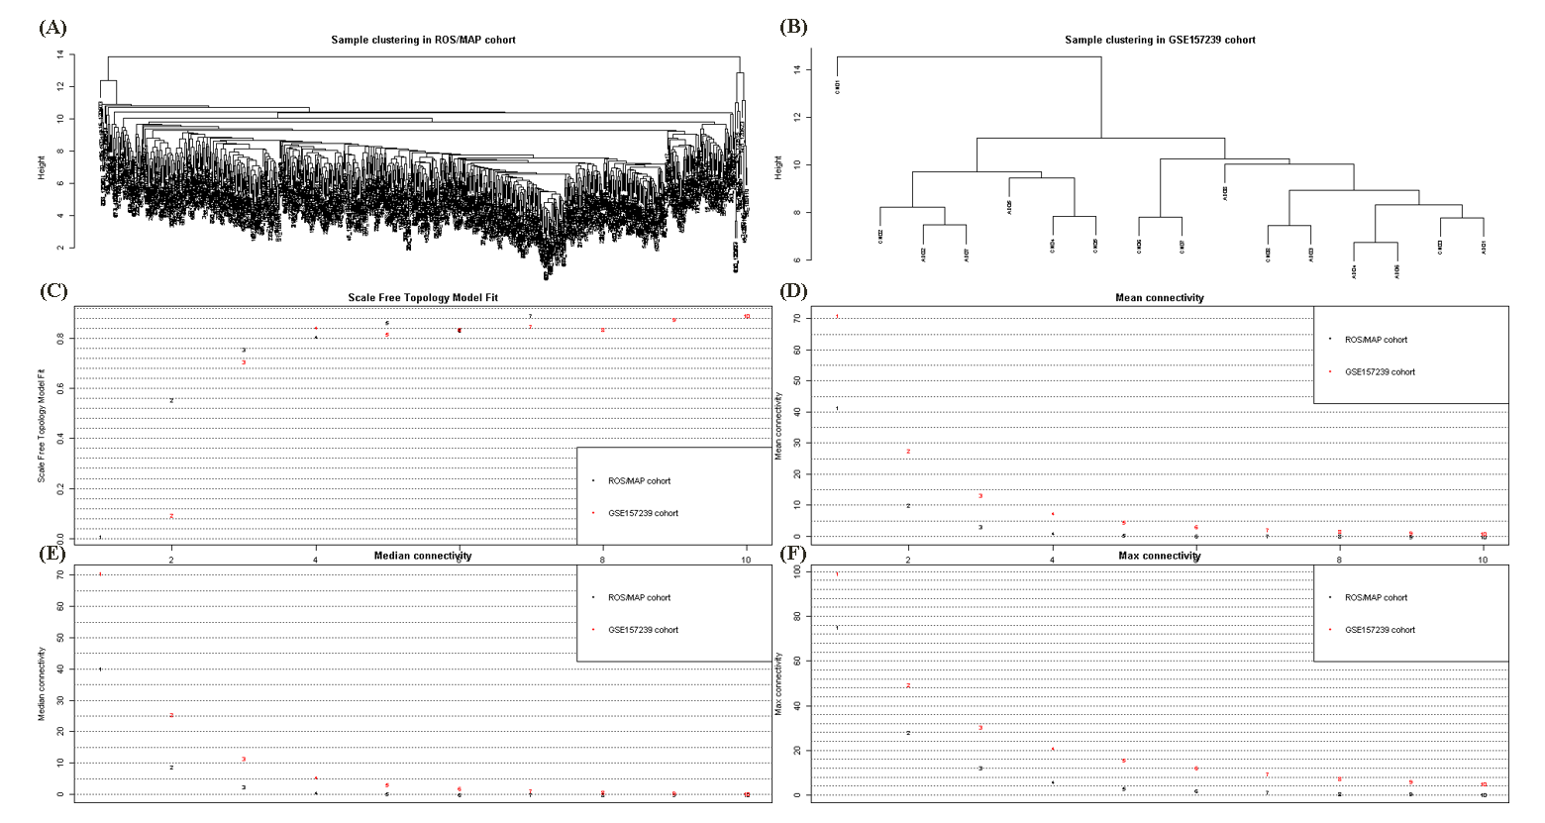
(A, B) Hierarchical clustering dendrogram of samples in the ROS/MAP (A) and GSE157239 (B) datasets. (C) The plot showing the scale-free topology fitting index (y-axis) for different soft-thresholding powers (β) (x-axis). (D to F) Analysis of median, mean, and max connectivity (degree, y-axis) for various soft-thresholding powers (x-axis). The soft thresholding power value of β (= 4) was selected for each dataset to best approximate a scale-free topology because the scale-free topology index reached 0.8 and connectivity measurements decreased considerably.

Abbreviations: MAP, Memory and Aging Project; ROS, Religious Orders Study.

Supplemental figure 3. Correspondence of ROS/MAP set-specific and ROS/MAP-GSE157239 consensus modules
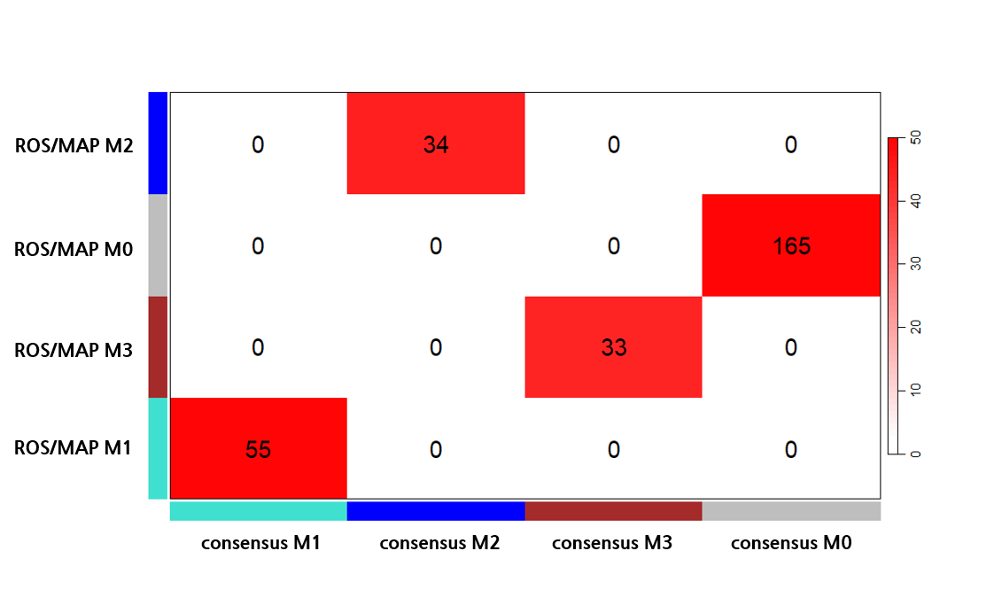
Each row in the table corresponds to a module from the ROS/MAP dataset, and each column to a ROS/MAP-GSE157239 consensus module. The number in each cell represents the count of miRNAs in the corresponding row and column. Color scale indicates the significance of the overlap, with red indicating more significant overlap based on the −log10 transformed P values from Fisher’s exact test.

Abbreviations: CM, consensus module; M, module; MAP, Memory and Aging Project; ROS, Religious Orders Study.

Supplemental figure 4. Pearson correlation matrix of modules from the ROS/MAP and consensus modules from the combined ROS/MAP and GEO datasets
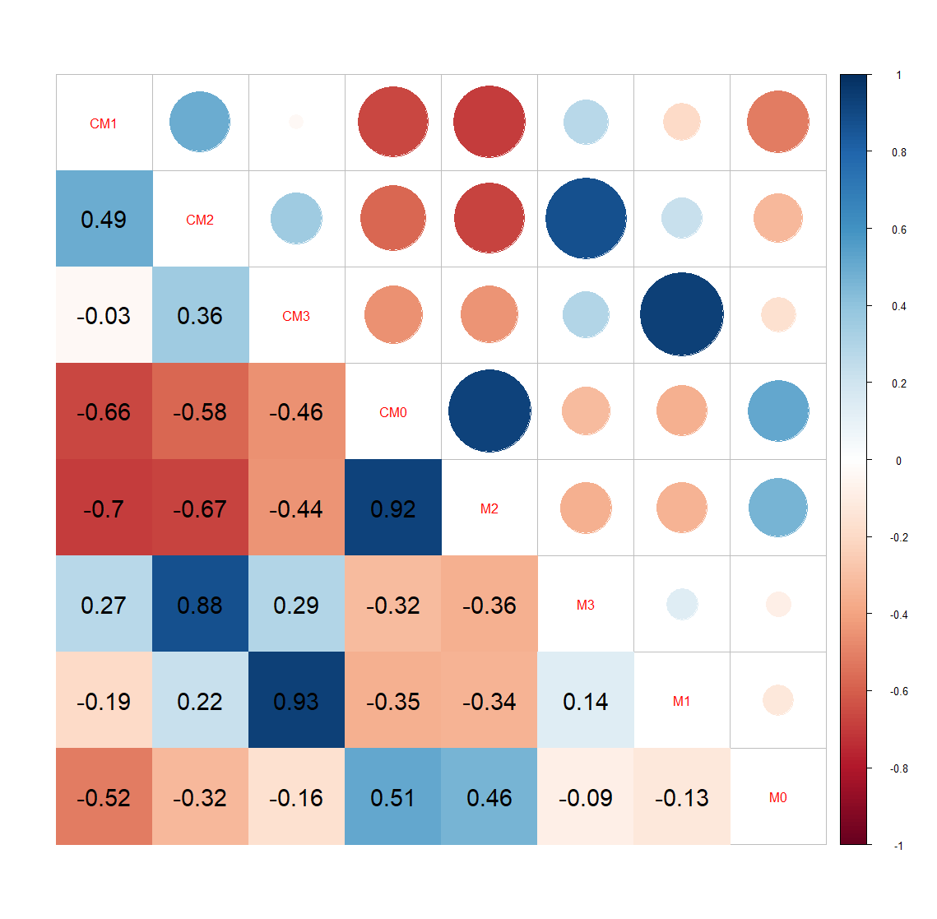
The color scale depicts the strength of the Pearson correlation coefficient. Blue colors represent positive correlations, while red colors denote negative correlations. The darker the color, the stronger the association. Superimposed text reflects the actual numerical value of the Pearson correlation coefficient.

Abbreviations: GEO, Gene Expression Omnibus; MAP, Memory and Aging Project; ROS, Religious Orders Study.

