Supplementary
Figure S-1 Heat map of the category “Travel” across Quebec’s 17 administrative regions (January 2020 -July 2022).
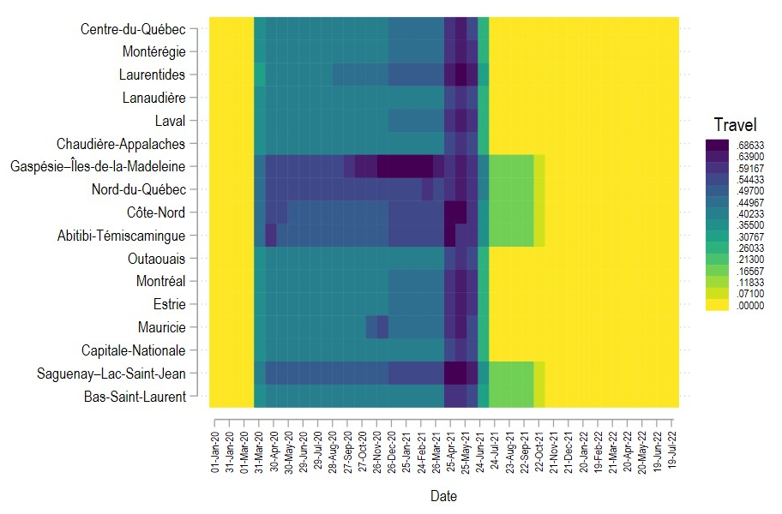
Note The presentation of results in the figure is based on the order of the regions' numbers, which have been previously provided in Tables 2 and 3.
Figure S-2 Heat map of the category “Distancing” across Quebec’s 17 administrative regions (January 2020 -July 2022).
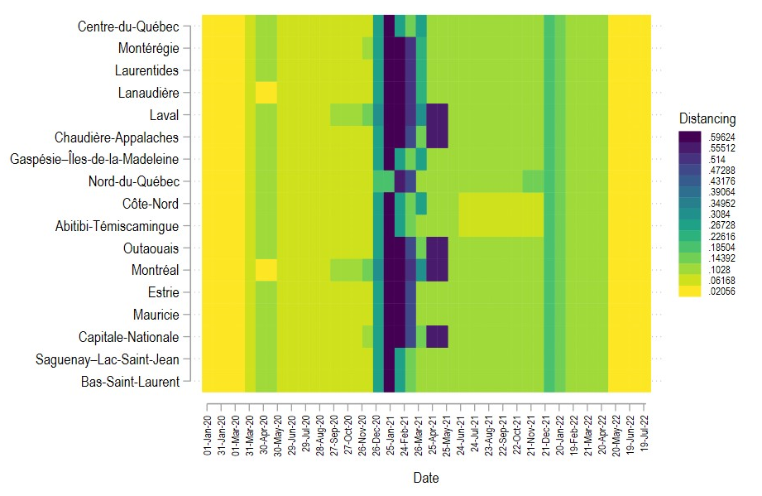
Note The presentation of results in the figure is based on the order of the regions' numbers, which have been previously provided in Tables 2 and 3.
Figure S-3 Heat map of the category “Closuring/Opening” across Quebec’s 17 administrative regions (January 2020 -July 2022).
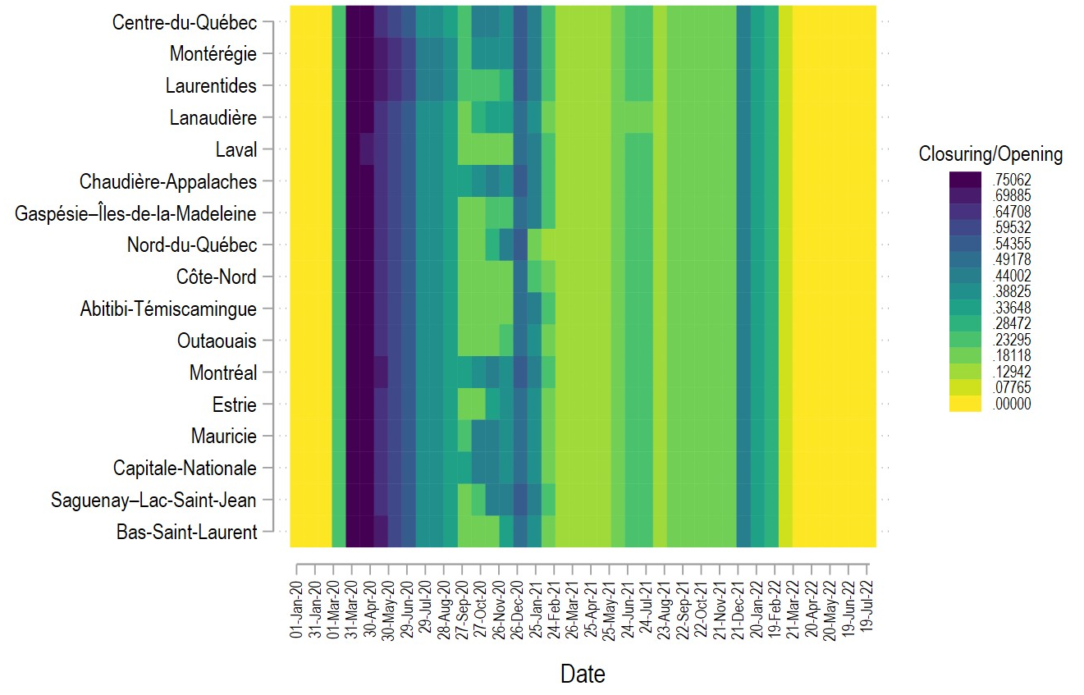
Note The presentation of results in the figure is based on the order of the regions' numbers, which have been previously provided in Tables 2 and 3.

