Journal: Biodiversity and Conservation

Short-term extinction predicted by population viability analysis for a Neotropical salt marsh endemic bird
Giovanna Sandretti-Silva¹, Fabio Stucchi Vannucchi¹, Larissa Teixeira^{1,2}, Tan Tjui Yeuw^{3,4}, Gustavo Maruyama Mori¹, Bianca Luiza Reinert† & Marcos R. Bornschein¹

¹ Universidade Estadual Paulista (UNESP), Instituto de Biociências, Departamento de Ciências Biológicas e Ambientais, Praça Infante Dom Henrique s/no, CEP 11330-900, São Vicente, São Paulo, Brazil.
² Mater Natura – Instituto de Estudos Ambientais, Rua Emiliano Perneta 297, conjunto 122, CEP 80010-050, Curitiba, Paraná, Brazil.
³ Wageningen University & Research, Aquaculture and Fisheries Group, Wageningen, The Netherlands
⁴ Wageningen University & Research, Wageningen Marine Research, Yerseke, The Netherlands
† In memorian
Corresponding Author: Marcos Ricardo Bornschein. E-mail: marcos.bornschein@unesp.br
Table A1. Ages of territorial adult Paraná Antwren (Formicivora acutirostris) individuals in Sectors 2 and 3, in Guaratuba Bay, southern Brazil, in December 2022.
Age (years) | Number of individuals | Proportion (%)
1 | 12 | 19.4%
2 | 5 | 8.1%
3 | 9 | 14.5%
4 | 6 | 9.7%
5 | 2 | 3.2%
6 | 2 | 3.2%
7 | 3 | 4.8%
8 | 7 | 11.3%
9 | 4 | 6.5%
10 | 2 | 3.2%
11 | 3 | 4.8%
12 | 3 | 4.8%
13 | 1 | 1.6%
14 | 2 | 3.2%
15 | 1 | 1.6%
Total | 62 | 100%

Table A2. Offspring productivity (independent fledglings) of the Paraná Antwren Formicivora acutirostris per territory in Guaratuba Bay, Southern Brazil. Blank cells indicate unmonitored territories during the breeding season, and cells with dashes indicate that territory did not exist during the mentioned breeding season.
Territory name | Breeding season
Territory name | 2006 / 2007 | 2007 / 2008 | 2008 / 2009 | 2009 / 2010 | 2010 / 2011 | 2011 / 2012 | 2012 / 2013 | 2013 / 2014 | 2014 / 2015 | 2015 / 2016 | 2016 / 2017 | 2017 / 2018 | 2018 / 2019 | 2019 / 2020 | 2020 / 2021 | 2021 / 2022 | 2022 / 2023 | Total
Jundiaquara island
Rosinha | 0 | 0 | 0 | 0 | 0 | 0 | 1 | 0 | 0 | 1 | 0 | 0 | 0 | 0 | 0 | 0 | 0 | 2
Magenta | 0 | 0 | 0 | 0 | 0 | 0 | 1 | 0 | 0 | 0 | 0 | 0 | 0 | 2 | 0 | 0 | 0 | 3
Rosaldo | 0 | 0 | 0 | 0 | 1 | 2 | 0 | 2 | 2 | 1 | 0 | 0 | 0 | 3 | 0 | 0 | 0 | 11
Mãezinha | 0 | 1 | 0 | 0 | 0 | 0 | 0 | 2 | 1 | 2 | 0 | 0 | 0 | 0 | 0 | 0 | 0 | 6
Azulzinho | 0 | 2 | 0 | 2 | 0 | 1 | 4 | 2 | 1 | 3 | 1 | 0 | 0 | 3 | 0 | 1 | 0 | 20
Velho | 1 | 1 | 0 | 2 | 3 | 2 | 2 | 3 | 2 | 2 | 4 | 0 | 2 | 2 | 0 | 1 | 0 | 27
Viúva | 0 | 0 | --- | --- | --- | --- | --- | --- | --- | --- | --- | --- | --- | --- | --- | --- | --- | 0
K | 0 | 0 | --- | --- | --- | --- | --- | --- | --- | --- | --- | --- | --- | --- | --- | --- | --- | 0
Riozinho | 1 | 3 | 0 | 1 | 2 | 1 | 0 | 1 | 2 | 1 | 1 | 2 | 2 | 3 | 0 | 2 | 0 | 22
Herbacinho | 0 | 0 | 0 | 0 | 0 | 0 | 2 | 0 | 0 | 0 | 0 | 0 | 0 | 2 | 0 | 0 | 0 | 4
Acelerado | 0 | 1 | 0 | 0 | 1 | 1 | 0 | 1 | 1 | 1 | 1 | 1 | 0 | 2 | 0 | 0 | 2 | 12
Mão de borracha | 0 | 0 | 0 | 0 | 2 | 2 | 1 | 3 | 1 | 3 | 1 | 1 | 2 | 1 | 0 | 2 | 2 | 21
Ponta L | 0 | 0 | 0 | 2 | 2 | 1 | 2 | 0 | 0 | 1 | 1 | 1 | 2 | 3 | 0 | 0 | 1 | 16
Capim-serra | 0 | 0 | 0 | 3 | 0 | 0 | 2 | 0 | 2 | 2 | 3 | 1 | 1 | 1 | 0 | 2 | 1 | 18
New azulzinho | --- | --- | --- | --- | --- | 0 | 0 | 0 | 0 | 0 | 0 | 1 | 1 | --- | --- | --- | --- | 2
Espremido | --- | --- | --- | --- | --- | --- | --- | --- | --- | 0 | 0 | 0 | --- | --- | 0 | --- | --- | 0
Vigor | --- | --- | --- | --- | --- | --- | --- | --- | --- | --- | --- | --- | 0 | 0 | --- | --- | 0 | 0
Boquinha | --- | --- | --- | --- | --- | 0 | 0 | 0 | 2 | 0 | 0 | 0 | 2 | 2 | 0 | --- | --- | 6
David Cooperfield | --- | --- | --- | --- | --- | --- | 0 | 0 | 1 | 0 | 0 | 2 | 0 | 0 | 0 | 0 | 0 | 3
Number of territories | 14 | 14 | 12 | 12 | 12 | 14 | 15 | 15 | 15 | 16 | 16 | 16 | 16 | 15 | 15 | 13 | 14
Continente
Vizinho |  |  |  | 0 | 0 |  | 0 | 2 | 0 | 1 | 1 |  | 1 | 0 | 0 | 2 | 0 | 7
Barbantinho |  |  |  | 0 | 0 |  | 0 | 2 | 2 | 2 | 2 |  | 2 | 2 | 0 | 0 | 0 | 12
Listrão |  |  |  | 0 | 2 |  | 0 | 1 | 1 | 0 | 0 |  |  | 2 | 0 | 0 | 0 | 6
Amarelinha |  | 0 |  | 0 | 0 |  | 0 | 0 | 0 | 0 | 0 |  | 0 | 0 | 0 | 0 | 0 | 0
Asinha |  |  |  | 0 | 0 |  | 0 | 2 | 2 | 2 | 1 |  | 0 | 0 | 0 | 3 | 0 | 10
Beringela |  |  |  | 0 | 0 |  | 2 | 0 | 0 | 2 | 0 |  | 0 | 3 | 0 | 1 | 2 | 10
Vermelhinha |  | 0 |  | 0 | 0 |  | 0 | 1 | 0 | 0 | 0 |  | 0 | 2 | 0 | 0 | 1 | 4
Vitório pai |  | 0 |  | 0 | 0 |  | 0 | 1 | 0 | 0 | 0 |  | 0 | 0 | 0 | 0 | 0 | 1
Colorado |  | 0 |  | 0 | 0 |  | 2 | 1 | 0 | 2 | 0 |  | 0 | 0 | --- | --- | 0 | 5
Choquinha |  | 0 |  | 0 | 0 |  | 0 | 0 | 0 | 1 | 0 |  | 0 | --- | 0 | 0 | 0 | 1
Global |  |  |  | --- | --- | --- | --- | --- | --- | 0 | 0 |  | 0 | 0 | --- | --- | --- | 0
Confusão |  |  |  | --- | --- | --- | --- | --- | --- | 0 | 0 |  | 0 | 0 | --- | --- | --- | 0
Elisa |  |  |  | --- | --- | --- | --- | --- | --- | 0 | 0 |  | 0 | 0 | --- | --- | --- | 0
Dinha |  |  |  | --- | --- | --- | --- | --- | --- | --- | --- |  | --- | 1 | 0 | --- | --- | 1
Number of territories |  | 51 |  | 10 | 10 |  | 10 | 10 | 10 | 13 | 13 |  | 12 | 13 | 10 | 9 | 10
Folharada Island
Primeirinho |  |  |  | 1 | 1 | 3 | 3 | 1 | 0 | 1 | 2 |  | 0 | 1 | 0 | 0 | 0 | 13
Dezinho |  |  |  | 0 | 1 | 1 | 1 | 0 | 1 | 1 | 0 |  | 0 | 1 | 0 | 0 | 1 | 7
Manguito |  |  |  | 0 | 0 | 0 | 1 | 0 | 2 | 0 | 0 |  | 0 | 1 | 0 | 0 | — | 4
Jamaicano |  |  |  | 1 | 4 | 1 | 1 | 1 | 0 | 0 | 0 |  | 0 | 0 | 0 | 0 | 1 | 9
Brasileiro |  |  |  | 1 | 0 | 2 | 0 | 0 | 0 | 0 | --- |  | --- | --- | --- | --- | — | 3
Salsicha |  |  |  | 0 | 1 | 2 | 0 | 0 | 3 | 0 | 1 |  | 0 | 0 | 0 | 0 | — | 7
Ypsilone |  |  |  | 1 | 0 | 0 | 0 | 1 | 1 | 1 | 0 |  | 0 | 0 | --- | --- | 0 | 4
Desrrabado |  |  |  | 0 | 0 | 1 | 0 | 0 | 2 | 1 | 0 |  | 0 | 0 | 0 | 0 | 0 | 4
Hibisquito |  |  |  | 0 | 2 | 2 | 0 | 0 | 0 | 0 | 0 |  | 0 | 1 | 1 | 0 | 1 | 7
Canalito |  |  |  | 0 | 0 | 2 | 0 | 0 | 0 | 1 | 0 |  | 0 | 1 | 0 | 1 | 0 | 5
Tremilique |  |  |  | --- | --- | 1 | 3 | 0 | 0 | 0 | 0 |  | 0 | --- | --- | --- | --- | 4
Capivara |  |  |  | --- | --- | --- | 0 | 0 | 0 | --- | --- |  | --- | --- | --- | --- | --- | 0
Denirson |  |  |  | --- | --- | 0 | 0 | 0 | --- | 0 | --- |  | --- | --- | --- | --- | --- | 0
Kalito |  |  |  | --- | --- | 0 | --- | --- | --- | --- | --- | --- | --- | --- | --- | --- | 0 | 0
Alemão |  |  |  | --- | --- | --- | --- | --- | --- | --- | --- | --- | --- | 0 | --- | --- | --- | 0
Dividido |  |  |  | --- | --- | --- | --- | --- | --- | --- | --- | --- | 0 | 1 | --- | --- | --- | 1
Number of territories |  |  |  | 10 | 10 | 13 | 13 | 13 | 12 | 12 | 10 |  | 11 | 11 | 8 | 8 | 8
Lagoa do Parado
Uno |  |  |  |  |  |  | 1 |  |  |  |  |  |  |  |  |  |  | 1
Choque |  |  |  |  |  |  | 1 |  |  |  |  |  |  |  |  |  |  | 1
Moranguinho |  |  |  |  |  |  | 0 |  |  |  |  |  |  |  |  |  |  | 0
Bico |  |  |  |  |  |  | 0 |  |  |  |  |  |  |  |  |  |  | 0
Cachaça |  |  |  |  |  |  | 0 |  |  |  |  |  |  |  |  |  |  | 0
Number of territories |  |  |  |  |  |  | 5
¹ The monitored area was smaller. It was expanded and has remained standardized since the 2009/2010 breeding season.

Table A3. Demographic results for the population viability analysis (PVA) of the Paraná Antwren Formicivora acutirostris in the simulated scenarios. Abbreviations: stoch r- = mean population growth rate; YE = year of extinction; GenDiv = genetic diversity; G = generation.
Scenario | Stoch-r | SD(r) | Probability of extinction (E) |  |  | Mean YE | GeneDiv (2123) | Size of simulated extant population
Scenario | Stoch-r | SD(r) | 2040 (3G) | 2052 (5G) | 2123 | Mean YE | GeneDiv (2123) | 2023 | 2029 (1G) | 2035 (2G) | 2040 (3G)
Evaluation scenarios
Baseline | -0.1013 | 0.1054 | 2.6% | 24.5% | 97.8% | 2068 | 0.7893 | 853 | 566 | 379 | 276
Optimistic | -0.0227 | 0.0550 | 0% | 0% | 0.6% | 2119 | 0.9547 | 3,832 | 3,276 | 2,799 | 2,464
Pessimistic | -0.1629 | 0.1105 | 56.9% | 99.6% | 100% | 2041 |  | 87 | 30 | 10 | 5
Continente | -0.1465 | 0.1070 | 15.1% | 93.4% | 100% | 2046 |  | 161 | 65 | 24 | 10
Folharada | -0.1431 | 0.1083 | 9.6% | 89.6% | 100% | 2047 |  | 187 | 78 | 29 | 13
Lagoa do Parado | -0.1246 | 0.1006 | 0.2% | 34% | 100% | 2055 |  | 340 | 168 | 78 | 39
Conservation scenarios – Baía de Guaratuba population¹
BG | -0.1077 | 0.1438 | 9.3% | 34.2% | 98.9% | 2064 | 0.7499 | 329 | 223 | 155 | 120
BG_K | -0.1007 | 0.1436 | 9.8% | 34.7% | 98.8% | 2063 | 0.773 | 325 | 219 | 153 | 118
BG_P02 | -0.0684 | 0.1362 | 6.1% | 23.0% | 83.4% | 2070 | 0.857 | 328 | 271 | 230 | 207
BG_P04 | -0.0589 | 0.1341 | 5.0% | 19.4% | 78.4% | 2071 | 0.8651 | 329 | 281 | 247 | 225
BG_P06 | -0.0476 | 0.1278 | 4.1% | 16.9% | 72.2% | 2073 | 0.8786 | 331 | 298 | 271 | 253
BG_P08 | -0.0384 | 0.1250 | 4.3% | 15.5% | 65.1% | 2073 | 0.8871 | 335 | 313 | 293 | 279
BG_P10 | -0.0280 | 0.1192 | 3.9% | 15.1% | 60.6% | 2073 | 0.889 | 327 | 315 | 303 | 293
BG_P12 | -0.0178 | 0.1137 | 3.2% | 10.8% | 52.3% | 2074 | 0.892 | 335 | 335 | 332 | 326
BG_P14 | -0.0090 | 0.1105 | 2.8% | 10.5% | 48.5% | 2074 | 0.9001 | 328 | 338 | 341 | 338
BG_P16 | -0.0008 | 0.1048 | 2.5% | 9.1% | 42.3% | 2074 | 0.9035 | 331 | 353 | 363 | 364
BG_P18 | 0.0105 | 0.0998 | 1.9% | 8.0% | 36.2% | 2073 | 0.9071 | 335 | 372 | 390 | 392
BG_P20 | 0.0200 | 0.0955 | 1.9% | 7.5% | 33.0% | 2074 | 0.9083 | 329 | 374 | 398 | 408
BG_P02_K | -0.0684 | 0.1365 | 5.7% | 22.8% | 82.1% | 2069 | 0.8892 | 329 | 274 | 238 | 219
BG_P04_K | -0.0577 | 0.1334 | 5.3% | 18.6% | 75.1% | 2071 | 0.9014 | 338 | 297 | 271 | 259
BG_P06_K | -0.0472 | 0.1291 | 4.5% | 17.6% | 70.3% | 2072 | 0.9089 | 332 | 301 | 283 | 278
BG_P08_K | -0.0356 | 0.1240 | 3.8% | 14.8% | 65.3% | 2073 | 0.9157 | 327 | 308 | 299 | 297
BG_P10_K | -0.0255 | 0.1204 | 2.8% | 14.4% | 59.2% | 2072 | 0.9236 | 330 | 324 | 324 | 330
BG_P12_K | -0.0139 | 0.1145 | 2.9% | 11.8% | 52.5% | 2073 | 0.928 | 331 | 339 | 351 | 363
BG_P14_K | -0.0032 | 0.1085 | 2.8% | 10.4% | 47.4% | 2074 | 0.9315 | 332 | 352 | 372 | 391
BG_P16_K | 0.0066 | 0.1041 | 2.4% | 8.7% | 41.5% | 2074 | 0.935 | 329 | 361 | 393 | 416
BG_P18_K | 0.0181 | 0.0982 | 2.1% | 7.4% | 36.2% | 2075 | 0.937 | 337 | 383 | 423 | 455
BG_P20_K | 0.0291 | 0.0930 | 2.0% | 6.8% | 33.1% | 2074 | 0.9383 | 330 | 386 | 436 | 473
¹ We calculated Stoch-r and SD(r) of Baía de Guaratuba population only after 2023, upon the implementation of the manegement actions.
Table A4. Number of territories of the Paraná Antwren Formicivora acutirostris present in the studied sectors in the Guaratuba Bay estuary (Sectors 1, 2, and 3) during the study period. The territories presented were considered if they persisted during the breeding season, and the reproductive activities were verified. Blank cells indicate unmonitored sector.
Year | Sector
Year | Jundiaquara Island | Continente | Folharada Island
2006 | 14
2007 | 14
2008 | 12
2009 | 12 | 10 | 10
2010 | 12 | 10 | 10
2011 | 14 | 9 | 13
2012 | 15 | 10 | 13
2013 | 15 | 10 | 13
2014 | 15 | 10 | 12
2015 | 16 | 10 | 12
2016 | 16 | 13 | 10
2017 | 16 | 13 | 10
2018 | 16 | 13 | 11
2019 | 15 | 13 | 11
2020 | 15 | 10 | 8
2021 | 13 | 10 | 8
2022 | 14 | 10 | 8
2023 | 12 | 9 | 6

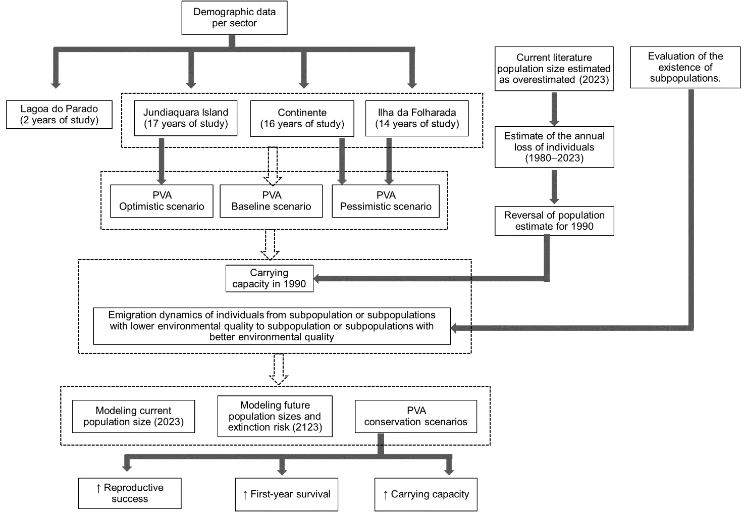
Fig. A1 Flowchart of the methods used to conduct the population viability analysis (PVA) of the Paraná Antwren Formicivora acutirostris in the present study

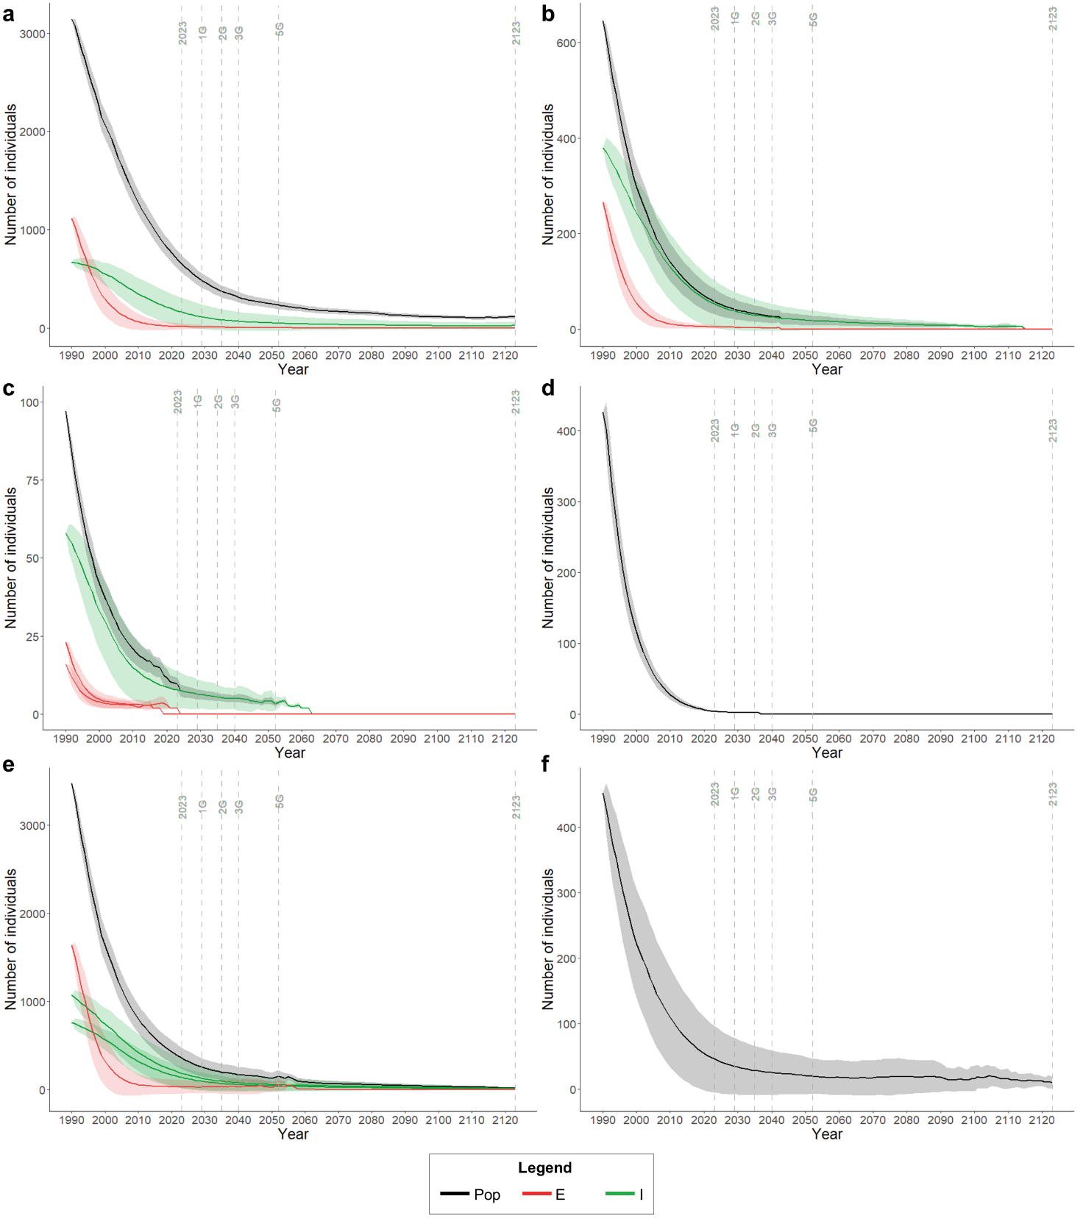
Fig. A2 Population performance of populations of Formicivora acutirostris between 1990 and 2123 in the baseline scenario. a Baía de Antonina population. b Rio Nhundiaquara population. c Rio Guaraguaçu population. d Balneário Flórida population. e Baía de Guaratuba population. f Itapoá population. Abbreviations: Pop = total population; E = emigration subpopulations (lower-quality); I = immigration subpopulations (high-quality)

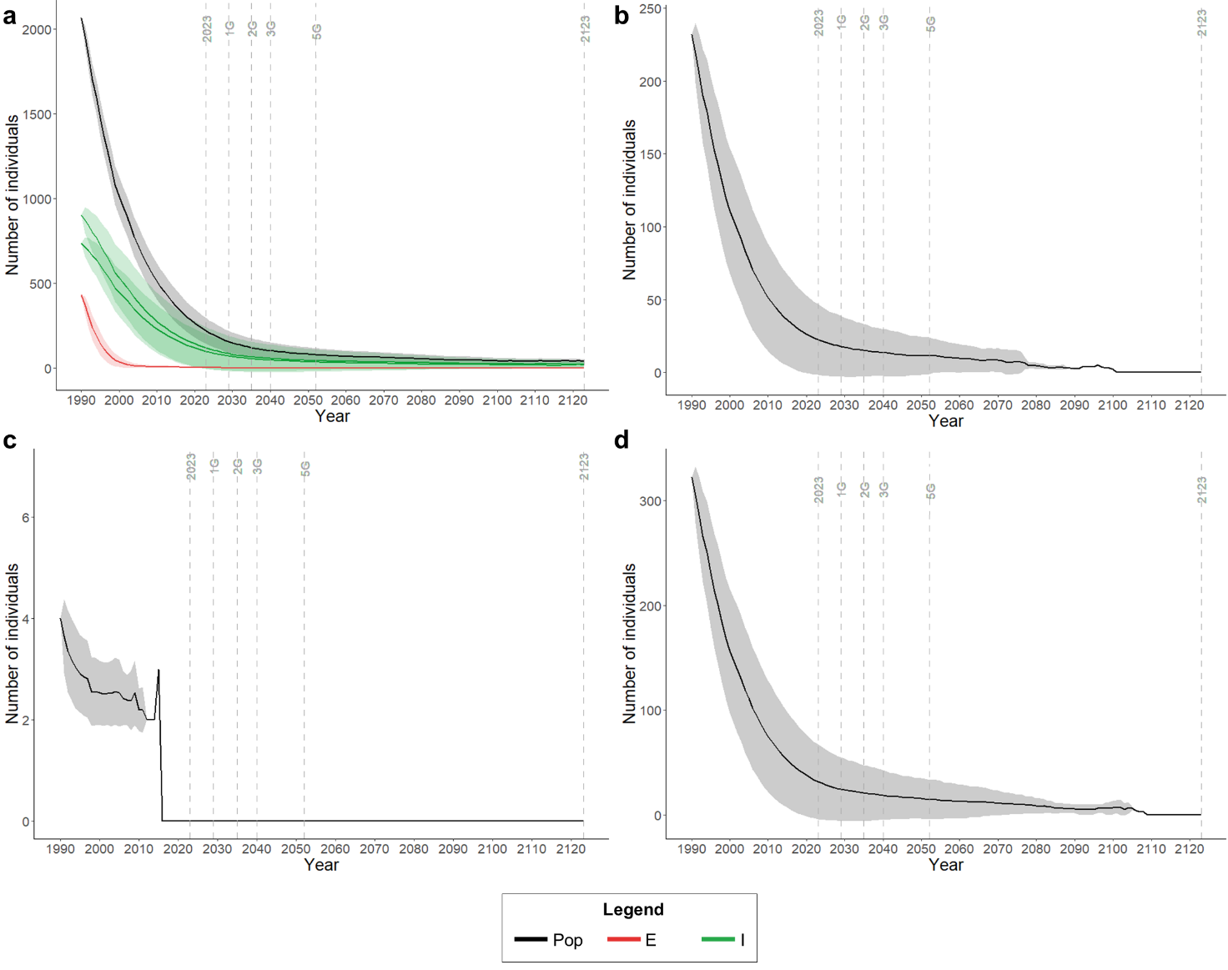
Fig. A3 Population performance of populations of Formicivora acutirostris between 1990 and 2123 in the baseline scenario a Baía de Babitonga population. b Itapocu population. c Rio da Madre population. d Lagoas do Sul population. Abbreviations: Abbreviations: Pop = total population; E = emigration subpopulations (lower-quality); I = immigration subpopulations (high-quality)

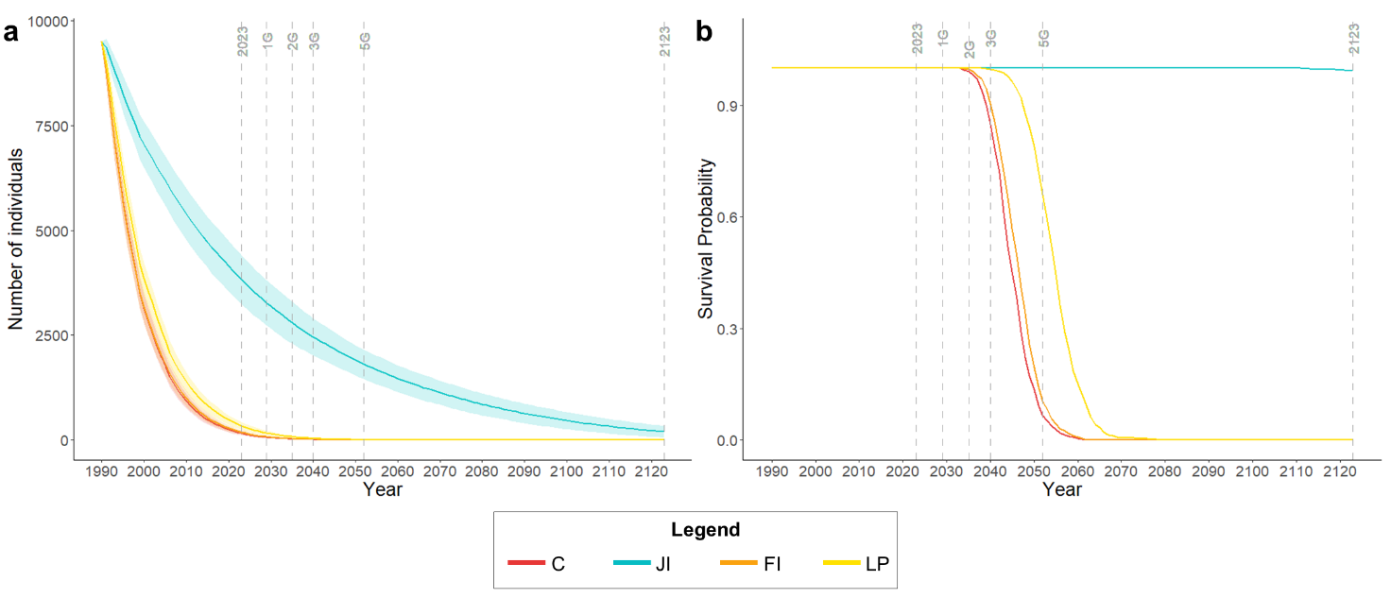Fig. A4 Population performance of Formicivora acutirostris between 1990 and 2123 considering the parameters of distinct sectors studied in Guaratuba Bay. a Mean value and SD for population size. b Mean value and SE for the survival probability. Abbreviations: C = Continente; JI = Jundiaquara Island; FI = Folharada Island; LP = Lagoa do Parado

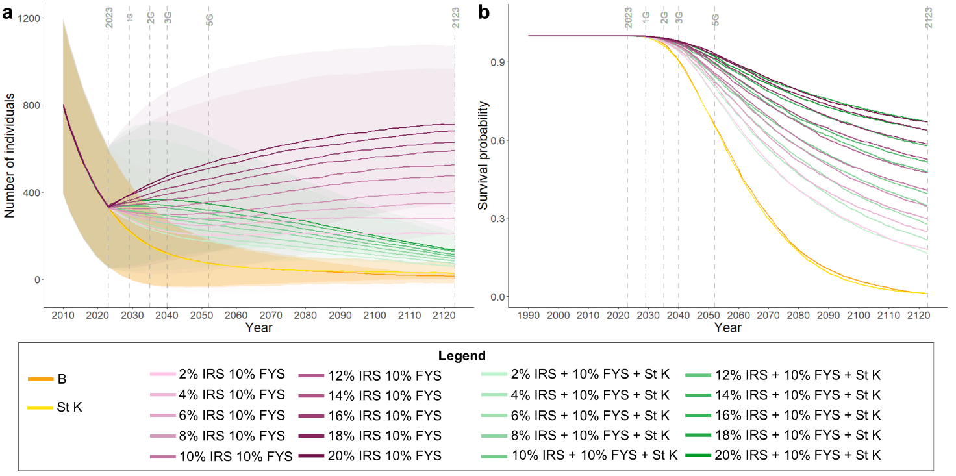
Fig. A5 Population performance of Formicivora acutirostris between 2023 and 2123 considering distinct conservation scenarios applied to the baseline scenario. a Mean value and SD for the Baía de Guarauba population size for simulations without extinction (extant). b Mean value and SE for the survival probability of the Baía de Guaratuba population. Abbreviations: B = baseline scenario; K = carrying capacity; St K = conservation scenario of stabilized carrying capacity; IRS/FYS = conservation scenarios of improved productivity and first-year survival; St K + IRS/FYS = conservation scenarios of stabilized carrying capacity and improved productivity and first-year survival

