Supplemental Figures

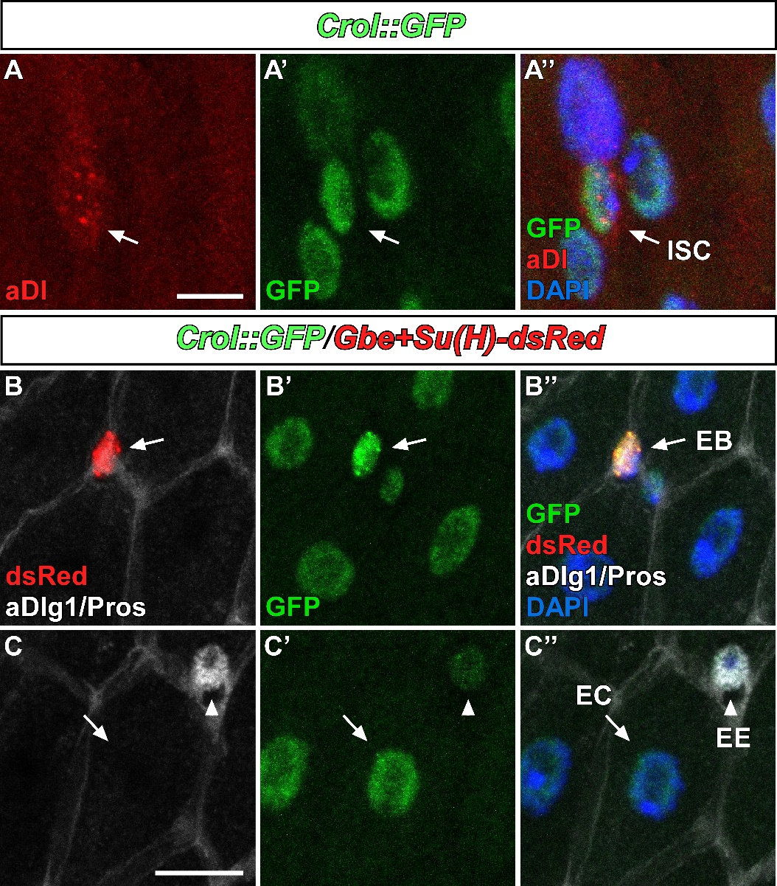
Fig.S1: Crol is expressed in the adult Drosophila midgut
(A-A’’) Confocal images of Crol::GFP in adult midguts of MF showing localization of Crol in nuclei of ISC positive for antibody staining against the ISC marker Delta (aDl). Scale bar is 5µm. (B-C’’) Confocal images of Crol::GFP combined with the EB marker Gbe+Su(H)-dsRed showing Crol localization in (B-B’’) dsRed positive EC, and (C-C’’) in epithelial EC stained with antibody against the septate junction marker discs large 1 (aDlg1) and enteroendocrine cells (EE) stained by anti-prospero (Pros). Scale bar is 10µm.

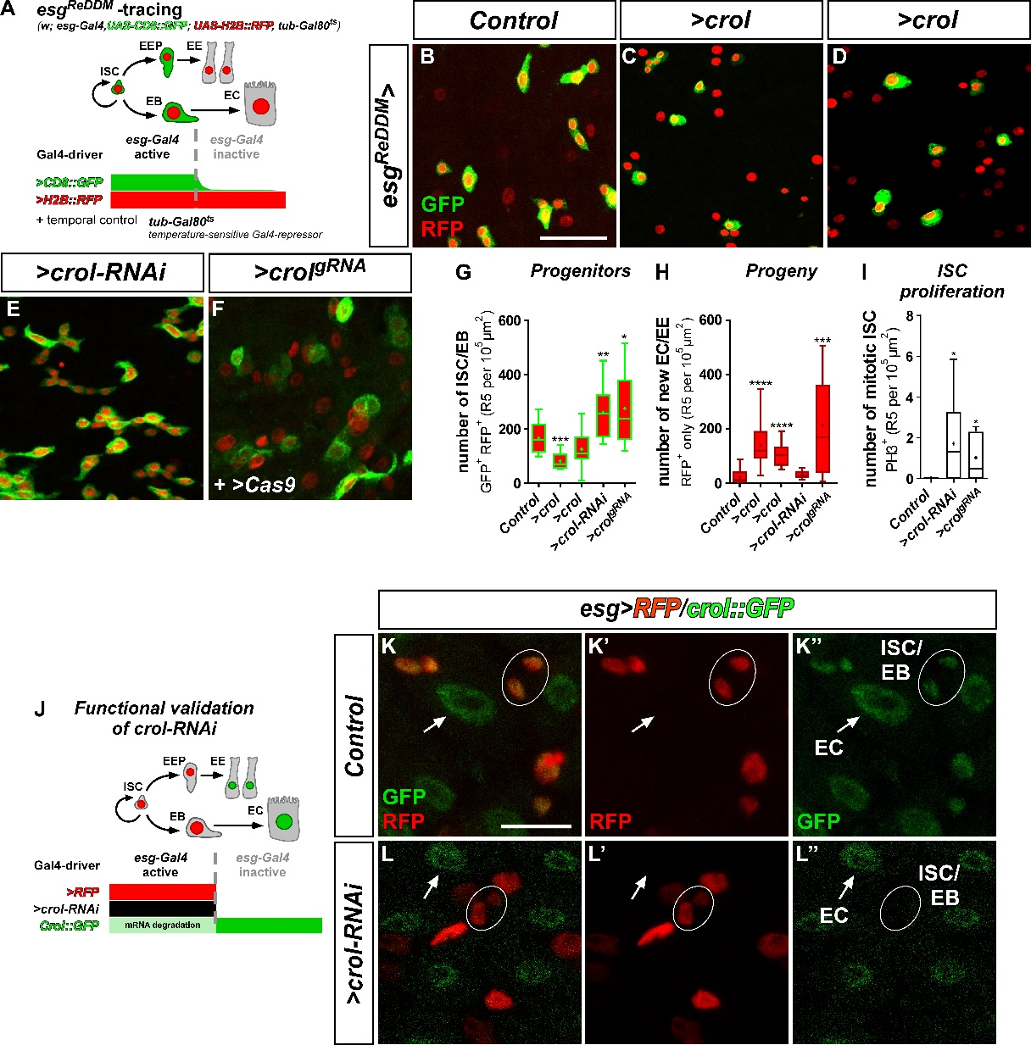
Fig.S2: Crol controls ISC proliferation and intestinal homeostasis
(A) Schematic of esg^{ReDDM} tracing. esg-Gal4, active in progenitor cells, double marks ISC/EB driving expression of >CD8::GFP (membrane, green) and >H2B::RFP (nuclei, red). Upon differentiation new epithelial EC and EE lose CD8::GFP signal, whereas nuclear H2B::RFP persists due to its long half-life enabling tracing of ISC/EB progeny. Transgene expression is timely controlled by an ubiquitously expressed temperature sensitive Gal80 repressor (tub-Gal80^{ts}). (B-F) Confocal images of adult midguts after seven days of esg^{ReDDM} tracing in (B) controls, OE of crol using two other overexpression lines: (C) Bloomington line BL58359 and (D) BL56762, (E) KD of crol using another RNAi-line: BL44643, and (F) knockout (KO) of crol induced by a crol guide RNA transgene (>crol^{gRNA}) consisting of two single gRNAs binding crol cDNA for CRISPR/Cas9 induced KO by >Cas9. Scale bar is 50µm. (G-I) Quantifications of (G) progenitor cell numbers (n=15,11,15,12,8), (H) progeny (n=15,11,15,12,8), and (I) ISC proliferation encompassing number of mitotically active ISC positive for aPH3 staining (n=8,9,5). Mean is indicated by (+) and asterisks denote significances from student’s t-test (*p<0.05, **p<0.01, ***p<0.001, ****p<0.0001). (J) Schematic of a model for functional validation of >crol-RNAi and crol::GFP transgenes. Crol::GFP shows presence of Crol protein in all cell types and is combined with esg-Gal4 driving expression of >RFP and >crol-RNAi in ISC/EB. Expression of >crol-RNAi leads to mRNA degradation within ISC/EB resulting in the subsequent loss of Crol::GFP signal. (K-L’’) Confocal images of adult midguts with crol::GFP and esg>RFP in (K-K’’) controls and (L-L’’) combined with >crol-RNAi resulting in visible loss of Crol::GFP signal within ISC/EB (outlined with white ellipses). White arrowheads point to EC that are positive for Crol::GFP signal in both conditions. Scale bar is 10µm.
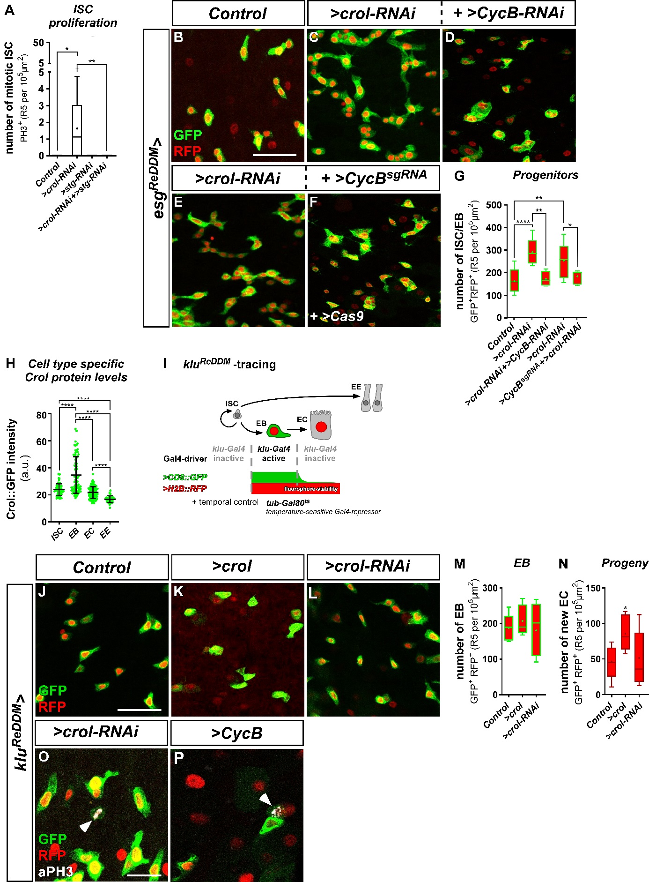
Fig.S3: Crol controls proliferation in ISC and EB by regulating CycB
(A) Quantification of mitotic ISC upon KD of stg and crol in esg^{ReDDM} traced for seven days (n=8,15,5,9). (B-F) Confocal images of adult midguts after seven days of esg^{ReDDM} tracing in (B) controls, (C) upon expression of >crol-RNAi (D) combined with >CycB-RNAi, and (E) >crol-RNAi (F) combined with >CycB^{sgRNA} and >Cas9 for CRISPR/Cas9 induced KO. Scale bar is 50µm. (G) Quantification of progenitor cell numbers in esg^{ReDDM} specific manipulations traced for seven days (n=13,8,4,10,6). (H) Quantification of Crol protein levels within different cell types of adult midguts indicated by Crol::GFP intensities (n=63,77,115,40). Means and standard deviations are visualized by vertical lines and asterisks denote significances from student’s t-test (****p<0.0001). (I) Schematic of klu^{ReDDM} tracing. Klu-Gal4, active in EB, double marks EB driving expression of >CD8::GFP (membrane, green) and >H2B::RFP (nuclei, red). Upon differentiation new epithelial EC lose CD8::GFP signal, whereas nuclear H2B::RFP persists due to its long half-life enabling tracing of EB progeny. ISC and EE are not labelled/traced by fluorophores. Transgene expression is timely controlled by an ubiquitously expressed temperature sensitive Gal80 repressor (tub-Gal80^{ts}). (J-L) Confocal images of adult midguts after seven days of klu^{ReDDM} tracing in (J) controls, (K) >crol, and >crol-RNAi. Scale bar is 50µm. (M-N) Quantifications of (M) EB numbers and (N) progeny upon seven days of klu^{ReDDM} specific manipulation and tracing (n=7,6,9/7,6,9). Means are indicated by (+) and asterisks denote significances from student’s t-test (*p<0.05). (O-P) Confocal images of midguts after seven days of klu^{ReDDM} tracing driving expression of (O) >crol-RNAi and (P) >CycB. Mitotically active EB are visualized by aPH3 staining. Scale bar is 20µm.

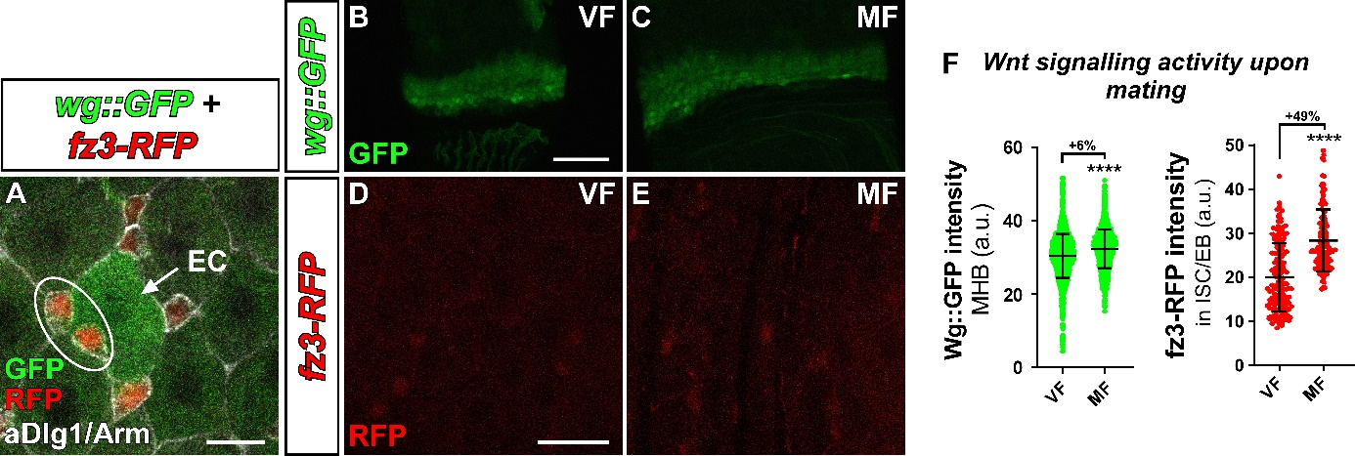
Fig.S4: Wnt/Wg activity in ISC/EB responds to mating dependent 20HE release
(A) Confocal image of wg::GFP combined with fz3-RFP in adult midgut showing Wg::GFP signal in EC marked by aDlg1 staining (white arrow) and fz3-RFP signal in surrounding ISC/EB stained by aArm and outlined by white ellipse. Scale bar is 10µm. (B-C) Confocal images of Wg::GFP in midgut-hindgut boundaries (MHB) of (B) VF and (C) MF. Scale bar is 50µm. (D-E) Confocal images of fz3-RFP in midguts of (D) VF and (E) MF flies. Scale bar is 20µm. (F) Quantifications of Wg::GFP levels in MHB and fz3-RFP levels in ISC/EB upon mating (n=5229,5660/150,129). Fold changes are shown in percentages, means and standard deviations are indicated by vertical lines and asterisks denote significances from student’s t-test (****p<0.0001).

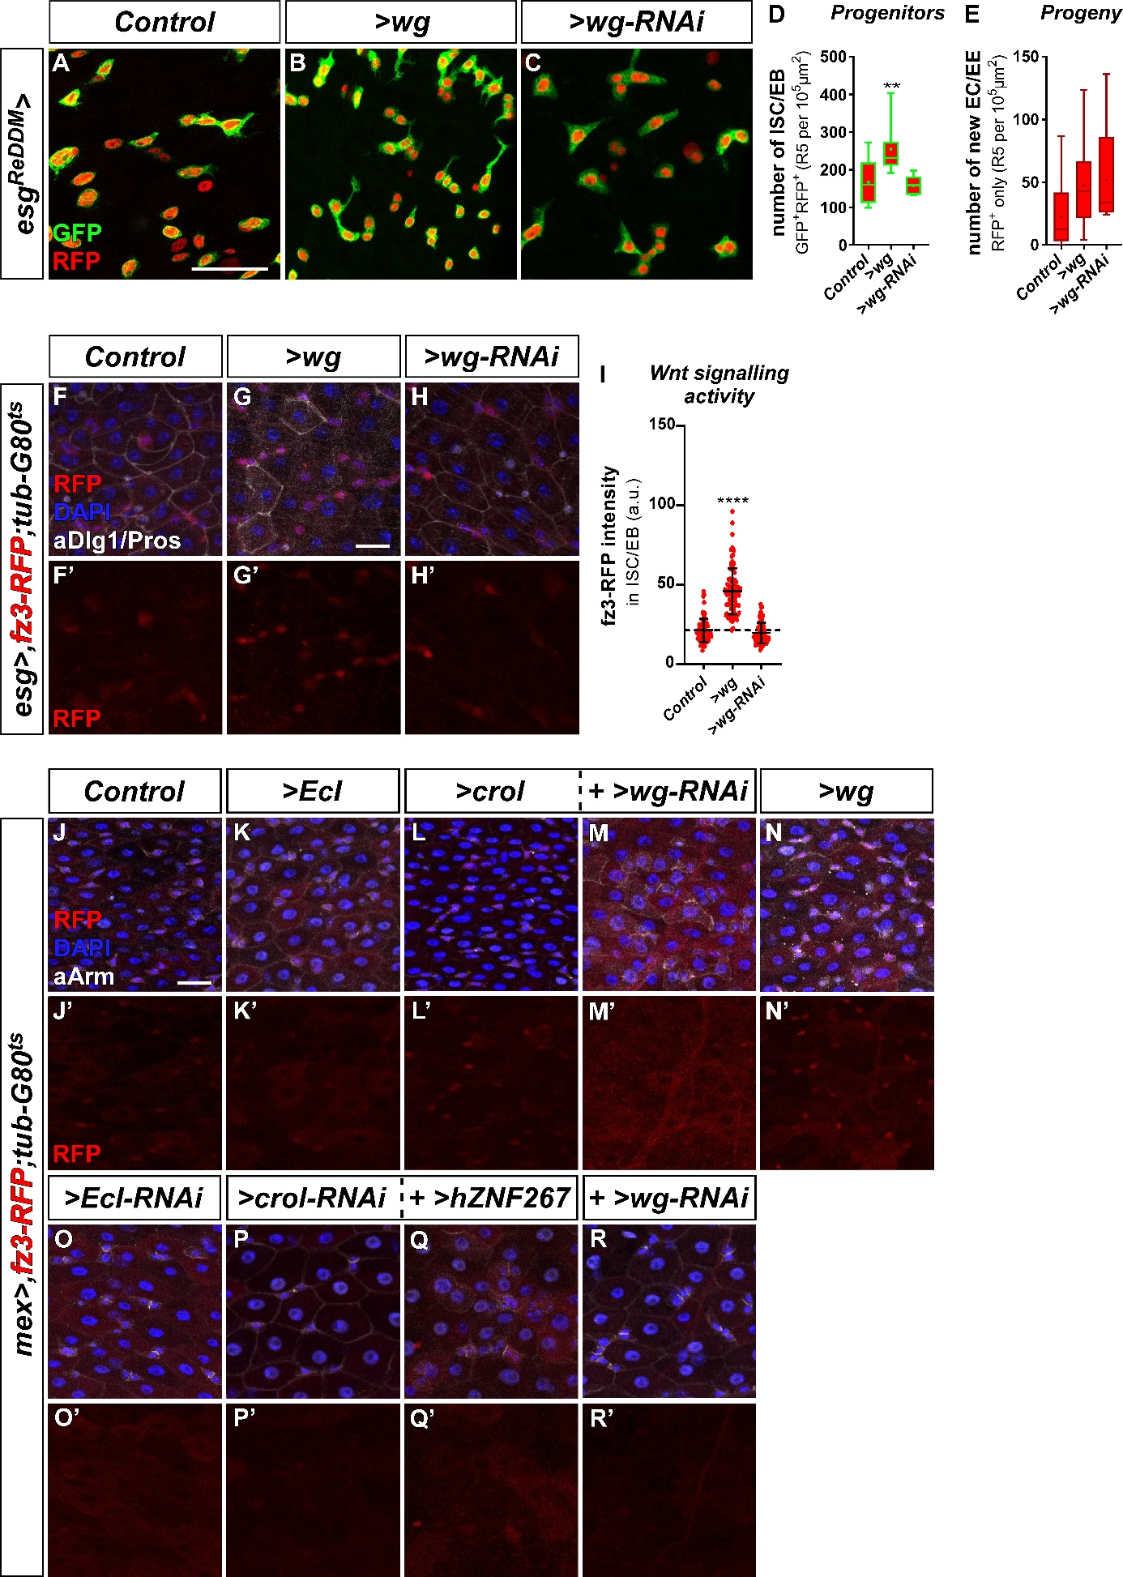
Fig.S5: Epithelial EC derived Wg-ligands activate Wnt/wg signalling in ISC
(A-C) Confocal images of adult midguts after seven days of esg^{ReDDM} tracing in (A) controls, upon (B) OE, and (C) KD of wg. Scale bar is 50µm. (D-E) Quantifications of (D) progenitor cell number and (E) progeny upon ISC/EB specific manipulations of wg (n= 15,7,5/15,7,5). Means are indicated by (+) and asterisks denote significances from student’s t-test (**p<0.001). (F-H’) Confocal images of fz3-RFP combined with esg-Gal4 and tub-Gal80^{ts} in adult midguts after three days of shifting in (F-F’) controls, combined with ISC/EB specific (G-G’) OE, and (H-H’) KD of wg. EC and EE are marked by antibody staining against Dlg1 and Pros. Scale bar is 20µm. (I) Quantification of fz3-RFP levels in ISC/EB upon esg-Gal4 specific >wg and >wg-RNAi (n=90,90,90). Means and standard deviations are indicated by vertical lines and asterisks denote significances from student’s t-test (****p<0.0001). (J-R’) Confocal images of fz3-RFP combined with mex-Gal4 and tub-Gal80^{ts} in adult midguts after one day of shifting in (J-J’) controls, EC specific OE of (K-K’) EcI, (L-L’) crol (M-M’) with simultaneous KD of wg, and (N-N’) wg, and KD of (O-O’) EcI, (P-P’) crol (Q-Q’) with simultaneous expression of >hZNF267, and (R-R’) wg in EC. ISC/EB are marked with anti-Armadillo (aArm) staining. Scale bar is 20µm.

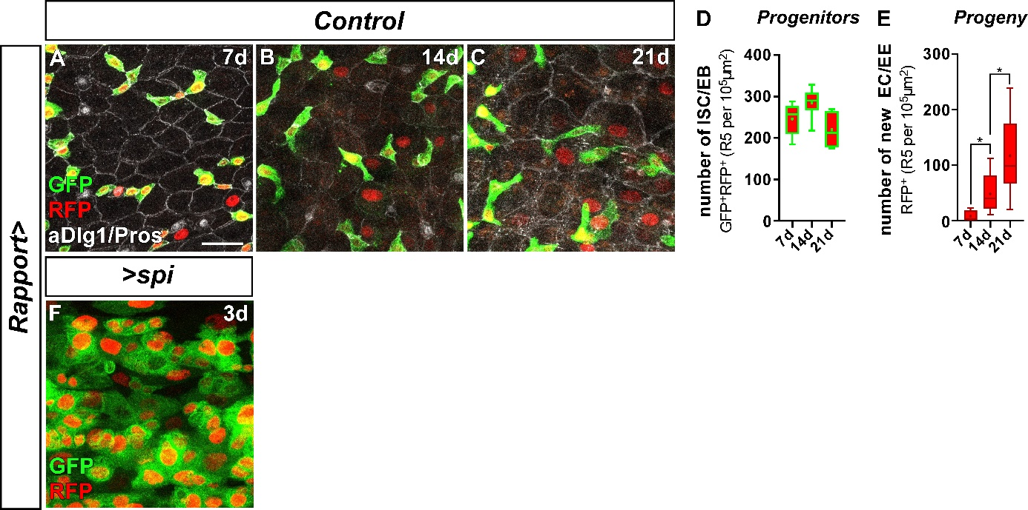
Fig.S6: Rapport tracing shows incremental tissue renewal over three weeks
(A-C) Confocal images of adult midguts with Rapport expression system in controls after (A) seven, (B) 14, and (C) 21 days of tracing showing GFP⁺RFP⁺ ISC/EB and their RFP⁺ progeny. EC and EE are marked by anti-Dlg1 and aPros staining. Scale bar is 20µm. (D-E) Quantifications of (D) progenitor cell number and (E) progeny in control midguts upon seven, 14 and 21 days (7d, 14d, 21d) of tracing (n=5,7,7/5,7,7). Means are indicated by (+) and asterisks denote significances from student’s t-test (*p<0.05). (F) Confocal image of an adult midgut after three days of Rapport tracing and EC specific OE of spitz (>spi).

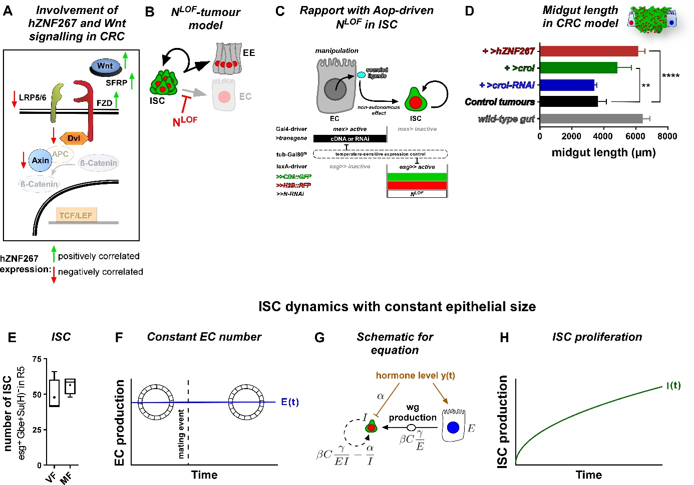
Fig.S7: Additional data for tumour and mathematical modelling
(A) Schematic of the involvement of ZNF267 and Wnt signalling in CRC. Wnt ligand is bound by secreted frizzled related proteins (SFRP) preventing binding to the frizzled receptor (FZD) and its co-receptors LDL receptor related protein 5 and 6 (LRP5/6). Dishevelled segment polarity protein 1 (DVL) forms a complex with both receptors and recruits the destruction complex consisting of APC and axin 1 (AXIN) which degrade cytoplasmic ß-Catenin thereby preventing its translocation to the nucleus and binding to transcription factors of the TCF/LEF family. Marked with green arrows are components that positively correlate with enhanced ZNF267 expression in CRC, whereas components with negative correlation of expression are marked with red arrows. (B) Schematic of the N^{LOF}tumour model. N^{LOF} in ISC blocks differentiation into EC inducing the formation of ISC and EE tumours. (C) Schematic of the combination of Rapport with a N^{LOF}-tumour model. Rapport consist of a mex-Gal4 driver enabling EC specific expression of UAS-driven cDNAs or RNAi constructs and an esg^{lexReDDM} system based on lexA/Aop allowing Gal4/UAS independent labelling and tracing of ISC/EB by esg-lexA driven expression of Aop-CD8::GFP and Aop-H2B::mCherry and additional expression of Aop-N-RNAi for induction of N^{LOF} within ISC (lexA/Aop abbreviated as ‘>>’ hereafter), both expression systems are timely controlled by a tub-Gal80^{ts} repressor. (D) Quantification of midgut length as a readout for epithelial deterioration in a CRC model combined with ISC/EB specific manipulations of crol/ZNF267 (n=14,7,8,5,5). Column bars show means with standard deviations and asterisks denote significances from student’s t-test (**p<0.01, ****p<0.0001). (E) Quantification of ISC numbers in VF compared to MF (n=4,4). Mean is indicated by (+). (F-H) Function showing ISC dynamics with constant epithelial size. (F) Function visualizing constant EC number resulting in constant intestinal size depicted by gut sections. (G) Schematic for equation visualizing the divergent effect of 20HE hormone on ISC ($I$) inhibiting ISC proliferation and on EC ($E)$ stimulating Wg production $βC\frac{γ}{E}$. In a situation with blocked EC differentiation ISC proliferation increases with $βc\frac{γ}{EI}-\frac{α}{I}$. (H) Function showing ISC proliferation $I\left(t\right)$over time in a situation of constant EC number.

