SUPPLEMENTAL FIGURES
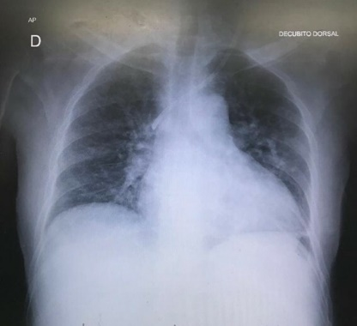
Supplemental Figure 1: Inadequate haemodialysis catheter position at the superior vena cava, insertion at the left internal jugular vein. AP: anteroposterior chest view; D: right side of chest radiography; DECUBITO DORSAL: supine position.
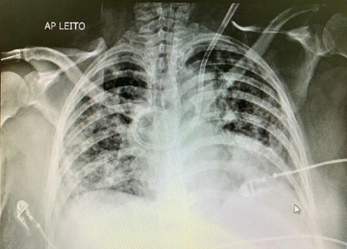
Supplemental Figure 2: Inadequate haemodialysis catheter position at the azygos vein, insertion at the left internal jugular vein. AP: anteroposterior chest view; LEITO: bedside radiography.

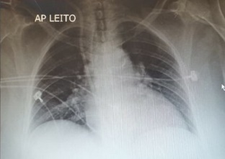
Supplemental Figure 3: Inadequate intracardiac haemodialysis catheter position, insertion at the right internal jugular vein. AP: anteroposterior chest view; LEITO: bedside radiography.
.
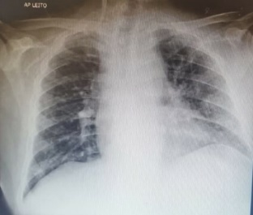
Supplemental Figure 4: Inadequate haemodialysis catheter position at the right axillary vein, insertion at the right internal jugular vein. AP: anteroposterior chest view; LEITO: bedside radiography.
.
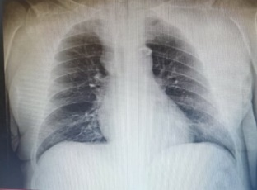
Supplemental Figure 5: Inadequate haemodialysis catheter position at the left brachiocephalic vein, insertion at the left internal jugular vein.
.

