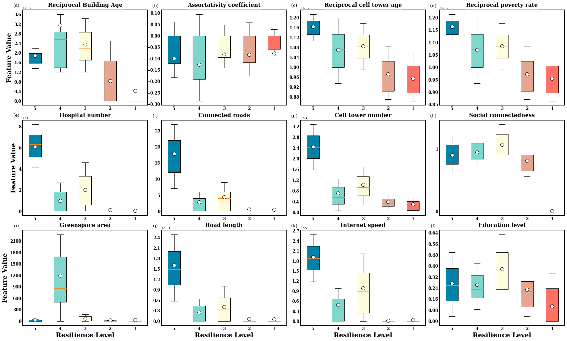
Supplementary Figure 1. Characteristics of clusters in Greater Los Angeles.

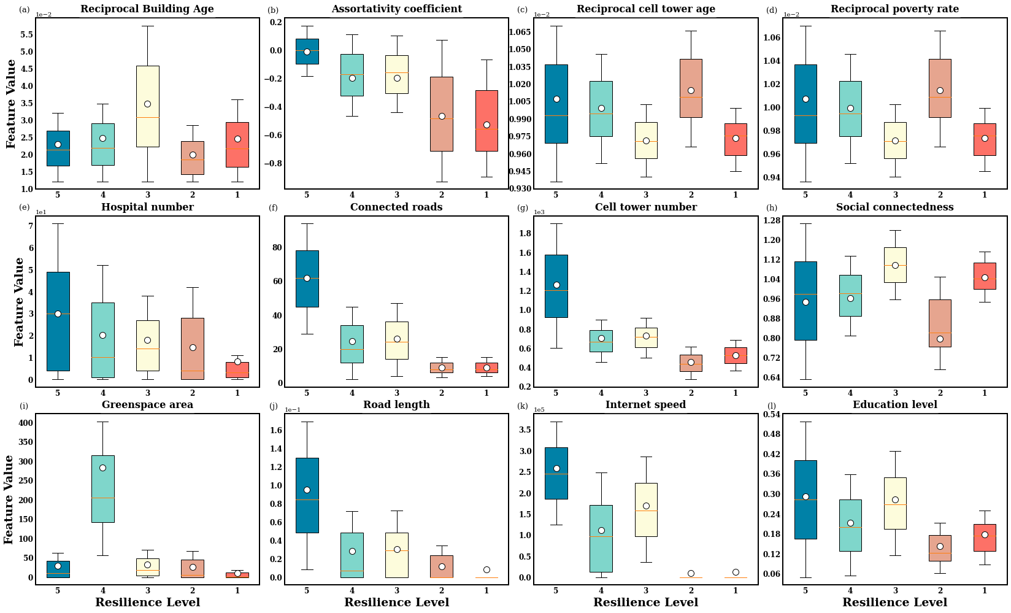
Supplementary Figure 2. Characteristics of clusters in Greater Chicago.
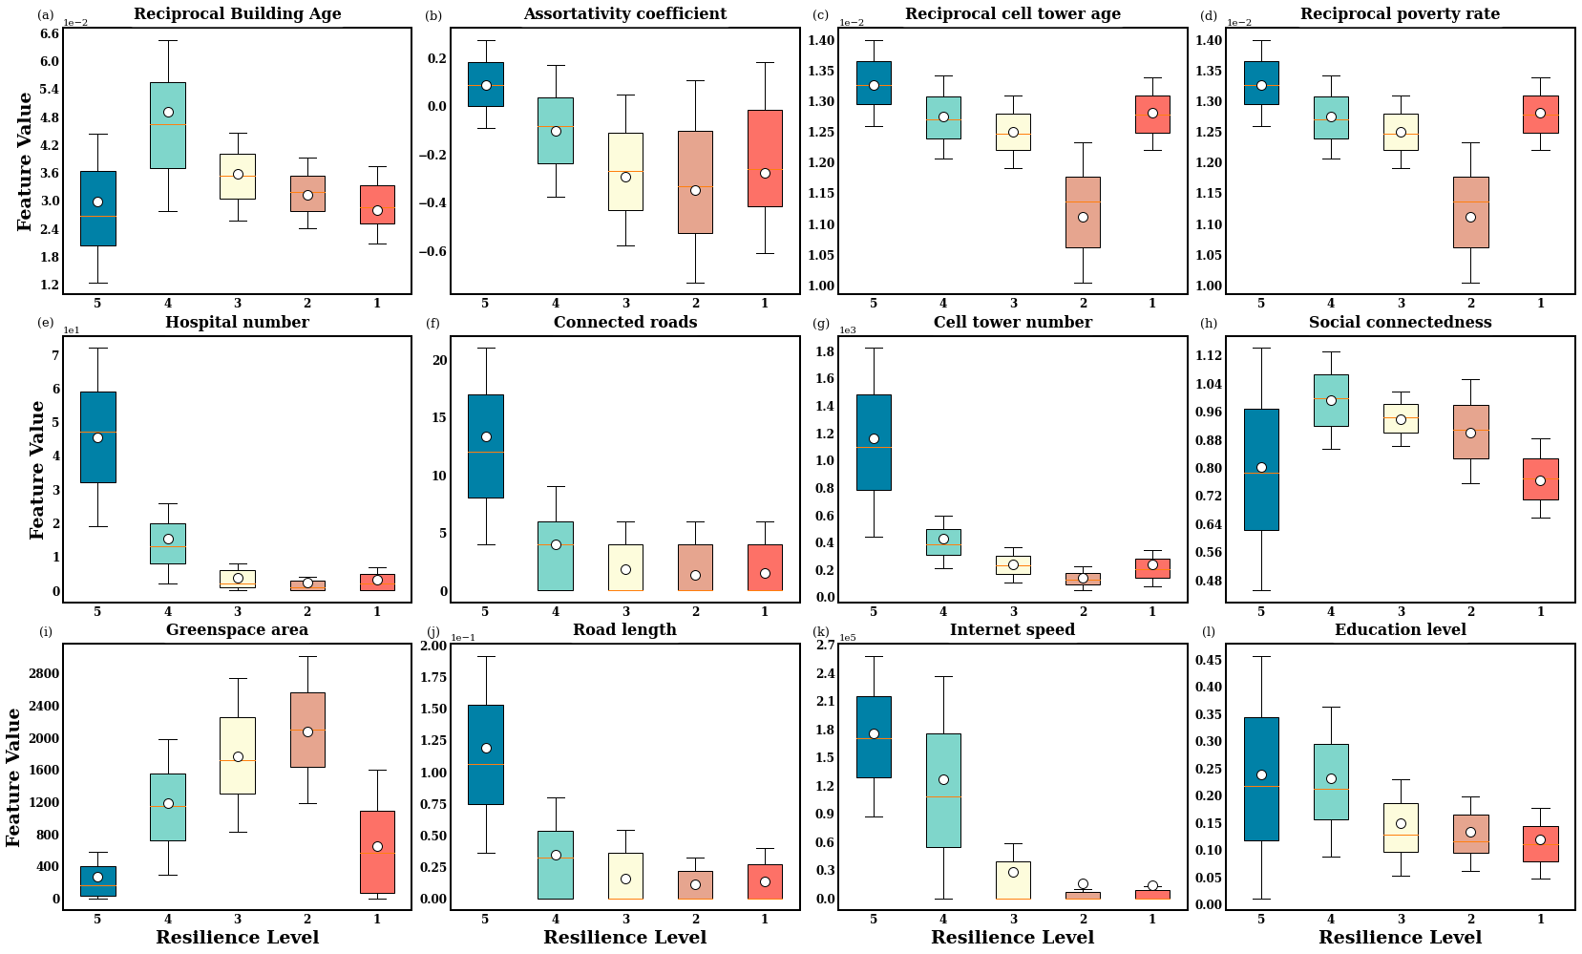
Supplementary Figure 3. Characteristics of clusters in Greater Dallas.
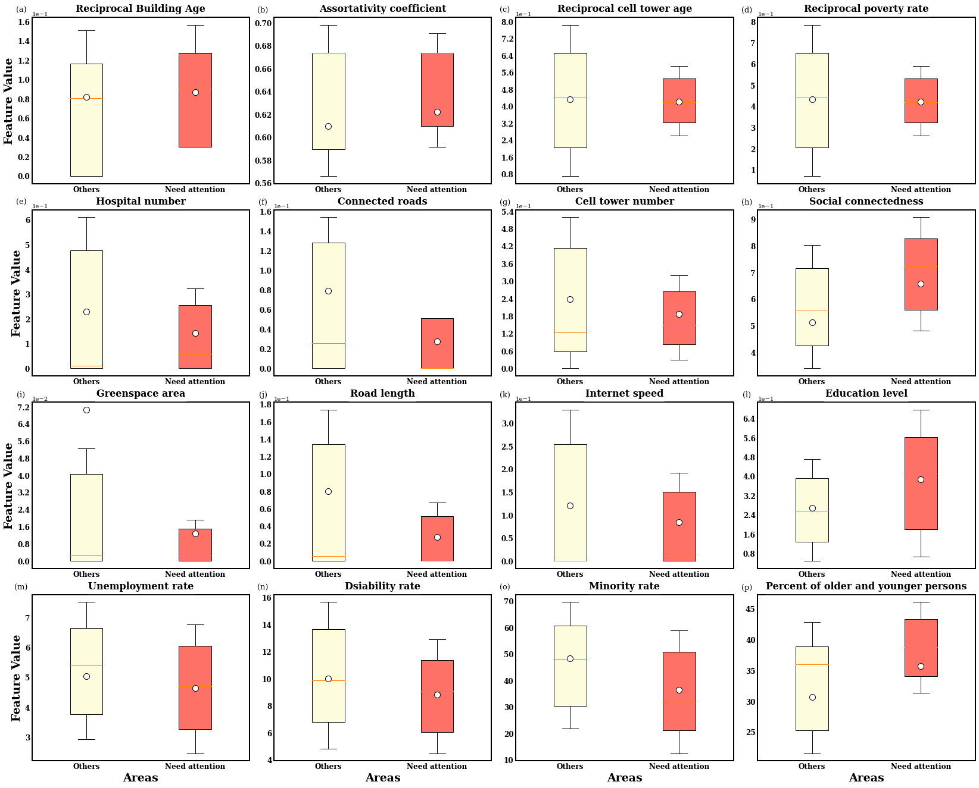
Supplementary Figure 4. Comparisons between characteristics of clusters in areas needing special attention and other areas in Greater Los Angeles.
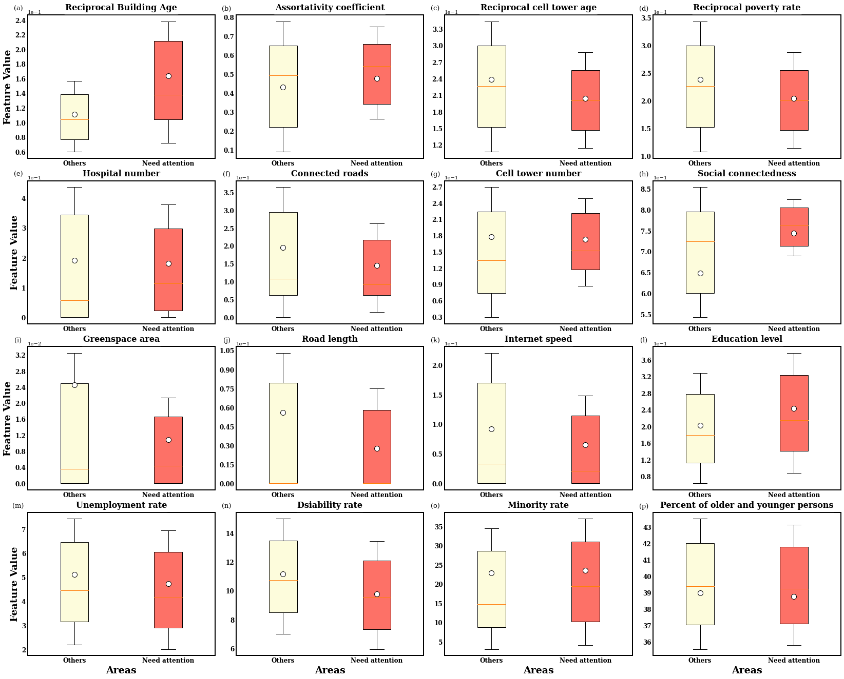
Supplementary Figure 5. Comparisons between characteristics of clusters in areas needing special attention and other areas in Greater Chicago.
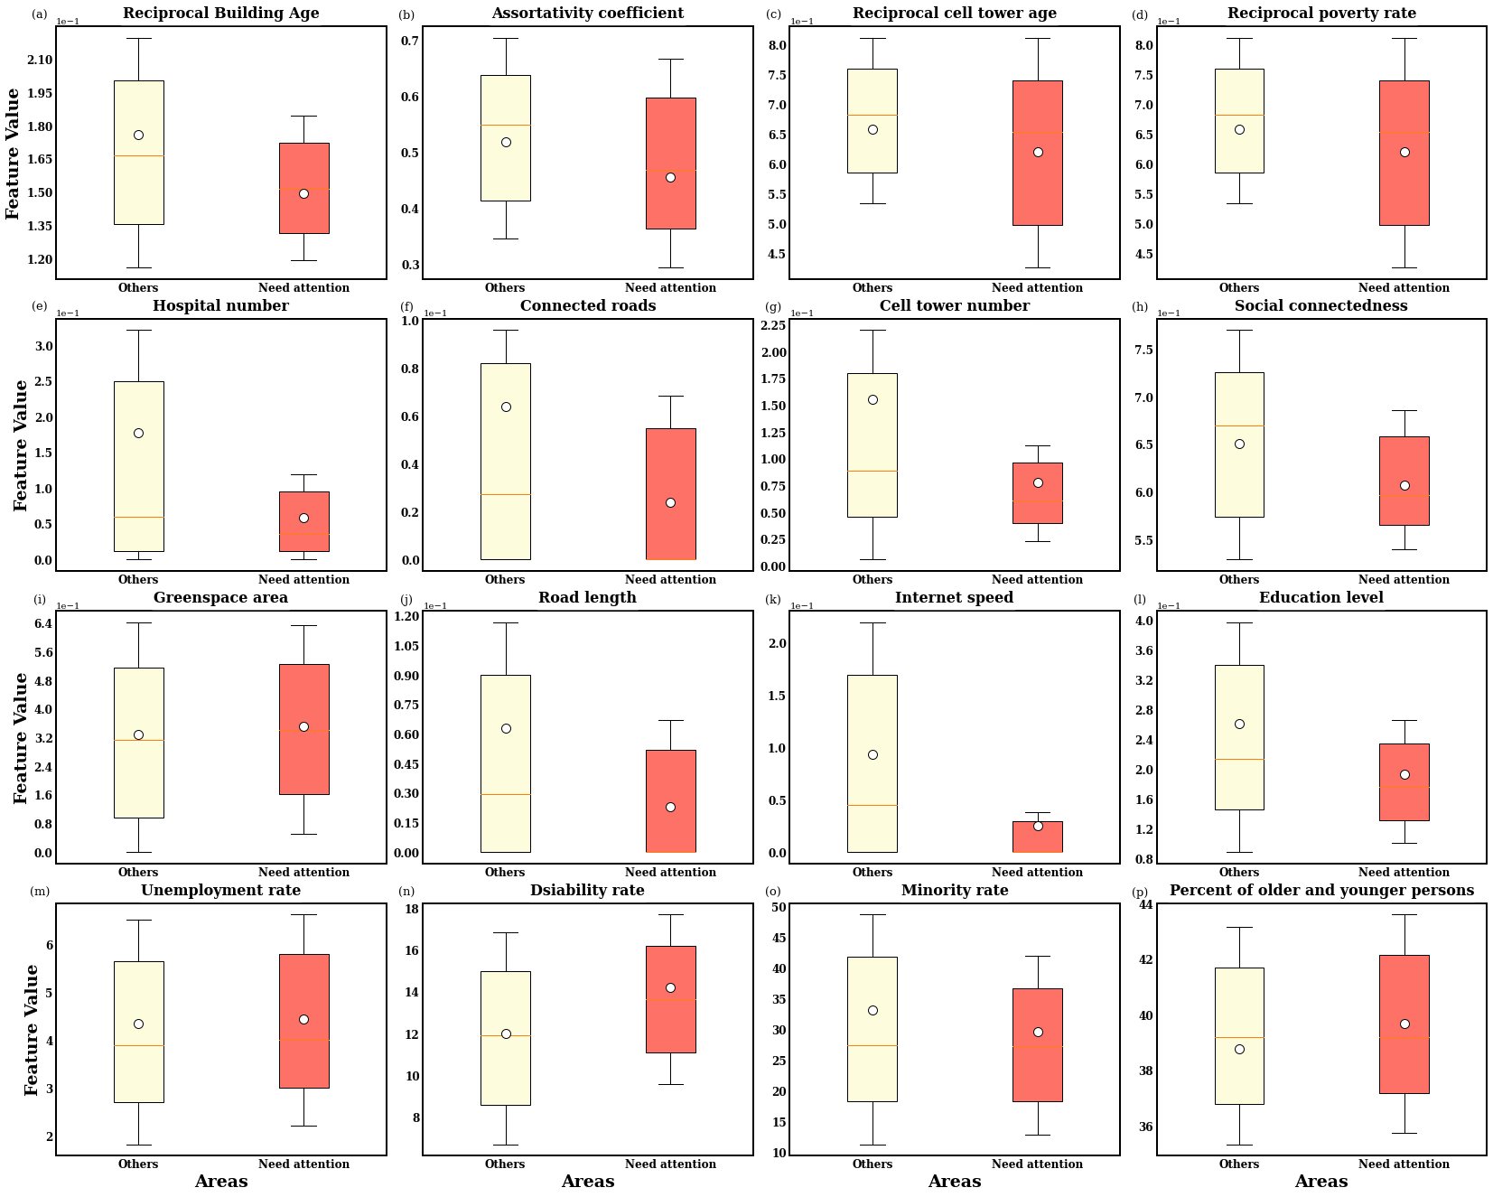
Supplementary Figure 6. Comparisons between characteristics of clusters in areas needing special attention and other areas in Greater Dallas.

.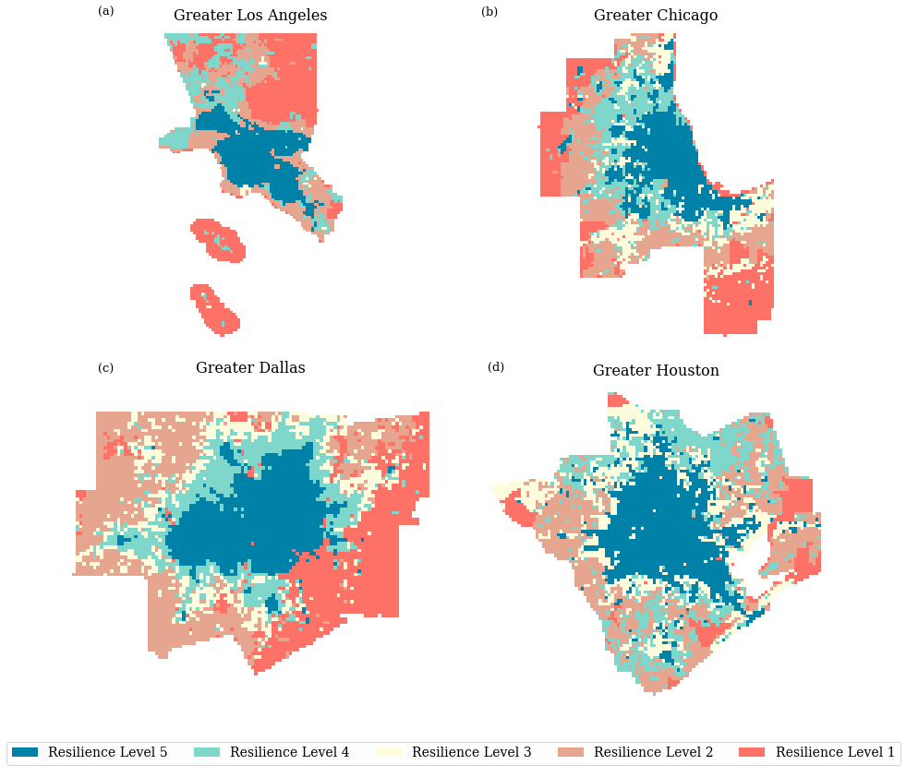
Supplementary Figure 7. Geographical distribution of flood-risk level in all four MSAs after urban development. Geographical distribution of flood-risk levels in (a) Greater Los Angeles, (b) Greater Chicago, (c) Greater Dallas, (d) Greater Houston. For communities with the poorest resilience level, both the number of hospitals within 30 minutes’ driving distance and the road length will increase twenty percent.
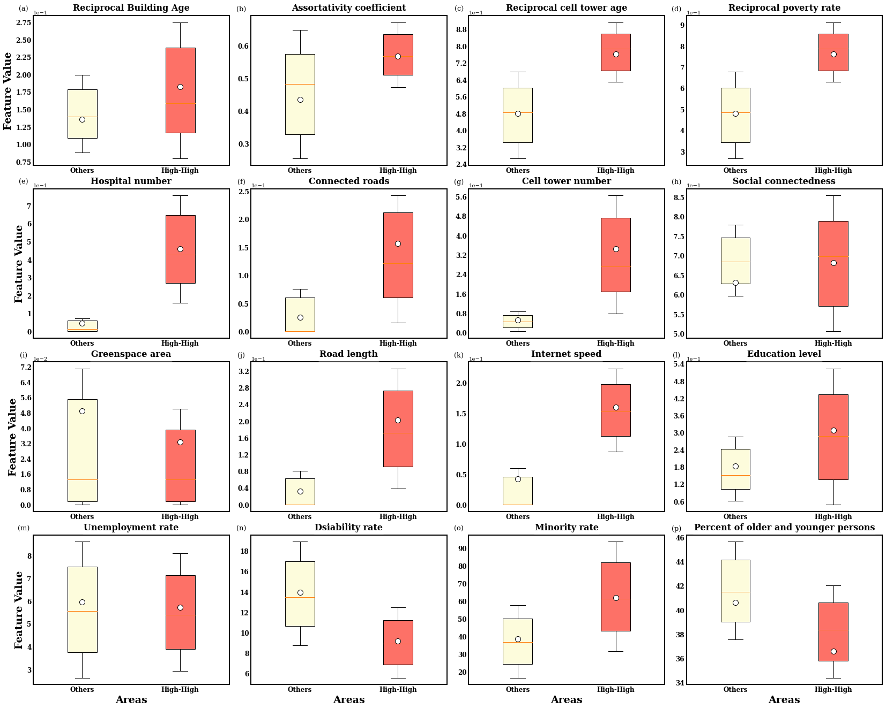
Supplementary Figure 8. Comparisons between characteristics of clusters in high-high areas and other areas in Greater Houston.

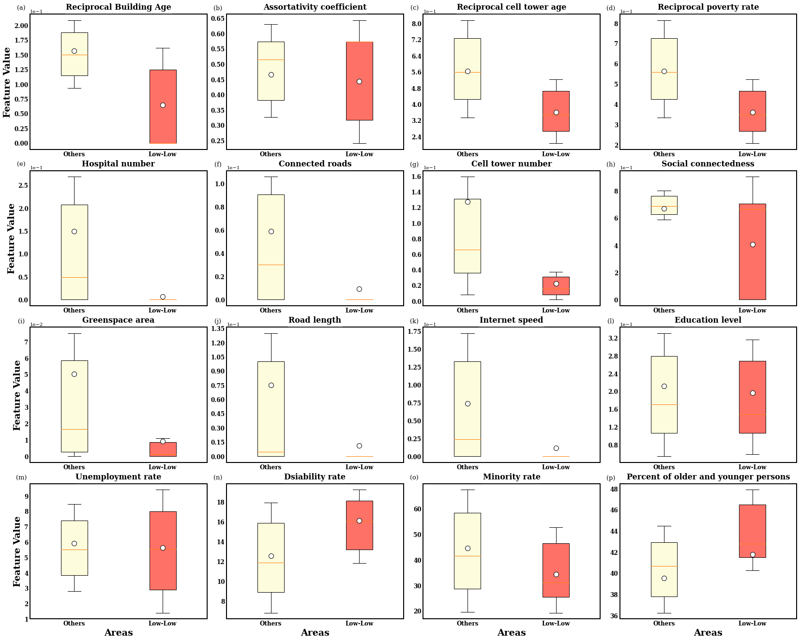
Supplementary Figure 9. Comparisons between characteristics of clusters in low-low areas and other areas in Greater Houston.
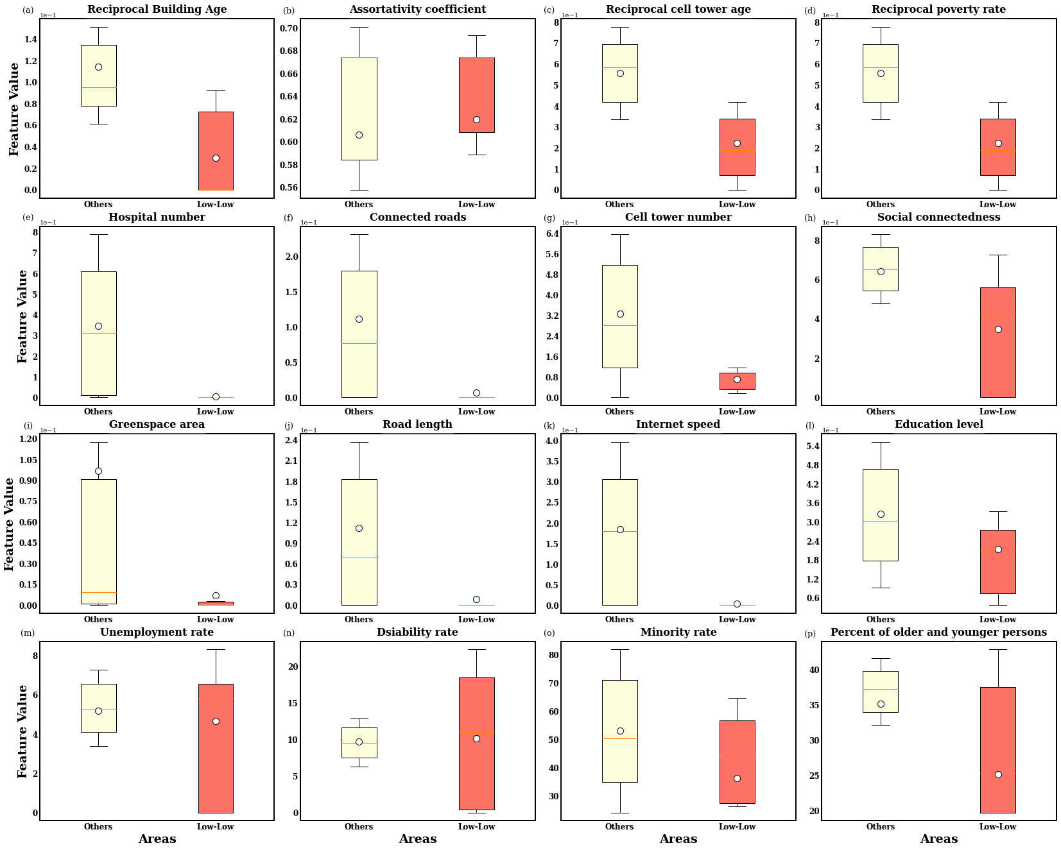
Supplementary Figure 10. Comparisons between characteristics of clusters in low-low areas and other areas in Greater Los Angeles.
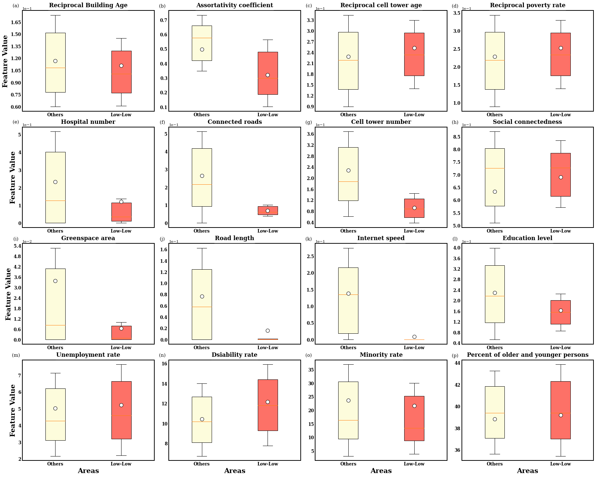
Supplementary Figure 11. Comparisons between characteristics of clusters in low-low areas and other areas in Greater Chicago.
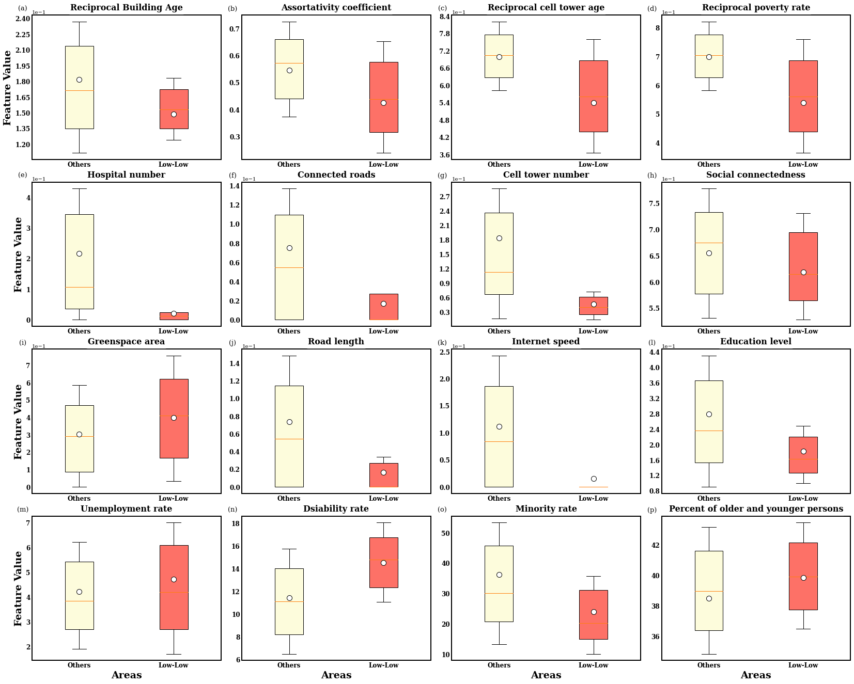
Supplementary Figure 12. Comparisons between characteristics of clusters in low-low areas and other areas in Greater Dallas.
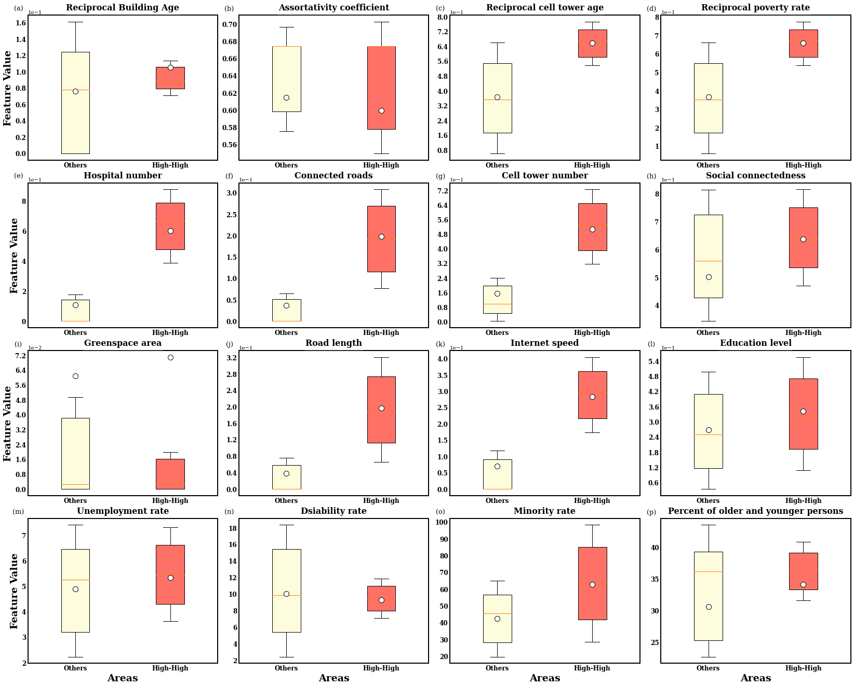
Supplementary Figure 13 Comparisons between characteristics of clusters in high-high areas and other areas in Greater Los Angeles.
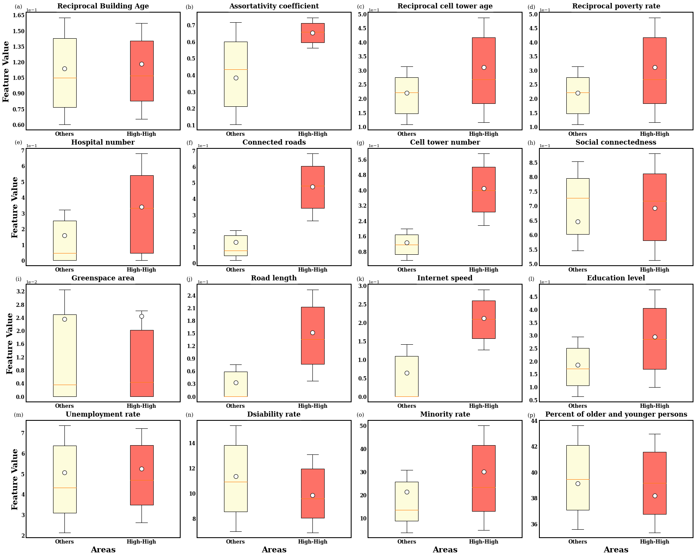
Supplementary Figure 14 Comparisons between characteristics of clusters in high-high areas and other areas in Greater Chicago.
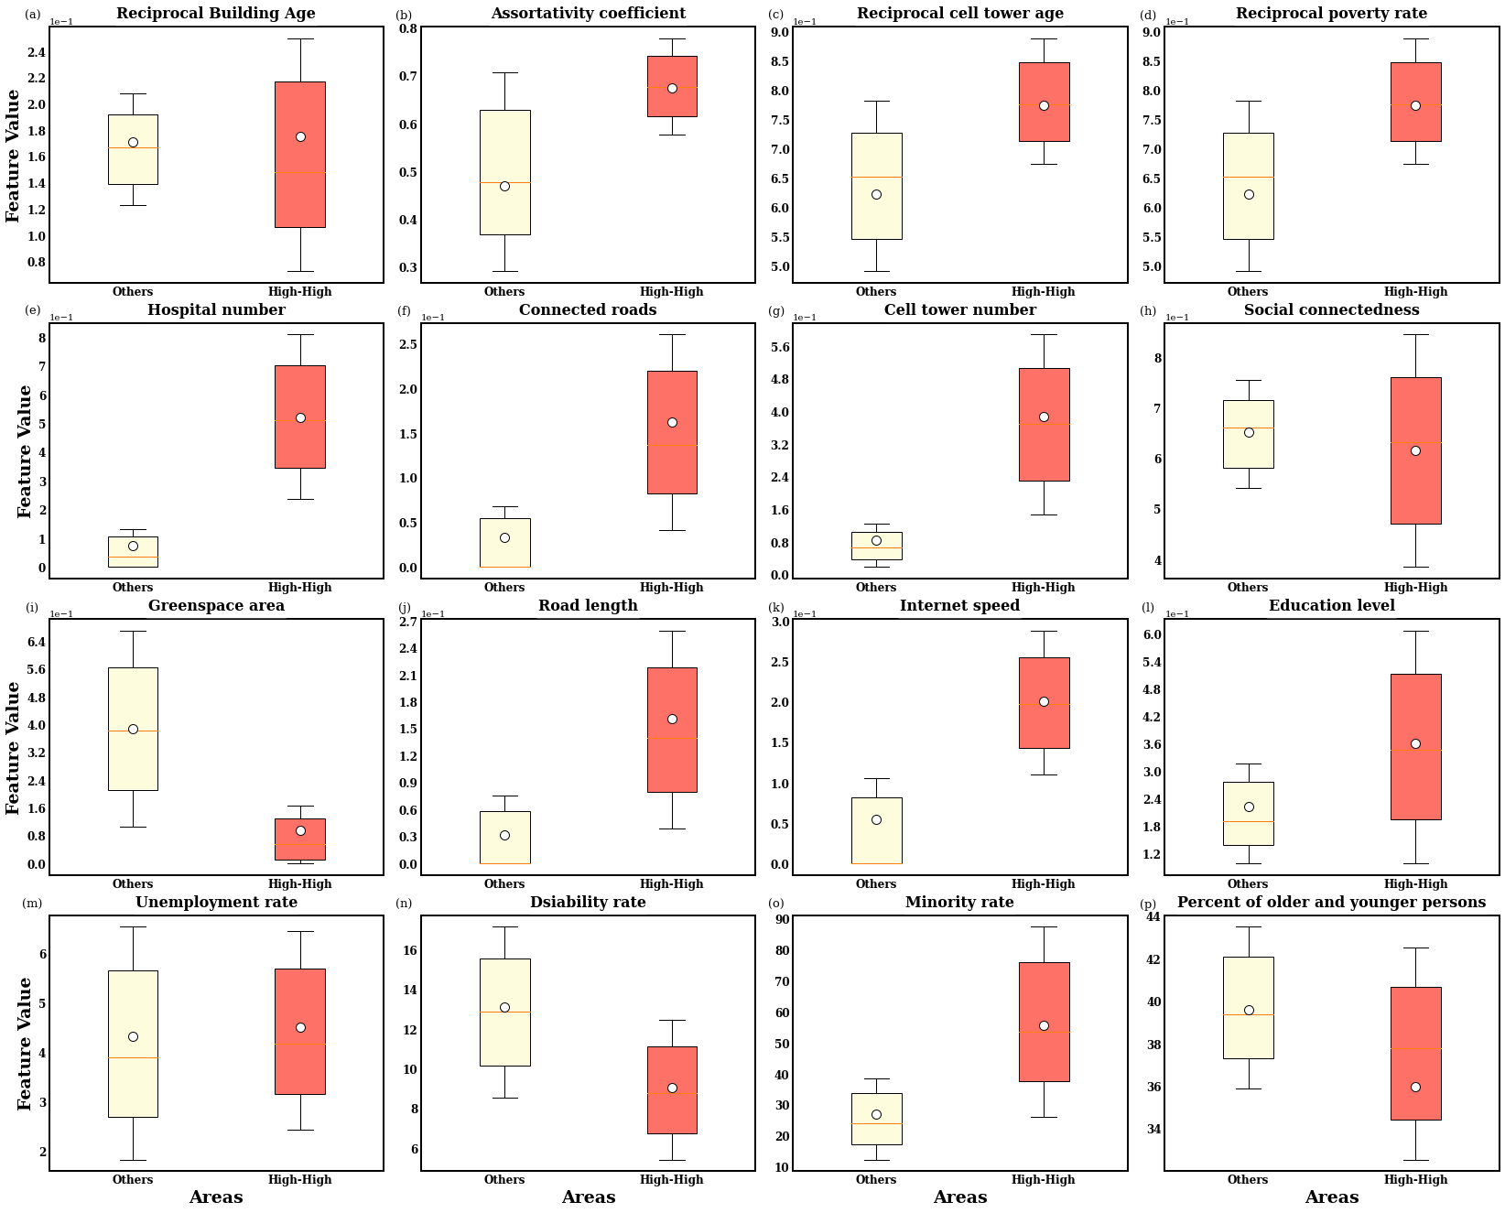
Supplementary Figure 15. Comparisons between characteristics of clusters in high-high areas and other areas in Greater Dallas.

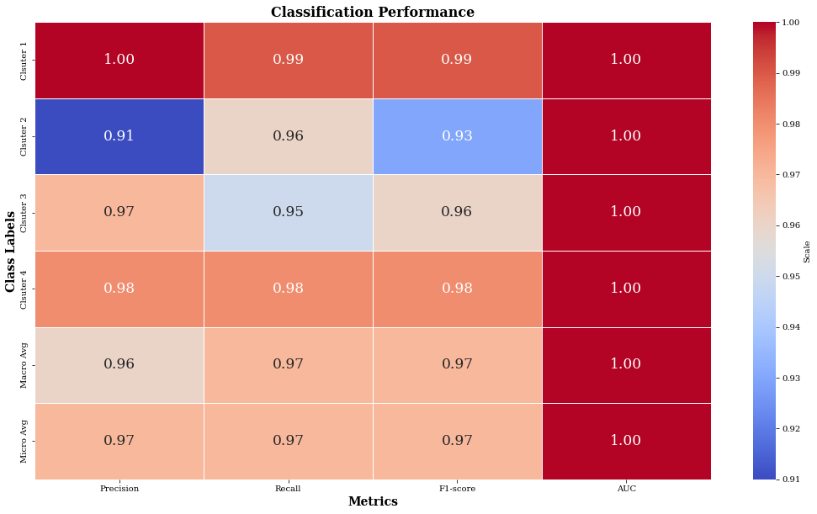
Supplementary Figure 8. Performances of random forest classifier results with cluster results as labels for Greater Los Angeles.
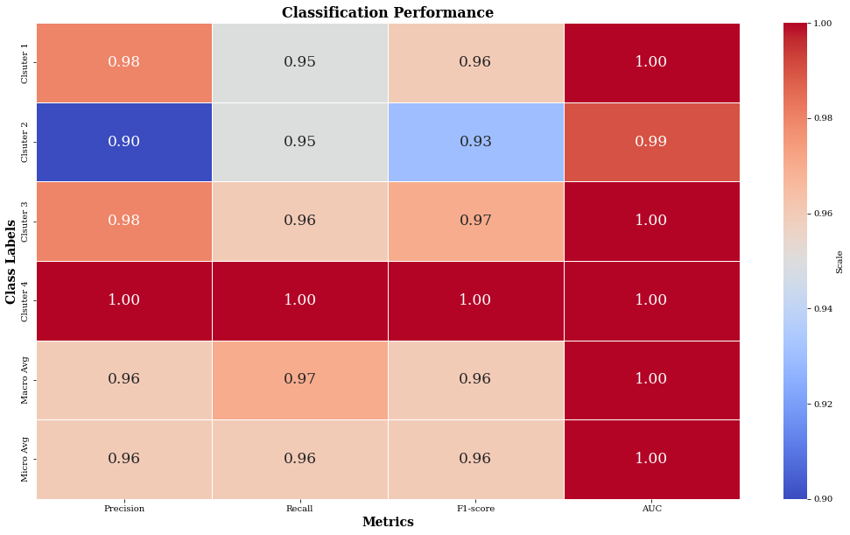
Supplementary Figure 9. Performances of random forest classifier results with cluster results as labels for Greater Chicago.

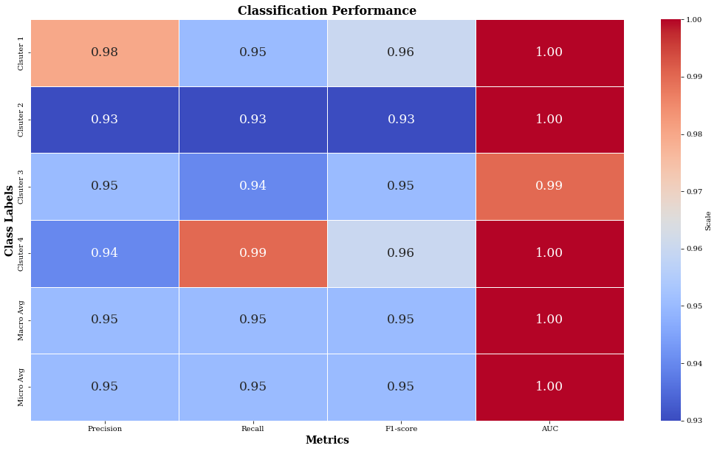
Supplementary Figure 10. Performances of random forest classifier results with cluster results as labels for Greater Dallas.

Supplementary Table .1 Data source of community resilience assessment features.
Resilience related aspects | Features | Data Source
Fac-Rob | Building age | National Structure Inventory (NSI) dataset
Fac-Red | Available number of hospitals within 30 min driving distance | SafeGraph POI data + OpenStreetMap road data
Fac-Red | Area of green space | National Land Cover Database (NLCD)
Tran-Rob | Assortativity index | OpenStreetMap road data
Tran-Red | Number of roads connected with grid cell | OpenStreetMap road data
Tran-Res | Road density | OpenStreetMap road data
Com-Rob | Cell tower age | OpenCellID dataset
Com-Red | Available number of cell towers | OpenCellID dataset
Com-Res | Average download speed | Ookla’s dataset
Soc-Rob | Poverty rate | US Census Bureau dataset
Soc-Red | Connectedness | Social Capital Atlas dataset
Soc-Res | Education level | US Census Bureau dataset
Note: Fac is the short format of facility
Tran is the short format of transportation
Com is the short format of communication
Soc is the short format of society
Rob is the short format of robustness
Red is the short format of redundancy
Res is the short format of resourcefulness

