Gleditsia sinensis galactomannan based composite hydrogel with exceptional water retention
Yuyu Eª, Zeyu Changª, Wen Li^{b}, Pengfei Li^{b}, Fuhou Lei^{b}, Jianxin Jiangª, Wengui Duan^{c}, Shengguang Yuan^{d}, Kun Wang^{a,}*, Xiaopeng Peng^{e,}*
ª Department of Chemistry and Chemical Engineering, Beijing Forestry University, MOE Engineering Research Center of Forestry Biomass Materials and Bioenergy, Beijing 100083, China;
^{b} GuangXi Key Laboratory of Chemistry and Engineering of Forest Products, College of Chemistry and Chemical Engineering, Guangxi Minzu University, Nanning, 530006, China;
^{c} School of Chemistry and Chemical Engineering, Guangxi University, Nanning, 530004, China;
^{d} State Key Laboratory of Environmental Aquatic Chemistry, Research Centre for Eco-Environmental Sciences, Chinese Academy of Sciences, Beijing, China;;
^{e} State Key Laboratory of Tree Genetics and Breeding, Key Laboratory of Tree Breeding and Cultivation of the National Forestry and Grassland Administration, Research Institute of Forestry, Chinese Academy of Forestry, Beijing 100091, China.
* Corresponding author: wangkun@bjfu.edu.cn, tel. /fax: +86-1062337090

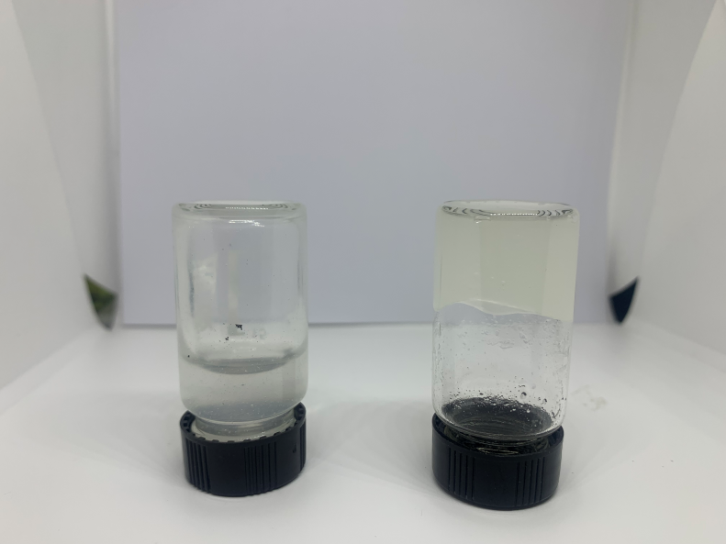
Figure. S1 Photographs of GM/BDE/HA hydrogel.

Figure. S2 XPS spectra (a) wide scan, (b) C 1s and (c) O 1s of GM/EDE/HA hydrogel; (d) wide scan, (e) C 1s and (f) O 1s of GM/BDE/HA hydrogel.

Table S1. The compositions of the prepared various hydrogels
GM (g) | HA (g) | EDE (g) | BDE (g) | HDE (g) | Water (g) | NaOH (40 wt%, g) | Gelation
0.05 | 0.15 | - | 0.25 | - | 4.425 | 0.125
0.1 | 0.1 | - | 0.25 | - | 4.425 | 0.125
0.15 | 0.05 | - | 0.25 | - | 4.425 | 0.125
0.1 | 0.1 | - | 0.25 | - | 4.30 | 0.25
0.1 | 0.1 | - | 0.25 | - | 4.175 | 0.375
0.1 | 0.1 | - | 0.5 | - | 4.175 | 0.125
0.15 | 0.05 | 0.25 | - | - | 4.425 | 0.125
0.15 | 0.05 | - | - | 0.25 | 4.425 | 0.125
: Gel ; : Semi-solid gel; : Sol

Table. S2 Formation energies of the interactions between AQP₃ and different HAs.
Compounds | E (Kcal/mol)
HA₁ | -6.90
HA₂ | -9.22
HA₃ | -10.42
HA₄ | -12.13
HA₅ | -12.88
HA₆ | -14.98

Table. S3 Interaction table of the intra- and inter-molecular H-bond in HAs.
Compounds | Ligand | Receptor | Interaction | Distance (Å) | E (Kcal/mol)
HA₁ | O-39 | O | H-acceptor | 3.06 | -0.9
HA₂ | O-84 | O | H-acceptor | 2.97 | -0.7
HA₃ | O-79 | O | H-acceptor | 2.85 | -0.8
HA₃ | O-115 | O | H-acceptor | 2.88 | -0.9
HA₄ | O-27 | O | H-donor | 3.28 | -0.6
HA₄ | N-86 | O | H-donor | 3.42 | -0.7
HA₄ | O-170 | O | H-donor | 2.87 | -1.9

