Supplementary material:
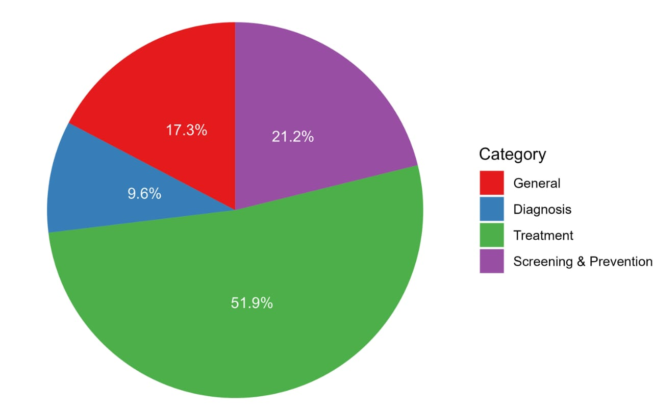
Figure 1: A pie chart of the proportions of categories asked to LLMs
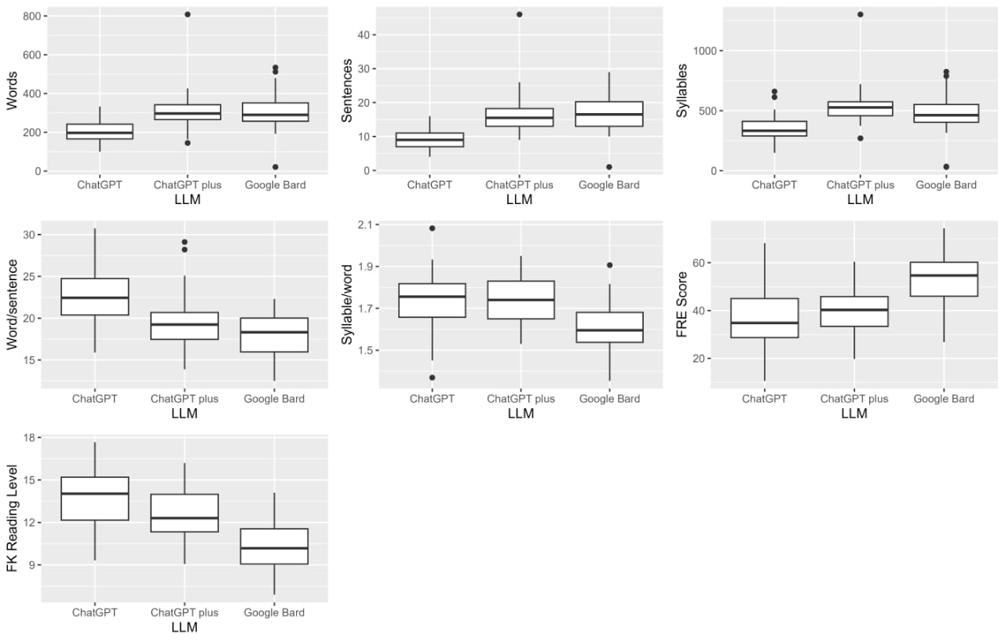
Figure 2: Boxplots depicting a description of selected numerical parameters of LLMs, including Words, sentences, syllables, word/sentence, syllable/word, FRE score, and FK Reading levels.

