Supplement B: Self-reported vaccine-specific behavior

Fig. S1: Odds Ratios and 95%-Confidence Intervals for tetanus vaccination behavior: “Which of the following diseases have you been vaccinated against in the last five years? [Tetanus]”
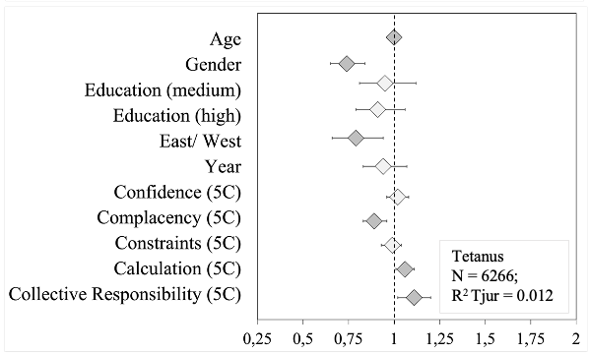
Note. Diamond shapes indicate the odds ratio and whiskers the 95% Confidence interval. Dark grey diamonds mark statistically significant predictors (p < 0.05). Gender (reference category: male), education (low), east/west (east), and year (2016) are dummy-coded variables.

Table S2: Logistic Regressions for tetanus vaccination behavior: “Which of the following diseases have you been vaccinated against in the last five years? [Tetanus]” in the Full Sample and all subgroups.
 | Full Sample |  |  | (A) People over 60 |  |  | (B) Chronical illnesses |  |  | (C) Migration |  |  | (D) HCW |  |  | (E) Parents |  |  | (F) Pregnant women
Predictors | OR | CI | p | OR | CI | p | OR | CI | p | OR | CI | p | OR | CI | p | OR | CI | p | OR | CI | p
Age | 1.01 | 1.00 – 1.01 | 0.002 | 0.96 | 0.94 – 0.98 | <0.001 | 1.00 | 0.99 – 1.00 | 0.402 | 1.00 | 0.99 – 1.02 | 0.666 | 1.03 | 1.01 – 1.05 | <0.001 | 1.03 | 1.01 – 1.05 | 0.005 | 1.04 | 0.99 – 1.08 | 0.096
Gender | 0.74 | 0.65 – 0.84 | <0.001 | 0.94 | 0.73 – 1.19 | 0.590 | 0.74 | 0.58 – 0.92 | 0.009 | 0.67 | 0.41 – 1.08 | 0.103 | 0.63 | 0.36 – 1.06 | 0.091 | 0.58 | 0.42 – 0.80 | 0.001
Education (medium) | 0.95 | 0.81 – 1.12 | 0.555 | 0.82 | 0.59 – 1.16 | 0.258 | 0.97 | 0.72 – 1.32 | 0.847 | 0.73 | 0.40 – 1.35 | 0.316 | 1.58 | 0.96 – 2.65 | 0.075 | 1.07 | 0.75 – 1.55 | 0.707 | 1.16 | 0.69 – 1.95 | 0.584
Education (high) | 0.91 | 0.79 – 1.06 | 0.232 | 0.99 | 0.76 – 1.30 | 0.960 | 0.95 | 0.73 – 1.22 | 0.670 | 0.70 | 0.41 – 1.18 | 0.181 | 0.96 | 0.59 – 1.58 | 0.882 | 0.80 | 0.58 – 1.10 | 0.167 | 0.87 | 0.54 – 1.36 | 0.536
East/ West | 0.79 | 0.66 – 0.94 | 0.010 | 0.78 | 0.58 – 1.04 | 0.099 | 0.78 | 0.58 – 1.03 | 0.080 | 0.57 | 0.19 – 1.48 | 0.273 | 0.91 | 0.49 – 1.59 | 0.739 | 0.63 | 0.41 – 0.93 | 0.024 | 0.93 | 0.53 – 1.59 | 0.802
Survey 2018 (vs. 2016) | 0.94 | 0.83 – 1.07 | 0.325 | 0.84 | 0.66 – 1.07 | 0.159 | 0.88 | 0.70 – 1.10 | 0.261 | 0.81 | 0.51 – 1.27 | 0.351 | 0.94 | 0.63 – 1.41 | 0.775 | 0.74 | 0.56 – 0.96 | 0.026 | 0.62 | 0.43 – 0.89 | 0.011
Confidence (5C) | 1.02 | 0.96 – 1.08 | 0.548 | 1.03 | 0.93 – 1.14 | 0.507 | 1.03 | 0.93 – 1.13 | 0.591 | 0.86 | 0.70 – 1.05 | 0.150 | 0.91 | 0.75 – 1.10 | 0.353 | 1.11 | 0.98 – 1.26 | 0.107 | 1.16 | 0.96 – 1.39 | 0.125
Constraints (5C) | 0.99 | 0.93 – 1.04 | 0.629 | 1.06 | 0.92 – 1.24 | 0.439 | 0.98 | 0.88 – 1.08 | 0.652 | 0.96 | 0.80 – 1.17 | 0.681 | 0.92 | 0.78 – 1.09 | 0.309 | 0.95 | 0.86 – 1.07 | 0.399 | 0.95 | 0.81 – 1.13 | 0.558
Coll. Responsibility (5C) | 1.11 | 1.02 – 1.20 | 0.013 | 1.03 | 0.89 – 1.17 | 0.702 | 1.06 | 0.92 – 1.22 | 0.384 | 1.28 | 1.02 – 1.60 | 0.036 | 1.44 | 1.09 – 1.89 | 0.008 | 1.19 | 0.98 – 1.44 | 0.075 | 0.98 | 0.67 – 1.39 | 0.905
Calculation (5C) | 1.06 | 1.01 – 1.11 | 0.022 | 1.01 | 0.93 – 1.10 | 0.795 | 1.10 | 1.02 – 1.20 | 0.015 | 1.00 | 0.85 – 1.17 | 0.991 | 1.01 | 0.87 – 1.16 | 0.926 | 1.04 | 0.94 – 1.15 | 0.412 | 0.98 | 0.85 – 1.11 | 0.717
Complacency (5C) | 0.89 | 0.83 – 0.96 | 0.003 | 0.93 | 0.82 – 1.05 | 0.218 | 0.87 | 0.77 – 0.98 | 0.022 | 0.77 | 0.60 – 0.97 | 0.025 | 1.03 | 0.78 – 1.42 | 0.825 | 0.92 | 0.76 – 1.11 | 0.355 | 0.70 | 0.53 – 0.90 | 0.006
N | 6385 |  |  | 1877 |  |  | 2147 |  |  | 386 |  |  | 692 |  |  | 1403 |  |  | 629
R² Tjur | 0.012 |  |  | 0.016 |  |  | 0.011 |  |  | 0.050 |  |  | 0.043 |  |  | 0.034 |  |  | 0.039

Fig. S2: Odds Ratios and 95%-Confidence Intervals for rubella vaccination behavior: “Which of the following diseases have you been vaccinated against in the last five years? [Rubella]”
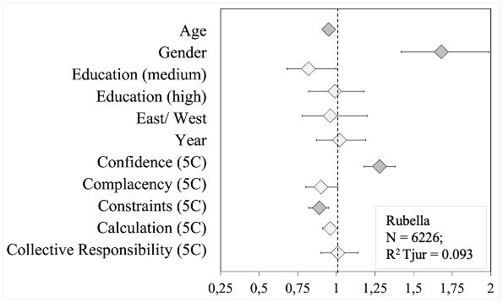
Note. Diamond shapes indicate the odds ratio and whiskers the 95% Confidence interval. Dark grey diamonds mark statistically significant predictors (p < 0.05). Gender (reference category: male), education (low), east/west (east), and year (2016) are dummy-coded variables.

Table S3: Logistic Regressions for rubella vaccination behavior: “Which of the following diseases have you been vaccinated against in the last five years? [Rubella]” in the Full Sample and all subgroups.
 | Full Sample |  |  | (A) People over 60 |  |  | (B) Chronical illnesses |  |  | (C) Migration |  |  | (D) HCW |  |  | (E) Parents |  |  | (F) Pregnant women
Predictors | OR | CI | p | OR | CI | p | OR | CI | p | OR | CI | p | OR | CI | p | OR | CI | p | OR | CI | p
Age | 0.95 | 0.94 – 0.96 | <0.001 | 0.96 | 0.93 – 1.00 | 0.033 | 0.95 | 0.94 – 0.96 | <0.001 | 0.95 | 0.93 – 0.97 | <0.001 | 0.94 | 0.92 – 0.96 | <0.001 | 0.93 | 0.91 – 0.95 | <0.001 | 0.95 | 0.91 – 0.99 | 0.013
Gender | 1.68 | 1.42 – 1.99 | <0.001 | 1.23 | 0.78 – 1.99 | 0.378 | 1.54 | 1.12 – 2.15 | 0.009 | 2.05 | 0.98 – 4.62 | 0.066 | 1.43 | 0.85 – 2.48 | 0.192 | 1.49 | 1.07 – 2.08 | 0.019
Education (medium) | 0.82 | 0.68 – 1.00 | 0.052 | 0.65 | 0.29 – 1.30 | 0.251 | 0.84 | 0.57 – 1.24 | 0.395 | 0.64 | 0.26 – 1.52 | 0.313 | 0.98 | 0.60 – 1.60 | 0.948 | 1.03 | 0.73 – 1.46 | 0.875 | 0.86 | 0.52 – 1.39 | 0.530
Education (high) | 0.99 | 0.82 – 1.18 | 0.872 | 0.88 | 0.52 – 1.45 | 0.621 | 0.93 | 0.65 – 1.32 | 0.681 | 1.18 | 0.56 – 2.54 | 0.659 | 1.10 | 0.65 – 1.84 | 0.724 | 0.75 | 0.54 – 1.04 | 0.087 | 0.86 | 0.56 – 1.34 | 0.508
East/ West | 0.96 | 0.78 – 1.20 | 0.740 | 0.86 | 0.53 – 1.46 | 0.571 | 1.03 | 0.70 – 1.55 | 0.892 | 0.80 | 0.22 – 3.86 | 0.754 | 1.70 | 0.90 – 3.43 | 0.117 | 1.31 | 0.89 – 1.97 | 0.178 | 3.44 | 1.86 – 6.90 | <0.001
Survey 2018 (vs. 2016) | 1.02 | 0.87 – 1.19 | 0.819 | 1.49 | 0.94 – 2.35 | 0.087 | 1.12 | 0.83 – 1.52 | 0.468 | 1.12 | 0.59 – 2.14 | 0.740 | 1.13 | 0.75 – 1.70 | 0.567 | 0.93 | 0.71 – 1.23 | 0.624 | 0.89 | 0.62 – 1.26 | 0.501
Confidence (5C) | 1.28 | 1.18 – 1.38 | <0.001 | 1.29 | 1.04 – 1.64 | 0.024 | 1.31 | 1.13 – 1.53 | <0.001 | 1.21 | 0.90 – 1.68 | 0.222 | 1.23 | 1.01 – 1.51 | 0.046 | 1.12 | 0.97 – 1.28 | 0.116 | 1.24 | 1.03 – 1.50 | 0.027
Constraints (5C) | 0.89 | 0.82 – 0.95 | 0.001 | 1.25 | 1.00 – 1.53 | 0.039 | 0.95 | 0.82 – 1.08 | 0.444 | 0.72 | 0.50 – 0.97 | 0.046 | 0.85 | 0.69 – 1.02 | 0.101 | 0.85 | 0.75 – 0.96 | 0.010 | 0.94 | 0.79 – 1.11 | 0.481
Coll. Responsibility (5C) | 1.01 | 0.90 – 1.14 | 0.867 | 0.90 | 0.73 – 1.17 | 0.390 | 0.81 | 0.68 – 1.00 | 0.036 | 0.85 | 0.63 – 1.21 | 0.338 | 1.14 | 0.80 – 1.80 | 0.509 | 1.01 | 0.81 – 1.29 | 0.940 | 0.89 | 0.61 – 1.34 | 0.554
Calculation (5C) | 0.96 | 0.91 – 1.01 | 0.137 | 0.93 | 0.79 – 1.10 | 0.359 | 0.95 | 0.86 – 1.06 | 0.386 | 0.92 | 0.74 – 1.15 | 0.435 | 0.90 | 0.78 – 1.04 | 0.142 | 0.90 | 0.82 – 1.00 | 0.039 | 0.91 | 0.80 – 1.03 | 0.136
Complacency (5C) | 0.90 | 0.80 – 1.01 | 0.080 | 0.99 | 0.77 – 1.23 | 0.951 | 0.81 | 0.64 – 1.01 | 0.075 | 0.73 | 0.43 – 1.12 | 0.189 | 0.97 | 0.68 – 1.32 | 0.872 | 0.72 | 0.54 – 0.93 | 0.018 | 0.83 | 0.59 – 1.11 | 0.225
N | 6226 |  |  | 1861 |  |  | 2102 |  |  | 370 |  |  | 674 |  |  | 1371 |  |  | 619
R² Tjur | 0.093 |  |  | 0.012 |  |  | 0.090 |  |  | 0.105 |  |  | 0.096 |  |  | 0.074 |  |  | 0.054

Fig. S3: Odds Ratios and 95%-Confidence Intervals for varicella vaccination behavior: “Which of the following diseases have you been vaccinated against in the last five years? [Varicella]”
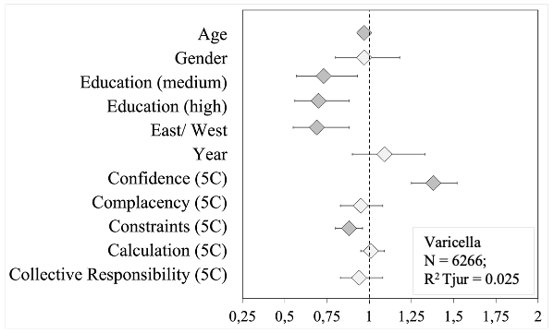
Note. Diamond shapes indicate the odds ratio and whiskers the 95% Confidence interval. Dark grey diamonds mark statistically significant predictors (p < 0.05). Gender (reference category: male), education (low), east/west (east), and year (2016) are dummy-coded variables.
Table S4: Logistic Regressions for varicella vaccination behavior: “Which of the following diseases have you been vaccinated against in the last five years? [Varicella]” in the Full Sample and all subgroups.
 | Full Sample |  |  | (A) People over 60 |  |  | (B) Chronical illnesses |  |  | (C) Migration |  |  | (D) HCW |  |  | (E) Parents |  |  | (F) Pregnant women
Predictors | OR | CI | p | OR | CI | p | OR | CI | p | OR | CI | p | OR | CI | p | OR | CI | p | OR | CI | p
Age | 0.97 | 0.97 – 0.98 | <0.001 | 0.98 | 0.94 – 1.01 | 0.208 | 0.97 | 0.95 – 0.98 | <0.001 | 0.97 | 0.94 – 1.00 | 0.041 | 0.97 | 0.94 – 0.99 | 0.003 | 0.98 | 0.96 – 1.01 | 0.258 | 1.02 | 0.96 – 1.09 | 0.478
Gender | 0.97 | 0.80 – 1.18 | 0.773 | 0.84 | 0.53 – 1.34 | 0.472 | 0.60 | 0.42 – 0.87 | 0.006 | 0.72 | 0.31 – 1.75 | 0.458 | 0.87 | 0.47 – 1.70 | 0.679 | 0.84 | 0.57 – 1.27 | 0.408
Education (medium) | 0.73 | 0.57 – 0.93 | 0.011 | 0.66 | 0.31 – 1.27 | 0.239 | 0.80 | 0.50 – 1.25 | 0.337 | 1.36 | 0.43 – 4.48 | 0.604 | 0.57 | 0.30 – 1.08 | 0.089 | 0.90 | 0.57 – 1.42 | 0.659 | 0.81 | 0.40 – 1.60 | 0.537
Education (high) | 0.70 | 0.56 – 0.88 | 0.002 | 0.60 | 0.35 – 1.00 | 0.057 | 0.54 | 0.35 – 0.84 | 0.007 | 1.65 | 0.61 – 4.94 | 0.341 | 0.58 | 0.29 – 1.13 | 0.116 | 0.71 | 0.46 – 1.09 | 0.116 | 0.66 | 0.35 – 1.26 | 0.201
East/ West | 0.69 | 0.55 – 0.88 | 0.002 | 0.50 | 0.31 – 0.80 | 0.004 | 0.64 | 0.43 – 0.98 | 0.034 | 1.56 | 0.29 – 29.16 | 0.676 | 0.77 | 0.39 – 1.60 | 0.454 | 0.84 | 0.53 – 1.39 | 0.485 | 1.49 | 0.69 – 3.73 | 0.352
Survey 2018 (vs. 2016) | 1.09 | 0.90 – 1.33 | 0.358 | 0.94 | 0.58 – 1.49 | 0.795 | 1.17 | 0.82 – 1.68 | 0.394 | 0.59 | 0.25 – 1.35 | 0.214 | 1.01 | 0.59 – 1.73 | 0.972 | 1.37 | 0.95 – 1.97 | 0.092 | 1.44 | 0.86 – 2.44 | 0.164
Confidence (5C) | 1.38 | 1.25 – 1.52 | <0.001 | 1.38 | 1.10 – 1.77 | 0.007 | 1.31 | 1.11 – 1.57 | 0.002 | 1.37 | 0.92 – 2.17 | 0.142 | 1.43 | 1.09 – 1.93 | 0.013 | 1.23 | 1.02 – 1.48 | 0.031 | 1.29 | 0.99 – 1.73 | 0.070
Constraints (5C) | 0.88 | 0.80 – 0.96 | 0.006 | 1.24 | 0.97 – 1.53 | 0.065 | 0.81 | 0.66 – 0.97 | 0.029 | 0.91 | 0.60 – 1.29 | 0.637 | 0.66 | 0.44 – 0.90 | 0.019 | 0.72 | 0.58 – 0.87 | 0.001 | 1.03 | 0.80 – 1.29 | 0.805
Coll. Responsibility (5C) | 0.94 | 0.83 – 1.08 | 0.365 | 0.96 | 0.77 – 1.27 | 0.770 | 0.83 | 0.68 – 1.05 | 0.094 | 1.00 | 0.66 – 1.77 | 0.999 | 1.01 | 0.67 – 1.74 | 0.982 | 0.92 | 0.71 – 1.25 | 0.558 | 0.69 | 0.45 – 1.09 | 0.087
Calculation (5C) | 1.01 | 0.95 – 1.09 | 0.697 | 0.99 | 0.85 – 1.18 | 0.929 | 0.99 | 0.87 – 1.13 | 0.891 | 1.10 | 0.83 – 1.52 | 0.521 | 1.00 | 0.83 – 1.21 | 0.996 | 0.98 | 0.86 – 1.12 | 0.743 | 0.96 | 0.80 – 1.16 | 0.683
Complacency (5C) | 0.95 | 0.83 – 1.08 | 0.474 | 0.72 | 0.49 – 0.97 | 0.054 | 0.92 | 0.71 – 1.14 | 0.468 | 0.70 | 0.30 – 1.22 | 0.297 | 1.15 | 0.73 – 1.67 | 0.502 | 0.92 | 0.66 – 1.21 | 0.590 | 1.21 | 0.83 – 1.67 | 0.286
N | 6266 |  |  | 1858 |  |  | 2105 |  |  | 379 |  |  | 680 |  |  | 1358 |  |  | 610
R² Tjur | 0.025 |  |  | 0.017 |  |  | 0.035 |  |  | 0.034 |  |  | 0.042 |  |  | 0.021 |  |  | 0.026

Fig. S4: Odds Ratios and 95%-Confidence Intervals for pertussis vaccination behavior: “Which of the following diseases have you been vaccinated against in the last five years? [Pertussis]”
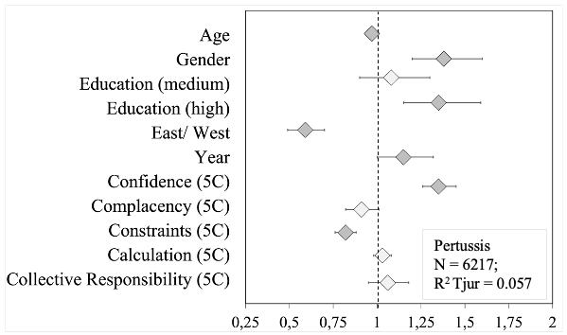
Note. Diamond shapes indicate the odds ratio and whiskers the 95% Confidence interval. Dark grey diamonds mark statistically significant predictors (p < 0.05). Gender (reference category: male), education (low), east/west (east), and year (2016) are dummy-coded variables.
Table S5: Logistic Regressions for pertussis vaccination behavior: “Which of the following diseases have you been vaccinated against in the last five years? [Pertussis]” in the Full Sample and all subgroups.
 | Full Sample |  |  | (A) People over 60 |  |  | (B) Chronical illnesses |  |  | (C) Migration |  |  | (D) HCW |  |  | (E) Parents |  |  | (F) Pregnant women
Predictors | OR | CI | p | OR | CI | p | OR | CI | p | OR | CI | p | OR | CI | p | OR | CI | p | OR | CI | p
Age | 0.97 | 0.97 – 0.98 | <0.001 | 0.95 | 0.93 – 0.98 | <0.001 | 0.96 | 0.96 – 0.97 | <0.001 | 0.96 | 0.94 – 0.99 | 0.001 | 0.98 | 0.96 – 0.99 | 0.002 | 0.98 | 0.96 – 1.00 | 0.024 | 0.99 | 0.95 – 1.03 | 0.726
Gender | 1.38 | 1.20 – 1.60 | <0.001 | 0.97 | 0.69 – 1.36 | 0.844 | 1.28 | 0.99 – 1.66 | 0.063 | 1.14 | 0.57 – 2.37 | 0.708 | 1.34 | 0.87 – 2.08 | 0.186 | 1.35 | 1.01 – 1.81 | 0.047
Education (medium) | 1.08 | 0.90 – 1.30 | 0.400 | 1.32 | 0.82 – 2.09 | 0.238 | 1.10 | 0.79 – 1.52 | 0.565 | 1.70 | 0.73 – 4.12 | 0.226 | 1.20 | 0.77 – 1.88 | 0.414 | 1.19 | 0.85 – 1.69 | 0.315 | 0.96 | 0.58 – 1.58 | 0.870
Education (high) | 1.35 | 1.15 – 1.59 | <0.001 | 1.05 | 0.72 – 1.52 | 0.798 | 1.10 | 0.83 – 1.46 | 0.518 | 1.53 | 0.68 – 3.56 | 0.309 | 1.76 | 1.13 – 2.74 | 0.012 | 1.47 | 1.08 – 2.01 | 0.015 | 1.18 | 0.76 – 1.85 | 0.460
East/ West | 0.59 | 0.49 – 0.70 | <0.001 | 0.48 | 0.34 – 0.68 | <0.001 | 0.51 | 0.38 – 0.68 | <0.001 | 0.37 | 0.13 – 1.19 | 0.077 | 0.72 | 0.45 – 1.16 | 0.170 | 0.78 | 0.56 – 1.11 | 0.157 | 1.31 | 0.77 – 2.29 | 0.327
Survey 2018 (vs. 2016) | 1.15 | 1.00 – 1.32 | 0.047 | 1.35 | 0.96 – 1.88 | 0.079 | 1.18 | 0.92 – 1.52 | 0.185 | 0.98 | 0.51 – 1.89 | 0.959 | 1.12 | 0.78 – 1.60 | 0.546 | 1.03 | 0.80 – 1.33 | 0.826 | 1.00 | 0.70 – 1.42 | 0.999
Confidence (5C) | 1.35 | 1.26 – 1.45 | <0.001 | 1.36 | 1.16 – 1.62 | <0.001 | 1.32 | 1.17 – 1.49 | <0.001 | 1.28 | 0.95 – 1.76 | 0.123 | 1.45 | 1.21 – 1.75 | <0.001 | 1.25 | 1.10 – 1.43 | 0.001 | 1.22 | 1.01 – 1.48 | 0.040
Constraints (5C) | 0.82 | 0.76 – 0.88 | <0.001 | 1.00 | 0.81 – 1.20 | 0.984 | 0.85 | 0.74 – 0.95 | 0.008 | 0.75 | 0.52 – 1.02 | 0.089 | 0.65 | 0.52 – 0.79 | <0.001 | 0.74 | 0.65 – 0.83 | <0.001 | 0.82 | 0.68 – 0.97 | 0.027
Coll. Responsibility (5C) | 1.06 | 0.95 – 1.18 | 0.316 | 1.07 | 0.88 – 1.33 | 0.538 | 1.01 | 0.85 – 1.21 | 0.950 | 0.88 | 0.65 – 1.24 | 0.438 | 1.08 | 0.80 – 1.51 | 0.651 | 0.95 | 0.78 – 1.18 | 0.633 | 1.02 | 0.71 – 1.55 | 0.905
Calculation (5C) | 1.03 | 0.98 – 1.08 | 0.313 | 1.00 | 0.89 – 1.13 | 0.994 | 1.05 | 0.96 – 1.15 | 0.320 | 0.94 | 0.76 – 1.18 | 0.598 | 1.03 | 0.91 – 1.17 | 0.663 | 1.00 | 0.92 – 1.10 | 0.956 | 0.98 | 0.87 – 1.11 | 0.778
Complacency (5C) | 0.91 | 0.82 – 1.01 | 0.079 | 0.95 | 0.77 – 1.13 | 0.564 | 0.95 | 0.80 – 1.11 | 0.553 | 1.11 | 0.77 – 1.53 | 0.552 | 0.80 | 0.54 – 1.10 | 0.205 | 0.86 | 0.68 – 1.06 | 0.189 | 1.02 | 0.76 – 1.34 | 0.897
N | 6217 |  |  | 1863 |  |  | 2106 |  |  | 379 |  |  | 673 |  |  | 1337 |  |  | 604
R² Tjur | 0.057 |  |  | 0.028 |  |  | 0.066 |  |  | 0.076 |  |  | 0.081 |  |  | 0.045 |  |  | 0.021

