Appendix A

Developmental process of the patient decision aid ‘Diagnostic testing for dementia or not’

Development phase

We gained insights into the needs, preferences and values of the stakeholders. Based on this information, we created a prototype of the web-based patient decision aid in collaboration with a steering group of stakeholders.

Input for the PtDA’s content came from several sources:
- In an integrative review, we examined the preferences and values of people with memory complains and significant others in deciding on diagnostic testing for dementia. We identified that preferences for diagnostic testing arose from the feeling of needing to do something, beliefs on the necessity and expected outcomes of starting a diagnostic trajectory. These views could be influenced by the normalization or validation of symptoms, the support or wishes of the social network, interactions with health care professionals, the health status of the person with memory complaints, and societal factors such as stigma and socioeconomic status (9).
- In an interview study, we identified values, information and decisional needs of patients with memory complaints, significant others and health care professionals in primary care (GPs and practice-based nurses) in deciding on diagnostic testing for dementia. Most patients and significant others were guided by their hope or need for clarity on their symptoms and support or tools to improve their quality of life. GPs’ a priori preferences were similar but were not dominant as they were guided by patient characteristics such as age and comorbidity. Towards the actual decision, the perceived severity of the patient’s symptoms and contextual factors influenced the decision on if and how diagnostic testing for memory complaints was initiated. GPs were importantly guided by patients’ needs and preferences.
- A steering group was formed to include the perspectives of different stakeholders during the development process of the PtDA. The steering group included 4 GPs, 4 significant others of people with dementia and one representative of the working group that developed the guideline on Dementia of the Dutch College of General Practitioners. The Dutch patient association for dementia patients (Alzheimer Nederland) was consulted on the involvement of stakeholders in the steering group. During the development process (January-December 2022) the steering group met two times for a 2-hour meeting. During these meetings the stakeholders provided their feedback on prototypes of the PtDA and results of the interview study and review were corroborated by the stakeholders.
- The general practice guideline on ‘Dementia’ of the Dutch College of General Practitioners (2).

User consultation phase

Based on the input provided in the development phase a prototype of the web-based patient decision aid was developed and evaluated using the think-aloud method (46) by end users (i.e. older adults, people with memory complaints, GPs and practice-based nurses). These potential users were asked to go through the PtDA and were encouraged to immediately express any comments on the PtDA. Afterwards, the researcher asked a few additional questions such as; “What is your general impression?” and “What did you particularly appreciate?”. The think-aloud interviews lasted between 20 and 40 min. The interviews were conducted in two rounds, after each round the PtDA was adapted based on the input of the end-users. There were mainly layout, wording and technical adaptions made.

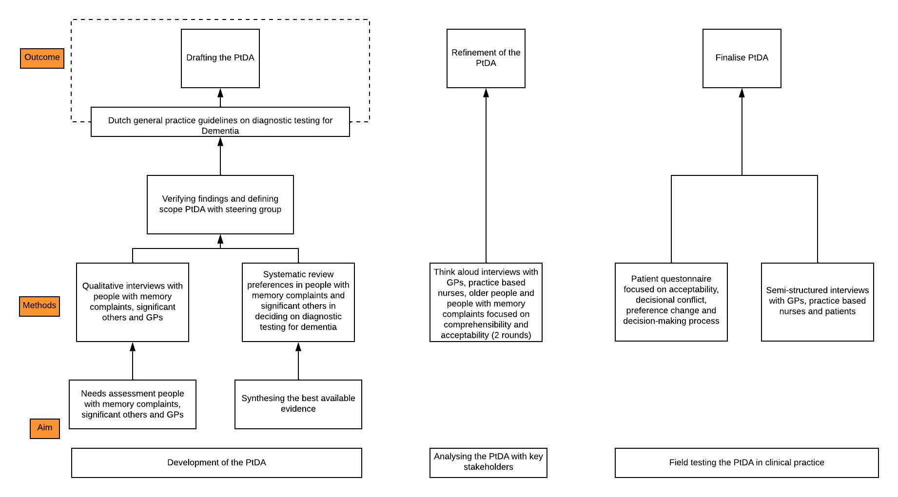
Figure S1. Visualization of the development process of the PtDA

Appendix B.

Table S1: Survey questions
Question | Answer option
1.What is your age?
2.What is your gender? | Female
 | Male
 | I’d rather not say
 | Other, namely
3.What is your highest completed education? | Primary education
 | Junior vocational education
 | Senior vocational or academic education
4.How did you come into contact with the patient decision aid? | My general practitioner advised it
 | I searched for information on memory complaints myself
 | I am a health care professional
 | Other, namely
In case ‘health care professional’ answered in previous question
4.1. What kind of health care professional are you? | General practitioner
 | Practice-based nurse
 | Other, namely
4.2. I used the patient decision aid because
4.3. I used the patient decision aid | Alone
 | Together with a patient
 | Together with a significant other
 | Together with a patient and significant other
 | Other, namely
5.I used the patient decision aid because | I have worries about my own memory
 | I have worries about my significant other’ memory
 | A health care professional worries about my memory
 | Other, because
In case ‘significant other’ answered in previous question
5.1. My relation to my significant other with memory complaints is | Spouse
 | Child
 | Other, namely
6. I used the patient decision aid | Alone
 | Together with a significant other
 | Together with a health care professional
 | Other, namely
7. After using the patient decision aid my preference on diagnostic testing for dementia are | Unchanged. I wanted to start diagnostic testing and I still prefer to.
 | Unchanged. I did not want to start diagnostic testing and I still prefer to.
 | Changed. I wanted to start diagnostic testing, but I prefer to refrain from diagnostic testing now.
 | Changed. I wanted to refrain from diagnostic testing, but I prefer to start diagnostic testing now.
 | I do not know yet.
8. The length of the patient decision aid was | Too short
 | Too long
 | Good
9. The amount of information was | Too much
 | Too little
 | Good
10. For each of the following topics [causes of memory complaints, treatment and care for dementia, diagnostic testing for dementia, possible implications of diagnostic testing] indicate what you think about the information provided in the patient decision aid | Bad
 | Reasonable
 | Good
 | Very good
10. I thought the information in the patient decision aid | Slanted towards starting diagnostic testing for dementia
 | Slanted towards refraining from diagnostic testing for dementia
 | Balanced
11. Was the patient decision aid useful in deciding on diagnostic testing for dementia? | Yes
 | No
12. What did you think of the patient decision aid. Did it make the decision easier or more difficult? | Easier
 | More difficult
 | I do not know
13. Do you think we included enough information to help a person with memory complaints decide about diagnostic testing for dementia? | Yes
 | No
14. What did you like about the patient decision aid?
15. What suggestions do you have to improve the patient decision aid?

Appendix C.

Table S2: Semi-structured interview guide online users
Main questions | Subtopics
How did you experience the use of the patient decision aid?
Why did you use the patient decision aid? | - How did you come into contact with the patient decision aid?  - What were your expectations of the patient decision aid?  - Did you already discuss your worries about your memory with a health care professional?
What do you think of the patient decision aid? | - Which information was of added value for you?  - Which information was less relevant for you?  - Did you miss information?  - Do you have suggestions for improvement?  - To what extent did the patient decision aid help you in deciding on diagnostic testing for dementia?
To what extent did the patient decision aid help you in gaining more insight into your personal preferences regarding diagnostic testing for dementia? | - What parts of the patient decision aid helped you in this?  - What else could help you in gaining more insight into your preferences?  - To what extent did the patient decision aid help you gaining more insight into the preferences of your significant other?  - Did you discuss the patient decision with your significant other? Why (not)?  - Did your significant also you use the patient decision aid?
Did the patient decision aid make the choice about diagnostic testing for dementia easier or more difficult? | - Why?  - Did you find the choice on diagnostic testing difficult before using the patient decision aid?
What have you decided on diagnostic testing for dementia after using the patient decision aid? | - Why?  - What were your considerations in this decision?

Appendix D.

Table S3: Semi-structured interview guide for general practitioners and practice-based nurses

Main questions | Subtopics
Have you used the patient decision aid in your daily practice? | - What are reasons for (not) using the patient decision aid?  - Are you planning to use the patient decision aid in future consultations? Why (not)?
What is your experience when using the patient decision aid? | - What was the reason for using the patient decision aid?  - At which moment did you use the patient decision aid?  - To discuss diagnostic testing in general practice?  - To discuss referral for specialized testing?  - How did you use the patient decision aid?  - Together with a patient? Referred the patient to the website to do it on their own?  - To what extent did you feel you were (better) informed about patients’/significant others’ preferences?  - How did you experience the decision-making process when using the patient decision aid?  - Were patients/significant others better prepared for the decision-making process?
To what extent is the patient decision of added value in deciding on diagnostic testing for dementia for you? | - Why (not)?  - Are there patients for which you find the patient decision aid of more/less added value?  - Do you think the patient decision aid helps patients/significant others in deciding on diagnostic testing? Why (not)?
Did the patient decision change the way you approach consults on memory complaints? | - Why do you think this is the case?
What do you think of the patient decision aid? | - Which information was of added value for you?  - Which information was less relevant for you?  - Did you miss information?  - Do you have suggestions for improvement?

Appendix E. Web metrics of the PtDA
Table S4. Web metrics of the PtDA between December 2021 and April 2022

Step | Step visits | Step proceeded | Proceeded rate
Home page | 7229 | 5233 | 72%
Step 1 – Learning more about memory problems and dementia | 4520 | 4432 | 98%
Step 2 -Conducting dementia diagnostics | 3872 | 3353 | 96%
Step 3: Advantages and disadvantages of dementia diagnostics | 2988 | 2886 | 97%
Step 4: What suits you best? | 2456 | 2049 | 83%
PtDA completed | 1980

Table S5. Web metrics of the PtDA between December 2021 and September 2022

Step | Step visits | Step proceeded | Proceeded rate
Home page | 10604 | 7649 | 72%
Step 1 – Learning more about memory problems and dementia | 6656 | 6526 | 98%
Step 2 -Conducting dementia diagnostics | 5666 | 5463 | 96%
Step 3: Advantages and disadvantages of dementia diagnostics | 4359 | 4213 | 97%
Step 4: What suits you best? | 3540 | 2954 | 83%
PtDA completed | 2870

