Supplementary information for

Optical Strain Engineering Enables Dynamic Spatial Control of 2D Nanomaterial Properties
Paula L. Lalaguna^{1*}, Paul Souchu^{1,2}, Neel Mackinnon³, Frances Crimin³, Rahul Kumar¹, Shailendra Kumar Chaubey¹, Asma Sarguroh¹, Amy McWilliam³, Alexey Ganin¹, Donald MacLaren³, Sonja Franke-Arnold³, Jörg B. Götte³, Stephen M. Barnett³, Nikolaj Gadegaard⁴ & Malcolm Kadodwala^{1*}
¹ School of Chemistry, University of Glasgow, Glasgow G12 8QQ, UK.
² Faculté des sciences et ingénierie, Université de Toulouse UPS, Toulouse 31400, France
³ SUPA, School of Physics and Astronomy, University of Glasgow, Glasgow G12 8QQ, UK.
⁴ James Watt School of Engineering, University of Glasgow, Glasgow G12 8QQ, UK.
*Email to: p.laborda-lalaguna.1@research.gla.ac.uk, malcolm.kadodwala@glasgow.ac.uk
Table of Contents
1. Set up for I-V measurements of monolayer graphene 2
2. Raman spectroscopy of monolayer graphene 3
3. AFM of graphene when illuminated with a Gaussian beam 4
4. Finite-element electromagnetic simulations of Laguerre-Gaussian beams in air 5
5. Finite-element simulated laser heating of Laguerre-Gaussian beams in monolayer graphene on SiO₂/Si 6
6. Photoluminescence spectroscopy of monolayer WS₂ 7
7. Photoluminescence spectroscopy of monolayer WS2 8
8. Response of monolayer WS₂ to temperature 9
9. Finite-element simulated laser heating of Laguerre-Gaussian beams in monolayer WS₂ 10
10. Power-dependent photoluminescence on CVD-grown and exfoliated monolayer WS₂ 11
11. Derivation of momentum flux density inside a medium 12
12. Derivation of angular momentum continuity equation inside a medium 14
13. Calculation of net forces and torques imparted on a material 16
14. Supplementary numerical simulations of angular momentum flux in WS₂ 19

Set up for I-V measurements of monolayer graphene

An image of the Graphenea card where the GFET (graphene field effect transistor) is incorporated into is shown in Figure S1a. This includes switches for the drain and the source, and individual sources for each FET device. Each graphene channel can be selected with the external individual source switches. A schematic of the electric circuit is shown in Figure S1b.
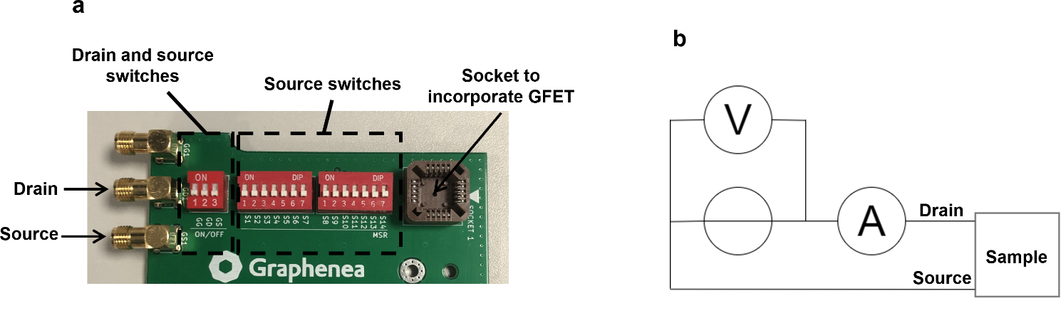
Figure S1: a, Image of the card (Graphenea) where the GFET can be incorporated. b, Electrical circuit of the GFET.

A schematic of the optical set up for laser illumination of the monolayer graphene is displayed in Figure S2 (see Methods for description).
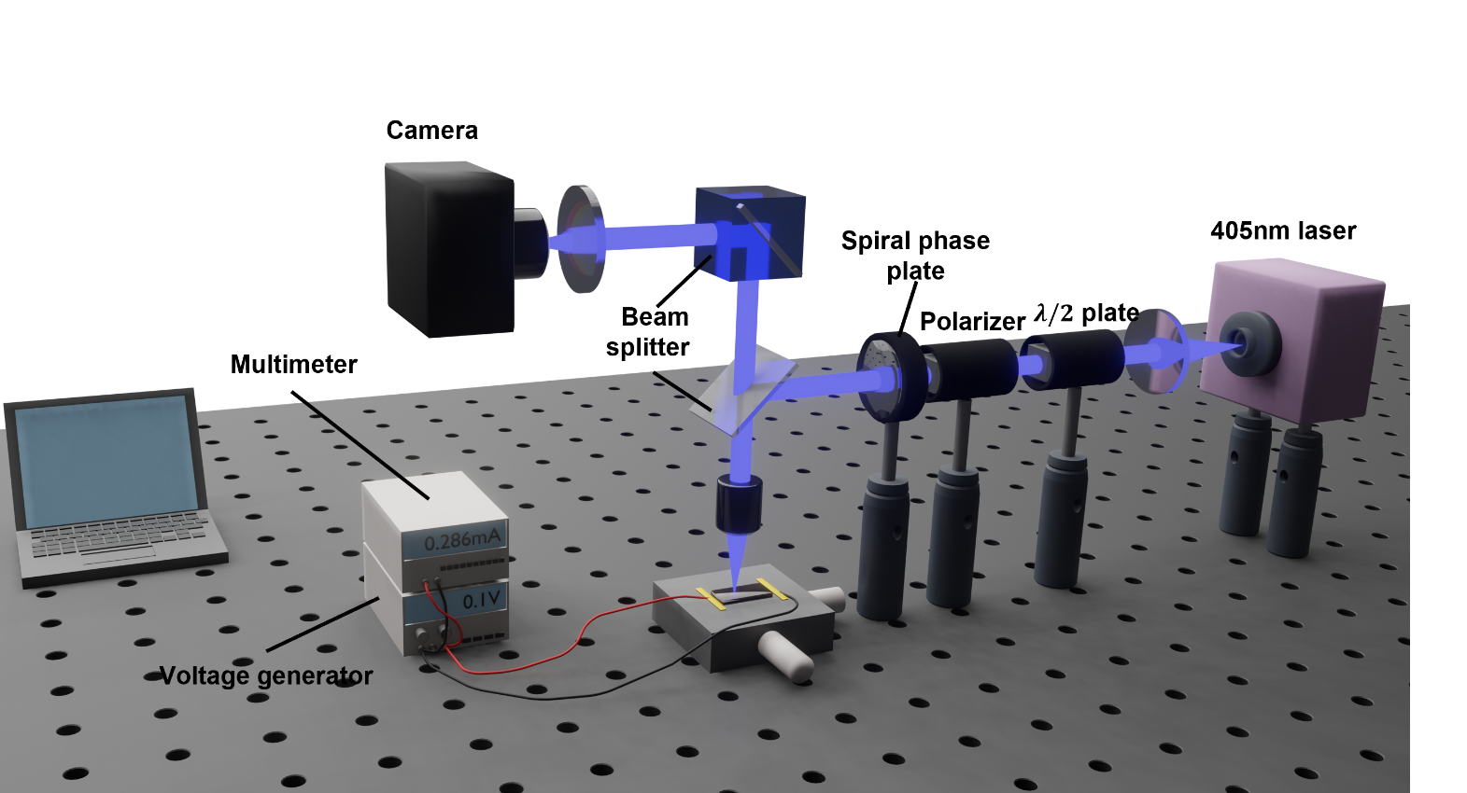
Figure S2: Optical set up to illuminate the GFET with Gaussian and LG beams and conduct I-V curves. The LG beam is created by inserting a spiral phase plate ($l=2,$ 405 nm, Vortex Photonics) along the optical path. The beam is directed towards the sample with a 50:50 beam splitter and a 10X objective (NA=0.25).

Raman spectroscopy of monolayer graphene

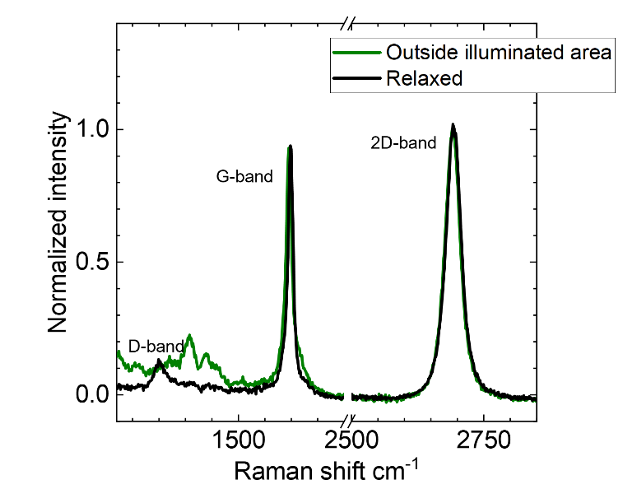
Figure S3: Raman spectra collected at the illuminated area with an LG beam ($l=2$) after a relaxation period >48 hours (black) and outside illuminated area (green). The spectra have been normalised to the maximum intensity of the 2D-band.

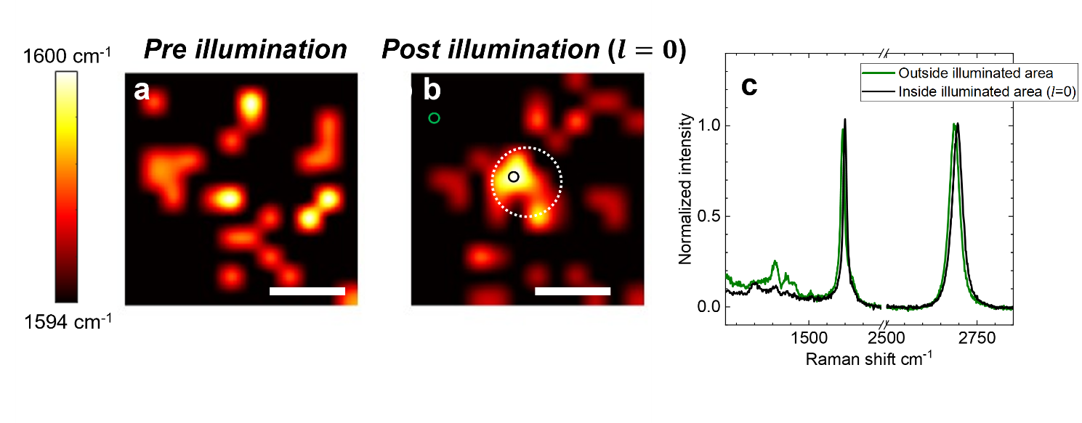
Figure S4: Raman mapping of the G-band position before illumination (a) and after Gaussian beam ($l=0$) illumination (b) (scale bar: $30μ$m). The approximate illuminated area in b is indicated with a white dotted circle. c, Raman spectra collected at the illuminated (black) and outside illuminated (green) positions depicted by the black and green circles, respectively, in panel b.

AFM of graphene when illuminated with a Gaussian beam

Supplementary AFM measurements collected with a Gaussian beam ($l=0$) are shown in Figure S5. Figure S5 shows that the changes in contrast after illuminating with Gaussian beam are much smaller than those observed with LG beam ($l=2$) in Figure 3 of the main manuscript. Furthermore, the root-mean-square roughness (R_{RMS}) only increases by 0.3 nm.
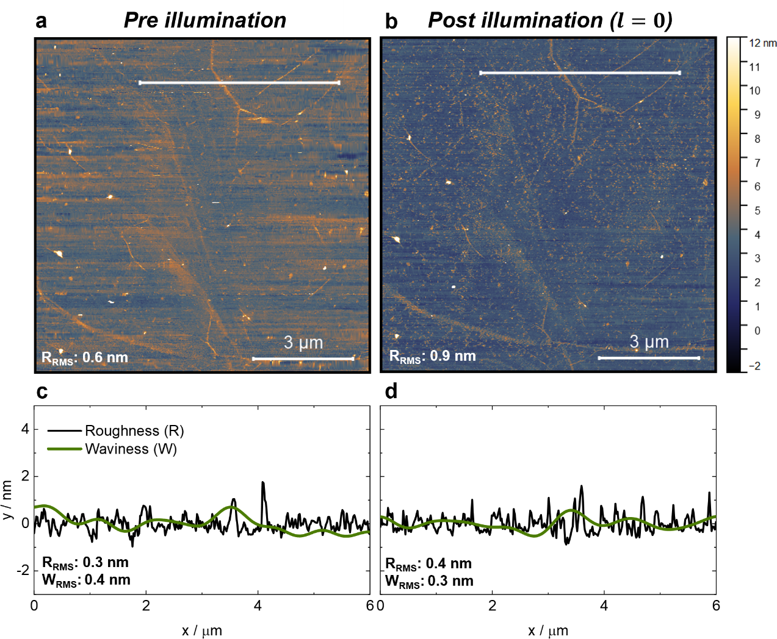
Figure S5: AFM characterisation of graphene before illumination (a) and after illumination (b) with Gaussian ($l=0$) beam (excitation power: 500 μW). The root-mean-square roughness (R_{RMS}) of both a and b is displayed at the bottom left corner. c,d, Variation in roughness (black) and waviness (green) across the white cut lines in a and b, respectively. The root-mean-square roughness (R_{RMS}) and waviness (W_{RMS}) have been added at the bottom left corner. See Methods for details.

Finite-element electromagnetic simulations of Laguerre-Gaussian beams in air

Electromagnetic simulations of Laguerre-Gaussian beams (see Methods for details) were first tested in air. Figure S6 shows that the size of the LG beam increases for larger topological charge as expected, and the helicity of the phase fronts is reversed upon changing the sign of the topological charge.
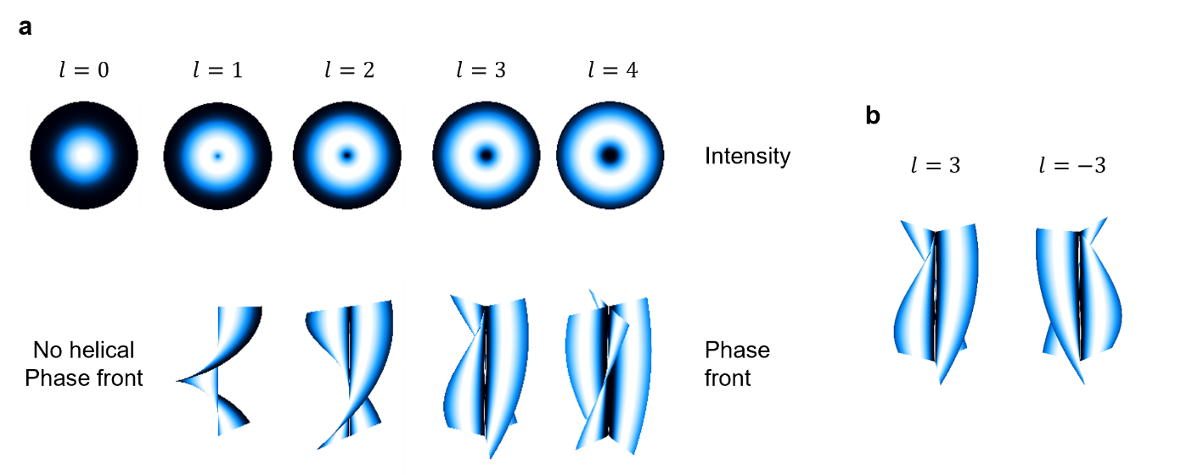
Figure S6: a, Simulated intensity and phase front of LG beams in air for varying topological charges. b, Phase fronts for $l=3$ and $l=-3$ beams.
The validity of the simulations was also checked by simulating the angular momentum (AM) flux in air.¹ The results from these simulations show that the AM flux increases linearly as a function of topological charge (Figure S7a) and power (Figure S7b) as expected.

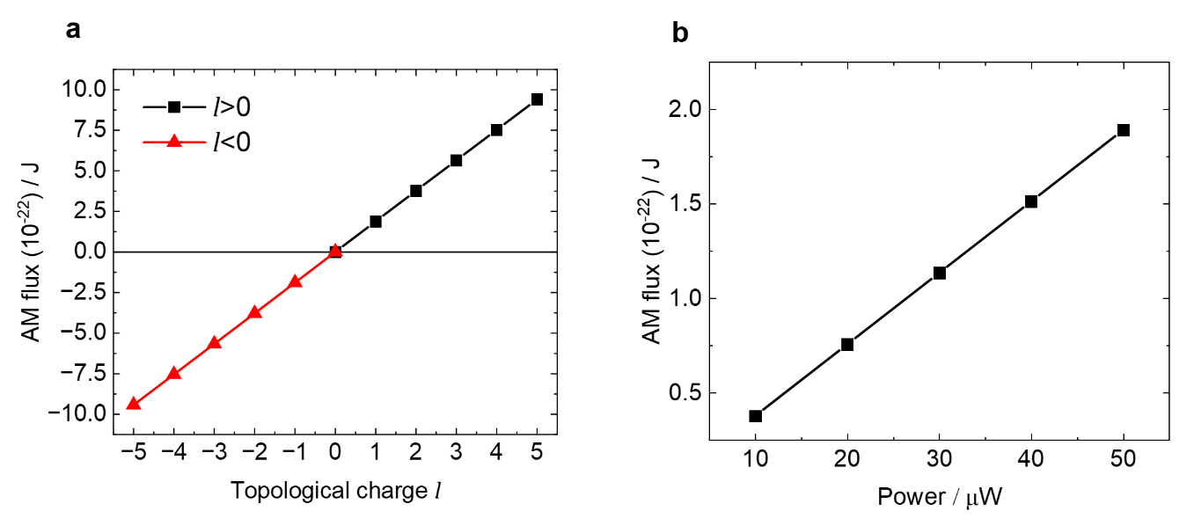
Figure S7: a, Angular momentum (AM) flux in air as a function of topological charge for a transverse-normalised Laguerre-Gaussian beam. Excitation power: 50$μW$. b, AM flux in air as a function of excitation power.

Finite-element simulated laser heating of Laguerre-Gaussian beams in monolayer graphene on SiO₂/Si

Laser heating simulations (see Methods for details) were performed for monolayer graphene on SiO₂/Si, and the results are shown in Figure S8. It is obtained that LG beams for increasing topological charges produce smaller temperature rises than a Gaussian beam, as the power is distributed over a larger area.

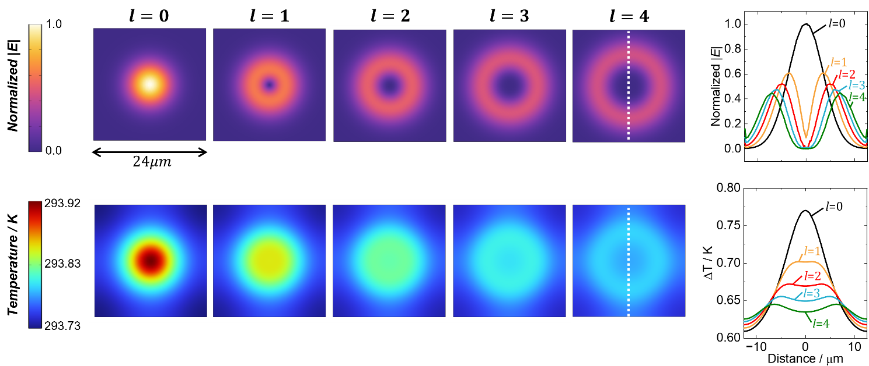
Figure S8: Simulated electric field intensity and temperature at graphene-substrate interface ($w_{0}=12.4λ$, power: $1mW$) for Gaussian beam and Laguerre-Gaussian beams of varying topological charges in monolayer graphene on SiO₂/Si. A cut line (white line) of the electric field intensity and temperature rise with respect to the initial temperature $T_{0}=293.15 K$ is displayed on the right-hand side.

Photoluminescence spectroscopy of monolayer WS₂

A schematic of the photoluminescence (PL) set up used to conduct PL spectroscopy of monolayer WS₂ is shown in Figure S9 (see Methods for description).
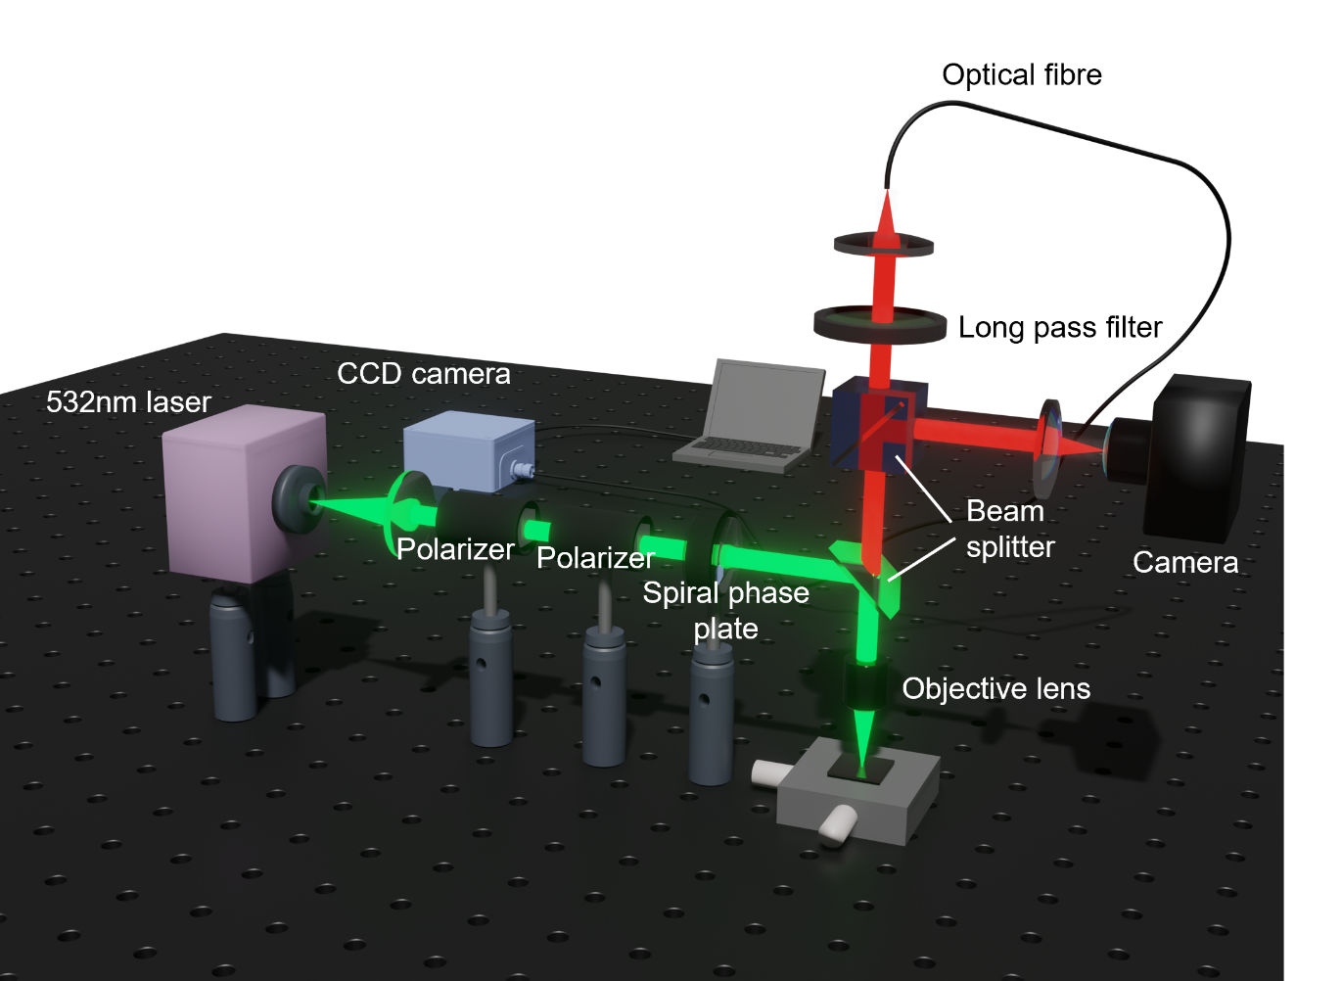
Figure S9: PL set up using a 532nm laser and the resulting red photoluminescence from monolayer WS₂. The LG beam is created by inserting a spiral phase plate ($l=4$, 532 nm, Vortex photonics) along the optical path. The beam is directed towards the sample with a 50:50 beam splitter and a 60X objective (NA=0.9).

Photoluminescence spectroscopy of monolayer WS2

The changes observed for exfoliated monolayer with LG beams are displayed in Figure S10.
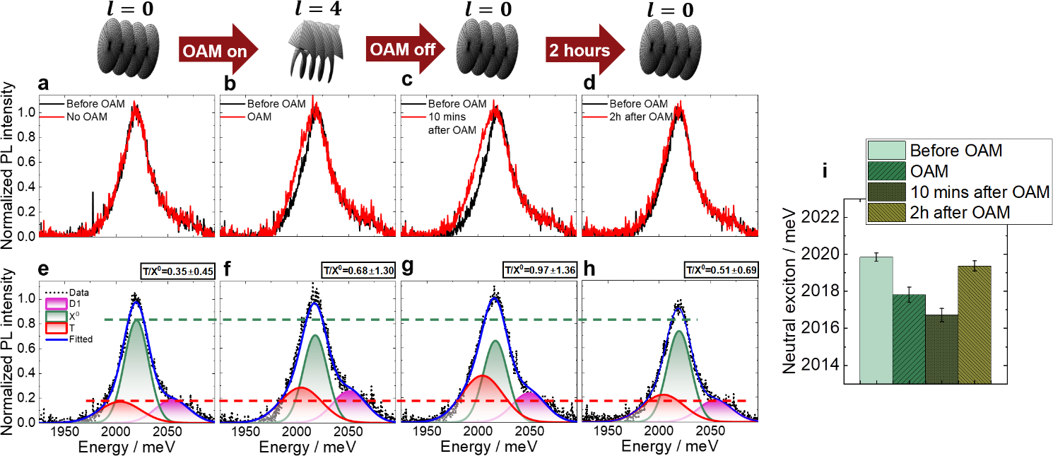
Figure S10: a, Reference spectra with no OAM (red) and right before OAM is introduced (black), showing no change between the two consecutive spectra. b, Spectrum collected with OAM $l=4$ (red) compared to the spectrum before OAM (black). c, Spectrum collected with a Gaussian beam (c) 10 minutes and (d) 2 hours after OAM (red), compared to the spectrum before OAM (black). e,f,g,h, Gaussian fits for the red spectra shown in a,b,c,d, respectively. i, Changes in the energies of the neutral exciton (X⁰) obtained from the fittings shown in panels e,f,g,h. In panels e,f,g,h, the green and red horizontal lines indicate changes in neutral exciton (X⁰) and trion (T) emissions, respectively, and the T/X⁰ intensity ratio is indicated at the top right corner.
The red shift in PL observed with LG beams across different positions in the CVD-grown monolayer and exfoliated monolayer flakes is shown in Figure S11a and Figure S11b, respectively.
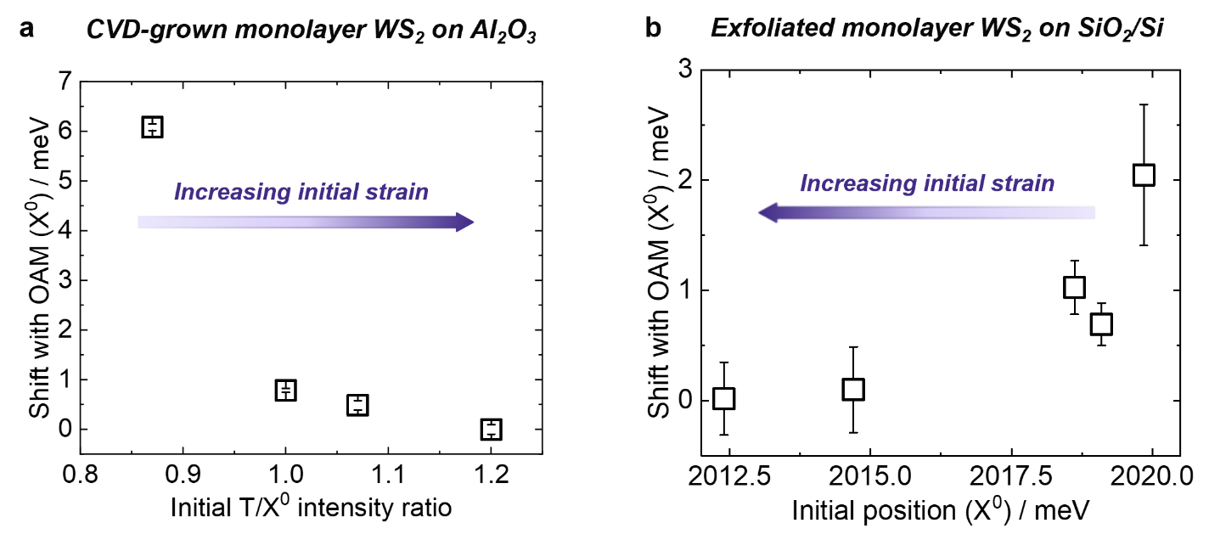
Figure S11: a, Shift with OAM for the neutral exciton (meV) as a function of T/X⁰ intensity ratio in the CVD-grown monolayer. b, Shift with OAM for the neutral exciton (meV) as a function of the initial position of the neutral exciton (meV) in exfoliated monolayer sample. The error bars were obtained from Gaussian fittings of experimental data.

Response of monolayer WS₂ to temperature

Heating of monolayer WS₂ was carried out using a commercial heating table (Linkam Scientific CO 102). Heating was performed from 20$°$C to 50 $°$C in increasing steps of 10$°$C. Before collecting the PL spectrum, the sample was left to stabilise at that temperature for 1h.
The changes in the PL spectra associated with heating the CVD-grown monolayer WS₂ on Al₂O₃ are shown in Figure S12a, showing a red shift of the PL emission. The energies of the neutral exciton and trion decrease as a function of temperature at approximately the same rate (Figure S12b), contrary to our observations with OAM (Figure 4g,h in the main manuscript). Furthermore, the trion-to-neutral exciton intensity ratio only changes significantly for a temperature of 40 $℃$ and above (Figure S12c).
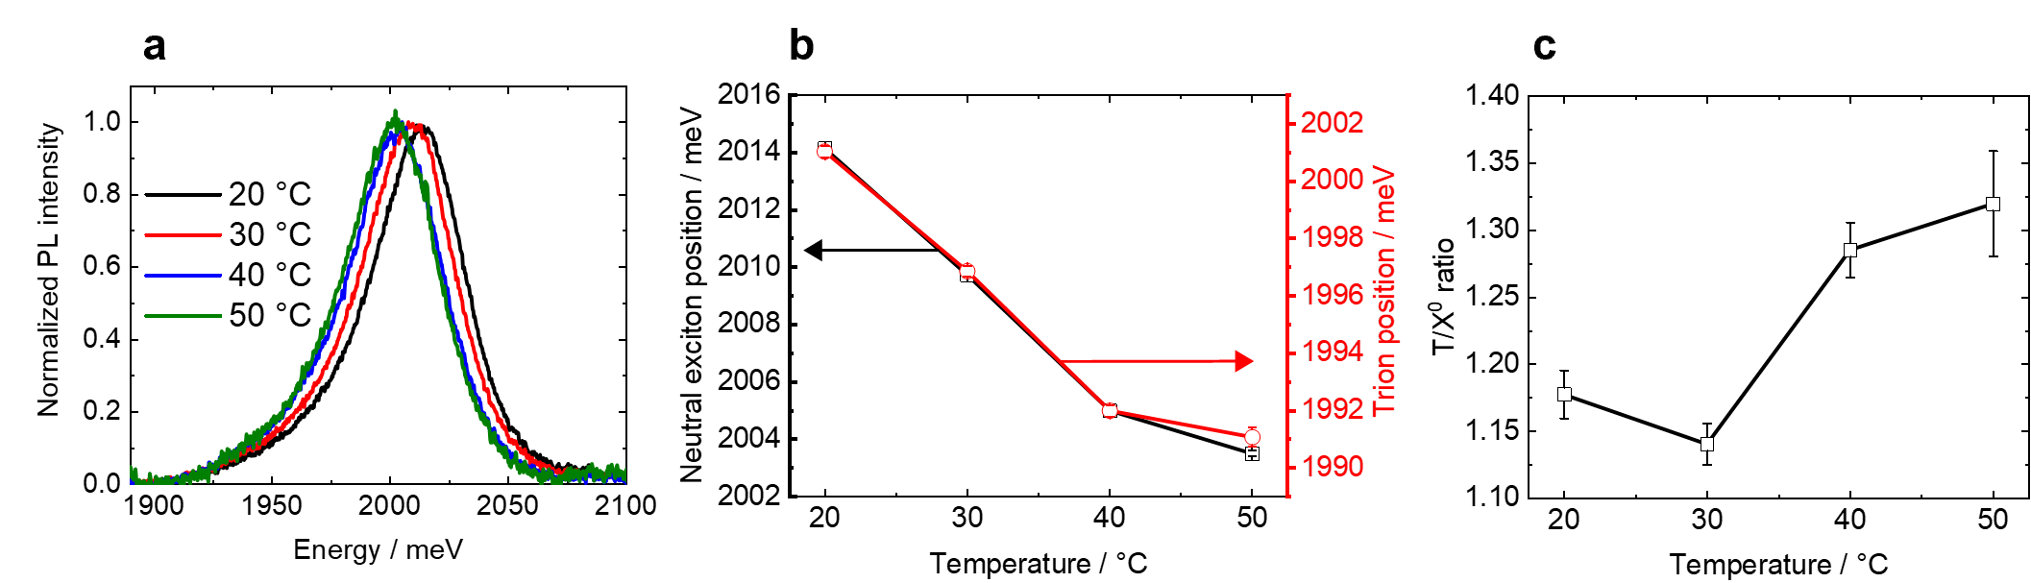
Figure S12: a, Normalised PL spectrum of CVD-grown monolayer WS₂ on Al₂O₃ as a function of temperature. b, Energy positions for neutral exciton energy (black) and trion energy (red) as a function of temperature. c, Trion-to-neutral exciton ratio as a function of temperature. The energy position and T/X⁰ ratio were obtained from Gaussian fittings of the experimental data in a.

Experimental heating of an exfoliated monolayer flake is shown in Figure S13, also showing that the energy of the neutral exciton and trion decrease at the same rate within fitting error, and the trion-to-neutral exciton ratio only changes significantly for a temperature of 40 $℃$ and above.

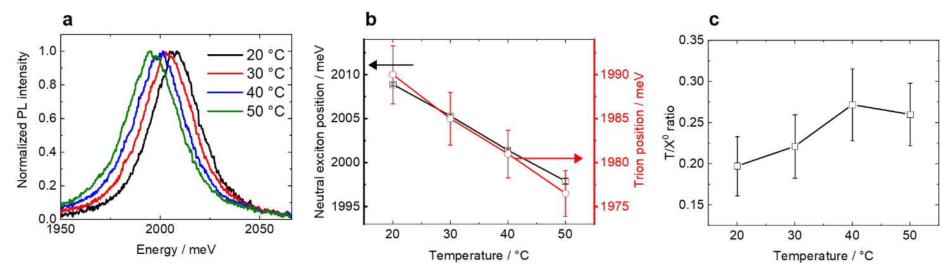
Figure S13: a, Normalised PL spectrum of an exfoliated monolayer WS₂ flake on SiO₂/Si as a function of temperature. b, Energy positions for neutral exciton energy (black) and trion energy (red) as a function of temperature. c, Trion-to-neutral exciton ratio as a function of temperature. The energy position and T/X⁰ ratio were obtained from Gaussian fittings of the experimental data in a.

Finite-element simulated laser heating of Laguerre-Gaussian beams in monolayer WS₂

Laser heating simulations (see Methods for details) were performed for monolayer WS₂ on the two different substrates used, Al₂O₃ and SiO₂/Si, and the results are shown in Figure S14 and Figure S15, respectively. In both cases, it is obtained that LG beams for increasing topological charges produce smaller temperature rises than a Gaussian beam, as the power is distributed over a larger area.
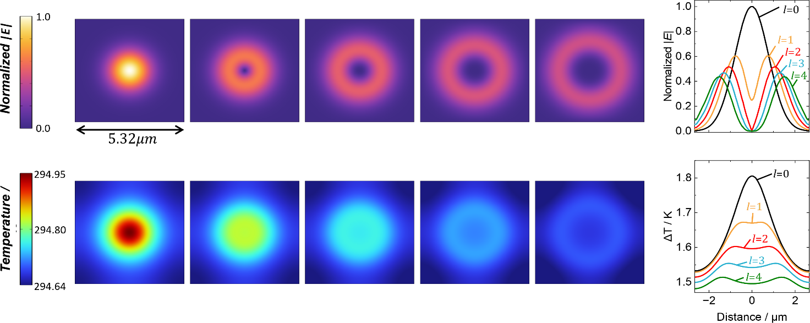
Figure S14: Simulated electric field intensity and temperature for Gaussian and Laguerre-Gaussian beams of varying topological charges in monolayer WS₂ on Al₂O₃. Excitation power: $200μW$. A cut line (white line) of the electric field intensity and temperature rise with respect to the initial temperature $T_{0}=293.15 K$ is displayed on the right-hand side.

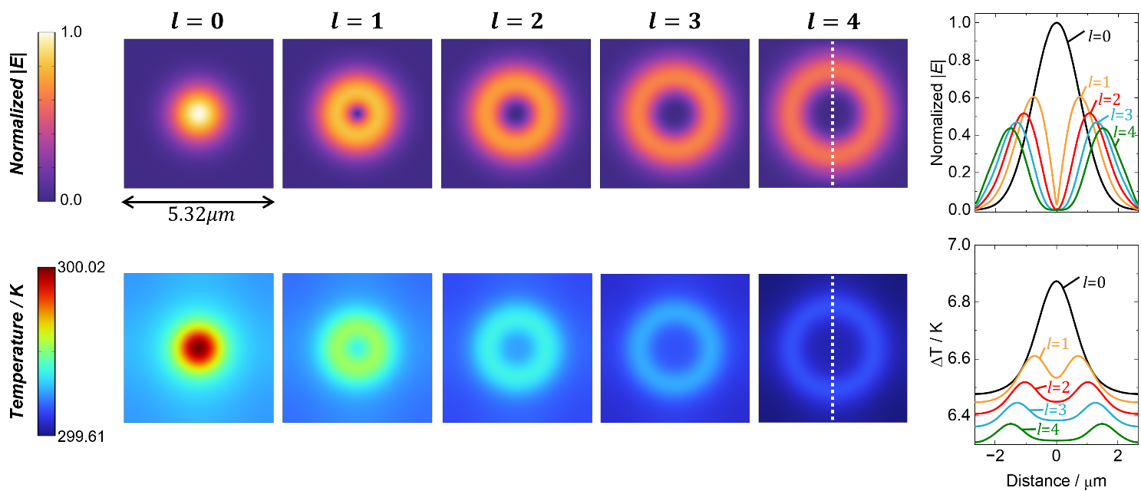
Figure S15: Simulated electric field intensity and temperature for Gaussian and Laguerre-Gaussian beams of varying topological charges in monolayer WS₂ on SiO₂/Si. Excitation power: $200μW$. A cut line (white line) of the electric field intensity and temperature rise with respect to the initial temperature $T_{0}=293.15 K$ is displayed on the right-hand side.

Power-dependent photoluminescence on CVD-grown and exfoliated monolayer WS₂

The power-dependent PL spectrum of CVD-grown full-coverage monolayer WS₂ on Al₂O₃ is shown in Figure S16a, where the energy and trion-to-neutral exciton intensity ratio do not change with laser power, in agreement with the literature.² In exfoliated monolayer WS₂, the trion is particularly dominant at large excitation powers (Figure S16b), in agreement with the literature.³ As LG beams have less power density than Gaussian beams (Supplementary section 9), the red shift and appearance of a shoulder at lower energy with LG beam illumination cannot be accounted for by a change in power density of the beam in the exfoliated monolayer, as reduced power density would result in a blue shift, not a red shift.
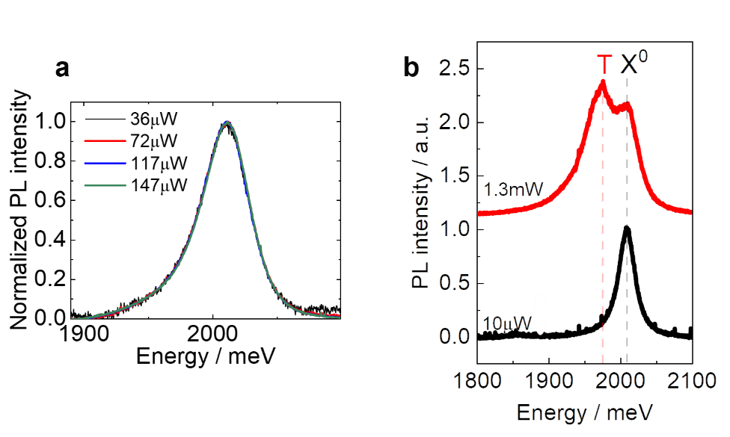
Figure S16: a, Power-dependent PL in CVD-grown monolayer WS₂ on Al₂O₃. b, Power-dependent PL in exfoliated monolayer WS₂ flakes on SiO₂/Si.

Derivation of momentum flux density inside a medium

In this section, we use the local continuity of momentum within a dielectric medium to derive an expression for the electromagnetic momentum flux tensor inside the medium. The conservation of the $i$-th component of electromagnetic momentum inside the medium can be expressed using the continuity equation:
 | $$\frac{∂g_{i}}{∂t}+f_{i}=-∇_{j}T_{ij},$$ | $$\left( 1 \right)$$
where $g_{i}$ is the momentum density, $f_{i}$ is the Lorentz force density, and $T_{ij}$ is the momentum flux tensor (the $ij$-h component of $T_{ij}$ is the flux of the $i$ component of momentum in the $j$ direction). A sum over repeated indices is implied. If we now write down expressions for the momentum density $g$, and the Lorentz force density, $f$, we can obtain an expression for $T_{ij}$ from the requirement that equation $\left( 1 \right)$ is satisfied.
In free space, the momentum density of light is straightforwardly given by $g=\frac{1}{c^{2}}E×H$.⁴ However, inside the medium the definition of electromagnetic momentum is more subtle, and different formulations exist.⁵ Here we use the Abraham form, and take the momentum density of light inside the medium to be $g=\frac{1}{c^{2}}E×H$.
The Lorentz force density can be written
 | $$f=\left(P∙∇\right)E+\frac{∂P}{∂t}×B$$ | $$\left( 2 \right)$$
where $P$ is the polarisation density.⁶
Substituting in these expressions for momentum density and Lorentz force density, equation $\left( 1 \right)$ becomes:
 | $$\frac{1}{c^{2}}\frac{∂}{∂t}\left(ε_{ijk}E_{j}H_{k}\right)+P_{j}∇_{j}E_{i}+ε_{ijk}{\dot{P}}_{j}B_{k}=-∇_{j}T_{ij},$$ | $$\left( 3 \right)$$

where a dot above a symbol indicates a time derivative. Assuming that the material is nonmagnetic, we have $H=\frac{1}{μ_{0}}B$, so the left-hand side of equation $\left( 3 \right)$ can be rewritten as:
 | $$ε_{0}\left(ε_{ijk}{\dot{E}}_{j}B_{k}+ε_{ijk}E_{j}{\dot{B}}_{k}\right)+P_{j}∇_{j}E_{i}+ε_{ijk}{\dot{P}}_{j}B_{k}.$$ | $$\left( 4 \right)$$

We then use the definition of the displacement field, $D=ε_{0}E+P$, to remove the polarisation field from the expression above:
$$ε_{0}\left(ε_{ijk}{\dot{E}}_{j}B_{k}+ε_{ijk}E_{j}{\dot{B}}_{k}\right)+P_{j}∇_{j}E_{i}+ε_{ijk}{\dot{P}}_{j}B_{k}.$$

$$=ε_{0}\left(ε_{ijk}{\dot{E}}_{j}B_{k}+ε_{ijk}E_{j}{\dot{B}}_{k}\right)+(D_{j}-ε_{0}E_{j})∇_{j}E_{i}+ε_{ijk}({\dot{D}}_{j}-ε_{0}{\dot{E}}_{j})B_{k}.$$

 | $$=ε_{0}ε_{ijk}E_{j}{\dot{B}}_{k}+(D_{j}-ε_{0}E_{j})∇_{j}E_{i}+ε_{ijk}{\dot{D}}_{j}B_{k}.$$ | $$\left( 5 \right)$$

We now use Maxwell’s equations $∇×E=-\dot{B}$ and $∇×H=\dot{D}=\frac{1}{μ_{0}}∇×B$ (where we assume that the medium is non-magnetic):
$$ε_{0}ε_{ijk}E_{j}{\dot{B}}_{k}+(D_{j}-ε_{0}E_{j})∇_{j}E_{i}+ε_{ijk}{\dot{D}}_{j}B_{k}.$$

 | $$=-ε_{0}ε_{ijk}E_{j}ε_{klm}∇_{l}E_{m}+(D_{j}-ε_{0}E_{j})∇_{j}E_{i}+\frac{1}{μ_{0}}ε_{ijk}B_{k}ε_{jlm}∇_{l}B_{m}.$$ | $$\left( 6 \right)$$

Finally, we use the identity $ε_{abc}ε_{ade}=δ_{bc}δ_{ce}-δ_{be}δ_{cd}$ to write:
$$-ε_{0}ε_{ijk}E_{j}ε_{klm}∇_{l}E_{m}+(D_{j}-ε_{0}E_{j})∇_{j}E_{i}+\frac{1}{μ_{0}}ε_{ijk}B_{k}ε_{jlm}∇_{l}B_{m}$$

$$=-ε_{0}(δ_{il}δ_{jm}-δ_{im}δ_{jl})E_{j}∇_{l}E_{m}+(D_{j}-ε_{0}E_{j})∇_{j}E_{i}+\frac{1}{μ_{0}}(δ_{lk}δ_{im}-δ_{km}δ_{il})B_{k}∇_{l}B_{m}$$

 | $$=-ε_{0}E_{j}∇_{i}E_{j}+D_{j}∇_{j}E_{i}+\frac{1}{μ_{0}}B_{k}∇_{k}B_{i}-\frac{1}{μ_{0}}B_{k}∇_{i}B_{k}.$$ | $$\left( 7 \right)$$

Our task is now to write the expression $\left( 7 \right)$ as the divergence of a second rank tensor. It is straightforward to show that this is accomplished if we define
 | $$T_{ij}=-E_{i}D_{j}-\frac{1}{μ_{0}}B_{i}B_{j}+\frac{1}{2}\left(ε_{0}E_{k}E_{k}+\frac{1}{μ_{0}}B_{k}B_{k}\right)δ_{ij},$$ | $$\left( 8 \right)$$

since $-∇_{j}T_{ij}$ is:
$$-∇_{j}T_{ij}=-∇_{j}\left[-E_{i}D_{j}-\frac{1}{μ_{0}}B_{i}B_{j}+\frac{1}{2}\left(ε_{0}E_{k}E_{k}+\frac{1}{μ_{0}}B_{k}B_{k}\right)δ_{ij}\right]$$

 | $$=D_{j}∇_{j}E_{i}+E_{i}∇_{j}D_{j}+\frac{1}{μ_{0}}B_{i}∇_{j}B_{j}+\frac{1}{μ_{0}}B_{j}∇_{j}B_{i}-ε_{0}E_{k}∇_{i}E_{k}-\frac{1}{μ_{0}}B_{k}∇_{i}B_{k}.$$ | $$\left( 9 \right)$$

Assuming there are no free charges, we can use Maxwell’s equations $∇∙D=0$ and $∇∙B=0$, so the equality of equations $\left( 7 \right)$ and $\left( 9 \right)$ immediately follows.

Derivation of angular momentum continuity equation inside a medium

Angular momentum $L$ is the cross product of the position vector $r$ with the linear momentum $p$:
 | $$L=r×p.$$ | $$\left( 10 \right)$$

Similarly, we can define the angular momentum flux density as the “cross product” of the position vector with the momentum flux tensor.¹ The $i$-component of the angular momentum flux in the $l$ direction is:
 | $$M_{li}=ε_{ijk}r_{j}T_{kl}.$$ | $$\left( 11 \right)$$

Using the expression derived for the linear momentum flux density in supplementary section 11 (equation $\left( 8 \right)$), the angular momentum flux density in the medium is given by
 | $$M_{li}=ε_{ijk}r_{j}T_{kl}=ε_{ijk}r_{j}\left[\frac{1}{2}δ_{kl}\left(ε_{0}E_{m}E_{m}+\frac{1}{μ_{0}}B_{m}B_{m}\right)-ε_{0}E_{k}D_{l}-μ_{0}^{-1}B_{k}B_{l}\right].$$ | $$\left( 12 \right)$$

To obtain a continuity equation for the angular momentum of light, we begin by taking the cross product of the position vector $r$ and the linear momentum continuity equation $\left( 1 \right)$:
 | $$\frac{1}{c^{2}}ε_{ijk}r_{j}\frac{∂}{∂t}{\left(E×H\right)}_{k}+ε_{ijk}r_{j}P_{m}∇_{m}E_{k}+ε_{ijk}r_{j}ε_{klm}{\dot{P}}_{l}B_{m}=-ε_{ijk}r_{j}∇_{l}T_{kl}.$$ | $$\left( 13 \right)$$

The first term in equation $\left( 13 \right)$ represents the time derivative of the angular momentum density $\frac{1}{c^{2}}r×(E×H)$. The second two terms are $r×f$, where $f$ is the Lorentz force density given in equation $\left( 2 \right)$, and so these correspond to a torque density. However, this is not the total torque density. The force density was defined as the force acting on the centre of each electric dipole, and therefore the torque density derived from this does not include the torque on each individual dipole about its own centre. We might expect an extra torque, with a form like $τ_{orienting}=P×E$, which would act to orient each dipole to align with the electric field.
Finally, we note that the term on the right-hand side is not quite equal to the divergence of the angular momentum flux density. The divergence of $M$ is equal to the divergence of the cross product of $r$ and $T$, but so far the right-hand side of equation $\left( 13 \right)$ is the cross product of $r$ with the divergence of $T$. We can see that the divergence of $M$ will have an extra contribution, due to the product rule when the divergence is taken:
 | $$∇_{l}M_{li}=∇_{l}\left(ε_{ijk}r_{j}T_{kl}\right)=ε_{ijk}T_{kl}∇_{l}\left(r_{j}\right)+ε_{ijk}r_{j}∇_{l}\left(T_{kl}\right).$$ | $$\left( 14 \right)$$

The expression $ε_{ijk}T_{kl}∇_{l}\left(r_{j}\right)$ becomes
$$ε_{ijk}T_{kl}∇_{l}\left(r_{j}\right)=ε_{ijk}T_{kl}δ_{lj}$$

$$=ε_{ijk}δ_{lj}\left(-E_{k}D_{l}-\frac{1}{μ_{0}}B_{k}B_{l}+\frac{1}{2}\left(ε_{0}E_{m}E_{m}+\frac{1}{μ_{0}}B_{m}B_{m}\right)δ_{kl}\right)$$

 | $$=ε_{ijk}\left(-E_{k}D_{j}-\frac{1}{μ_{0}}B_{k}B_{j}+\frac{1}{2}\left(ε_{0}E_{m}E_{m}+\frac{1}{μ_{0}}B_{m}B_{m}\right)δ_{kj}\right).$$ | $$\left( 15 \right)$$

Because $ε_{ijk}δ_{kj}=0$, the part involving $E^{2}$ and $B^{2}$ vanishes, and because $ε_{ijk}$ is antisymmetric, the contraction with the symmetric tensor $B_{k}B_{j}$ also vanishes. We can then use $D=ε_{0}E+P$ to write:
 | $$ε_{ijk}T_{kl}∇_{l}\left(r_{j}\right)=-ε_{ijk}E_{k}\left(ε_{0}E_{j}+P_{j}\right)=-ε_{ijk}E_{k}P_{j},$$ | $$\left( 16 \right)$$

where we have again used the antisymmetry of $ε_{ijk}$ to write $ε_{ijk}E_{k}E_{j}=0.$ Equation
$\left( 14 \right)$ therefore becomes:
 | $$∇_{l}M_{li}=ε_{ijk}r_{j}∇_{l}T_{kl}-{\left(P×E\right)}_{i}.$$ | $$\left( 17 \right)$$

We can therefore see that if we add ${\left(P×E\right)}_{i}$ to both sides of equation
$\left( 13 \right)$, we obtain the continuity equation:
 | $$\frac{1}{c^{2}}ε_{ijk}r_{j}\frac{∂}{∂t}{\left(E×H\right)}_{k}+ε_{ijk}r_{j}P_{m}∇_{m}E_{k}+ε_{ijk}r_{j}ε_{klm}{\dot{P}}_{l}B_{m}+ε_{ijk}P_{j}E_{k}=-∇_{l}M_{li}.$$ | $$\left( 18 \right)$$

Equation $\left( 18 \right)$ is the continuity equation for angular momentum inside the medium: the divergence of the angular momentum flux density on the right-hand side is equated to the local rate of change of angular momentum on the left. This rate of change is given by the time derivative of the optical angular momentum density (both the torque due to the Lorentz force density $r×\left(P∙∇\right)E+\frac{∂P}{∂t}×B$, and also the torque on each dipole about its own centre, $P×E$).

Calculation of net forces and torques imparted on a material

Recall that the continuity equation for linear momentum of light is given by (Supplementary Section 11):
 | $$\frac{1}{c^{2}}\frac{∂}{∂t}\left(ε_{ijk}E_{j}H_{k}\right)+P_{j}∇_{j}E_{i}+ε_{ijk}{\dot{P}}_{j}B_{k}=-∇_{j}T_{ij},$$ | $$\left( 19 \right)$$

If an experiment is performed with a continuous source of monochromatic light, then it is possible to time-average the continuity equation over a cycle. Under this averaging, the term corresponding to the time derivative of the Poynting vector vanishes, and we are therefore able to equate the divergence of the momentum flux density with the force on the dielectric,
 | $$P_{j}∇_{j}E_{i}+ε_{ijk}{\dot{P}}_{j}B_{k}=-∇_{j}T_{ij}.$$ | $$\left( 20 \right)$$

This can be rewritten with the divergence theorem to find the force on a volume in terms of the integral of the momentum flux through the surface enclosing the volume,
 | $$\iiint{force_{i}}dV=-\oint{T_{ij}n_{j}dS},$$ | $$\left( 21 \right)$$

where $n_{j}$ is a unit vector in the direction of the surface element $dS$. Therefore, the force imparted by the beam at an interface can be calculated by considering the surface integral of $T_{ij}$ over a surface enclosing the interface; this could, for example, be the difference in momentum fluxes through a plane just before the interface and one just after.
Similarly, a net torque can be obtained from the surface integral of the angular momentum flux density in the same way as a force can be obtained from the linear momentum. If a beam is propagating in the $z$ direction normal to an interface, then the torque about this propagation direction will be given by the difference in the fluxes of the $z$ component of angular momentum through two planes on either side of the interface. The relevant component of the angular momentum flux tensor, to be evaluated on either side of the interface, is:
$$M_{zz}=ε_{zjk}r_{j}T_{kz}=ε_{zjk}r_{j}\left[-E_{k}D_{z}-\frac{1}{μ_{0}}B_{k}B_{z}+\frac{1}{2}\left(ε_{0}E_{m}E_{m}+\frac{1}{μ_{0}}B_{m}B_{m}\right)δ_{kz}\right]$$

 | $$y(E_{x}D_{z}+μ_{0}^{-1}B_{x}B_{z})-x\left(E_{y}D_{z}+μ_{0}^{-1}B_{y}B_{z}\right)$$ | $$\left( 22 \right)$$

where we have made use of the fact that $ε_{azz}=0$.
We now compute the cycle-average of equation $\left( 22 \right)$ for monochromatic fields. We begin by expressing the real electric and magnetic field components $E_{i}$ and $B_{j}$ in terms of complex fields $E_{i}$ and $B_{j}$:
 | $$E_{i}=Re\left\{E_{i}\right\}=Re\{{\tilde{E}}_{i}exp⁡(-iωt)\}$$ | $$\left( 23 \right)$$

 | $$B_{j}=Re\left\{B_{j}\right\}=Re\left\{{\tilde{B}}_{j}\exp\left(-iωt\right)\right\},$$ | $$\left( 24 \right)$$
with complex amplitudes ${\tilde{E}}_{i}$ and ${\tilde{B}}_{j}$. Maxwell’s equations in the medium in the absence of sources are:
 | $$∇∙B=0.$$ | $$\left( 25 \right)$$

 | $$∇∙D=0.$$ | $$\left( 26 \right)$$

 | $$∇×E+\frac{∂B}{∂t}=0.$$ | $$\left( 27 \right)$$

 | $$∇×H-\frac{∂D}{∂t}=0.$$ | $$\left( 28 \right)$$

Note $D=εE$ and $B=μH$.
In terms of the complex fields, Maxwell’s equations become
 | $$∇∙B=0,$$ | $$\left( 29 \right)$$

 | $$∇∙D=0,$$ | $$\left( 30 \right)$$

 | $$∇×E-iωB=0,$$ | $$\left( 31 \right)$$

 | $$∇×H+iωD=0.$$ | $$\left( 32 \right)$$

From the last two equations we obtain:
 | $${\tilde{B}}_{j}=\frac{1}{iω}ε_{jkl}\frac{∂}{∂r_{k}}{\tilde{E}}_{l},$$ | $$\left( 33 \right)$$

 | $${\tilde{D}}_{i}=-\frac{1}{iω}ε_{ikl}\frac{∂}{∂r_{k}}{\tilde{H}}_{l}.$$ | $$\left( 34 \right)$$

The cycle-averaged angular momentum flux density is given by:
$${\overline{M}}_{zz}=\frac{1}{2}Re\left\{y\left({\tilde{E}}_{x}{\tilde{D}}_{z}^{*}+μ_{0}^{-1}{\tilde{B}}_{x}{\tilde{B}}_{z}^{*}\right)-x\left({\tilde{E}}_{y}{\tilde{D}}_{z}^{*}+μ_{0}^{-1}{\tilde{B}}_{y}{\tilde{B}}_{z}^{*}\right)\right\}$$

$$=\frac{1}{2}Re\left\{\left(y{\tilde{E}}_{x}-x{\tilde{E}}_{y}\right){\tilde{D}}_{z}^{*}+μ_{0}^{-1}\left(y{\tilde{B}}_{x}-x{\tilde{B}}_{y}\right){\tilde{B}}_{z}^{*}\right\}$$

$$=\frac{1}{2}Re\left\{\left(y{\tilde{E}}_{x}-x{\tilde{E}}_{y}\right)\frac{1}{iω}\left(\frac{∂}{∂x}{\tilde{H}}_{y}^{*}-\frac{∂}{∂y}{\tilde{H}}_{x}^{*}\right) +μ_{0}^{-1}\left(y{\tilde{B}}_{x}-x{\tilde{B}}_{y}\right)\frac{1}{iω}\left(\frac{∂}{∂y}{\tilde{E}}_{x}^{*}-\frac{∂}{∂x}{\tilde{E}}_{y}^{*}\right)\right\}$$

 | $$=\frac{1}{2ω}Re\left\{-i\left[\left(y{\tilde{E}}_{x}-x{\tilde{E}}_{y}\right)\left(\frac{∂}{∂x}{\tilde{H}}_{y}^{*}-\frac{∂}{∂y}{\tilde{H}}_{x}^{*}\right) +μ_{0}^{-1}\left(y{\tilde{B}}_{x}-x{\tilde{B}}_{y}\right)\left(\frac{∂}{∂y}{\tilde{E}}_{x}^{*}-\frac{∂}{∂x}{\tilde{E}}_{y}^{*}\right)\right]\right\}$$ | $$\left( 35 \right)$$

The angular momentum (AM) flux is then obtained from the surface integral of the angular momentum flux density ${\overline{M}}_{zz}$:
 | $${\left(AM flux\right)}_{zz}=\frac{1}{2ω}Re\left\{-i\iint{\left[\left(y{\tilde{E}}_{x}-x{\tilde{E}}_{y}\right)\left(\frac{∂}{∂x}{\tilde{H}}_{y}^{*}-\frac{∂}{∂y}{\tilde{H}}_{x}^{*}\right) +μ_{0}^{-1}\left(y{\tilde{B}}_{x}-x{\tilde{B}}_{y}\right)\left(\frac{∂}{∂y}{\tilde{E}}_{x}^{*}-\frac{∂}{∂x}{\tilde{E}}_{y}^{*}\right)\right]dxdy}\right\}$$ | $$\left( 36 \right)$$

For a linearly-polarised beam (i.e. no spin angular momentum), the AM flux equals to the orbital angular momentum (OAM) flux.

Supplementary numerical simulations of angular momentum flux in WS₂

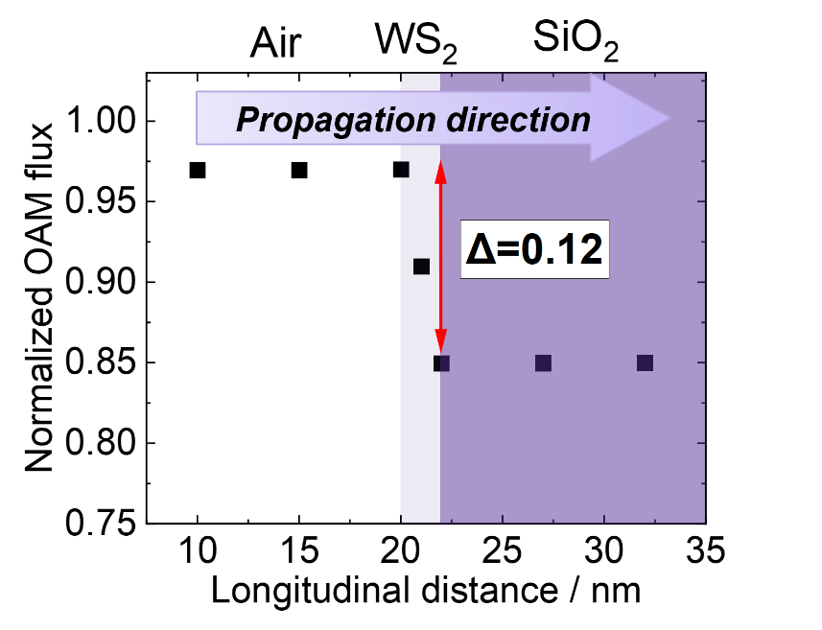
Figure S17: Simulated orbital angular momentum flux as an LG beam ($l=4$) propagates through air, WS₂ and SiO₂, normalised by the orbital angular momentum flux of the beam in air.

References

1 Barnett, S. M. Optical angular-momentum flux. Optics B: Quantum and Semiclassical Optics 4 (2002).
2 McCreary, K. M. et al. The Effect of Preparation Conditions on Raman and Photoluminescence of Monolayer WS2. Sci Rep 6, 35154 (2016). https://doi.org:10.1038/srep35154
3 Wei, K., Liu, Y., Yang, H., Cheng, X. A. & Jiang, T. Large range modification of exciton species in monolayer WS2. Appl Optics 55, 6251-6255 (2016). https://doi.org:10.1364/Ao.55.006251
4 Jackson, J. D. Classical electrodynamics. (Third edition. New York : Wiley, [1999] ©1999, 1999).
5 Barnett, S. M. & Loudon, R. The enigma of optical momentum in a medium. Philosophical Transactions of the Royal Society A: Mathematical, Physical and Engineering Sciences 368, 927-939 (2010). https://doi.org:10.1098/rsta.2009.0207
6 Barnett, S. M. & Loudon, R. On the electromagnetic force on a dielectric medium. Journal of Physics B: Atomic, Molecular and Optical Physics 39, S671 (2006). https://doi.org:10.1088/0953-4075/39/15/S14

Note that this expression treats the material as a collection of electric dipoles specified by $P$, and the electric part of the Lorentz force is taken as force on the centre of each dipole. An alternative approach would be to consider the Lorentz force on each individual charge, rather than each dipole – the distinction between the two approaches is relevant to the torque calculation of Supplementary section 12.

