SUPPLEMENTARY FIGURES

(b)
(a)

Fig S1: Spatial pattern of correlation coefficient of (a) PC 2 with temperature at 2m and (b) PC 1 with relative humidity at 2m obtained from IMDAA reanalysis data for April-May of 1980-2020.

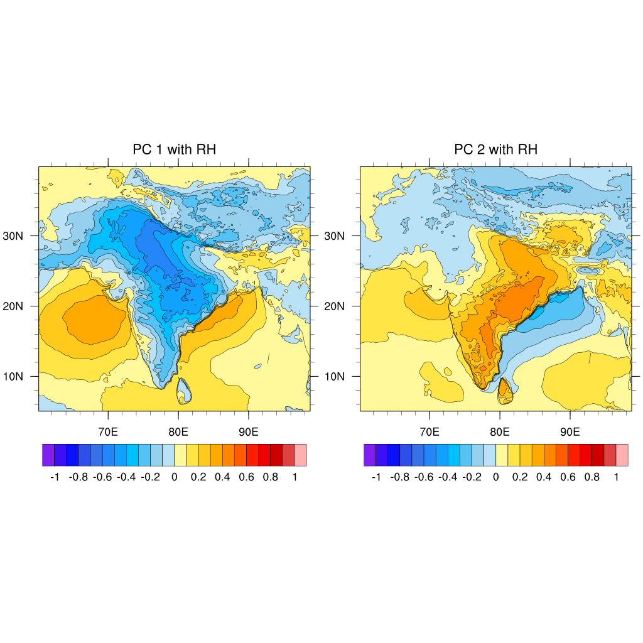
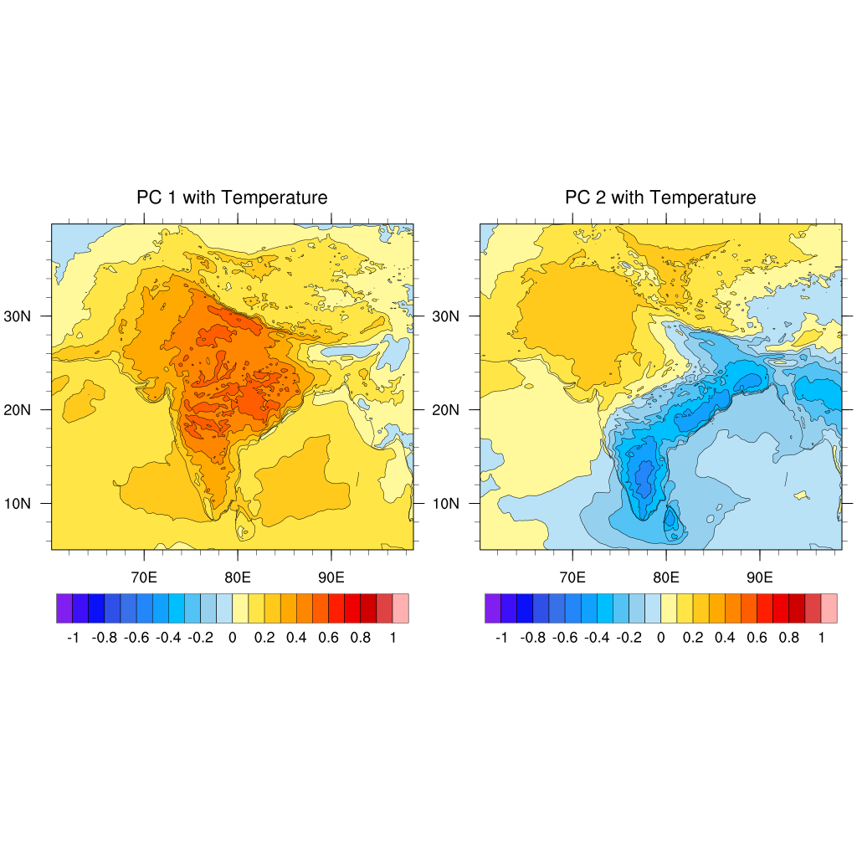

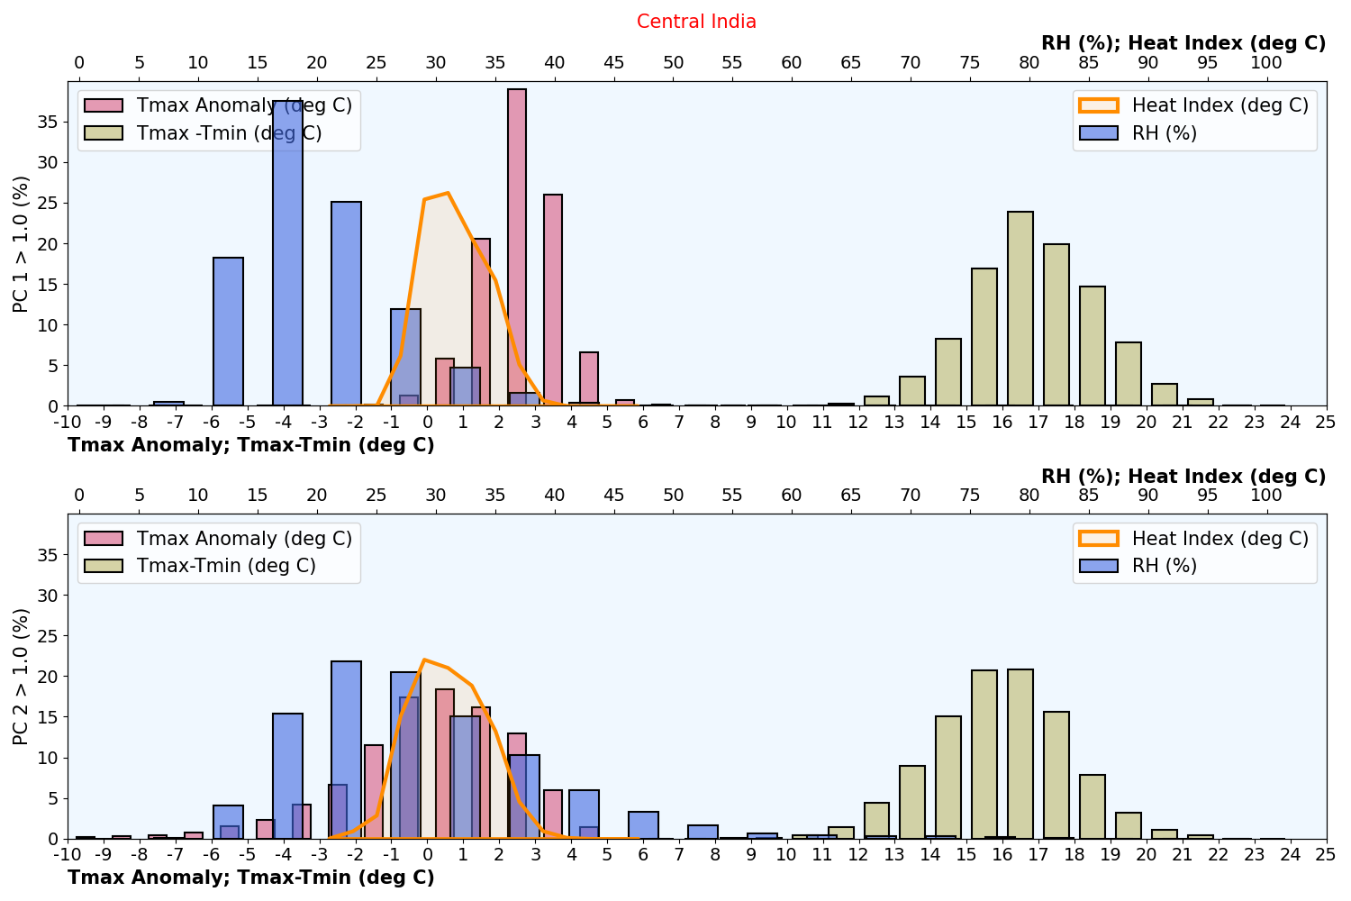
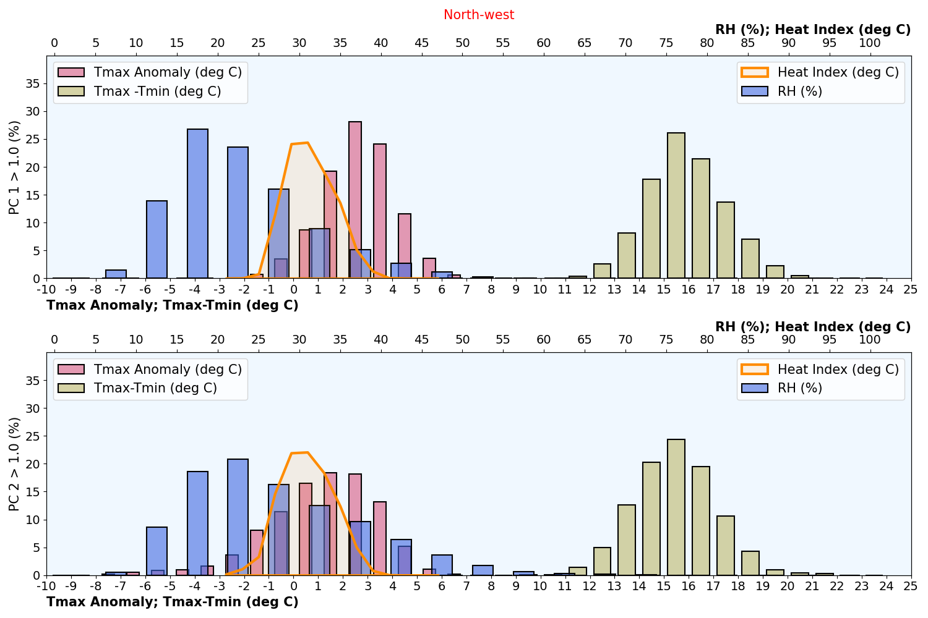
(a)

(b)

Fig S2: Histogram (in % distribution) of maximum temperature anomaly (⁰ C), Heat Index (HI; ⁰ C), diurnal temperature range (DTR; daily maximum – minimum temperature) and Relative Humidity (RH; %) for (a) Central India (b) Northwest India for those days when PC 1 > 1.0 and PC 2 > 1.0 during April-May from 1980-2020. The red, green and blue bars represent the histogram of maximum temperature anomaly, DTR and RH and the orange line represent the histogram of HI. The bottom x-axis gives the maximum temperature anomaly and DTR, while the top x-axis represents the RH and HI. The left y-axis gives the histogram (% distribution) of all the variables.

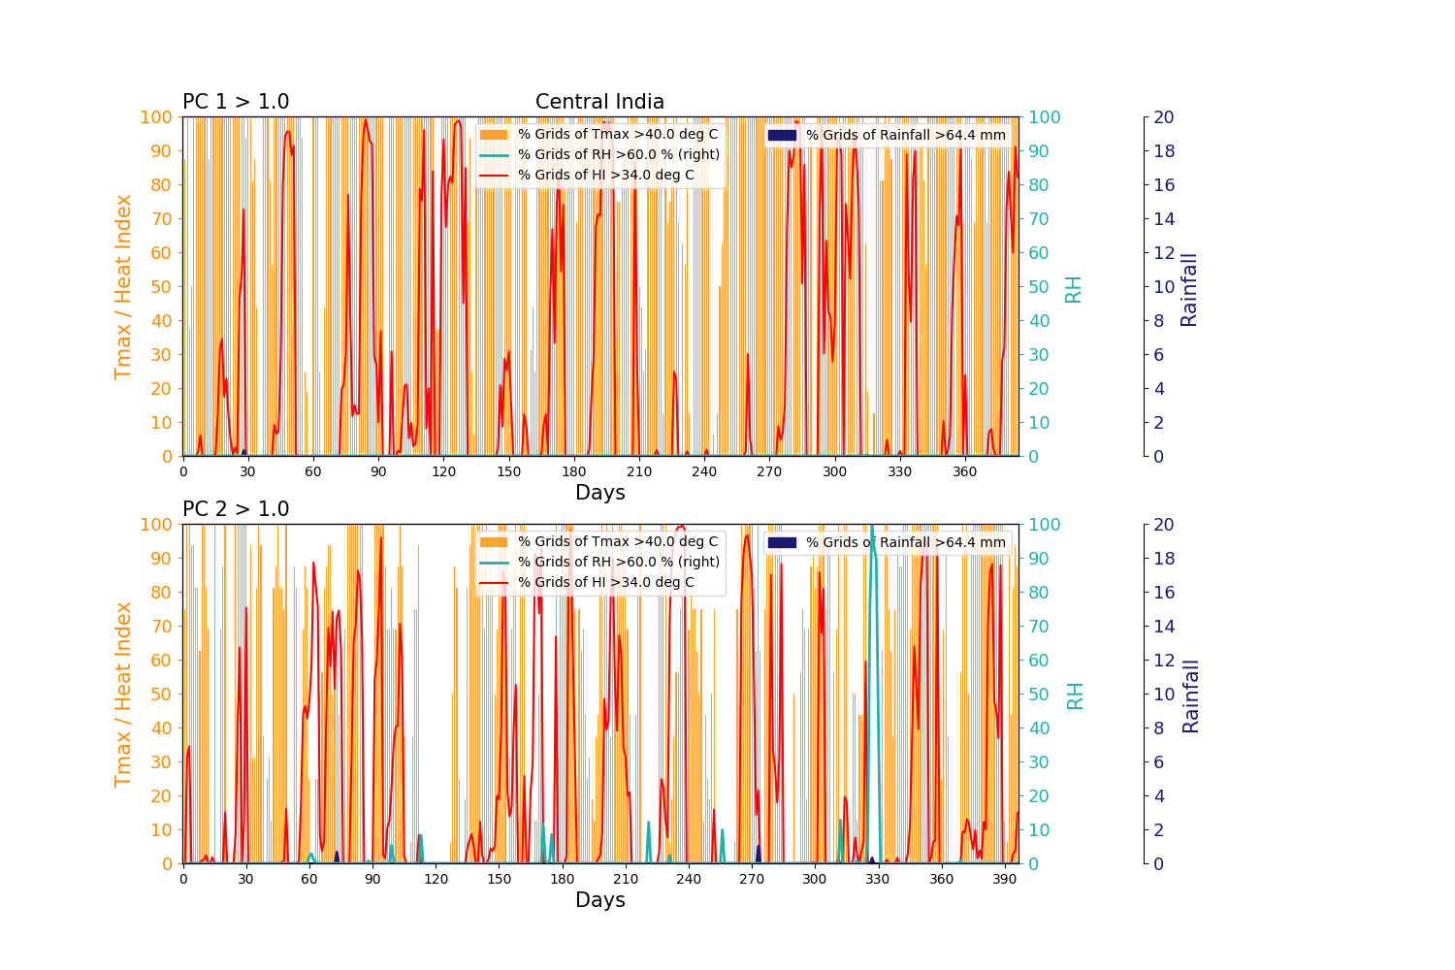
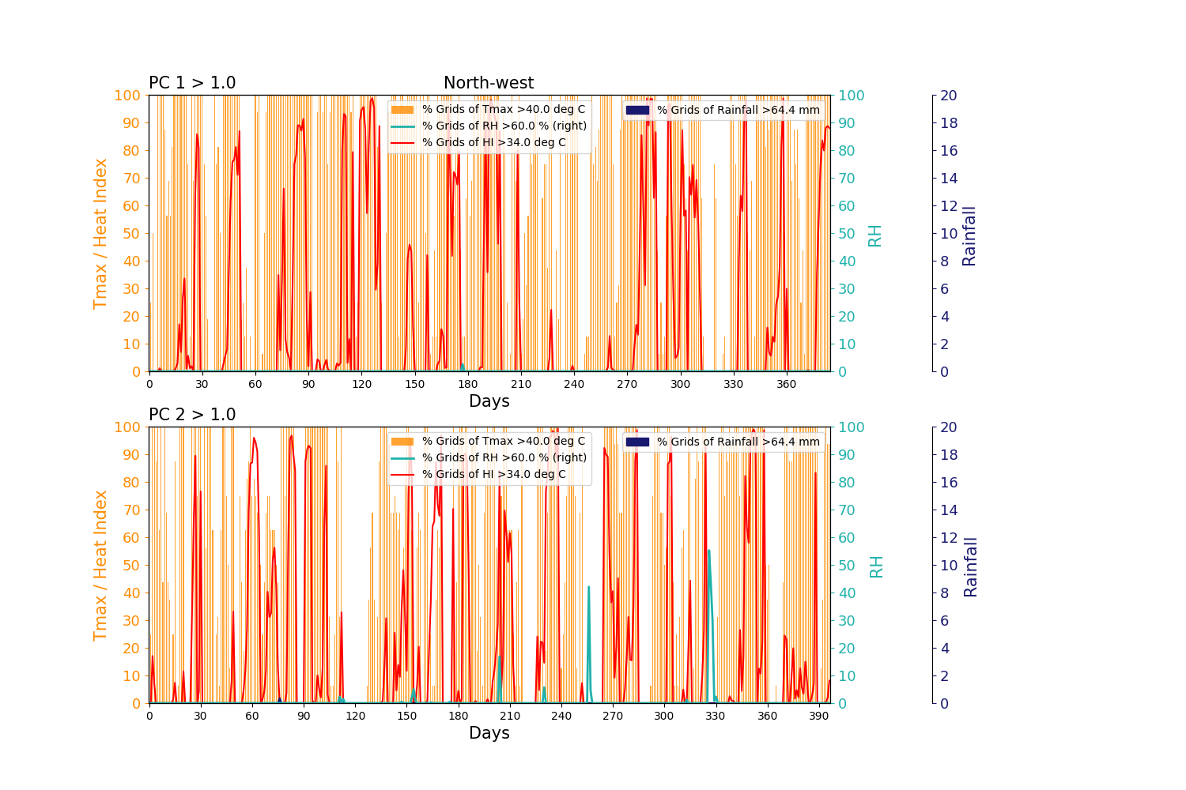
(b)
(a)
Fig S3: Percentage of grids for each day on (a) Central India (b) Northwest India, satisfying the conditions such as maximum temperature greater than 37⁰ C (orange bars), Heat Index (HI) > 37 ⁰ C (red line), Relative Humidity (RH) > 60% (green line) and daily rainfall > 64.5 mm (blue filled lines) only for those days when PC 1 > 1.0 and PC 2 > 1.0 during April-May from 1980-2020. The x-axis represents the days and the y-axis from left to right represents the maximum temperature/ HI, RH and Rainfall, respectively.

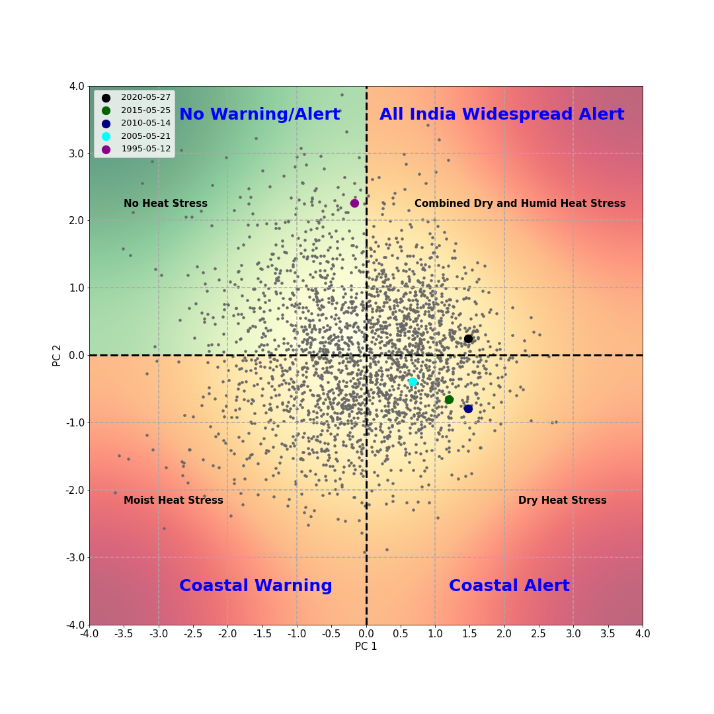
Fig S4: [PC 1, PC 2] phase space scatter plot for the real-time monitoring of the dry and moist heat stress associated to the dominant modes of summer temperature ISO over the Indian region. The clusters defined in the four different quadrants are shown in the blue shaded boxes and named as Phases 1 to 4.
Phase 4
Phase 1
Phase 2
Phase 3

