Enhanced Antibacterial and Antibiofilm Effects of Thiolated Chitosan-Encapsulated Nisin and Selenium Nanoparticles: A Potential Nanotechnology-Based Solution for Antibiotic-Resistant Bacterial Infections

Mozhgan Derakhshan Sefidi, Bita Bakhshi*
Department of Bacteriology, Faculty of Medical Sciences, Tarbiat Modares University, Tehran, Iran
* Corresponding author at: Department of Bacteriology, Faculty of Medical Sciences, Tarbiat Modares University, Tehran, Iran. E-mail address: b.bakhshi@modares.ac.ir (B. Bakhshi).

Mozhgan Derakhshan Sefidi m.derakhshan@modares.ac.ir
Bita Bakhshi b.bakhshi@modares.ac.ir

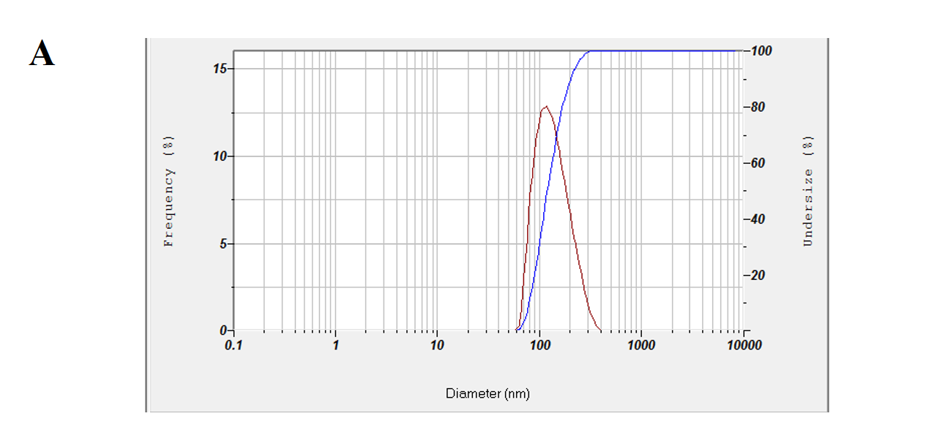
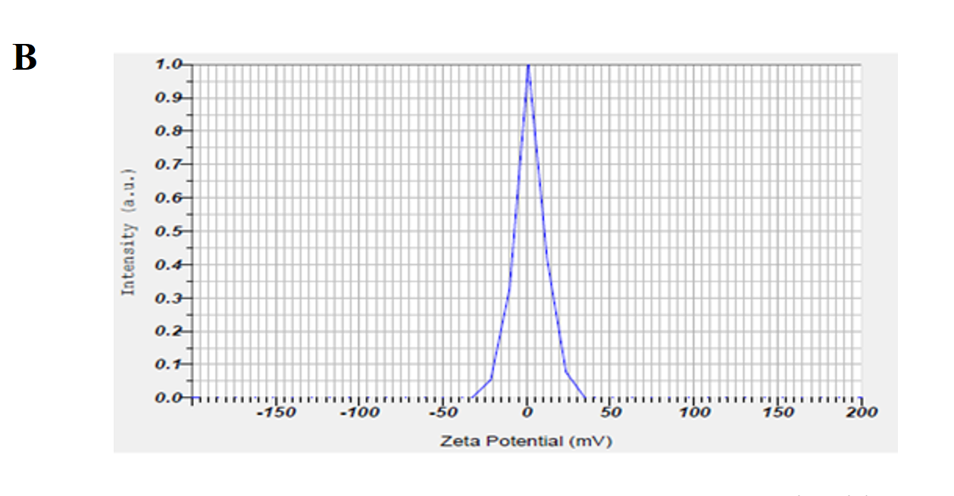
TCs-N-SeNPs. A) Average size and polydispersity index, and B) Zeta potential range

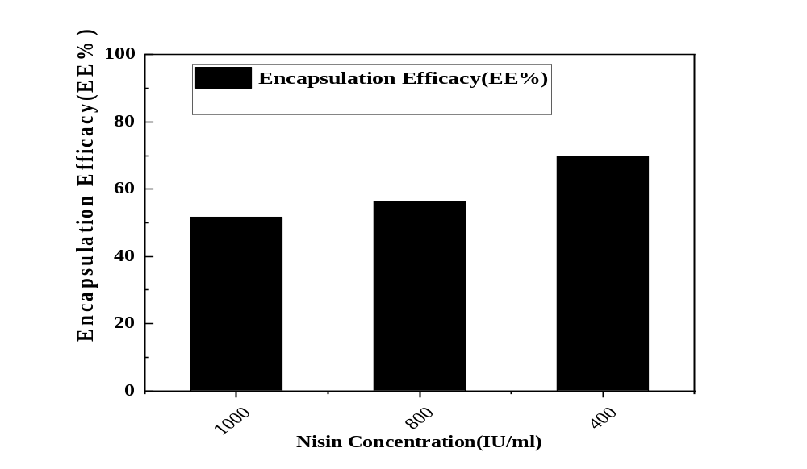

Effect of different nisin concentrations on the effectiveness of encapsulation

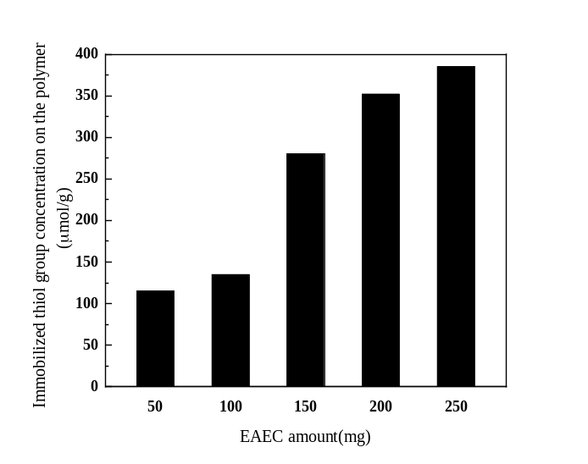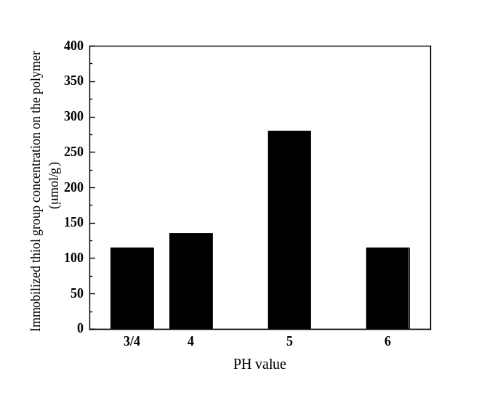
B
A

The effect of A) EDEC quantity, and B) pH value on the number of thiol groups adsorbed on polymer (Mean±SD)

Antimicrobial activity evaluation of different concentrations of TCs-N-SeNPs against standard strains by CFU Counting

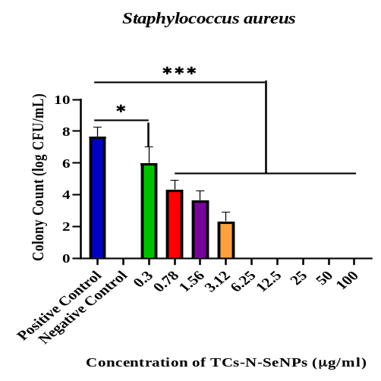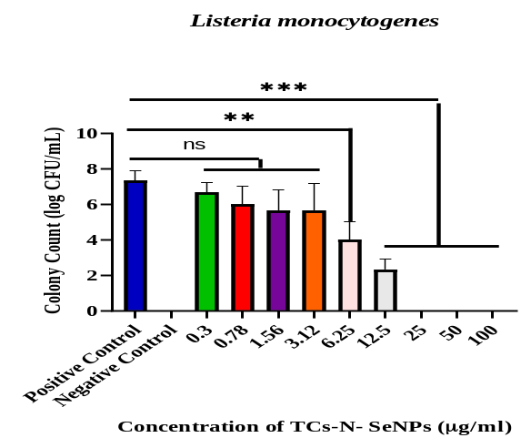

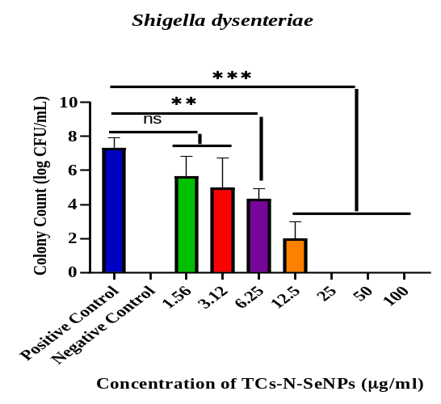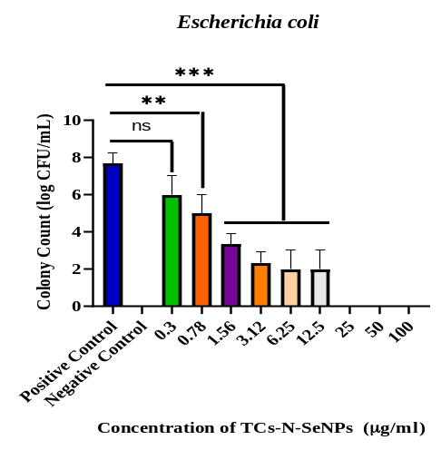

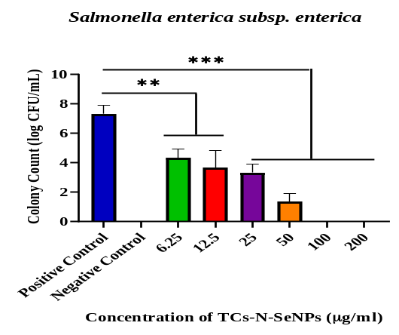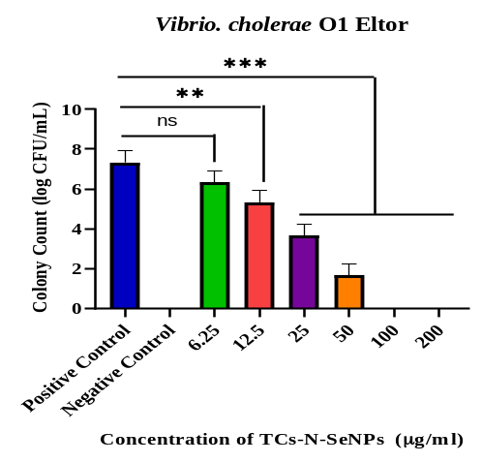

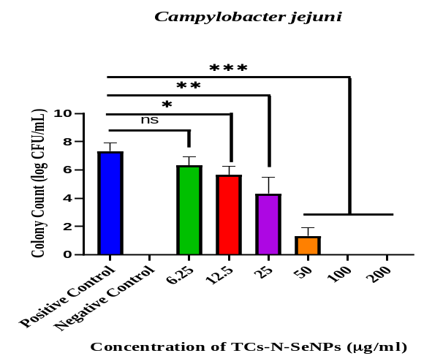

The antibacterial activity of TCs-N-Se NPs was demonstrated against Vibrio cholerae O1 Eltor(ATCC14035), Campylobacter jejuni(ATCC29428), Salmonella enterica subsp. enterica (ATCC17430), Shigella dysenteriae(PTCC1188), Escherichia coli(ATCC25922), Listeria monocytogenes(ATCC19115), and Staphylococcus aureus(ATCC29733). The measurement of bacterial growth used CFUs. The findings of Triplicate tests (mean±SD). For various concentrations in comparison to the control, (ns: No Significant, *P-value<0.05, **P-value<0.01, ***P-value<0.001)

