Insights into Homogenous Bulk Boron Doping at the Tetrahedral Site of NCM811 Cathode Materials: Structure Stabilization by Inductive Effect on TM-O-B Bonds
Bixian Yingª, Zhenjie Tengª, Maxim Avdeev^{b,c}, Anatoliy Senyshyn^{d}, Jiali Peng^{e}, Søren Bredmose Simonsen^{f}, Sylvio Indris^{e}, Oleksandr Dolotko^{e}, Richard Schmuch^{g}, Michael Merz^{h, i}, Peter Nagel^{h, i}, Stefan Schuppler^{h, i}, Helmut Ehrenberg^{e}, Martin Winter^{a, j}, & Karin Kleiner^{a*}
Address
ª MEET, Battery Research Cetre, University of Muenster, 48149 Muenster, Germany
^{b} Australian Centre for Neutron Scattering, Australian Nuclear Science and Technology Organisation, New Illawarra Rd, Lucas Heights NSW 2234, Sydney, Australia
^{c} School of Chemistry, The University of Sydney, Sydney, NSW 2006, Australia
^{d} Heinz Maier-Leibnitz Centre, Technical University of Munich, 85747 Garching, Germany
^{e} Institute for Applied Materials, Karlsruhe Institute of Technology, 76344 Eggenstein-Leopoldshafen, Germany
^{f} Department of Energy Conversion and Storage, DTU Energy, Technical University of Denmark, 2800 Kongens Lyngby, Denmark
^{g} Fraunhofer Research Institution for Battery Cell Production FFB, University Muenster, 48165 Münster, Germany
^{h} Institute for Quantum Materials and Technologies, Karlsruhe Institute of Technology, 76021 Karlsruhe, Germany
^{i} Karlsruhe Nano Micro Facility, Karlsruhe Institute of Technology, 76344 Eggenstein-Leopoldshafen, Germany
^{j} Helmholtz-Institute Muenster, IEK-12, Research Institute in Juelich, 48149 Muenster, Germany
* Corresponding author. University of Muenster, Germany
E-mail address: karin.kleiner@uni-muenster.de (Karin Kleiner)

Supporting information
Details about Rietveld refinement:
Reflection broadening:
Regarding the refinement process, the broadening of reflections is dissected into two components: instrumental and sample-related. The instrumental aspect is characterized using a Gaussian function (${FWHM}^{2}(Gaussian)=U∙\tan^{2}(θ)+V∙tan(θ)+W$) wherein U, V, and W parameters have no physical meaning and are derived from standard material. The sample contribution adheres to a Lorentzian shape and is defined in terms of X (strain broadening) and Y (particle size broadening) of the reflections, as expressed by Eq. 1
 | $$FWHM(lorentzian) = X tan(θ) +\frac{Y}{cos\left(θ\right)}$$ | Eq. 1
Anisotropic strain broadening arises from fluctuations in parameters, e.g. a variation in $d$-spacing^{1,2}. Eq.1 is thus modified by an additional term $F_{SZ}$ to account for anisotropic size broadening (Eq.2)
 | $$FWHM(lorentzian) = X tan(θ) +\frac{Y+ F_{SZ}}{cos\left(θ\right)}$$ | Eq. 2
Assuming that the variation of the $d$-spacing ($\frac{1}{d^{2}}=M_{hkl}=α_{1}h^{2}+α_{2}k^{2}+α_{3}l^{2}+α_{4}kl+α_{5}hl+α_{6}hk$ with $h, k, l$, the Miller indices and $α_{i}$, the metric parameters of the reciprocal lattice) follows a Gaussian distribution the anisotropic contribution is a function of the variance $σ^{2}$ using Bragg´s law.
 | $$F_{SZ}=\sqrt{σ^{2}} +d^{2}tan(θ)$$ | Eq. 3
The variation $σ^{2}$, in turn, is governed by the variance of ${\frac{1}{d^{2}}=M}_{hkl}$ and elementary statistics gives Eq.4.
 | $$σ^{2}(M_{hkl})=\sum_{ij}{\left(C_{ij}\frac{∂M_{hkl}}{∂α_{i}}∙\frac{∂M_{hkl}}{∂α_{j}}\right)=\sum_{HKL}{\left(S_{HKL}h^{H}k^{K}l^{L}\right)}}$$ | Eq. 4
with $C_{ij}=〈{(α}_{i}-〈α_{i}〉) (α_{j}-〈α_{j}〉)〉$, the covariance matrix, $〈α_{j}〉$, the mean value of the metric parameter, $S_{HKL}$ the strain parameters and $H+K+L=4$. Note that $\frac{∂M_{hkl}}{∂α_{1}}= h^{2}, \frac{∂M_{hkl}}{∂α_{2}}= k^{2},$… , $\frac{∂M_{hkl}}{∂α_{6}}= hk$. In a rhombohedral symmetry the metric parameter $α_{1}=α_{2}=α_{6}$ and $α_{4}=α_{5}=0$ and thus only three anisotropic strain parameters (${S_{400}, S}_{202}$ and $S_{004}$) exist. In the present case, only $S_{202}$ differs significantly from zero as determined with Rietveld refinement.

General X-ray powder diffraction refinement analysis:
The Thompson-Cox-Hastings pseudo-Voigt convoluted with axial divergence asymmetry function was used as the normalized peak shape function. The instrumental reflection broadening parameters (U, V, W) were determined separately by using a LaB6 NIST standard. These parameters were included in the refinement using an instrumental resolution file (.irf) file. Upon the refinement, the parameters are refined according to the following sequence:
- Background interpolation and subtraction were used for the refinements. Therefore we have chosen 30 points on the background.
- The zero shift was refined and left to be free.
- In cases where the XRD pattern includes an aluminium (Al) phase attributed to electrode coating, reflections originating from the current collector's Al phase were omitted during the refinement process.
- The zero shift was refined in the initial scans and was fixed for the subsequent scans since the position of the capillary did not change upon cycling.
- The scale factor was refined and was left to be free.
- The lattice parameters a, and c were refined according to the space group.
- The overall Debye-Waller factor (Bov) was refined.
- The isotropic strain value X and crystalline value Y were refined.
- The Lorenztian contribution, isotropic, and anisotropic strain values were refined.
- The disorder was refined by introducing two more atoms (Ni in the Li 3b site, and Li in Ni 3a site). The total occupancy was restricted to the stoichiometry value (Ni in Ni 3a site+ Li in Ni 3a site = 0.6664, Li in Ni 3a site+ Ni in Ni 3a site = 0.8333,).

Neutron powder diffraction refinement analysis:
The NCM811 and NCM811_5B samples underwent initial synchrotron X-ray powder diffraction measurements, and these data were refined to ensure their integrity. Subsequently, structure model parameters were refined based on neutron diffraction data. The Thompson-Cox-Hastings pseudo-Voigt function, convoluted with an axial divergence asymmetry function, served as the normalized peak shape model. The instrumental reflection broadening parameters (U, V, W) were independently determined using a LaB6 NIST standard and were then incorporated into the refinement process through an instrumental resolution file (.irf). During the refinement, the parameters underwent optimization in the following sequence:
- The background interpolation and subtraction were used for the refinements. Therefore we have chosen 30 points on the background.
- The zero shift was refined and left to be free.
- The scale factor was refined and was left to be free.
- The lattice parameters a, and c were refined according to the space group (see Tab. S2 NCM811 parameters) in hexagonal setting.
- The isotropic Debye-Waller factor for every site was refined.
- The isotropic strain value X and crystalline value Y were refined.
- The Lorenztian contribution, isotropic, and anisotropic strain values were refined.
- The disorder was refined by introducing two more atoms (Ni in the Li 3b site, and Li in the Ni 3a site). The total occupancy was restricted to the stoichiometry value (Ni in Ni 3a site+ Li in Ni 3a site = 0.6664, Li in Ni 3a site+ Ni in Ni 3a site = 0.8333,).
- Fix the previously refined parameters and refine the B atom in 4 different ways: a. introduce boron on the Li 3b site, b. introduce boron on the Ni 3a site, introduce boron on the O 6c site, d. introduce boron on the tetrahedral site (Note that there are 6 equivalent positions on one 6d-site per unit cell in a hexagonal setting and follows the symmetry operations of $R\overline{3}mH$ space group. See Tab. S2 NCM811with boron site)

Figure:
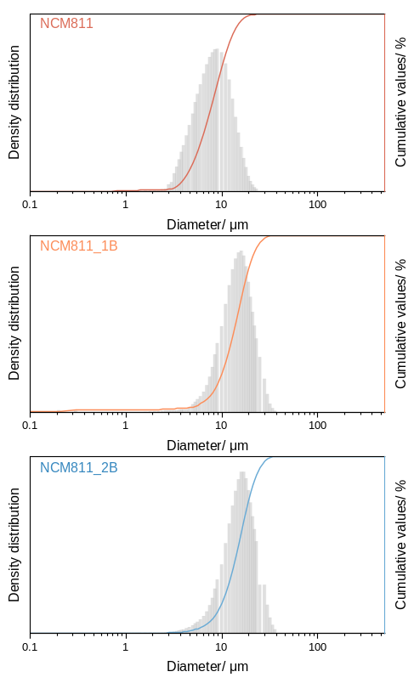
Fig.S 1 Particle size distribution of NCM811, NCM811_1B, and NCM811_2B.
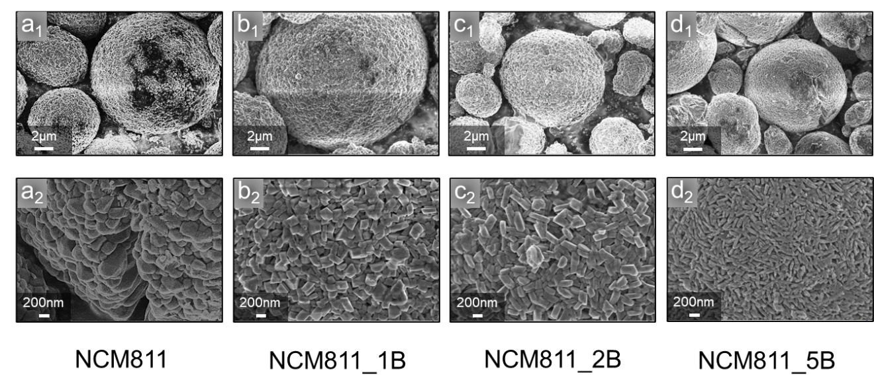
Fig.S2 SEM images of NCM811_xB (x= 0, 0.5, 1, 2, 5%)

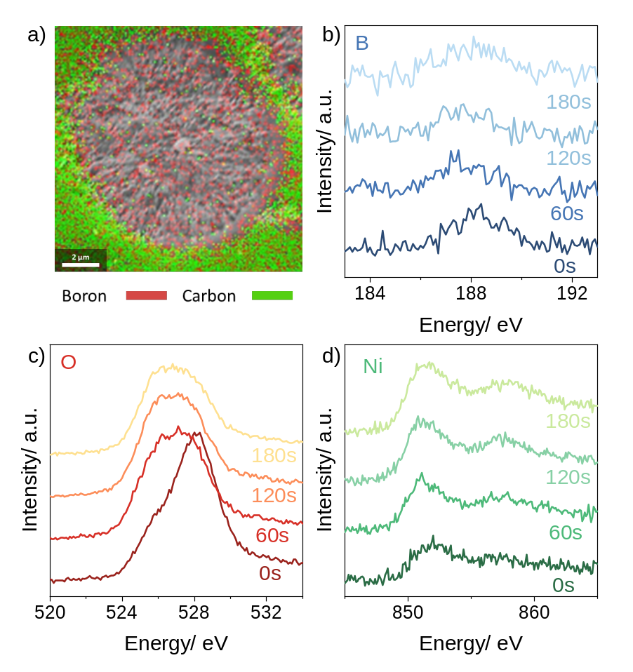
Fig.S3 a) A cross-section of NCM811_5B electrode with SEM-EDX measurement. XPS depth profiles of NCM811_5B: b) B K edge, c) O K edge, and Ni L edge.
Fig.S3 depicts the results of SEM-EDX analysis performed on a cross-section of NCM811_5B, which confirmed the homogeneous distribution of boron within the particles, providing evidence for the successful bulk boron doping. However, it should be noted that due to the similarity in detection energies of boron and carbon, some boron signals may be detected in the matrix, and carbon signals may be detected in the bulk. Nevertheless, the analysis showed that in the bulk region, there is a much higher concentration of boron compared to carbon, while in the matrix region, carbon dominates. XPS depth profiles of the boron K edge (Fig.S2b) show a homogenous boron distribution from the surface to the bulk as well.
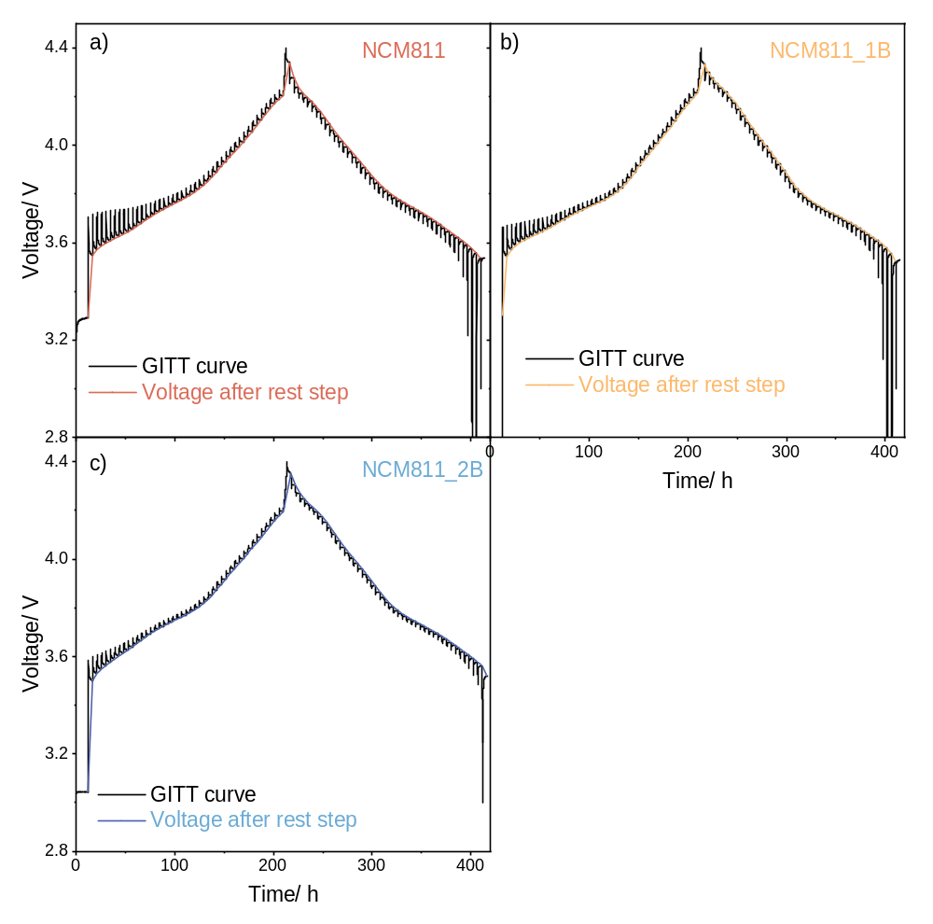
Fig.S4 GITT data of NCM811, NCM811_1B and NCM811_2B. During each charging/discharging step, a constant current of 9 mA g⁻¹ (0.05 C-rate) was applied for 0.5 h, followed by a 4-hour rest, continuing until it reached the voltage limit.

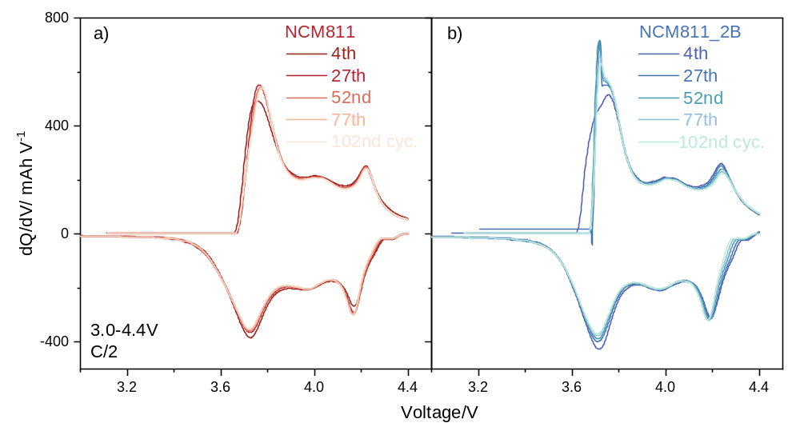
Fig.S6 dQ/dV curve of NCM811 and BNCM811_2B during cycling stability.
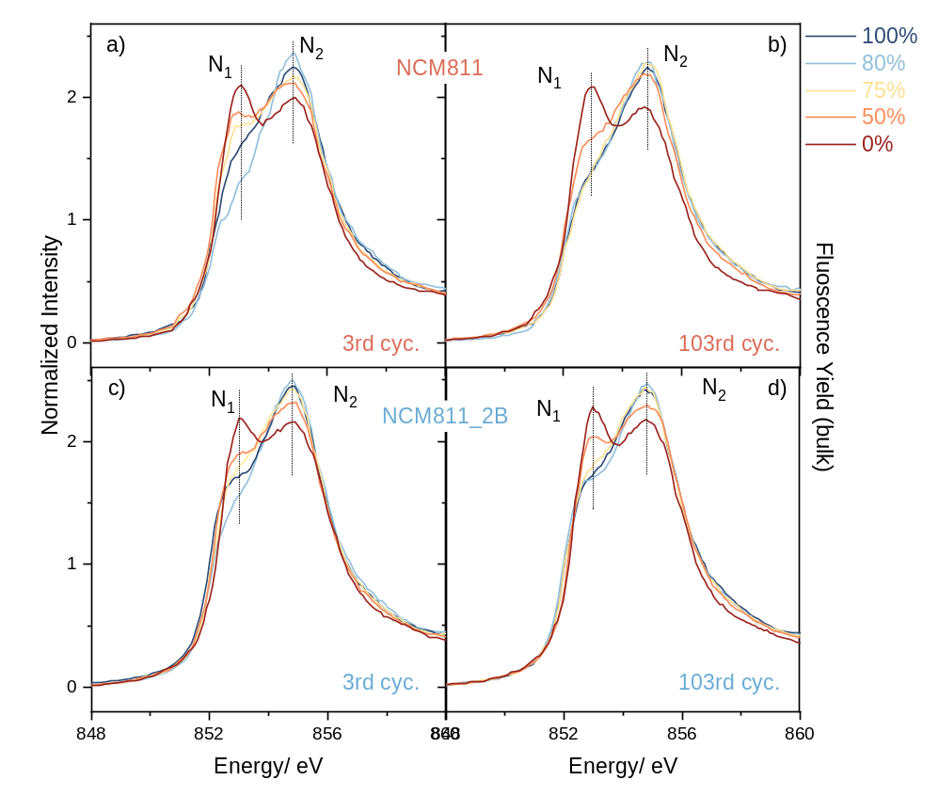
Fig.S7 NEXAFS data of cycled samples on Ni L edge with 0%, 50%, 75%, 80%, and 100% states of charges (SOCs) in fluorescence yield. Cycled NCM811 a) at 3rd cycle (cyc.), b) at 103rd cyc. Cycled NCM811_2B c) at 3rd cycle (cyc.), d) at 103rd cyc.

Tables:
To give the reader a better understanding of how the refinement of the data was performed, the following tables give parameters used and obtained upon data processing. R_{Bragg} values are given for the most important refinements. They reflect the difference between the observed and calculated structure factors normalized to the observed values, multiplied by their multiplicity. Note that Rp values are not actively included to minimize mismatches in the refinement. The table also includes the estimated standard deviations of lattice parameters obtained from the Rietveld refinement analysis. These standard deviations have been multiplied by correlated residuals^{3,4}.

Tab.S1 Refinement analysis results of XRD (Cu source) for NCM811_xB (x= 0, 0.5, 1, 2, 5%)
NCM811_xB | a = b lattice parameter | c lattice parameter | R_{Bragg}
0B | 2.8675(1) | 14.1955(11) | 2.01
0.5B | 2.8700(1) | 14.1956(11) | 2.82
1B | 2.8721(1) | 14.1963(12) | 1.63
2B | 2.8734(1) | 14.1967(10) | 1.71
5B | 2.8746(1) | 14.1985(11) | 1.23

Tab.S2 Crystallographic parameters used in this work.
LiNi_{0.8}Co_{0.1}Mn_{0.1}O₂ Cell parameters⁵
Space group: R-3mH, a = b = 2.8645 Å, c = 14.161 Å, gamma = 120°, V = 100.63 Å³, Z = 3
Atomic positions
Name | site | x | y | z | Fract.
Li1 | 3b | 0.00 | 0.00 | 0.50 | 0.98(1)
Ni1 | 3b | 0.00 | 0.00 | 0.50 | 0.02(1)
Li2 | 3a | 0.00 | 0.00 | 0.00 | 0.05(2)
Ni2 | 3a | 0.00 | 0.00 | 0.00 | 0.75(2)
Co1 | 3a | 0.00 | 0.00 | 0.00 | 0.10
Mn1 | 3a | 0.00 | 0.00 | 0.00 | 0.10
O1 | 6c | 0.00 | 0.00 | 0.259(1) | 1.00
LiNi_{0.8}Co_{0.1}Mn_{0.1}O₂B_{0.05} Cell parameters
Space group: R-3mH, a = b = 2.8645 Å, c = 14.161 Å, gamma = 120°, V = 100.63 Å³, Z = 3
Atomic positions
Name | site | x | y | z | Fract.
Li1 | 3b | 0.00 | 0.00 | 0.50 | 0.98(1)
Ni1 | 3b | 0.00 | 0.00 | 0.50 | 0.02(1)
Li2 | 3a | 0.00 | 0.00 | 0.00 | 0.05(2)
Ni2 | 3a | 0.00 | 0.00 | 0.00 | 0.75(2)
Co1 | 3a | 0.00 | 0.00 | 0.00 | 0.10
Mn1 | 3a | 0.00 | 0.00 | 0.00 | 0.10
O1 | 6c | 0.00 | 0.00 | 0.259(1) | 1.00
B1 (tetrahedral site) | 6d | 0.00 | 0.00 | 0.140 | 0.05

Reference:
1 Stephens, P. W. Phenomenological model of anisotropic peak broadening in powder diffraction. Journal of Applied Crystallography 32, 281-289 (1999).
2 Rodriguez-Carvajal, J., Fernandez-Diaz, M. & Martinez, J. Neutron diffraction study on structural and magnetic properties of La2NiO4. Journal of Physics: Condensed Matter 3, 3215 (1991).
3 Bérar, J.-F. & Lelann, P. ESD's and estimated probable error obtained in Rietveld refinements with local correlations. Journal of applied crystallography 24, 1-5 (1991).
4 Berar, J. Data optimization and propagation of errors in powder diffraction,“Acc. Pow. Diff II”, NIST sp. Pub 846, 63 (1992).
5 Arai, H., Tsuda, M. & Sakurai, Y. Lithium nickelate electrodes with enhanced high-temperature performance and thermal stability. Journal of power sources 90, 76-81 (2000).

