Table 3: In silico identified potential inhibitors from medicinal plants against SARS-CoV-2 main protease.
S. No. | Medicinal Plants | Phytoconstituents | Structure | Docking Energy | Reference
 | Aloe vera | Feralolide | 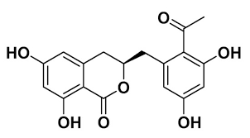 | −7.9 Kcal/mol | [57]
 | Aloe vera | Aloesin | 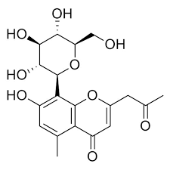 | −7.7 Kcal/mol | [57]
 | Andrographispaniculata | Andrographolide | 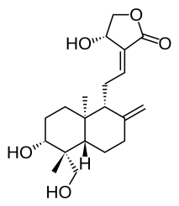 | −3.09 Kcal/mol | [58]
 | Cephalotaxuswilsoniana | Taiwanhomoflavone A | 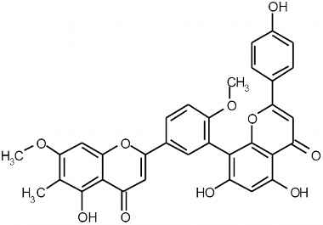 | -9.6 Kcal/mol | [59]
 | Lactucavirosa | Lactucopirin | 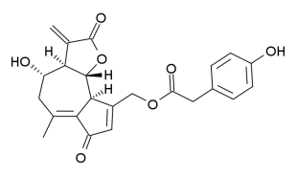 | -8.2 Kcal/mol | [60]
 | Broussonetiapapyrifera | Papyriflavonol A | 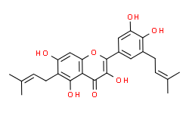 | -7.9 Kcal/mol | [61]
 | Broussonetiapapyrifera | 3′-(3-methylbut-2-enyl)-3′,4′,7-trihydroxyflavane | 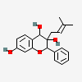 | -8.2 Kcal/mol | [61]
 | Broussonetiapapyrifera | Broussoflavan A | 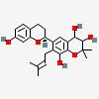 | -7.8 Kcal/mol | [61]
 | Broussonetiapapyrifera | Kazinol F | 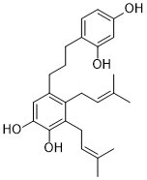 | -8.1 Kcal/mol | [61]
 | Broussonetiapapyrifera | Kazinol J | 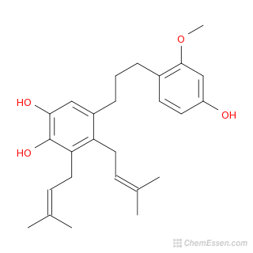 | -8.0 Kcal/mol | [61]
 | Calendula officinals | Rutin | 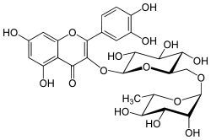 | -8.8 Kcal/mol | [62]
 | Calendula officinals | Isorhamnetin-3-O-β-D | 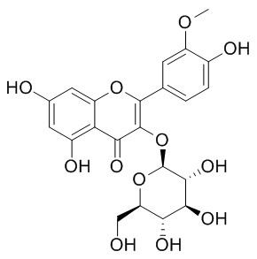 | -8.7 Kcal/mol | [62]
 | Calendula officinals | Calendoflaside | 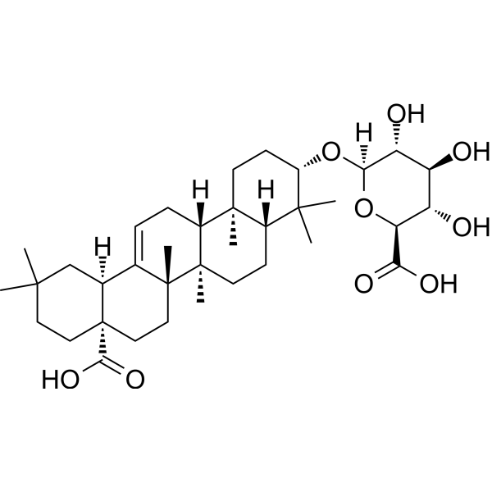 | -8.5 Kcal/mol | [62]
 | Cinnamon Spp. | Tenufolin | 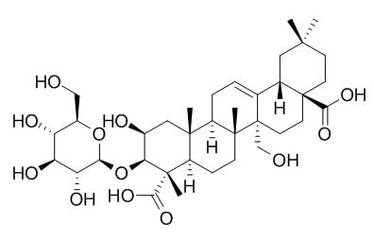 | −8.8 Kcal/mol | [63]
 | Clerodendrum spp. | Taraxerol | 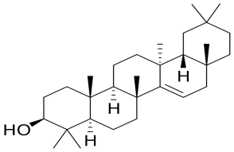 | −8.4 Kcal/mol | [64]
 | Clerodendrum spp. | Friedelin | 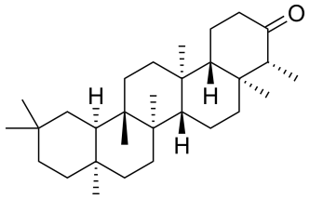 | −7.9 Kcal/mol | [64]
 | Clerodendrum spp. | Stigmasterol | 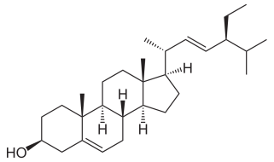 | −7.7 Kcal/mol | [64]
 | Strychnosusambarensis | 10-Hydroxyusambarensine | 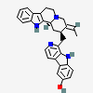 | −10.0 Kcal/mol | [65]
 | Strychnosusambarensis | Strychnopentamine | 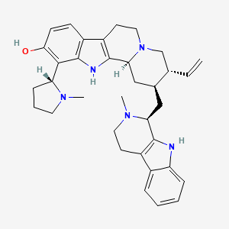 | −8.2 Kcal/mol | [65]
 | Strychnosusambarensis | Isostrychnopentamine | 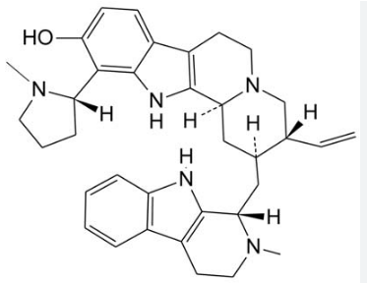 | −8.1 Kcal/mol | [65]
 | Cryptolepissanguinolenta | Cryptoquindoline | 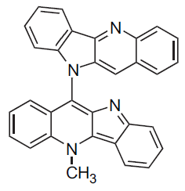 | −9.7 Kcal/mol | [65]
 | Cryptolepissanguinolenta | Cryptospirolepine | 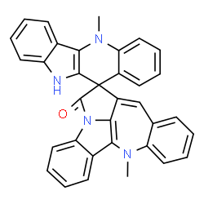 | −9.2 Kcal/mol | [65]
 | Cryptolepissanguinolenta | Isocryptolepine | 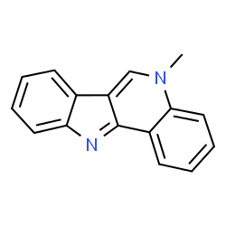 | −8.5 Kcal/mol | [65]
 | Tecleatrichocarpa | Normelicopicine | 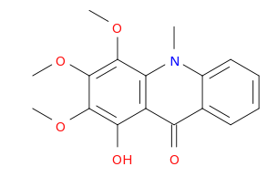 | −8.1 Kcal/mol | [65]
 |  | 5’-0-O-Demethyl-dioncophylline A | 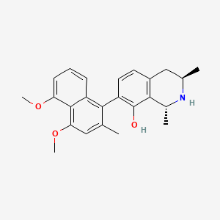 | −8.0 Kcal/mol
 | Curcuma longa | (1E,6E)-1,2,6,7-tetrahydroxy-1,7-bis(4-hydroxy-3-methoxyphenyl)hepta-1,6-diene-3,5-dione) | 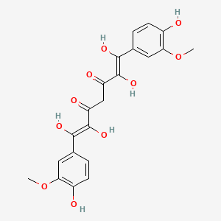 | −9.08 Kcal/mol | [66]
 | Curcuma longa | (4Z,6E)‐1,5‐dihydroxy‐1,7‐bis(4‐hydroxyphenyl)hepta‐4,6‐dien‐3‐one | 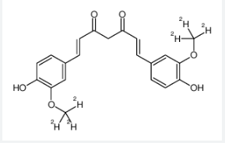 | −8.07 Kcal/mol | [66]
 | Mauritiaflexuosa | 13-cis-β-carotene | 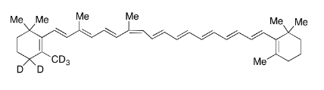 | −10.23 Kcal/mol | [67]
 | Mauritiaflexuosa | α-carotene | 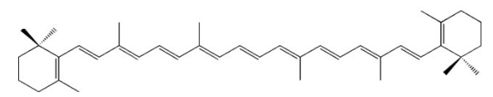 | −8.34 Kcal/mol | [67]
 | Ocimum sanctum | Vicenin | 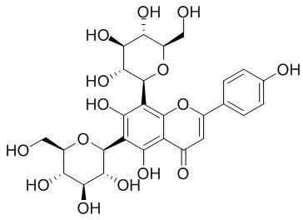 | −8.97 Kcal/mol | [55]
 | Ocimum sanctum | Isorientin 4′-O-glucoside 2″-O-p-hydroxybenzoagte | 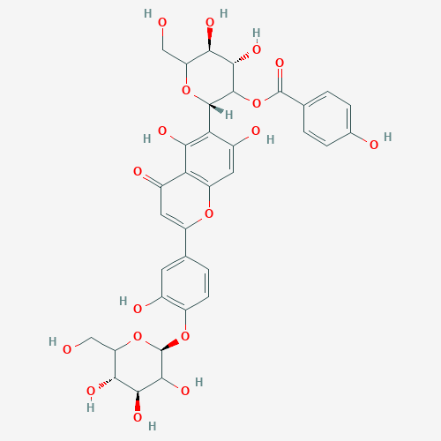 | −8.55 Kcal/mol | [55]
 | Ocimum sanctum | Ursolic acid | 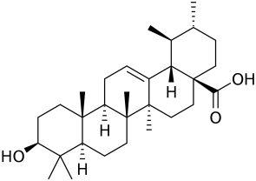 | −8.52 Kcal/mol | [55]
 | Tinosporacordifolia | Tinocordiside | 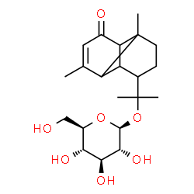 | −8.10 Kcal/mol | [55]
 | Withaniasomnifera | Withanoside II | 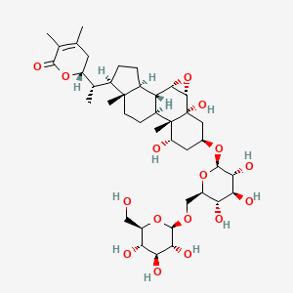 | −11.30 Kcal/mol | [54]
 | Withaniasomnifera | Withanoside IV | 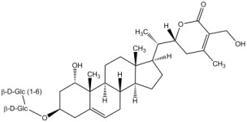 | −11.02 Kcal/mol | [54]
 | Withaniasomnifera | Withanoside V | 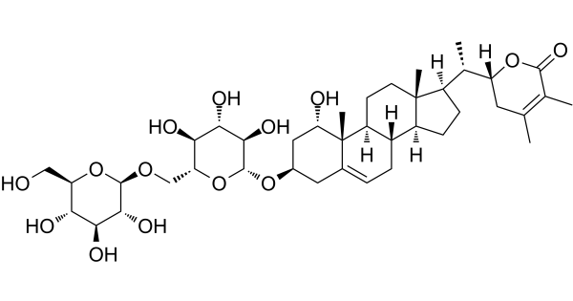 | −8.96 Kcal/mol | [54]
 | Withaniasomnifera | Sitoindoside IX | 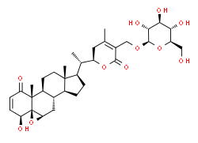 | −8.37 Kcal/mol | [54]
 | Uncariatomentosa | Speciophylline | 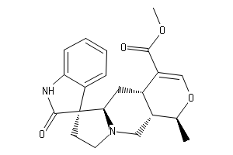 | −8.1 Kcal/mol | [39]
 | Uncariatomentosa | Cadambine | 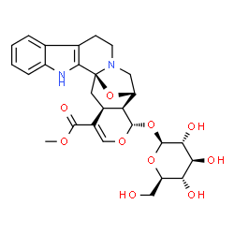 | −8.6 Kcal/mol | [39]
 | Uncariatomentosa | Proanthocyanidin B2 | 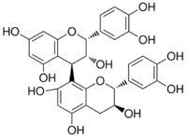 | −9.2 Kcal/mol | [39]
 | Allium sativum | Alliin | 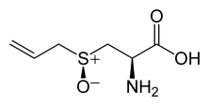 | −12.61 Kcal/mol | [68]
 | Justiciaadhatoda | Anisotine | 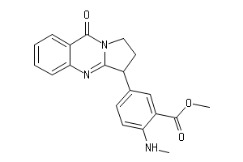 | −7.9 Kcal/mol | [69]

