Supplementary material

Vegetation resistance to aridity thresholds depends on local environmental conditions in global drylands

Christin Abel^{1*} (0000-0001-8938-4124), Fernando T. Maestre^{2,3} (0000-0002-7434-4856), Miguel Berdugo⁴ (0000-0003-1053-8907), Torbern Tagesson^{1,5} (0000-0003-3011-1775), Abdulhakim M. Abdi^{1,6} (0000-0001-6486-8747), Stephanie Horion¹ (0000-0001-6716-1333), Rasmus Fensholt¹ (0000-0003-3067-4527)

¹ University of Copenhagen, Department of Geosciences and Natural Resource Management
² Instituto Multidisciplinar para el Estudio del Medio “Ramon Margalef”, Universidad de Alicante, Carretera de San Vicente del Raspeig s/n, Alicante, Spain
³ Departamento de Ecología, Universidad de Alicante, Carretera de San Vicente del Raspeig s/n, Alicante, Spain
⁴ Complutense University of Madrid, Department of Biodiversity, Ecology and Evolution
⁵ Lund University, Department of Physical Geography and Ecosystem Science
⁶ Lund University, Centre for Environmental and Climate Science

*Corresponding author, christin.abel@ign.ku.dk

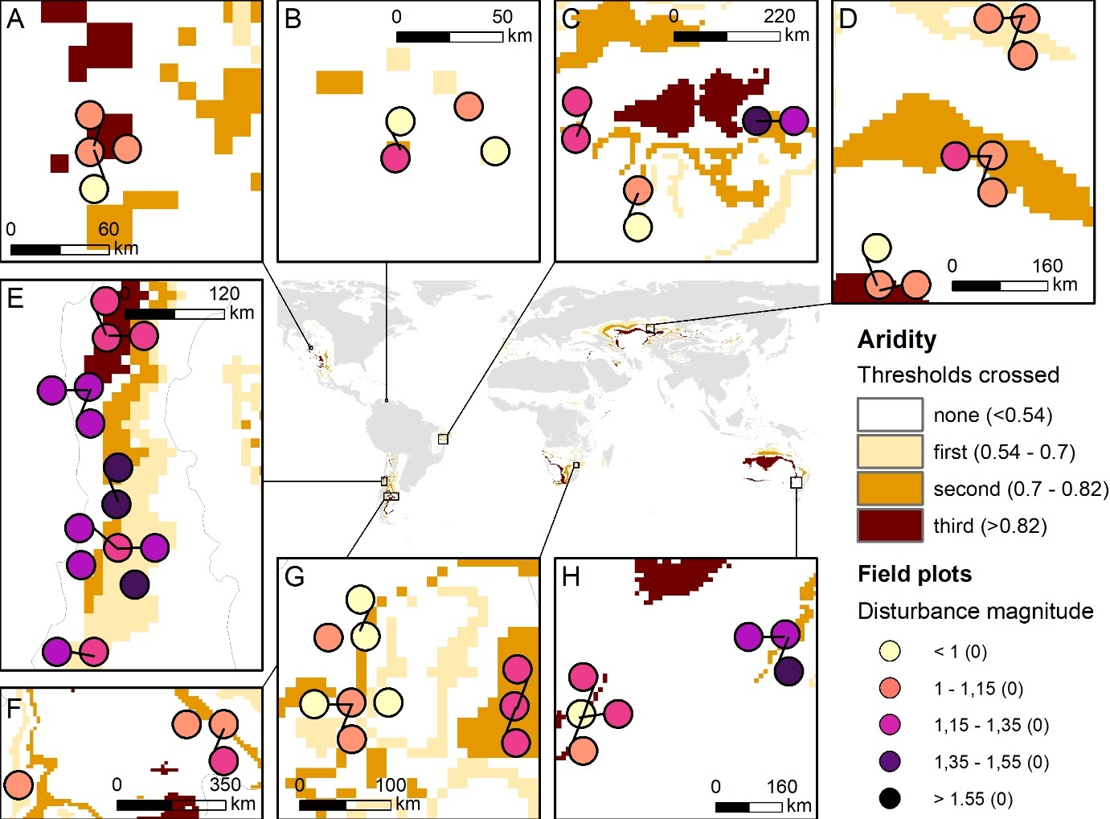
Figure S1. Disturbance magnitude (inverse of vegetation resistance) across sites (A - H) and areas where an aridity threshold has been crossed between 2000 and 2022 (sand, orange and dark red colors relate to the first, second, and third threshold).

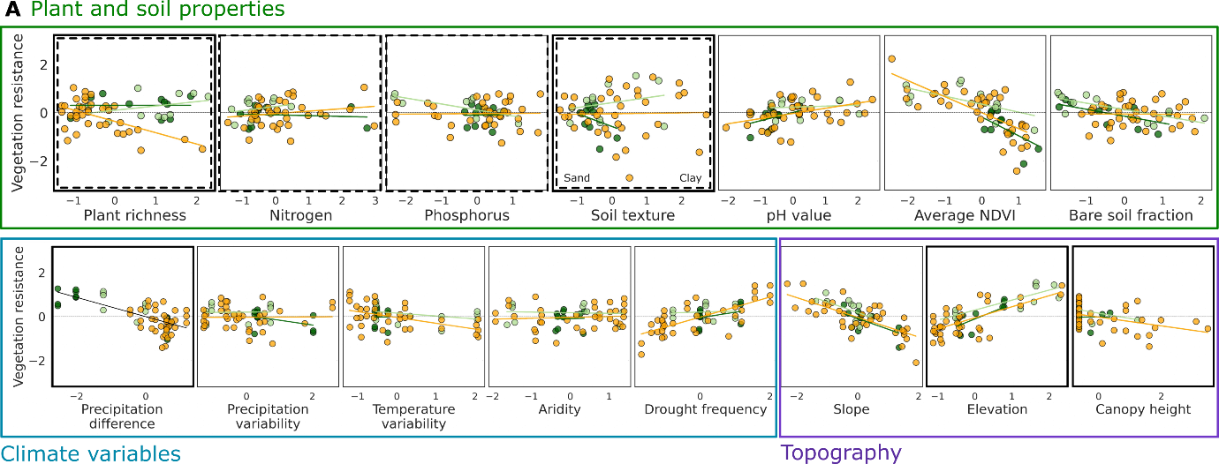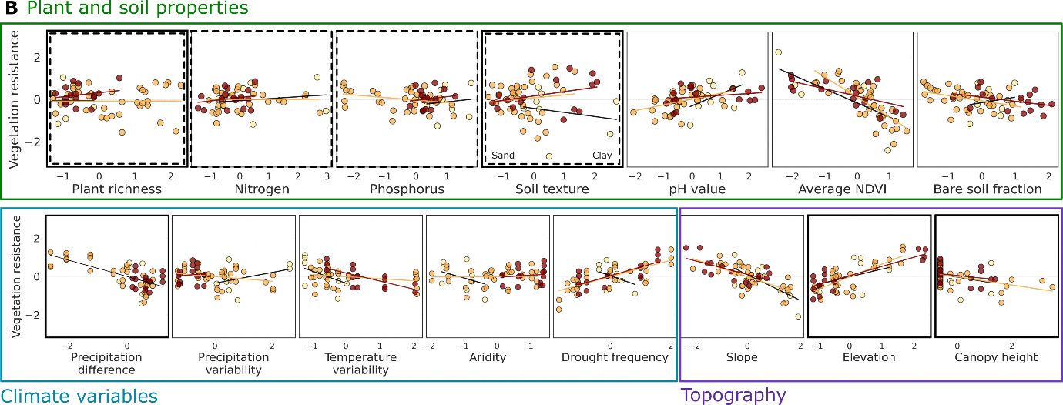
Figure S2. Relationship of vegetation resistance (y-axis) on individual variables (x-axes). A) in light green, orange, and dark green we show sites that were characterized as grassland, shrubland, and forest. B) in sand, orange, and dark red we show sites where the first, second or third aridity threshold has been crossed respectively.

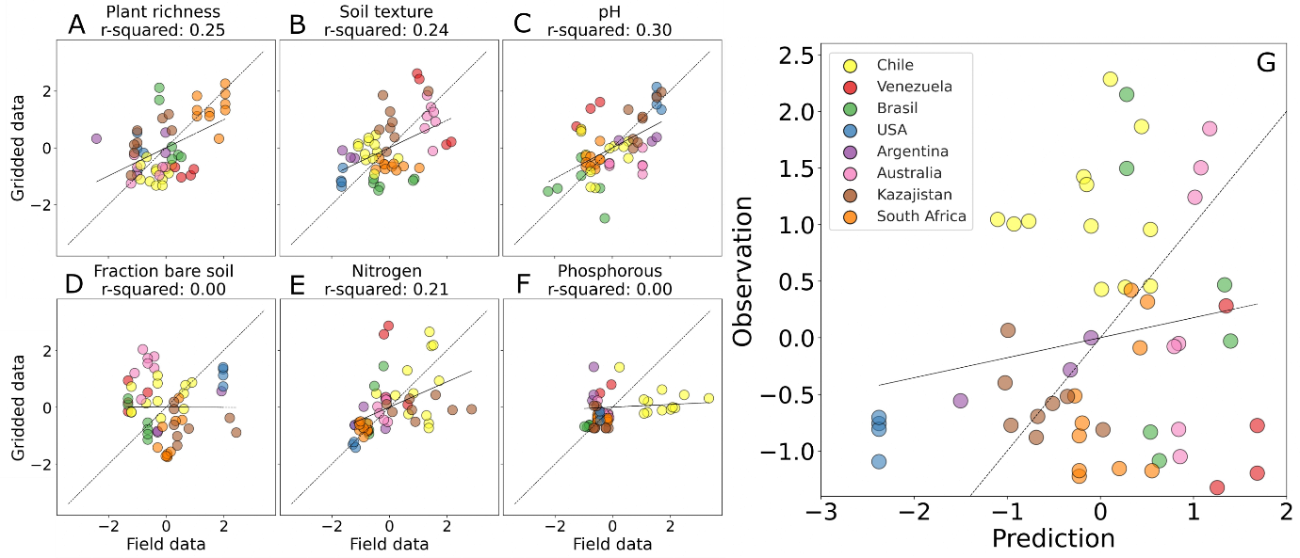
Figure S3. Relationship between measured field data and available gridded datasets (at 1000m spatial resolution) for biotic and abiotic variables (A - F) important for vegetation resistance when crossing aridity thresholds. Overall fit of predicted vegetation resistance potential based on gridded data and observed resistance at local scale for all field sites (G).

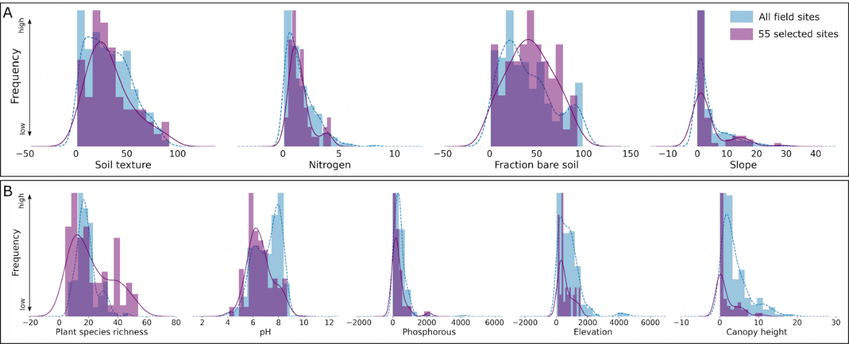
Figure S4 Distribution of data within the 55 selected field sites (purple) and all available field sites (blue) for biotic and abiotic variables.

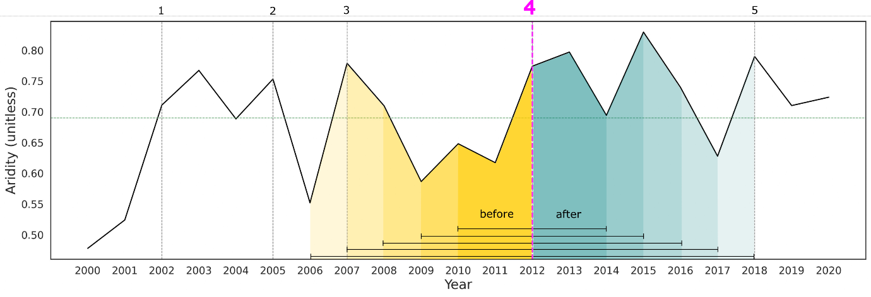
Figure S5. Determination of timing of a threshold crossing. Here, the second threshold was crossed (at 0.7 aridity; horizontal dashed line) considering the beginning and end of the time series. Vertical dashed lines represent all the times when the threshold was crossed (1 – 5). Within moving windows of two to six years, the difference of average aridity values before and after each crossing was calculated. We retain the year of crossing with the largest difference in aridity across window sizes and potential crossings (pink vertical line).

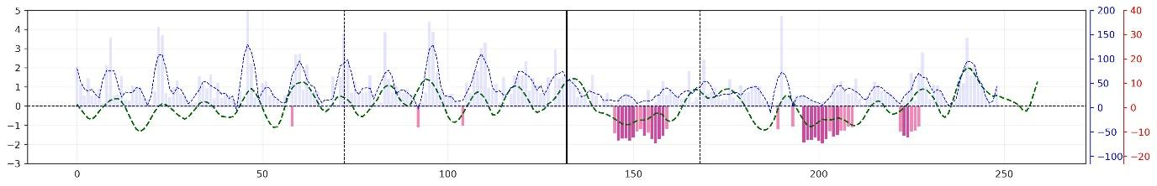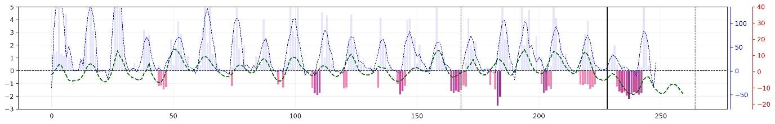Figure S6. Monthly time series of standardized NDVI (green), precipitation (blue), and SPEI reflecting drought intensities (shades of purple) from 2000 to 2022 for a site in Brazil that has no drought history (a) and for a site in Chile that has experienced recurrent droughts before crossing a threshold (b). The black solid line indicates the time when an aridity threshold was crossed. Black dashed lines mark five years before and three years after the threshold has been crossed.

Table S1. Results of the model selection procedure for vegetation resistance when crossing aridity thresholds, showing the averaged results for the best models. We indicate predictor estimates, standard errors and P values, the variable importance (the number of times each predictor was selected in the set of best models divided by all models), and variance inflation factors (VIF). The VIF values obtained were below 5 in all cases, hence multicollinearity was not problematic. Nitrogen = total nitrogen, Phosphorous = total phosphorous, pH = soil pH, and Soil texture = soil clay content.
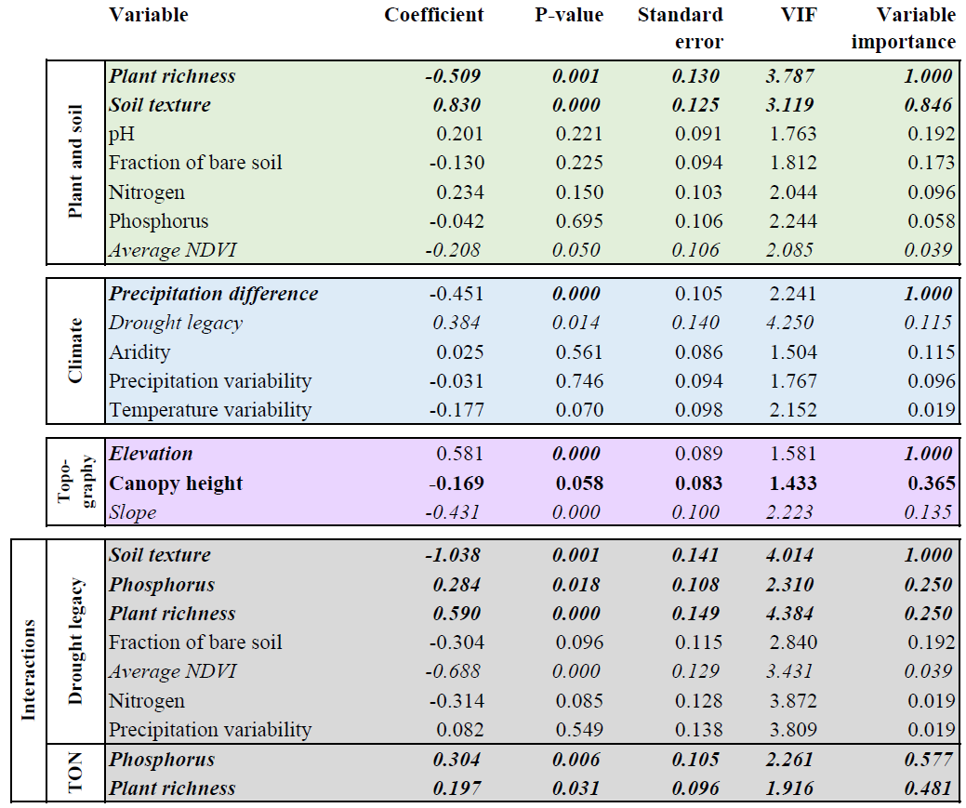

Table S2. Gridded input data used in the model parameterization. Presented is the native spatial resolution and data source.
Variables | Gridded data | Spatial resolution | Data source
Plant richness | Vascular plant alpha-diversity | 0.05 degree | https://doi.org/10.25829/idiv.3506-p4c0mo
Total nitrogen | Total nitrogen | 250m | https://doi.org/10.17027/isric-soilgrids.f0797a68-1692-11ea-a7c0-a0481ca9e724
Soil texture (clay content) | Clay content | 250m | https://doi.org/10.17027/isric-soilgrids.713396f7-1687-11ea-a7c0-a0481ca9e724
pH | Soil pH in H2O | 250m | https://doi.org/10.17027/isric-soilgrids.713396fd-1687-11ea-a7c0-a0481ca9e724
Phosphorous | Soil plant available phosphorus | 0.05 degree | https://doi.org/10.1038/s41597-023-02022-4
Precipitation | ERA5 total precipitation | 0.1 degree | Hersbach, H., Bell, B., Berrisford, P., Biavati, G., Horányi, A., Muñoz Sabater, J., Nicolas, J., Peubey, C., Radu, R., Rozum, I., Schepers, D., Simmons, A., Soci, C., Dee, D., Thépaut, J-N. (2023): ERA5 monthly averaged data on single levels from 1940 to present. Copernicus Climate Change Service (C3S) Climate Data Store (CDS), DOI: 10.24381/cds.f17050d7 (Accessed on 29-06-2023)
Temperature | ERA5 2m temperature | 0.1 degree
Aridity | ERA5 total precipitation | 0.1 degree
Aridity | ERA5 potential evapotranspiration | 0.1 degree | Singer, M. B., Asfaw, D. T., Rosolem, R., Cuthbert, M. O., Miralles, D. G., MacLeod, D., Quichimbo, E. A., & Michaelides, K. (2021). Hourly potential evapotranspiration at 0.1° resolution for the global land surface from 1981-present. Scientific Data, 8(1), 224. https://doi.org/10.1038/s41597-021-01003-9
Vegetation productivity | NDVI based on Landsat | 0.03 degree | https://developers.google.com/earth-engine/datasets/catalog/landsat
Fraction of bare soil | Vegetation cover fraction | 0.05 degree | Song, X.-P., Hansen, M. C., Stehman, S. v, Potapov, P. v, Tyukavina, A., Vermote, E. F., & Townshend, J. R. (2018). Global land change from 1982 to 2016. Nature, 560(7720), 639–643. https://doi.org/10.1038/s41586-018-0411-9
Drought legacy | SPEI drought index | 0.5 degree | https://spei.csic.es/
Elevation | MERIT Digital Elevation Model | 90m | Yamazaki D., D. Ikeshima, R. Tawatari, T. Yamaguchi, F. O'Loughlin, J.C. Neal, C.C. Sampson, S. Kanae & P.D. Bates. A high accuracy map of global terrain elevations. Geophysical Research Letters, vol.44, pp.5844-5853, 2017. doi:10.1002/2017GL072874
Slope | MERIT Digital Elevation Model | 90m
Canopy height | ETH Global Sentinel-2 10m Canopy Height (2020) | 10m | (Lang et al., 2023)

