Extended data and Figures
Present-day mass loss rates are a precursor for West Antarctic Ice Sheet collapse

Tim van den Akker¹, William H. Lipscomb², Gunter R. Leguy², Jorjo Bernales¹, Constantijn J. Berends¹, Willem Jan van de Berg¹, Roderik S.W. van de Wal^{1,3}

¹Institute for Marine and Atmospheric Research Utrecht, Utrecht University, Netherlands
​​²Climate and Global Dynamics Laboratory, National Center for Atmospheric Research, Boulder, CO, USA
³Department of Physical Geography, Utrecht University, Netherlands

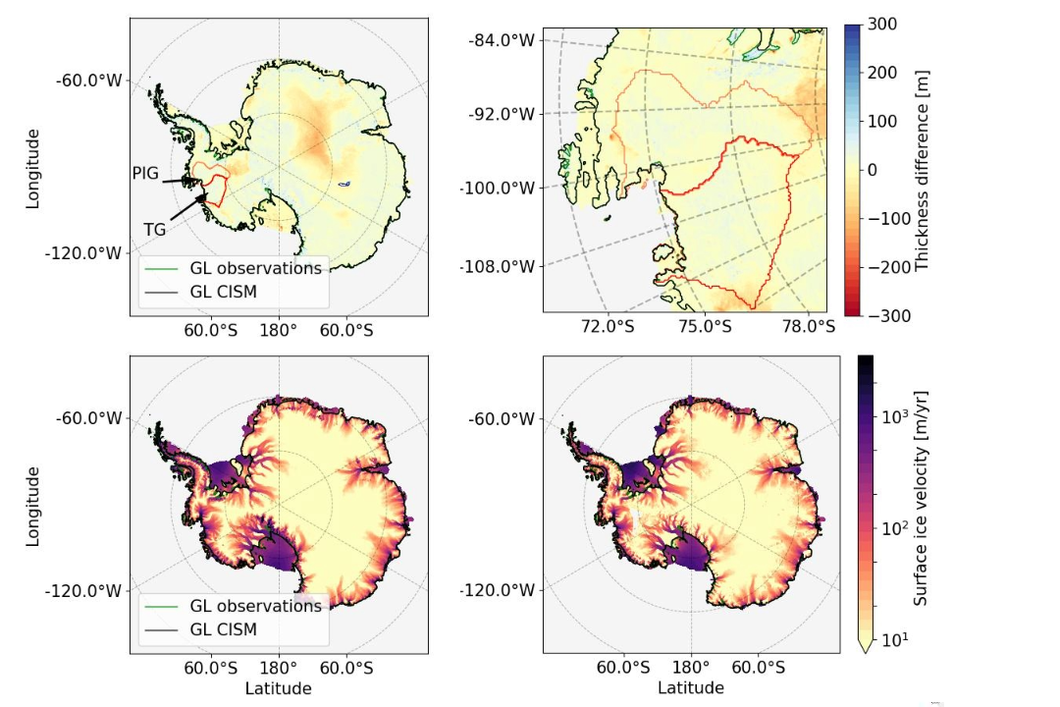
Figure S1. Modelled present-day state with the transient initialisation. (Top) Ice thickness difference between final state of the transient initialization and observations for all of Antarctica (RMSE = 34 m, left) and the AB region (RMSE= 19.3 m) (right). Black contour lines represent the modelled grounding line. The observed grounding line (green) is only visible at places where the modelled and observed grounding line deviate in position, for example at the PIG grounding line. Red and orange contours are drawn around the TG and PIG basins, respectively. (Bottom) modelled (left) and observed [1] (right) ice surface velocitie (RMSE AIS total = 158 m/yr, AB = 141.6 m/yr, AB-shelves only = 288.3 m/yr).

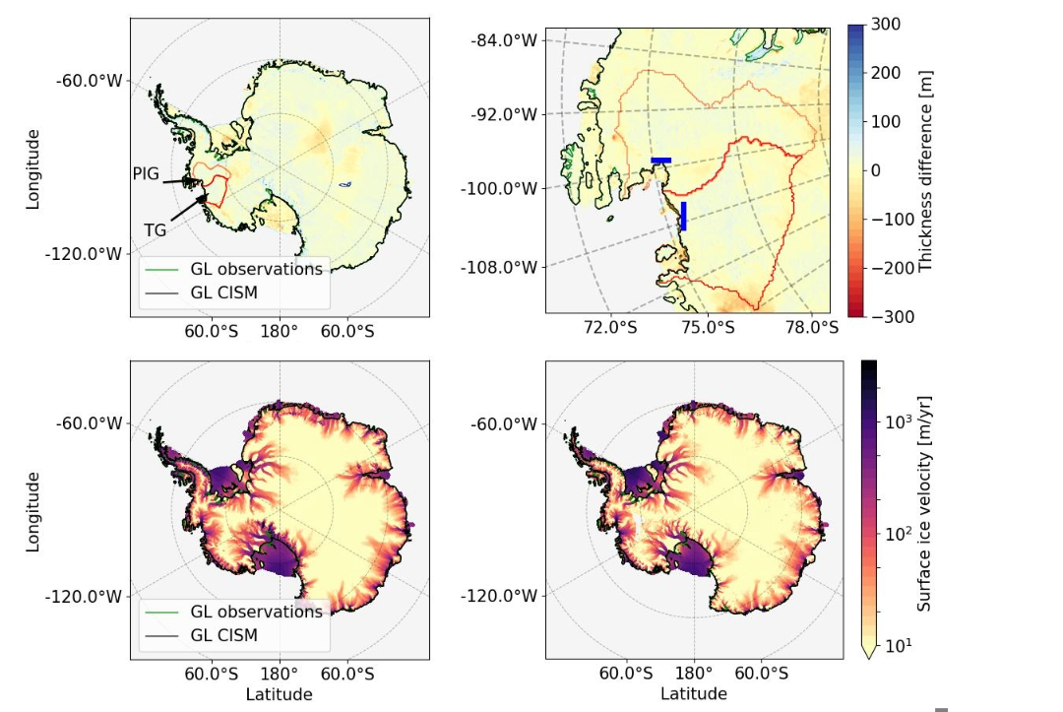

Figure S2. Modelled present-day state, same as Fig S1 but for the equilibrium initialisations. (top) The thickness RMSE is 31 m for the full domain and 24.4 m for the AB. The blue lines in TG and PIG show the locations of the cross sections used in Figure S3, perpendicular to the main flow lines (bottom) Modelled (left) and observed [1] (right) ice surface velocitie (RMSE is 146 m/yr for the full domain, 215 m/yr for AB, and 456 m/yr for AB-shelves only).

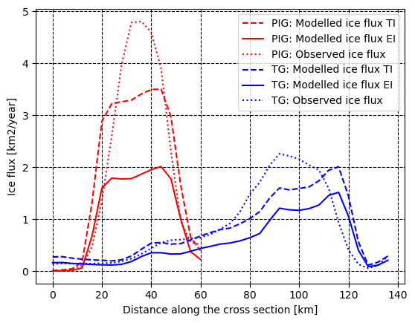

Figure S3. Fluxes across the blue lines shown in Figure S2. Flux across the cross sections in figure S2 for the Transient Initialization (TI), Equilibrium Initialization (EI) and the observations [2], for PIG (red) and TG (blue). Distance along the cross section is for PIG from left to right and for TG top to bottom shown in blue stripes in Figure S2. The sum of the fluxes for the TG cross section are: 19.3 (EI), 27.6 (TI) and 28.3 (Obs) km² yr⁻¹, the sum of the fluxes for the PIG cross section are: 17.0 (EI), 30.4 (TI), 31.1 (Obs) ) km² yr⁻¹ .

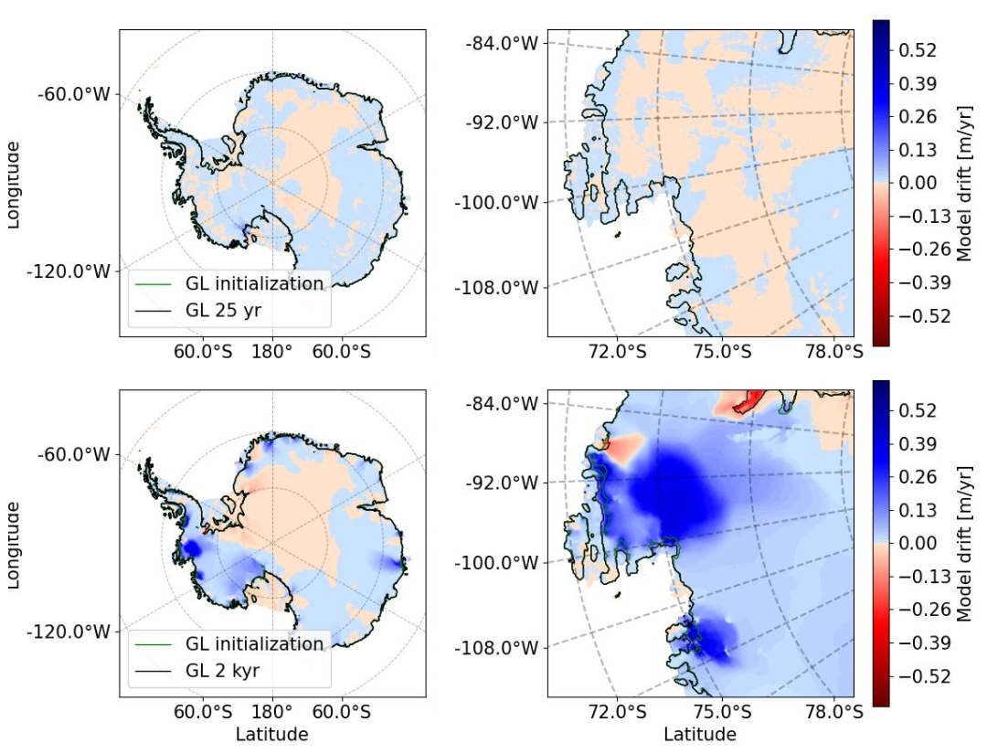
Figure S4. Averaged model drift of the transient simulation. (Top) Mean model drift in the first 25 years after initialization for all Antarctica (left) and the AB region (right). (Bottom) Mean model drift during a continuation of 2 kyr. The modelled grounding line is shown at initialization (green) and after 25 yrs and 2 kyr for respectively the upper and lower panel (black).
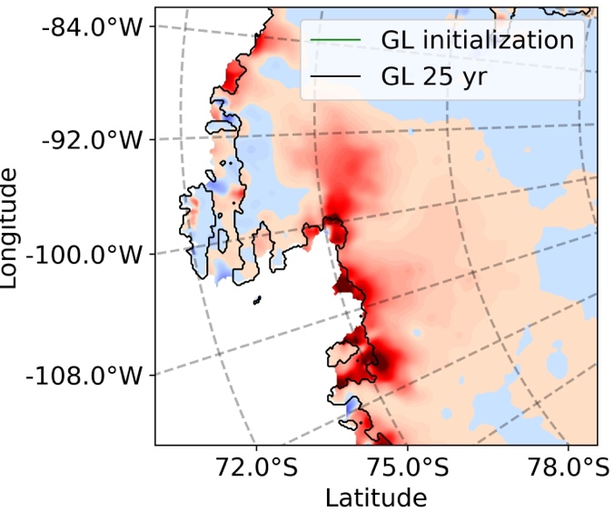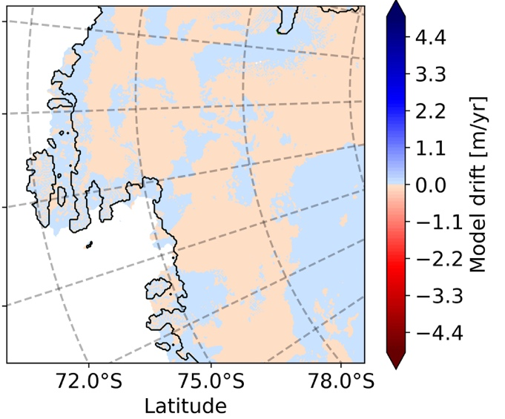
Figure S5. Instantanous model drift in ice thickness compared to the observed mass change rates in the AB region. (Right) Mass change rates of [3]. (Left) Model drift averaged of the first 25 years after the transien initialization.

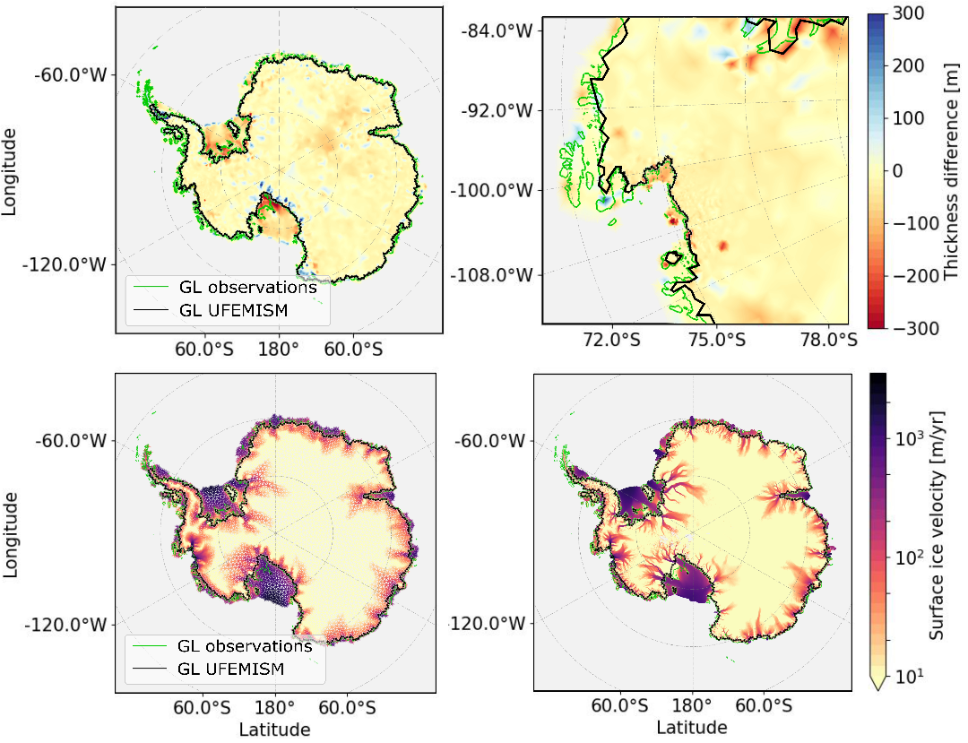
Figure S6 UFEMISM. (Top) Ice thickness difference between the UFEMISM initial state and observations for (left) the AIS and (right) the Amundsen Sea region. The thickness RMSE is 80.3 m for the full domain and 86.88 m for the AB (Bottom) Antarctic ice surface speed (m/yr, log scale) for (left) the end of the UFEMISM initialization procedure (plotted on the triangular mesh) and (right) observation from [1]. RMSE is 209.4 m/yr for the full domain, 147.8 m/yr for AB, and 380.7 m/yr for AB-shelves only).

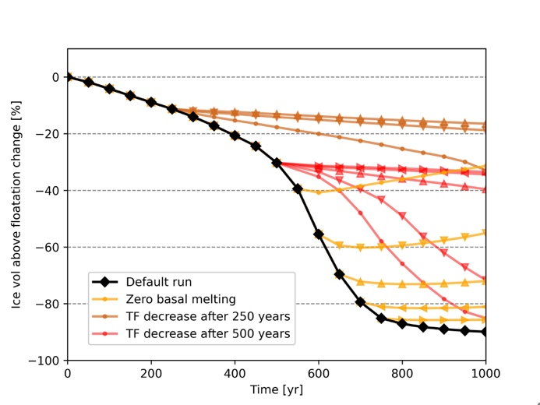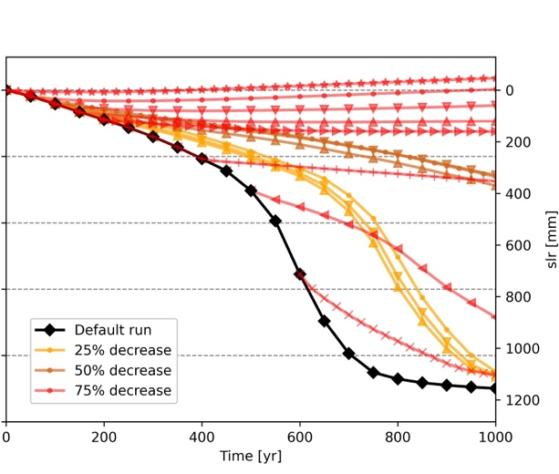

Figure S7. The impact of decreasing basal melt rates on the deglaciation. (left) ) Evolution of ice volume (shown as a percentage compared to the volume available in the initialized state (see Fig S1.) for PIG and TG combined and its as sea-level equivalent on the right y-axis) over 1000 years in experiments with a sudden decrease in basal melt rates. Red lines show where the thermal forcing is instantly decreased after 250 years by 1.5 and 2.5 K (yellow lines) and 1.5, 2, 2.5 and 3 K (brown lines). Red lines indicate runs where the basal melting is instantly switched off after 500, 600, 700 and 800 years. (right) Percentage of the basal melt rates applied: 25% (red), 50% (brown) and 75% (yellow). The 50% and 75% basal melt rate experiments are started at 50, 100 and 150 years, the 25% basal melt rate experiments are started at 0, 50, 100, 150, 200, 400, 500 and 600 years after the start of a transient continuation run.

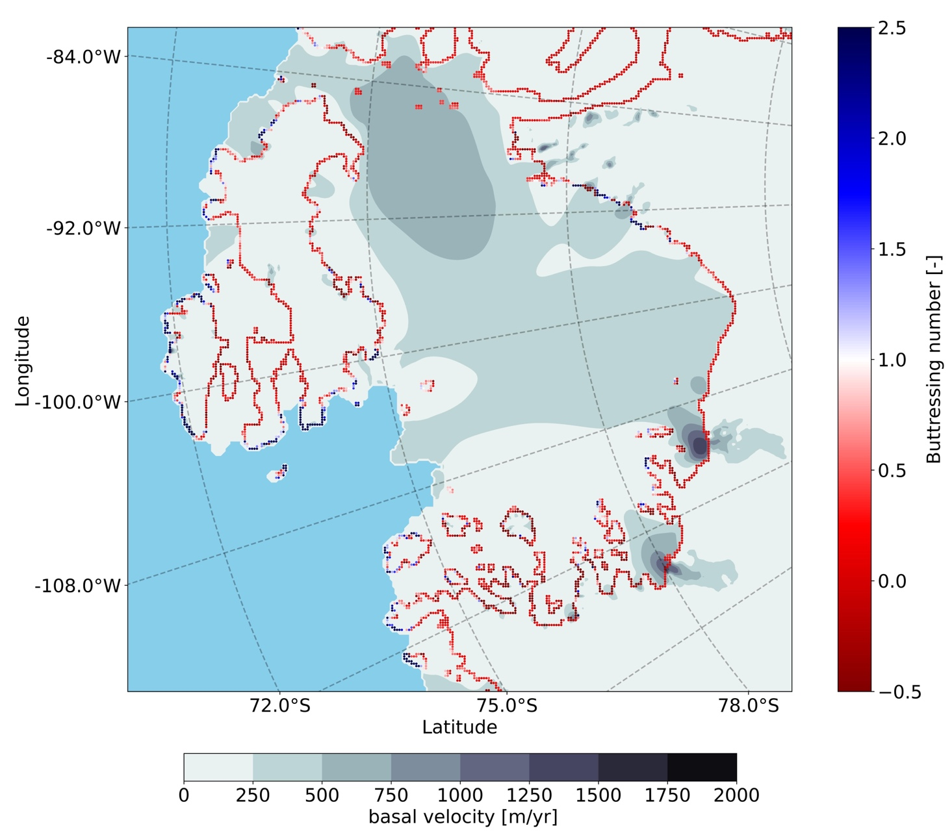
Figure S8. Buttressing number. Buttressing number after the collapse in the default experiment, calculated following [4]. A number below (above) one means that the ice shelf provides more (less) back stress to the upstream grounded ice compared to a column of ocean water with the same thickness.

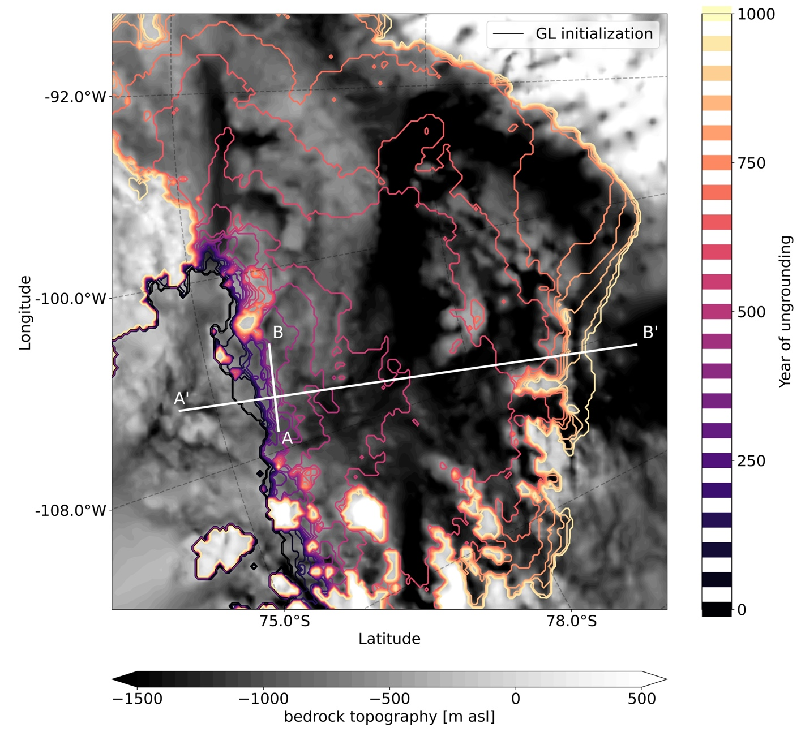
Figure S9 Bedrock profile, the grounding line at different timesteps, the cross section in Figure 1 (A’B’), and the ridge shown in Figure 1 (AB). The bedrock profile (grey) with magma contours showing the grounding line at different years during the default continuation experiment. Contour lines clumped together highlight areas where the grounding line stabilizes for long periods. The short white line (AB) shows the last prominent ridge before the accelerated collapse starts, and the long white semi-horizontal white line (A’B’) shows the location of the cross section plotted in Fig 1c.

Table S1. Description of the sensitivity analysis done in Figure 3. The experiments are listed in the same order as in Table 1.

8km grid, partial melt parameterization
This run tests the sensitivity to grid resolution in combination with a partial melt parameterization (PMP, see [5]) applied at the grounding line. This run has its own initialization.

High basal melt versus thermal forcing
$γ_{0}$ in Eq. 1.5 modulates the relation between ocean temperature and basal melt rate. A higher value means a higher sensitivity of the basal melt rate to temperature changes. Since ocean temperature increases with depth in the Amundsen Sea, melt rates change with depth: a higher (lower) value for $γ_{0}$increases (decreases) the sensitivity of melt rates to the ice draft depth, thereby speeding up (slowing down) ice retreat. We use $γ_{0}$= 50,000 m yr⁻¹, the largest value reported in [6].

This run is done with the default initialization (with $γ_{0}$= 30,000 m yr⁻¹ ), but the ocean temperatures are recalculated at $t=0$, so that the basal melt rates at $t=0$are unchanged from the initialization with $γ_{0}$= 30,000 m yr⁻¹ .

Larger flow factor (softer ice)
Glen’s flow law (see Eq. S1, with $τ_{i,j}$, $A\left(T^{*}\right)$ , $ϵ_{e}$ and$ϵ_{i,j}$ respectively the deviatoric stress, the temperature dependent rate factor, the effective strain rate and the strain rate) is multiplied by a factor E, referred to as the flow enhancement factor. A value higher (lower) than 1 means that the effective viscosity of the ice is smaller (larger) for given strain rates, that the ice is generally softer (stiffer), and the velocities are higher (lower). The default values are 1.0 for grounded ice (no correction) and 0.5 for floating ice. In this sensitivity run, we set E = 1.5 for grounded ice and E = 1 for floating ice. A new initialized state is obtained.

 | $$τ_{i,j}=E*A{\left(T^{*}\right)}^{\frac{-1}{n}}ϵ_{e}^{\frac{1-n}{n}}ϵ_{i,j}$$ | (S1)

No ocean connection
For ice resting on bedrock below sea level, we decrease the effective pressure based on the height above floatation to account for a possible connection to the ocean; see Eq. 1.3 and [7, 8]. In this simulation we set p = 0 (instead of the default, p = 0.5), implying overburden pressure everywhere. A new initialized state is obtained.

Schoof basal sliding law
We apply the Schoof basal sliding law described in [7] instead of the regularized Coulomb law (Eq 1.1). We use the original initialization, but we locally prescribe friction coefficients in the Schoof law to match the basal friction from the regularized Coulomb law (Eq 1.1).

Powerlaw
This run is similar to the one previously described, but with a new initialization where we tune for a constant in the powerlaw (a multiplicative factor similar to $C_{c}$ in Eq 1.1, see Eq. S2), to test if the slightly different geometry and inversion impact the continuation. The powerlaw exponent m is set to 1/3). A new initialized state is obtained.

$$τ_{b}=C_{p}u_{b}^{m}$$ | (S2)

Thermal forcing capped at the maximum found at the grounding line
We determine the thermal forcing of PIG and TG at the present-day grounding line, and the maximum value found in those basins (respectively 3.73 K and 4.1 K) is used as an upper limit for the thermal forcing in newly ungrounded cells, to test whether the interpolation of thermal forcing under present-day grounded ice is affecting the collapse.

Relaxed asthenosphere, relaxation time = 3000 yr
This run is done with an ELRA GIA model [9], with a relaxation period of 3000 yr. This causes bedrock uplift rates of ~1 cm/yr. The original initialization is used, so we assume isostatic equilibrium at the end of our default initialized state.

Powerlaw, original initialization
This run is done with a classical powerlaw relation as in Eq. S2 between basal velocities and basal sliding (with an exponent m = 1/3). The original initialization is used, but the tuned parameter in the default sliding law is modified in such a way that at $t=0$, the powerlaw and the default sliding law give the same basal friction.

SMB increase by 20%
The SMB over Antarctica is expected to increase with increasing temperatures in the future, so in this run we instantly increase the SMB by 20% at the start of the default continuation run. The original initialization is used.

Smaller flow factor (stiffer ice)
We apply a flow factor of 0.25 for floating ice and 0.5 for grounded ice. A new initialized state is obtained.

Mass change rates only applied on the shelves
We apply the satellite-observed mass change rates only for floating ice, and not for grounded ice, during the transient spin-up. This results in higher values of the friction parameter C_{c} in regions where the ice is thinning.

8km-grid, floatation condition melt parameterization
We test the Floatation Condition Melt Parameterization (FCMP, see [5]), where melt is applied only to cells whose centre is floating. This gives a step function in basal melt rates, compared to the smoothly changing rates in the PMP scheme. We run at 8km resolution, with a new initialized state.

Reduce basal melt rates after 50 years by 25%
We instantly decrease the calculated basal melt rates by 25% after running 50 years in the continuation run. The original initialization is used.

Floatation condition melt parameterization
Similar to the FCMP on 8-km run, but run at 4-km resolution. A new initialization is used.

ELRA isostasy, relaxation time = 100 yr
Similar to Relaxed asthenosphere, relaxation time = 3000 yr, but now with a relaxation time of 100 years. This produces uplift rates exceeding 50 cm/yr. The original initialization is used.

Full ocean connection, p = 1
Similar to p = 0, new initialization, but in this case with a full ocean connection (p = 1). A new initialization is used.

Low basal melt versus thermal forcing
Similar to High basal melt versus thermal forcing, but with $γ_{0}$=10,000, close to the lowest value tested in [6]. We use the original initialization and recalculate the ocean temperatures so the basal melt rates at t = 0 match those of the default run.

Decrease basal melt rates after 50 years by 50%
Similar to Decrease basal melt rates after 50 years by 25%, but now we halve the basal melt rates instantly after 50 years. The original initialization is used.

No-melt parameterziation
For this run we apply the No Melt Parameterization [5], where no basal melting is applied in partly floating cells (i.e., cells that contain the grounding line). A new initialization is used.

8-km grid, no-melt parameterization 8-km
Similar to No-melt parameterziation, but run at 8-km resolution. A new initialization is used.

References

1. Rignot, E., et al., Four decades of Antarctic Ice Sheet mass balance from 1979–2017. Proceedings of the National Academy of Sciences, 2019. 116(4): p. 1095-1103.
2. Morlighem, M., et al., Deep glacial troughs and stabilizing ridges unveiled beneath the margins of the Antarctic ice sheet. Nature Geoscience, 2020. 13(2): p. 132-137.
3. Smith, B., et al., Pervasive ice sheet mass loss reflects competing ocean and atmosphere processes. Science, 2020. 368(6496): p. 1239-1242.
4. Gudmundsson, G.H., et al., Instantaneous Antarctic ice sheet mass loss driven by thinning ice shelves. Geophysical Research Letters, 2019. 46(23): p. 13903-13909.
5. Leguy, G.R., W.H. Lipscomb, and X.S. Asay-Davis, Marine ice sheet experiments with the Community Ice Sheet Model. The Cryosphere, 2021. 15(7): p. 3229-3253.
6. Jourdain, N.C., et al., A protocol for calculating basal melt rates in the ISMIP6 Antarctic ice sheet projections. The Cryosphere, 2020. 14: p. 3111-3134.
7. Leguy, G., X. Asay-Davis, and W. Lipscomb, Parameterization of basal friction near grounding lines in a one-dimensional ice sheet model. The Cryosphere, 2014. 8(4): p. 1239-1259.
8. Berdahl, M., et al., Exploring ice sheet model sensitivity to ocean thermal forcing and basal sliding using the Community Ice Sheet Model (CISM). The Cryosphere, 2023. 17(4): p. 1513-1543.
9. Hagdorn, M.K., Reconstruction of the past and forecast of the future European and British ice sheets and associated sea–level change, in Edinburgh Research Archive. 2003.

