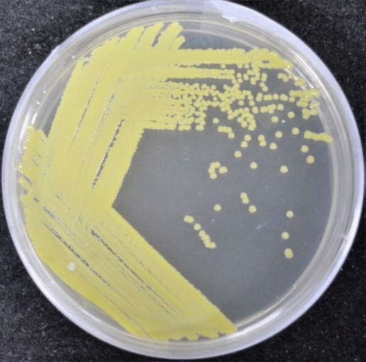  A  A | 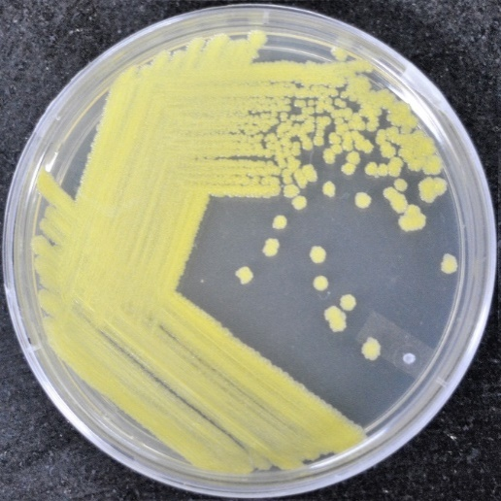  B
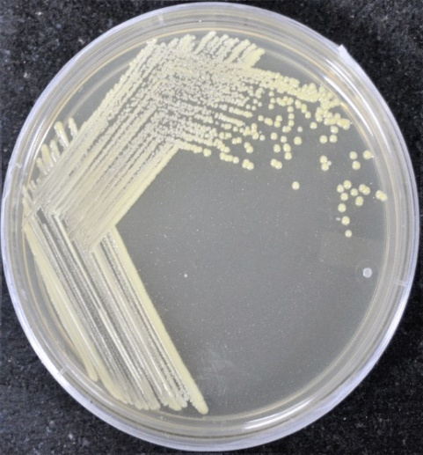  C | 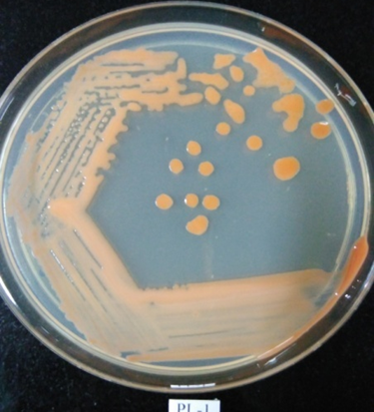  D
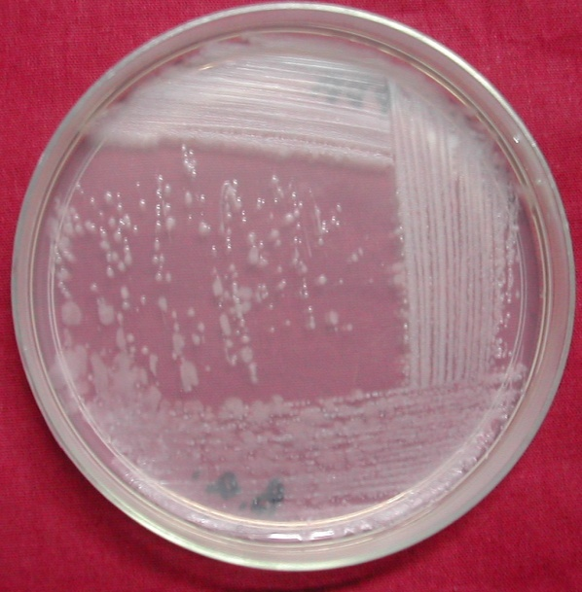  E | 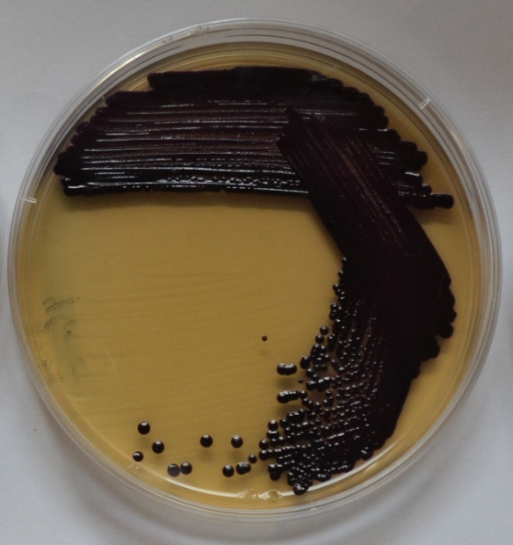  F
Fig. 2: Different reference bacterial cultures used in this study (A) Micrococcus alovereae DCB-10, (B) Micrococcus yunnanensis JCR 24, (C) Kocuria palustris LLP 18, (D) Kocuria salina PL-1(E) Bacillus amyloliquefaciens BA1 and (F) Chromobacteria violaceum TRFM-24

