Materials and Methods

S1 Photochemical Model, KINETICS

We adapt the Caltech/JPL photochemical and transport model, KINETICS, for the early Mars atmosphere. Additional input and output files from our study can be found in the Caltech online repository (see acknowledgements). The KINETICS software is described in the original references (27, 51), and the work can be reproduced with all reactions and rate constants used in this study which are included in the provided output files. We consider the chemistry of 28 species linked by 172 reactions on an altitude grid spaced on average with three bins per scale height that extends to 500 km (well above the exobase for our five atmospheric pressures considered). Our model calculates and outputs chemical abundances for each species at every level by computing the chemical production and loss rates at each altitude as well as the diffusive flux between each altitude grid with the 1-D continuity equation:

$\frac{dn_{i}}{dt}=P_{i}-L_{i}-\frac{∂ϕ_{i}}{∂z},$ (S1)

where n_{i} is the number density of species i, φ_{i} the vertical flux, P_{i} the chemical production rate, and L_{i} the chemical loss rate, all evaluated at time t and altitude z. The vertical flux is given by

$ϕ_{i}= -D_{i}\left(\frac{∂n_{i}}{∂z}+\frac{n_{i}}{H_{i}}+\frac{1-α_{i}}{T}\frac{∂T}{∂z}n\right)-K\left(\frac{∂n_{i}}{∂z}+\frac{n_{i}}{H_{a}}+\frac{1}{T}\frac{∂T}{∂z}n\right), (S2)$

where D_{i} is the species’ molecular diffusion coefficient, $H_{i}$ the species’ scale height, $H_{atm}$ the atmospheric scale height, $α_{i}$ the thermal diffusion parameter, $K_{zz}$ the vertical eddy diffusion coefficient, and T the temperature (53). The flux consists of molecular diffusion (which can be derived from the molecular theory of ideal gases) and eddy transport. We calculate the eddy diffusion coefficient profile according to the formulation in (54).
We assume a zero-flux upper and lower boundary condition for all species except the following: O (the rate of escape from the top via dissociative recombination is solved for in an iteration of KINETICS runs); O₂ (a ground deposition velocity of 2x10⁻⁶ cm/s or fluxes of loss to the surface as described in the main text); H (the rate of thermal escape is solved for as described in the main text); H₂ (the rate of thermal escape is solved for and near-surface emissions are parametrized as described in the main text); HNO₂, HNO₃, and HO₂NO₂ (a ground deposition velocity of 10⁻² cm/s), CO (a ground deposition velocity of 10⁻⁶ cm/s), and ion species (a zero-concentration at the surface is considered).

S2 Radiative Transfer Model, REDFOX

REDFOX calculates radiative transfer for discrete intervals in the spectral range from v = 0 to 10⁵ cm⁻¹. We individually studied the temperature responses to including CO₂-H₂, H₂-H₂, as well as added N₂-H₂ CIA (52) in our scenarios, and even in the two cases of added 300 mbar of N₂ we found the latter to affect surface temperatures less than 2 K. Surface temperature changes between the 5 atmospheres considered are mainly attributed to variations in surface pressure opposed to the compositional variations. This is in agreement with (14), which found that the more heterogeneous electron density distribution of the major atmospheric constituent CO₂ strengthens the multipole moments and increases the polarizability leading to a stronger CIA effect in comparison to that of any added N₂. This result is in contrast to the early Earth study by (55), which had found N₂-H₂ to significantly increase their temperatures. The difference lies mainly in the large amounts of CO₂ in early Mars, with major absorption bands in the same wavelength range as the N₂-H₂ CIA. See (33) for a full list of atmospheric absorbers included in our correlated-k radiative transfer and for details about the cross sections. Water concentrations in convective regions in the troposphere are adjusted to follow modern Earth-like relative humidity profiles after (56) with surface RH=0.77, including the potential presence of a liquid water ocean.

Figure S1 shows the temperature-pressure profiles as computed by REDFOX after iteration with KINETICS. The temperature profiles are similar in the upper regions, where the atmospheric density is not large enough for significant longwave absorption. The near-surface temperature shows the greatest response to near-surface photochemistry and surface interactions, and the thicker atmospheres show a warming of up to 60 K compared to our thinner atmospheres.

Note for our coldest resulting tropospheres without added N₂, such as in the case of 200 mbar atmospheres and the 500 mbar atmosphere with lowest H₂ fluxes, CO₂ may partially freeze out in parts of the troposphere. A caveat of 1D models is the global treatment of such freeze out, potentially leading to artificial full atmospheric collapse in such cases (e.g., 57). In an effort to compare all our cases with the intended surface pressure, we prevented global CO₂ freeze out.

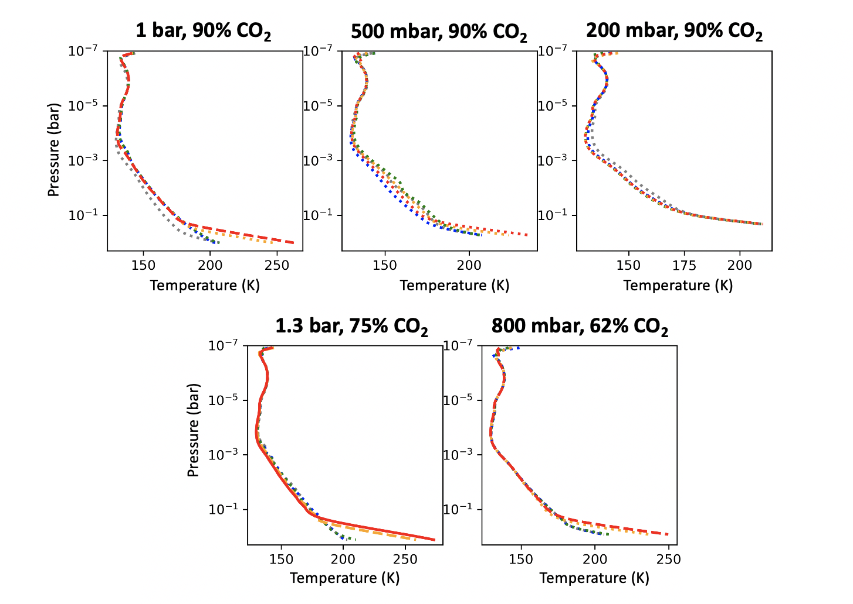

Figure S1. Temperature-pressure profiles computed by REDFOX after iteration with KINETICS. The top three panels assume a background CO₂ atmosphere with 10% N₂ in a 1 bar atmosphere (left), 500 mbar atmosphere (center), and 200 mbar atmosphere (right). The lower left panels show the cases with 300 mbar N₂ added to 1 bar and 500 mbar of CO₂. Cases with no hydrogen source are plotted in grey, lower limit H₂ fluxes in blue, intermediates in green and orange, and upper limit H₂ fluxes in red. Cases with surface temperatures cooler than 250 K are plotted in a dotted linestyle, greater than 250 K are plotted in a dashed linestyle, and greater than 270 K in a solid linestyle.

S3 Relating Hydration to an Atmospheric Hydrogen Source

Clay minerals and other hydrated minerals will incorporate OH-groups and H₂O-groups, and the case of OH groups can be thought of as an oxygen sink since one H is liberated for every OH-group that is incorporated. The ratio of OH:H₂O groups incorporated is dependent on the mineral, and in this work we make the assumption that it is serpentine-like. With the simplifying assumption that 2 OH must be incorporated for one release of H₂, for serpentine, the ratio of H₂O incorporated to H₂ released is ~4-40 (23). (17) finds that 100-900m GEL water is lost to crustal hydration during the Noachian and 10-100m GEL during the Hesperian.

Crustal hydration is not the only source of water loss. We base assumptions on Fe(II) to Fe(III) oxidation depths on (18-20): 10-5 km during the Noachian and 5-1 km during the Hesperian. Regular basalt at Mars contains ~20 wt% FeO, and the Fe³⁺/Fe^{T} is < 0.2-0.3 for relatively unaltered basalts and 0.6-0.9 for highly altered basalts (58). Therefore, assuming 10-60% of all Fe(II) becomes oxidized to Fe(III), which requires 0.5 mol O per Fe, this relates to 32-382m GEL lost during the Noachian and 6-192m GEL during the Hesperian.

Furthermore, oxidation of FeS minerals to sulfate contributes as a third relevant mechanism (23), and Fe oxidation via chlorates may also be efficient (39). However, neither of these aqueous mechanisms would release H₂, and therefore we ignore them in our work. With similar assumptions as iron oxidation, we acknowledge the former contributes 2-29m GEL water loss during the Noachian and 0.5-15m GEL loss during the Hesperian.

The total water lost (in units of m GEL) can be related to a flux lost (in units of molecules/cm²/s) with another simplifying assumption that loss was approximately constant over a respective era:

$$F_{water loss}=D⋅A⋅ρ⋅\frac{1}{μ_{water}}⋅N_{A}⋅\frac{1}{t}⋅\frac{1}{A},$$

where D is the depth of water in cm GEL, A is the surface area of Mars (cm²), $ρ$ is the density (g/cm³) of water, $μ_{water}$ is the mean molecular weight of water (18 g/mol), $N_{A}$ is Avogadro’s constant, and t is the duration of a given epoch. This flux may then be related to the flux of hydrogen released according to the ratio, n, of ~4-40 for H2O loss : H2 release:

$$F_{H2}=\frac{F_{water loss}}{n}$$

This relates to a range of hydrogen released to the atmosphere between ~10¹⁰-2x10¹² H₂/cm²/s during the Noachian and ~10⁹-3x10¹¹ H₂/cm²/s during the Hesperian.

S3 Effect of Water Photolysis Rates on CO Runaway

CO runaway at Mars occurs when the production of HOx radicals is limited. At present-day Mars, dust storms are known to increase hydrogen escape via lofting water into the stratosphere. At early Mars, a similar effect may result from periods of strong convection. Here, we demonstrate that lofting water into the stratosphere supplies an insufficient amount of HOx to balance the CO runaway.

Additionally, it was recently found that the extended tail region for the photolysis cross section of water is non-negligible due to the solar spectrum hosting an increased number of photons at longer wavelengths (59). Here, we demonstrate that the effect of the faster water photolysis (i.e., faster supply of HOx) is also insufficient to balance the CO runaway.

O₂ sink | 0 O₂/cm²/s | 0 O₂/cm²/s | 10⁸ O₂/cm²/s | 10⁸ O₂/cm²/s | 10⁹ O₂/cm²/s | 10⁹ O₂/cm²/s
Modification: | convection | photolysis | convection | photolysis | convection | photolysis
% change in [CO] near surface: | -2.4% | -13.4% | -1.3% | -15.6% | -0.05% | -9.0%
% change in [CO] in stratosphere: | -2.4% | -13.4% | -1.3% | -15.6% | -0.05% | -9.0%

Table S1. Percent change in surface and stratospheric CO concentrations due to periods of strong convection or the inclusion of the tail region in the water photolysis cross sections.

References for Materials and Methods
51. H. Nair et al., A photochemical model of the Martian atmosphere. Icarus 111, 124-150 (1994).
52. Borysow, A. and Frommhold L., Theoretical collision-induced rototranslational absorption spectra for modeling Titan’s atmosphere: H₂-N₂ pairs, AJ 303, 495 (1986).
53. Y. L. Yung & W. B. DeMore, Photochemistry of Planetary Atmospheres (Oxford University Press, Oxford, UK, 1998).
54. A. S. Ackerman, M. S. Marley, Precipitating condensation clouds in substellar atmosphere. The Astrophysical Journal 556, 872 (2001).
55. Wordsworth, R. and Pierrehumbert, R. Hydrogen-nitrogen greenhouse warming in Earth's early atmosphere. Science, 339, 6115, (2013).
56. Manabe, S. and Wetherald, R., Thermal Equilibrium of the Atmosphere with a Given Distribution of Relative Humidity, Journal of Atmos. Sci. 24, 3 (1967).
57. Forget et al., 3D modelling of the early Martian climate under a denser CO2 atmosphere: Temperatures and CO2 ice clouds. Icarus, 222 (2013).
58. R. V. Morris et al., Mössbauer mineralogy of rock, soil, and dust at Gusev crater, Mars: Spirit's journey through weakly altered olivine basalt on the plains and pervasively altered basalt in the Columbia Hills. JGR: Planets 111, E2 (2006).
59. Ranjan et al., Photochemistry of anoxic abiotic habitable planet atmospheres: Impact of New H₂O photolysis cross sections. AJ 896, 148 (2020).

