Supplementary information for
On a roll – a direct comparison of extraction methods for the recovery of eDNA from roller swabbing of surfaces.

Austin M. Guthrie^{1,4}, Paul Nevill^{1,4} Christine E. Cooper², Philip W. Bateman^{3,4}, Mieke van der Heyde^{1,4}
¹ Trace, and Environmental DNA Laboratory, School of Life and Molecular Sciences, Curtin University, Perth, Western Australia, 6102
² School of Molecular and Life Sciences, Curtin University, Perth, Western Australia, 6102
³ Behavioural Ecology Laboratory, School of Molecular and Life Sciences, Curtin University, Perth, Western Australia, 6102
⁴MBioMe - Mine Site Biomonitoring using eDNA Research Group, Trace and Environmental DNA (TrEnD) Laboratory, School of Molecular and Life Sciences, Curtin University, Perth, Western Australia 6102

Corresponding author:
Austin Guthrie
School of Molecular and Life Sciences
Curtin University, Perth, Western Australia, 6102
austin.guthrie@curtin.edu.au

Supplementary Methods
Single-use 50 mm microfibre rollers were decontaminated by submersion in a 10% bleach solution (White King Premium Bleach, ∼5% sodium hypochlorite) for 10 minutes, thoroughly rinsed with deionised water and allowed to dry in a sterile fume hood. Rollers were further decontaminated in a UV cabinet for 15 minutes before being stored in zip lock bags until use. Roller frames were decontaminated prior to sampling by submersion in 100% bleach (White King Premium Bleach, ∼5% sodium hypochlorite) for 10 minutes before being thoroughly rinsed in deionised water.
A dog specific primer assay CYTBCA3-kh was used (Kurniasih et al., 2020), targeting a 105 base pair region of the cytochrome B gene with the primers CYTBCA-kh_F (5’-CCT TAG CCA ATG CCT ATT C-3’) and CYTBCA-kh_R (5’-GCG ACT TGT CCG ATA ATG-3’). In silico testing of the assay against common lab contaminants and potential field contaminants confirmed its specificity in detecting only domestic dog DNA.
DNA extracts were amplified on a StepOnePlus real-time PCR system (Applied Biosystems, Massachusetts, USA) under the following conditions: 95°C for 5 minutes and 50 cycles of 95 °C for 30 seconds, 58°C annealing temperature for 30 seconds and 72°C for 45 seconds. A melt curve of 95°C for 15 seconds, 60°C for one minute and 95°C for 15 seconds was used, ending with a ten-minute elongation at 72°C. Each 25 μL qPCR mix contained: 2.5mM MgCl2 (Applied Biosystems), 1× PCR Gold buffer (Applied Biosystems), 0.25 mM dNTPs (Astral Scientific, Australia), 0.4 mg/mL bovine serum albumin (Fisher Biotec, Australia), 0.4 μmol/L forward and reverse primer, 1 U AmpliTaq Gold DNA polymerase (Applied Biosystems) and 0.6 μL of a 1:10,000 solution of SYBR Green dye (Life Technologies, USA). Cycle-threshold (Ct) values were recorded for all samples and all PCR reactions were performed in duplicate and a single 1/10 dilution was included per sample. Positive controls using synthetic dog DNA were included at multiple dilutions (1 ng/µL, 0.1 ng/µL and 0.01 ng/µL), containing a 1000 bp region of the mitochondrial cytochrome B gene, and non-template positive controls (Quenda, Black Cockatoo and Tiger Snake) were added to confirm primer specificity. Extraction controls and non-template controls were included in qPCR runs.

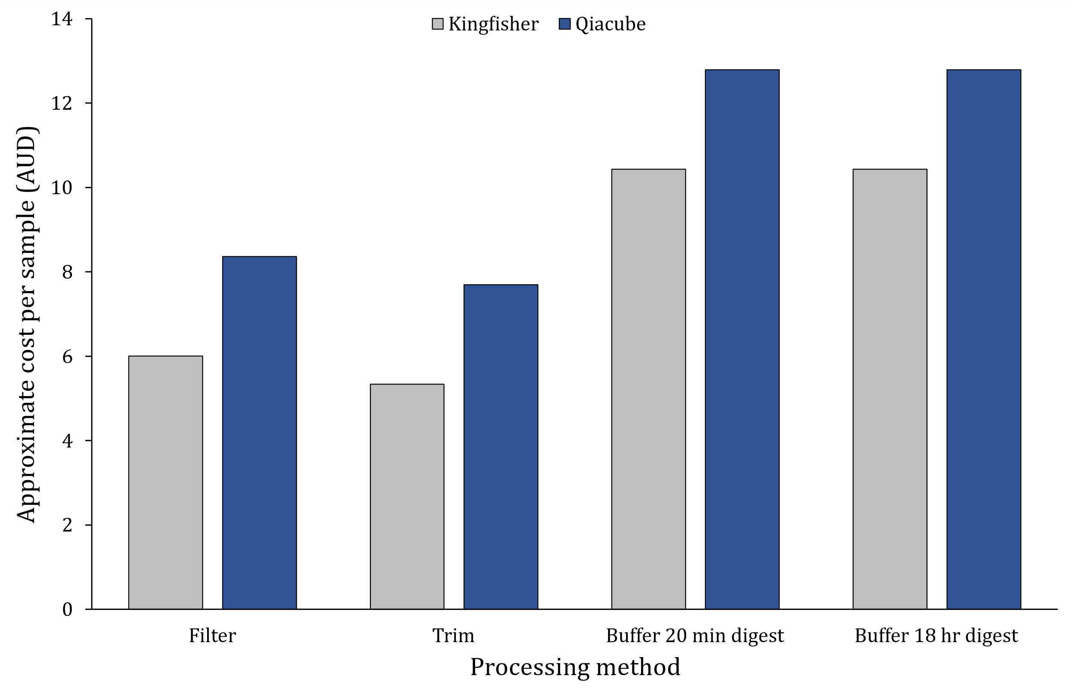
Supplementary Figure 1. Approximate sample costs for processing and extraction methods for eDNA extracts from surface roller swabs. Costs calculated using current pricing as of late 2023 for reagents, consumables and equipment. Note costing does not include labour or initial capital costs of extraction equipment including QiaCube (Qiagen) or KingFisher Flex (ThermoFisher Scientific). All pricing in Australian Dollar (AUD).
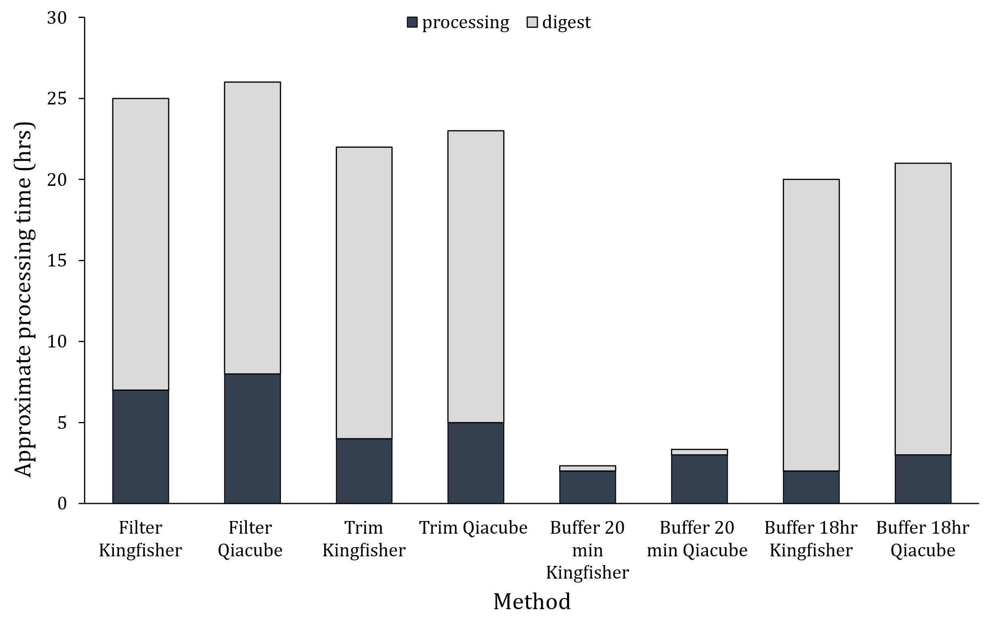
Supplementary Figure 2. Approximate time for processing and lysis (digest) of surface roller swabs between four processing methods (filter, trim, buffer 20min and buffer 18hr) and two extraction methods. (Qiacube and Kingfisher).

