Photo-patternable, large-area solid-state liquid metal film coated via solution shearing for soft electronics

Gun-Hee Lee^{1,2,6}, Hyeonji Kim^{1,6}, Juhyun Lee², Congqi Yang³, Heemin Kang⁴, Seongjun Park³, Jiheong Kang¹, Zhenan Bao⁵, Jae-Woong Jeong^{2,}*, and Steve Park^{1,}*

¹ Department of Materials Science and Engineering, Korea Advanced Institute of Science and Technology (KAIST), 291 Daehak-ro, Yuseong-gu, Daejeon 34141, Republic of Korea
² School of Electrical Engineering, Korea Advanced Institute of Science and Technology (KAIST), 291 Daehak-ro, Yuseong-gu, Daejeon 34141, Republic of Korea
³ Department of Bio and Brain Engineering, Korea Advanced Institute of Science and Technology (KAIST), 291 Daehak-ro, Yuseong-gu, Daejeon 34141, Republic of Korea
⁴ Department of Materials Science and Engineering, Korea University, 145 Anam-ro, Seongbuk-gu, Seoul 02841, Republic of Korea
⁵Department of Chemical Engineering, Stanford University, Stanford, California 94305, United States
⁶ These authors contributed equally: G.-H.L., H.K.

*Corresponding authors: J.-W.J. (jjeong1@kaist.ac.kr), S.P. (stevepark@kaist.ac.kr)

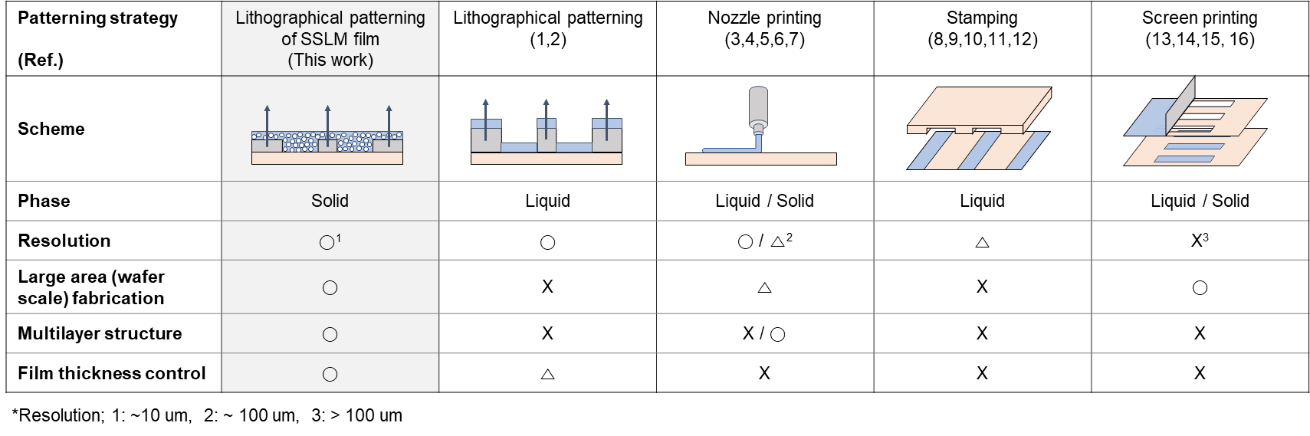
Supplementary Table 1| Comparison of various patterning techniques.
References
1. Kim MG, Brown DK, Brand O. Nanofabrication for all-soft and high-density electronic devices based on liquid metal. Nat Commun 2020, 11(1): 1002.
2. Park CW, Moon YG, Seong H, Jung SW, Oh JY, Na BS, et al. Photolithography-Based Patterning of Liquid Metal Interconnects for Monolithically Integrated Stretchable Circuits. ACS Appl Mater Interfaces 2016, 8(24): 15459-15465.
3. Park Y-GA, Hyeon Seok; Kim, Ju-Young; Park, Jang-Ung. High-resolution, reconfigurable printing of liquid metals with three-dimensional structures. Sci Adv 2019, 5.
4. Mohammed MG, Kramer R. All-Printed Flexible and Stretchable Electronics. Adv Mater 2017, 29(19).
5. Ma B, Xu C, Chi J, Chen J, Zhao C, Liu H. A Versatile Approach for Direct Patterning of Liquid Metal Using Magnetic Field. Adv Funct Mater 2019, 29(28).
6. Yoon Y, Kim S, Kim D, Kauh SK, Lee J. Four Degrees-of-Freedom Direct Writing of Liquid Metal Patterns on Uneven Surfaces. Adv Mater Tech 2019, 4(2).
7. Veerapandian S, Jang W, Seol JB, Wang HB, Kong M, Thiyagarajan K, et al. Hydrogen-doped viscoplastic liquid metal microparticles for stretchable printed metal lines. Nat Mater: 9.
8. Kim M-g, Kim C, Alrowais H, Brand O. Multiscale and Uniform Liquid Metal Thin-Film Patterning Based on Soft Lithography for 3D Heterogeneous Integrated Soft Microsystems: Additive Stamping and Subtractive Reverse Stamping. Adv Mater Tech 2018, 3(7).
9. Kim M-g, Alrowais H, Pavlidis S, Brand O. Size-Scalable and High-Density Liquid-Metal-Based Soft Electronic Passive Components and Circuits Using Soft Lithography. Adv Funct Mater 2017, 27(3).
10. Wang Q, Yu Y, Yang J, Liu J. Fast Fabrication of Flexible Functional Circuits Based on Liquid Metal Dual-Trans Printing. Adv Mater 2015, 27(44): 7109-7116.
11. Park, J. E., Kang, H. S., Koo, M., & Park, C. Autonomous Surface Reconciliation of a Liquid‐Metal Conductor Micropatterned on a Deformable Hydrogel. Adv Mater 2020, 32(37), 2002178.
12. Gozen BA, Tabatabai A, Ozdoganlar OB, Majidi C. High-density soft-matter electronics with micron-scale line width. Adv Mater 2014, 26(30): 5211-5216.
13. Mou L, Qi J, Tang L, Dong R, Xia Y, Gao Y, et al. Highly Stretchable and Biocompatible Liquid Metal-Elastomer Conductors for Self-Healing Electronics. Small 2020, 16(51): e2005336.
14. Zhang Q, Gao YX, Liu J. Atomized spraying of liquid metal droplets on desired substrate surfaces as a generalized way for ubiquitous printed electronics. Appl Phys A-Mater Sci Process 2014, 116(3): 1091-1097.
15. Ou ML, Qiu WK, Huang KY, Feng HL, Chu S. Ultrastretchable Liquid Metal Electrical Conductors Built-in Cloth Fiber Networks for Wearable Electronics. ACS Appl Mater Interfaces 2020, 12(6): 7673-7678.
16. Ma, Z., Huang, Q., Xu, Q., Zhuang, Q., Zhao, X., Zheng, Z. et al. Permeable superelastic liquid-metal fibre mat enables biocompatible and monolithic stretchable electronics. Nat Mater 2021, 1-10. https://doi.org/10.1038/s41563-020-00902-3

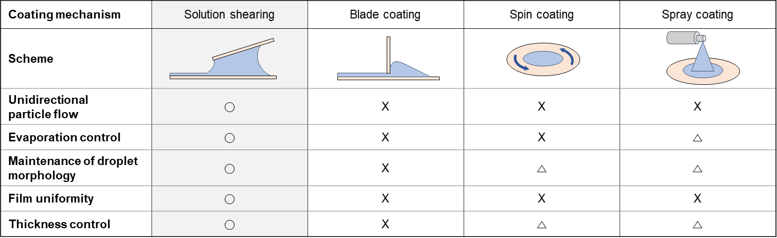
Supplementary Table 2| Coating techniques and their properties.

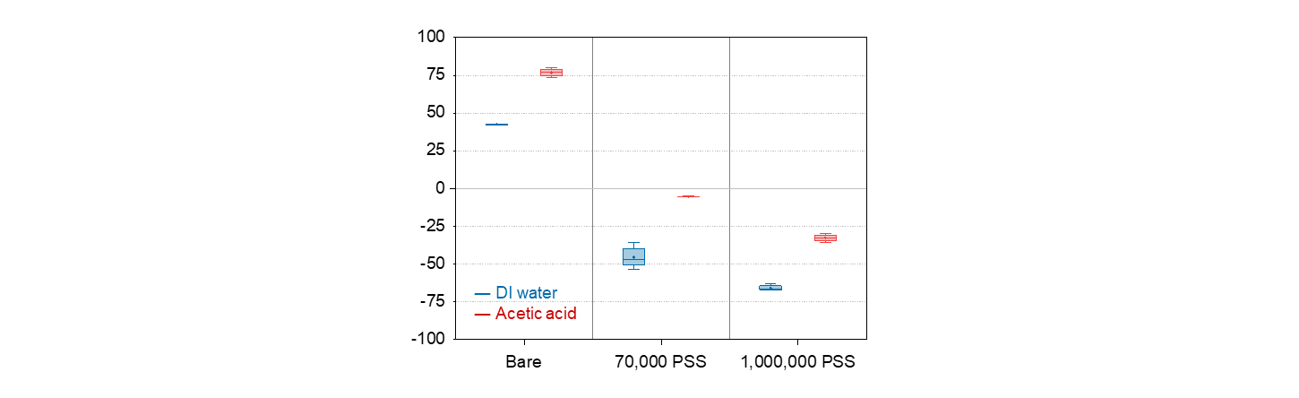
Supplementary Fig. 1| Zeta potential values of LM particles with different solvents and additives.
Each column exhibits the zeta potential value of ink with LM, with LM and 70,000 MW PSS, and with LM and 1,000,000 MW PSS, respectively. Zeta potential increased by the addition of acetic acid.

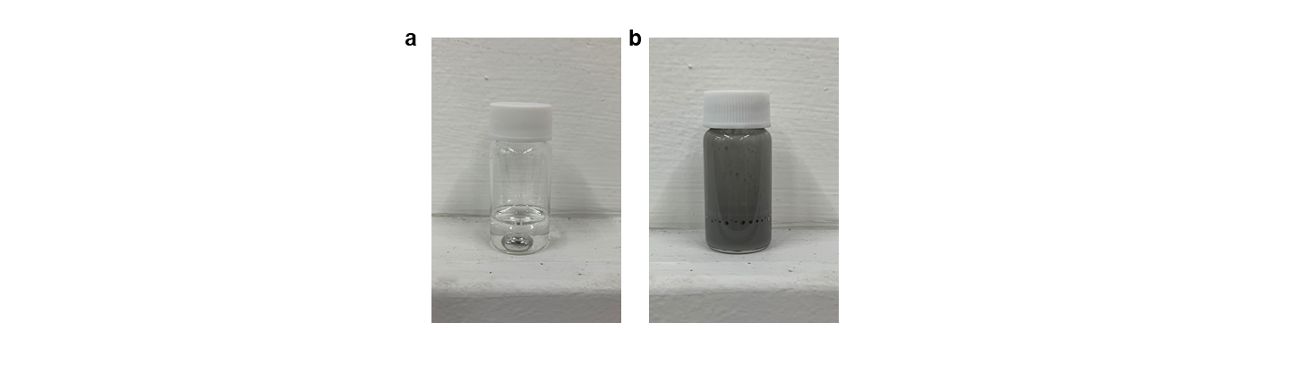
Supplementary Fig. 2| Reaction after addition of HCl. (a) Photograph of reduced LM particle when HCl was added in the LM ink without PSS. (b) Photograph of LM ink with PSS after the addition of HCl.

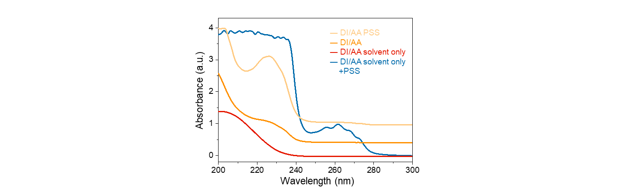
Supplementary Fig. 3| UV-Vis absorbance spectra for various ink components.

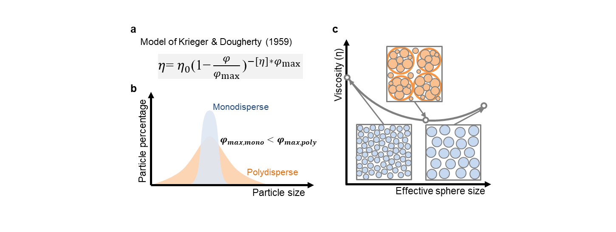
Supplementary Fig. 4| Viscosity of suspensions with different particle size distributions.
The equation derived by Krieger & Dougherty relates the suspension viscosity (η) to the liquid viscosity (η₀), solid fraction (φ), and maximum solid fraction (φ_{max}) (a). If the particles are polydispersed, maximum solid fraction is higher than that of monodispersed suspension, attributed to efficiently filled space (b). Therefore, according to the above equation, at a given shear rate and solid fraction, a polydispersed suspension’s viscosity will be lower (c).


Supplementary Fig. 5| SEM image of SSLM film with 5 wt% PSS.
Aggregated particles have been observed with SSLM film with 5 wt% PSS. This result suggests that the addition of excess bridging polymer yields stronger interaction between particles and induces the aggregation of particles.
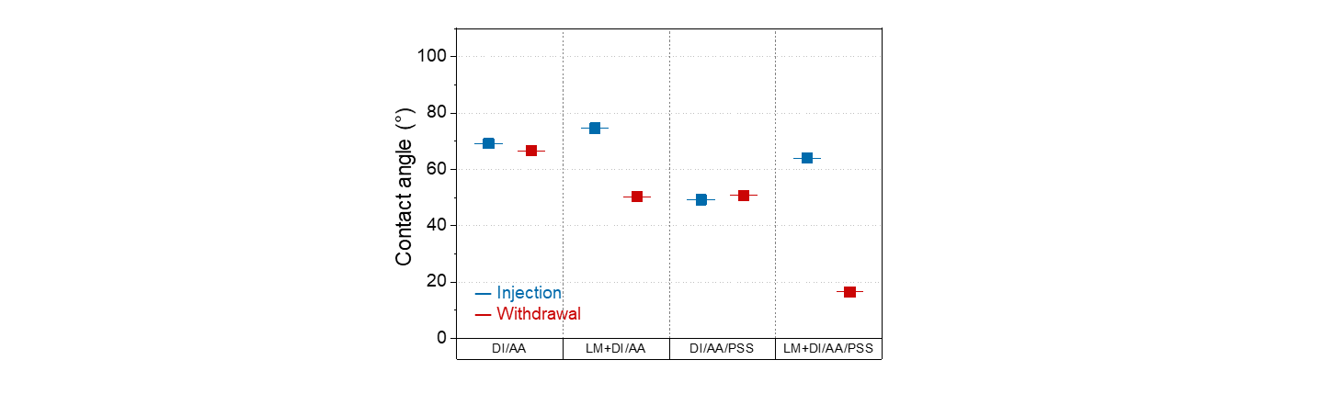
Supplementary Fig. 6| Contact angles of various ink compositions.
The presence of PSS, which works as a surfactant, lowers the contact angle of the ink.

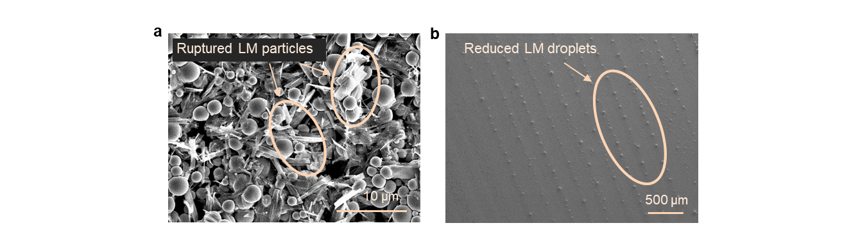
Supplementary Fig. 7| LM film coated with ink without PSS. (a) SEM image of LM particles without PSS. (b) SEM image of LM film without PSS.
Rupturing and reduction of LM particles have been observed after solution shearing with LM ink without PSS. The stability of bare LM particles covered with a thin oxide layer is not enough to endure the solution shearing-based film formation process.

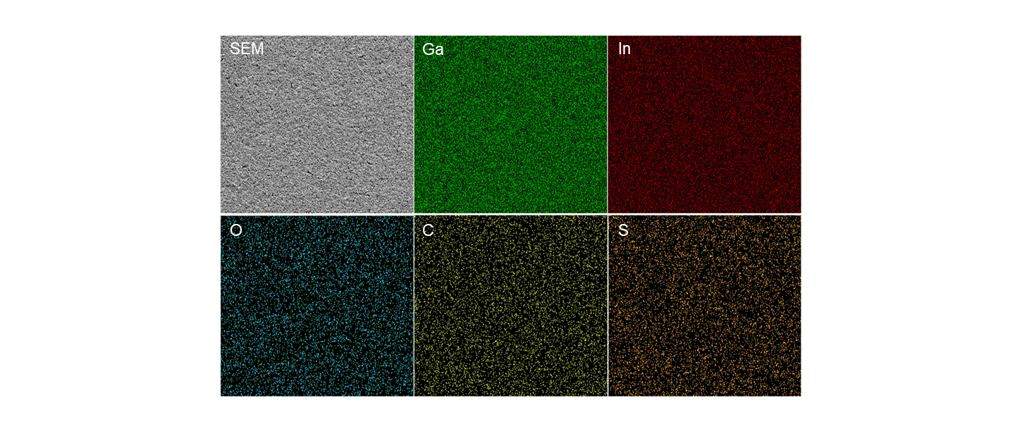
Supplementary Fig. 8| Energy dispersive X-ray spectroscopy (EDS) of SSLM film.
Elements (Ga, In, O, C and S) of SSLM were mapped with different colors. All elements are distributed evenly over the film.

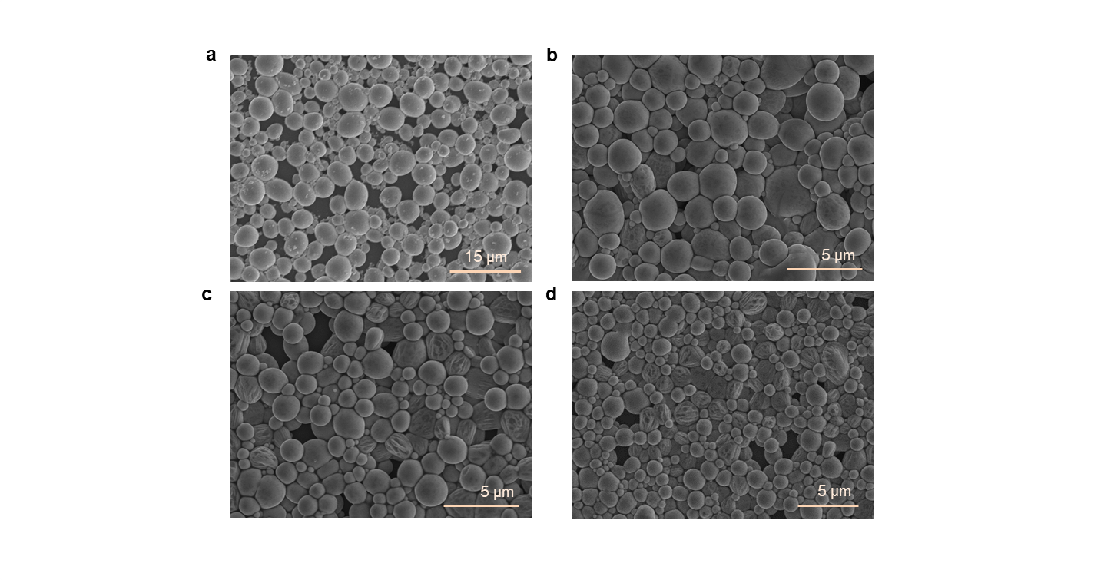
Supplementary Fig. 9| SEM images of ink with different tip sonication time. (a) 5 min, (b) 30 min, (c) 60 min, and (d) 120 min.

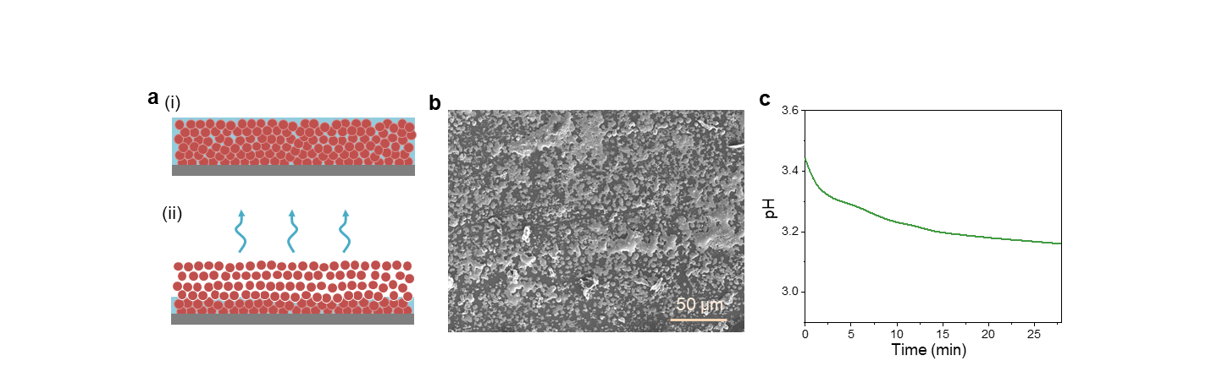
Supplementary Fig. 10| Film formation during solution shearing. (a) Schematic illustration of (i) wet film and (ii) dry film formation. (b) SEM image of bottom layer of dry film. (c) pH change during solvent evaporation.
Figure (c) above indicates that as the solvent evaporates away, the pH decreases. We assume that when the LM particles are in an acidic environment at an elevated temperature (i.e. heated substrate) over an extended time, the gallium oxide layer eventually dissolves away, causing the LM particles to merge inducing bulk-like continuous thin-film formation.
When shearing occurs in the evaporative regime, the LM particles swiftly move towards the contact line and self-assemble to thin-film. Due to such accumulation of LM particles, the concentration of the solution near the contact line increases rapidly. In other words, at the contact line, the proportion of LM particles quickly increases relative to the solvent. In this model, since there is a relatively small amount of solvent, the time it takes for this remaining solvent to evaporate away is expected to be relatively short. This consequently means that LM particles spend less time under acidic conditions.
In the Landau-Levich (LL) regime, the solution is extruded out away from the blade generating a liquid layer; thin-film then forms as the solvent evaporates from this liquid layer (this film is named as wet film in this article) as presented in Supplementary Movie 8. Here, the concentration of the liquid layer is relatively low. Since there is a relatively large amount of solvent that needs to be evaporated, the LM particles spend a longer time in an acidic condition. Therefore, the difference in the thin-film morphologies in the two coating regimes is attributed to the difference in the time frame the LM particles are annealed in an acidic solution.
The fact that SSLM film (coated in the evaporative regime) can be coated and patterned on a variety of substrates implies that the bottom most layer of the SSLM film has a strong adherence to surfaces (otherwise, the SSLM film would be lifted off of the substrate during lift-off process). Since solvent evaporates away from the top, the bottommost layer is annealed in the acidic solution the longest. We assume that as a consequence, the LM particles in the bottom layer reacts with the surface to form a strong adhesion. As Figure b suggests, even after mechanically scraping off the SSLM film, parts of the bottommost layer remain intact, corroborating our hypothesis.

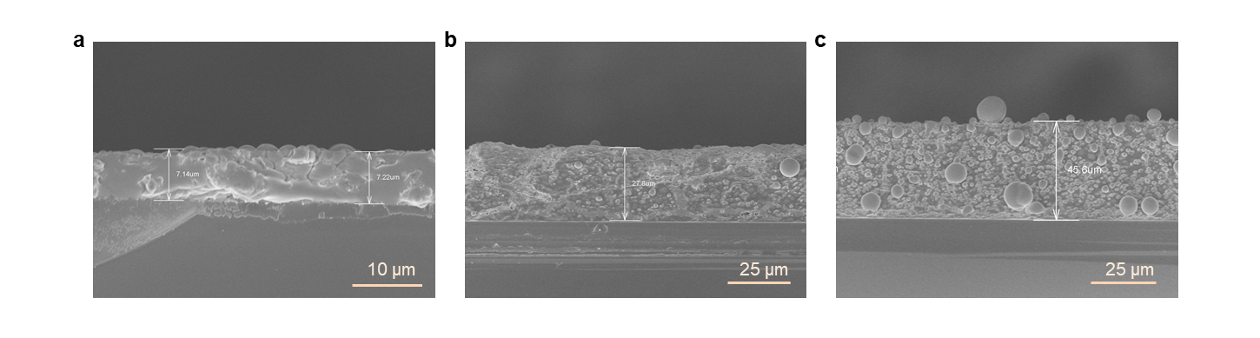
Supplementary Fig. 11| SEM images of wet LM film coated at (a) 10 mm/sec, (b) 15 mm/sec, and (c) 30 mm/sec.

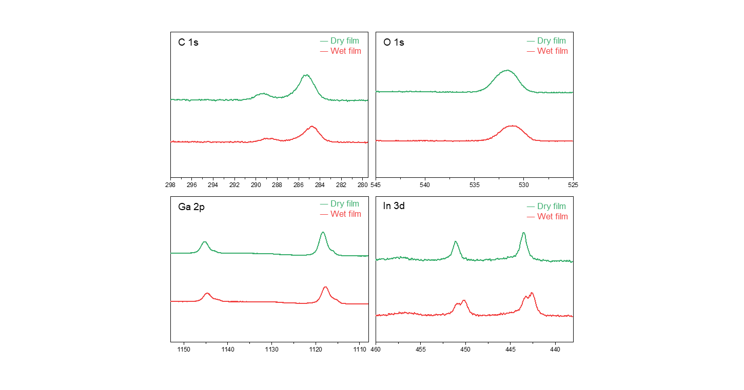
Supplementary Fig. 12| XPS spectrum of dry film and wet film for C 1s, O 1s, Ga 2p, and In 3d.
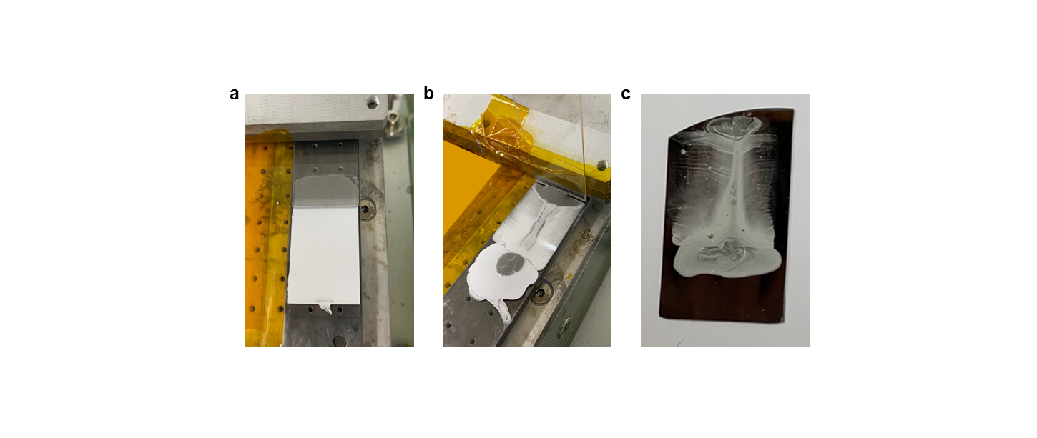 Supplementary Fig. 13| SSLM film coated with solution shearing and blade coating. (a) Photograph of SSLM film during solution shearing process. (b) Photograph of SSLM film during blade coating (blade angle: 90°). (c) Photograph of SSLM film coated with blade coating.
In solution shearing, the solution is contained between the blade and the substrate. As the blade moves, boundary-driven flow occurs that drives the motion of solute forward towards the meniscus and ultimately to the contact line. Furthermore, since the solution is exposed to air only at the meniscus (at the edge of the blade), solvent evaporation occurs selectively in this region. The gradient in solvent evaporation rate causes capillary flow or Marangoni flow (due to the difference in surface tension caused by temperature or concentration variation) that can also steer the solute towards the contact line. Moreover, as described in the main text, inter-particle attraction furthermore attracts solute to the contact line. These effects together result in directional flow of solute, and along with the localized solvent evaporation region, yield uniform thin-film formation as the blade moves across the substrate.
In blade coating, where the blade is vertically standing, the aforementioned boundary-driven flow does not occur. Also, since solvent evaporation does not occur selectively at the meniscus due to the exposure of the solution to air in all regions, the solution does not flow directionally towards the meniscus and dries in random locations in a non-controllable manner. These effects ultimately yield non-uniform thin-film.

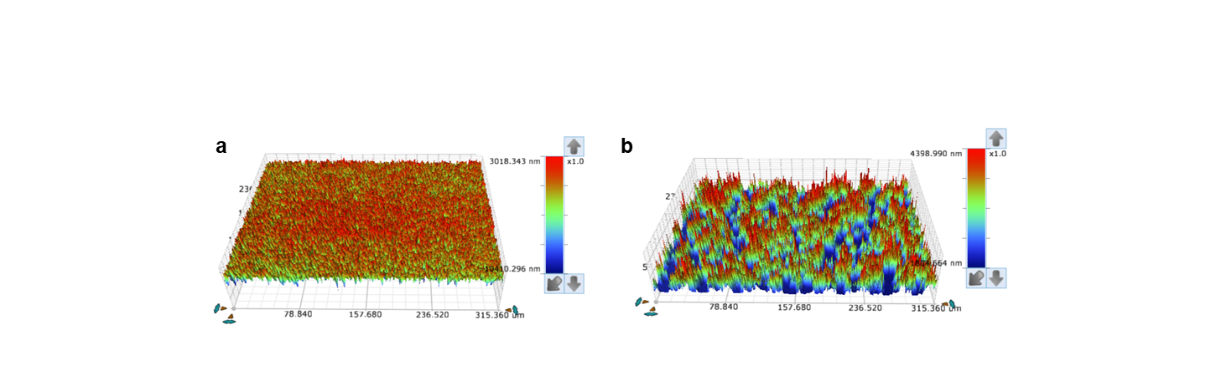
Supplementary Fig. 14| 3D surface profile images of SSLM film coated with (a) solution shearing and (b) blade coating.

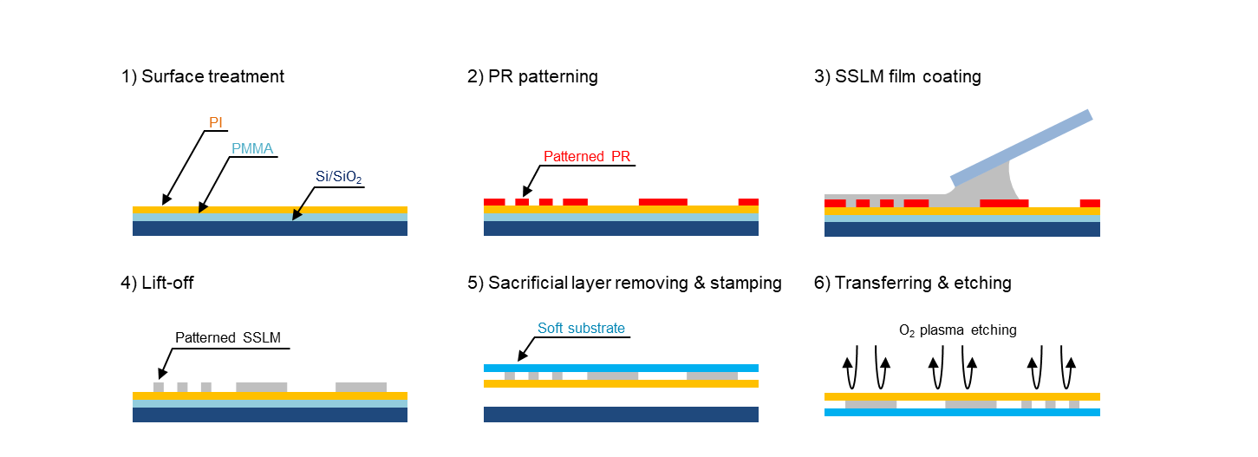
Supplementary Fig. 15| Schematic illustration of soft electronics fabrication with SSLM film through conventional transfer printing.
Detail description regarding transfer printing is presented in the Method section. 1) PMMA working as a sacrificial layer, PI working as a temporary substrate. 2) PR layers were coated on the substrate sequentially and patterned through a conventional photolithographic process. 3) SSLM film was coated on a patterned substrate with the solution shearing. 4) Lift-off-based patterning was conducted with bath sonication. 5) SSLM film was patterned, PMMA sacrificial layer was removed by putting the sample in the acetone overnight. Then, PI film with patterned SSLM film was delaminated from the original substrate by stamping with soft substrate. 6) After transferring, oxygen plasma etching was conducted to remove the PI film.

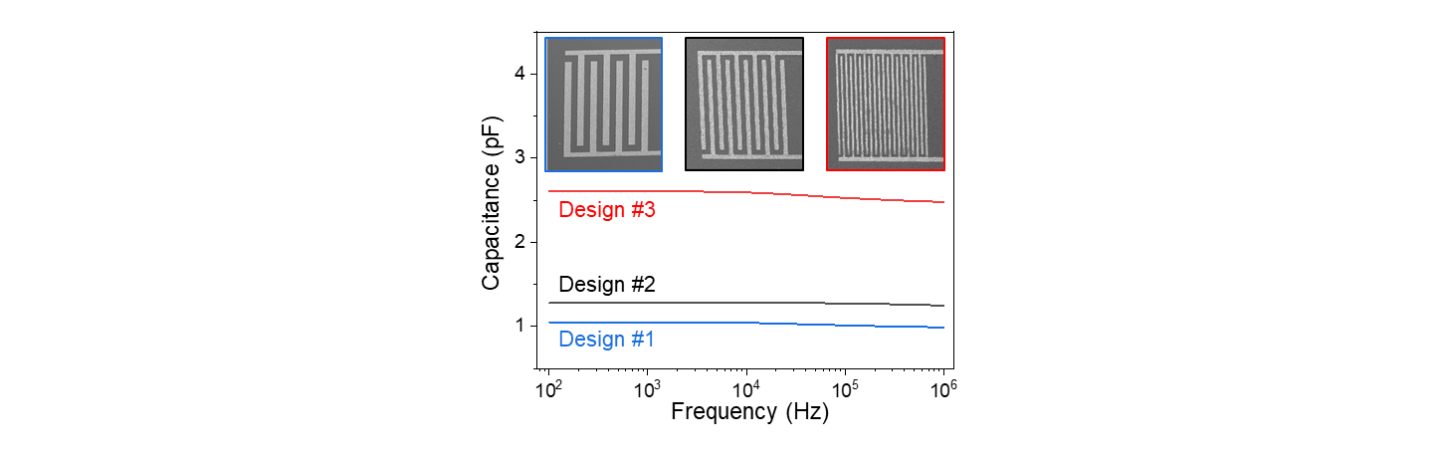
Supplementary Fig. 16| Capacitance versus frequency (100 Hz to 100 KHz) of interdigitated electrodes (IDT) fabricated with SSLM film.
The capacitance of IDT increases with the number of electrode fingers.

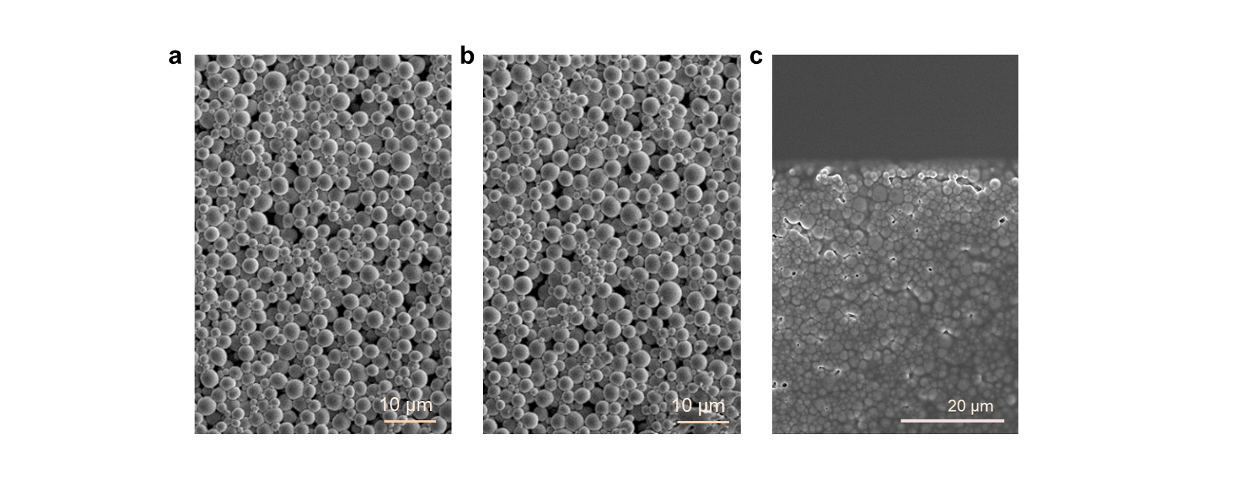
Supplementary Fig. 17| Spin coating on SSLM film. (a) SEM images of SSLM film before, (b) after spinning the substrate at 4,000 rpm, and (c) after PI coating on SSLM film using spin coating.

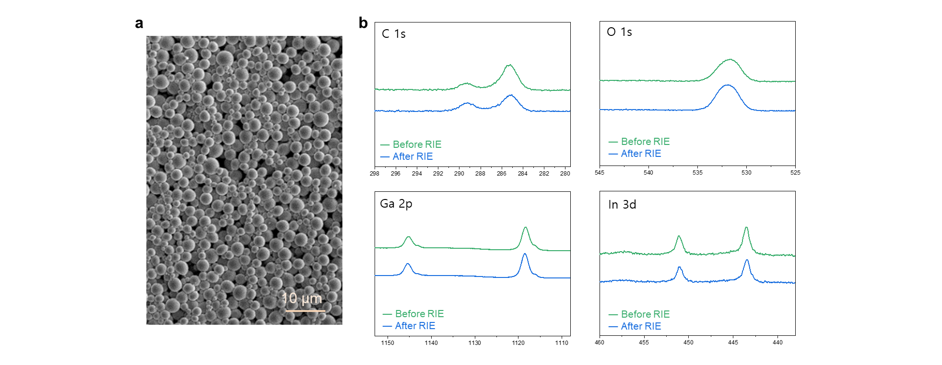
Supplementary Fig. 18| Oxygen plasma RIE on SSLM film. (a) SEM image of SSLM film after RIE. (b)
XPS spectrum of SSLM film before and after RIE for C 1s, O 1s, Ga 2p, and In 3d.
There was no rupturing in SSLM film and no notable change in the XPS spectrum was observed. These results together indicate the chemical stability of SSLM film.

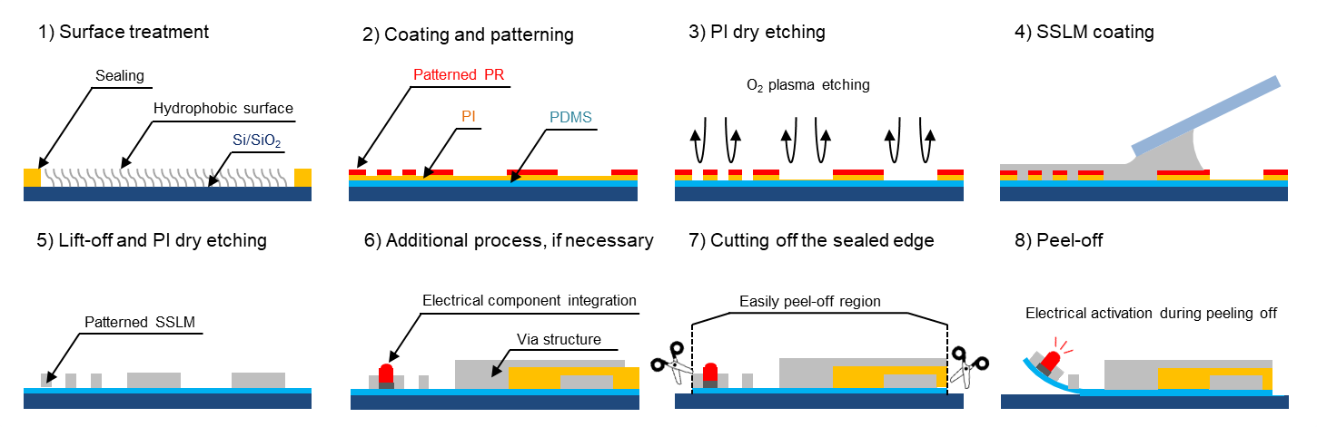
Supplementary Fig. 19| Schematic illustration of soft electronics fabrication with SSLM film through direct patterning on soft substrate.
Detail description regarding direct patterning is presented in the Method section. 1) Before coating PDMS film on a rigid substrate, the substrate was modified as a hydrophobic surface by chemical vapor deposition to facilitate the delamination of the film. Here, all four edges of the glass were sealed with PI tape prior to the hydrophobic coating process to maintain hydrophilicity so that delamination can be prevented during organic solution included processing. 2) PDMS solution was poured on a glass slide and spin-coated and cured to form a PDMS film. Subsequently, PI solution was spin-coated on the PDMS-coated glass and PR was patterned with the aforementioned methods. 3) Oxygen plasma etching was conducted to remove PI film in the regions absent of PR. 4) SSLM film was coated through solution shearing. 5) SSLM film was patterned directly on the PDMS film by following the abovementioned lift-off process. The remaining PI was removed by oxygen plasma etching. 6) Additional processes were conducted such as integration with electrical components or multilayer structuring. For the multilayer structure, we repeated the same sequence from the PI coating on the SSLM patterned PDMS. 7) For delaminating the sample, the edge of PDMS was cut along the hydrophobic/hydrophilic border. 8) SSLM-based soft electronics was lifted off of the substrate.

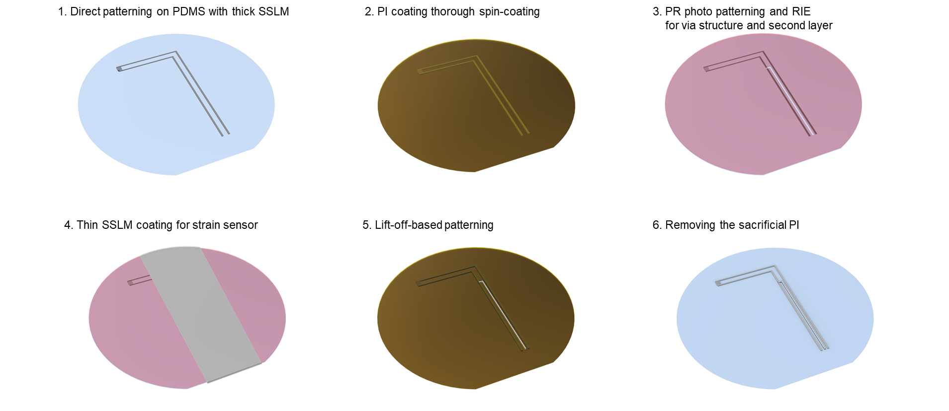
Supplementary Fig. 20| Schematic illustration of multilayer electronics fabrication with SSLM through conventional cleanroom process.

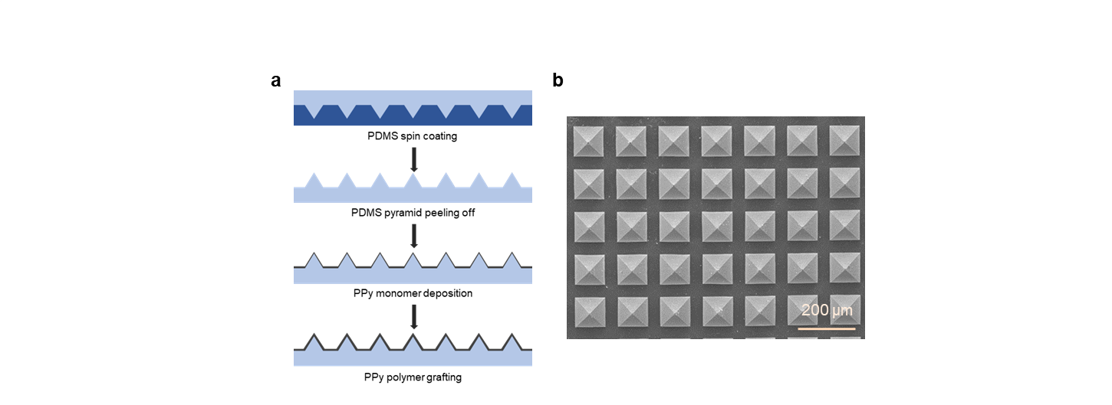
Supplementary Fig. 21| Pyramid structured piezoresistive pressure sensor. (a) Fabrication process of pyramid structured pressure sensor coated with conducive polymer (polypyrrole). (b) Top view SEM image of fabricated pyramid structures.

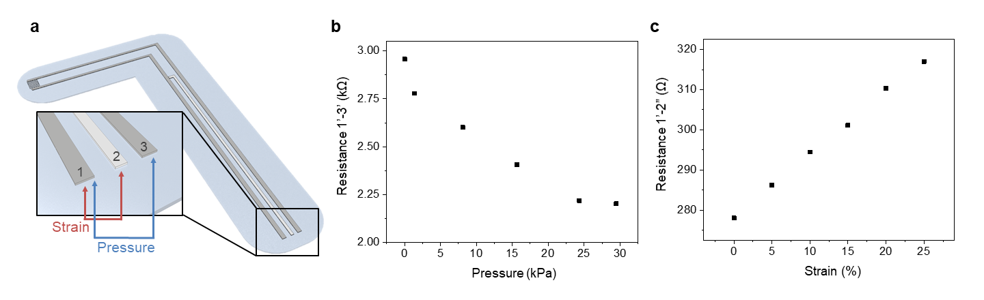
Supplementary Fig. 22| Characterization of SSLM-based artificial finger. (a) Illustration of the artificial finger. (b) Resistance variation between terminal 1’ and 3’ according to pressure. (c) Resistance variation between terminal 1’ and 2” according to strain.
To monitor the pressure and strain with the artificial finger, three terminals were connected with an LCR meter. Terminal 1’ and terminal 3’ are located in the first layer (’ represents the first layer) and are made up of thick SSLM film. Terminal 2” is located in the second layer (” represents the second layer) made up of a thin SSLM film. Pressure can be monitored by measuring the resistance between terminals 1’ and 3’. The resistance between 1’ and 3’ was determined by the contact resistance of the pyrrole-coated pressure sensor and SSLM-based interdigitated electrode since the resistance of thick SSLM film is negligibly low compare to the conductive polymer. Also, as we discussed in Fig. 5d, the resistance of thick SSLM film is stable under the application of strain. Therefore, pressure can be independently monitored even when the mechanical strain was applied to the artificial finger. To monitor the strain, the thin SSLM film was electrically connected to one of the thick electrodes in layer 1 using ‘via hole.’ Since, the resistance of thin-film varies with strain, measuring the resistance between the terminal 1’ and 2” can determine strain.
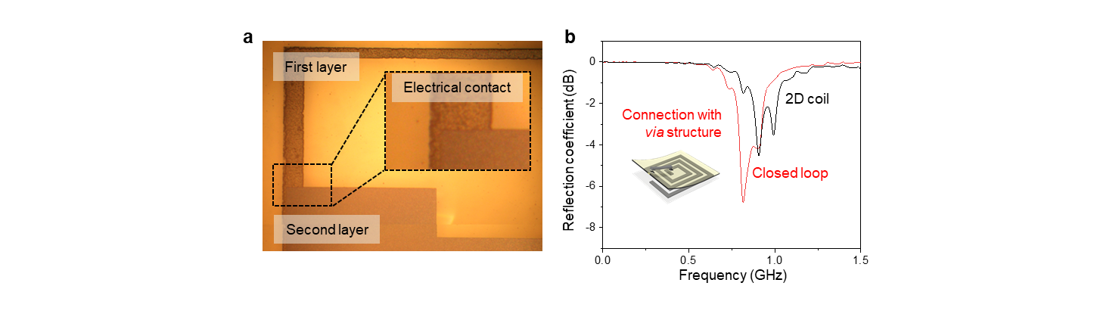
Supplementary Fig. 23| SSLM film-based antenna for wireless communication. (a) Optical image of stacked structure for via connection. (b) Reflection coefficient spectra of SSLM film-based antenna of non-closed 2D coil (black) and closed coil with via connection (red).

