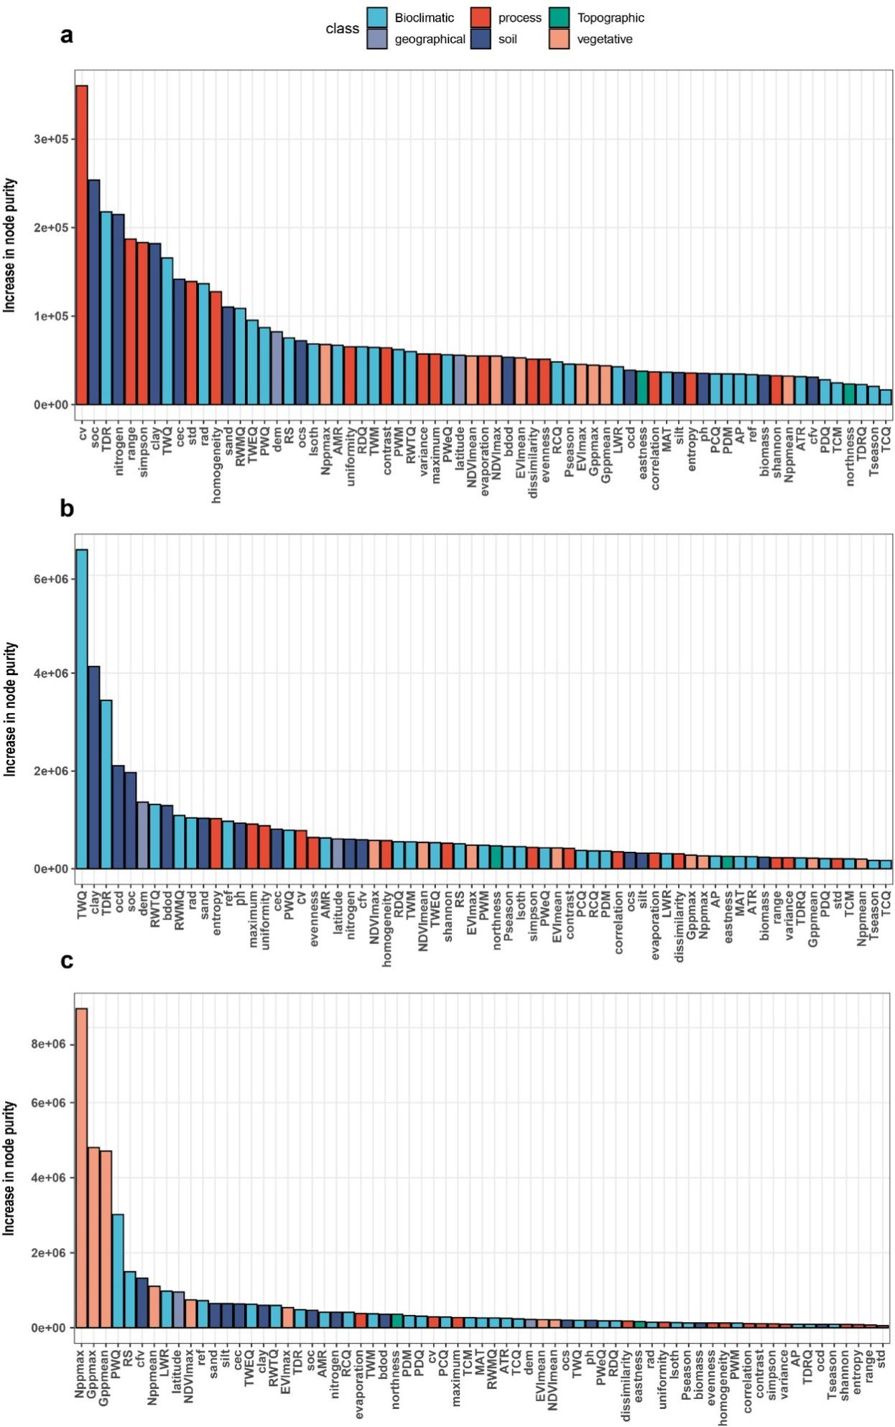
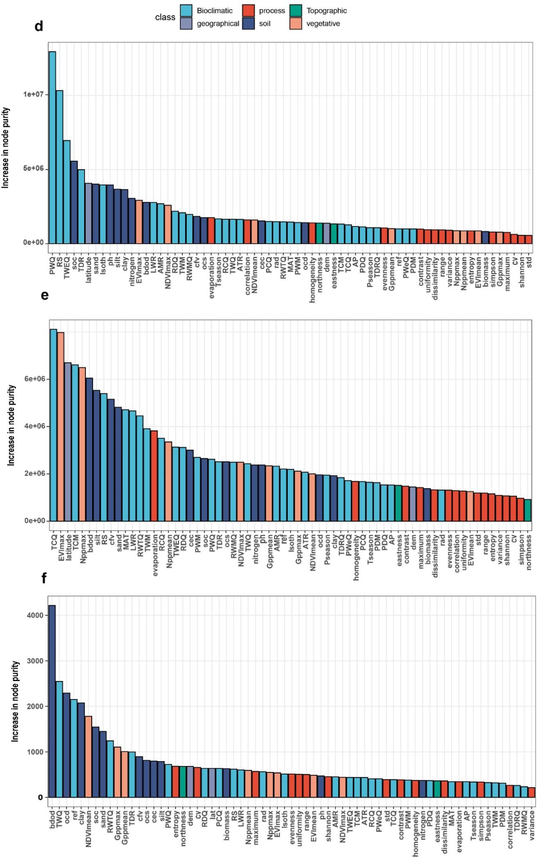
Extended Data Fig. 1 | Variable importance (increase in node purity) of random forests run with all predictors. (a) ammonium oxidation to nitrate. (b) nitrogen removal. (c) nitrogen fixation. (d) nitrate reduction to ammonium. (e) mineralization. (f) nitrogen retention index. Climate and soil properties are the most important variables for the AON, NR, NOA, M, NIRI process. Vegetation are the most important variables for the NF process.
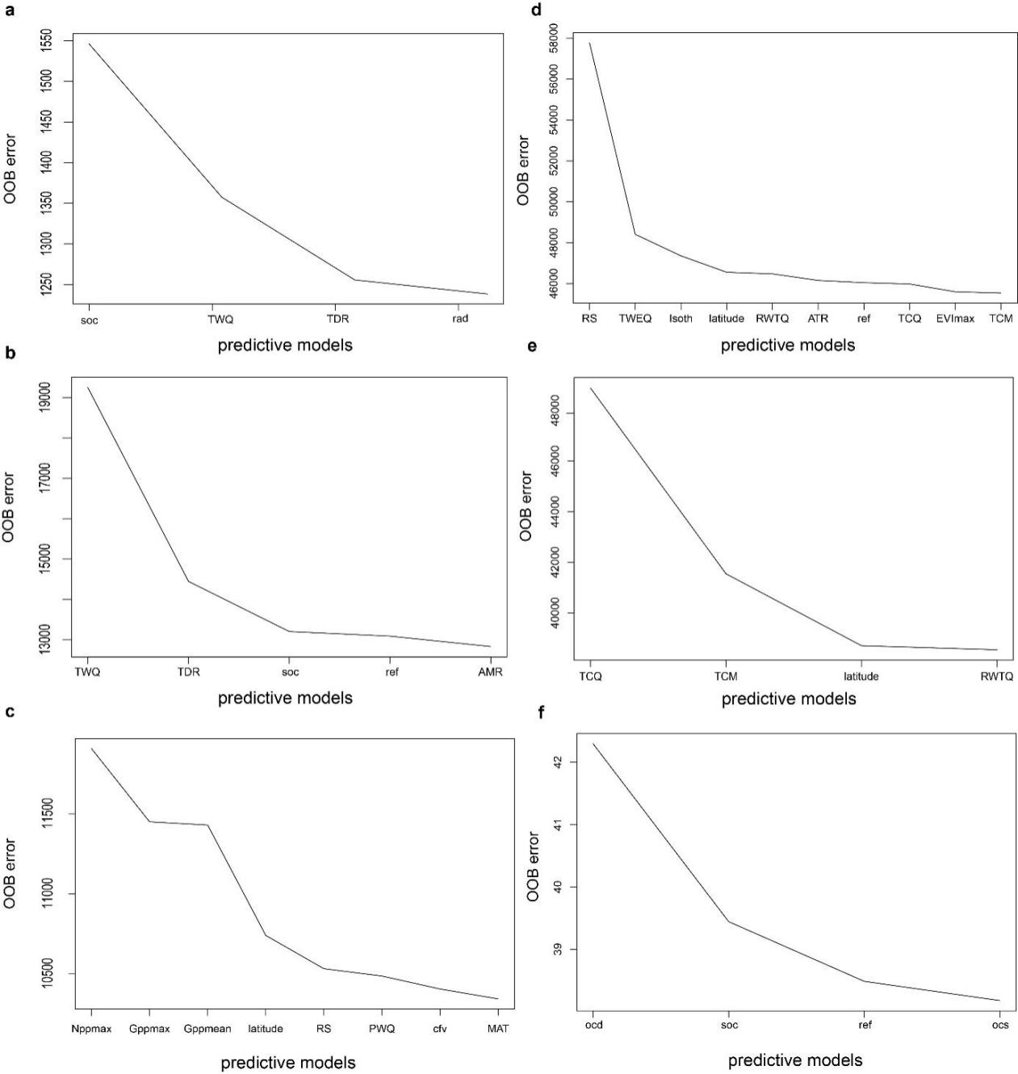
Extended Data Fig. 2 | Variable selection using random forests. (a) ammonium oxidation to nitrate. (b) nitrogen removal. (c) nitrogen fixation. (d) nitrate reduction to ammonium. (e) mineralization. (f) nitrogen retention index.
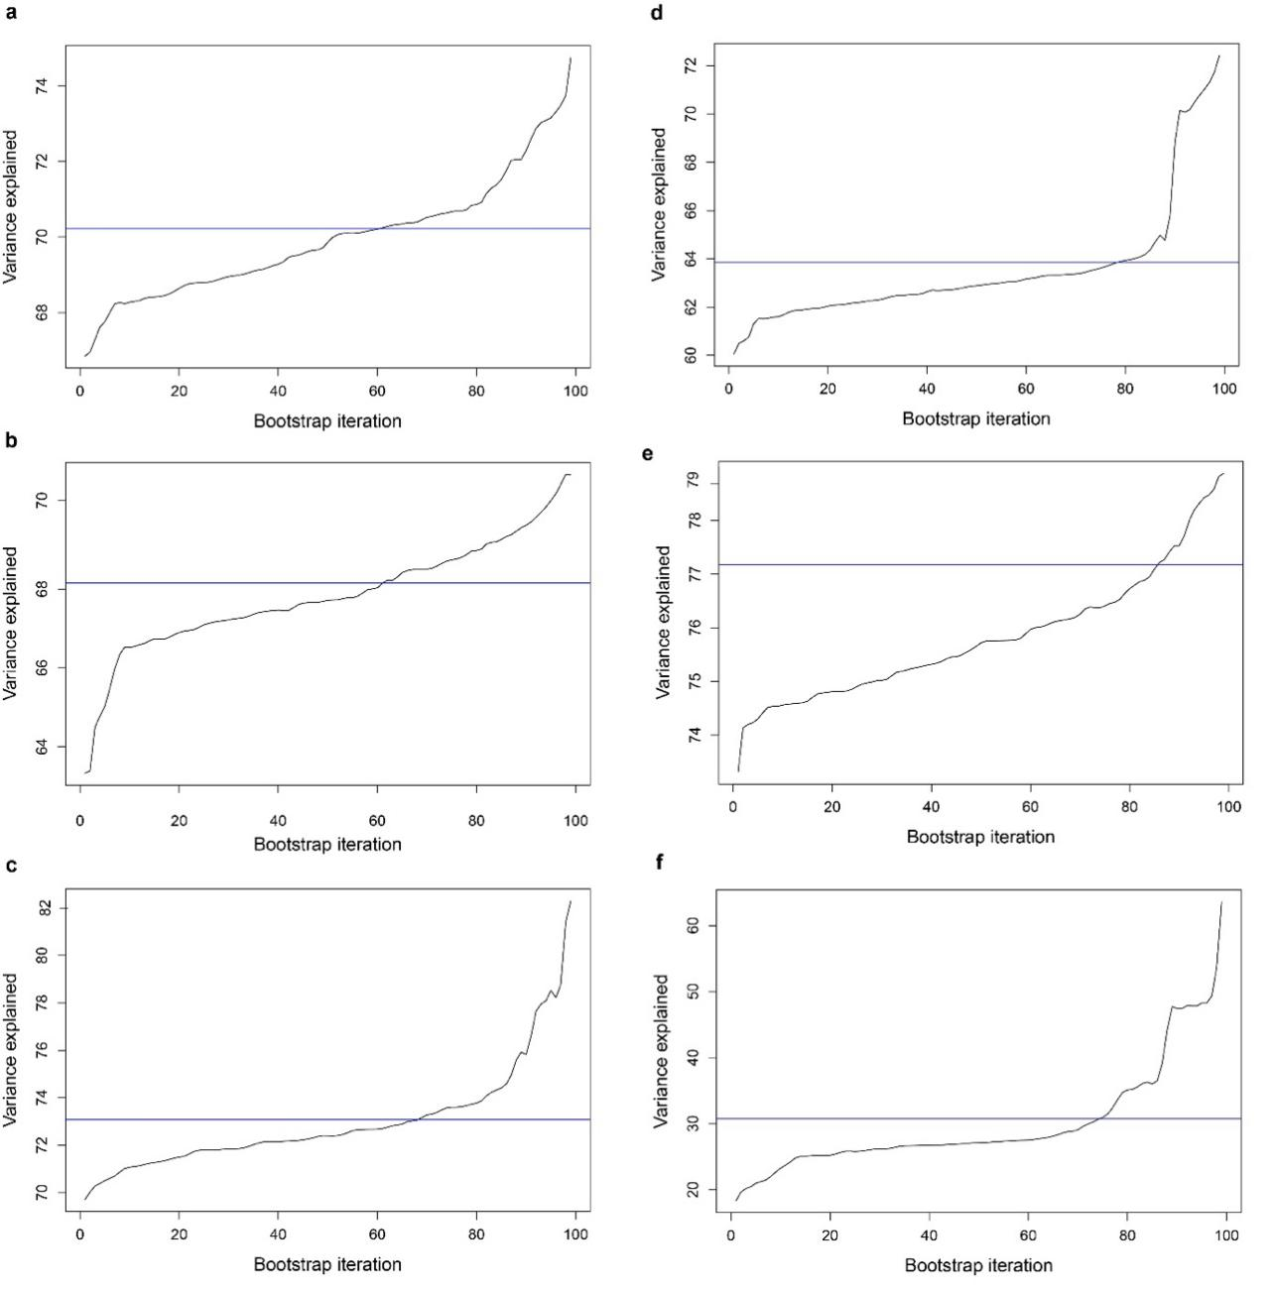
Extended Data Fig. 3 | Cross-validation of final random forest models (with the most important predictors). (a) Ammonium oxidation to nitrate. (b) Nitrogen removal. (c) Nitrogen fixation. (d) Nitrate reduction to ammonium. (e) Mineralization. (f) Nitrogen retention index.
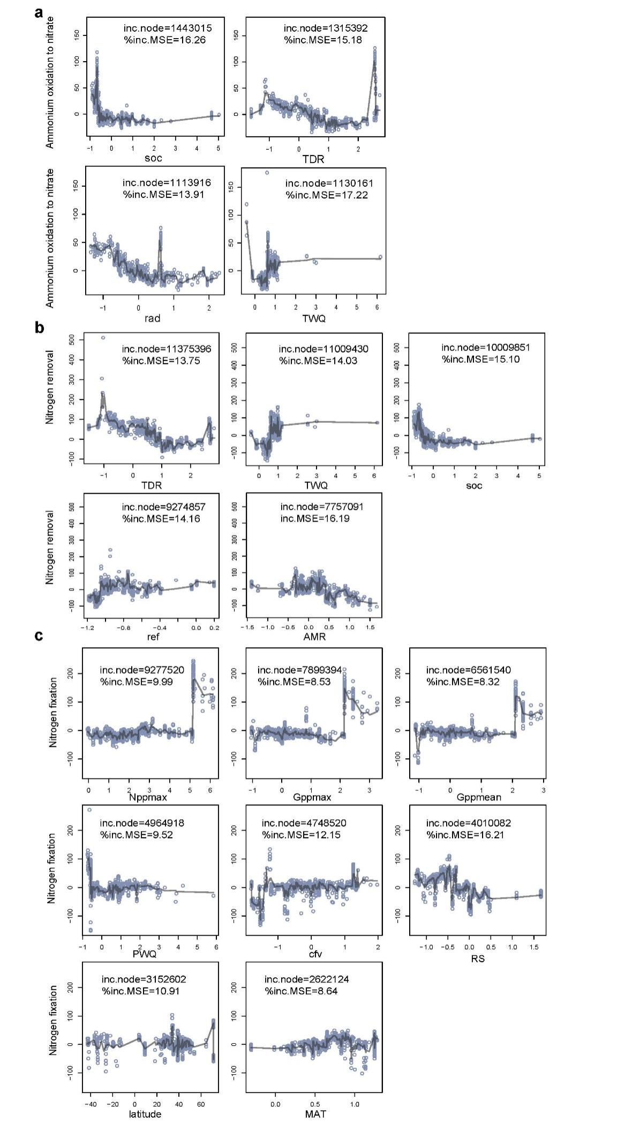
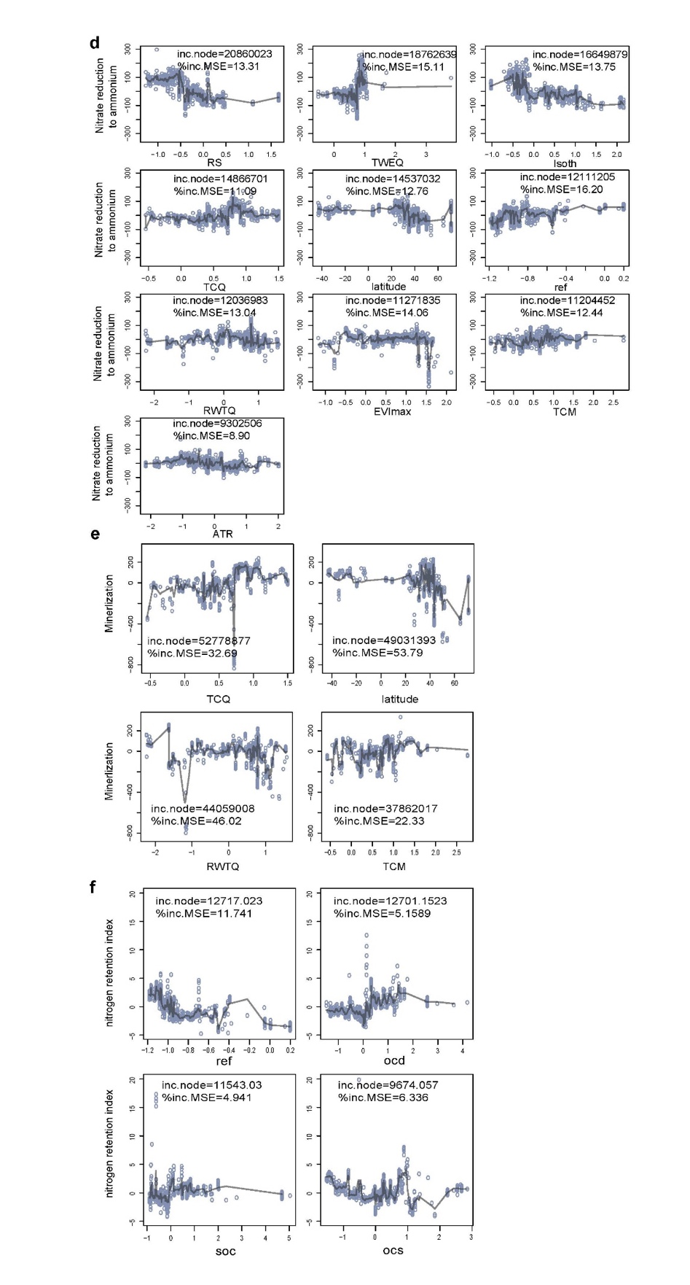
Extended Data Fig. 4 | Partial feature contributions (the marginal effect of a variable on response) of the most important variables for N-cycling process driven by genes. Variable importance (inc.node ) is the decrease in the residual sum of squares that results from splitting regression trees using the variable. The percentage increase in mean squared error (% inc.MSE) is the increase in model error as a result of randomly shuffling the order of values in the vector. (a) Ammonium oxidation to nitrate. (b) Nitrogen removal. (c) Nitrogen fixation. (d) Nitrate reduction to ammonium. (e) Mineralization. (f) Nitrogen retention index.
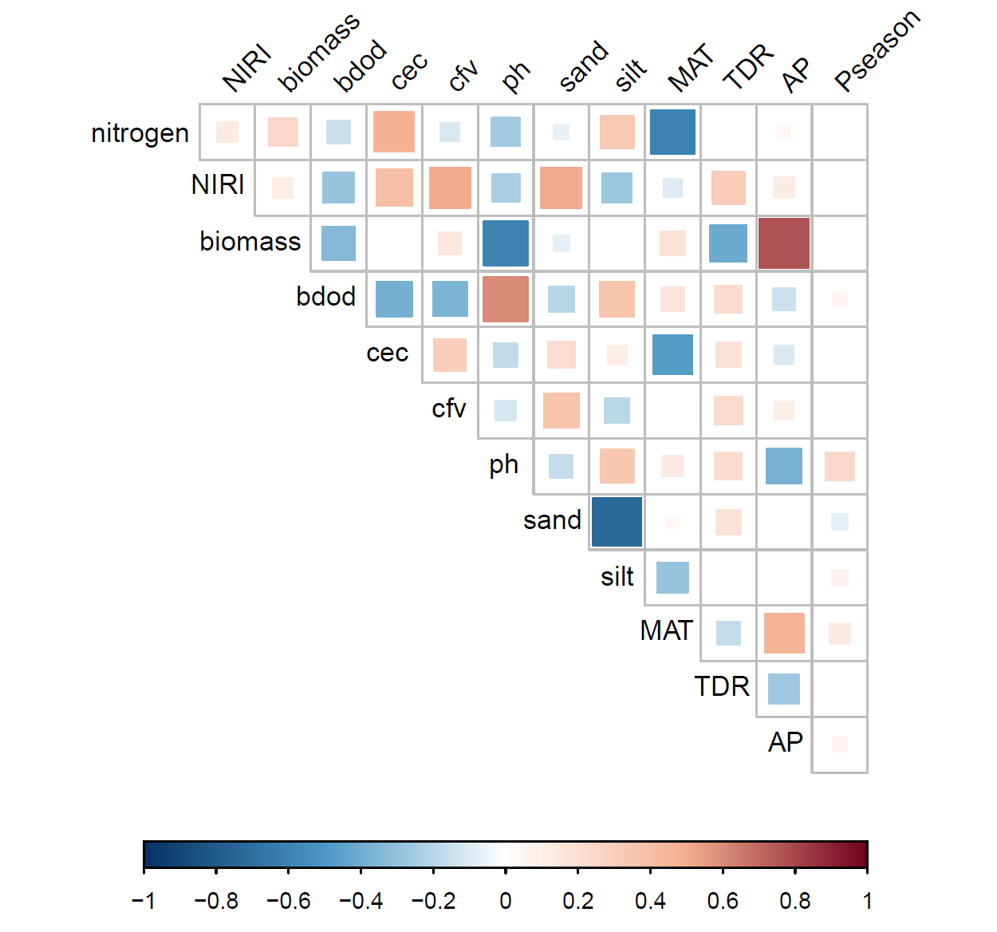
Extended Data Fig. 5 | The relationship between nitrogen, NIRI, environmental factors.

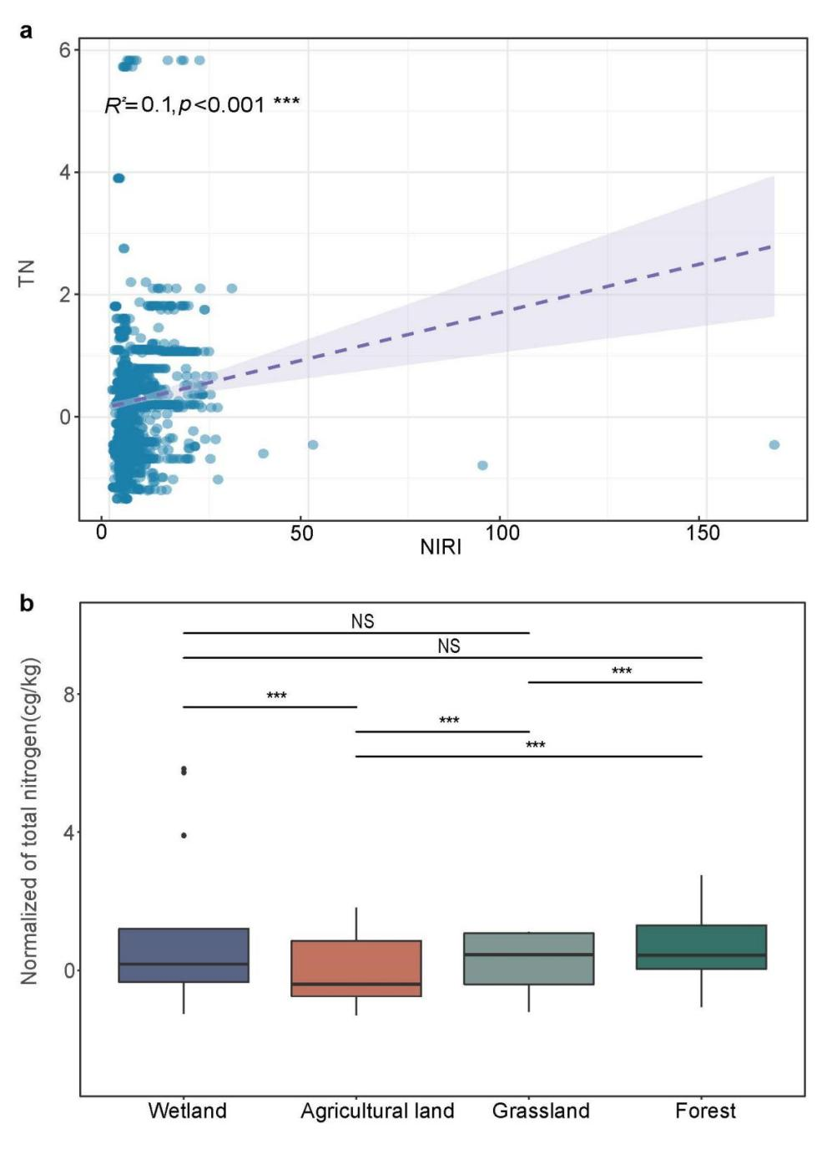
Extended Data Fig. 6 | (a) The relationship between NIRI and TN. (b) Box plot of the total nitrogen in different ecosystems. The upper and lower bounds of boxes correspond to the 25th and 75th percentiles, with a median line shown. Whiskers represent 1.5*IQR (interquartile range). Dots represent outliers. Significance was determined using Wilcoxon rank-sum test: *P < 0.05, **P < 0.005, ***P < 0.00005. NS is not significant.

Extended Data Table 1 | Comparison of random-forest models running with all 67 predictors (full model) and with the most important predictors (final model). AON (ammonium oxidation to nitrate), NR (N removal), NOA (nitrate reduction to ammonium), NF (N fixation), M (mineralization), nitrogen retention index (NIRI), soil total nitrogen (N).
Nitrogen pathway | Mean of squared residuals |  | Variance explained (%)
Nitrogen pathway | Full model | Final model | Full model | Final model
AON | 1256.326 | 1243.96 | 69.92 | 70.22
NR | 13191.61 | 12867.32 | 67.35 | 68.15
NOA | 46791.37 | 45777.64 | 63.06 | 63.85
NF | 10554.67 | 10216.42 | 72.19 | 73.08
M | 38913.75 | 38777.02 | 73.63 | 73.72
NIRI | 38.94638 | 37.48358 | 28 | 30.71
NIRI/N | 848.9478 | 671.9189 | 66.32 | 73.34

