Appendix 1: information about the above-ground fauna taxonomy

This appendix provides information about the identity of the above-ground small invertebrates (body size < 5 mm) collected on Stipagrostis sabulicola. While most of those species could not be fully expertised, this content will allow the link with species list in future taxonomic or ecological work on Stipagrostis sabulicola habitat. Sequencing data accession numbers to COI-5P (target region size = 658 bp) and complete 28S rDNA are provided in Table S1 of this appendix. Figures S1 – S31 are included directly at the end of this appendix. Phylogenetic trees were trimmed to show only the close phylogenetic context of each OTUs. The following ‘grey literature’ checklists of Namibian species mentioned in the text are abbreviated as follows:
NBD – The Namibia Biodiversity Database Web Site (Irish 2003-2023, consulted the 15th of October 2023).
NSSWH – Namib Sand Sea World Heritage Nomination. Annex 11. Table of Invertebrates & Protista (Seely 2012).

ARACHNIDA
Araneae
Salticidae
Salticinae sp.
Dorsally white with markings dorsally on the cephalothorax and abdomen, of variable intensity, from orange to dark brown (Figs. S1, S2) . Ventrally whitish, as the legs but with dark extremities (Fig. S3). Phylogenetic placement, among 341 Salticidae OTUs (BOLD) retrieves it as the sister group of Cembalea heteropogon (Simon, 1910) (Fig. S4), nested within the Heliophanus genus. Cembalea heteropogon is already known from Namibia (NBD). Other non-sequenced representatives of Cembalea are present in Namibia: C. hirsuta Wesołowska, 2011 and C. triloris Haddad & Wesołowska, 2011 (NBD). All three species differ from our specimens from the body colour patterns (Simon 1910, Haddad & Wesołowska 2011, Wesołowska 2011). We remain cautious regarding the genus assignation, until proper morphological analysis can be conducted.

Trachelidae
Thysanina sp.
A whitish spider with grey markings dorsally on the abdomen (Fig. S5). Phylogenetic placement, among 116 Trachelidae OTUs (BOLD) , retrieves it as sister to an unidentified Thysanina sp. the pair being sister to Thysanina gracilis Lyle & Haddad, 2006 (Fig. S6). This latter species and several other Thysanina spp. are known to occur in Namibia (Lyle & Haddad, 2006). Its white colour seems similar to Thysanina serica Simon, 1910 but the abdominal pattern differs (Lyle & Haddad, 2006).

Oribatida
Zygoribatula sp.
Roundish, brown shelled oribatid mite (Figs S7, S8), retrieved abundantly on S. sabulicola. Morphological investigations were conducted allowing us to recognize an undescribed species of the species-rich genus Zygoribatula. The species description is pending.

Pseudoscorpionides
Olpiidae
Nanolpium sp.
?= Nanolpium sp. B : Judson & Heurtault (1996) p. 324.
White pseudoscorpion with dark claws (Fig. S9). Found sister to Olpium pallipes (Olpiidae) (Fig. S10). Another Olpiidae, “Nanolpium sp. B” was previously reported from S. sabulicola, 6 km South-West of Gobabeb (Judson & Heurtault 1996). We confirmed morphologically the Nanolpium identity (Beier 1964, 1966). It is likely that our species is the same as the one reported by Judson & Heurtault (1996), being rather common on S. sabulicola, and also being the only Pseudoscorpion species we collected here.

INSECTA
Coleoptera
Cucujoidea
Cybocephalidae
Cybocephalus sp.
Dark, shiny, rounded beetle, dorsally convex, with the ability to fold its head under the pronotum (Figs S11, S12). The final step of our phylogenetic placement included 377 OTUs representing seven families of Coleoptera; and retrieved this species as sister-ground to Cybocephalus (being the only Cybocephalidae publicly represented on BOLD). Subtree is shown in Fig. S13. Assignation to Cybocephalus was then confirmed by Dr. Trevor Smith, from pictures. The NBD reports only two species of Cybocephalidae, Cybocephalus dudichi Endrödy-Younga, 1962 and Cybocephalus rudebecki Endrödy-Younga, 1967, but further study is necessary to confirm our species identity. No Cybocephalidae were reported from the Namib Sand Sea to our knowledge. Cybocephalus species are primarily feeding on scale insects, and complement their diet with pollen (Smith 2022).
Coccinellidae
Exochomus flaviventris Mader, 1954
Round ladybird with black elytra and yellow spots on the prothorax, the frons and the clypeus (Fig. S14). Abdominal sterna 1 to 3 ventrally mostly black, turning yellow toward the sides, abdominal sterna 4 to 6 ventrally yellow (Fig. 15). We collected a single specimen of this species, with colours matching the male of Exochomus flaviventris Mader (Fabres et al. 1981), which is also reported in the Namib Sand Sea (NSSWH). E. flaviventris is a well documented predator of mealybugs and scale insects (Fabres et al. 1981). E. flaviventris has been reported to be the biggest consumer of cassava associated coccids, compared to other cassava associated ladybirds (Kanika-Kiamfu et al. 1993). DNA barcode unfortunately not obtained.
Curculionidae
Tychiini
Sibinia sp.
Light brown weevil (in ethanol), Fig. S16. Our rapid phylogenetic placement retrieved this species nested in Sibinia. The final step included 82 OTUs representing Sibinia and the closest genera selected from the preliminary tree (Eubulus, Micrelus, Cleopomiarus, Miarus, Ochyromera, Plocetes, Lignyodes). Subtree is shown in Fig. S17. Bootstrap values are low at the Sibinia node. We then confirmed that the species was fitting with the morphological diagnosis of Sibinia provided by Clark (1978): sides of abdominal sternum 2 covering sides of sternum 3 and 4 and pygidium exposed, protruding from the elytra. Sibinia luteoviridis (Gyllenhal, 1836) and Sibinia micros Caldara, 1989 were previously recorded in the vicinity of Gobabeb, in pitfall traps in the bed of the ephemeral Kuiseb river (Henschel et al. 2003). Further morphological analysis is required to check whether Sibinia sp. belongs to any of the two species known from the Kuiseb. According to Clark (1978), Sibinia species are exclusive plant feeders, and spend most of their life on the host plant.

Hemiptera
Cicadomorpha
Cicadellidae
Deltocephalinae sp.
A pale, flat and elongated leafhopper with a strongly spatulate crown (Figs S18–S20). The spatulate crown and hind leg chaetotaxy of the juveniles are fitting with Paradorydiini (according to Dmitriev 2001) but our specimens do not have the distinct median carina on the crown usually present in this group (Dmitriev 2001). For phylogenetic placement we retrieved 94 sequences of 28S rDNA of Deltocephalinae on genbank. Our species was found sister to the single Paradorydiini OTU: Paradorydium lanceolatum (Fig. S21). This genus is known from Namibia (P. paradoxum (Herrich-Schäffer, 1837) and P. quadrigonum (Naudé, 1926)), but none of the species matches the one presented here. We thus estimate our species to be a close relative of the genus Paradorydium, but remain careful with the taxonomic assignment due to the morphological discrepancy. Paradorydium spp. are commonly feeding on grasses, which is fitting with our species being collected on S. sabulicola.

Coccomorpha

Diaspididae sp.
This armoured scale insect was retrieved as a sister group of Parlatoria (2 spp on BOLD: P. pergandii and P. theae), with a bootstrap support of 30%. We consider that taxonomic assignment beyond the family is not currently possible with the barcode sequence. Morphological analysis will be required for genus and species determination. The species is found abundantly on the stem of S. sabulicola, encroached under the sheaths and is evidently a sap feeder. From the Sand Dune Sea, the Diaspididae Namibia spinosa Munting 1969 has been previously reported (Namibia National Committee for World Heritage 2012), but found on Acacia sp., but it seems that the Diaspididae on Stipagrostis sabulicola have never been formally identified. The honeydew produced by the Diaspididae associated with Stipagrostis sabulicola has been previously indicated as a food source for the desert dune ant Camponotus detritus (Curtis 2015).

Pseudococcidae sp.
From our sampling, all mobile individuals that resemble scale insects were devoid of silks. Some are probably the larvae of the Diaspididae sp. FPO. A larger specimen was picked for sequencing. Our phylogenetic placement recovered it nested within Pseudococcidae. Within the family, node bootstrap supports are generally extremely low. Our species is nested in a clade that regroups some Phenacoccus (paraphylatic), Pseudococcus (polyphyletic) and Antonina. We consider that taxonomic assignment beyond the family is not currently possible with the barcode sequence. Morphological analysis will be required.

Hymenoptera
Chalcididae
Haltichellinae
Haltichellinae sp. FPO
For this species, phylogenetic placement based purely on BOLD COI public data could not be achieved, due to the high level of retrieved paraphyly/polyphyly of and within the families of Parasitoid wasps. We retrieved all 18S rDNA, 28S D2D3 and 28S D5 sequences listed in the Chalcidoidea dataset of Heraty et al. (2013) (see their Appendix 1). Alignment was done with Muscle, and performed a ML inference with Raxml-ng using the GTR+G model. We retrieved the species nested within Haltichellinae. Chalcididae associated with Stipagrostis sabulica were previously reported (Prinsloo 1981).

Psocodea
Liposcelidinae
Liposcelis sp.
Flat, wingless booklice (Fig. S28). Only a partial COI-5P could be retrieved from the sequencing data, with a reading frame broken in 5’. Nonetheless, the species is found nested within Liposcelis (Fig. S29) also fitting with the morphological habitus of the collected specimen. Liposcelis spp. have a mixed diet and can consume fungi and dead plant and animal material. On S. sabulicola, they seemed more abundant on the senescent and dead leaves.

Thysanoptera
Phlaeothripidae
Haplothrips sp.
Black thrips (Fig. S30). After a rapid phylogenetic placement identifying it as a Phlaeothripidae, we retrieved all 28S sequences of this family on genbank and ran another analysis. Our species nested among Haplothrips species. We then retrieved all Haplothrips COI sequences on Genbank and BOLD and merged both sets. Our species was found sister of Haplothrips cenchricola, those species being nested in a strongly supported clade including several species of Haplothrips (Fig. S31).
Haplothrips nigricornis and H. tardus have been reported from Namibia (NBD). Our species does not match with H. nigricornis represented on Genbank / BOLD (H. tardus not represented). Haplothrips species are polliniser, some are suspected to be predatory.

FIGURES.
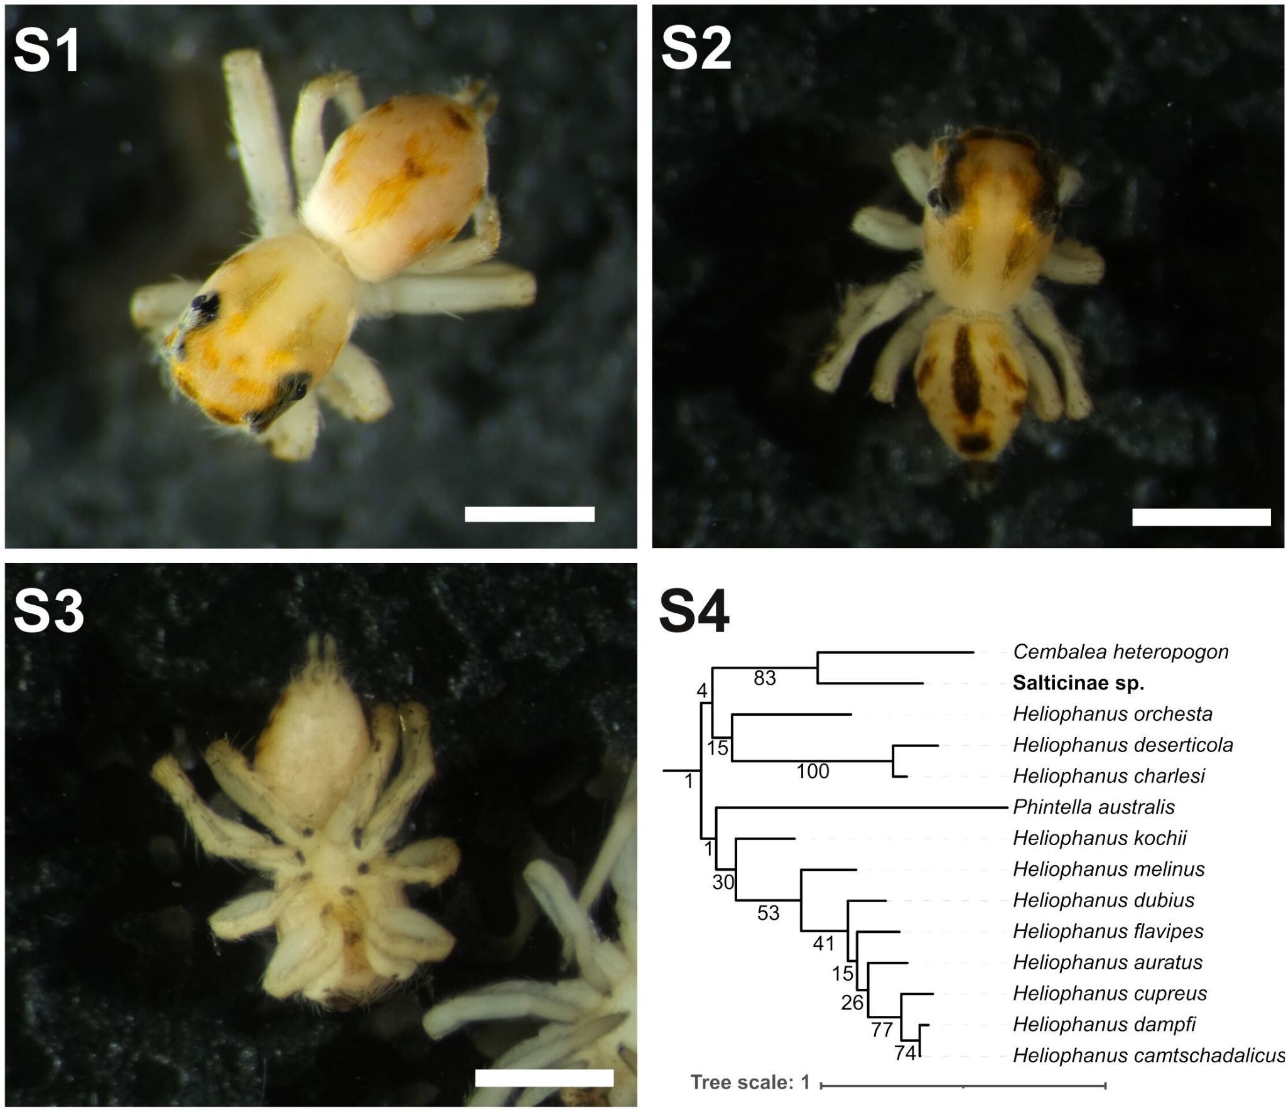
Figures S1–4: Salticinae sp. S1 dorsal side, S2 dorsal side colour variant, S3 ventral side, S4 phylogenetic placement among BOLD OTUs (COI-5P) using maximum likelihood criterion, bootstrap supports shown next to the nodes, our species shown in bold.

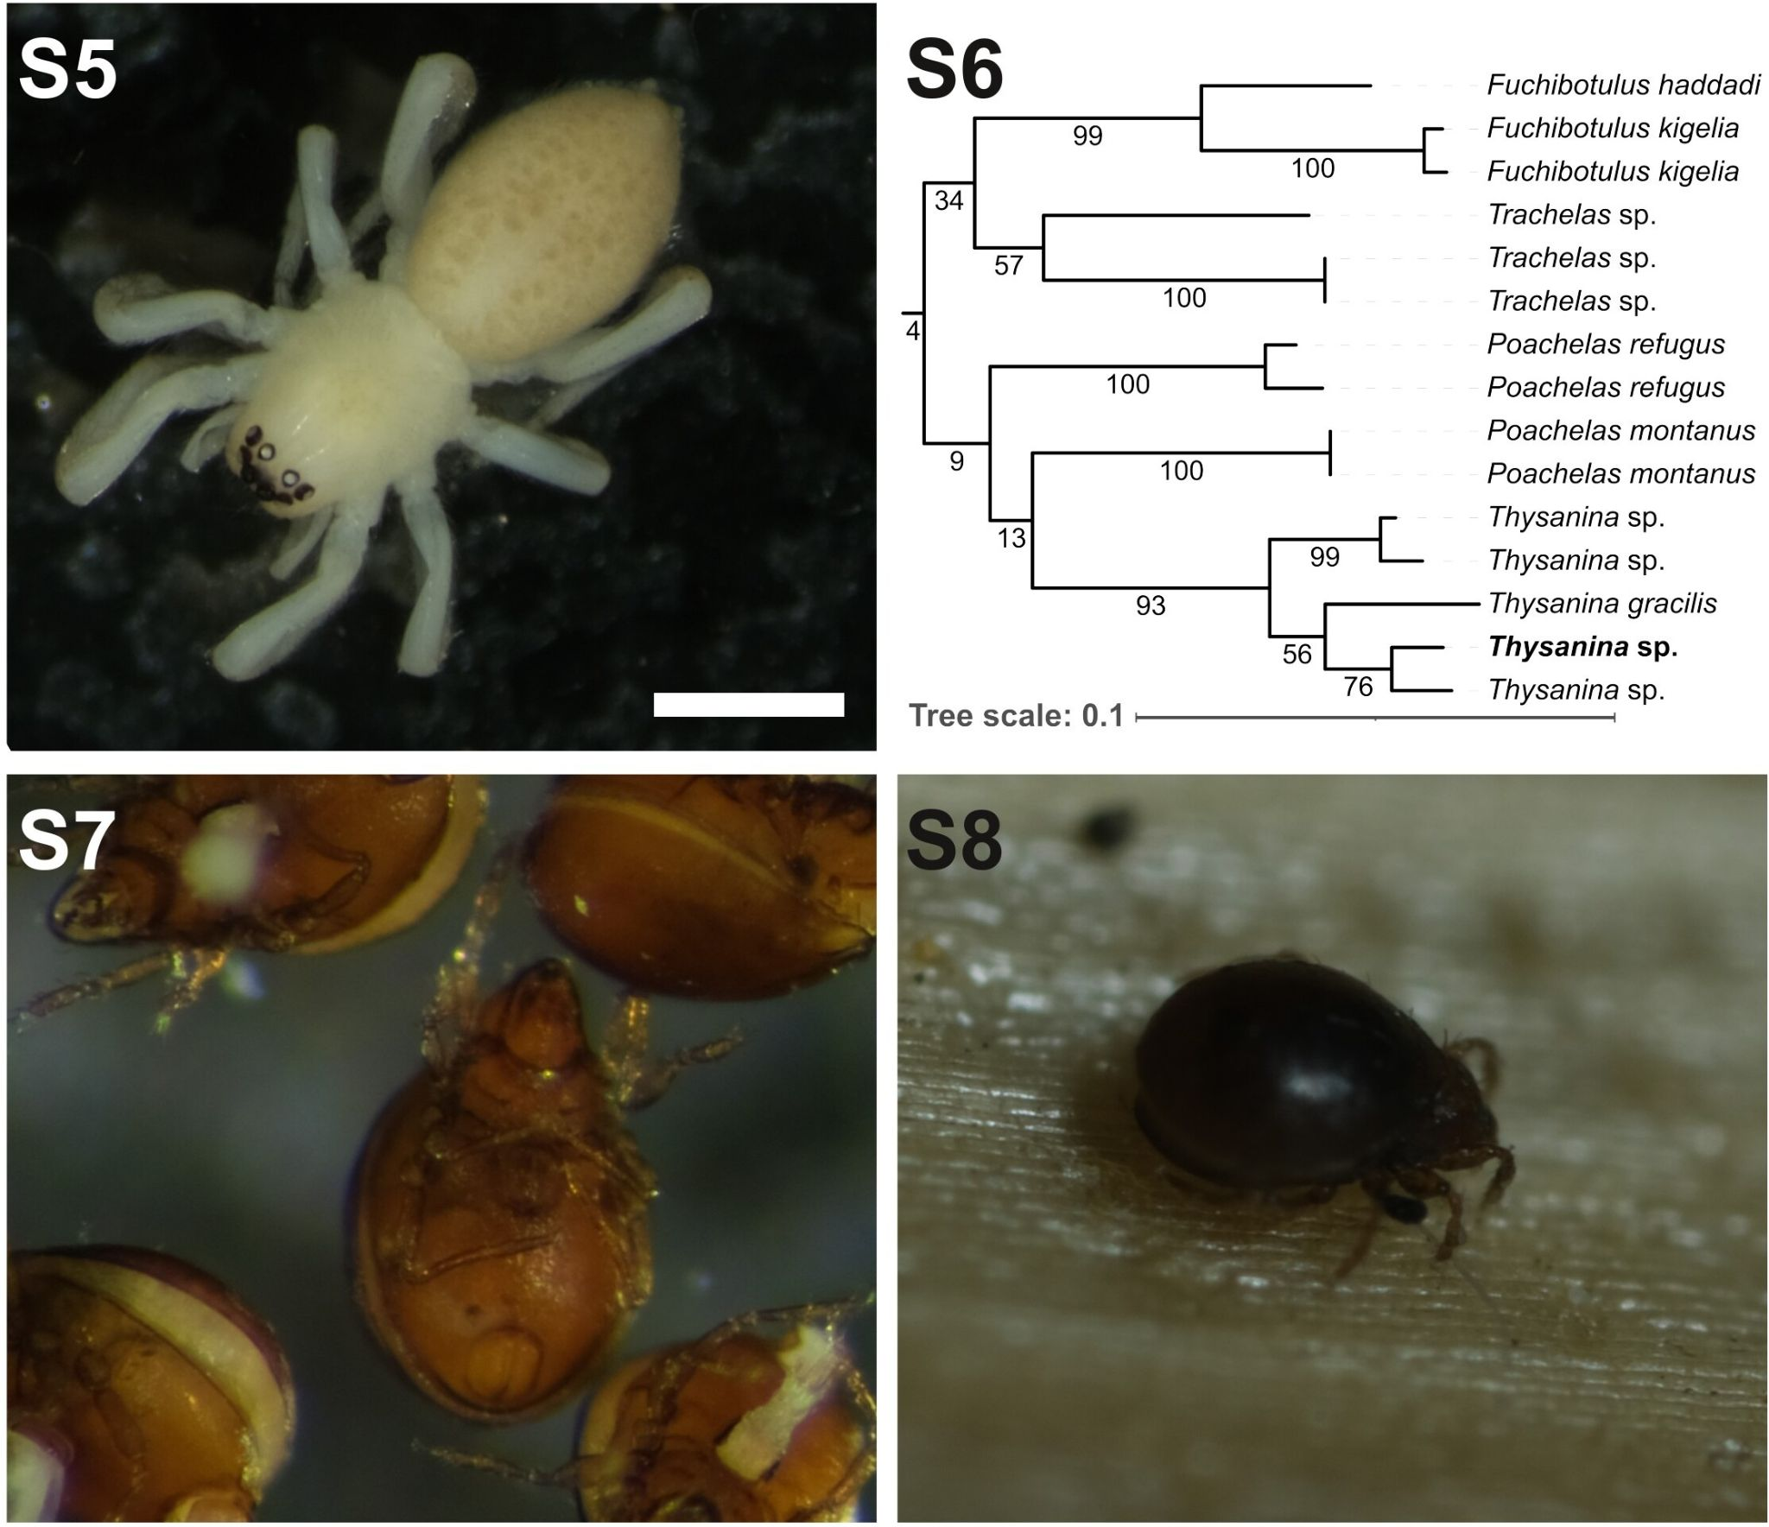
Figures S5–S6: Thysanina sp. S5 dorsal side, S6 phylogenetic placement among BOLD OTUs (COI-5P) using maximum likelihood criterion, bootstrap supports shown next to the nodes, our species shown in bold. Figures S7–S8: Zygoribatula sp. S7 ventral side, S8 on the stem of S. sabulicola.
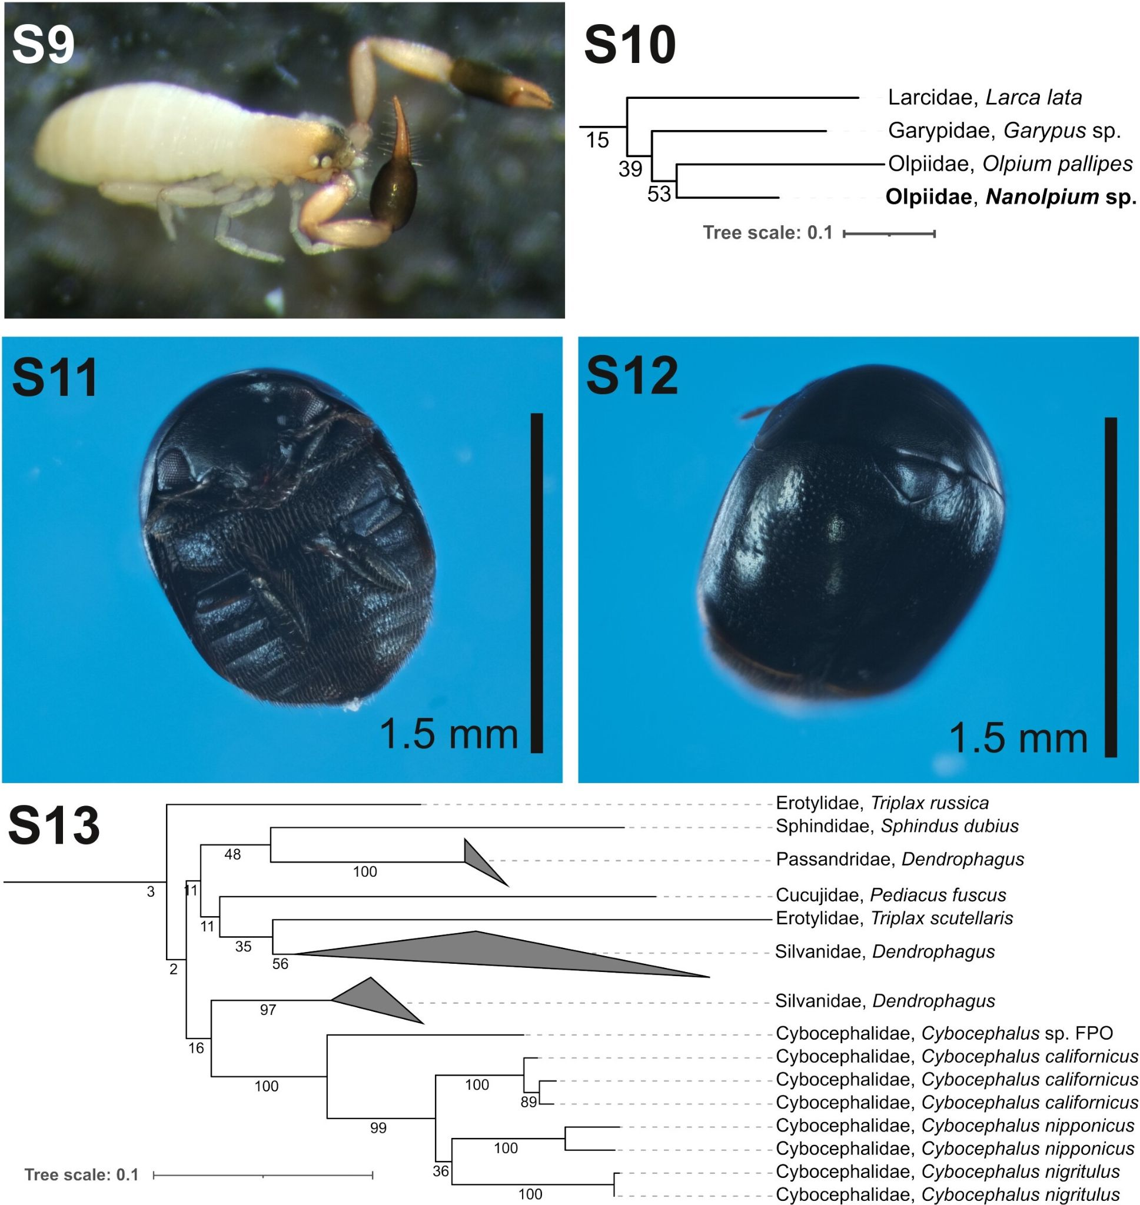
Figures S9–S10: Nanolpium sp. S9 dorsal side, S10 phylogenetic placement among BOLD OTUs (COI-5P) using maximum likelihood criterion, bootstrap supports shown next to the nodes, our species shown in bold. Figures S11–S13: Cybocephalus sp. S11 dorsal side, S12 ventral side; S13 phylogenetic placement among BOLD OTUs (COI-5P) using maximum likelihood criterion, bootstrap supports shown next to the nodes, our species shown in bold.
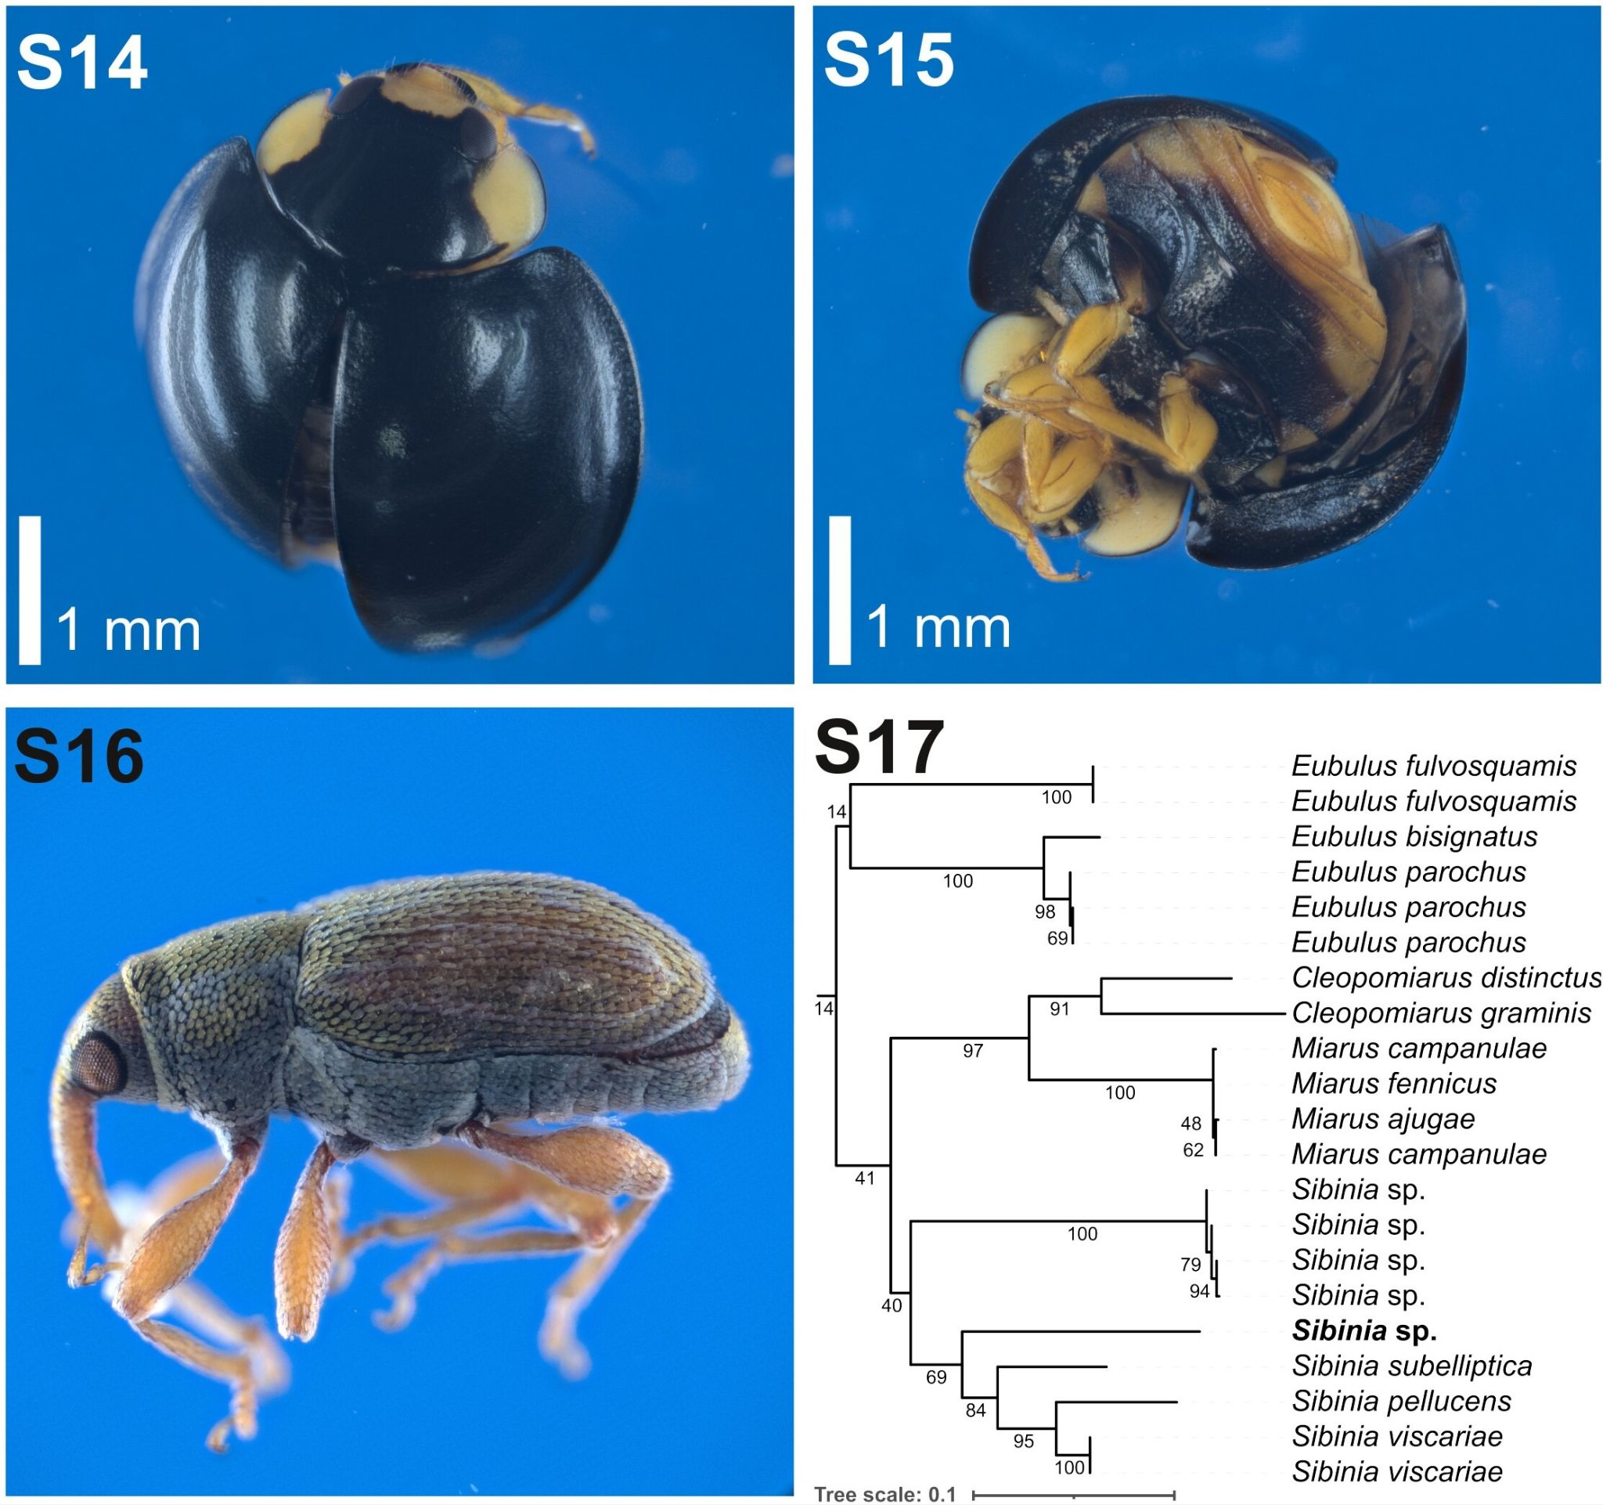
Figures S14–S15: Exochomus flaviventris S14 dorsal side, S15 ventral side.
Figures S16–S17: Sibinia sp. S16 lateral side; S17 phylogenetic placement among BOLD OTUs (COI-5P) using maximum likelihood criterion, bootstrap supports shown next to the nodes, our species shown in bold.

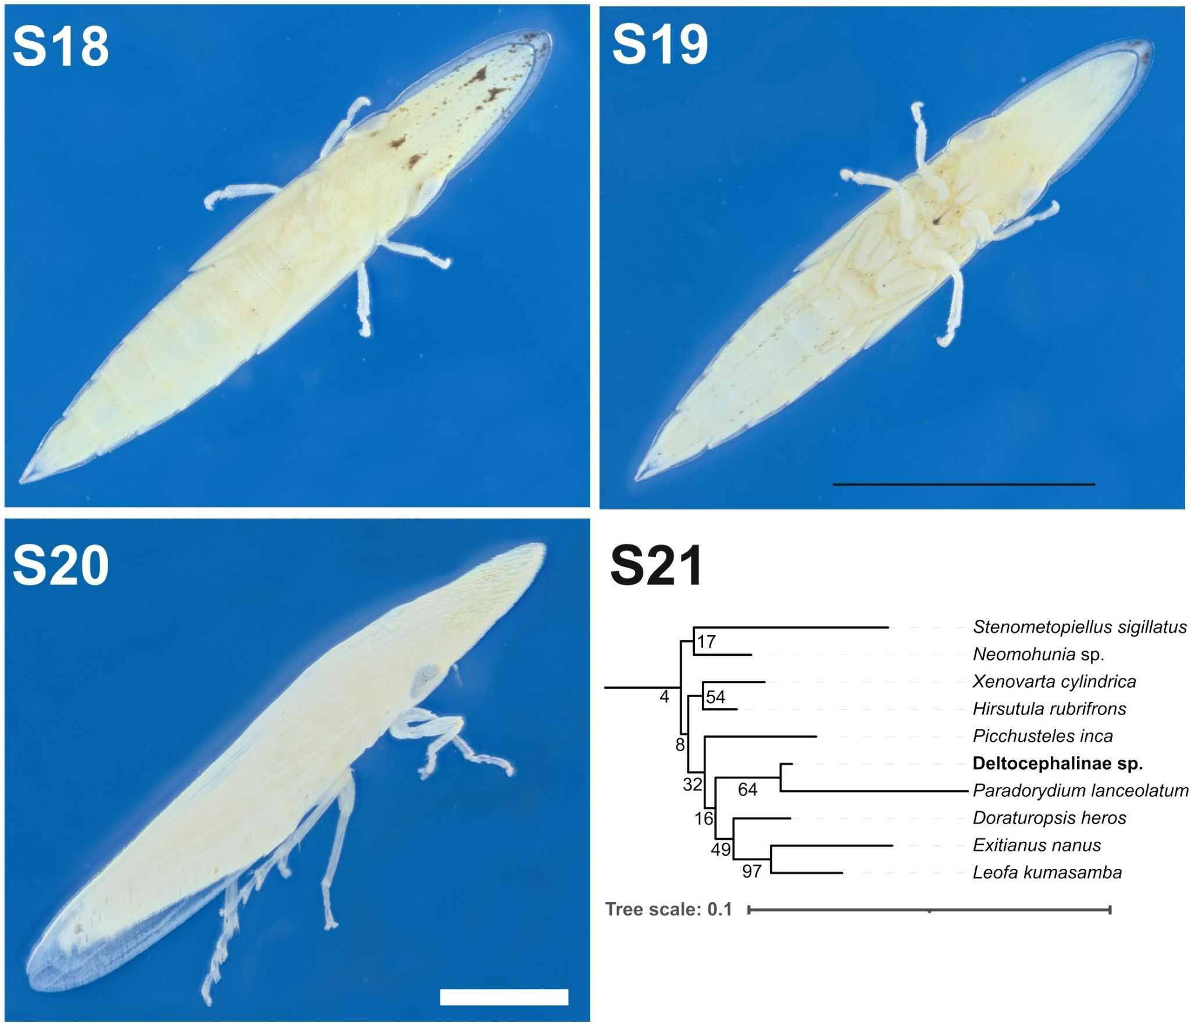
Figures S18–S21: Deltocephalinae sp. S18 larva dorsal side, S19 larva ventral side, S20 adult, dorso-lateral view, S21 phylogenetic placement among BOLD OTUs (COI-5P) using maximum likelihood criterion, bootstrap supports shown next to the nodes, our species shown in bold.

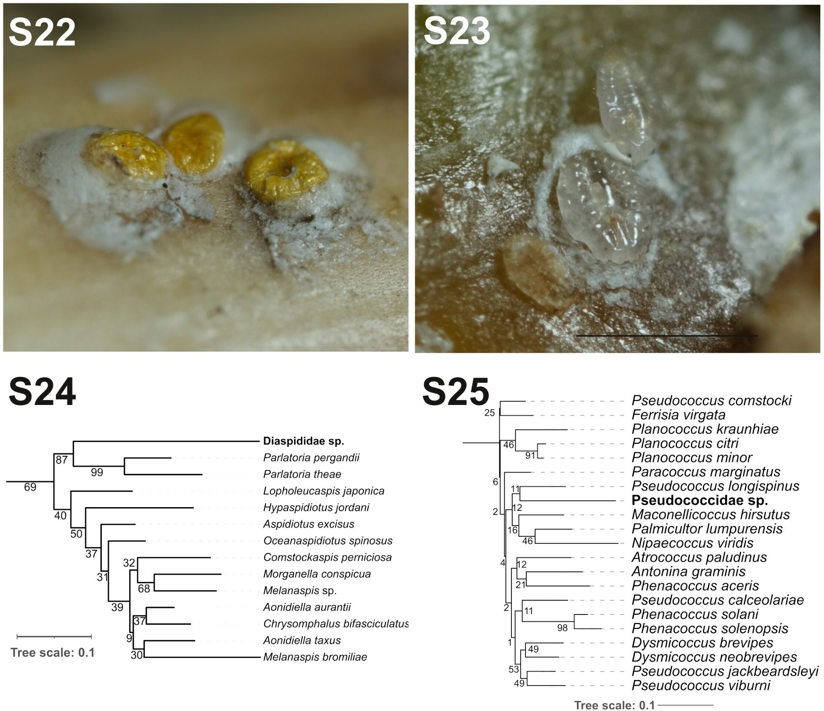
Figures S22–S24: Diaspididae sp. S22 individuals on S. sabulicola, S23 manually uncovered adult body, S24 phylogenetic placement among BOLD OTUs (COI-5P) using maximum likelihood criterion, bootstrap supports shown next to the nodes, our species shown in bold. Figure S25 : Pseudococcidae sp., phylogenetic placement among BOLD OTUs (COI-5P) using maximum likelihood criterion, bootstrap supports shown next to the nodes, our species shown in bold.
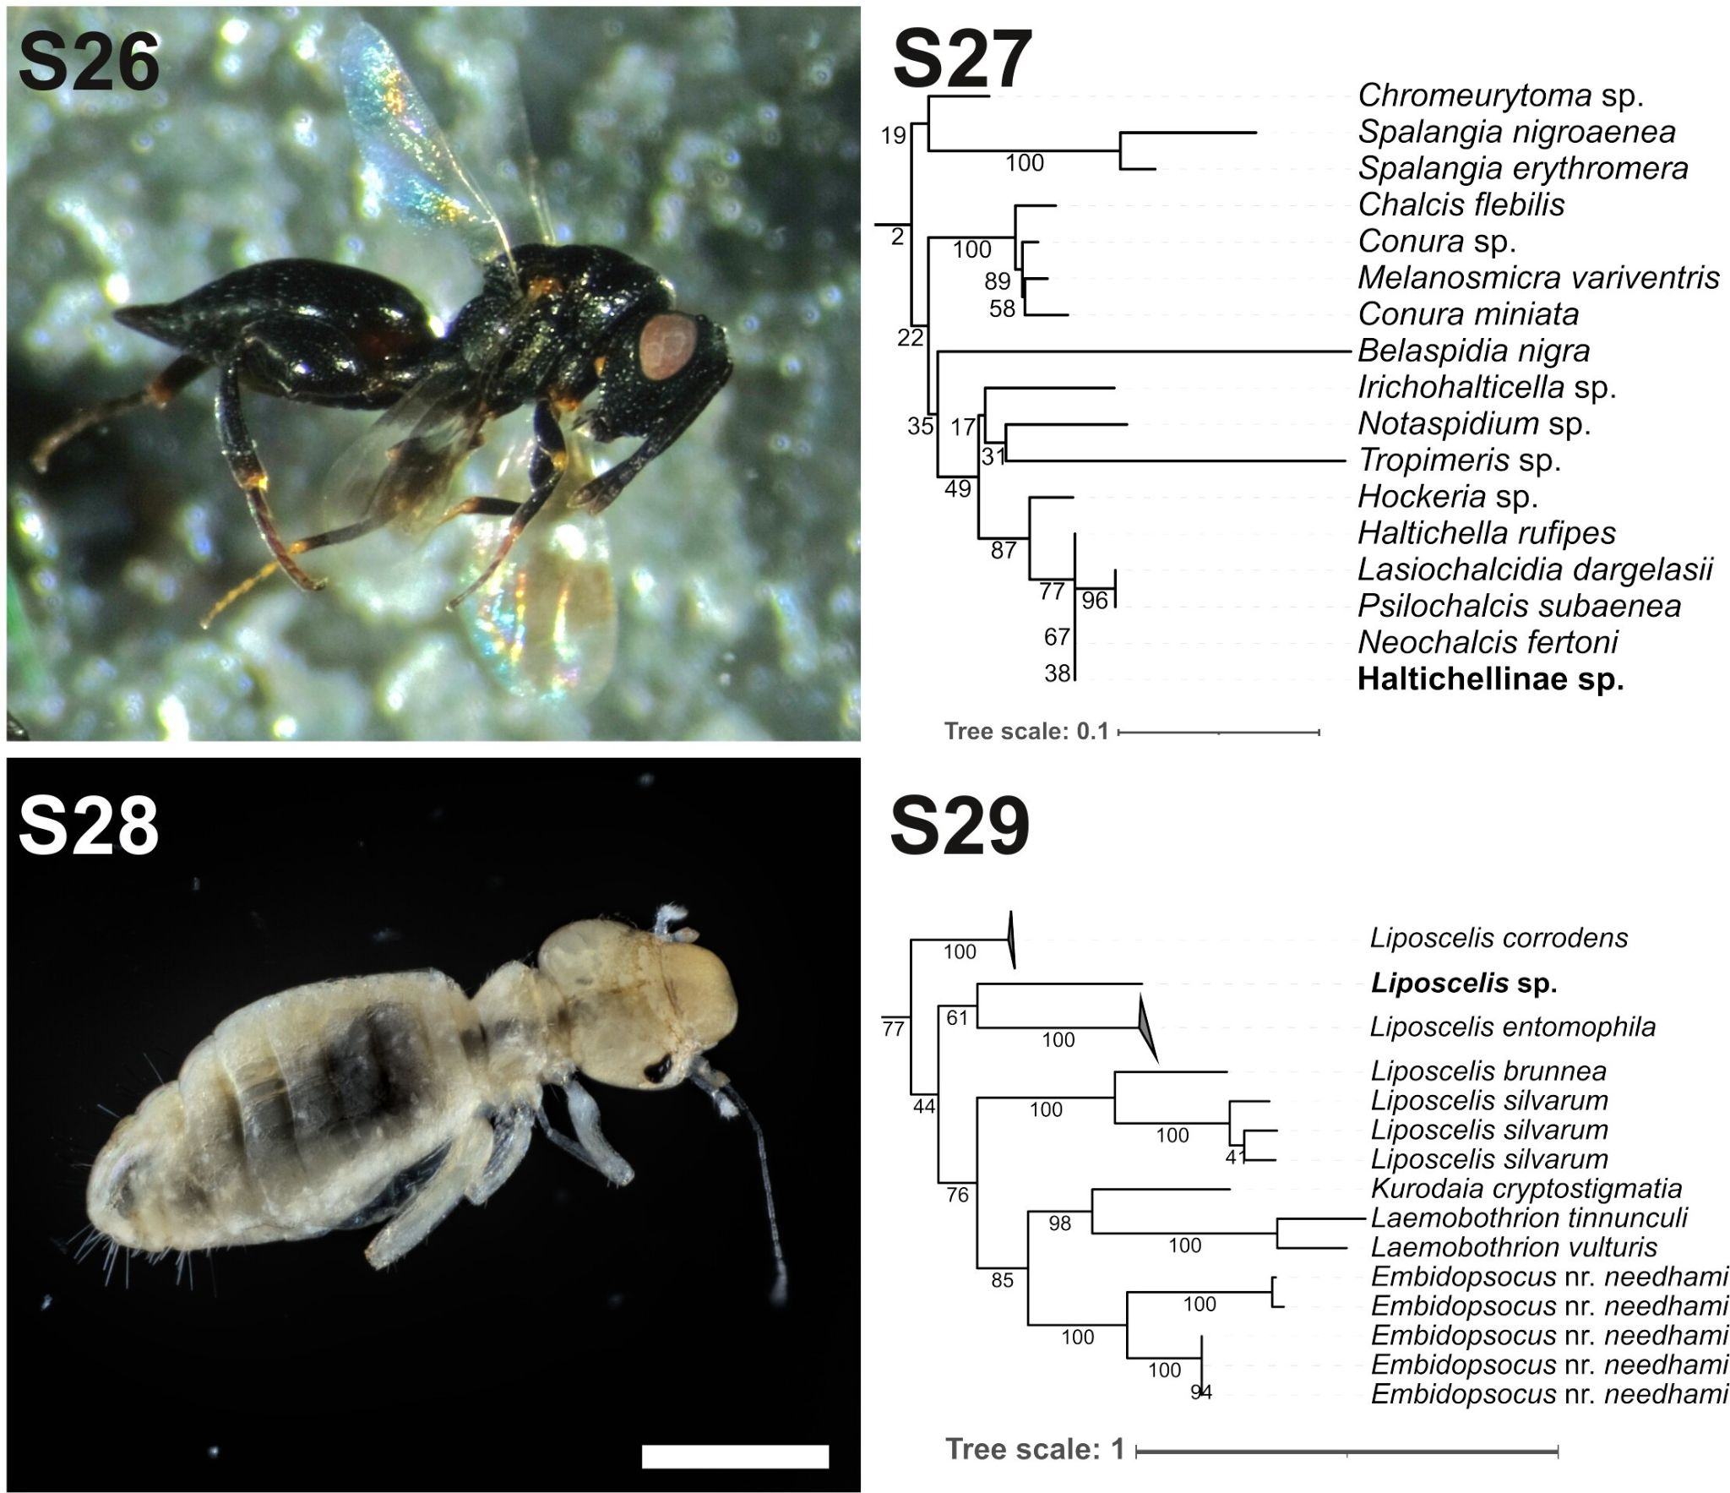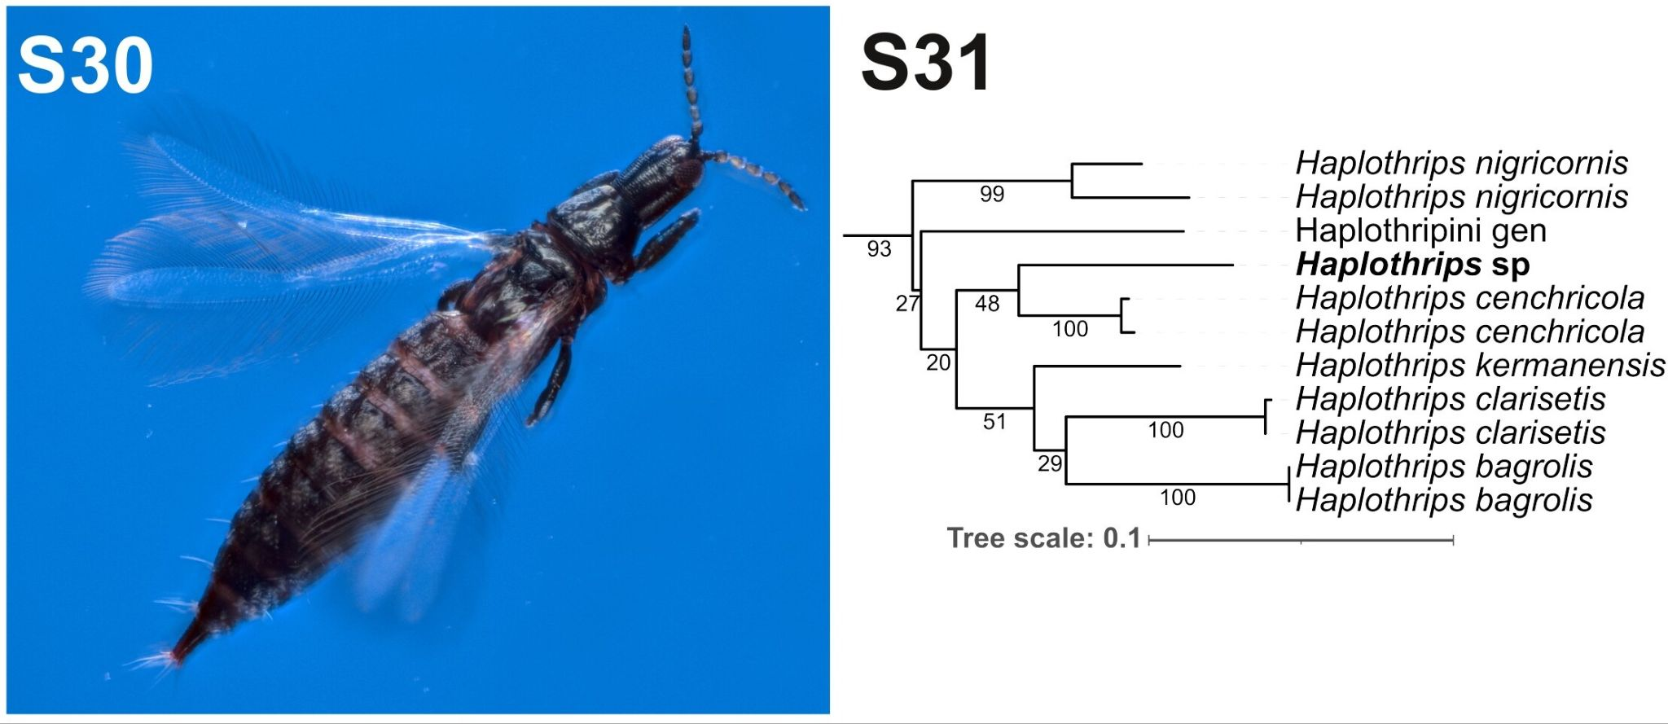
Figures S26, S27: Haltichellinae sp. S26 lateral side, S27 phylogenetic placement among Genbank OTUs (18S + 28S) using maximum likelihood criterion, bootstrap supports shown next to the nodes, our species shown in bold. Figures S28, S29 : Liposcelis sp. S28 dorsal side, S29 phylogenetic placement among BOLD OTUs (COI-5P) using maximum likelihood criterion, bootstrap supports shown next to the nodes, our species shown in bold. Figures S28, S29 : Haplothrips sp. S30 dorsal side, S31 phylogenetic placement among BOLD + Genbank OTUs (COI-5P) using maximum likelihood criterion, bootstrap supports shown next to the nodes, our species shown in bold.
TABLE.
Table S1: Genbank accession number for the COI-5P and 28S rDNA of the sequenced species.
Taxon | COI Accession number | 28S Accession Number
Salticinae sp. | TO BE PROVIDED | TO BE PROVIDED
Thysanina sp. | TO BE PROVIDED | TO BE PROVIDED
Nanolpium sp. | TO BE PROVIDED | TO BE PROVIDED
Zygoribatula sp. | TO BE PROVIDED | TO BE PROVIDED
Cyphobelus sp. | TO BE PROVIDED | TO BE PROVIDED
Sibina sp. | TO BE PROVIDED | TO BE PROVIDED
Deltocephalinae sp. | TO BE PROVIDED | TO BE PROVIDED
Diaspididae sp. | TO BE PROVIDED | TO BE PROVIDED
Pseudococcidae sp. | TO BE PROVIDED | TO BE PROVIDED
Haltichellinae sp. | TO BE PROVIDED | TO BE PROVIDED
Liposcelis sp. | TO BE PROVIDED | TO BE PROVIDED
Haplothrips sp. | TO BE PROVIDED | TO BE PROVIDED

REFERENCES

Beier M. (1964) Weiteres zur Kenntnis der Pseudoscorpioniden-Fauna des südlichen Afrika. Annals of the Natal Museum 16, 30–90.
Beier M. (1966) Ergänzungen zur Pseudoscorpioniden-Fauna des südlichen Afrika. Annals of the Natal Museum 18, 455–470.
Clark W. (1978) The weevil genus Sibinia: natural history, taxonomy, phylogeny, and zoogeography, with revision of the New World species. Quaestiones entomologicae 14 (2), 92–389.
Curtis B. A. (1985) Activity of the Namib Desert dune ant, Camponotus detritus. South African Journal of Zoology 20, 41–48.
Dmitriev D. A. (2001) Larvae of some species of the subfamily Eupelicinae (Homoptera: Cicadellidae). Zoosystemalica Rossica 9 (2), 353–357.
Fabres G., Kiyindou A. and Epouna-Mouinga S. (1981) Les Entomophages inféodés à la cochenille du manioc Phenacoccus manihoti (Hom. Pseudococcidae) en République Populaire du Congo : 2 - étude morphologique comparative de trois espèces dominantes de Coccinellidae (Col.). Cahiers ORSTOM. Série Biologie, 3–8.
Fürsch H. (1961) Revision der afrikanischen Arten um Exochomus flavipes Thunb. Col. Cocc.. Entomologische Arbeiten Museum G. Frey 12, 68–92.
Haddad C. R. and Wesołowska W. (2011) New Species and New Records of Jumping Spiders (Araneae: Salticidae) from Central South Africa. African Invertebrates 52 (1), 51–134.
Henschel J. R., Mtuleni V., Pallett J. and Seely K. M. (2003) The surface-dwelling arthropod fauna of Gobabeb with a description of the long-term pitfall trapping project. Namibia Scientific Society 51, 65–92.
Heraty J. M., Burks R. A., Cruaud A., Gibson G. A. P., Liljeblad J., Munro J., Rasplus J.-Y., Delvare G., Janšta P., Gumovsky A., Huber J., Woolley J. B., Krogmann L., Heydon S., Polaszek A., Schmidt S., Darling D. C., Gates M. W., Mottern J., Murray E., Dal Molin A., Triapitsyn S., Baur H., Pinto J. D., van Noort S., George J. and Yoder M. (2013) A phylogenetic analysis of the megadiverse Chalcidoidea (Hymenoptera). Cladistics 29 (5), 466–542.
Irish J. (2002-2023) Namibia Biodiversity Database Web Site, https://www.biodiversity.org.na, accessed the 15th of October 2023.
Judson M. L. I. and Heurtault J. (1996) Nanolpium species (Garypoidea, Olpiidae) on grasses in southern Africa - a new niche for pseudoscorpions." Proceedings of the XIIIth Congress of Arachnology, 3-8 September 1995, Geneva. Revue Suisse de Zoologie HS, 321–326.
Kanika-Kiamfu J., Iperti G. and Brun J. (1993) Étude de la consommation alimentaire d'Exochomus flaviventris (Col.: Coccinellidae) prédateur de la cochenille du maniocPhenacoccus manihoti (Hom.: Pseudococcidae). Entomophaga 38, 291–298.
Lyle R. and Haddad C. R. (2006) A revision of the Afrotropical tracheline sac spider genus Thysanina Simon, 1910 (Araneae: Corinnidae). African Invertebrates 47, 95–116.
Smith T. (2022) Review of the Cybocephalidae (Coleoptera) of North America and the West Indies with descriptions of two new species of 𝐶𝑦𝑏𝑜𝑐𝑒𝑝ℎ𝑎𝑙𝑢𝑠 Erichson. Insecta Mundi 0950, 1–35.
Umeh E.-D. N. (1990) Exochomus troberti Mulsant (Coleoptera: Coccinellidae): A predator of cassava mealybug, Phenacoccus manihoti Mat-Ferr (Homoptera: Pseudococcidae) in southeastern Nigeria. International Journal of Tropical Insect Science 11 (02), 189–195.
Wesołowska W. (2011) New species and new records of jumping spiders from Botswana, Namibia and Zimbabwe (Araneae: Salticidae). Genus 22 (2), 307–346.
Seely M. (Ed.), (2012) Namib Sand Sea World Heritage Nomination. Annexes. Namibia National Committee for World Heritage, Windhoek, 1–496.

