Catechol-Conjugated Alginate Biopolymer for Eco-Friendly Synthesis of Gold Nanoparticles: A Promising Approach for Photothermal and Radiotherapy in Breast Cancer Treatment
Mohammadreza Ghaffarlou¹, Hamid Rashidzadeh², Ali Mohammadi², Navid Mousazadeh², Murat Barsbay¹, Ali Sharafi², Mahmoud Gharbavi^{3*}, Hossein Danafar^{2*}, Siamak Javani^{4,5*}

- Hacettepe University, Department of Chemistry, Beytepe, Ankara 06800, Turkey.
- Zanjan Pharmaceutical Biotechnology Research Center, Zanjan University of Medical Sciences, Zanjan, Iran.
- Nanotechnology Research Center, Ahvaz Jundishapur University of Medical Sciences, Ahvaz, Iran
- Medical Cellular and Molecular Research Center, Golestan University of Medical Sciences, Gorgan, Iran
- School of Advanced Technologies in Medicine, Golestan University of Medical Sciences, Gorgan, Iran

*Corresponding Authors:
Mahmoud Gharbavi; Email: gharbavi1981@gmail.com
Siamak Javani; Email: siamackjavani@yahoo.com
Hossein Danafar; Email: danafar@zums.ac.ir
Number of pages: 4
Number of figures: 3
Number of tables: 0

Supporting figures

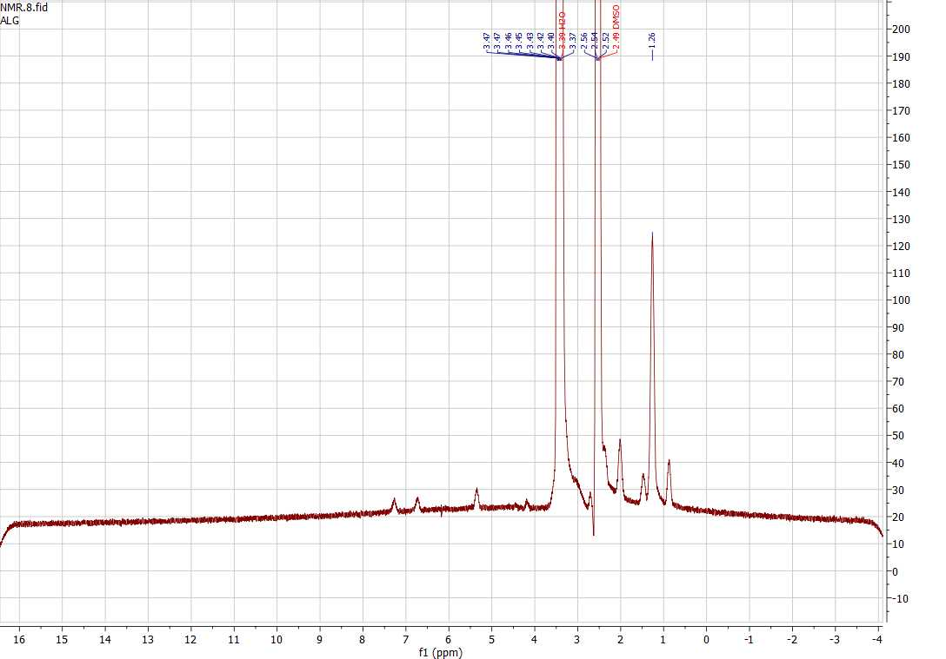
Fig. S1. ¹HNMR spectrum of Alg.

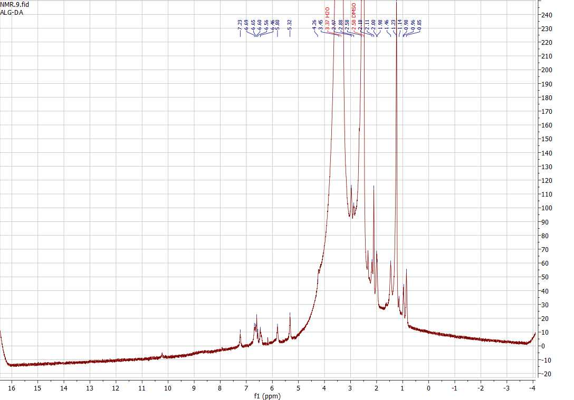

Fig. S2. ¹HNMR spectrum of Alg-DA.

Fig. S3. Hydrodynamic size of Au@Alg-DA NPs over 4 weeks.

