Target gene | substrate | Primer name | Primer sequence (5'- 3') | Amplicon size (bp) | AT (°C) | Program | Reference
16S rRNA | ……. | 1055f | ATGGCTGTCGTCAGCT | 352 | 53 | 300s at 94°C, 40 cycles: 30s at 94°C, 30s at 53°C 30s at 72°C | Harms et al., 2003
16S rRNA | ……. | 1392r | AACGCGAAGAACCTTAC
c230 | aerobic aromatic hydrocarbons | C230F | AAGAGGCATGGGGGCGCACCGGTTCGATCA | 406 | 57 | 300s at 94°C, 40 cycles: 30s at 94°C, 30s at 57°C 30s at 72°C | Sei et al., 1999
c230 | aerobic aromatic hydrocarbons | C230R | CCAGCAAACACCTCGTTGCGGTTGCC
PAH-RHDα GN | aerobic polyaromatic hydrocarbons | PAH-RHDα GN F | GAGATGCATACCACGTKGGTTGGA | 306 | 57 | 300s at 94°C, 40 cycles: 30s at 94°C, 30s at 57°C 30s at 72°C | Cèbron et al., 2008
PAH-RHDα GN | aerobic polyaromatic hydrocarbons | PAH-RHDα GN R | AGCTGTTGTTCGGGAAGAYWGTGCMGTT
bamA | anaerobic aromatic hydrocarbons | oah_f | GCAGTACAAYTCCTACACSACYGABATGGT | 300 | 58 | 300s at 94°C, 45 cycles: 30s at 94°C, 30s at 58°C 30s at 72°C | Staats et al., 2011
bamA | anaerobic aromatic hydrocarbons | oah_r | CCRTGCTTSGGRCCVGCCTGVCCGAA
Table S1: Information of hydrocarbon degrading genes studied: Name and sequences of the primer’s pairs used to construct DNA standard and to quantify by qPCR. The amplicon size and the annealing temperature (AT) showed are the corresponding to the insert in the DNA standards.

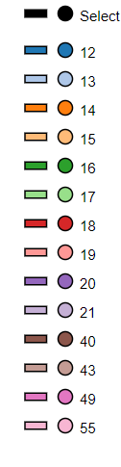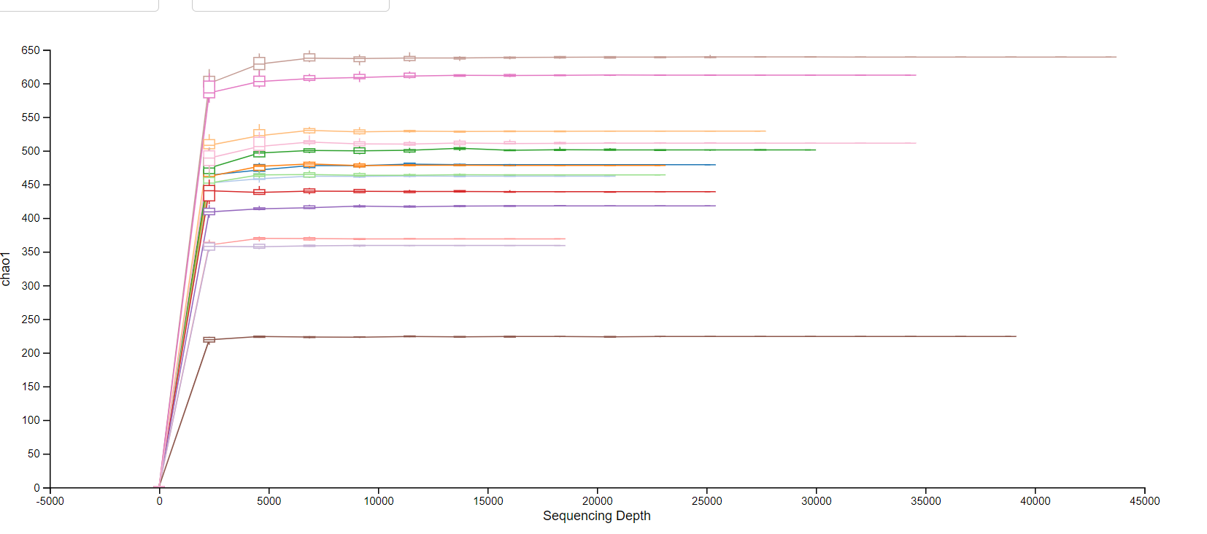
Figure S1: Rarefaction curves of sediment samples from C, D and E sites

