Supplementary Information

Synthesis and characterization of conductive flexible cellulose carbon nanohorn sheets for human tissue applications
Karthik Paneer Selvam¹, Taichi Nagahata², Kosuke Kato², Mayuko Koreishi², Toshiyuki Nakamura³, Yoshimasa Nakamura³, Takeshi Nishikawa¹, Ayano Satoh^{2*}, Yasuhiko Hayashi^{1*}
¹Graduate School of Natural Science and Technology, Okayama University, 3-1-1 Tsushima-naka, Kita-ku, Okayama, 700-8530 Japan
²Graduate School of Interdisciplinary Science and Engineering in Health Systems, Okayama University, 3-1-1 Tsushima-naka, Kita-ku, Okayama, 700-8530 Japan
³Graduate School of Environmental and Life Science, Okayama University, 1-1-1 Tsushima-naka, Kita-ku, Okayama, 700-8530 Japan
* hayashi.yasuhiko@okayama-u.ac.jp; Tel: +81-086-251-8230

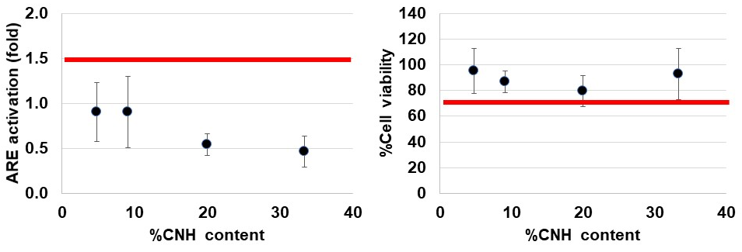
Supplementary Figure S1
The Cnh-cel sheets did not activate or kill keratinocytes according to the bioassay evaluating skin sensitization AOP#2, OECD TG442D (1.5> , %70< are the positive prediction lines, shown in red lines, respectively). Bars, SD (n=3). Note that no %CNH content dependency was detected (P>0.05, by ANOVA, https://goodcalculators.com/one-way-anova-calculator/).
Supplementary methods:
Human keratinocyte cell line, HaCaT was obtained from German Cancer Research Center (DKFZ, Heidelberg, Germany) and maintained in Dulbecco's Modified Eagle Medium supplemented 10% fetal bovine serum. Cells were transfected by pNL[NlucP/ARE/Hygro] (#CS180902, Promega) and cells expressing the transgene stably were selected by hygromycin. The assay was performed according to the SOP of OECD TG442D.
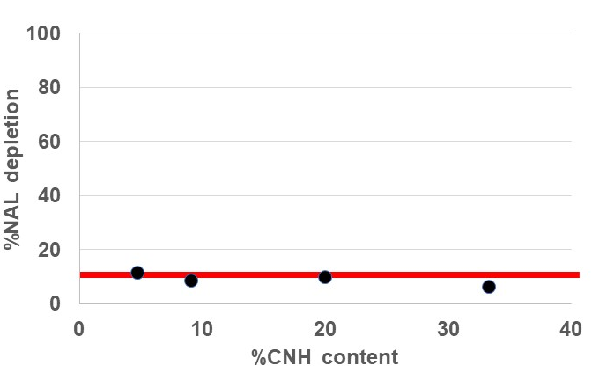
Supplementary Figure S2
The Cnh-cel sheets did not react with the test compound, N-acetyl lysine according to the assay evaluate skin sensitization AOP#1, OECD TG442C (4~11%> are the positive prediction lines, shown in red, respectively.). Note that the positive control, phenyl-acetaldehyde exhibited 88% depletion.
Supplementary methods:
The amino acid depletion reactivity assay kit was obtained from Fujifilm, Tokyo, Japan. The assay was performed according to the SOP of OECD TG442C and the manufacturer’s protocol.

