Supplementary Material
Title: Beyond biophobia: positive appraisal of bats among German residents during the COVID-19 pandemic - with consequences for conservation intentions

Authors: Tanja M. Straka, Joanna Coleman, Ewan A. Macdonald, Svea Rogge, Tigga Kingston and Maarten H. Jacobs

Tables
Table S1: Distribution channels for both surveys (2021 and 2022) with the aim to reach a broad public.
Channel | Target groups | Link
SurveyCircle | Online support platform for any kind of survey subjects for research projects and final degrees, not only researcher and students but any kind of supporter can do the surveys to collect or donate points in a ranking-system | www.surveycircle.com
Facebook | Three groups for finding survey participants among students, open to all kind of study subjects and degrees (restricted entry; access permission of the group admins) | „Umfragen für Studienarbeiten” https://www.facebook.com/groups/1438198899793916/?hoisted_section_header_type=recently_seen&multi_permalinks=3411102822503504  „Umfragen“  https://www.facebook.com/groups/1401791523441452  „Umfragen und Umfrageteilnehmer finden“  https://www.facebook.com/groups/1607738379538908
Emails | 500 + email addresses of different institutions; ranging from gardeners to kindergardens to sport clubs in Germany | see Straka et al. 2022 for more details.

Table S2: Factor analysis of discrete emotions using method = minres with „varimax“ rotation.
 | Factor 1 | Factor 2
Fear | 0.72
Anger | 0.55
Disgust | 0.70
Interest |  | 0.68
Compassion |  | 0.62
Joy |  | 0.65
Sadness* |  | 0.45
*not included due to loading below 0.50

Table S3: Effect size ± SD socio-demographic variables on positive and negative emotions based on ordinal logistic regression analyses. Effect sizes with three asterisks are have significance levels <0.001.

 | Positive Emotions  Effect ± SD  p-value | Negative Emotions  Effect ± SD  p-value
Socio-demographics
Male | 0.20 ± 0.17  p = 0.24 | -0.24 ± 0.15  p = 0.10
Other | -0.76 ± 1.34  p = 0.51 | 0.32 ± 0.86  p = 0.71
30-45 | -0.65 ± 0.20*** | 0.53 ± 0.19  p = 0.004
46-55 | -1.00 ± 0.23*** | 0.83 ± 0.20***
56-65 | -1.23 ± 0.27*** | 1.15 ± 0.22***
66+ | -1.13 ± 0.33*** | 1.10 ± 0.27***
Suburban | -0.34 ± 0.21  p = 0.11 | 0.03 ± 0.18  p = 0.88
Rural | 0.04 ± 0.26  p = 0.88 | 0.15 ± 0.24  p = 0.53

Figures
Figure S1: Original survey instrument in German measuring emotions (above) and behavioural intentions (below)

Emotions:
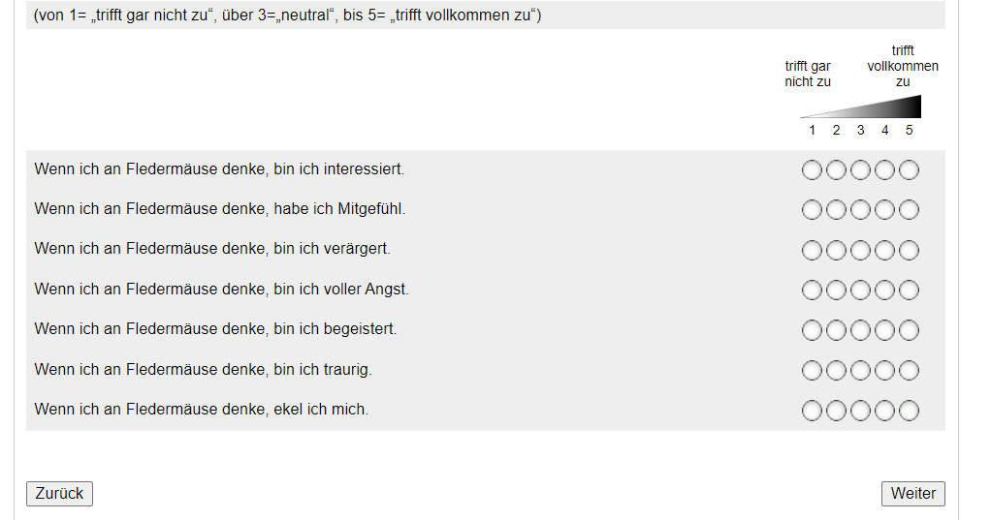

Behavioural intentions
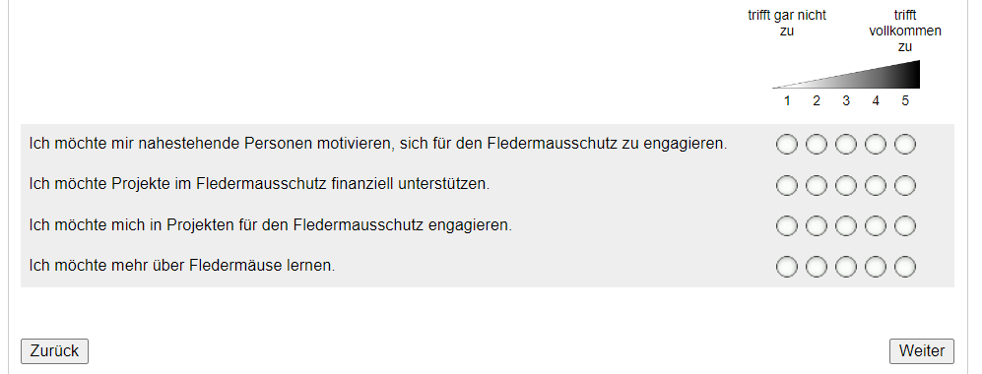

Figure S2: Distribution of discrete emotion ratings in 2021 and 2022. Significant differences between years based on Wilcoxon rank-sum test and marked in bold.
