Supporting Information
A Novel Synergistic Antimicrobial Mechanism of Azalomycin F Acting on Lipoteichoic Acid Synthase and Cell Envelope
Zilong Luo^{1,5}, Pingyi Li^{1,5}, Duoduo Zhang^{1,5}, Jianping Zhu², Wan Wang³, Wenjia Zhao¹, Peibo Li⁴, Ganjun Yuan^{1,2,*}
¹Biotechnological Engineering Center for Pharmaceutical Research and Development, Jiangxi Agricultural University, Nanchang 330045, China
²Laboratory of Natural Medicine and Microbiological Drug, College of Bioscience and Bioengineering, Jiangxi Agricultural University, Nanchang 330045, China
³School of Basic Medicine, Nanchang Medical College, Nanchang 330006, China
⁴School of Life Sciences, Sun Yat-sen University, Guangzhou 510275, China
⁵These authors contributed equally: Zilong Luo, Pingyi Li, Duoduo Zhang
*Correspondence: Ganjun Yuan, gyuan@jxau.edu.cn

Contents
1. Experiments Details
Calculations for the quenching constants, the thermodynamic parameters and the Hill’s coefficients (n_{H})
2. Figures
Figure S1. Basic analyses for the mass spectrometry data from the proteome of S. aureus treated with and without azalomycin F.
Figure S2. Schematic diagram of a KEGG pathway (as peptidoglycan biosynthesis) which significantly enriched differentially expressed proteins.
Figure S3. Enzyme activities of eLtaS (left), LtaS (middle) and LtaS-embedded liposome (right).
Figure S4. Stern-Volmer (left) and double logarithmic (right) plots of eLtaS quenched by azalomycin F respectively at 298 and 308 k in five incubation systems.
Figure S5. Stern-Volmer (left) and double logarithmic (right) plots of eLtaS quenched by azalomycin F respectively at 298 and 308 k in five incubation systems.
Figure S6. Synchronous fluorescence spectra of eLtaS and LtaS quenched by azalomycin F at 25°C.
Figure S7. Amino acid residues and sites of azalomycin F binding to the LtaS.
3. Tables
Table S1. Amino acid residues of LtaS interacting with azalomycin F by ESI MS.
Table S2. The molecular docking of the guanidyl side chain of azalomycin F (AZF) and eLtaS.
Table S3. List of TOF/MS parameters.

1. Experimental Details
Calculations for the quenching constant, thermodynamic parameters, and Hill’s coefficient
To explore the quenching mechanism of azalomycin F to eLtaS or LtaS，the fluorescence quenching were analyzed according to the Stern–Volmer equation as follows：
$F_{0}∕F=1+K_{sv}\left[Q\right]=1+K_{q}τ_{0}\left[Q\right]$ (1)
where F₀ and F represent the maximum fluorescence intensity of eLtaS or LtaS in the absence and presence of azalomycin F, respectively; τ₀ is the average lifetime of fluorescent molecule without azalomycin F, approximately 10⁻⁸ s³¹; K_{sv} is the Stern–Volmer quenching constant, and K_{q} is the bimolecular quenching rate constant; [Q] is the concentration of azalomycin F.
Based on the linear regression plots of F₀ / F versus [Q] at different temperatures, the values of K_{sv} and K_{q} can be obtained from the corresponding slope.
To understand the binding constant and the number of binding sites of eLtaS or LtaS interacting with azalomycin F, the static quenching interaction was analyzed according to the double logarithm equation as follows²⁷:
$lg\left[\left(F_{0}-F\right)∕F\right]=lgK_{a}+nlg\left[Q\right]$ (2)
where F₀ and F represent the maximum fluorescence intensity of eLtaS or LtaS in the absence and presence of azalomycin F, respectively. K_{a} is the binding constant, n is the number of binding sites between every eLtaS or LtaS and azalomycin F molecules, and [Q] is the concentration of azalomycin F.
Based on the double logarithmic plots of lg[(F₀ – F)/F] versus lg[Q] at different temperatures, the values of K_{a} and n can be obtained from the corresponding slope^{28,29}.
To elucidate the binding forces of eLtaS or LtaS interacting with azalomycin F, the thermodynamic parameters for each system were calculated from the van’t Hoff equation^{24,31,43}:
$\ln\left(K_{a2}∕K_{a1}\right)=ΔH\left(1∕T_{1}-1∕T_{2}\right)∕R$ (3)
$ΔG=-RΤ\ln{K_{a}}$ (4)
$ΔS=-\left(ΔG-ΔH\right)∕T$ (5)
where Ka is the binding constant, and T is the temperature; K_{a1} and K_{a2} are the binding constants for a system at two different temperatures T₁ and T₂; R is the gas constant, equal to 8.314 J/(mol∙k); ΔH, ΔG and ΔS are the enthalpy change, Gibbs free energy and entropy change, respectively.
In biochemistry, the binding of a ligand molecule at one site of a macromolecule often influences the affinity for other ligand molecules at additional sites, and this is known as cooperative effect which can be quantitatively analyzed by Hill’s coefficient (n_{H}). Thereby, the n_{H} for each incubation system was analyzed according to Hill’s equation as follows⁴⁴:
$lg\left[Y∕\left(1-Y\right)\right]=lgK_{a}+n_{H}lg\left[Q\right]$ (6)
where Y is the fraction of binding saturation, namely the fraction of sites occupied by the ligand; K_{a} is the binding constant, and [Q] is the concentration of azalomycin F; n_{H} is the Hill’s coefficient.
Based on the linear regression plots of lg[Y/(1 – Y)] versus lg[Q] for each system at different temperature, the n_{H} can be obtained from the corresponding slope.
For Hill’s equation, Y/(1-Y) can be calculated from L and L_{m} according to the following formula⁴⁴:
$Y∕\left(1-Y\right)=L∕\left(L_{m}-L\right)$ (2)
$L=1-F∕F_{0}$ (3)
$1/L=N+1/{L_{m}}·1∕\left[Q\right]$ (4)
where F₀ and F represent the maximum fluorescence intensity of eLtaS or LtaS in the absence and presence of azalomycin F, respectively; 1/L_{m} is the slope of the linear regression plot for 1/L versus 1/[Q], and N is the intercept of the corresponding plot.

2. Figures

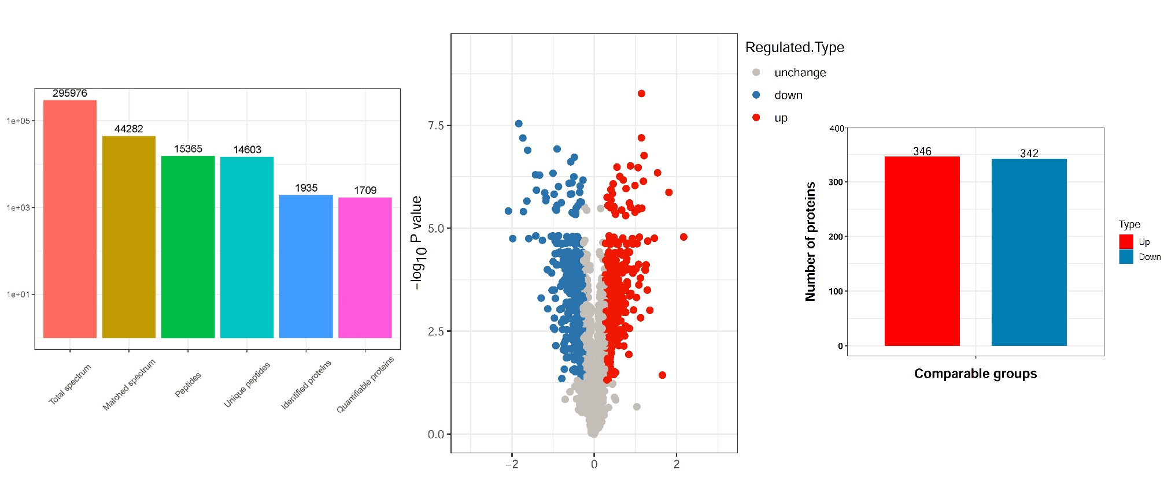

Fig. S1 Basic analyses for the mass spectrometry data from the proteome of S. aureus treated with and without azalomycin F. Left, statistical chart of the mass spectrometry data; Middle, volcano map for the quantification of differentially expressed proteins; Right, column chart for the distribution of differentially expressed proteins.

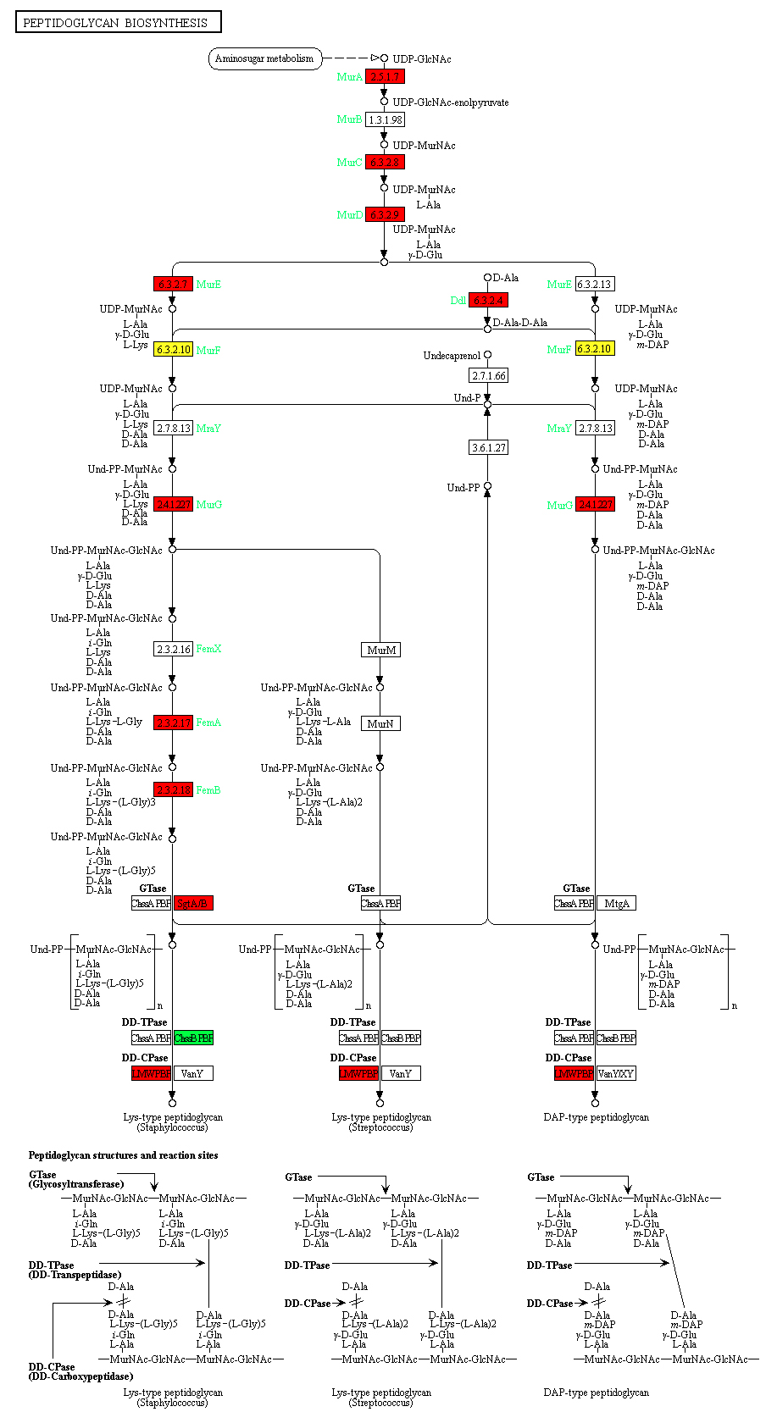

Fig. S2 Schematic diagram of a KEGG pathway (as peptidoglycan biosynthesis) which significantly enriched differentially expressed proteins. Red, represents upregulated differential proteins; Green, represents downregulated differential proteins; Yellow, indicates multiple proteins presented in this node, including upregulated and downregulated differential proteins.

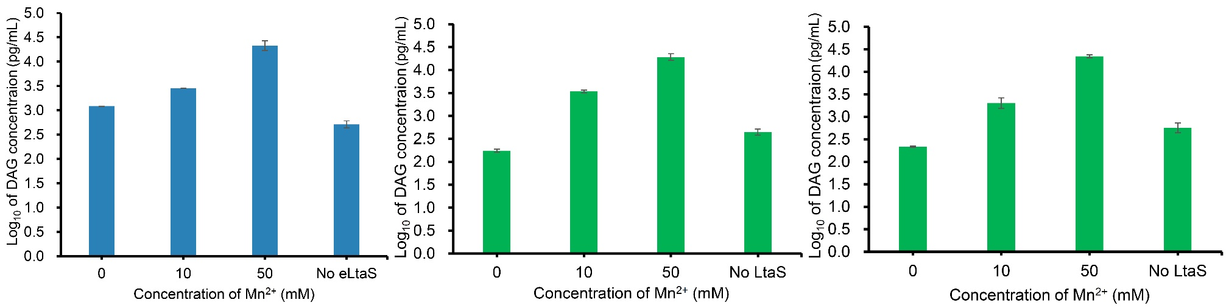

Fig. S3 Enzyme activities of eLtaS (Left), LtaS (Middle) and LtaS-embedded liposome (Right).

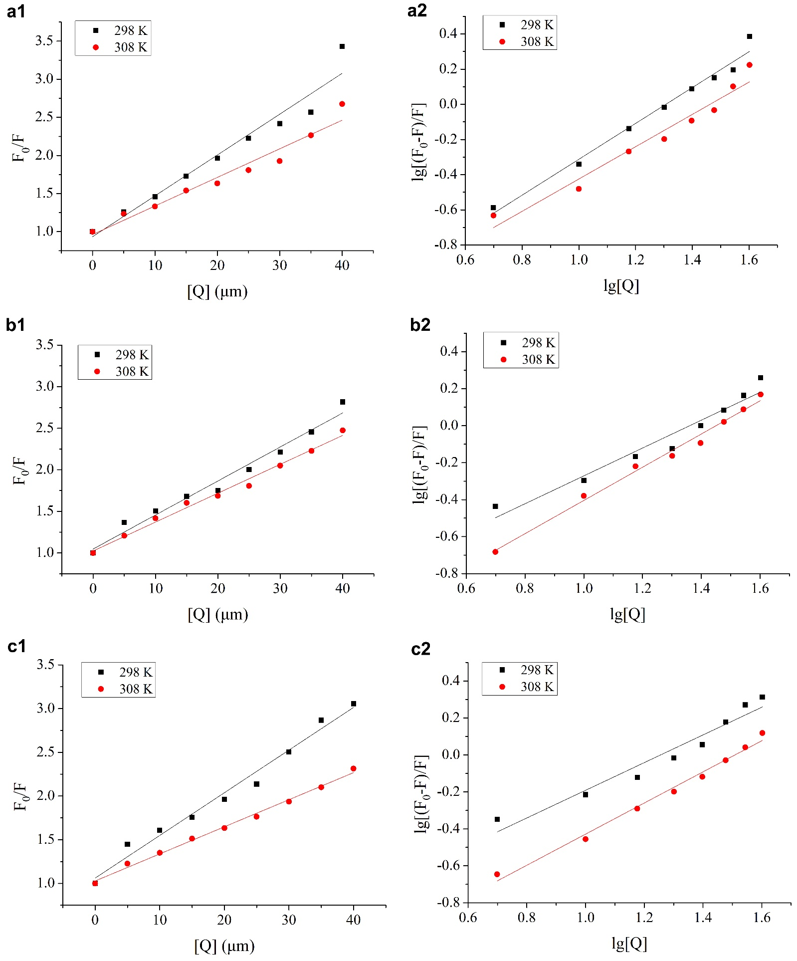

Fig. S4 Stern-Volmer (left) and double logarithmic (right) plots of eLtaS quenched by azalomycin F respectively at 298 and 308 K in five incubation systems. a1 and a2, b1 and b2, and c1 and c2 correspond to systems (A) eLtaS/azalomycin F, (B) eLtaS/DPPG/azalomycin F and (C) eLtaS/DPPG/MnCl2/azalomycin F, respectively.

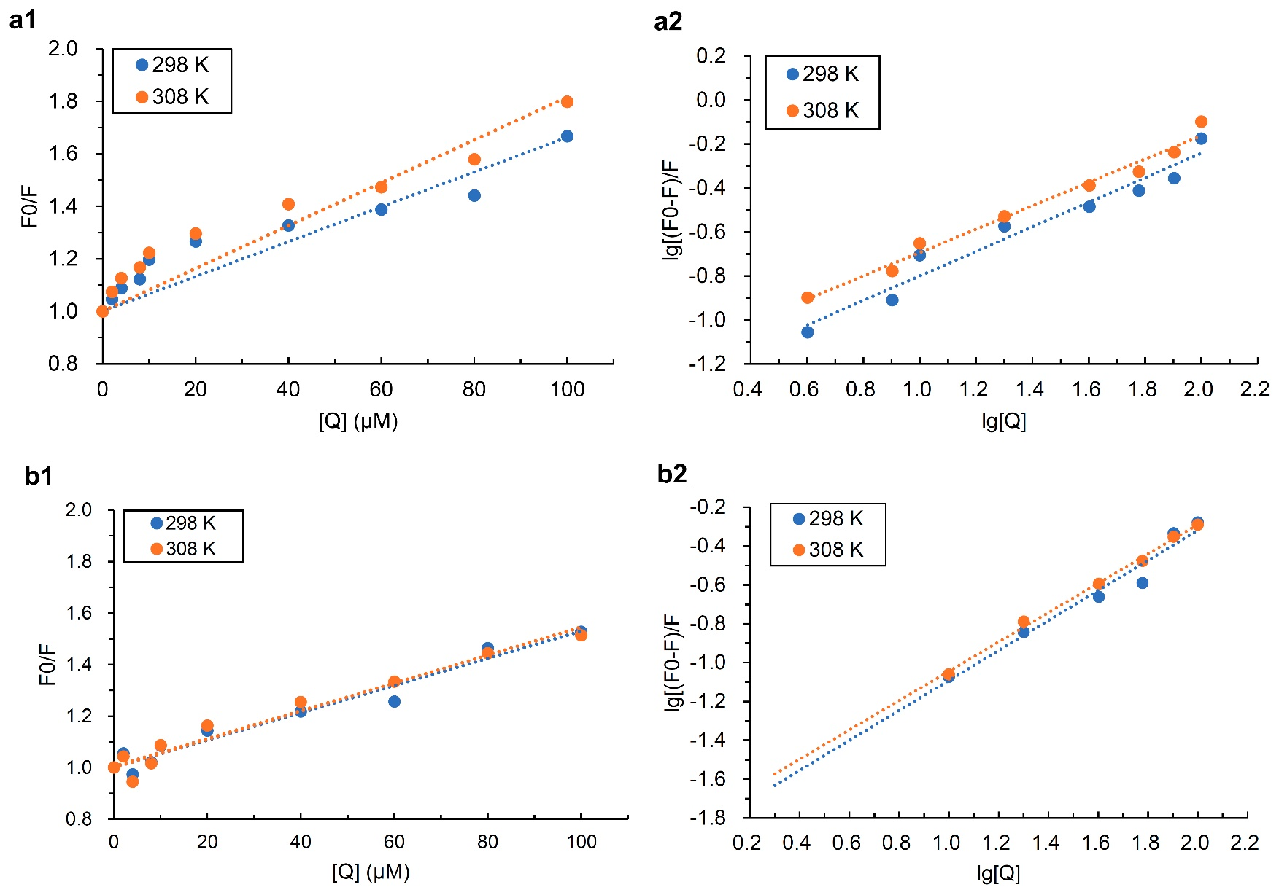

Fig. S5 Stern-Volmer (left) and double logarithmic (right) plots of eLtaS quenched by azalomycin F respectively at 298 and 308 K in five incubation systems. a1 and a2, and b1 and b2 correspond to systems (D) LtaS-embedded liposome/azalomycin F, and (E) LtaS-embedded liposome/MnCl₂/azalomycin F, respectively.

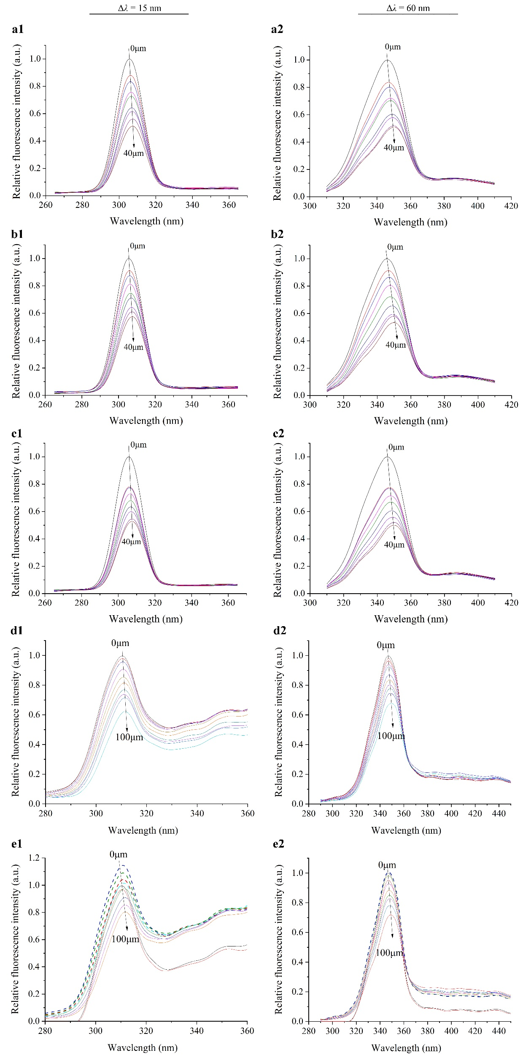

Fig. S6 Synchronous fluorescence spectra of eLtaS and LtaS quenched by azalomycin F at 25°C. Systems (A), eLtaS/azalomycin F; (B), eLtaS/DPPG/azalomycin F; (C), eLtaS/DPPG/MnCl₂/azalomycin F; (D), LtaS-embedded liposome/azalomycin F; and (E), LtaS-embedded liposome/MnCl₂/azalomycin F. The tyrosine synchronous fluorescence spectra a1 to e1 of left column corresponded systems (A) to (E), with the wavelength difference (Δλ) kept as 15 nm, and while the tryptophan synchronous fluorescence spectra a2 to e2 of right column corresponded systems (A) to (E), with the Δλ kept as 60 nm. For systems (A) to (C), the concentrations of azalomycin F were respectively 0, 5, 10, 15, 20, 25, 30, 35 and 40 μM, and those of eLtaS were 5 μM. For systems (D) and (E), the concentrations of azalomycin F were respectively 0, 2, 4, 8, 10, 20, 40, 60, 80 and 100 μM, and those of LtaS-embedded liposome were 5 μM.

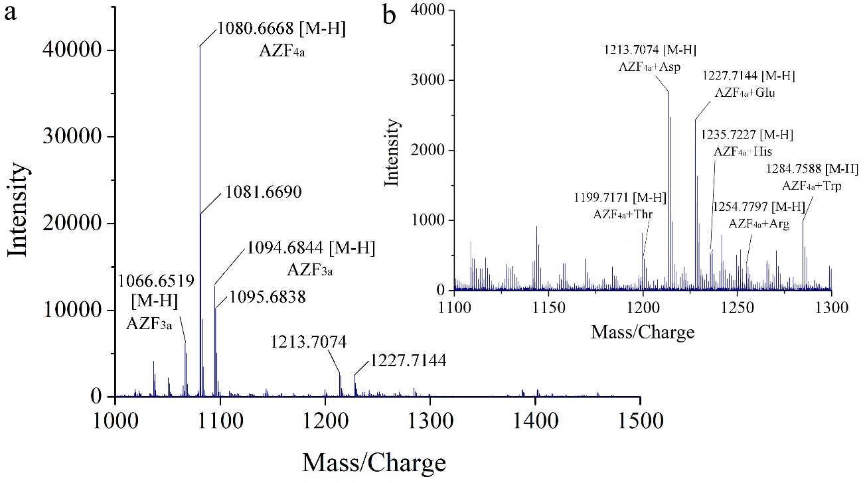

Fig. S7 Amino acid residues and sites of azalomycin F binding to the LtaS. a: electrospray ionization mass spectrometry analyses for the binding of azalomycin F to the amino acid residues of LtaS in negative ion mode; b: amplification for the mass-to-charge ratios from 1,100 to 1,300 in the mass spectra a.

3. Supplementary Tables

Table S1: Amino acid residues of LtaS interacting with azalomycin F by ESI MS.
Complex ª | [M-H]- |  |  |  | M⁺
Complex ª | (m/z) |  | Intensity |  | (m/z) |  | Intensity
Complex ª | Observed | Calculated | Intensity |  | Observed | Calculated | Intensity
AZF_{4a}/Aspartic acid | 1213.7074 | 1213.6958 | 2833 |  | 1214.7105 | 1214.7037 | 2319
AZF_{4a}/Glutamic acid | 1227.7144 | 1227.7115 | 2433 |  | 1228.7283 | 1228.7193 | 1600
AZF_{4a}/Tryptophan | 1284.7588 | 1284.7482 | 986 |  | 1285.7655 | 1285.7560 | 623
AZF_{4a}/Histidine | 1235.7227 | 1235.7278 | 502 |  | 1236.7398 | 1236.7356 | 571
AZF_{4a}/Threonine | 1199.7171 | 1199.7166 | 447 |  | 1200.7291 | 1200.7244 | 285
AZF_{4a}/Arginine | 1254.7797 | 1254.7700 | 406 |  | 1255.7846 | 1255.7779 | 334
AZF_{4a}/Phenylalanine | 1245.7335 | 1245.7373 | 185 |  | 1246.7497 | 1246.7451 | 207
AZF_{4a}/Tyrosine | 1261.7425 | 1261.7322 | 114 |  | 1262.7552 | 1262.7400 | 67
DMAZF_{4a}/Glutamic acid | 1141.7235 | 1141.7111 | 407 |  | 1142.7203 | 1142.7189 | 422
DMAZF_{4a}/Aspartic acid | 1127.7055 | 1127.6954 | 377 |  | 1128.7103 | 1128.7033 | 333
DMAZF_{4a}/Threonine | 1113.7175 | 1113.7162 | 157 |  | 1114.7208 | 1114.7240 | 90
DMAZF_{4a}/Tryptophan | 1198.7495 | 1198.7478 | 149 |  | 1199.7611 | 1199.7556 | 205
DMAZF_{4a}/Phenylalanine | 1159.7367 | 1159.7369 | 116 |  | 1160.7365 | 1160.7447 | 42
DMAZF_{4a}/Histidine | 1149.7290 | 1149.7274 | 105 |  | 1150.7340 | 1150.7352 | 95
DMAZF_{4a}/Arginine | 1168.7792 | 1168.7696 | 99 |  | 1169.7829 | 1169.7774 | 98
DMAZF_{4a}/Tyrosine | 1175.7414 | 1175.7318 | 32 |  | 1176.7384 | 1176.7397 | 61
ª: AZF_{4a}, azalomycin F_{4a}; DMAZF_{4a}, demalonyl azalomycin F_{4a}.

Table S2: The molecular docking of the guanidyl side chain of azalomycin F (AZF) and eLtaS.
Residueª | Action  or effect | Whole molecule of AZF |  |  |  | Guanidyl side chain of AZF
Residueª | Action  or effect | AZF_{3a} | AZF_{4a} | AZF_{5a} |  | AZF_{3a} | AZF_{4a} | AZF_{5a}
Lys299 | Stabling the LTA growth | ┉ ^{b} | ┉ | ┉ |  | ┉ | ┉ | ┉
Thr300 | Catalytic residue binding to Mn²⁺
Glu255 | Binding to Mn²⁺ |  |  | ┉ |  | ┉ | ┉H | ┉
Asp475 | Binding to Mn²⁺ |  |  | ┉
His476 | Binding to Mn²⁺ | ┉ | ┉ |  |  | ┉
His416 | Binding to the substrates and protonating groups | ┉ | ┉ | ┉ |  | ┉ | ┉ | ┉
His347 | Binding to the substrates |  |  | ┉ |  | ┉H ^{c} | ┉
Asp349 | Binding to the substrates |  |  | ┉ |  |  |  | ┉
Phe353 | Binding to the substrates | ┉ | ┉ | ┉ |  | ┉ |  | ┉
Trp354 | Binding to the substrates | ┉ | ┉ | ┉ |  | ┉ | ┉ | ┉
Arg356 | Binding to the substrates |  |  | ┉ |  | ┉H
Leu384 | Binding to the substrates |  |  |  |  | ┉ |  | ┉
Tyr477 | Stabling the LTA growth |  | ┉ | ┉
Gly478 | Close to the residues of eLtaS active center | ┉ | ┉ | ┉ |  |  |  | ┉
Ser480 | Close to the residues of eLtaS active center | ┉ | ┉
Ala300 | Close to the residues of eLtaS active center | ┉ |  | ┉ |  |  | ┉
Ser256 | Close to the residues of eLtaS active center | ┉ |  |  |  | ┉ |  | ┉
Leu413 | Close to the residues of eLtaS active center |  |  | ┉ |  | ┉ | ┉
Tyr417 | Close to the residues of eLtaS active center |  |  |  |  | ┉ | ┉ | ┉
ª: Amino acid residues of eltaS active center. Those marked bold indicated that there were interactions with the guanidyl side chain of azalomycin F for all dockings, and those marked brown were not but close to the residues of eLtaS active center.
^{b:} ┉, indicated that there were hydrophobic interactions between the residues and the guanidyl side chain.
^{c:} ┉H, indicated that there were hydrogen bond interactions between the residues and the guanidyl side chain, and while just one can form for those docking having two hydrogen bond interactions.

Table S3. List of TOF/MS parameters ª.
Parameters | Negative mode
ISVF | -4500 V
TEM | 550 °C
Gas 1 | 50 psi
Gas 2 | 50 psi
Curtain gas | 30 psi
DP MS | -80 V
CE in MS | -10 eV
CE in MS/MS | -30 eV± 15 eV
Nebulizer and auxiliary gas | Nitrogen
Scan range | 50-1600 da
ª: Ionspray voltage floating (ISVF), The turbo spray temperature (TEM), Nebulizer gas (Gas 1), Heater gas (Gas 2), Curtain gas Declustering potential (DP), Collision energy in MS (CE in MS) and Collision energy in MS/MS (CE in MS/MS), Nebulizer and auxiliary gas, and scan range for negative ionization mode.

