Supplementary tables and figures.
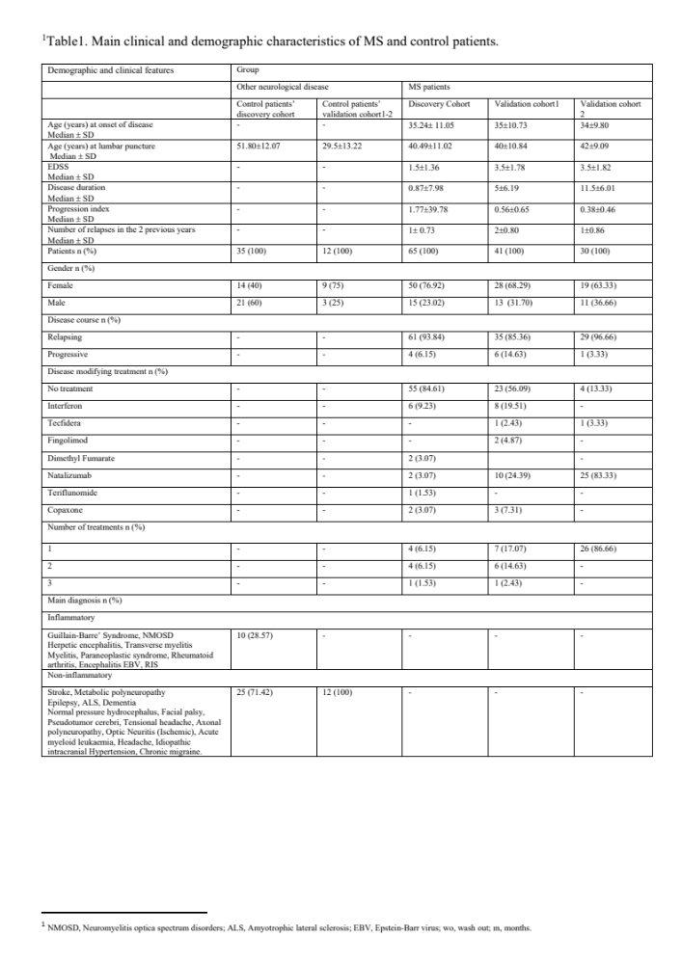
Supplementary Table1. Main clinical and demographic characteristics of patients with MS and control cases
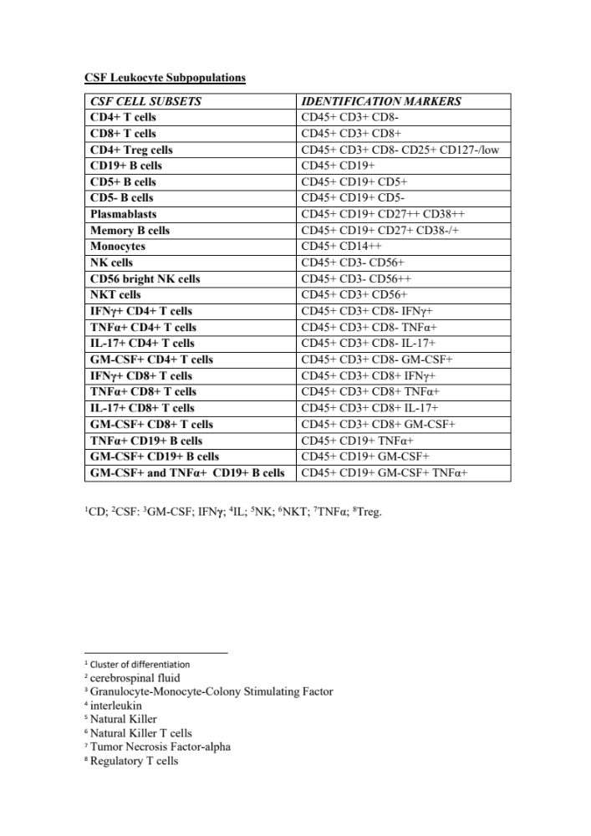
Supplementary Table 2. CSF Leukocyte subsets.
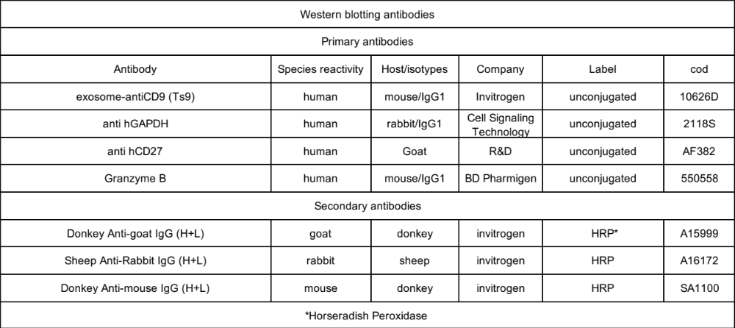
Supplementary Table 3. Primary and secondary antibodies are used for western blotting.
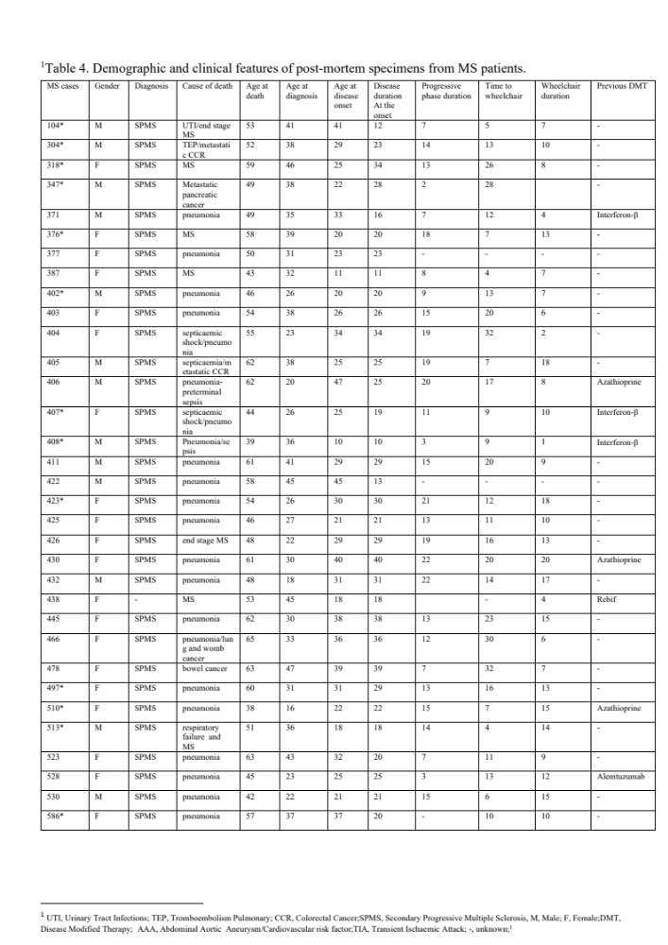
Supplementary Table 4. Demographic and clinical features of post-mortem MS cases

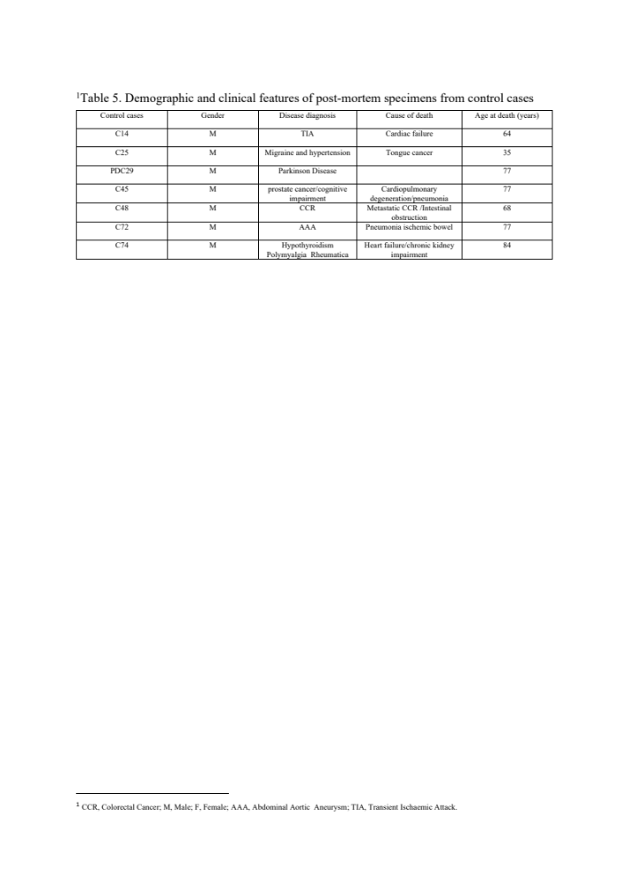
Supplementary Table 5. Demographic and clinical features of post-mortem control cases

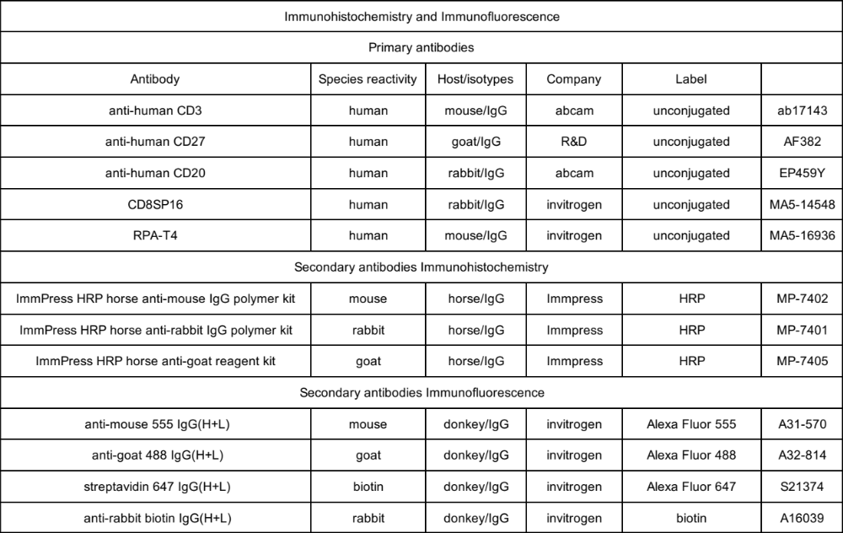
Supplementary Table 6. Primary and secondary antibodies are used for immunohistochemistry and immunofluorescence.

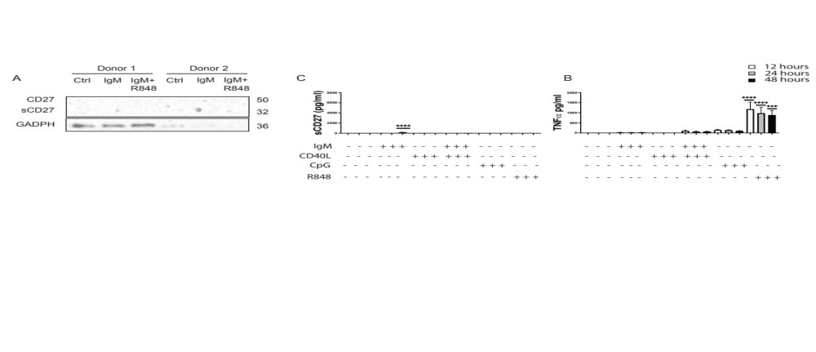
Supplementary Fig. 1. Levels of CD27 in B cells
Immunoblots (A) for CD27 in the whole cell lysate from purified B cells in resting and stimulated with IgM and R848. The protein extracts are from isolated B cells of 2 healthy donors. Histogram report levels of sCD27 (pg/ml) (B) and TNF (pg/ml) (C) detected on the supernatant of isolated B cells treated with IgM, CD40L, CPG ODN and R848 at 12, 24 and 48 hours as measured by Elisa. Data show means ± SD of 3 independent experiments. Statistical analysis was performed by using ordinary 2-way ANOVA.

