Supplementary material:
Morphological changes of RAW264.7 cell line after polarization into M1 macrophages, giving rise to pseudopodia from the round. A: RAW264.7 cells, round, agglomerated, weakly adherent, semi-suspended; B: M1 macrophage, extending pseudopodia, irregular, adherent growth, strong adherence, slightly larger size.
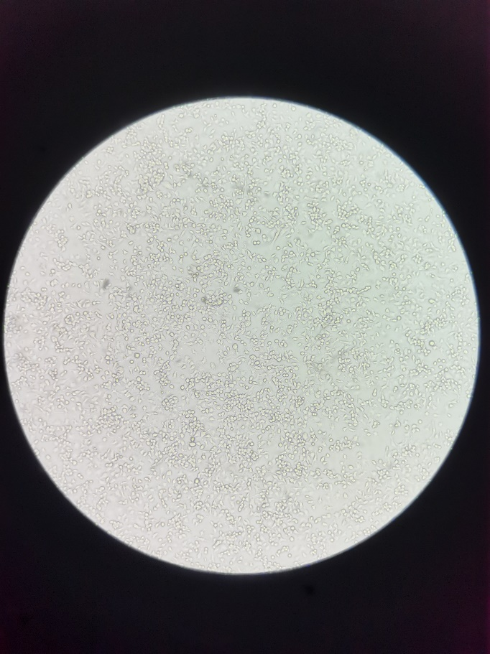
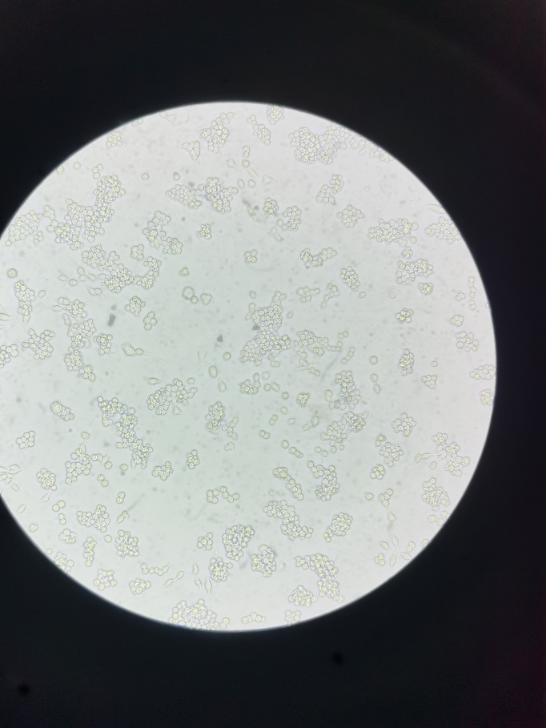
A B

