Supplementary material

Longitudinal association between household air pollution from solid fuel use and depression among middle-aged and older adults in China: a national cohort study

Xinyao Che ^{a,1}, Peiqin Quan ^{a,1}, Yinan Yang ^{b}, Xiaobin Hu ^{c,*}

ª Chengdu Center for Disease Control and Prevention, Chengdu 610000, China
^{b} Lanzhou University Second Hospital, Lanzhou 730000, China
^{c} School of Public Health, Lanzhou University, Lanzhou 730000, China

* Corresponding author at: School of Public Health, Lanzhou University, No.199, Donggang West Road, Chengguan District, Lanzhou, Gansu, China.
E-mail address: lzhuxb@126.com
¹ Authors contributed equally to this article.
Table of Contents
Table S1 Baseline characteristics of participates by gender (n (%)) …………………………p.3
Table S2 Baseline characteristics of participates by follow-up episode of depression (n(%))
………………………………………………………………………………………………p.4
Table S3 Association of depression with primary fuel types, stratified by potential modifiers
………………………………………………………………………………………………p.6
Table S4 Association of CES-D10 scores with primary fuel types, stratified by potential modifiers……………………………………………………………………………………p.8
Figure S1 The research areas included in the China Health and Retirement Longitudinal Study (CHARLS) in mainland China………………………………………………………p.10
Figure S2 Flowchart of the inclusion of participants………………………………………p.11

Table S1 Baseline characteristics of participates by gender (n (%))
Characteristic | Total | Male | Female | P value
Characteristic | (N=4745) | (N=2565) | (N=2180) | P value
Age (years) |  |  |  | <0.001
45~ | 3760(79.24) | 1976(77.04) | 1784(81.83)
65~ | 985(20.76) | 589(22.96) | 396(18.17)
Educational level |  |  |  | <0.001
No formal education | 1046(22.04) | 266(10.37) | 780(35.78)
Primary school | 1962(41.35) | 1124(43.82) | 838(38.44)
Middle school or above | 1737(36.61) | 1175(45.81) | 562(25.78)
Marital status |  |  |  | <0.001
Married | 4348(91.63) | 2400(93.57) | 1948(89.36)
Not married | 397(8.37) | 165(6.43) | 232(10.64)
Residence |  |  |  | 0.014
Urban | 1697(35.76) | 877(34.19) | 820(37.61)
Rural | 3048(64.24) | 1688(65.81) | 1360(62.39)
Smoking |  |  |  | <0.001
No | 3110(65.54) | 1045(40.74) | 2065(94.72)
Yes | 1635(34.46) | 1520(59.26) | 115(5.28)
Alcohol |  |  |  | <0.001
No | 2952(62.21) | 1012(39.45) | 1940(88.99)
Yes | 1793(37.79) | 1553(60.55) | 240(11.01)
Living alone |  |  |  | 0.907
No | 4566(96.23) | 2469(96.26) | 2097(96.19)
Yes | 179(3.77) | 96(3.74) | 83(3.81)
Socioeconomic status |  |  |  | <0.001
Good | 144(3.03) | 87(3.39) | 57(2.61)
Fair | 2862(60.32) | 1474(57.47) | 1388(63.67)
Bad | 1739(36.65) | 1004(39.14) | 735(33.72)
Independent cooking |  |  |  | 0.015
No | 154(3.25) | 98(3.82) | 56(2.57)
Yes | 4591(96.75) | 2467(96.18) | 2124(97.43)
Location |  |  |  | 0.257
South | 2537(53.47) | 1352(52.71) | 1185(54.36)
North | 2208(46.53) | 1213(47.29) | 995(45.64)
Sleeping time(h/d) |  |  |  | 0.015
0~ | 1589(33.49) | 820(31.97) | 769(35.28)
7~ | 1829(38.55) | 989(38.56) | 840(38.53)
9~ | 1327(27.97) | 756(29.47) | 571(26.19)
Diabetes |  |  |  | 0.074
No | 4490(94.63) | 2441(95.17) | 2049(93.99)
Yes | 255(5.37) | 124(4.83) | 131(6.01)

Table S1 Baseline characteristics of participates by gender (n(%))(Cont.)
Characteristic | Total | Male | Female | P value
Characteristic | (N=4745) | (N=2565) | (N=2180) | P value
Hypertension |  |  |  | 0.172
No | 2992(63.06) | 1640(63.94) | 1352(62.02)
Yes | 1753(36.94) | 925(36.06) | 828(37.98)
Heart diseases |  |  |  | 0.067
No | 4289(90.39) | 2337(91.11) | 1952(89.54)
Yes | 456(9.61) | 228(8.89) | 228(10.46)
Chronic lung disease |  |  |  | <0.001
No | 4330(91.25) | 2295(89.47) | 2035(93.35)
Yes | 415(8.75) | 270(10.53) | 145(6.65)

Table S2 Baseline characteristics of participates by follow-up episode of depression (n(%))
Characteristic | Total  (N=4745) | Depression  (N=1568) | Non-depression  (N=3177) | P value
Age (years) |  |  |  | 0.138
45~ | 3760(79.24) | 1223(78.00) | 2537(79.86)
65~ | 985(20.76) | 345(22.00) | 640(20.14)
Gender |  |  |  | <0.001
Male | 2565(54.06) | 719(45.85) | 1846(58.11)
Female | 2180(45.94) | 849(54.15) | 1331(41.89)
Educational level |  |  |  | <0.001
No formal education | 1046(22.04) | 431(27.49) | 615(19.36)
Primary school | 1962(41.35) | 694(44.26) | 1268(39.91)
Middle school or above | 1737(36.61) | 443(28.25) | 1294(40.73)
Marital status |  |  |  | 0.002
Married | 4348(91.63) | 1409(89.86) | 2939(92.51)
Not married | 397(8.37) | 159(10.14) | 238(7.49)
Residence |  |  |  | <0.001
Urban | 1697(35.76) | 458(29.21) | 1239(39.00)
Rural | 3048(64.24) | 1110(70.79) | 1938(61.00)
Smoking |  |  |  | 0.003
No | 3110(65.54) | 1074(68.49) | 2036(64.09)
Yes | 1635(34.46) | 494(31.51) | 1141(35.91)
Alcohol |  |  |  | <0.001
No | 2952(62.21) | 1058(67.47) | 1894(59.62)
Yes | 1793(37.79) | 510(32.53) | 1283(40.38)
Living alone |  |  |  | 0.501
No | 4566(96.23) | 1513(96.49) | 3053(96.10)
Yes | 179(3.77) | 55(3.51) | 124(3.90)

Table S2 Baseline characteristics of participates by follow-up episode of depression (n(%))(Cont.)
Characteristic | Total  (N=4745) | Depression  (N=1568) | Non-depression  (N=3177) | P value
Socioeconomic status |  |  |  | <0.001
Good | 144(3.03) | 30(1.91) | 114(3.59)
Fair | 2862(60.32) | 864(55.10) | 1998(62.89)
Bad | 1739(36.65) | 674(42.98) | 1065(33.52)
Independent cooking |  |  |  | 0.158
No | 154(3.25) | 59(3.76) | 95(2.99)
Yes | 4591(96.75) | 1509(96.24) | 3082(97.01)
Location |  |  |  | <0.001
South | 2537(53.47) | 914(58.29) | 1623(51.09)
North | 2208(46.53) | 654(41.71) | 1554(48.91)
Sleeping time(h/d) |  |  |  | <0.001
0~ | 1589(33.49) | 611(38.97) | 978(30.78)
7~ | 1829(38.55) | 545(34.76) | 1284(40.42)
9~ | 1327(27.97) | 412(26.28) | 915(28.80)
Diabetes |  |  |  | 0.044
No | 4490(94.63) | 1469(93.69) | 3021(95.09)
Yes | 255(5.37) | 99(6.31) | 156(4.91)
Hypertension |  |  |  | 0.114
No | 2992(63.06) | 964(61.48) | 2028(63.83)
Yes | 1753(36.94) | 604(38.52) | 1149(36.17)
Heart diseases |  |  |  | 0.006
No | 4289(90.39) | 1412(90.05) | 2918(91.85)
Yes | 456(9.61) | 156(9.95) | 259(8.15)
Chronic lung diseases |  |  |  | 0.039
No | 4330(91.25) | 1391(88.71) | 2898(91.22)
Yes | 415(8.75) | 177(11.29) | 279(8.78)

Table S3 Association of depression with primary fuel types, stratified by potential modifiers
Characteristic | Cooking |  | Heating |  | 
Characteristic | HR (95% CI)* | P_{interaction}** | HR (95% CI)* | P_{interaction}**
Age (years) |  | 0.331 |  | 0.745 | 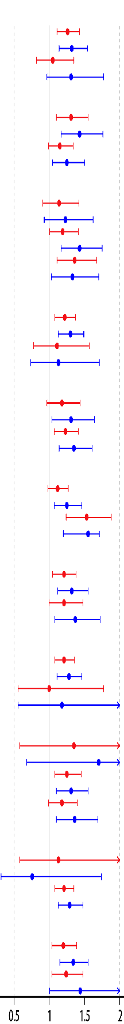
45~ | 1.26(1.11,1.43) |  | 1.32(1.14,1.54)
65~ | 1.05(0.82,1.35) |  | 1.31(0.97,1.77)
Gender |  | 0.264 |  | 0.359
Male | 1.31(1.10,1.55) |  | 1.43(1.17,1.76)
Female | 1.15(0.99,1.34) |  | 1.25(1.05,1.50)
Educational level |  | 0.236 |  | 0.670
No formal education | 1.14(0.91,1.42) |  | 1.23(0.93,1.62)
Primary school | 1.19(1.01,1.41) |  | 1.43(1.17,1.75)
Middle school or above | 1.36(1.11,1.67) |  | 1.33(1.03,1.70)
Marital status |  | 0.542 |  | 0.788
Married | 1.22(1.08,1.37) |  | 1.30(1.13,1.49)
Not married | 1.11(0.78,1.57) |  | 1.13(0.74,1.71)
Residence |  | 0.830 |  | 0.692
Urban | 1.18(0.97,1.44) |  | 1.31(1.04,1.64)
Rural | 1.23(1.07,1.41) |  | 1.35(1.14,1.61)
Smoking |  | 0.077 |  | 0.386
No | 1.12(0.98,1.27) |  | 1.25(1.07,1.46)
Yes | 1.53(1.24,1.88) |  | 1.55(1.20,1.71)
Alcohol |  | 0.593 |  | 0.291
No | 1.21(1.05,1.38) |  | 1.32(1.12,1.55)
Yes | 1.21(1.00,1.48) |  | 1.37(1.08,1.72)
Living alone |  | 0.289 |  | 0.806
No | 1.21(1.08,1.36) |  | 1.28(1.11,1.46)
Yes | 1.00(0.56,1.77) |  | 1.18(0.56,2.48)
Socioeconomic status |  | 0.473 |  | 0.082
Good | 1.35(0.58,3.15) |  | 1.70(0.68,4.28)
Fair | 1.25(1.08,1.45) |  | 1.31(1.10,1.55)
Bad | 1.18(0.99,1.40) |  | 1.36(1.10,1.69)
Independent cooking |  | 0.679 |  | 0.345
No | 1.13(0.58,2.21) |  | 0.76(0.32,1.74)
Yes | 1.21(1.08,1.35) |  | 1.29(1.13,1.48)
Location |  | 0.675 |  | 0.585
South | 1.20(1.04,1.39) |  | 1.34(1.15,1.55)
North | 1.24(1.04,1.48) |  | 1.44(1.01,2.06)

Table S3 Association of depression with primary fuel types, stratified by potential modifiers (Cont.)
Characteristic | Cooking |  | Heating
Characteristic | HR (95% CI)* | P_{interaction}** | HR (95% CI)* | P_{interaction}**
Sleeping time(h/d) |  | 0.708 |  | 0.757 | 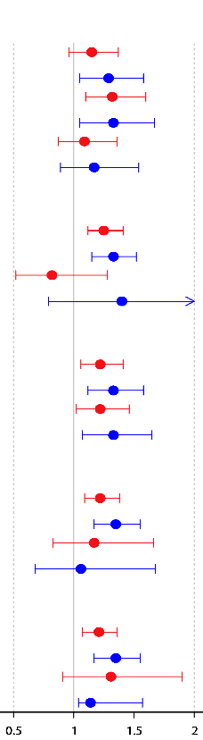
0~ | 1.15(0.96,1.37) |  | 1.29(1.05,1.58)
7~ | 1.32(1.10,1.60) |  | 1.33(1.05,1.67)
9~ | 1.09(0.87,1.36) |  | 1.17(0.89,1.54)
Diabetes |  | 1.168 |  | 0.722
No | 1.25(1.12,1.41) |  | 1.33(1.15,1.52)
Yes | 0.82(0.52,1.28) |  | 1.40(0.79,2.50)
Hypertension |  | 0.678 |  | 0.729
No | 1.22(1.06,1.41) |  | 1.33(1.12,1.58)
Yes | 1.22(1.02,1.46) |  | 1.33(1.07,1.65)
Heart diseases |  | 0.975 |  | 0.758
No | 1.22(1.09,1.38) |  | 1.35(1.17,1.55)
Yes | 1.17(0.83,1.66) |  | 1.06(0.68,1.68)
Chronic lung diseases |  | 0.940 |  | 0.164
No | 1.21(1.07,1.36) |  | 1.35(1.17,1.55)
Yes | 1.31(0.91,1.90) |  | 1.14(1.04,1.57)
Notes: *Model was adjusted for age, gender, education level, marital status, residence, smoking, alcohol, living alone, socioeconomic status, independent cooking, location, sleep time, diabetes, hypertension, heart disease, and chronic lung disease.
** The multiplicative interactions between the types of cooking and heating fuel (clean fuel and solid fuel) and the basic characteristics of the participates were tested.

Table S4 Association of CES-D10 scores with primary fuel types, stratified by potential modifiers
Characteristic | Cooking |  | Heating
Characteristic | β(95%CI)* | P value | β(95%CI)* | P value
Age (years) |  |  |  |  | 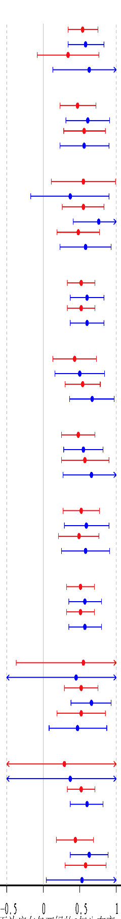
45~ | 0.54(0.34,0.75) | <0.001 | 0.58(0.34,0.83) | <0.001
65~ | 0.34(-0.08,0.76) | 0.115 | 0.63(0.13,1.13) | 0.013
Gender
Male | 0.47(0.23,0.72) | <0.001 | 0.61(0.31,0.91) | <0.001
Female | 0.56(0.28,0.85) | <0.001 | 0.56(0.23,0.90) | 0.001
Educational level
No formal education | 0.55(0.11,0.99) | 0.013 | 0.37(-0.17,0.90) | 0.181
Primary school | 0.55(0.26,0.83) | <0.001 | 0.76(0.41,1.10) | <0.001
Middle school or above | 0.48(0.19,0.77) | 0.001 | 0.58(0.23,0.93) | 0.001
Marital status
Married | 0.52(0.33,0.71) | <0.001 | 0.60(0.37,0.83) | <0.001
Not married | 0.52(0.33,0.71) | <0.001 | 0.60(0.37,0.83) | <0.001
Residence
Urban | 0.43(0.13,0.73) | 0.005 | 0.50(0.16,0.84) | 0.004
Rural | 0.54(0.30,0.78) | <0.001 | 0.67(0.36,0.97) | <0.001
Smoking
No | 0.48(0.25,0.71) | <0.001 | 0.55(0.28,0.82) | <0.001
Yes | 0.57(0.25,0.90) | <0.001 | 0.66(0.27,1.05) | 0.001
Alcohol
No | 0.52(0.27,0.77) | <0.001 | 0.59(0.29,0.90) | <0.001
Yes | 0.49(0.21,0.76) | 0.001 | 0.58(0.25,0.91) | 0.001
Living alone
No | 0.51(0.32,0.70) | <0.001 | 0.57(0.35,0.80) | <0.001
Yes | 0.51(0.32,0.70) | <0.001 | 0.57(0.35,0.80) | <0.001
Socioeconomic status
Good | 0.55(-0.37,1.47) | 0.240 | 0.45(-0.62,1.53) | 0.406
Fair | 0.52(0.29,0.75) | <0.001 | 0.66(0.38,0.93) | <0.001
Bad | 0.52(0.19,0.85) | 0.002 | 0.47(0.08,0.87) | 0.019
Independent cooking
No | 0.29(-0.91,1.50) | 0.633 | 0.37(-1.20,1.93) | 0.648
Yes | 0.52(0.33,0.71) | <0.001 | 0.60(0.37,0.82) | <0.001
Location
South | 0.44(0.18,0.69) | 0.001 | 0.63(0.37,0.89) | <0.001
North | 0.58(0.30,0.86) | <0.001 | 0.53(0.04,1.02) | 0.035

Table S4 Association of CES-D10 scores with primary fuel types, stratified by potential modifiers (Cont.)
Characteristic | Cooking |  | Heating
Characteristic | β(95%CI)* | P value | β(95%CI)* | P value
Sleeping time(h/d) |  |  |  | 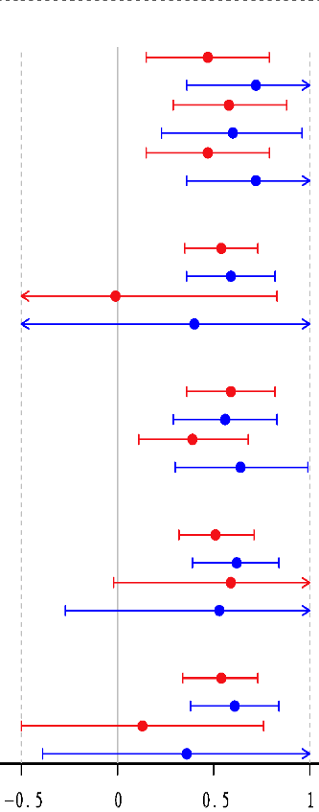
0~ | 0.47(0.15,0.79) | 0.004 | 0.72(0.36,1.08) | <0.001
7~ | 0.58(0.29,0.88) | <0.001 | 0.60(0.23,0.96) | 0.001
9~ | 0.47(0.15,0.79) | 0.004 | 0.72(0.36,1.08) | <0.001
Diabetes
No | 0.54(0.35,0.73) | <0.001 | 0.59(0.36,0.82) | <0.001
Yes | -0.01(-0.85,0.83) | 0.980 | 0.40(-0.61,1.40) | 0.440
Hypertension
No | 0.59(0.36,0.82) | <0.001 | 0.56(0.29,0.83) | <0.001
Yes | 0.39(0.11,0.68) | 0.007 | 0.64(0.30,0.99) | <0.001
Heart diseases
No | 0.51(0.32,0.71) | <0.001 | 0.62(0.39,0.84) | <0.001
Yes | 0.59(-0.02,1.20) | 0.059 | 0.53(-0.27,1.33) | 0.195
Chronic lung diseases
No | 0.54(0.34,0.73) | <0.001 | 0.61(0.38,0.84) | <0.001
Yes | 0.13(-0.50,0.76) | 0.681 | 0.36(-0.39,1.11) | 0.345
Notes: *Model was adjusted for age, gender, education level, marital status, residence, smoking, alcohol, living alone, socioeconomic status, independent cooking, location, sleep time, diabetes, hypertension, heart disease, and chronic lung disease.

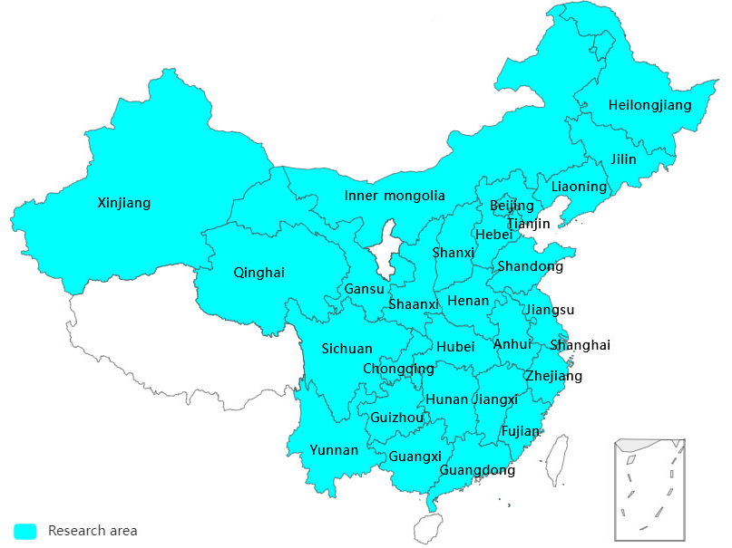

Figure S1
The research areas included in the China Health and Retirement Longitudinal Study (CHARLS) in mainland China

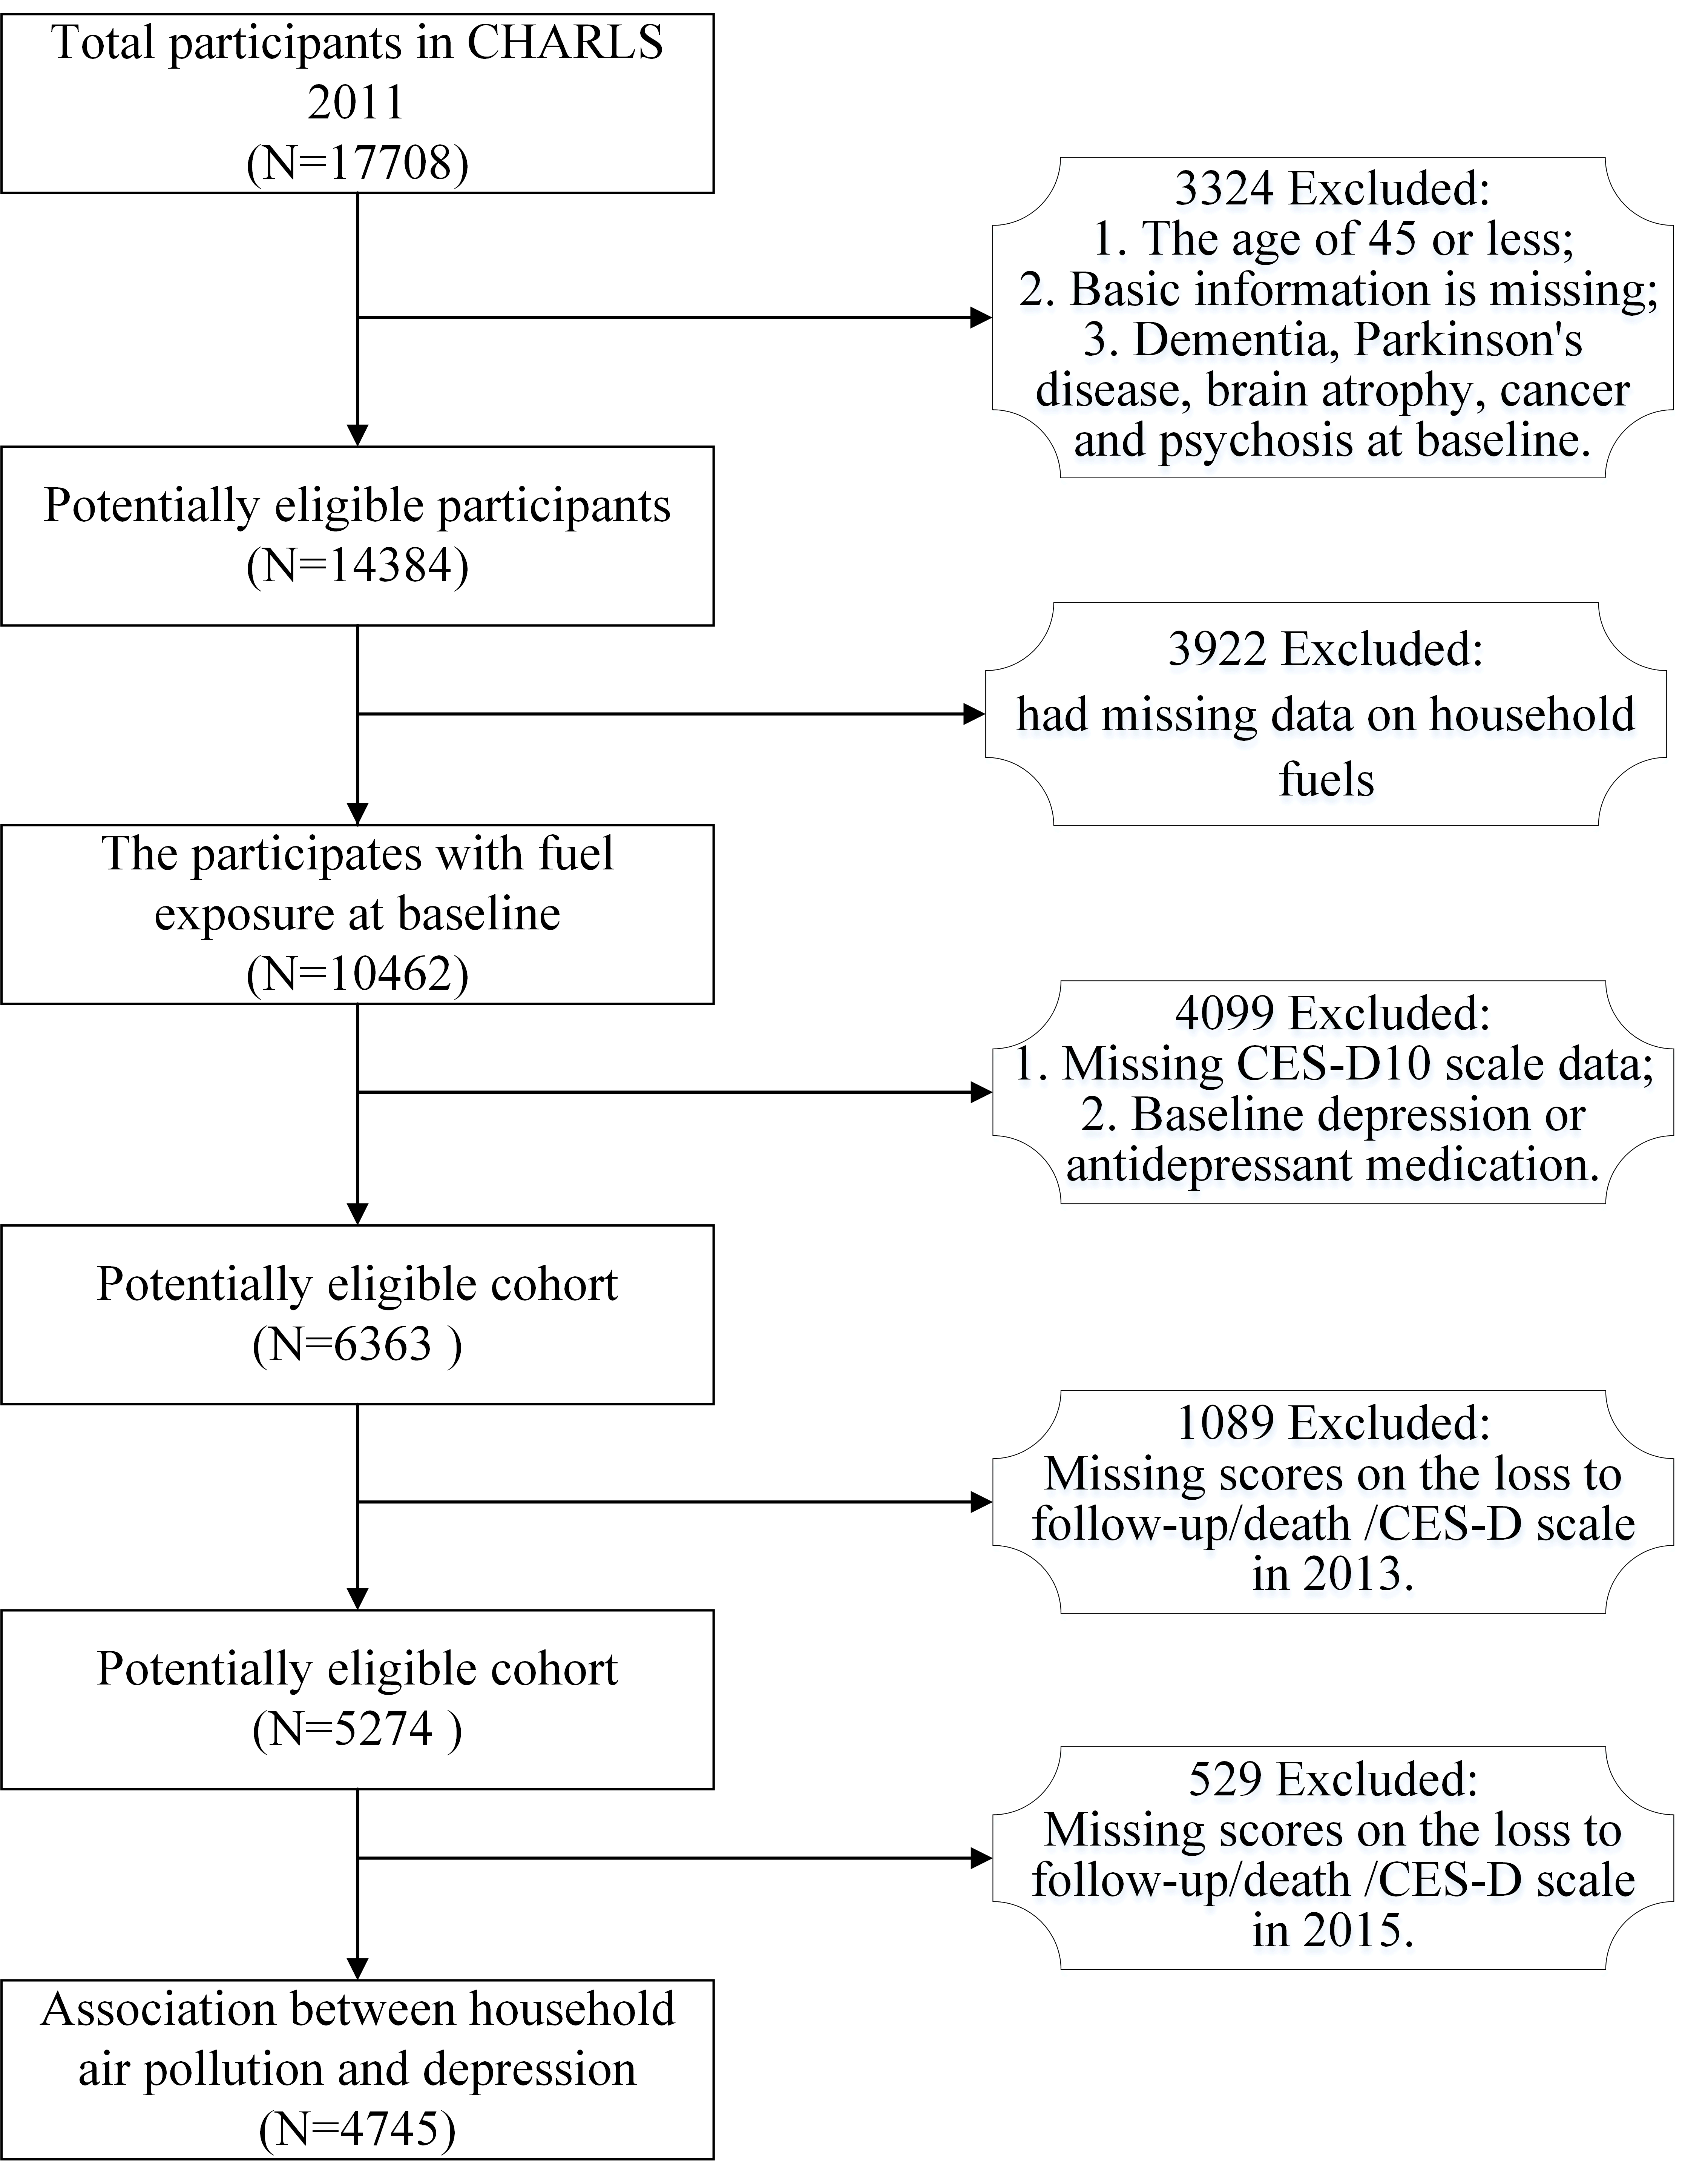
Figure S2 Flowchart of the inclusion of participants

