Supporting Information

Fabricating high-purity graphite disk electrodes as a cost-effective alternative in fundamental electrochemistry research
Claudia Spallacci*ª, Mikaela Görlin^{b}, Amol Kumar^{c}, Mun Hon Cheah*ª
ª Molecular Biomimetics, Department of Chemistry - Ångström Laboratory, Uppsala University, SE-75120 Uppsala, Sweden
^{b} Structural Chemistry, Department of Chemistry - Ångström Laboratory, Uppsala University, SE-75121 Uppsala, Sweden
^{c} Synthetic Molecular Chemistry, Department of Chemistry - Ångström Laboratory, Uppsala University, SE-75120 Uppsala, Sweden
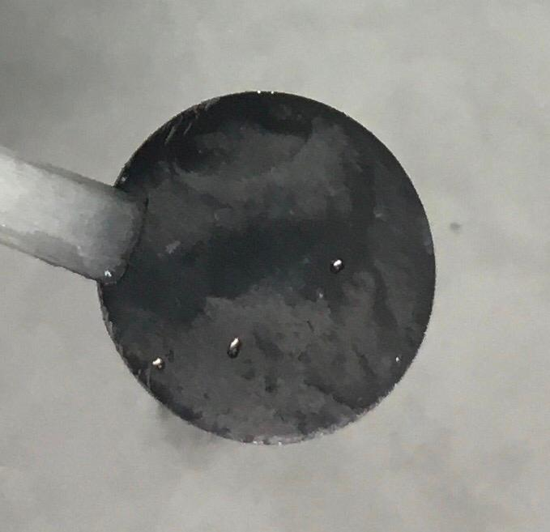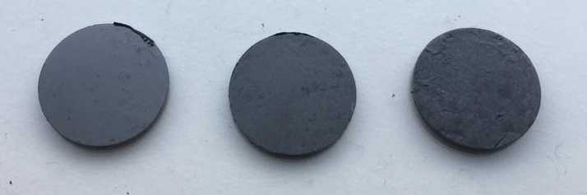
Figure S1. Newly fabricated GDEs of different PE percentages, respectively 5%, 15%, 25% and 35% from left to right.
Figure S2. (a) Potential window measurements of 5% PE GDE, 15% PE GDE, 25% PE GDE and 35% PE GDE in phosphate buffer 0.1 M and 1 M KCl, pH = 7. (b) 1 mM potassium ferricyanide in phosphate buffer 0.1 M, pH = 7, 1 M KCl.

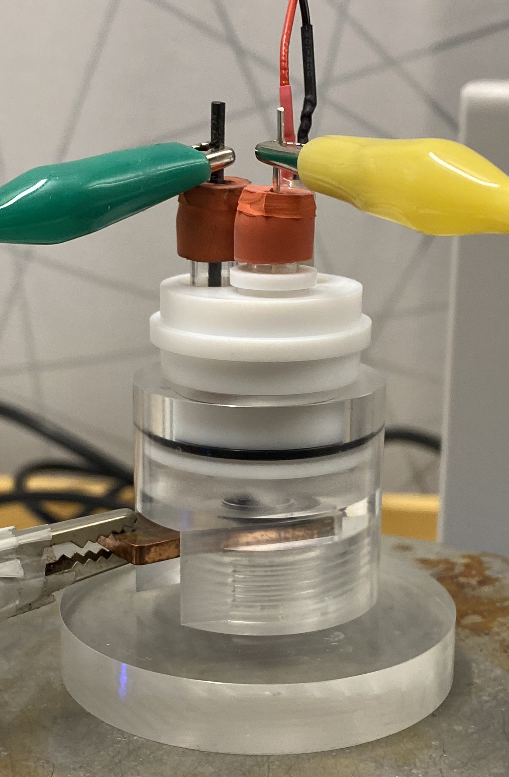
Counter electrode (graphite pencil rod)
Clark electrode (optional)
Reference electrode (Ag/AgCl 3M)
Counter electrode (GDE/GCE plate)
Figure S3. Custom-designed electrochemical cell under operating conditions.
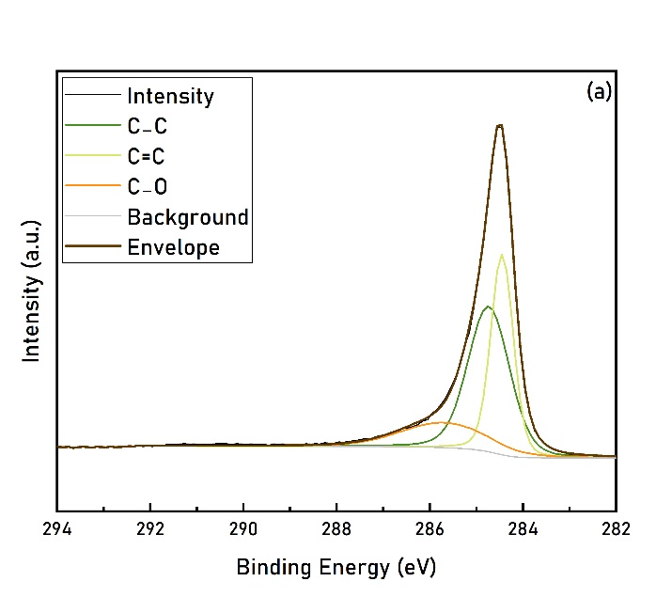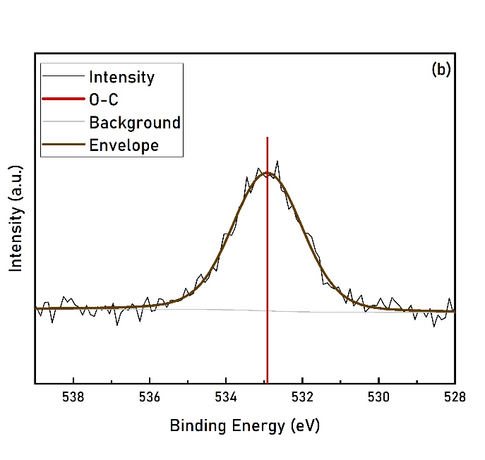Figure S4. XPS measurements of 25% PE GDE after polishing. High-resolution spectra of the (a) C 1s and (b) O 1s regions.
Measurement | BET Surface Area (cm² g⁻¹) | Sample weight (g) | Normalized BET Surface Area (cm²)
1 | 79832 | 0.0861 | 6874
2 | 56467 | 0.0864 | 4879
Average |  |  | 5856
Table S1. BET data for 25%PE GDE.
Figure S5. Potential window measurements of GCE, 15% PE GDE and 25% PE GDE for operativity in different electrolyte conditions. (a) Phosphate buffer 0.1 M, pH = 7. (b) MES buffer 0.1 M, pH = 6.5. (c) 0.1 M TBAPF₆ in acetonitrile.
Figure S6. Cyclic voltammetry measurements of 1 mM benzoquinone in 0.1M NBu₄PF₆ in acetonitrile for (a) 15% PE GDE and (b) 25% PE GDE.
Figure S7. Example of faradaic EASA experiment for GCE.
Figure S8. Plots of the linear dependence of the peak currents to the square root of the scan rate, comparing 15% PE, 25% PE GDEs and GCE.
Figure S9. (a) Example of double-layer capacitance measurements for the 15% PE GDE; (b) linear dependence of the anodic current at 0.15 V to the scan rate for all electrodes in MES buffer.
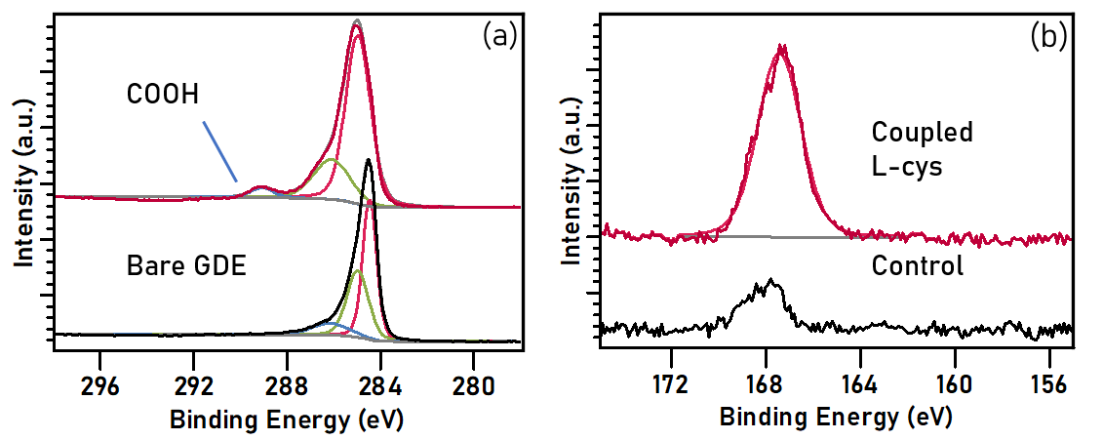
Figure S10. (a) C 1s spectra before and after electrode functionalization with 4-phenylacetic moieties. (b) S 2p spectra after covalent coupling of L-cysteine, compared to dropcasted solution.
Figure S11. Comparison of dropcasting of BOD on GDE and GCE.
$$Fc↔{Fc}^{+}$$
$$2{Fc}^{+}+{GODH}_{2} →2 Fc+GOD+ 2H^{+}$$
$$GOD+glucose → {GODH}_{2}+gluconolactone$$
Scheme S1. Mediated electron transfer process in presence of glucose oxidase.
Figure S12. GOD adsorbed on carboxyl functionalized GDE upon glucose addition.
Figure S13. GOD (a) covalently coupled and (b) adsorbed on carboxyl functionalized GCE upon glucose addition.
Fig S14. O₂ consumption measurement with Clark-type electrode upon addition of glucose, comparing covalent coupling of GOD on GDE and GCE.

