Supplementary online content
e Table 1 General characteristics of the entire cohort
Characteristics | Total
 | N=1603
Age, y, (IQR) | 62(55-68)
Sex, No. (%)
Male | 1168(72.86)
Female | 435(27.14)
Histologic type, No. (%)
Differentiated | 771(48.1)
Undifferentiated | 832(51.9)
Type of resection, No. (%)
Distal gastrectomy | 639(39.86)
Total gastrectomy | 964(60.14)
ASA score, No. (%)
1 | 236(14.72)
2 | 1253(78.17)
3 | 114(7.11)
ECOG PS, No. (%)
0 | 937(58.45)
≥ 1 | 666(41.55)
CCI, No. (%)
0 | 993(61.95)
≥ 1 | 610(38.05)
Lymphovascular invasion, No. (%)
Negative | 954(59.51)
Positive | 649(40.49)
pTNM stage, No. (%)
I | 510(31.81)
II | 423(26.39)
III | 670(41.80)
BMI, kg/m², (IQR) | 22.48(20.39-24.69)
FFMI, kg/m², (IQR)
Male | 17.34(16.29-18.33)
Female | 14.56 (13.82-15.28)
NLR | 2.04(1.52-2.87)
Hb, g/L, (IQR) | 129.40±25.20
Alb, g/L, (IQR) | 41.09±4.78
Glu, mmol/L, (IQR) | 5.65±1.46
ASA: American Society of Anesthesiologists; ECOG PS: Eastern cooperative oncology group performance status; CCI: charlson comorbidity index; BMI: body mass index; FFMI: fat-free mass index; NLR: neutrophil- lymphocyte ratio; Hb: hemoglobin; Alb: albumin; Glu: glucose

e Figure 1 The association between FFMI and overall survival based on sex-specific quartiles
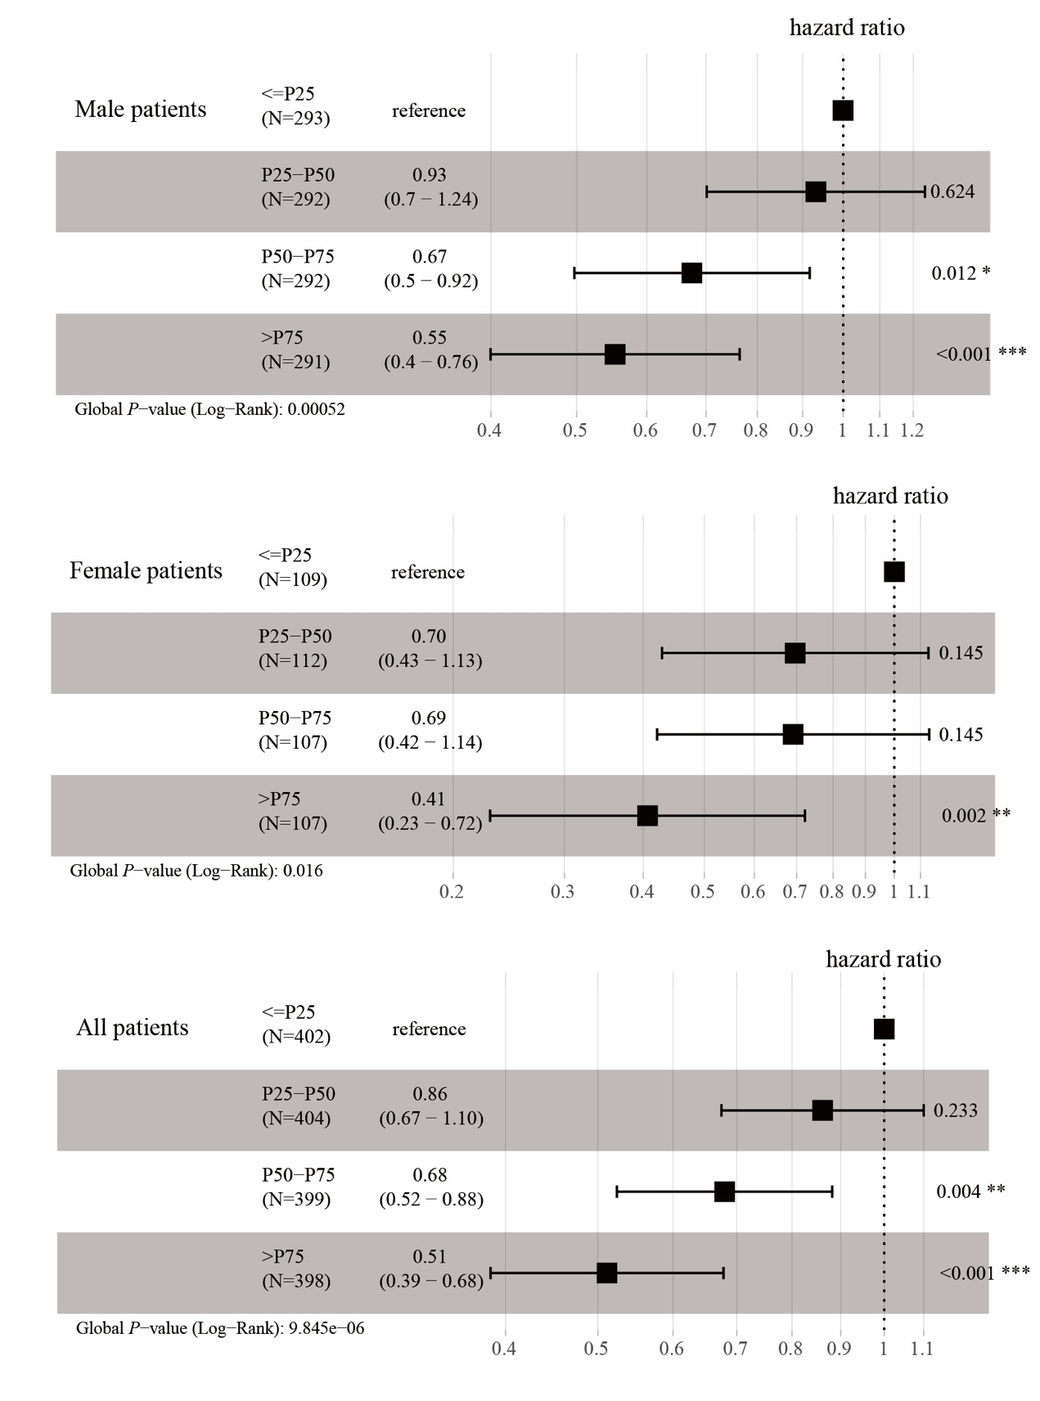

e Table 2 Comparison of postoperative recovery time in patients with different FFMI and BMI
 | FFMI |  |  |  |  | BMI
 |  | Low | Normal | P | Low |  | Normal | P
 |  | N=402 | N=402 |  | N=130 |  | N=1473
Time to ambulation, d, mean±SD |  | 2.55±1.34 | 2.39±1.33 | 0.006 | 2.31±0.94 |  | 2.44±1.37 | 0.523
Time to first flatus, d, mean±SD |  | 3.54±1.17 | 3.46±0.95 | 0.673 | 3.50±1.33 |  | 3.48±0.98 | 0.425
Time to first liquid intake, d, mean±SD |  | 4.80±2.74 | 4.81±3.56 | 0.202 | 4.95±3.69 |  | 4.80±3.34 | 0.456
Time to semifluid intake, d, mean±SD |  | 7.49±5.72 | 7.09±4.72 | 0.008 | 7.40±4.61 |  | 7.17±5.02 | 0.185
Postoperative hospital stays, d, mean±SD |  | 10.32±6.40 | 10.22±6.13 | 0.094 | 9.81±4.86 |  | 10.28±6.30 | 0.957
SD: standard deviation

e Table 3 Univariate and multivariate Cox regression for overall survival
 | Univariable |  | Multivariable
 | HR(95%CI） | P |  | HR(95%CI） | P
FFMI
Normal | Ref. |  |  | Ref.
Low | 1.47(1.20-1.80) | <0.001 |  | 1.23(1.00-1.51) | 0.049
BMI
High | Ref.
Low | 1.41(1.04-1.92) | 0.029 |  |  | 0.455
Lymphovascular invasion
Negative | Ref.
Positive | 2.75(2.26-3.34) | <0.001 |  |  | 0.121
Type of resection
Distal gastrectomy | Ref. |  |  | Ref.
Total gastrectomy | 2.06(1.66-2.55) | <0.001 |  | 1.47(1.18-1.83) | 0.001
Histologic type
Differentiated | Ref. |  |  | Ref.
Undifferentiated | 1.99(1.63-2.43) | <0.001 |  | 1.37(1.1137-1.68) | 0.003
pTNM stage
I | Ref. |  |  | Ref.
II | 3.79(2.37-6.08) | <0.001 |  | 4.62(2.76-7.71) | <0.001
III | 15.22(9.97-23.23) | <0.001 |  | 17.72(10.88-28.86) | <0.001
Adjuvant chemotherapy
Yes | Ref. |  |  | Ref.
No | 0.34(0.27-0.44) | <0.001 |  | 1.68(1.25-2.25) | 0.001
NLR
Low | Ref. |  |  | Ref.
High | 1.76(1.45-2.14) | <0.001 |  | 1.45(1.19-1.77) | <0.001
FFMI: fat-free mass index; BMI: body mass index; NLR: neutrophil-lymphocyte ratio

e Table 4 Comparison of postoperative complication in different FNC groups
Postoperative complication | High-risk Group | Low-risk Group | P
 | N=208(%) | N=1395(%)
Gastrointestinal hemorrhage | 5(2.4) | 20(1.4) | 0.451
Anastomotic leakage | 10(4.8) | 30(2.2) | 0.022
Wound problem | 4(1.9) | 8(0.6) | 0.094
Abdominal infection | 12(5.8) | 47(3.4) | 0.086
Delayed gastric emptying | 0(0) | 8(0.6) | 0.570
Ileus | 2(1.0) | 13(0.9) | 1.000
Lymphatic Leakage | 1(0.5) | 10(0.7) | 1.000
Pneumonia | 18(8.7) | 97(7.0) | 0.375
Cerebrovascular events | 1(0.5) | 7(0.5) | 1.000
Hepatic dysfunction | 5(2.4) | 20(1.4) | 0.451
Deep vein thrombosis | 1(0.5) | 8(0.6) | 1.000
Surgical complication | 26(12.5) | 112(8.0) | 0.032
Major complication | 32(15.4) | 184(13.2) | 0.387
Clavien-Dindo classification
1-2 | 23(71.9) | 144(78.3)
≥ 3 | 9(28.1) | 40(21.7) | 0.426

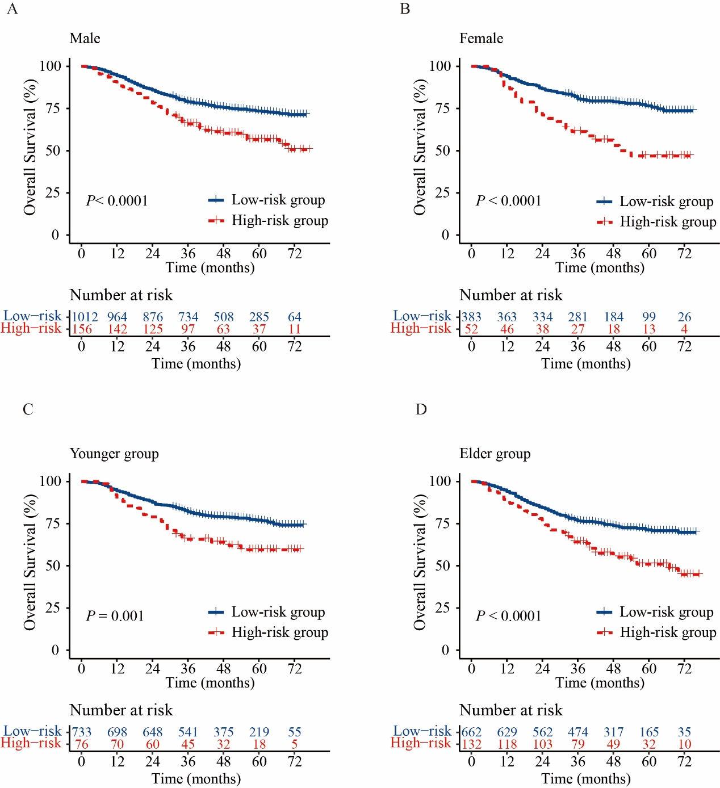e Figure 2 The overall survival curve of different FNC groups in A male patients B female patients C younger patients D elder patients

