Supplementing Information
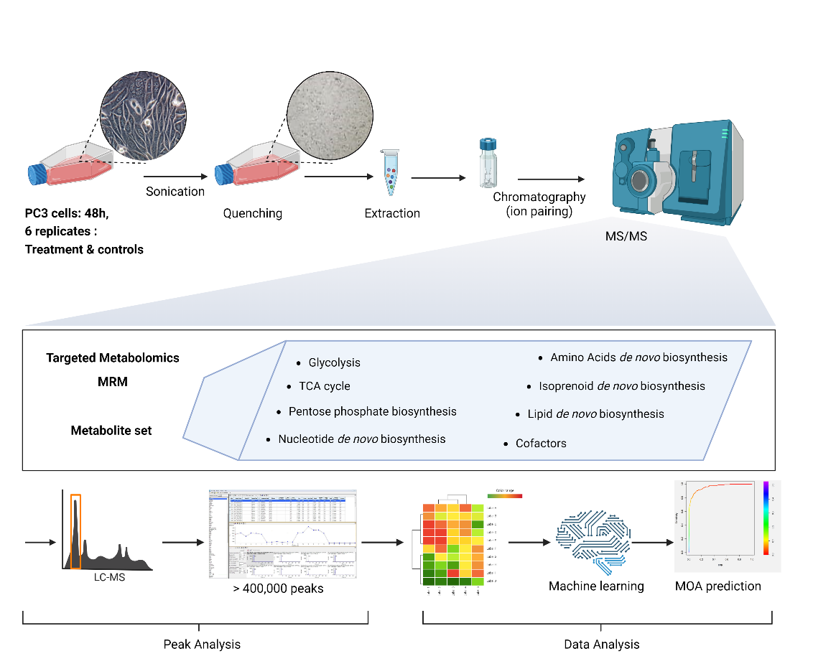
Fig. S1. Analysis workflow for MoA prediction

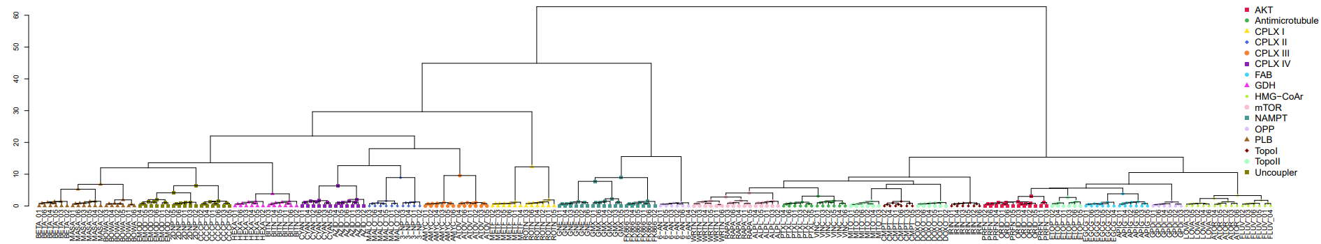

Fig. S2. Hierarchical cluster analysis of metabolic patterns of 38 reference compounds inhibiting different molecular targets of cancer metabolism in prostate cancer cells (PC-3) including all individual sample data. For higher magnification we refer to a separate file (Figure S2) formatted as pdf.

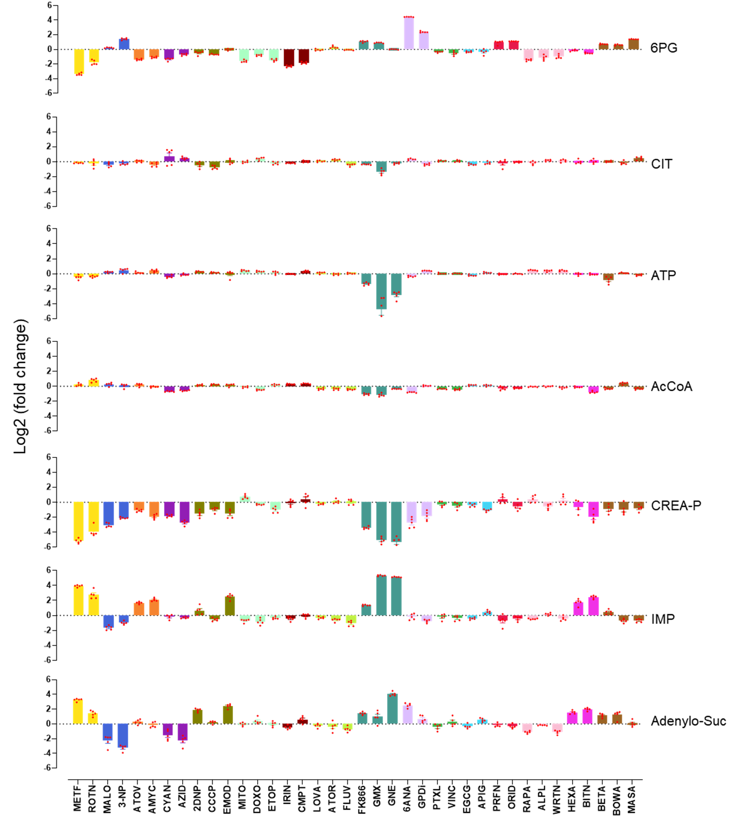
Fig. S3. Relative abundance of selected metabolites across all training data. Bars represent the average log₂-fold change of normalized peak areas of n=6 treatments and controls after 48 h incubation.
Compounds: BETA – betulinic acid, MASA – maslinic acid, BOWA – boswellic acid, EMOD – emodin, 2DNP – 2,4-dinitrophenol, CCCP – carbonyl cyanide chlorophenylhydrazone, HEXA – hexachlorophene, BITN - bithionol, CYAN – potassium cyanide, AZID – sodium azide, MALO – malonic acid, 3-NP – 3-nitropropionic acid, AMYC – antimycin A, ATOV – atovaquone , METF – metformin, ROTN – rotenone, GNE – GNE-617, GMX – GMX1778, FK866 – FK866, 6ANA – 6-aminonicotinamide, WRTN – wortmannin, RAPA – rapamycin, ALPL – alpelisib, PTXL – paclitaxel, VINC – vincristin, MITO – mitoxantrone, CMPT – camptothecin, DOXO – doxorubicin, IRIN – irinotecan, PRFN (PR) – perifosine, ORID (OR) – oridonin, ETOP – etoposid, EGCG – epigallocatechin gallate, APIG – apigenin, GPDi – glucose-6-phosphate dehydrogenase inhibitor, LOVA – lovastatin, ATOR – atorvastatin, FLUV – fluvastatin.
MoA: AKT – protein kinase B (AKT), Antimicrotubule, CPLX I – complex I, CPLX II – complex II, CPLX III – complex III, CPLX IV – complex IV, FAB – fatty acid biosynthesis, GDH – glutamate dehydrogenase, HMG-CoAr – HMG-CoA reductase, mTOR – PI3K/mTOR signaling, NAMPT – nicotinamide phosphoribosyltransferase, OPP – oxidative pentose phosphate pathway, PLB – phospholipid biosynthesis, TopoI – topoisomerase I, TopoII – topoisomerase II, uncoupler – uncoupling of oxidative phosphorylation.

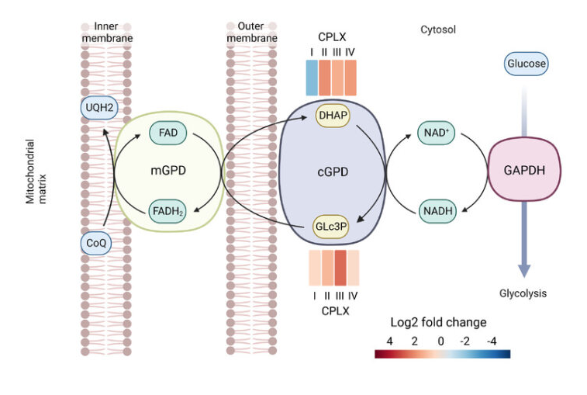
Fig. S4. The glycerol phosphate shuttle antagonizes mitochondrial dysfunction in cancer cells ³¹. By using cytosolic NADH, e.g., as a side-product of glycolysis, to reduce DHAP to glycerol 3-phosphate (Glc3P) cytosolic NAD is regenerated, which supports ongoing glycolytic flow. Glc3P can pass electrons to mitochondrial glycerol 3-phosphate dehydrogenase (EC 1.1.5.3), transferring reducing power to FADH₂. FADH₂ finally reduces CoQ at the inner mitochondrial membrane, which also regenerates DHAP.

A
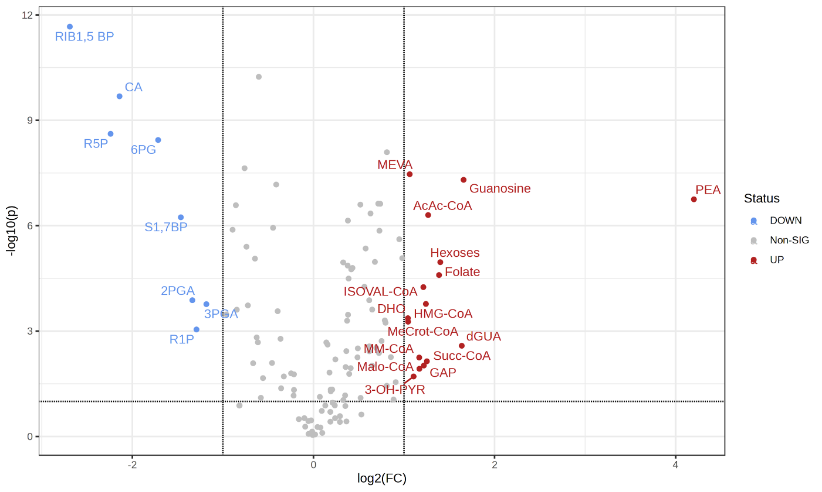
B
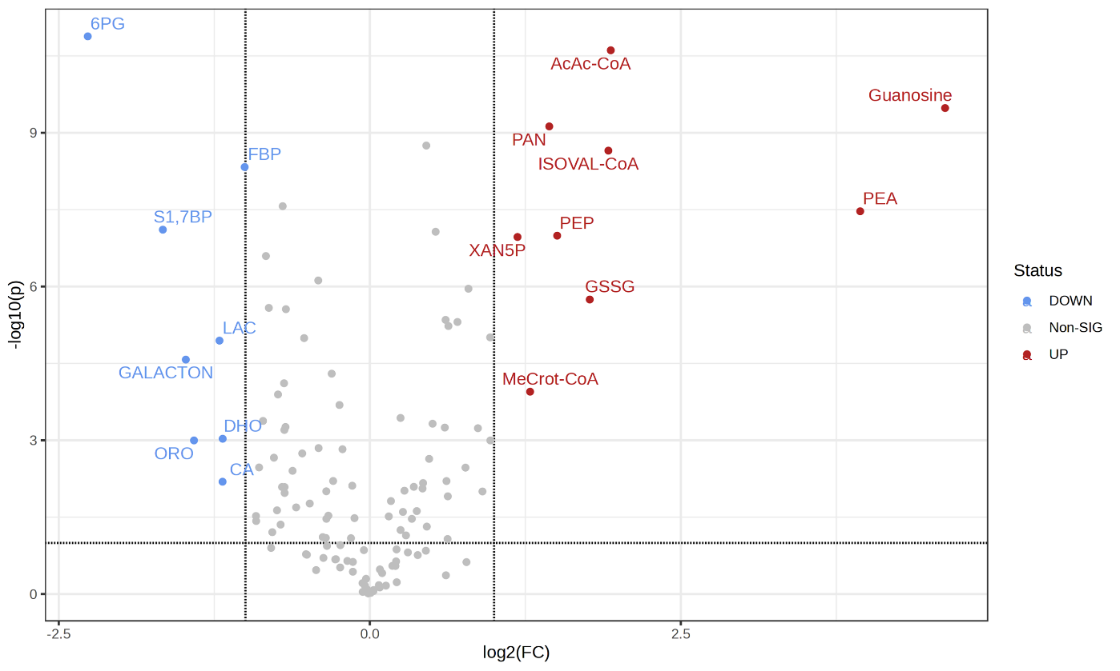

C
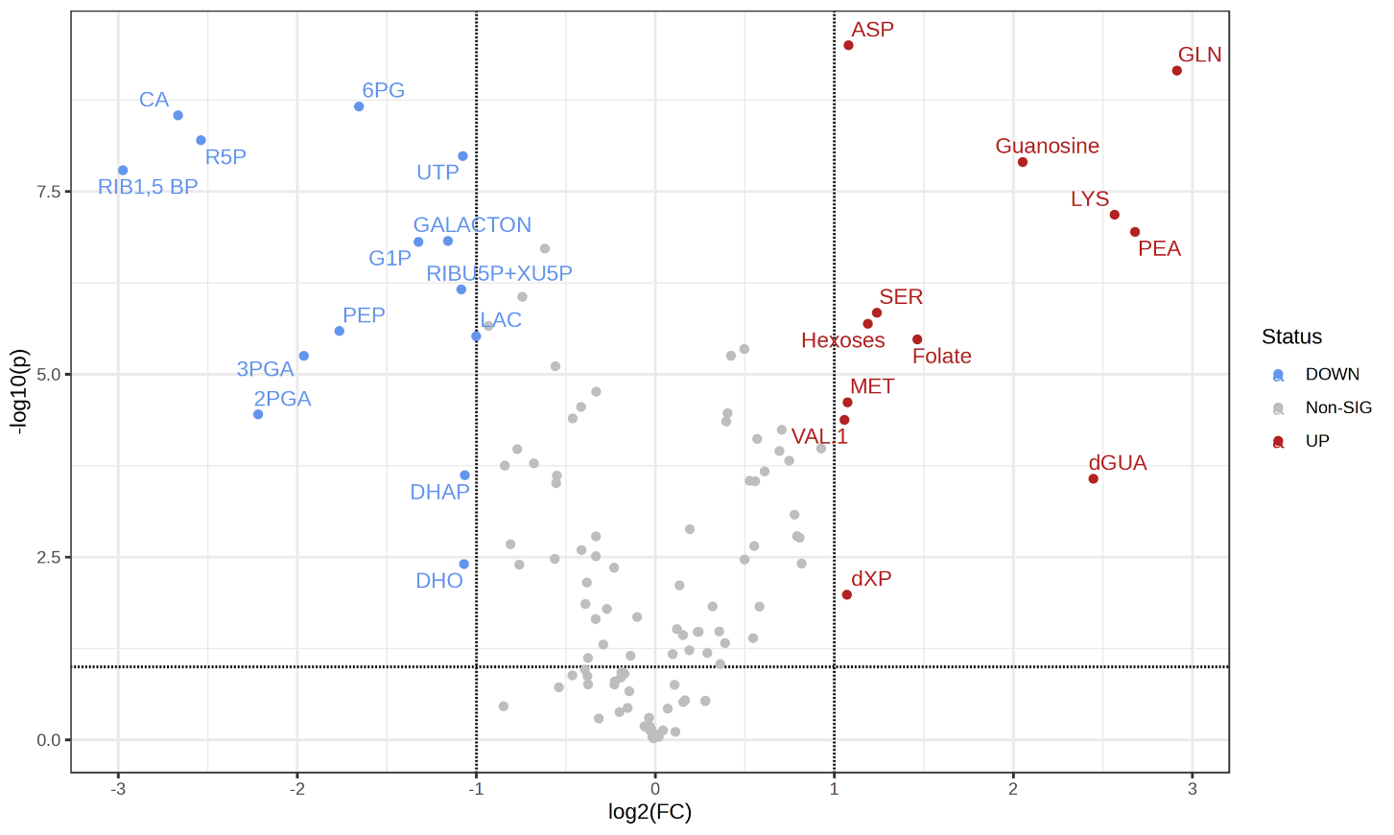
D
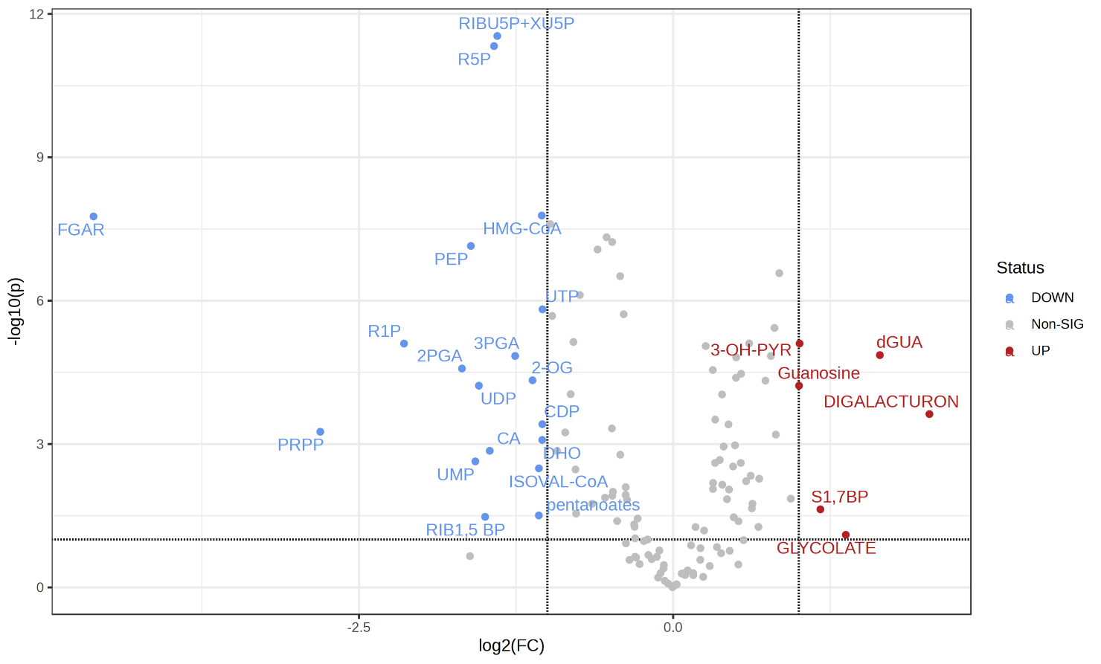

E
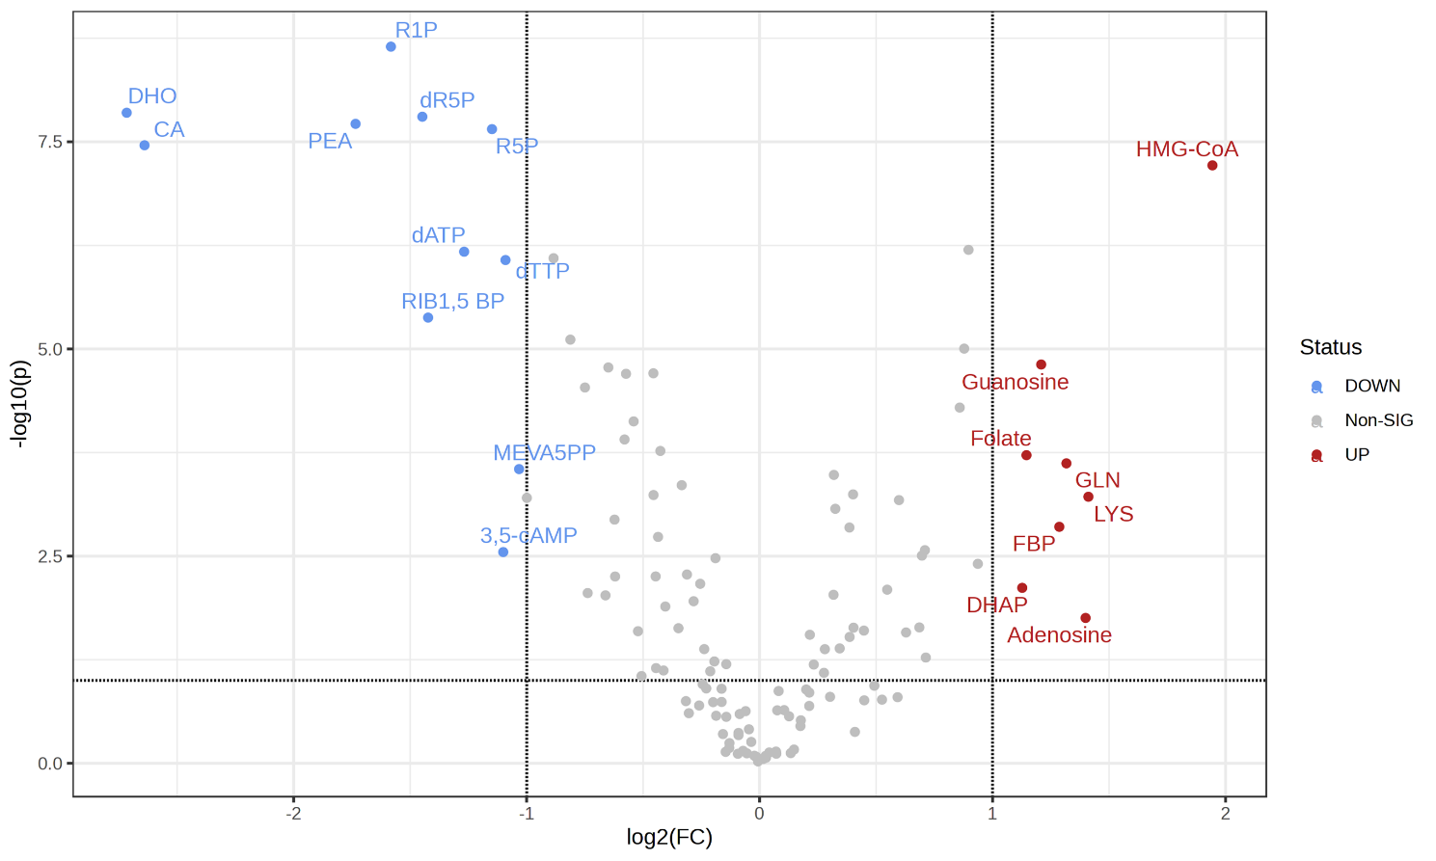F
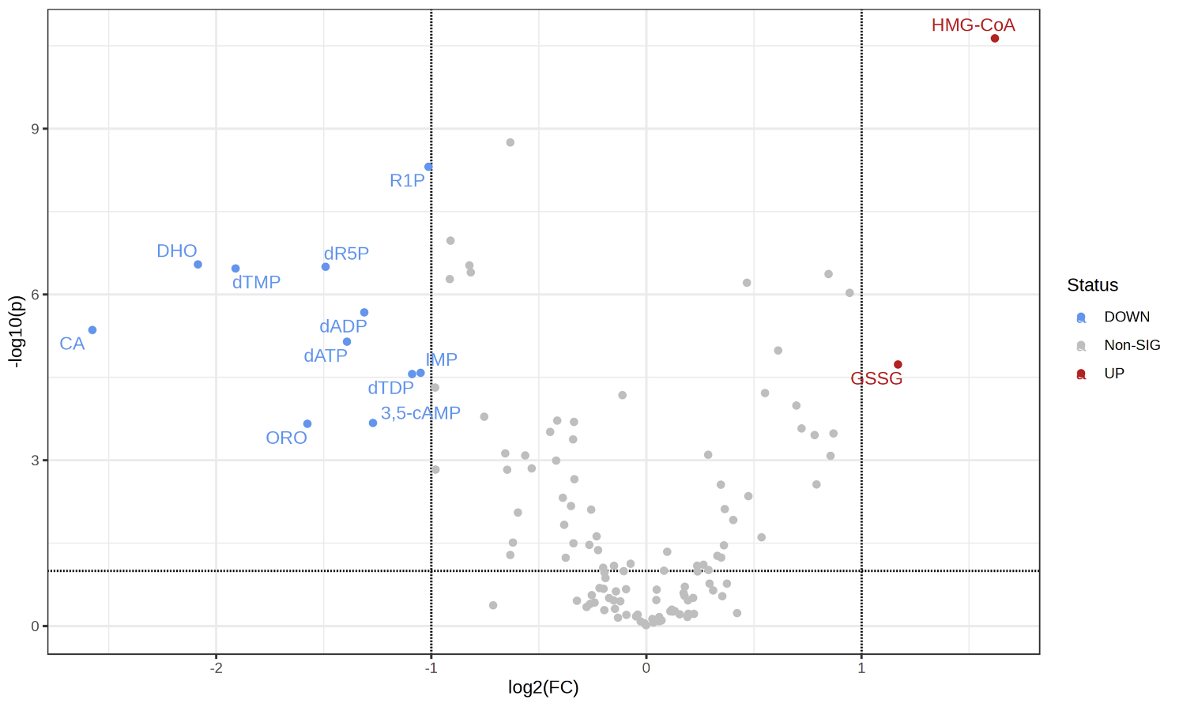

G
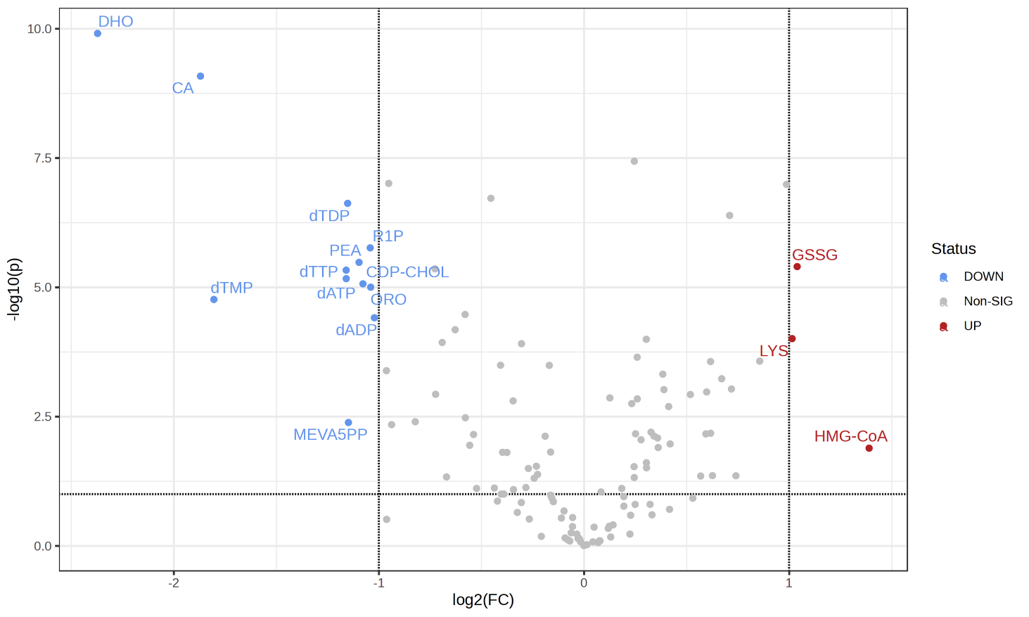
H
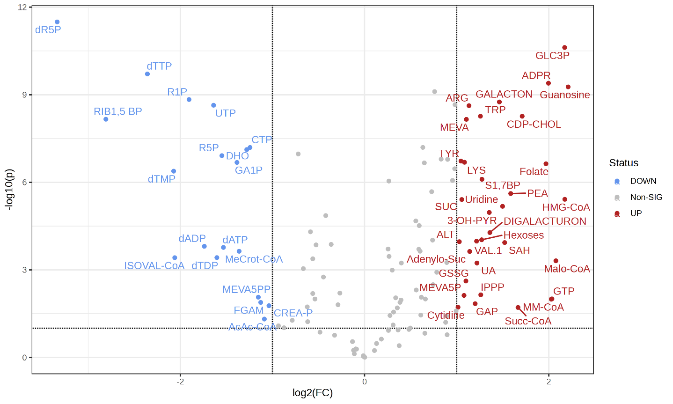

Fig. S5. Volcano plots representing relative metabolite abundances (average of n = 6 replicates) after 48 h in selected treatments versus non-treated vehicle controls, represented with accumulation (red), depletion (blue) and non-significant changes (gray) following the 48 h treatment with
Topoisomerase I inhibitors: (A) camptothecin, (B) irinotecan,
Topoisomerase II inhibitors: (C) mitoxantrone, (D) doxorubicin,
HMG-CoA reductase inhibitors: (E) lovastatin (LOVA), (F) fluvastatin (FLUV), (G) atorvastatin (ATOR),
and putative PLB inhibitors (H) betulinic acid (BETA).
A legend for the metabolites’ abbreviations is given in Table S2.

Fig. S6. Orthogonal partial least squares (oPLS-DA) discrimination between all AKT inhibitors and all mTOR inhibitors, (A) scores, (B) loadings (importance of variables). For the analysis, all 48 h data of wortmannin, rapamycin and alpelisip were grouped as mTOR and compared against all data of perfosine and oridonin, grouped as AKT. Log2-fold changes vs. non-treated controls were range-scaled.

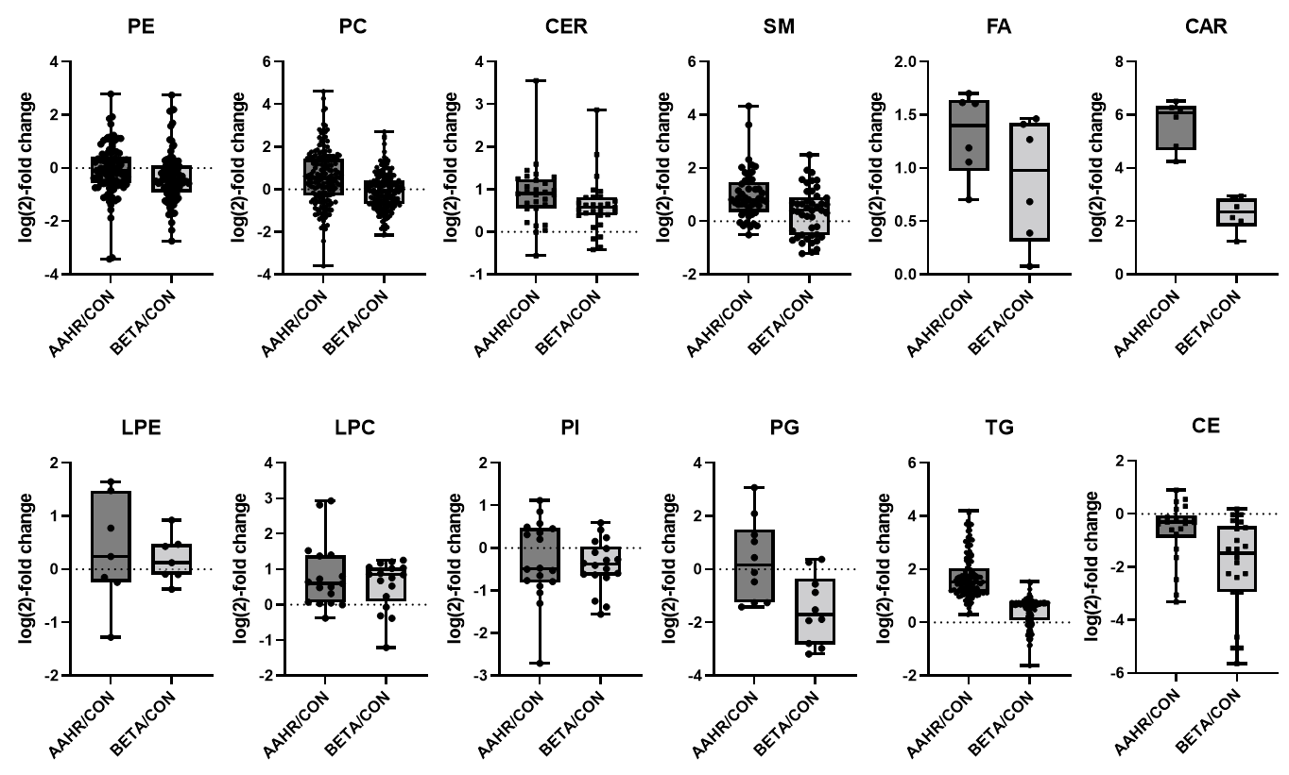

Fig. S7. The ratio of lipid levels of PC-3 cells treated for 48 h with AAHR (285 nM) or BETA (20 µM) versus DMSO controls. Each dot represents an individual lipid. All values are normalized to cell number and represent the average of five independent experiments per annotated lipid. Annotations of individual lipids and their peak heights are presented in Table S5.
PE – diacylglycerophosphoethanolamines, PC – diacylglycerophosphocholines, CER – ceramide, SM – sphingomyolin, FA – free fatty acids, CAR – acylcarnitines, LPE – monoacylglycerophosphoethanolamines, LPC - monoacylglycerophosphocholines, PI – phosphoinositides, PG – phosphoglycerates, TG – triacylglycerides, CE – cholesterol esters.

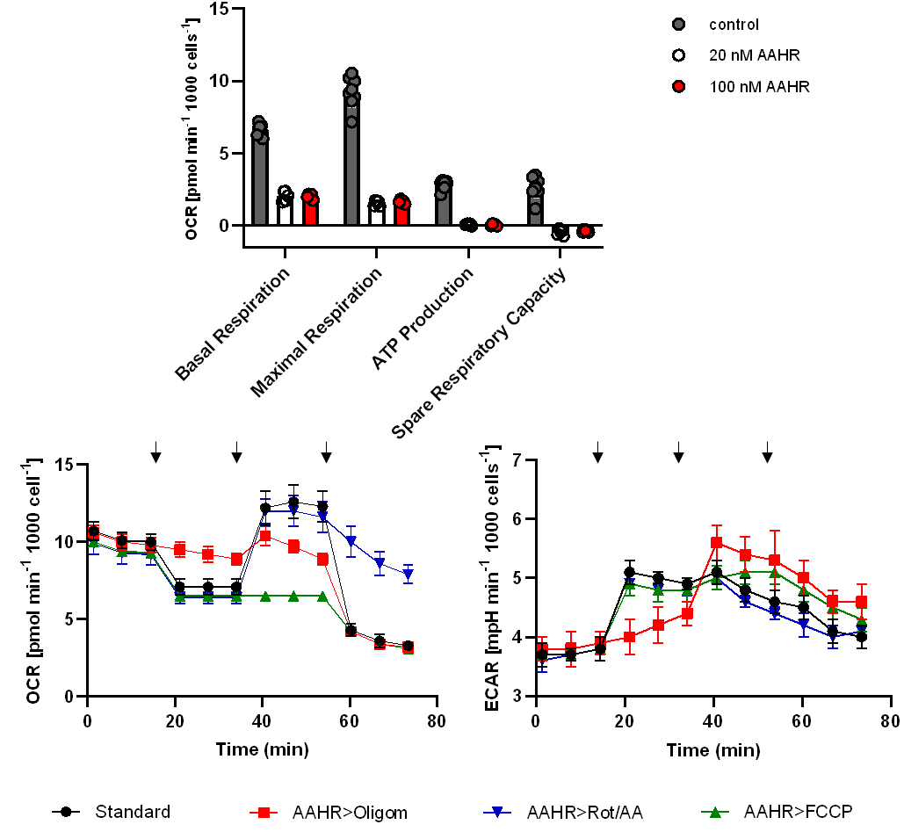
B
C
A
Fig. S8. Analyses of mitochondrial function and ATP production in PC-3 cells.
(A) Parameters obtained from a Seahorse XF Cell Mito Stress Test following a 24 h treatment with AAHR. Basal respiration: oxygen consumption rate (OCR) used to investigate cellular ATP demand resulting from mitochondrial respiration at baseline; Maximal respiration: OCR attained by stimulating the respiratory chain to operate at maximum capacity, shows the maximum rate of respiration the cell can achieve. Spare respiratory capacity indicates the capability of the cell to respond to an energetic demand and how close the cell is to returning to its theoretical maximum. ATP production: oxygen consumption linked cellular ATP production rate.
(B) Patterns of OCR, and (C) ECAR (extracellular acidification rate) during the Seahorse XF Cell Mito Stress Test. Arrows indicate the sequential substance injection. In a standard assay, the order of injection is: 1. oligomycin, 2. FCCP, 3. rotenone/antimycin A. In the modified assays, one of the substances was replaced by AAHR, respectively.
Fig. S9. Analyses of cellular coenzyme Q levels after 48 h treatment with AAHR (285 nM), BETA (20 µM) and DMSO (control).

Fig. S10. AAHR accumulation in the mitochondria of PC-3 cells.
PC-3 cells were treated with AAHR for 4 h followed by counterstaining with MitoTrackerTM Green and analysis by performing confocal laser scanning microscopy. (A) Overview of a few cells; (B) close-up of a single cell. The fluorescence of AAHR and MitoTrackerTM Green is depicted in red and green, respectively. The overlay shows the co-localization of both AAHR and MitoTrackerTM Green. Pearson’s Correlation Coefficient was calculated using eight micrographs and revealed 0.8558±0.058. Bars represent 20 µm.

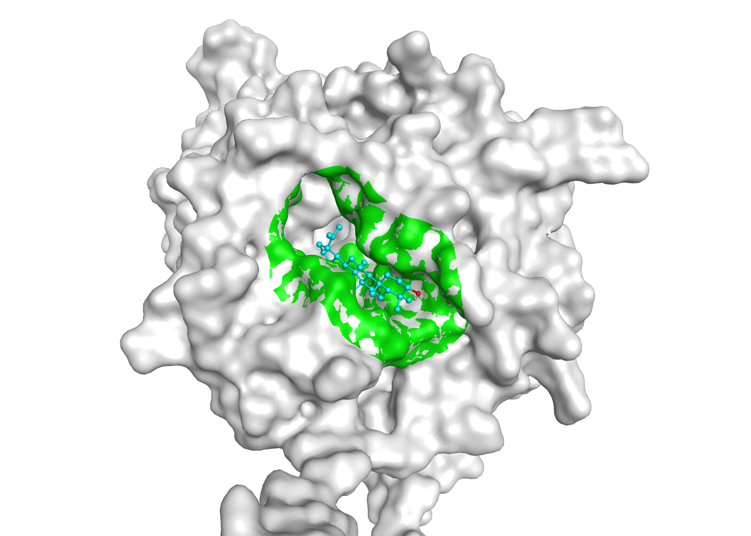
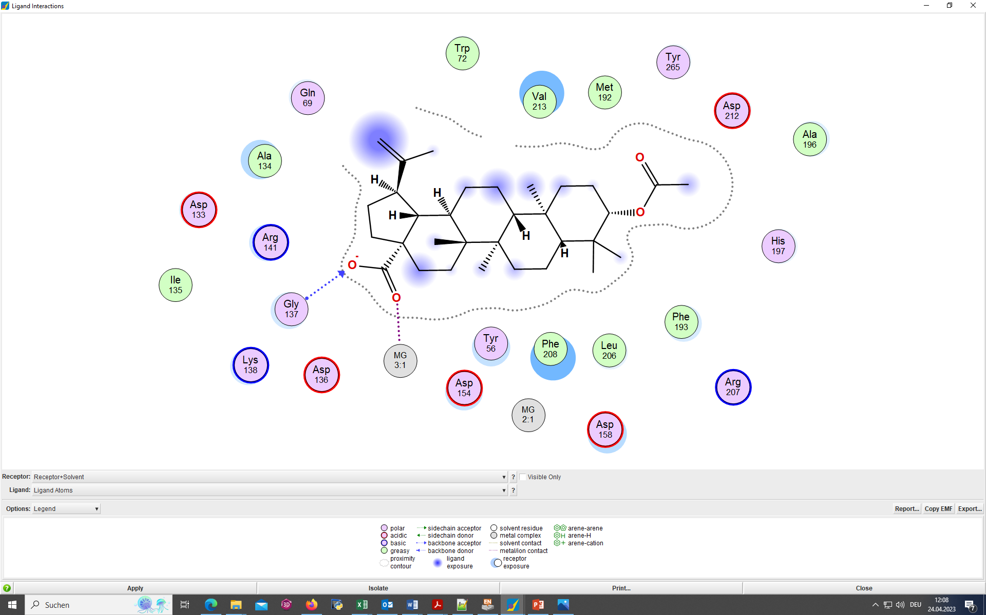
A

B

Fig. S11. Molecular docking of pentacyclic triterpenes with CEPT1 and CPT1. (A) Molecular surface of CEPT1 with docked BETA as ligand. The binding site is represented in green. (B) 2D-interactions showing that the carboxyl group of acid-based pentacyclic diterpenes exhibits favorable hydrogen bond interactions, while the aromatic part has hydrophobic interactions with non-polar residues.

Table S1. IC₅₀ values, MeA and structural information for training and prediction compounds
Table S2. Structural information and LC-MS/MS parameters of analyzed CCEM metabolites
Table S3. Sum-normalized raw data (peak area) of training and prediction compounds
Table S4. Binding affinity of triterpenoid ligands to the CEPT1 and CPT1 enzymes, in comparison to the native substrate CDP-choline
Table S5. Cell number-normalized lipidomics data of control, BA and AAHR treated PC-3

