Supplementary Information

Hyaluronic acid stimulation of stem cells for cardiac repair: a cell-free strategy for myocardial infarct

Seon-Yeong Jeong^{1,}*, Bong-Woo Park^{2,3}*, Jimin Kim¹, Seulki Lee¹, Haedeun You¹, Joohyun Lee¹, Susie Lee², Jae-Hyun Park², Jinju Kim², Woosup Sim², Kiwon Ban⁴, Joonghoon Park⁵, Hun-Jun Park^{2,6,#}, Soo Kim^{1,#}
¹Brexogen Research Center, Brexogen Inc., Songpa‑gu, Seoul, 05855, South Korea.
²Department of Biomedicine & Health Sciences, The Catholic University of Korea.
³Catholic High-Performance Cell Therapy Center and Department of Medical Life Science, College of Medicine, The Catholic University of Korea, Seoul, 06591, Republic of Korea.
⁴Department of BiomedicalScience, City University of Hong Kong, Kowloon Tong, Hong Kong.
⁵Graduate School of International Agricultural Technology, Institutes of Green-Bio Science and Technology, Seoul National University, Pyeongchang, Gangwon-do, 25354, South Korea.
⁶Division of Cardiology, Department of Internal Medicine, Seoul St. Mary’s Hospital, The Catholic University of Korea.
* These authors contributed equally
# Address for Correspondence:
Hun-Jun Park, MD., PhD., Seoul St. Mary’s Hospital, The Catholic University of Korea, 222 Banpo-daero, Seocho-gu, Seoul, 137-701, Republic of Korea. Email: cardioman@catholic.ac.kr
Soo Kim, PhD., Brexogen Research Center, Brexogen Inc., Songpa‑gu, Seoul 05855, South Korea. Email: sue.kim@brexogen.com
Supplementary Figures
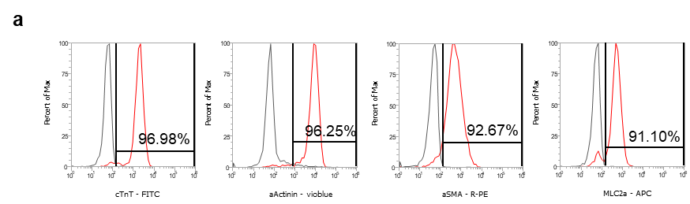
Supplementary Fig. 1 Characterization of hiPSC-CM.
a Characterization of hiPSC-CM was performed by flow cytometric analysis with cardiomyocyte markers including cardiac troponin T (cTnT), actinin alpha (α-actinin), alpha smooth muscle actin (α-SMA) and myosin light chain 2a (MLC2a).

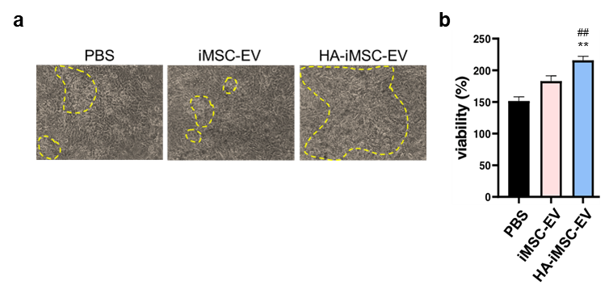
Supplementary Fig. 2 Protection effects of the HA-iMSC-EVs on primary neonatal rat cardiomyocyte.
a-b EVs were treated to primary neonatal rat cardiomyocyte damaged with 500 μM of H₂O₂ for 2h. a Video were recorded for 15 seconds, and the beating area were marked yellow line. b After 48 h, relative viable cells were increased in EV-treated groups compared to PBS group. Mean ± SD, n= 3, **p < 0.01 vs PBS; ##p < 0.01 vs iMSC-EV.

