Supplementary for
Direct Electrolytic Extraction of Lithium Metal from Brines Based on Sandwich-structured Garnet Electrolyte
Nan Zhang^{1,#}, Hongpeng Zheng^{1,#}, Guoyao Li¹, Cheng Ouyang¹, Yu Yang², Hong Zhu², Rongzi Zhang³, Haidong Sun³, Yuhan Lin³, Hezhou Liu¹, Huanan Duan^{1,*}
1. State Key Laboratory of Metal Matrix Composites, School of Materials Science and Engineering, Shanghai Jiao Tong University, Shanghai 200240, P.R. China
2. University of Michigan-Shanghai Jiao Tong University Joint Institute, Shanghai Jiao Tong University, Shanghai, 200240 P. R. China
3. QingHai Salt Lake Industry Co., Ltd., No. 28, Huanghe Road, Golmud 816000, Qinghai, P.R. China
*E-mail: hd1@sjtu.edu.cn
# Nan Zhang and Hongpeng Zheng contributed equally to this work.

Contents
Fig. S1 – Fig. S22 1-24
Table S1 – Table S6 25-30
Supplementary Note 1 31-35
Supplementary References 36

Fig. S1 | Schematic diagram and digital photos of the DEEL device. a, A demonstration DEEL device and its main components. b-c, The actual setup of the DEEL device.

Fig. S2 | Video screenshots of the water immersion test. a-d, Video screenshots of 100 μm-Polished LLZTO immersed in water for 0 min (a), 1 min (b), 2 min (c), and 3 min (d), respectively. e-h, Video screenshots of Pristine-Surface LLZTO immersed in water for 0 min (e), 1 min (f), 2 min (g), and 3 min (h), respectively.

Fig. S3 | Electrochemical properties of the sandwich-structured LLZTO. a, Au|LLZTO|Au EIS spectrum, inset shows the equivalent circuit used for fitting. b, Arrhenius plots comparison of Pristine-Surface and 100 μm-Polished surface.

Fig. S4 | SEM images of the Pristine-Surface LLZTO before and after immersion in water. a-b, The cross-sectional (a) and surface (b) SEM images of the Pristine-Surface LLZTO before immersion in water. c-d, The cross-sectional (c) and surface (d) SEM images of the Pristine-Surface LLZTO after immersion in water.

Fig. S5 | SEM images of the 100 μm-Polished LLZTO before and after immersion in water. a-b, The cross-sectional (a) and surface (b) SEM images of the 100 μm-Polished LLZTO before immersion in water. c-d, The cross-sectional (c) and surface (d) SEM images of the 100 μm-Polished LLZTO after immersion in water.

Fig. S6 | The ionic conductivity comparison before and after exposure to air for 7 days.

Fig. S7 | XRD patterns of different LLZTO pellets. XRD patterns of the Pristine-Surface, 40 μm-Polished surface, and 100 μm-Polished surface of Ta5Li-4 (a), Ta5Li0 (b), and Ta5Li4 (c) LLZTO pellets.

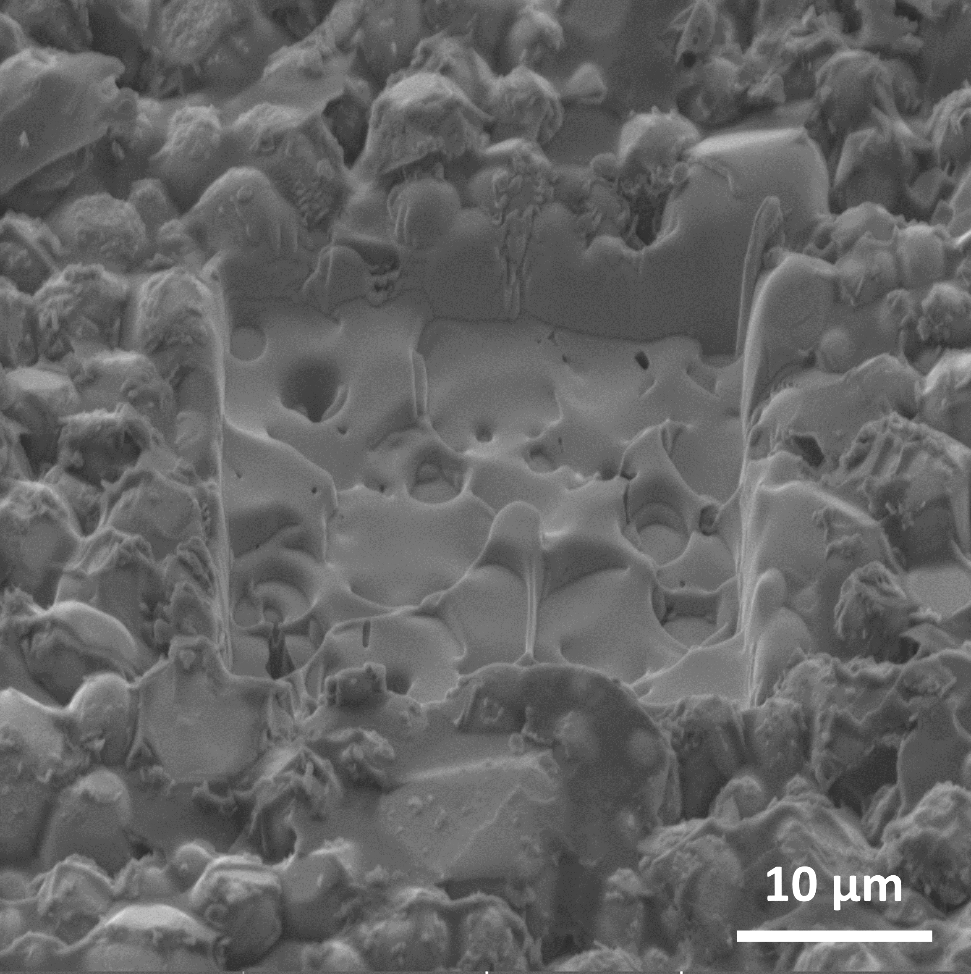
Fig. S8 | SEM image corresponding to TOF-SIMS.

Fig. S9 | The morphology of the Li|LLZTO cross-section after lithium extraction for 10 h with the current density of 0.05 mA cm⁻². a, The SEM image. b, The corresponding linear scanning.

Fig. S10 | Lithium extraction performance with the current density of 0.10 mA cm⁻² for 48 h. Lithium extraction performance in 0.2 (a), 0.33 (b), 0.6 (c), and 1 mol L⁻¹ (d) LiCl solution.

Fig. S11 | Lithium extraction performance with the current density of 0.20 mA cm⁻² for 48 h. Lithium extraction performance in 0.2 (a), 0.33 (b), 0.6 (c), and 1 mol L⁻¹ (d) LiCl solution.

Fig. S12 | Lithium extraction performance with current densities of 0.1, 0.2, 0.3, 0.4, 0.5 mA cm⁻² for 1 h. The LiCl concentration is 1.0 (a), 0.6 (b), 0.33 (c), and 0.2 (d) mol L⁻¹.

Fig. S13 | Lithium extraction performance in 0.01 mol L⁻¹ LiCl solution with the current density of 0.10 mA cm⁻² for 27 h.

Fig. S14 | Lithium extraction performance in 0.05 mol L⁻¹ LiCl solution without Mg²⁺. a, Lithium extraction performance with the current density of 0.1, 0.2, 0.3, 0.4, and 0.5 mA cm⁻² for 1 h. b, Lithium extraction performance with the current density of 0.20 mA cm⁻² for 48 h.

Fig. S15 | SEM images of the LLZTO pellets before and after lithium extraction in a solution with Mg/Li = 10. a, The cross-sectional SEM image of the LLZTO pellet before lithium extraction. b, The cross-sectional SEM image of the LLZTO pellet after lithium extraction.

Fig. S16 | Characterization of the LLZTO pellets before and after lithium extraction in a solution with Mg/Li = 10. a, XRD spectrum before and after lithium extraction. b, Li⁺ conductivity before and after lithium extraction.

Fig. S17 | Digital photo of the Chaerhan Salt Lake brine and the lithium extraction performance. a, A digital photo of the Chaerhan Salt Lake brine. b, Lithium extraction performance with current densities of 0.06, 0.07 and 0.08 mA cm⁻² for 1 h. c, Lithium extraction performance with current densities of 0.05 and 0.06 mA cm⁻² for 2 h.

Fig. S18 | Scaled-up DEEL device using a parallel cell configuration. a-b, Schematic diagram of the scaled-up devices used with single (a) and multiple (b) DEEL devices. c-d, Digital photos of a scaled-up DEEL device.

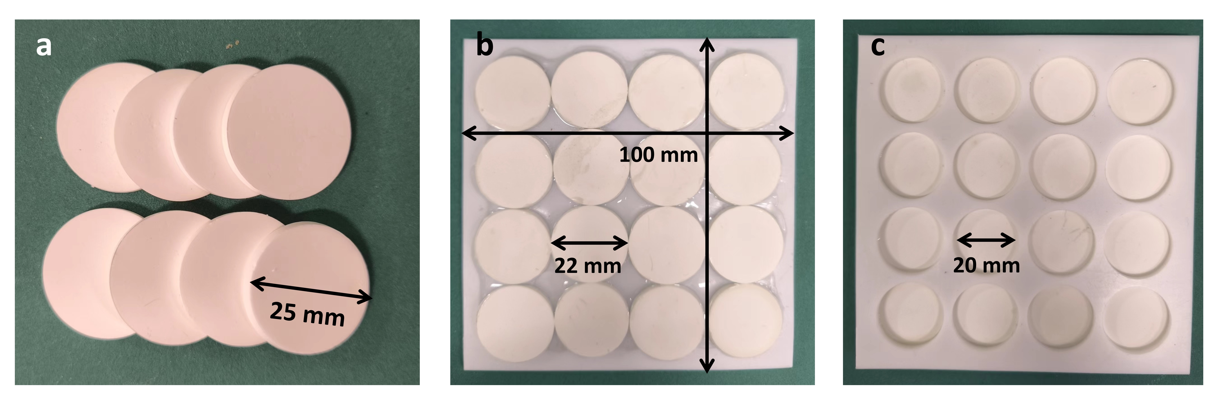
Fig. S19 | Expanding ideas for LLZTO. a, LLZTO pellets with a larger diameter (the diameter of the die is 25 mm, and the diameter of the LLZTO pellets after sintering is 22 mm). b-c, 16 LLZTO pellets are glued onto a PTFE board with φ20 mm holes using UV resin. The side in contact with brine (b) and the side in contact with LOE (c).

Fig. S20 | Thinning ideas for LLZTO. a, The minimum thickness of LLZTO pellets prepared by solid-state sintering method is below 500 μm. b-c, A piece of LLZTO thin film prepared by tape casting method (b) and round LLZTO slices (c).

Fig. S21 | A DEEL device that can accommodate ceramic plates with a side length of 100 mm. a, A digital photo of the parts in DEEL device. b, A digital photo of the assembled DEEL device. c, Schematic diagram of several stacked DEEL devices.

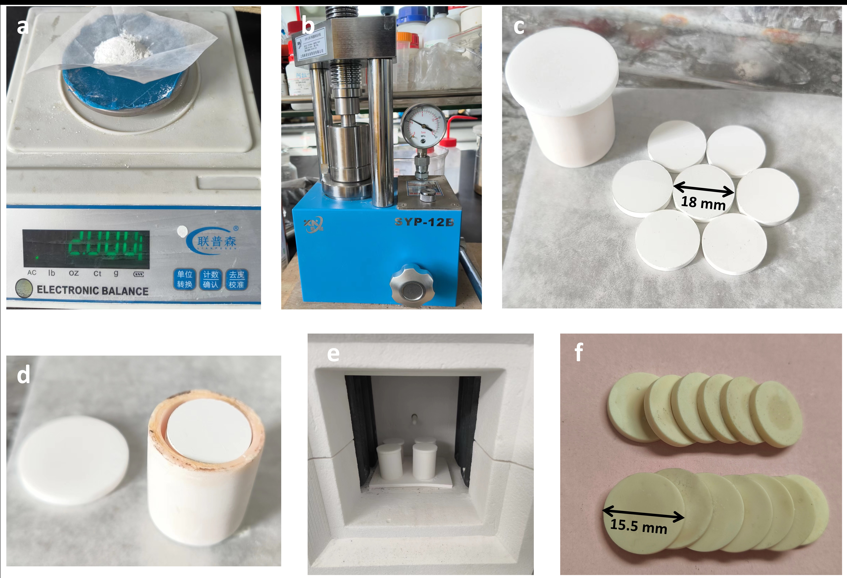
Fig. S22 | Preparation method of LLZTO pellets. a, 2 g of tetragonal powder was weighed. b, Green pellets were pressed using the 12 mm and 18 mm stainless-steel die. c, Green pellet with a diameter of 18 mm. d, The sintering method without mother powder in the crucible. e, A furnace for sintering. f, LLZTO pellets with a diameter of ~15.5 mm.

Methods | Advantages | Disadvantages
Chemical precipitation | Simple operation and low cost | Environmental pollution caused by chemicals
Evaporation crystallization | Large production scale, fully utilizing clean energy such as solar energy | High energy consumption and long duration
Solution extraction | High selectivity and recovery rate | High cost, extraction agent causing equipment corrosion
Ion exchange adsorption | Low cost and high efficiency | Poor circulation and severe dissolution loss
Electrodialysis | Suitable for brine with high Mg/Li ratio | High membrane cost and low recycling efficiency
Table S1 | Comparison of conventional lithium extraction methods.

Test number | Mass before immersion (g) | Mass after immersion (g) | Mass difference (g) | Relative density (%)
1 | 1.9456 | 1.6527 | 0.2929 | 97.2
2 | 1.9282 | 1.6373 | 0.2909 | 97.0
3 | 1.9222 | 1.6298 | 0.2924 | 96.2
Table S2 | Test results of relative density of LLZTO pellets.

T (K) | Li₅₂La₂₄Zr₁₂Ta₄O₉₆ (eV) | Li₅₀La₂₄Zr₁₂Ta₄O₉₅ (eV) | Li₂O (eV) | ΔG (eV)
0 | -1356.94 | -1341.48 | -13.31 | 2.15
100 | -1357.30 | -1341.84 | -13.31 | 2.15
200 | -1359.10 | -1343.63 | -13.36 | 2.11
300 | -1362.42 | -1346.92 | -13.48 | 2.02
400 | -1367.03 | -1351.48 | -13.67 | 1.88
500 | -1372.70 | -1357.08 | -13.92 | 1.69
600 | -1379.26 | -1363.56 | -14.23 | 1.46
700 | -1386.57 | -1370.78 | -14.59 | 1.20
800 | -1394.55 | -1378.66 | -14.99 | 0.91
900 | -1403.12 | -1387.11 | -15.43 | 0.58
1000 | -1412.21 | -1396.07 | -15.90 | 0.24
1100 | -1421.77 | -1405.50 | -16.39 | -0.13
1200 | -1431.77 | -1415.36 | -16.92 | -0.51
1300 | -1442.16 | -1425.61 | -17.47 | -0.92
1400 | -1452.92 | -1436.21 | -18.05 | -1.34
1500 | -1464.03 | -1447.16 | -18.64 | -1.78
1600 | -1475.45 | -1458.42 | -19.26 | -2.23
1700 | -1487.17 | -1469.97 | -19.90 | -2.70
1800 | -1499.18 | -1481.81 | -20.55 | -3.18
1900 | -1511.46 | -1493.90 | -21.22 | -3.67
2000 | -1523.98 | -1506.24 | -21.91 | -4.17
Table S3 | ΔG of LLZTO losing a Li₂O molecule at different temperatures.

C_{Li+} (mol L⁻¹) | C_{Mg2+} (mol L⁻¹) | Input capacity (mAh) | Theoretical Li extraction (mg) | Li⁺ concentration by ICP (mg L⁻¹) | Actual Li extraction (mg) | Current efficiency (%)
0.05 | 0 | 9.6 | 2.487 | 162.021 | 2.430 | 97.71
0.05 | 0.5 | 4.8 | 1.244 | 71.981 | 1.079 | 86.74
Table S4 | Comparison of current efficiency in 0.05 mol L⁻¹ LiCl solution without and with Mg²⁺.

mg L⁻¹ | $${\text{C}}_{\text{L}{\text{i}}^{\text{+}}}$$ | $${\text{C}}_{{\text{Mg}}^{\text{2+}}}$$ | $${\text{C}}_{{\text{Zr}}^{\text{4+}}}$$ | $${\text{C}}_{{\text{Ta}}^{\text{5+}}}$$ | $${\text{C}}_{{\text{La}}^{\text{3+}}}$$
Chaerhan Salt Lake brine | 335.014 | 147574.730 | 0.090 | 0.048 | 0.032
Table S5 | Concentration of different ions in Chaerhan Salt Lake brine.

Methods | Materials | μ (μg cm⁻² h⁻¹) | References
Adsorption | MnO₂ ion sieve | 0.0052 | ¹
Adsorption | H₂TiO₃ | 0.0308 | ²
Solution extraction | poly (ethylene-co-vinyl alcohol) | 12.6 | ³
Electrolysis | Li_{1+x}Al_{y}Ge_{2-y}(PO₄)₃ | 57 | ⁴
Electrolysis | Li_{6.5}La₃Zr_{1.5}Ta_{0.5}O₁₂ | 25 | Li|LLZTO|Cu
Electrolysis | Li_{6.5}La₃Zr_{1.5}Ta_{0.5}O₁₂ | 126 | Cu/LOE|LLZTO|Cu
Table S6 | Summary of lithium extraction rates for some common lithium extraction materials.

Supplementary Note 1
Calculation method of the technoeconomic analysis (TEA) for lithium extraction from salt-lake brine
Assuming that there are 15 days for sintering and 350 days for lithium extraction each year.

1. Sintering process
1.1 Raw material cost
The thickness of the LLZTO pellets is 500 μm. The quantity and price of raw materials required per square meter of LLZTO pellets (reference: https://www.metal.com/) are shown in Table S7. The calculated raw material cost per square meter of LLZTO pellets is $17.31. The cost of raw materials required for sintering 17.5 m² of LLZTO pellets per day is $17.31 $\text{×}$ 17.5 = $302.98.

Raw material | Quantity (kg) | Price ($/kg) | Cost ($)
LiOH·H₂O | 0.650 | 22.30 | 14.50
La₂O₃ | 1.165 | 0.59 | 0.69
ZrO₂ | 0.438 | 4.70 | 2.06
Ta₂O₅ | 0.264 | 0.24 | 0.06
Total | 2.517 |  | 17.31
Table S7 | Raw material cost for sintering process.

1.2 Electricity cost
The maximum amount of powder that can be mixed by the mixer in a single operation is 45 kg, so 45/2.517=17.5 m² LLZTO pellets can be prepared each time. The speed of the continuous sintering furnace is 1m/h. The power, operating time, and energy consumption of the equipment are shown in Table S8 (Reference: https://cn.made-in-china.com/). The electricity cost is 8 cents/kWh, resulting in a daily electricity cost of $141.54 for sintering 17.5 m² of LLZTO pellets.

Equipment | Power (kW) | Operating time (h) | Energy consumption (kWh) | Cost ($)
Mixer | 2.2 | 6 | 13.2 | 1.06
Sifter | 2 | 3 | 6 | 0.48
Furnace | 100 | 17.5 | 1750 | 140
Total |  |  | 1769.2 | 141.54
Table S8 | Electricity cost for sintering process.

1.3 Daily capital cost
Capital recovery factor (CRF) is based on a discount rate i = 5 and the lifetime of all the equipment is 20 years. The cost of the equipment is approximately $41700.
CRF_{device} = $\frac{\text{ⅈ}{\left(\text{1+}\text{ⅈ}\right)}^{\text{y}}}{{\left(\text{1+}\text{ⅈ}\right)}^{\text{y}}\text{-1}}\text{=}\frac{\text{0.05×}{\text{1.05}}^{\text{20}}}{{\text{1.05}}^{\text{20}}\text{-1}}\text{ = 0.08}$
Cap cost_{device} = $$\text{41,700 × }\frac{\text{0.08}}{\text{350}}\text{ = }$$9.53/day

1.4 Labor cost
Operating labor cost $175,320/year
Maintenance cost $2,000/year
Supervision cost $306,810/year
Total cost $\frac{\text{\$175320+2000+306810}}{\text{365}}\text{ = \$1,326.38}$/day
The total cost of the sintering process for 15 days to obtain 17.5 $\text{×}$ 15 = 262.5 m² LLZTO pellets is:
$(302.98 + 141.54 + 9.53 + 485.81) $\text{×}$ 15 = $26,706.45

2 Lithium extraction process
2.1 Raw material cost
${\text{ρ}}_{\text{LOE}}\text{⋅}\text{= }$1.26 g/cm³, and the thickness of the separator is 10 μm.
Mass of LOE required per square meter of LLZTO:
$${\text{m}}_{\text{LOE}}\text{ = }{\text{ρ}}_{\text{LOE}}\text{⋅}{\text{V}}_{\text{LOE}}\text{ = 1.26 × 10 ×}{\text{ 10}}^{\text{-4}}\text{ ×}{\text{ 100}}^{\text{2}}\text{ = 12.6 }\text{g}$$
${\text{ρ}}_{\text{Cu}}\text{⋅}\text{= }$8.96 g/cm³, and the thickness of the Cu foil is 3 μm.
Mass of Cu foil required per square meter of LLZTO:
$${\text{m}}_{\text{Cu}}\text{ =}{\text{ ρ}}_{\text{Cu}}\text{⋅}{\text{V}}_{\text{Cu}}\text{ = 8.96 × 3 × }{\text{10}}^{\text{-4}}\text{ ×}{\text{ 100}}^{\text{2}}\text{ = 26.9 }\text{g}$$
The quantity and price of LOE, Cu foil, and separator used with the LLZTO pellets are shown in Table S9. It can be calculated that the total cost of the 3 components is $0.55/m². The total cost of the components required for 262.5 m² LLZTO pellets is $0.55 $\text{×}$ 262.5 = $144.38.

Component | Quantity | Price | Cost ($)
LOE | 12.6 g | $8.34/kg | 0.11
Cu foil | 26.9 g | $11.13/kg | 0.30
Separator | 1 m² | $0.14/m² | 0.14
Total |  |  | 0.55
Table S9 | Raw material cost for lithium extraction process.

2.2 Daily electricity cost
The power of the power supply device for lithium extraction is 0.025 kW/m², so the electricity cost for 262.5 m² LLZTO is:
0.025 kW/m² $\text{×}$ 24 h $\text{×}$ 262.5 m² $\text{×}$ $0.08 = $12.6/day

2.3 Daily capital cost
Capital recovery factor (CRF) is based on a discount rate i = 5 and the lifetime of the lithium extraction device is 10 years. The cost of the lithium extraction device is $100/m².
CRF_{device} = $\frac{\text{ⅈ}{\left(\text{1+}\text{ⅈ}\right)}^{\text{y}}}{{\left(\text{1+}\text{ⅈ}\right)}^{\text{y}}\text{-1}}\text{=}\frac{\text{0.05×}{\text{1.05}}^{\text{10}}}{{\text{1.05}}^{\text{10}}\text{-1}}\text{ = 0.13}$
Cap cost_{device} = $$\text{100 × }\frac{\text{0.13}}{\text{350}}\text{ × 262.5= }$$9.75/day

2.4 Labor cost
Operating labor cost $0.84/m²$\text{× }$17.5 m²/day $\text{×}$ 2 = $29.4/day
The disassemble and installation of the lithium extraction device is included in the operating labor cost.
Maintenance cost $2,000/year
Total cost $\text{\$29.4 +}\frac{\text{\$2000}}{\text{365}}\text{ = \$34.88}$/day
The total cost of extracting Li using 262.5 m² LLZTO for 350 days is:
$144.38 + $(12.6 + 9.75 + 34.88) $\text{×}$ 350 = $20,174.69

3. Post-treatment of brine
3.1 Adsorbent cost
After the reduction of C_{Li+} in brine from 335 mg/L to 70 mg/L, it is necessary to perform post-treatment on the brine before it can be discharged back into the salt-lake. Cu, as a sacrificial electrode, can cause C_{Cu2+} in brine to become: $\frac{\left(\text{335-70}\right)\text{×}\frac{\text{64}}{\text{7}}}{\text{2}}\text{ = 1211}$mg/L, or 0.019 mol/L. Dithizone is a common Cu²⁺ adsorbent, assuming an adsorption efficiency of 90%, the required amount of Dithizone is:
0.019 mol/L $\text{×}$ 256 g/mol $\text{×}$ 90% = 4.38 g/L
LLZTO can extract Li⁺ from approximately 120 L of brine per square meter per day, and the amount of brine that needs to be treated each year is:
120 L $\text{×}$ 350 $\text{×}$ 262.5 = 11,025,000 L
The required amount of Dithizone is:
4.38 g/L $\text{×}$ 11,025,000 L= 48.29 ton
The price of Dithizone is $3500/ton. Assuming that 85% of Dithizone can be recycled, the annual cost of Dithizone is:
$3500 $\text{×}$ 48.29 $\text{×}$ (1-85%) = $25,352.25

3.2 Labor cost
Operating labor cost $26,300/year
Maintenance cost $2,000/year
Total cost $\frac{\text{\$26300+2000}}{\text{365}}\text{ = \$72.6}$/day
Assuming a monthly brine treatment, the annual labor cost is:
$72.6 $\text{×}$ 12 = $871.23
The total cost of post-treatment of brine is:
$25,352.25 + $871.23 = $26,223.48

4. Profit
The total cost of sintering and lithium extraction process for a year is:
$26,706.45 + $20,174.69 + $26,223.48 = $73,104.62
Considering that the Li extraction rate is 126 μg/(cm²·h), the current efficiency is 97.71%, and the purity of the extracted Li is 99.475%, it can be calculated that the amount of extracted Li per day is:
126 μg/(cm²·h) $\text{×}$ 10000 cm² $\text{×}$ 24 h $\text{×}$ 97.71% $\text{×}$ 99.475% = 29.39 g/m²
The amount of extracted Li using 262.5 m² LLZTO per year is:
29.39 g/m² $\text{×}$ 262.5 m² $\text{×}$ 350 = 2700 kg
The price of pure lithium is $167/kg (Reference: metal.com), so the annual income from lithium extraction is:
2700 $\text{×}$ $167 = $450,900
The annual profit is:
$450,900 - $73,104.62 = $377,795.38

5. Energy consumption
According to Table S8, the daily electricity cost of sintering process is 1769.2 kWh, and the annual electricity cost is 1769.2 kWh $\text{×}$ 15 = 26538 kWh, i.e., 95.24 GJ.
The power of the power supply device for lithium extraction is 0.025 kW/m2, and the annual electricity cost is 0.025 kW/m² $\text{×}$ 24 h $\text{×}$ 350 $\text{×}$ 262.5 m² = 55125 kWh, i.e., 198.45 GJ.
Overall energy consumption:
95.24 + 198.45 = 293.69 GJ
Supplementary References

1. Zandevakili, S.; Ranjbar, M.; Ehteshamzadeh, M., Recovery of lithium from Urmia Lake by a nanostructure MnO2 ion sieve. Hydrometallurgy 2014, 149, 148-152.
2. Wei, S.; Wei, Y.; Chen, T.; Liu, C.; Tang, Y., Porous lithium ion sieves nanofibers: General synthesis strategy and highly selective recovery of lithium from brine water. Chemical Engineering Journal 2020, 379, 122407.
3. Xing, L.; Song, J.; Li, Z.; Liu, J.; Huang, T.; Dou, P.; Chen, Y.; Li, X.-M.; He, T., Solvent stable nanoporous poly (ethylene-co-vinyl alcohol) barrier membranes for liquid-liquid extraction of lithium from a salt lake brine. Journal of Membrane Science 2016, 520, 596-606.
4. Yang, S.; Zhang, F.; Ding, H.; He, P.; Zhou, H., Lithium Metal Extraction from Seawater. Joule 2018, 2 (9), 1648-1651.

