Date-______
QUESTIONNAIRE

1. Full name- ____________________________________________

2. Age (in completed years)-______

3. Gender- □Male □Female

4. Height (in cm)-_________

5. Weight (in kg)-__________

6. Education-_____________

7. Area of residence- □Urban □Rural

8. Do you play chess? □Yes □No

9. For how many years have you been playing chess?
□ 1-5 years □ 6-10 years □ >10 years

10. How many days a week do you play chess?
□ 1-2 days □ 3-4 days □ ⩾5 days

11. Have you undergone any formal training in a chess academy? □Yes □No

12. If yes, then for how many years?
_____________

13. Have you represented at the district/ state/ national/ international level? □Yes □No

14. If yes, then how many times? ____________

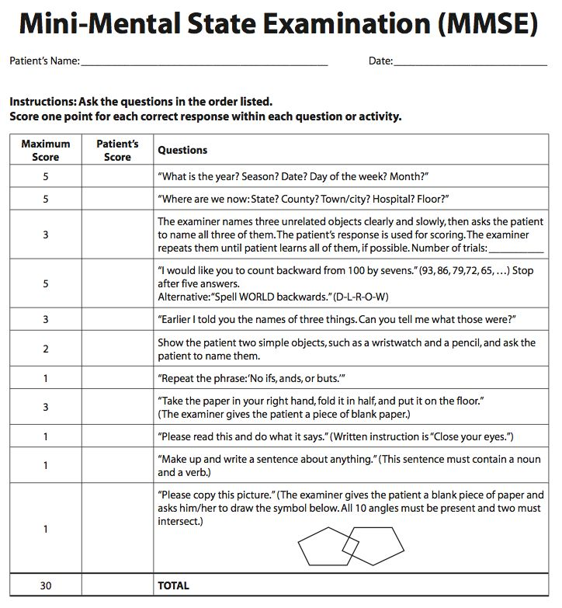
Assent to be a Participant in a Research Study

1. What do we wish to tell you?
I am [Name of Principal investigator], want to tell you about something we are doing called a research study. A research study is when doctors collect a lot of information to learn more about something related to health and disease.
After we tell / explain you about it, we will ask if you'd like to be in this study or not.
2. Why are we doing this study?
We are doing this study to, ‘to assess and compare cognitive functions among chess players and non-chess players aged 11 to 16 years in Western India’
So we are getting information from 120 boys and girls of described age.
3. What will happen to you if you are in this study?
Only if you agree, these things will happen:
i) Firstly demographic questionnaire will be handed to you and your height, weight and BMI will be measured.
ii) Then Mini Mental State Examination (MMSE) test will be administered.
The Mini Mental State Examination (MMSE) is a tool that can be used to examine mental health in a systematic and thorough manner. It’s an 11-question test that looks at five aspects of cognition: orientation, registration, attention and calculation, recall, and language. A score of ⩽23 indicates that one is suffering from cognitive impairment.
iii) Then cognitive functions will be assessed in subjects satisfying all the inclusion criteria using the following tests:-

Criteria | Test | Details
i) Intelligence | Dr. Bhatia Intelligence Test | It is one of the most widely used, pre-validated and reliable intelligence tests in India.  1.Koh’s Block design test  2.Pass along test  3.Pattern drawing test  4.Immediate memory test  5.Picture construction test  Based on all five subtests, the battery calculates the overall Intelligence Quotient (IQ).
ii) Executive task and selective attention | Color-word interference test (Stroop test) | In this test, subject will be asked to read the font color instead of meaning of the word and press the corresponding key on keyboard. In this test, ‘congruent’ means font color is same as meaning of word. For example, if the word displayed is ‘red’ but it’s font color is red then the subject has to press ‘R’ for correct answer. Whereas ‘incongruent’ means font color is different from meaning of word. For example, if the word displayed is ‘red’ but it’s font color is blue then the subject has to press ‘B’ for correct answer.
ii) Executive task and selective attention | Eriksen-Flanker test | In this test, participants will see 5 letters at a time and will have to respond with respect to middle letter. If middle letter is X/C then participant will have to press A on keyboard whereas if middle letter is V/B then participant will have to press L on keyboard.
iii) Working Memory | N-back test | Specifically, 2-back test will be used and subjects will be asked to press ‘m’ key on keyboard whenever the stimuli is same as 2 trials before whereas if it not matches the no response.
iv) Reaction time | Deary-Liewald task | This test will be done in two parts i.e, simple reaction time task and choice reaction time task. In simple reaction time task of this test, subject is supposed to press any key on keyboard as soon as ‘X’ is seen on screen. In choice reaction time task of this test, as soon as ‘X’ is displayed on one of the four white boxes on screen then subject has to press corresponding key (i.e, Z/X/C/V) on keyboard.

4. Is this bad or dangerous for you to get involved in this research? Will this study hurt? (explain risks involved as applicable)
There are no anticipated risks associated with your participation in this study
5. How will this research study be useful to you?
No, this study won't make you feel better or get well. But the doctors might find out something that will help other children like you later.
6. Will everybody come to know about your condition? (Confidentiality)
We will not tell other people that you are in this research and we won't share information about you to anyone who does not work in the research study.
Your participation in this study will remain confidential and your identity will not be revealed at any point of time except as required by law
7. Do you get anything for being in the research?
You won’t get any reimbursements or small gifts/incentives.
8. Do you have any questions?
You can ask questions any time. You can ask now. You can ask later. You can talk to me or you can talk to someone else.
9. Do you have to be in this study?
No, you don't. No one will force you if you don't want to do this. If you don't want to be in this study, just tell us. And remember, you can say yes now and change your mind later. It's up to you. This will not affect in any way your future.
10. Who can you talk to or ask questions to?
Principal investigator: [Name of principal investigator]
Email: [Email of principal investigator]
11. Signature of Person Conducting Assent Discussion
I have explained the study to ______________________(print name of child here) in language he/she can understand, and the child has agreed to be in the study.
__________________________________ _______________
Signature of Person Conducting Assent Discussion Date
_______________________________
Name of Person Conducting Assent Discussion
Assent Statement
I have read this information (or had the information read to me) I have had my questions answered and know that I can ask questions later if I have them.
I agree to take part in the research.
Name of child ________________ Signature of child: ____________________
Date: _______________
OR
I do not wish to take part in the research and I have not signed the assent below. ___________ (initialled by child/minor)
I have witnessed the accurate reading of the assent form to the child, and the individual has had the opportunity to ask questions. I confirm that the individual has given consent freely. [in case of illiterate child]
Name of witness (not a parent)_________________ and
Thumb print of participant:
Signature of Witness ______________________
Date ________________________ Name of Investigator ---------------------------------
Signature of Investigator ____________ Date : -----------------
(Copies of the Child information sheet and duly filled and signed ICFs of child and parent shall be handed over to the participant or his/her attendant)

PARENT/ GUARDIAN INFORMED CONSENT FORM

Project title- A case control study to assess and compare cognitive functions among chess players and non-chess players aged 11 to 16 years in Western India
Introduction-
Your child is invited to take part in an academic research study. It is important that you read this research description and understand your role in it, as well as the nature of the participant.
Purpose of study-
- Primary objective: To compare cognitive functions among chess players and non-chess players aged 11 to 16 years in Western India
- Secondary objective: To assess cognitive functions among chess players and non-chess players aged 11 to 16 years in Western India
Study procedure to be followed-
i) Firstly demographic questionnaire will be handed to participant and their height, weight and BMI will be measured.
ii) Then Mini Mental State Examination (MMSE) test will be administered.
The Mini Mental State Examination (MMSE) is a tool that can be used to examine mental health in a systematic and thorough manner. It’s an 11-question test that looks at five aspects of cognition: orientation, registration, attention and calculation, recall, and language. A score of ⩽23 indicates that one is suffering from cognitive impairment.
iii) Then cognitive functions will be assessed in subjects satisfying all the inclusion criteria using the following tests:-

Criteria | Test | Details
i) Intelligence | Dr. Bhatia Intelligence Test | It is one of the most widely used, pre-validated and reliable intelligence tests in India.  1.Koh’s Block design test  2.Pass along test  3.Pattern drawing test  4.Immediate memory test  5.Picture construction test  Based on all five subtests, the battery calculates the overall Intelligence Quotient (IQ).
ii) Executive task and selective attention | Color-word interference test (Stroop test) | In this test, subject will be asked to read the font color instead of meaning of the word and press the corresponding key on keyboard. In this test, ‘congruent’ means font color is same as meaning of word. For example, if the word displayed is ‘red’ but it’s font color is red then the subject has to press ‘R’ for correct answer. Whereas ‘incongruent’ means font color is different from meaning of word. For example, if the word displayed is ‘red’ but it’s font color is blue then the subject has to press ‘B’ for correct answer.
ii) Executive task and selective attention | Eriksen-Flanker test | In this test, participants will see 5 letters at a time and will have to respond with respect to middle letter. If middle letter is X/C then participant will have to press A on keyboard whereas if middle letter is V/B then participant will have to press L on keyboard.
iii) Working Memory | N-back test | Specifically, 2-back test will be used and subjects will be asked to press ‘m’ key on keyboard whenever the stimuli is same as 2 trials before whereas if it not matches the no response.
iv) Reaction time | Deary-Liewald task | This test will be done in two parts i.e, simple reaction time task and choice reaction time task. In simple reaction time task of this test, subject is supposed to press any key on keyboard as soon as ‘X’ is seen on screen. In choice reaction time task of this test, as soon as ‘X’ is displayed on one of the four white boxes on screen then subject has to press corresponding key (i.e, Z/X/C/V) on keyboard.

Possible risks-
There are no anticipated risks associated with participation in this study
Possible benefits-
You and your child will not benefit directly from participating in this study research.
Possible benefits in the field of research may include that this study will help to determine the role of chess in enhancing cognitive functions. Moreover, this may add on to pertaining studies and fill the voids in current literatures in concerned region. This case control study may help for further research on use of chess as tool for educational and therapeutic purposes. This study may help to contribute in the existing knowledge whether chess improves cognitive performance or not.
Confidentiality-
Your child’s participation in this study will remain confidential and your child’s identity will not be revealed at any point of time except as required by law. Your child’s responses will be assigned to a code number that will not be linked to your name or other identifying information. All data and consent forms will be stored in a locked password-protected folder and will be kept confidential all the time. The results of this study may be published but your child’s identity will not be revealed in these publications.
Voluntary Participation-
Your child’s participation in this study is completely voluntary and you and your child may refuse to participate or may withdraw from the study at any point of time without penalty. If you or your child may choose to leave this study at any time, the information your child provided will be kept confidential and will not be disclosed.
Further information-
If you have any further questions about this study you may contact Principal investigator at [Email ID of Principal investigator].
Statement of Consent
I have read all the information given in this form for study titled , “A case control study to assess and compare cognitive functions among chess players and non-chess players aged 11 to 16 years in Western India”. I give my permission for my child to participate in this research study.
- The purpose, nature, expected effects of study and what will my child be expected to do have been sufficiently explained to me and my questions have been answered satisfactorily.
- I understand that my child’s participation in this study is completely voluntary and I or my child may refuse to participate or may withdraw from the study at any point of time without any penalty.
- I understand that my child’s identity will not be revealed in any publications.
- I give permission for my child to take part in this study and I give this consent voluntarily.
Signature
Name of the child (participant): ______________________________
Name of the participant's parent/guardian: ______________________________
Signature of the participant's parent/guardian: ___________________________
Date:____________
Name of the person obtaining consent: ______________________________
Signature of the person obtaining consent: ___________________________
Date:____________

