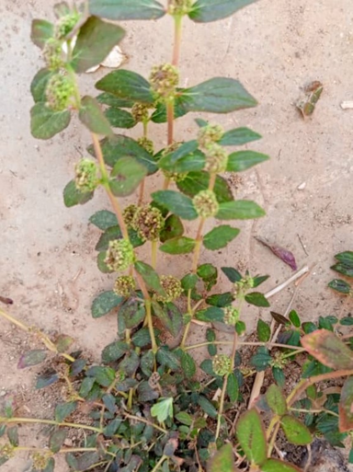
Photo of a Euphorbia hirta plant near a building
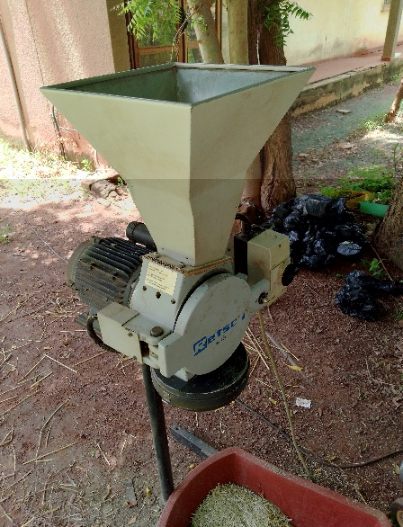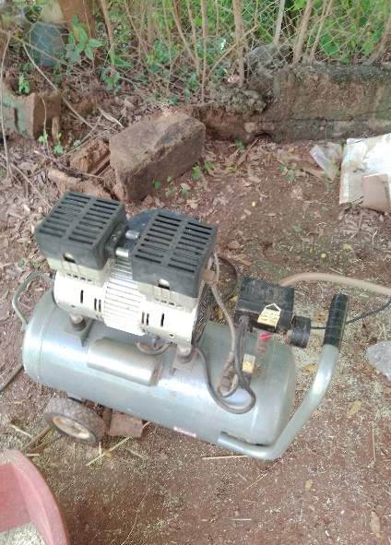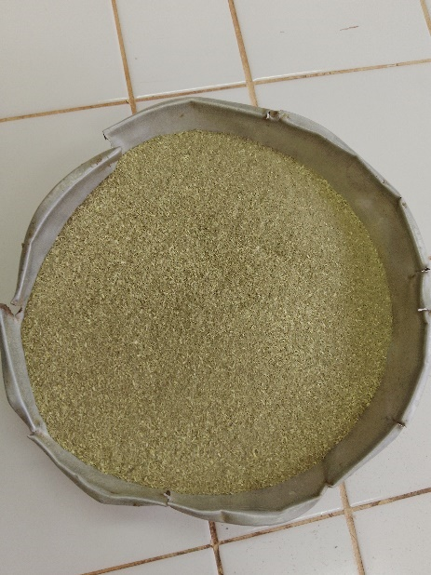
A B C
Photo Grinding equipment and E. hirta whole plant powder (A: Grinder; B: Blower; C: E. hirta whole plant powder. Photo
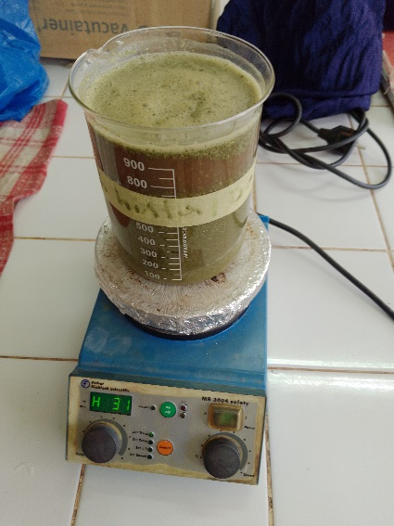 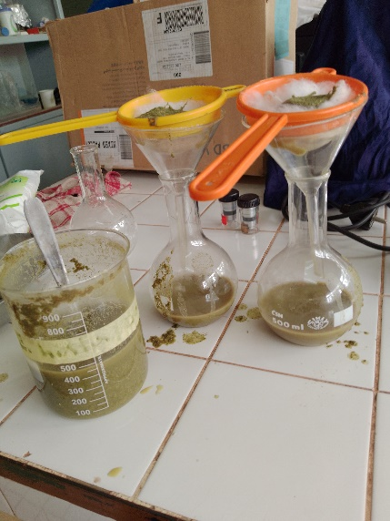 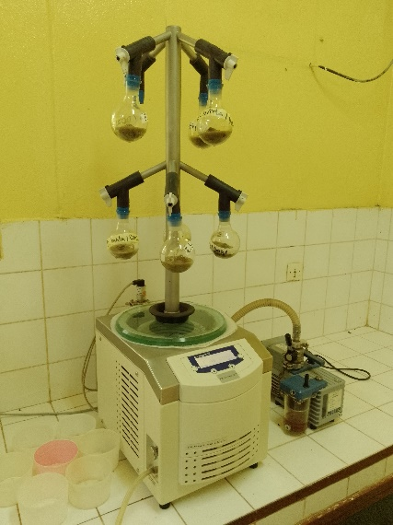A B C
Photo Production of aqueous extract : A: Maceration; B: Filtration; C: Lyophilization)
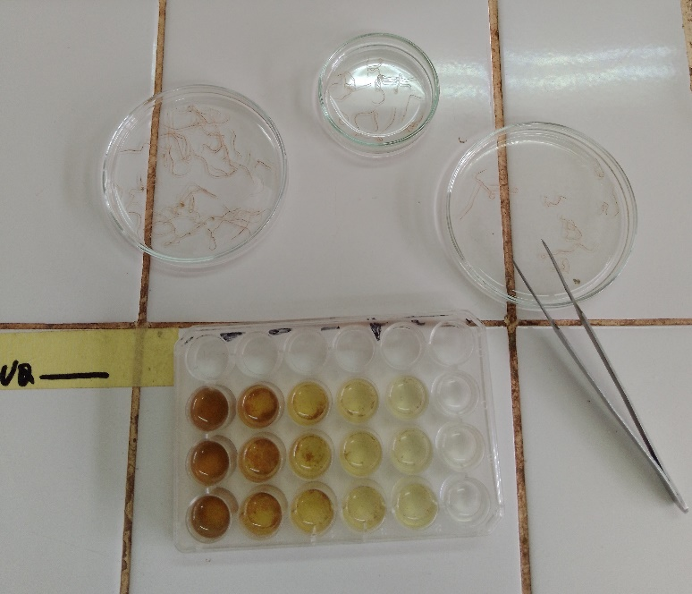
Adult worm mortality test
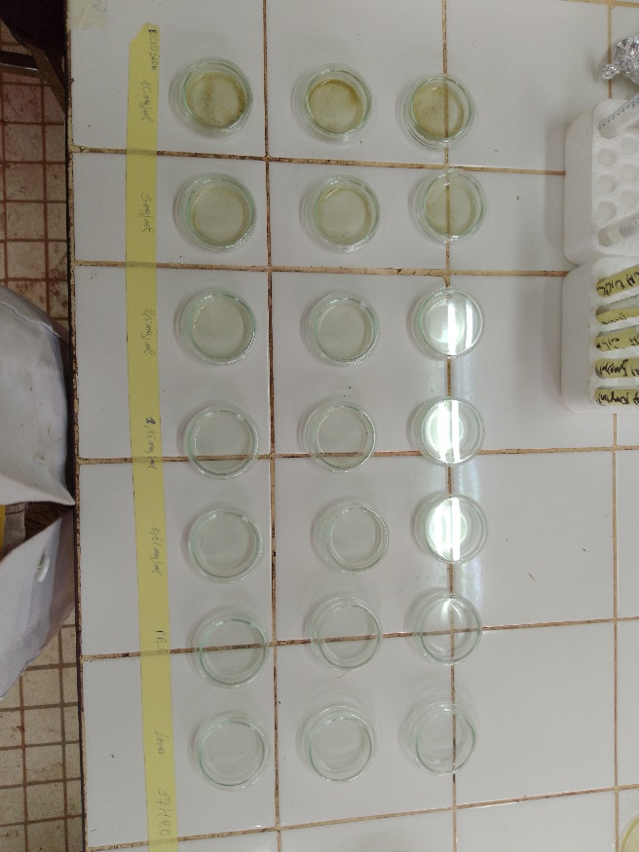
Photo : A repeat of an egg hatch inhibition test
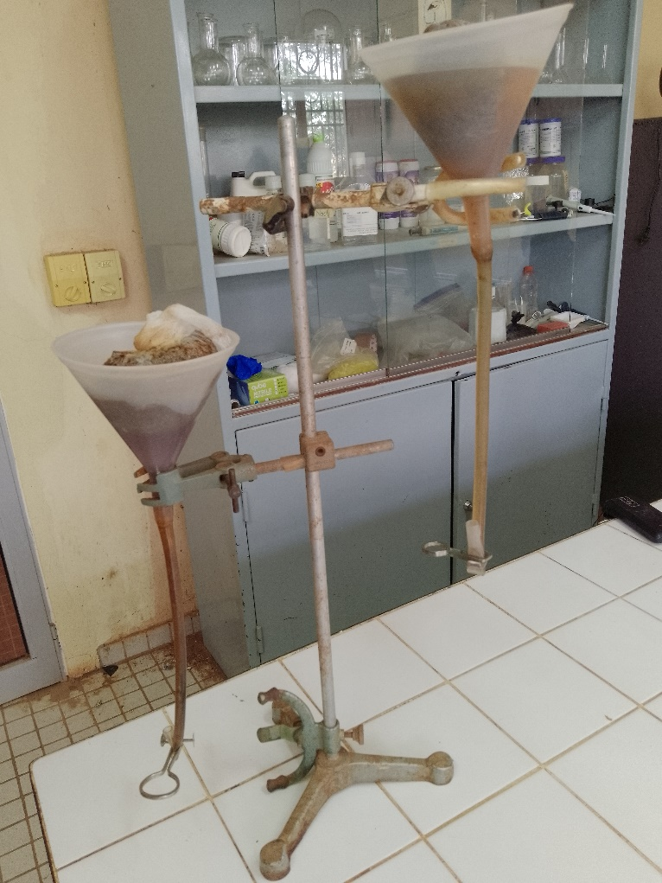
Photo: Harvesting L3 larvae with the Baermann device
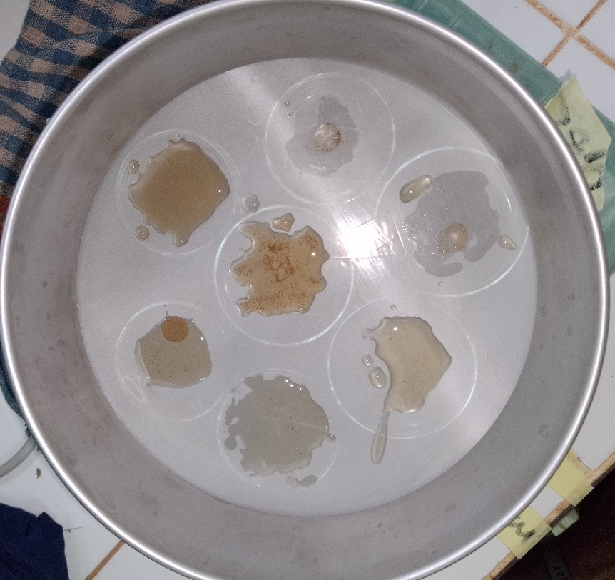
Photo Larval migration test repetition

