Supplementary Information

The January 2022 Hunga eruption cooled the southern hemisphere in 2022

Ashok Kumar Gupta^{1*}, Tushar Mittal², Kristen E. Fauria³, Ralf Bennartz³, and Jasper F. Kok¹

¹Department of Atmospheric and Oceanic Sciences, University of California, Los Angeles, CA, 90095, USA
²Department of Geosciences, Pennsylvania State University, University Park, PA, USA
³Department of Earth and Environmental Sciences, Vanderbilt University, Nashville, TN, USA

*Corresponding author (& present Address): Ashok Kumar Gupta, ashokgupta@atmos.ucla.edu

This PDF file includes:
Supplementary Note
Supplementary Results
Supplementary Methods
Supplementary Figures 1-10
Supplementary References

Supplementary Note

Previous observational work on Hunga eruption's radiative forcing
Recent studies on the climate impacts of the Hunga eruption have not considered the radiative effects of perturbed stratospheric aerosol and ozone with a radiative transfer model. Thus, the conclusion that Hunga warmed the planet, and associated dynamical and climatic changes, based on its input of water vapor alone may be premature¹. By taking the initial two months of water vapor profiles after the eruption time, previous studies² showed that the Hunga eruption was likely to warm the planet when the sulfate aerosol was in its growth phase. By sulfate aerosol growth phase, we mean here the period where the volcanic sulfur dioxide is being converted to sulfate aerosols via nucleation, coagulation, and hygroscopic growth³. Stratospheric sulfate aerosols from large volcanic eruptions can remain in the stratosphere for months to a few years, gradually dispersing and settling out, depending on the injection height of aerosol, particle size, coagulation, nucleation, and stratospheric circulation^{1,3}. Duchamp⁴ also concluded that the Hunga eruption would warm the planet based on water vapor. To date, only two studies^{5,6} have suggested that the Hunga could cool the planet. Zhu⁶ used global climate models to simulate the effect of enhanced SWV on SO₂ lifetime and aerosol evolution. They found that water vapor leads to more efficient aerosol growth, thus leading to larger extinction and a global radiative flux of ~ -0.1–0.2 W m⁻² during the 2 months post eruption.

In contrast, Schoeberl⁵ estimated a net radiative forcing based on a combination of scaling analysis from past subaerial eruptions (for aerosols) and radiative calculations for water vapor. Thus, none of the existing work has considered the impact of stratospheric aerosol in a way that explicitly accounts for the aerosol size-dependent radiative properties constrained by observations. The Zhu⁶ modeling results highlight that this is an important variable for the net radiative forcing. In addition, the radiative forcing due to changes in stratospheric ozone, which affect the magnitude of radiative cooling, have not been quantified.

Although our retrieved SO₂ mass is slightly higher than previous estimates by around 0.05-0.1 Tg, the SO₂ estimates by Carn⁶ after the eruption might have been affected by some rapid sulfate formation within the water-rich eruption plume³. In addition, if the majority of the SWV (~ 150 Tg) was sourced from seawater, the seawater sulfate concentration (~ 29 m moles kg⁻¹) can contribute up to an additional sulfate equivalent to ~ 0.28 Tg of SO₂.

We find that the maximum net radiative heating rate of 0.06 K day⁻¹ by the sulfate aerosols, due to dominant trapping of longwave radiation and a slight absorption of shortwave radiation, against a relative increase in aerosol extinction of up to 800% (Fig. 2b and Supplementary Figures 2b and 3b). This strong increase in stratospheric aerosol extinction gradually weakens from the tropics to the midlatitudes in the lower stratosphere, contributing to a positive heating rate of around 0.03 K day⁻¹ in the lower stratosphere (at around 21 km) across the SH. Here, the contrasting influence of longwave radiative heating rates for sulfate aerosol and SWV influences the sign and magnitude of the net radiative heating rate.

Using a FaIR⁷⁻⁸ simple climate model, we assessed that the given reduction in the combined net radiative flux by -0.48 $±$ 0.04 Wm⁻² could contribute to a relative 1-year averaged surface temperature cooling of 0.029 K (and ~0.1 K at the end of 2022), mainly due to sulfate radiative forcings. More detailed investigations are needed using the global climate model to accurately assess the net change in the surface temperature following the year after the Hunga eruption.

Effect of Hunga Tonga volcanic eruption on Ozone and the TOA radiative forcing
An explosive volcanic eruption can significantly perturb stratospheric ozone concentration especially near the enhanced domain of sulfate aerosol and moistened stratosphere^{8,9}. The water-rich stratosphere can also introduce a source of hydroxyl radicals which affects the ozone chemistry and its production/destruction timescales⁸⁻¹⁰. Stratospheric ozone modifies the radiative budget of the Earth system by absorbing radiation both in the IR (longwave) and in the ultraviolet (shortwave)¹¹.

When the ozone layer in the stratosphere is depleted, it causes less absorption of solar radiation, resulting in more radiation being upwelled. This leads to a cooling effect at the Earth's TOA, contrasting with positive shortwave radiative forcing at the tropopause. It is also important to note that the longwave radiative forcing is negative at the Earth's TOA and tropopause, further contributing to the cooling effect. This instantaneous radiative response of ozone depletion agrees with Shine¹² (see Table 5; therein).

The positive net radiative flux at 16 km altitude slightly counters the negative radiative forcing from sulfate aerosols (compare Supplementary Figure 2h and i). Similarly, and enhanced the net radiative flux at 16 km by 0.2-0.3 Wm⁻² in the SH (compare Supplementary Figure 2i and l).

Note that the seasonal and annual variations in the ozone concentration, near high latitudes could be driven by a combination of stratospheric dynamics and stratospheric chemistry (Supplementary Figures 6-7), and therefore detangling the meteorological factors on the changes in the ozone concentration before and after the eruption is complex. Nonetheless the annual-mean stratospheric ozone depletion signature after the Hunga eruption in the SH is relatively strong and therefore Hunga contribution into their depletion cannot be ignored as the depleting agents such as HNO₃ and HCl have also enhanced (see Supplementary Figure 4 between 10-30 hPa).

Volcano-Ozone interaction
There are multiple pathways through which ozone can be depleted after volcanic eruption, injecting substantial amounts of SO₂ and H₂O, including the halogen gases. (1) Some of the injected soluble reactive halogen gases mixed with sulfur gas such as Cl can reach into stratosphere^{13,14}. (2) The absorption and evaporation of the water by sulfate aerosol particles can modulate not only the liquid sulfate aerosol characteristics but also the soluble halogens compounds such as HCl, HOCl, HOBr, HBr, and HNO₃^{8,9}. (3) The soluble halogen gases can perturb the ozone concentration by activating the chlorine radicals through heterogeneous reactions (NOx and ClO cycle)^{8,9,15}. If there is chlorine activation after the eruption, the increase in NO₂, ClO or ClONO₂, HNO₃, and HOCl could indicate the cause for the loss of the ozone concentration. (4) When water interacts with sulfate aerosols in the stratosphere, it can influence the sulfate aerosol formation process through OH radicals¹⁵. These OH radicals (containing atomic oxygen) could decrease the ozone production¹⁵. On the other hand, it can accelerate the oxidation of SO₂ and hence the formation of sulfate aerosol layer¹⁵.
After the Hunga eruption, we observed that the sulfate aerosol also slightly enhanced near the eruption site around 20-26 km (Fig. 1b, c), where the ozone loss was prominent, especially in the SH. This agrees with the findings of Evan¹⁶. This indirectly indicates the linkage between the influence of SO₂ in a water-rich environment and H₂O (OH radicals) on ozone reduction. At the same time, we also observed increased concentrations of HNO₃ and HCl (Supplementary Figure 5) after the eruption, attributed to the influence of the ozone loss after the eruption in the upper stratosphere (near 32-36 km). In the lower (30-50 hPa around 17.5ºS) and middle (10 hPa around 0ºS) stratosphere, MLS observations show that the zonal-annual averaged ozone concentration has decreased by around 5-8% after the eruption relative to its background climatology (Fig. 1c and Supplementary Figure 5a).

Location of stratospheric water vapor layer and aerosol layer after the Hunga eruption
Even after one year following from the eruption, the height of the SWV layer has not moved down relative to the stratospheric aerosol (Fig. 1a, g). A few potential factors could contribute to this, such as the influence of tropical Brewer-Dobson circulation and less vertical mixing in the stratosphere compared to the troposphere, as well as a positive temperature inversion in the stratosphere. It is worth noting that determining the exact cause for static injected height of the SWV layer is not within the scope of this study.

For an explosive eruption, the initial injection height of the plume of sulfur gas and the associated altitude of its oxidation product, SO_{2,} determine the horizontal and vertical evolution of the sulfuric acid aerosol particles¹³. Thus, for the Hunga eruption too, the intensity and spatial extent of Hunga-related aerosol loading, and consequently radiative heating rates could vertically uplift the aerosol layer, which in turn can influence the lifetime of the aerosol and then stratospheric temperature, as indicated by Pinatubo¹³, which is an important parameter to be quantified.

Supplementary Methods

Quality of SAGE-III/ISS observations of three stratospheric species

For a given species, we used only those profiles at a given altitude when there was confidence in the retrieved products as indicated by the quality assurance bit flags. In a 32-bit integer, if bit 0, bit 1, bit 2, bit 3, and bit 4 are equal to 1, then these conditional values in profiles are not removed from the analysis (see SAGE-III/ATBD¹⁷). The limitation of solar radio-occultation measurement inherently influences the number of observations for a given season and latitude and altitude, primarily due to quality assurance during the retrieval of the products. To assess the influence of this issue on the number of observations in each season, we analyzed the seasonal- and zonal-mean latitude distribution of number of counts associated with stratospheric water vapor, ozone and 521 nm aerosol extinction coefficient during December 2019- November 2022 (Supplementary Figures 8-10). We applied nearest-neighbor interpolation (KD tree technique¹⁸) in each season to partially removed the sampling biases. These sampling biases can arise from various factors, such as viewing geometry of SAGE-III/ISS, causing an uneven spatial/temporal coverage of measurements and data gaps due to satellite operational issues onboard ISS.

Cloud screening between 20 and 36 km altitude
For the stratospheric constituents between 20-36 km altitude, we did not apply rigorous cloud screening tests, as cloud occurrence in this altitude range is almost negligible ¹⁹. There is a possibility of ice-rich umbrella clouds within 12 hours from the 15 Jan 2022 HTHH eruption²⁰, which could influence the aerosol layer. But these clouds dissipated within 10-20 minutes in the stratosphere²⁰ (see Supplementary Movie 2 in Gupta²⁰), and therefore, we assumed cloud-free aerosol conditions within the altitude range of 20-36 km.

AURA-MLS observations
We used the MLS²¹ (Microwave Limb Sounder) data to estimate the changes in ozone and other related stratospheric trace species before and after the HTHH eruption between 7 June 2017 and 14 Jan 2023. We also compared the annual variation in O₃ concentration with the MLS observations, which has spatial coverage between 82°S–82°N and vertical pressure level coverage 100 hPa to 0.1 hPa. We analyzed a few soluble reactive gases and radicals such as HCl and HNO₃ from MLS observations to assess the qualitative significance of the ozone reduction linked to the HTHH eruption (Supplementary Figure 5).

ERA5 (ECMWF Reanalysis) data set
The atmospheric profiles such as temperature, pressure, density from SAGE-III/ISS observations are available from around 8 to 100 km. Therefore, for the radiative transfer calculations, we employed collocated measurement of these atmospheric profiles below 8 km ERA5²² (ECMWF Reanalysis) datasets.
Sulfate aerosols retrievals
We evaluated the properties of stratospheric sulfate aerosols using a Mie lookup table (LUT^{23,24}) for sulfate aerosols with a unimodal log-normal distribution with geometric standard deviation ($σ$) of 1.2. Specifically, the LUT was designed for stratospheric sulfate aerosols and composed of 75% H₂SO₄ (sulfuric acid) and 25% H₂O (water). This LUT provides the extinction, asymmetry parameter, and single scattering albedo as a function of the effective radius (between 0.2 to 1.3 μm; area-weighted mean radius) and the wavelength (between 0.2/0.550 to 100/0.550 μm). This LUT was regenerated with respect to extinction at 521 nm.
The particle size distribution for unimodal log-normal distribution is expressed as:
 | $$F\left(r;\overline{r},σ,N_{0}\right)=\frac{N_{o}}{\left(\sqrt{2π}\right)σlnr}exp\left(\frac{{-ln⁡\left(r/\overline{r}\right)}^{2}}{2σ^{2}}\right)$$ | (1)
where $N_{o}$ is the number density (m⁻³), r is particle radius, $\overline{r }$is median radius (r). The effective radius is related to $\overline{r}$as
 | $$r_{eff} =\overline{r}* exp(5/2*{log⁡}^{2}σ)$$ | (2)

The extinction at $521nm$ wavelength is:

 | $$K_{ext} \left(521 nm\right)=\int{Q_{ext}\left(r,n,k,521nm\right)πr^{2}F\left(r;\overline{r},σ,N_{0}\right)dr}$$ | (3)
Based on the real part (n = 1.43) and imaginary part (k = 1.0000E-08) of the complex refractive index of sulfate aerosol at 521 nm ²⁵, we determined the extinction efficiency factor (Q_{ext} at 521 nm) using Mie theory. We used the SAGE-III based observed extinction coefficient and Mie-table to find the number size distribution as a function of latitude, longitude, and altitude (see Supplementary Figure 4 d, h).
Calculations of changes in the radiative heating rates and radiative fluxes: HTHH vs. CLIM periods

The composition and properties of atmospheric gases and aerosol conditions are used to analyze the difference between the upward and downward radiative fluxes at each altitude level. For each grid box, we used this difference in upward and downward fluxes at each altitude level to calculate the radiative heating rate due to each species as:

 | $$H=-\frac{1}{ρC_{p}}\frac{{∆F}_{net}\left(z\right)}{∆z}$$ | (4)
where $H$ indicates the heating rate [K s⁻¹], t is time (s), g is the acceleration due to gravity (m s⁻²), Cp is the specific heat content of air at constant pressure (J kg⁻¹ K⁻¹), and F is radiative flux (W m⁻²). $ρ indicates$ air density. $∆F$ indicates the radiative flux divergence, that is, the difference between the upward and downward radiative fluxes at each altitude level or pressure level, and $∆z$ is the layer thickness. Here, $F_{net}$ can be expressed as:
 | $$F_{net}\left(z,θ,ϕ,t\right)=F^{↓}\left(z,θ,ϕ,t\right)-F^{↑}\left(z,θ,ϕ,t\right)$$ | (5)
where $F^{↓}\left(z,θ,ϕ,t\right)$ and $F^{↑}\left(z,θ,ϕ,t\right)$ are:
 |  | $$F^{↑}\left(τ,μ,ϕ\right)=F_{O}^{↑}\left(τ,μ_{0}\right)e^{\left(\frac{-τ}{μ_{0}}\right)}+\int_{0}^{2π}{dϕ\int_{τ_{0}}^{1}{μI^{dif}}}\left(τ,μ,ϕ\right)dμ$$ | (6)
 | $$F^{↓}\left(τ,μ,ϕ\right)=F_{O}^{↓}\left(τ,μ_{0}\right)e^{\left(\frac{-τ}{μ_{0}}\right)}+\int_{0}^{2π}{dϕ\int_{τ_{0}}^{1}{μI^{dif}}}\left(τ,-μ,ϕ\right)dμ$$ |  | (7)
where $I^{dif}$ (diffuse radiance or source function) in Eq. (7) for 1-D plane-parallel and single scattering problem is described in LibRadtran²⁶ as:

 | $$μ\frac{I^{dif}\left(τ,μ,ϕ\right)}{dτ}=I^{dif}\left(τ,μ,ϕ\right)-\frac{ω\left(r\right)}{4π}\int_{0}^{2π}{dϕ^{'}\int_{-1}^{1}{dμ^{'}P\left(τ,μ,ϕ;{μ^{'},ϕ}^{'}\right)}}I^{dif}\left(τ,μ^{'},ϕ\right)-\left(1-ω\left(τ\right)\right)B\left[T\left(τ\right)\right]-\frac{ω\left(r\right)I^{0}}{4π}P\left(τ,μ,ϕ;μ_{0},ϕ_{0}\right)e^{\left(\frac{-τ}{μ_{0}}\right)}$$ | (8)
where $I^{0}\left(πF_{0}\right)$ is the solar irradiance at the top-of-the-atmosphere, $dτ=β_{ext}dz$ is the differential optical depth due to extinction ($β_{ext}=β_{sca}+β_{\left|abs\right|}$) of radiation by scattering plus absorption in a given layer thickness (dz), $B\left[T\left(τ\right)\right]$ is the Planck function, $ω$ is the single scattering albedo, and $P\left(τ,μ,ϕ;{μ^{'},ϕ}^{'}\right)$ is the phase function for light incident at ${μ^{'} \left(cosine of zenith angle\right),ϕ}^{'}(azimuth angle)$ that is scattered at $μ,ϕ$, which is expressed in LibRadtran model as:
 | $$P\left(τ,μ,ϕ;{μ^{'},ϕ}^{'}\right)=\sum_{l=0}^{2M-1}{\left(2l+1\right)g_{l}\left(τ,λ\right),P_{l}}\left(cosΦ\right)$$ | (9)
where $Φ$ is the phase angle; l is the moment from the Legendre polynomial; and M is the total moments.
The asymmetry factor is written as:
 | $$g_{l}\left(τ,λ\right)=\frac{1}{2}\int_{-1}^{1}{P_{l}\left(cosΦ\right)P\left(τ,Φ,λ\right)d\left(cosΦ\right)}$$ | (10)
where $P\left(τ,Φ\right)$ is expressed using standard Legendre polynomials. In this study, $ω\left(λ,τ\right)$ and $g\left(λ,τ\right)$ in Eqs. (9) and (10) are retrieved for sulfate aerosol particles between 20 and 36 km before and after the eruption using SAGE-III/ISS and Mie LUT.
As stated above, using the LibRadtran model with the DISORT solver^{27,28} and total 8 number of streams, we simulated changes in radiative fluxes and associated heating rates by incorporating observed seasonal-mean vertical profiles of atmospheric constituents, aerosol conditions, and seasonal-mean daily-insolation weighted solar zenith angle as a function of latitude and longitude. This simulation was separately conducted for the shortwave (0.28 – 4 μm) and longwave (4.0 –100 μm) components of radiative flux changes and heating rates.
The simulated 3D seasonal distribution of net radiative effects (NRE) due to changes in the vertical (20-36 km) profiles of stratospheric water vapor, ozone and sulfate aerosol as a function of latitude ($θ$) and longitude ($ϕ$) and seasons (S; DJF, MAM, JJA, SON) between HTHH and CLIM periods are calculated as:
 | $${{{NRE}_{H_{2}O}\left(θ,ϕ,z,S\right)=F}_{Net}\left(θ,ϕ,z,S\right)}_{H_{2}O}\left[HTHH\right]-{F_{Net}\left(θ,ϕ,z,S\right)}_{H_{2}O}\left[CLIM\right]$$ | (11)
 | $${{{NRE}_{O_{3}}\left(θ,ϕ,z,S\right)=F}_{Net}\left(θ,ϕ,z,S\right)}_{O_{3}}\left[HTHH\right]-{F_{Net}\left(θ,ϕ,z,S\right)}_{O_{3}}\left[CLIM\right]$$ | (12)
 | $${{{NRE}_{Aero}\left(θ,ϕ,z,S\right)=F}_{Net}\left(θ,ϕ,z,S\right)}_{Aero}\left[HTHH\right] -{F_{Net}\left(θ,ϕ,z,S\right)}_{Aero}\left[CLIM\right]$$ | (13)
where $F_{Net}$ is the sum of the shortwave and longwave components.
Eqs. (11)-(13) are used to compute the annual- and zonal (latitude versus altitude)-mean and vertical-mean (longitude-latitude) radiative effects of HTHH eruption for three different stratospheric species at TOA and 16 km (near tropical tropopause height).
 | $${NRE}_{Total}={NRE}_{H_{2}O}+{NRE}_{O_{3}}+{NRE}_{Strat.Aero}$$ | (14)
Finally, using Eq. (14), a combined net radiative effect at TOA and 16 km of the three stratospheric species is determined by summing up the corresponding net radiative response of each stratospheric species associated with the HTHH eruption. Note that the background atmospheric profiles (such as temperature, density, and pressure only) for both HTHH and CLIM periods are fixed to bring out the radiative response of $H_{2}O$, $O_{3}$ and stratospheric aerosols under idealized conditions, which form one of the limitations of this study.
Supplementary Figures

Supplementary Figure 1
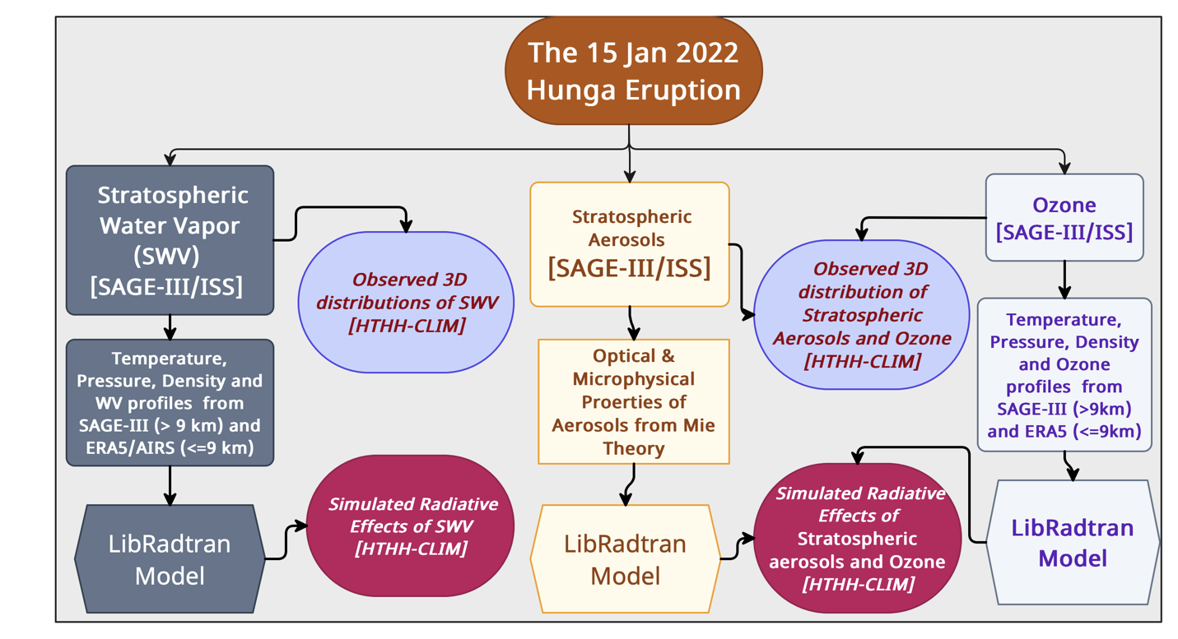
Supplementary Figure 1: Schematic summarizing the methods used to determine the net radiative effects of three stratospheric species associated with the 15 January 2022 Hunga eruption. Left-side blocks are related to SWV, middle-blocks are for stratospheric aerosols, and right-side blocks are related to stratospheric ozone.

Supplementary Figure 2

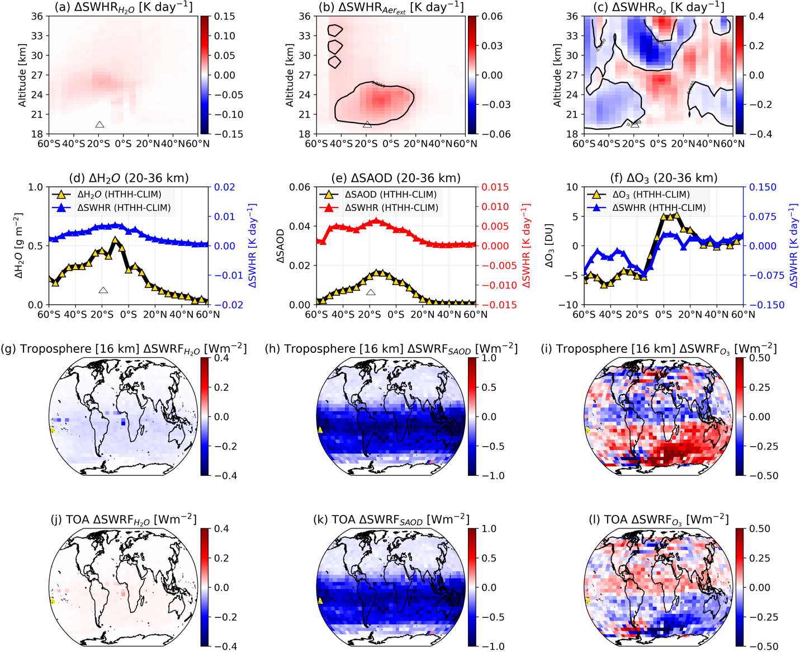

Supplementary Figure 3: Simulated annual-mean shortwave radiative effect of radiatively important stratospheric species after the HTHH eruption. Zonal-mean Latitude-altitude distribution of the difference shortwave radiative heating rates (NRHR) within the stratosphere during the year following the HTHH eruption and the reference (CLIM) period due to changes in (a) stratospheric water vapor (H₂O), (b) stratospheric sulfate-dominated aerosol, and (c) ozone (O₃). The 20-36 km layer-summed and longitudinally averaged changes in the latitudinal distribution of stratospheric H₂O, stratospheric SAOD loading, and O₃ concentration and associated mean SWHR are shown in (d), (e) and (f), respectively. The near-global map shows the changes in the clear-sky shortwave radiative Flux ($∆$SWRF) due to changes in (g) H₂O, (h) SAOD, and (i) ozone between the HTHH and CLIM periods at an altitude of 16 km (near tropical tropopause height). Panels (j)-(l) show the changes in the clear-sky $∆$SWRF at the top-of-the-atmosphere (TOA). Solid black contour lines in (a-c) demarcate the area near the zero value.

Supplementary Figure 3

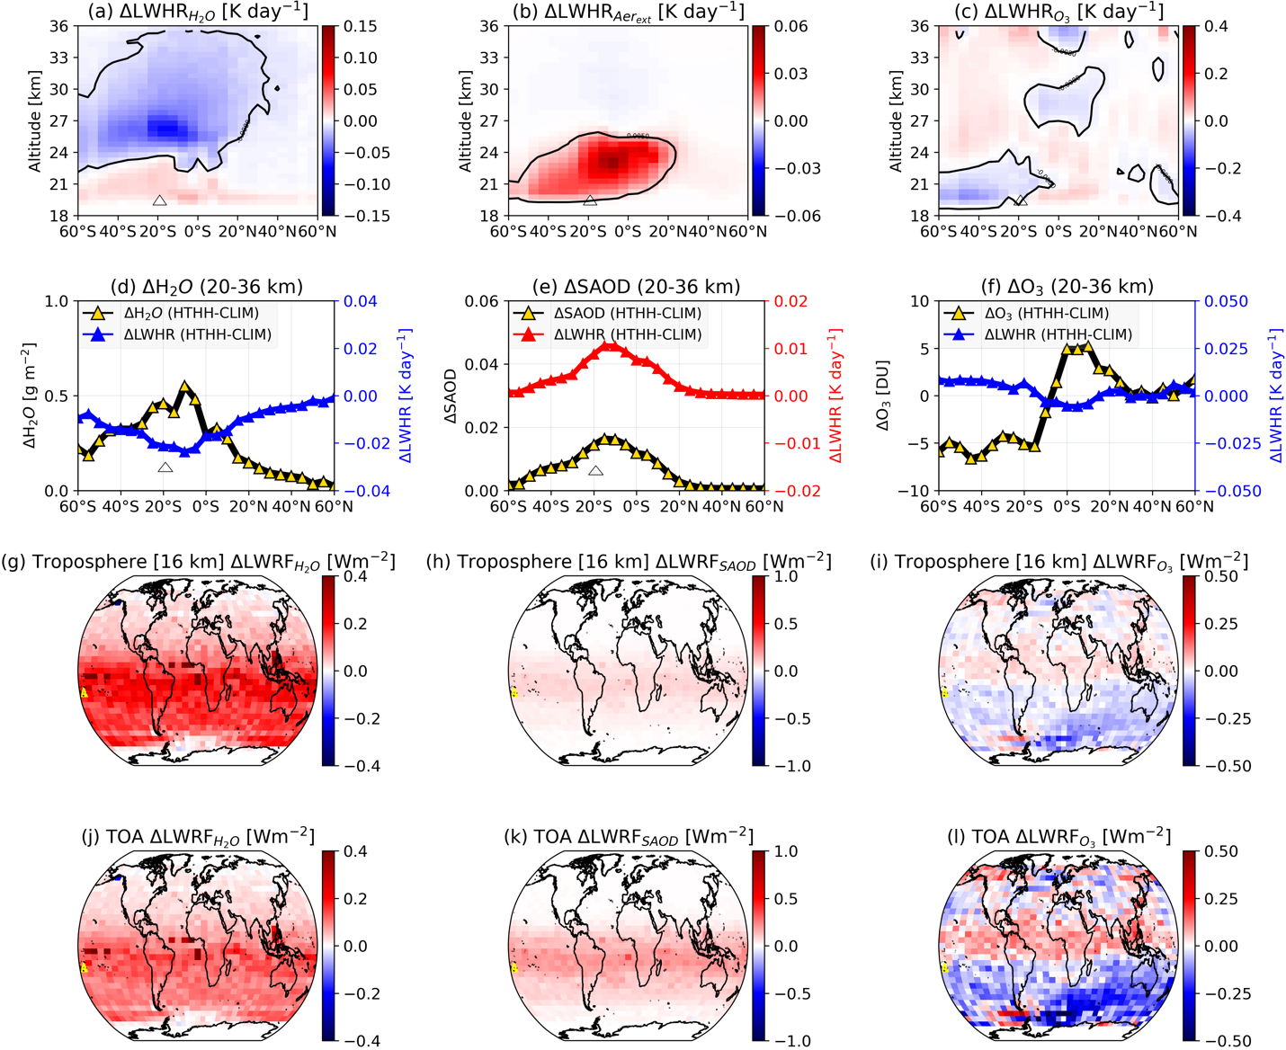

Supplementary Figure 3: Simulated annual-mean longwave radiative effect of radiatively important stratospheric species after the HTHH eruption. Same as Supplementary Figure 2, but for longwave component.

Supplementary Figure 4

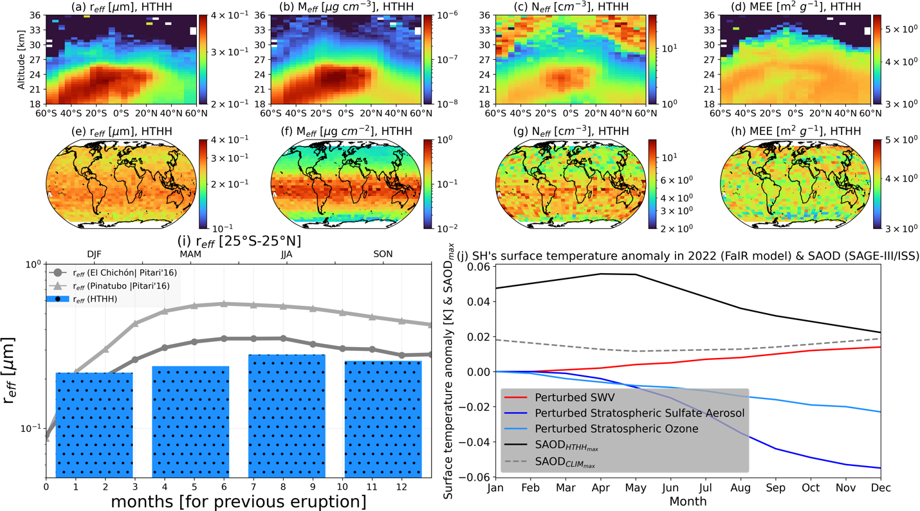

Supplementary Figure 4: Retrieved optical and microphysical properties of sulfate aerosols from Mie theory. Zonal-mean latitude-altitude distribution of retrieved stratospheric sulfate aerosols (a) mean effective radius (r_{eff}; µm), (b) mean effective aerosol mass of H₂SO₄ (M_{eff}; µg cm⁻³), (c) effective aerosol number density (N_{eff}; cm⁻³), and (d) mass extinction efficiency (MEE) of SO₂ (m²g⁻¹). (e) same (a), but for mean near-global map of r_{eff}; µm. (f) vertically-integrated effective aerosol mass of H₂SO₄ (M_{eff}; µg cm⁻²). (g) same (c) but for mean near-global map of N_{eff} (cm⁻³). (h) vertical-mean mass extinction efficiency (MEE) of SO₂ (m²g⁻¹). (i) Monthly variation of r_{eff} (µm) for El Chechen, Pinatubo from Pitari⁴², and seasonal variation of r_{eff} (µm) from Hunga eruption (j) interpolated monthly time series of surface temperature anomaly 1-year after the Hunga eruption as estimated based on instantaneous clear-sky radiative forcing input to the FaIR model.

Supplementary Figure 5

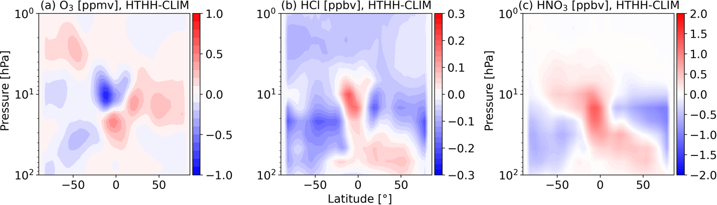
Supplementary Figure 5: Halogen gases during HTHH-CLIM periods from AURA-MLS. (a) Difference (HTHH-CLIM) of zonal-annual mean perturbation in ozone (O₃) concentration, (b) HCl, and (c) HNO₃, respectively.

Supplementary Figure 6

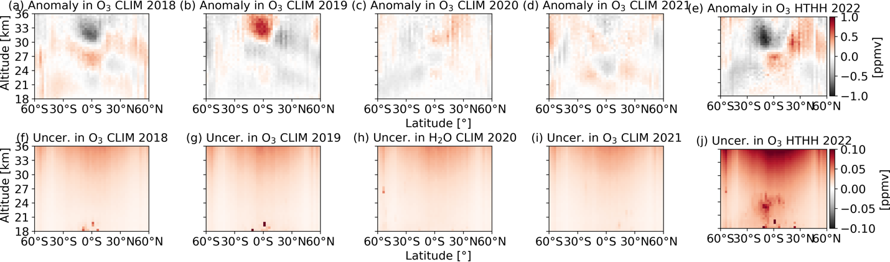

Supplementary Figure 6: Background annual variations in ozone concentration (ppmv) from SAGE-III/ISS. (a-e) Zonal mean latitude-altitude distribution of anomaly (relative to CLIM periods) in ozone concentration from lower to upper stratosphere (18-36 km altitude). Also (f-j) shows the annual random uncertainty associated with ozone measurement from SAGE-III/ISS.

Supplementary Figure 7

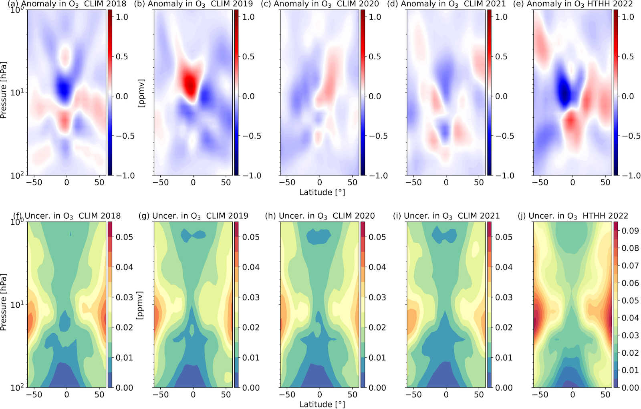
Supplementary Figure 7: Background annual variations in ozone concentration (ppmv) from MLS. (a-e) Zonal mean latitude-altitude distribution of anomaly (relative to CLIM periods) in ozone concentration from lower to upper stratosphere (100-1 hPa) with respect to 2018. Also (f-j) shows the annual random uncertainty associated with ozone measurement from MLS.

Supplementary Figure 8

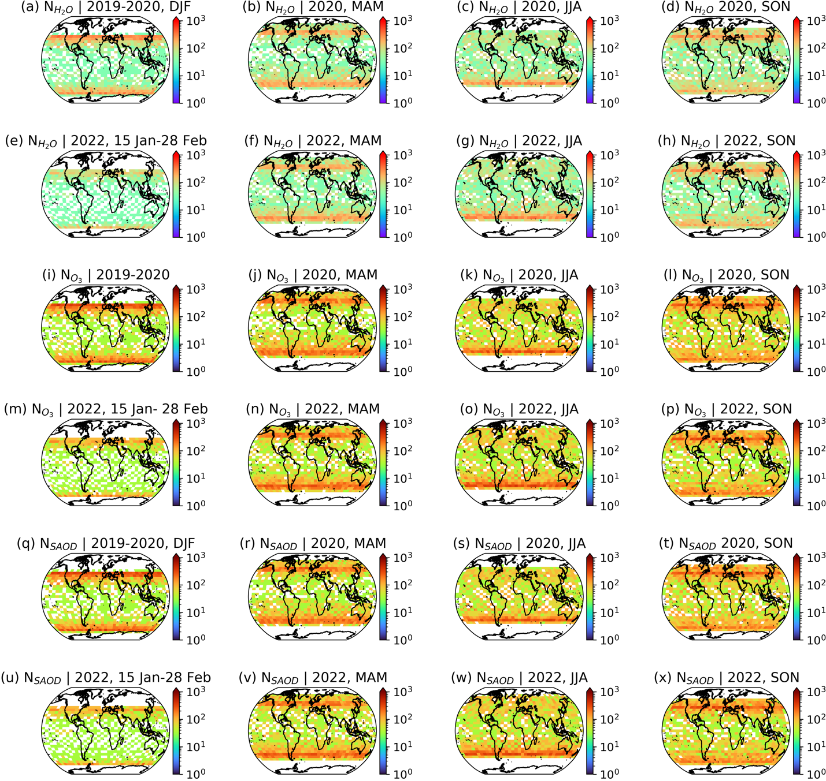

Supplementary Figure 8: Near-global seasonal coverage of number of counts of three stratospheric species between 20-36 altitude from SAGE-III/ISS observations (no interpolation). Near-global coverage of the number of counts of quality-controlled stratospheric H₂O (NH₂O) from 20 to 36 km altitude binned at 0.5 km during (a) DJF (2019-2020), (b) MAM (2020), (c) JJA (2020), and (d) SON (2020). (e-h) same as 2022 (except DJF as 15 Jan-28 Feb). (i-l) and (q-t) are the same as (a-b) but for stratospheric O₃ and aerosols, respectively. (m-p) and (u-x) are the same as (e-h) but for stratospheric O₃ and aerosols, respectively.

Supplementary Figure 9

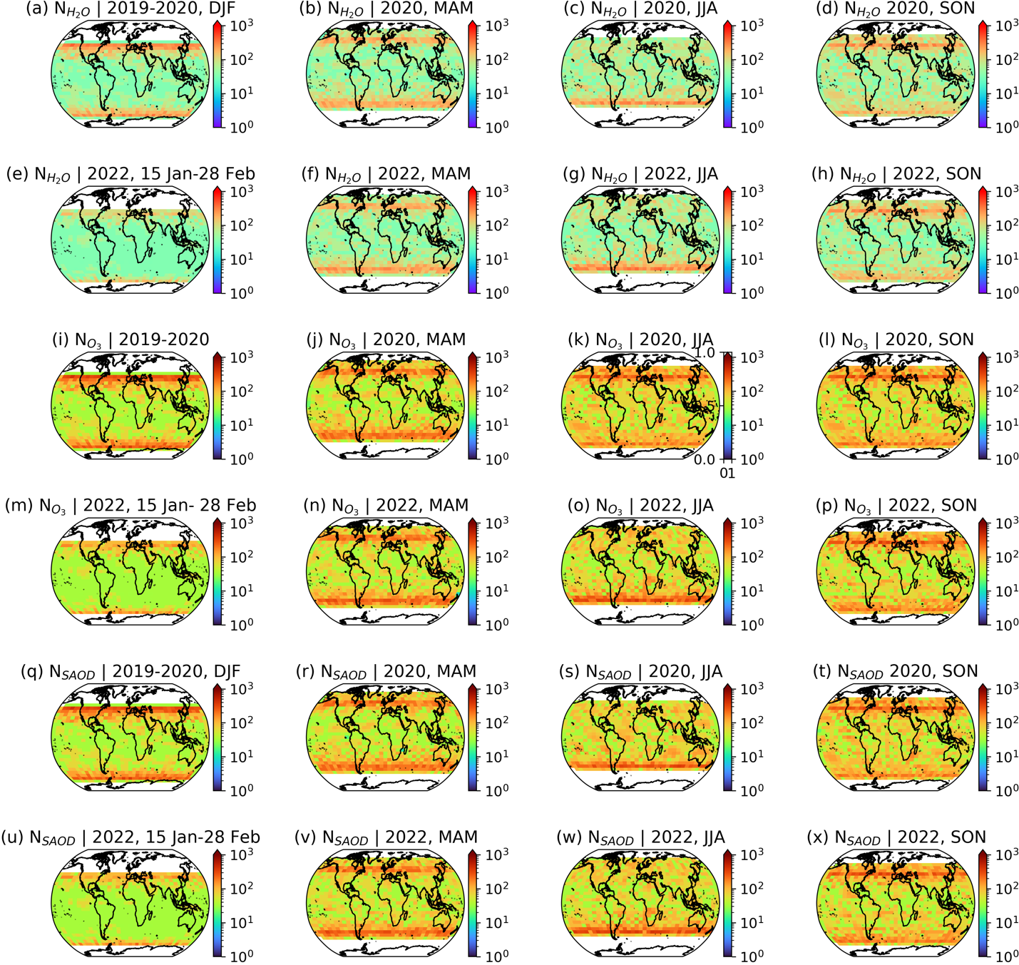

Supplementary Figure 9: Interpolated near-global seasonal coverage of number of counts of three stratospheric species between 20-36 altitude from SAGE-III/ISS observations. Same as Figure 8 but with K-dimensional regular grid tree interpolation.

Supplementary Figure 10

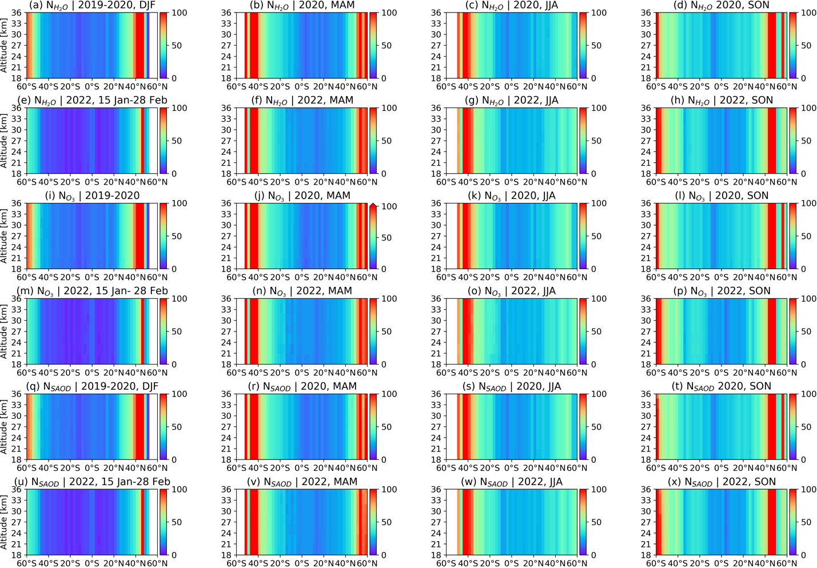

Supplementary Figure 10: Zonal-mean latitude and altitude coverage of the number of counts of three stratospheric species between 18-36 altitude from SAGE-III/ISS observations (no interpolation). The seasonal plots of the number of counts of each stratospheric species are depicted similarly in Figure 8.

Supplementary References
1. Jenkins, Stuart, Chris Smith, Myles Allen, and Roy Grainger. Tonga eruption increases chance of temporary surface temperature anomaly above 1.5° C. Nature Climate Change13, 2, 127-129 (2023).
2. Sellitto, P. et. al. The Unexpected Radiative Impact Of The Hunga Tonga Eruption Of 15 January 2022. Communications Earth & Environment 1, 288 (2022).
3. Günther, A., 2018. Stratospheric sulphur: MIPAS/Envisat measurements and chemical transport model simulations of carbonyl sulphide, sulphur dioxide, and sulphate aerosol.
4. Duchamp, C. et. al. Observation of the aerosol plume from the 2022 Hunga Tonga-Hunga Ha’apai eruption with SAGE III/ISS. Authorea Preprints (2023).
5. Schoeberl, M. The Estimated Climate Impact of the Hunga Tonga-Hunga Ha'apai Eruption Plume. Geophysical Research Letters 50, 18: e2023GL104634 (2023)..
6. Zhu, Y. et. al. Perturbations in stratospheric aerosol evolution due to the water-rich plume of the 2022 Hunga-Tonga eruption. Communications Earth & Environment, 3(1), 248 (2022).
7 Smith, C.J., et. al. FAIR v1. 3: a simple emissions-based impulse response and carbon cycle model. Geoscientific Model Development, 11(6), 2273-2297 (2018).
8. Carslaw, K. S. et. al. Stratospheric aerosol growth and HNO3 gas phase depletion from coupled HNO3 and water uptake by liquid particles. Geophys. Res. Lett., 21(23), 2479-2482 (1994).
9. Solomon, S., Garcia, R.R., Rowland, F.S. and Wuebbles, D.J. On the depletion of Antarctic ozone. Nature, 321(6072), 755-758 (1986).
10. Lu, J. et. al. Stratospheric Aerosol and Ozone Responses to the Hunga Tonga‐Hunga Ha'apai Volcanic Eruption. Geophys. Res. Lett., 50(4), e2022GL102315 (2023).
11. National Academies of Sciences, Engineering, and Medicine. Radiative Forcing of Climate Change: Expanding the Concept and Addressing Uncertainties. Washington, DC: The National Academies Press. https://doi.org/10.17226/11175 (2005).
12. Shine, K.P., Byrom, R.E. and Checa‐Garcia, R. Separating the shortwave and longwave components of greenhouse gas radiative forcing. Atmos. Science Letters, 23(10), e1116 (2022).
13. Stenchikov, G. et. al. How does a Pinatubo‐size volcanic cloud reach the middle stratosphere? Journal of Geophysical Research: Atmospheres, 126(10), e2020JD033829 (2021).
14, Gerlach, T.M., Westrich, H.R. and Symonds, R.B. Preeruption vapor in magma of the climactic Mount Pinatubo eruption: Source of the giant stratospheric sulfur dioxide cloud. Fire and mud: eruptions and lahars of Mount Pinatubo, Philippines, 415, 33 (1996).
15. LeGrande, A.N., Tsigaridis, K. and Bauer, S.E. Role of atmospheric chemistry in the climate impacts of stratospheric volcanic injections. Nature Geoscience, 9(9), 652-655 (2016).
16. Evan, Stephanie, et al. Rapid ozone depletion after humidification of the stratosphere by the Hunga Tonga Eruption. Science 382, 6668: eadg2551 (2023).
17. SA, E. SAGE III, https://eospso.gsfc.nasa.gov/sites/default/files/atbd/atbd-sage-cloud.pdf (2002).
18. Tong, W., Li, L., Zhou, X. and Franklin, J. Efficient spatiotemporal interpolation with spark machine learning. Earth Science Informatics, 12, 87-96 (2019).
19. Lauster, B. et. al. Occurrence of polar stratospheric clouds as derived from ground-based zenith DOAS observations using the colour index. Atmospheric Chemistry and Physics, 22(24), 15925-15942 (2022).
20. Gupta, A.K., Bennartz, R., Fauria, K.E. and Mittal, T. Eruption chronology of the December 2021 to January 2022 Hunga Tonga-Hunga Ha’apai eruption sequence. Communications Earth & Environment, 3(1), 314 (2022).
21. Waters, Joe W. et al. The earth observing system microwave limb sounder (EOS MLS) on the Aura satellite. IEEE transactions on geoscience and remote sensing 44, 5, 1075-1092 (2006).
22. Hersbach, H. et al. The ERA5 global reanalysis. Q. J. R. Meteorol. Soc. 146, 1999–2049 (2020).
23. Aubry, T.J., Toohey, M., Marshall, L., Schmidt, A. & Jellinek, A.M. A new volcanic stratospheric sulfate aerosol forcing emulator (EVA_H): Comparison with interactive stratospheric aerosol models. J. of Geophys. Res., Atmospheres, 125(3), e2019JD031303 (2020).
24. Toohey, M., Stevens, B., Schmidt, H. and Timmreck, C. Easy Volcanic Aerosol (EVA v1. 0): an idealized forcing generator for climate simulations. Geoscientific Model Development, 9(11), 4049-4070 (2016).
25. Armante, R. et. al. Evaluation of spectroscopic databases through radiative transfer simulations compared to observations. Application to the validation of GEISA 2015 with IASI and TCCON." Journal of Molecular Spectroscopy 327: 180-192 (2016).
26. LibRadtran document, http://www.libradtran.org/doc/libradtran.pdf (see Eq. 2.25), (2005)
27. Mayer, B. & Kylling, A. The libRadtran software package for radiative transfer calculations-description and examples of use. Atmos. Chem. Phys. 5, 7, 1855-1877 (2005).
28. Stamnes, K., Tsay, S.C., Wiscombe, W. and Laszlo, I. DISORT, general-purpose Fortran program for discrete-ordinate-method radiative transfer in scattering and emitting layered media: documentation of methodology (2000).

