Controllable preparation of Zeolite-P/calcined diatomite with MgCl₂
Zhengzheng Guo ª, Zijie Ren ^{a b} *, Huimin Gao^{a b}, Junfang Guan ^{a b}, Peiyue Li ^{c}, Renji Zheng ^{d} * *, Hang Yin ^{e}
ª School of Resources and Environment Engineering, Wuhan University of Technology, Wuhan 430070, China
^{b} Hubei Key Laboratory of Mineral Resources Processing and Environment, Wuhan 430070, China
^{c} CNBM Research Institute for Advanced Glass Materials Group Co., Ltd, Bengbu, 233018, PR China
^{d} School of Minerals Processing and Bioengineering, Central South University, Changsha 410083, China
^{e} China Energy Green Building Material CO., LT, Wuhan 430070, China
* Corresponding author: Zijie Ren
Email address: renzijie@whut.edu.cn
** Corresponding author: Renji Zheng
Email address: zhengrj@csu.edu.cn

Filtration test
The permeability testing device is shown in Fig S1. The test is as follows:
(1) 5 g dry sample was placed in a 100 mL beaker and 50 ml distilled water was added. The mixed solution was stirred well before pouring into the 1# test bottle.
(2) Turning on the positive air pump and controlling the vacuum degree at 7600 Pa ±100 Pa until the filter cake was formed and no more filtrate was permeated.
(3) Turning off the vacuum pump. 50-60 ml distilled water was added along the wall of the 1# test bottle. Sample was filtered at a vacuum of 7600±100 Pa. The volume of the filtrate should be around 40 ml, and the corresponding filtration time (t) and volume (V) were accurately recorded.
(4) Repeating step 3 three times and taking the average value to calculate the filtrate flow rate (Q) according to formula (1).
(5) The filter cake thickness (h) was accurately measured.
(6) The permeability (k) was calculated according to formula (2).
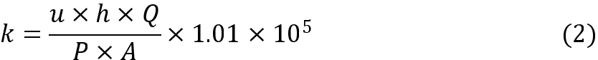
Where u was viscosity coefficient of distilled water, A represented filter area and P represented vacuum.
Adsorption capacity test
Typical, 0.04 g of M-D samples were scattered into 50 mL MB solution with different concentrations (10 -150 mg/L). Then, the mixed solution was stirred at room temperature for 30 min. After adsorption, the mixed solution was centrifuged to get supernatant at 3000 r/min using high speed centrifuge. The MB concentrations in supernatants were measured at maximum absorption wavelength of 664 nm using a UV-vis spectrometer.

The removal efficiency (R_{e}) and equilibrium adsorption capacity (Q_{e}) were calculated according to formula (3) and (4), respectively:
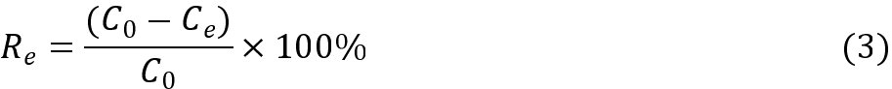
Where the C₀ and C_{e} were the initial and equilibrium concentration of MB, respectively. The V was the volume of the solution, and m represented the mass of the adsorbent.

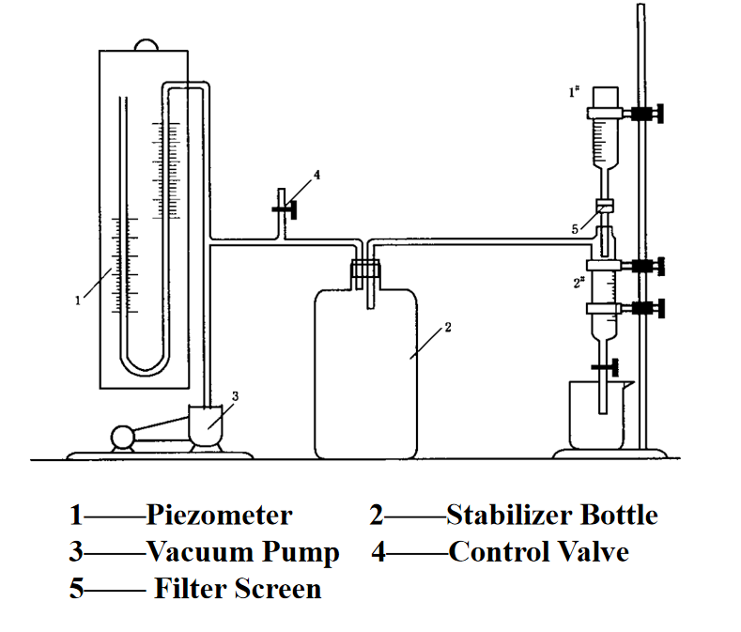
Figure S1

