Supporting Information

Discovery of N-substituted pyrazoline derivatives as novel 3-benzo[b]thiophene and 2-mercaptobenzimidazole inhibitor for the treatment of breast cancer

S. Jeyanthiª, S.SD. Elanchezhiyan^{b} and N. Muniayappan^{a*}

ªDepartment of Chemistry, Saraswathi Narayanan College, Madurai – 625 022,
Tamil Nadu, India.
^{b}Sethu Institute of Technology, Department of Chemistry, Kariapatti, Virthunagar District,
Tamil Nadu, India
*Corresponding author: Dr. N. Muniyappan
Tel/Fax: +91-9943562912

Email address: sakthisai588@gmail.com (S. Jeyanthi); chezhiyandasarathan@gmail.com (S. SD. Elanchezhiyan) nmuniyappan@gmail.com (N. Muniyappan)

Supporting spectra of compound 1(a)
Supporting spectra of compound 2(a)
Supporting spectra of compound 3(a)
Supporting spectra of compound 4(a)
Antimicrobial methodology
MTT Assay method

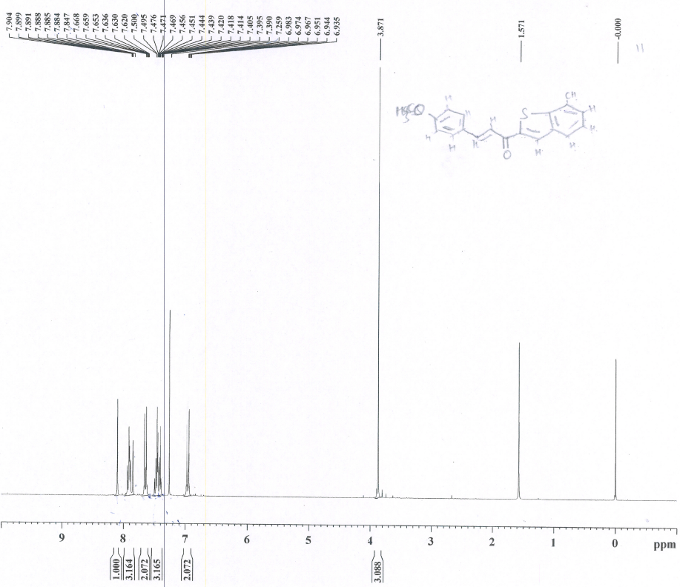
S1. ¹H NMR spectrum of compound 1a (CDCl₃, 300 MHz, 298 K).

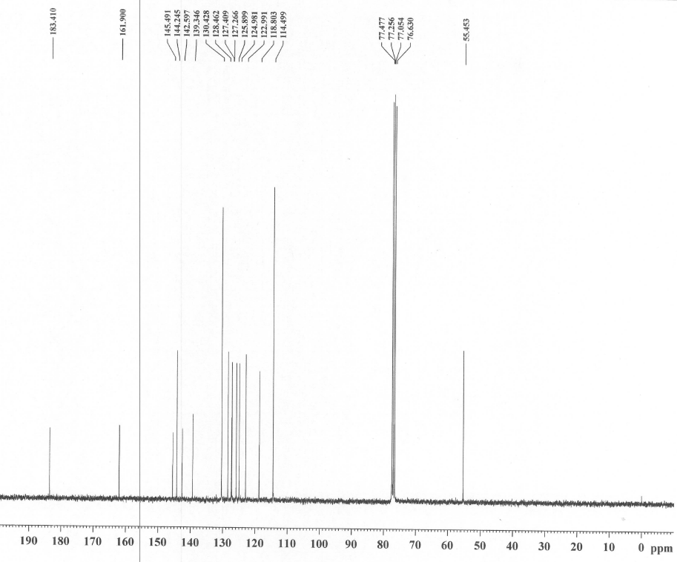
S2. ¹³C NMR spectrum of compound 1a (CDCl₃, 75 MHz, 297 K).

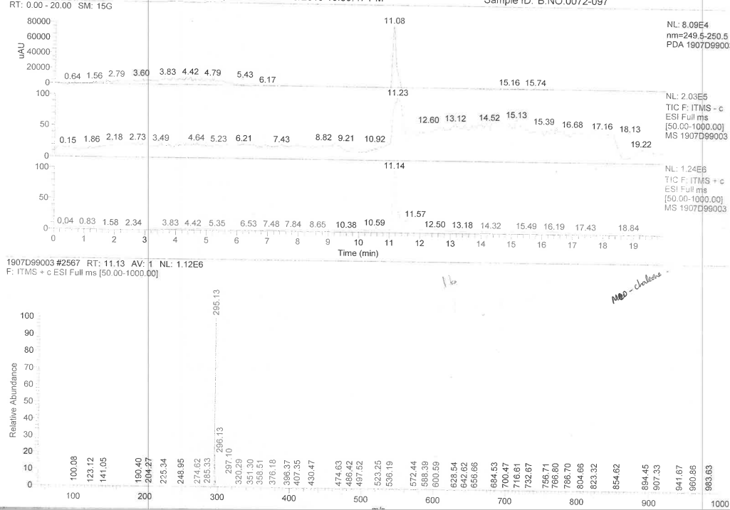
S3. LC-MS mass spectrum of compound 1a.

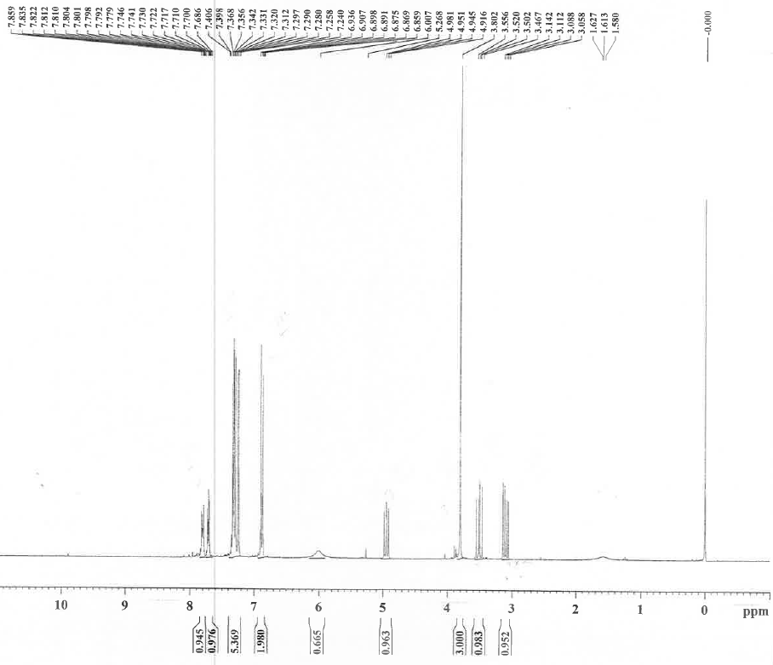
S4. ¹H NMR spectrum of compound 2a (CDCl₃, 300 MHz, 298 K).

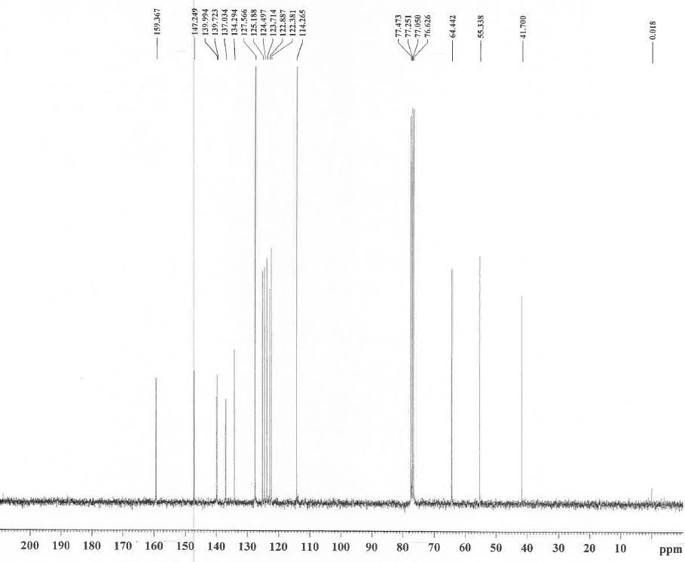
S5. ¹³C NMR spectrum of compound 2a (CDCl₃, 75 MHz, 297 K).

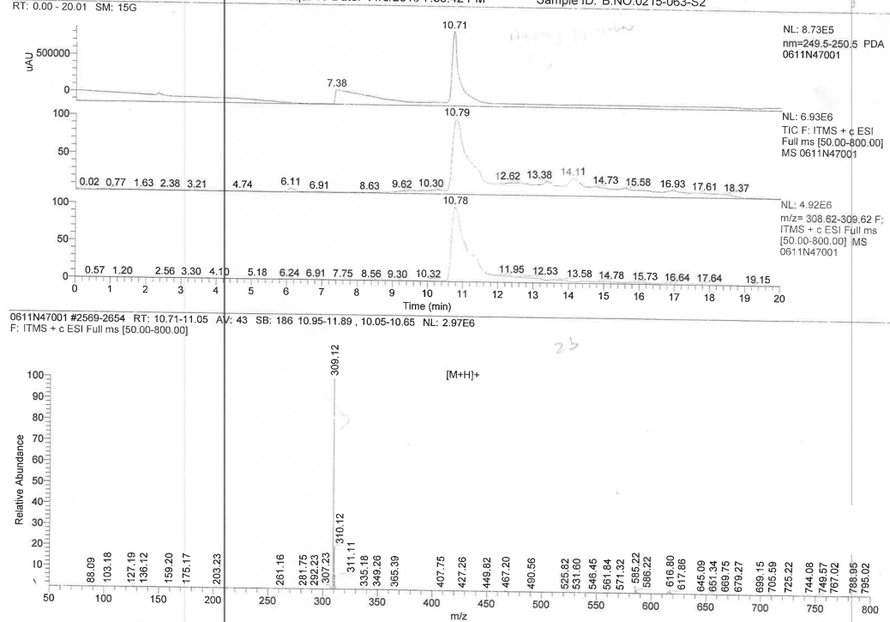
S6. LC-MS mass spectrum of compound 2a.

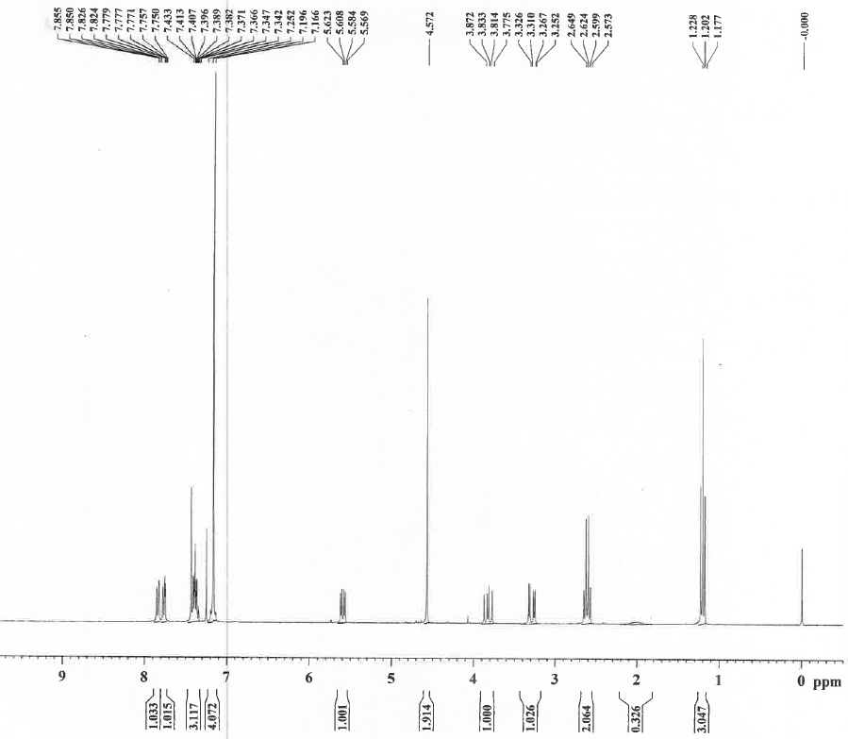
S7. ¹H NMR spectrum of compound 3a (CDCl₃, 300 MHz, 298 K).

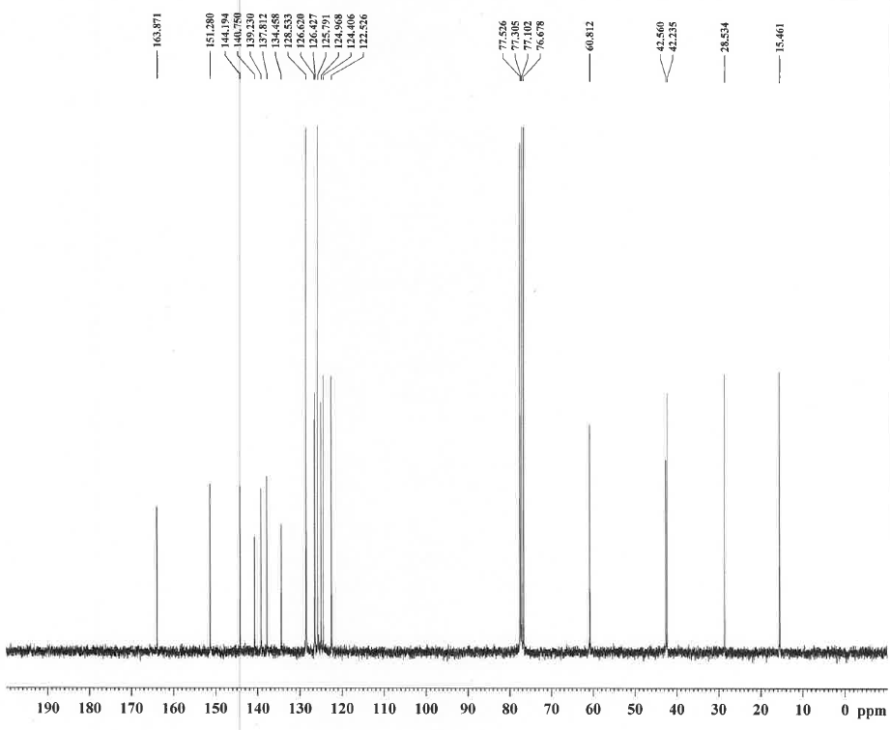
S8. ¹³C NMR spectrum of compound 3a (CDCl₃, 75 MHz, 297 K).

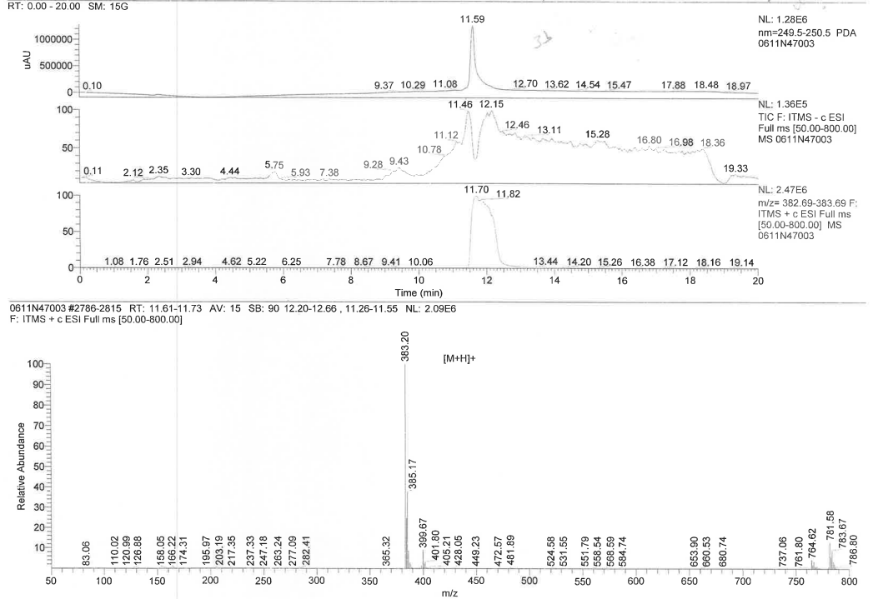
S9. LC-MS mass spectrum of compound 3a.

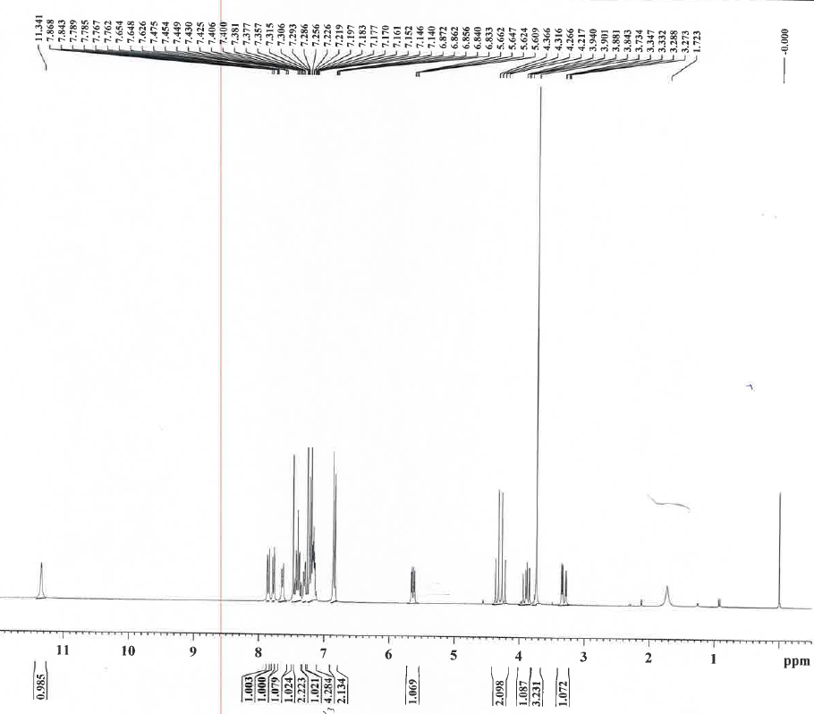
S10. ¹H NMR spectrum of compound 4a (CDCl₃, 300 MHz, 298 K).

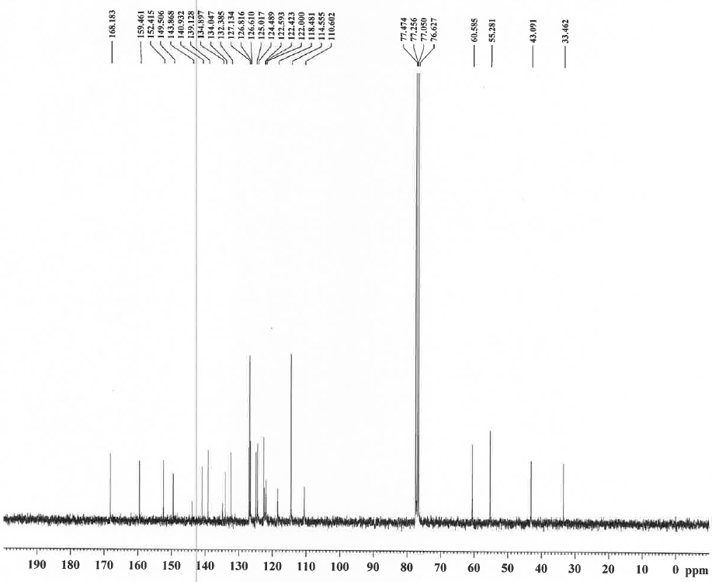
S11. ¹³C NMR spectrum of compound 4a(CDCl₃, 75 MHz, 297 K).

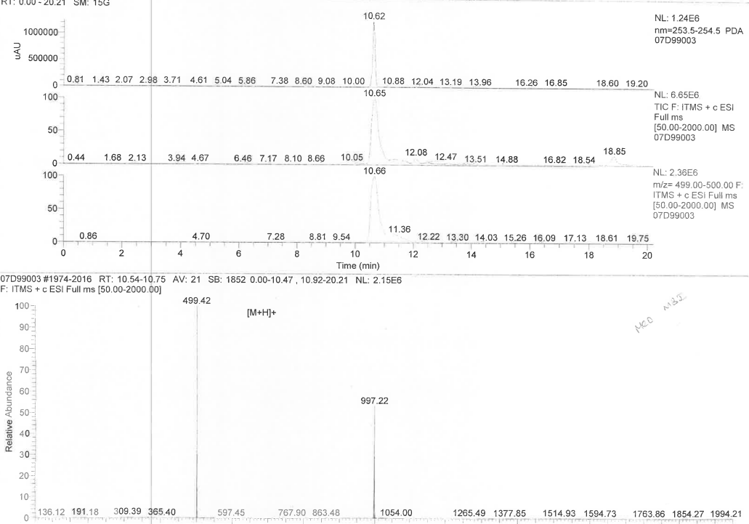
S12. LC-MS mass spectrum of compound 4a.

S13. Pharmacological activities:
S13.1. Antimicrobial methodology
The antimicrobial activity was screened against the clinical pathogens Bacillus subtilis, Staphylococcus aureus, Klebsiella pneumoniae and Escherichiacoli. The microorganism inoculum was prepared from 18 h broth culture and the suspension was adjusted to a turbidity of 0.5 McFarland (~1.5 × 10⁸ colony-forming units (cfu/mL)). Then, the Mueller–Hinton agar (MHA) was poured into petri dishes and inoculated with 100 μL of the suspension containing ~1.5 × 10⁸ cfu/mL of microorganisms. Wells were made using sterile cork borer and loaded with 300 μL of seven samples (4a, 4b, 4c, 4d, 4e, 4f and 4g) and the standard streptomycin sulphate was run on separately in individual plates with 100 μL concentrations for each pathogens. After incubation (37 °C, 24 or 48 h), the mean of the inhibition zone diameters were calculated. The antifungal activity was tested for A.flavus, A. fumigates, C.albicans and Mucor sp, for this, the fungal spore suspension was prepared ~1.5 × 10⁸ cfu/mL and inoculated 100 μL of the suspension. Wells were made using sterile cork borer and loaded with 300 μL of seven samples (4a, 4b, 4c, 4d, 4e, 4f and 4g) and the standard amphotericin B was run on separately in individual plates with 100 μL concentrations for each pathogen. After incubation (27 °C, 24 or 48 h), the mean of the inhibition zone diameters were calculated.
S13.2. Cytotoxicity activity
Traditionally, the in vitro determinations of toxic effects of unknown compounds have been performed by counting viable cells after staining with a vital dye. Alternative methods used are measurement of radioisotope incorporation as a measure of DNA synthesis, counting by automated counters and others which rely on dyes and cellular activity. The MTT system is a means of measuring the activity of living cells via mitochondrial dehydrogenases. The MTT method is simple, accurate and yields reproducible results. The key component is (3-[4, 5- dimethylthiazol-2-yl]-2, 5-diphenyl tetrazolium bromide) or MTT, is a water-soluble tetrazolium salt yielding a yellowish solution when prepared in media or salt solutions lacking phenol red. Dissolved MTT is converted to an insoluble purple formazan by cleavage of the tetrazolium ring by mitochondrial dehydrogenase enzymes of viable cells. This water insoluble formazan can be solubilized using DMSO, acidified isopropanol or other solvents (Pure propanol or ethanol). The resulting purple solution is spectrophotometrically measured. An increase or decrease in cell number results in a concomitant change in the amount of formazan formed, indicating the degree of cytotoxicity caused by the test material.
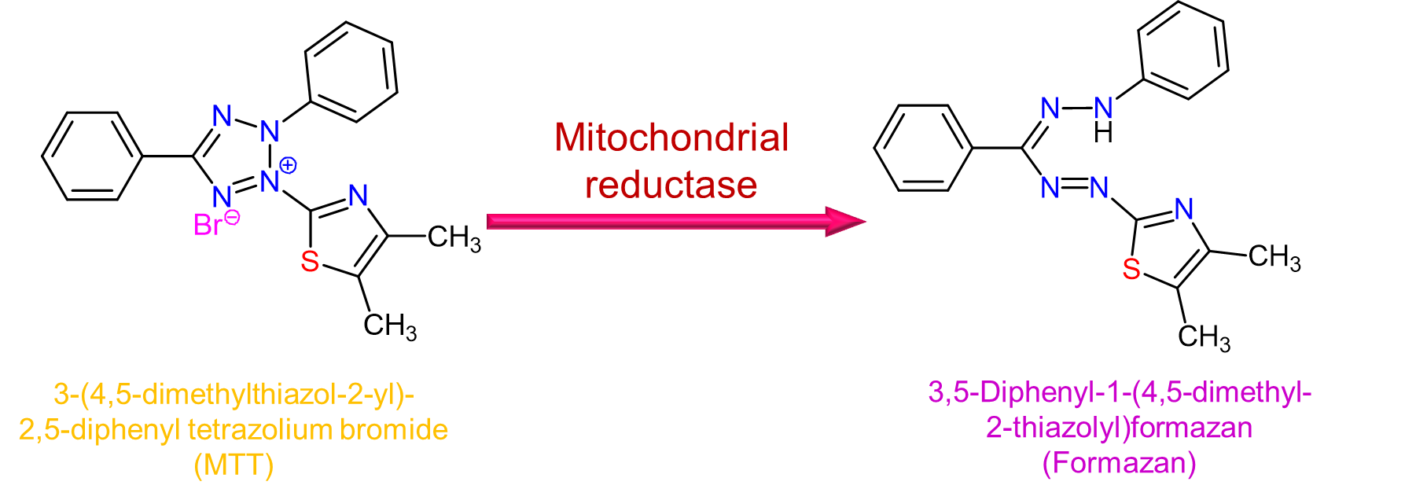
S13.3. Cell lines and culture medium
All the cell lines were procured from ATCC, stock cells were cultured in DMEM/F12 supplemented with 10% inactivated Fetal Bovine Serum (FBS), penicillin (100 IU/mL), streptomycin (100 µg/mL) in a humidified atmosphere of 5% CO₂ at 37 °C until confluent. The cell was dissociated with cell dissociating solution (0.2% trypsin, 0.02% EDTA, 0.05% glucose in PBS). The viability of the cells is checked and centrifuged. Further, 50,000 cells /well of Jurkat was seeded in a 96 well plate and incubated for 24 h at 37 °C, 5% CO₂ incubator.

S13.4. MTT method
The monolayer cell culture was trypsinized and the cell count was adjusted to 1.0 x 10⁵ cells/mL using respective media containing 10% FBS. To each well of the 96 well microtiter plate, 100 µL of the diluted cell suspension (50,000 cells/well) was added. After 24 h, when a partial monolayer was formed, the supernatant was flicked off, washed the monolayer once with medium and 100 µL of different test concentrations of test drugs were added on to the partial monolayer in micro-titer plates. The plates were then incubated at 37 °C for 24 h in 5% CO₂ atmosphere. After incubation the test solutions in the wells were discarded and 100 µL of MTT (5 mg/10 mL of MTT in PBS) was added to each well. The plates were incubated for 4 h at 37 °C in 5% CO₂ atmosphere. The supernatant was removed and 100 µL of DMSO was added and the plates were gently shaken to solubilize the formed formazan. The absorbance was measured using a microplate reader at a wavelength of 590 nm. The percentage growth inhibition was calculated using the following formula and concentration of test drug needed to inhibit cell growth by 50% (IC₅₀) values is generated from the dose-response curves for each cell line.
% Inhibition = 100 – (OD of sample/OD of Control) x 100 (1)
S13.5. Statistical evaluation
Calculation of IC₅₀ Value
The half maximal inhibitory concentration (IC₅₀) is a measure of the effectiveness of a compound in inhibiting biological or biochemical function. This quantitative measure indicates how much of a particular drug or other substance (inhibitor) is needed to inhibit a given biological process (or component of a process, i.e., an enzyme, cell, cell receptor or microorganism) by half.
The IC₅₀ of a drug can be determined by constructing a dose-response curve and examining the effect of different concentrations of antagonist on reversing agonist activity. IC₅₀ values can be calculated for a given antagonist by determining the concentration needed to inhibit half of the maximum biological response of the agonist.
The IC₅₀ values for cytotoxicity tests were derived from a nonlinear regression analysis (curve fit) based on sigmoid dose response curve (variable) and computed using Graph Pad Prism 6 (Graph pad, SanDiego, CA, USA)
S13.6. Nonlinear regression
In statistics, nonlinear regression is a form of regression analysis in which observational data are modeled by a function which is a nonlinear combination of the model parameters and depends on one or more independent variables. The data are fitted by a method of successive approximations.

S14. MTT absorption value for 3e compound
Cells | MCF-7 cells |  |  |  | Sample name |  |  | 3e
Blank | 0 | 10 | 20 | 30 | 40 | 50 | 60 | 70 | 80 | 90 | 100
0.05 | 1.248 | 0.945 | 0.812 | 0.782 | 0.645 | 0.574 | 0.512 | 0.394 | 0.224 | 0.184 | 0.162
0.046 | 1.268 | 0.936 | 0.785 | 0.684 | 0.665 | 0.566 | 0.503 | 0.364 | 0.236 | 0.201 | 0.154
0.054 | 1.298 | 0.974 | 0.764 | 0.684 | 0.628 | 0.563 | 0.485 | 0.314 | 0.257 | 0.241 | 0.184
 | 1.271 | 0.952 | 0.787 | 0.717 | 0.646 | 0.568 | 0.500 | 0.357 | 0.239 | 0.209 | 0.167
Mean | 0 | 25 | 38 | 44 | 49 | 55 | 61 | 72 | 81 | 84 | 87
Viability | 100 | 75 | 62 | 56 | 51 | 45 | 39 | 28 | 19 | 16 | 13
 | IC₅₀ = 43.25 ± 0.05 µM

S15. MTT absorption value for 4e compound
Cells | MCF-7 cells |  |  |  | Sample name |  |  | 4e
Blank | 0 | 10 | 20 | 30 | 40 | 50 | 60 | 70 | 80 | 90 | 100
0.042 | 1.264 | 0.936 | 0.805 | 0.764 | 0.643 | 0.568 | 0.460 | 0.422 | 0.361 | 0.248 | 0.222
0.044 | 1.257 | 0.845 | 0.745 | 0.693 | 0.584 | 0.517 | 0.486 | 0.444 | 0.366 | 0.268 | 0.236
0.059 | 1.294 | 0.912 | 0.796 | 0.623 | 0.623 | 0.562 | 0.427 | 0.393 | 0.387 | 0.289 | 0.225
 | 1.272 | 0.898 | 0.782 | 0.693 | 0.617 | 0.549 | 0.458 | 0.420 | 0.371 | 0.268 | 0.228
Mean | 0 | 29 | 39 | 45 | 52 | 57 | 64 | 67 | 71 | 79 | 82
Viability | 100 | 71 | 61 | 55 | 48 | 43 | 36 | 33 | 29 | 21 | 18
 | IC50 = 38.75± 0.05 µM

