Supplementary material

Sex-specific association of maternal glycaemia with the preschooler cognitive development in a prospective cohort study: “the higher the worse?”

Supplement materias captions
Figure S1 The participant flow chart
Figure S2 Directed acyclic graphs for this study
Figure S3 Gender differences in the full scale intelligent quotient of preschoolers.
Abbreviation: FSIQ, full scale intelligent quotient.
Figure S4 The association of plasma glucose (categories by tertiles) during pregnancy with full-scale interlligence quotient of preschoolers
Adjusting parity, prepregnancy BMI, maternal age, maternal IQ, monthly incomes, child gender, child age at testing, delivery, birth weight, gestational age, breastfeeding duration.
Table S1 The full-scale interlligence quotient for Chinese version of WPPSI-IV

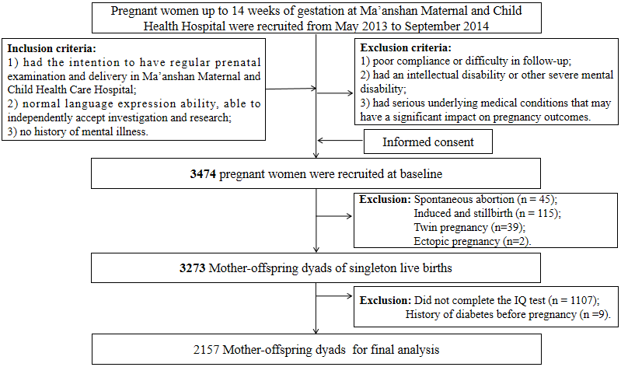
Figure S1 The participant flow chart

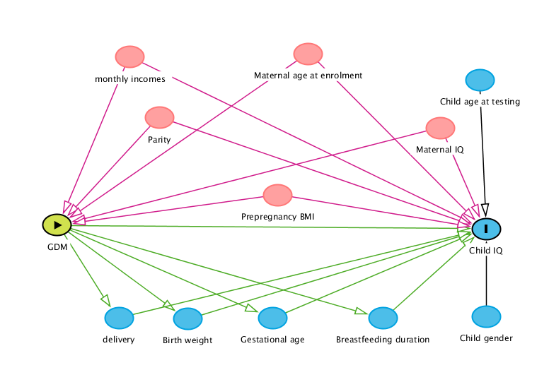
Figure S2 Directed acyclic graphs for this study

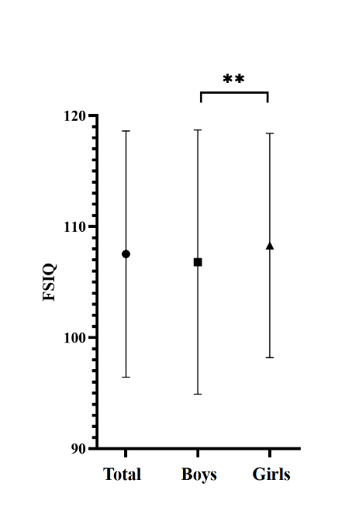
Figure S3 Gender differences in the full scale intelligent quotient of preschoolers.
Abbreviation: FSIQ, full scale intelligent quotient.

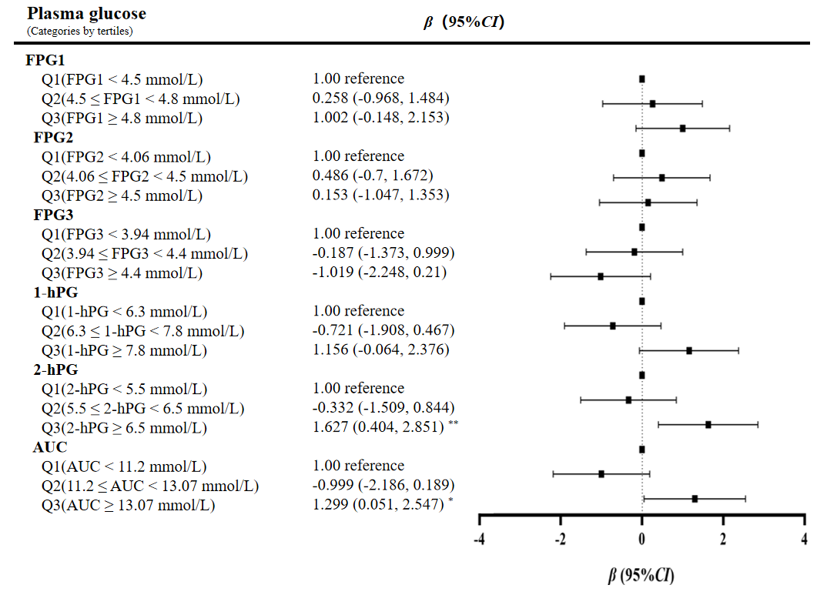

Figure S4 The association of plasma glucose (categories by tertiles) during pregnancy with full-scale interlligence quotient of preschoolers
Adjusting parity, prepregnancy BMI, maternal age, maternal IQ, monthly incomes, child gender, child age at testing, delivery, birth weight, gestational age, breastfeeding duration.

Table S1 The full-scale interlligence quotient for Chinese version of WPPSI-IV
 | Full scale interlligence quotient (2.5-4 years) | Full scale interlligence quotient (4-7 years)
VCI | Information | Information
 | Pictures Identifying | Similarities
 | Picture naming*
VSI | Block design | Block design
 | Object assembly | Object assembly
WMI | Picture memory | Picture memory
 | Zoo locations | Zoo locations
FRI |  | Matrix reasoning
 |  | Picture concepts
PSI |  | Bug search
 |  | Cancelation
 |  | Animal coding*
FRI, the fluid reasoning index; PSI, the processing speed index; VCI, the verbal comprehension index; VSI, the visual space index.
* non-main index.

