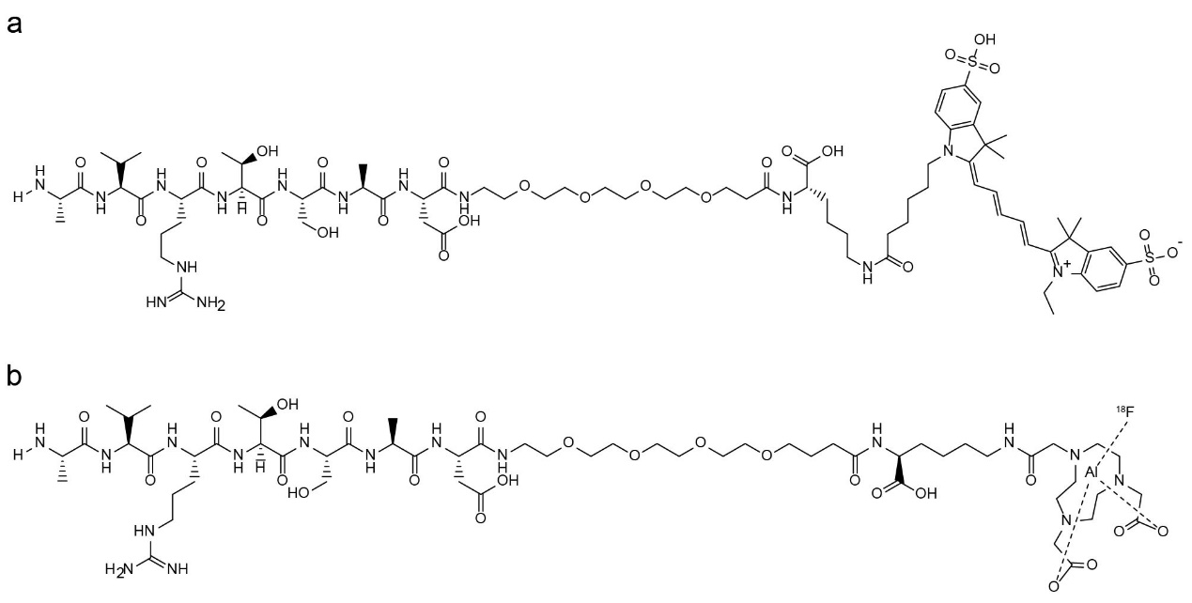
Fig. S1 Chemical structure of EDBp-Cy5 (a) and ¹⁸F-EDBp (b).

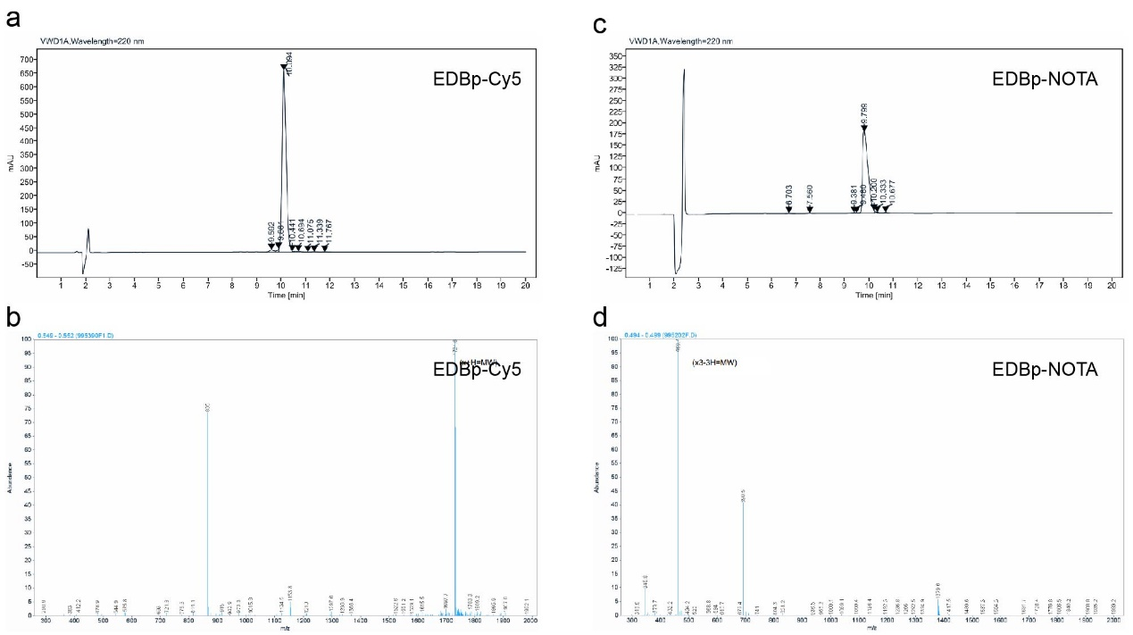
Fig. S2 Analytical high-performance liquid chromatography (HPLC) chromatograph (a) and mass spectrometry (MS) spectrum (b) of EDBp-Cy5. Analytical HPLC chromatograph (c) and mass MS spectrum (d) of EDBp-NOTA.

