Supplemental Materials

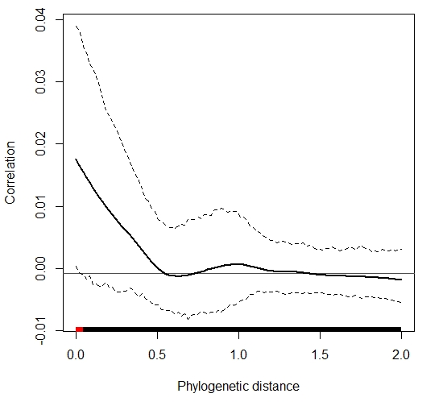

Figure S1: Plots of (A) log-transformed mean relative abundance of OTUs (points) among forest (●) versus built-environment (●) squirrels with 1:1 line (solid black) and (B) a phylocorrelogram of OTU deviation from the 1:1 line, which shows a positive phylogenetic signal over short phylogenetic distances (significance identified by a red line) for bacterial OTU bias towards squirrel local environment type.

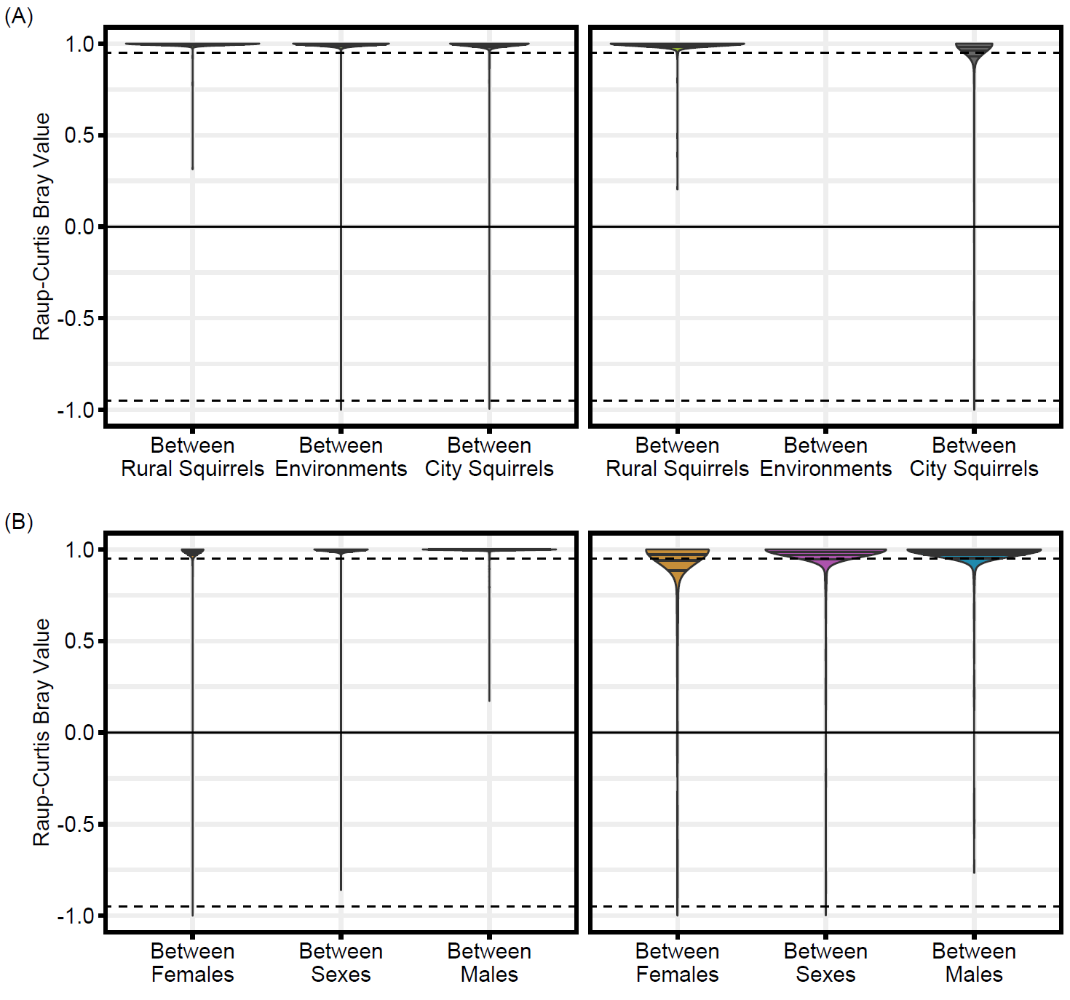

Figure S2: Plots of RC_{bray} values within and between (A) environments and (B) sexes, facetted by pairwise comparisons made between sites (left) versus within sites (right).

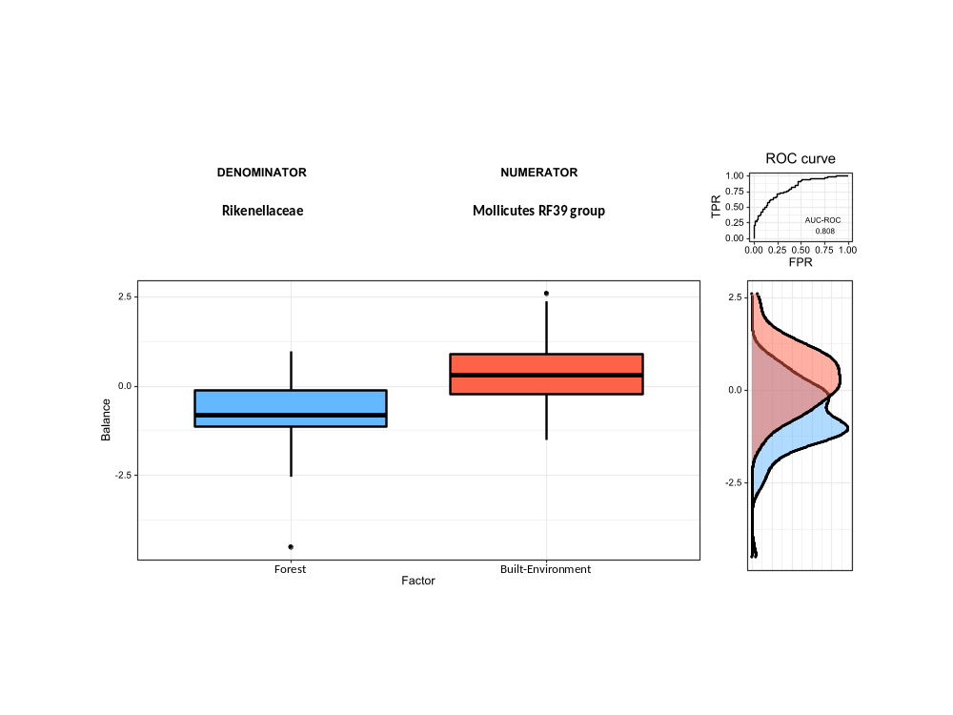
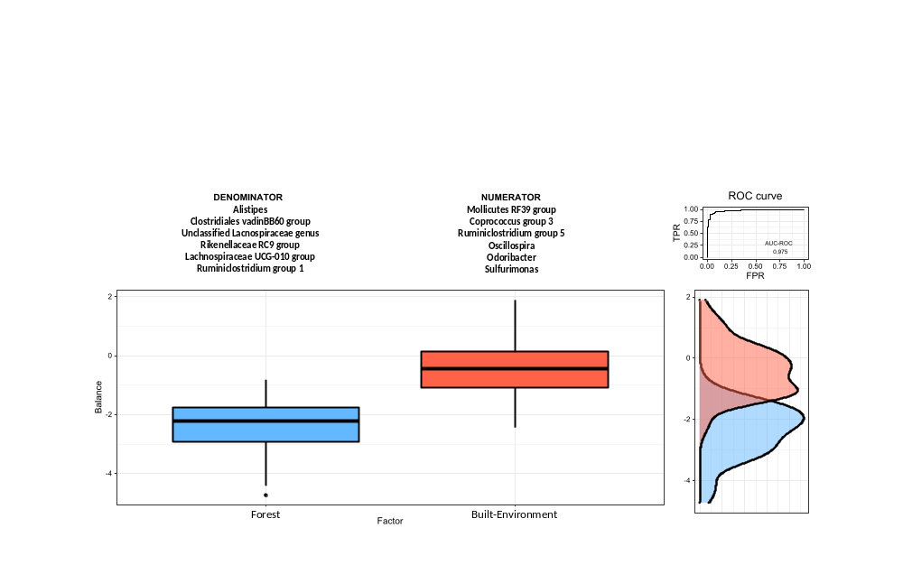

Figure S3: Boxplot, AUC-ROC curve, and density plots from selection balance analyses used to discriminate between forest and urban microbiomes at the bacterial taxonomic level of a) genus and b) family.

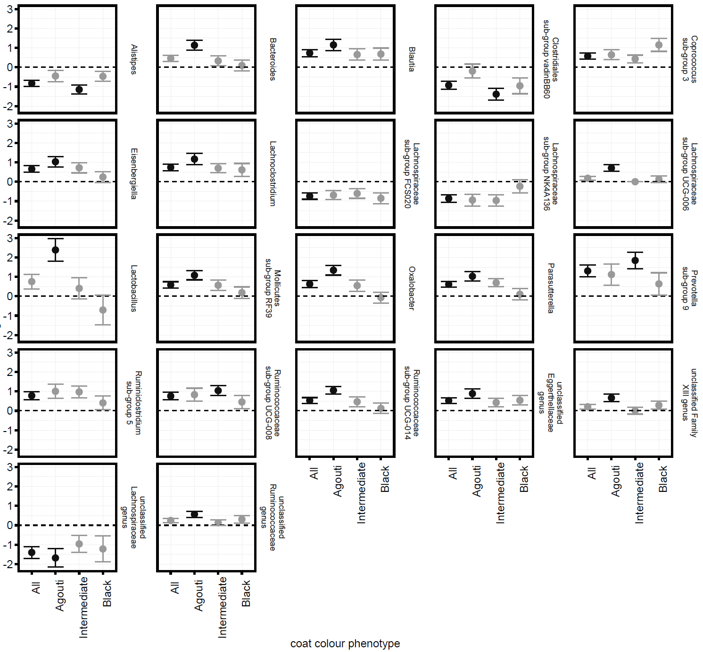
Figure S4: Forest plots of ANCOM-BC estimated log difference (dot) and standard error (whiskers) of genus abundances which significantly differed (black) or did not differ (grey) between forest (y-values < 0) and built-environment (y-values > 0) squirrels of pooled, or parsed coat colour phenotypes.

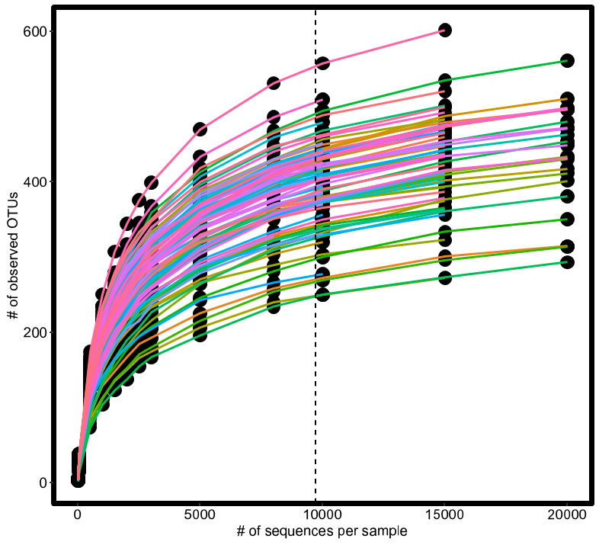

Figure S5: A rarefaction curve of observed # of OTUs versus sub-sampled sequencing depth. Coloured lines represent separate individuals. The dotted line demarcates level of rarefaction used for analyses.

