Synthesis of a [4[2+3]+6] hierarchical porous organic ‘cage of cages’

Qiang Zhu,^{1,2} Hang Qu,¹ Gokay Avci,³ Chengxi Zhao,^{1,5} Kim E. Jelfs,³ Marc A. Little*^{1,3} and Andrew I. Cooper*^{1,2}
¹ Materials Innovation Factory and Department of Chemistry, University of Liverpool, 51 Oxford Street, Liverpool L7 3NY, UK.
² Leverhulme Research Centre for Functional Materials Design, University of Liverpool, 51 Oxford Street, Liverpool L7 3NY, UK.
³ Department of Chemistry, Imperial College London, Molecular Sciences Research Hub, White City Campus, Wood Lane, London, W12 0BZ, UK
⁴ Institute of Chemical Sciences, Heriot-Watt University, Riccarton, Edinburgh, EH14 4AS UK.
⁵ Key Laboratory for Advanced Materials and Joint International Research Laboratory of Precision Chemistry and Molecular Engineering, Feringa Nobel Prize Scientist Joint Research Center, Frontiers Science Center for Materiobiology and Dynamic Chemistry, Institute of Fine Chemicals, School of Chemistry and Molecular Engineering East China University of Science and Technology, Shanghai 200237, China.

Supporting Information

Section 1 Materials and methods 2
Section 2 Molecular simulation 4
Section 3 Synthetic procedure 7
Section 4 Gas sorption analysis 11
Section 5 Crystal structure information 14
Reference 17

Section 1 Materials and methods

1.1 Materials
All reagents were obtained from Sigma-Aldrich, TCI Europe, Fisher, and Alfa Aesar and used as received. Anhydrous solvents were purchased from Acros Organics and used without further purification. All gases for sorption analysis were supplied by BOC at a purity of ≥99.9 %.

1.2 Methods
1.2.1 Molecular simulation
Both cage and cage-of-cages models were constructed in Tri²Di³, Tri⁴Di⁶, Tri⁸Di¹² topologies using the supramolecular toolkit (stk) software.¹ All cages were annealed with a molecular dynamics simulation at 700 K for 50 ns with a timestep of 0.5 fs after a 100 ps equilibration time with OPLS4 force field as implemented in the Macromodel Suite.² Five hundered random configurations from the total MD duration were sampled and energy minimized, with the lowest energy configuration selected for Density Functional Theory (DFT) calculations.

DFT calculations were performed with CP2K 2023.1³ version software using Generalized Gradient Approximation (GGA) theory with the PBE functional⁴ and def2-TZVP basis sets⁵. A planewave cut-off value of 400 Ry and a relative cut-off value of 100 Ry were parameterized to obtain converged energy levels and dispersion interactions were accounted for with Grimme’s DFT-D3 approach⁶.

The geometries of the [4[2+3]+6]cage was then fully optimized by means of the hybrid M06-2X functional⁷ in Gaussian16.⁸ The def2-SVP basis set^{9,10} was applied for all atoms. No symmetry or geometry constraint was imposed during optimizations. The optimized geometries were verified as local minima on the potential energy surface by frequency computations at the same theoretical level. ⁸

1.2.2 NMR
NMR spectra were recorded on a Bruker 400 NMR spectrometer at 400 MHz (¹H), 376 MHz (¹⁹F) and 100 MHz (¹³C) and referenced against the residual ¹H, ¹⁹F or ¹³C signal of the solvent.
1.2.3 MALDI-TOF MS
The molecular mass analysis was conducted on a Bruker Ultraflex MALDI TOF/TOF mass spectrometer using a reflection mode at Swansea University.

1.2.4 Powder X-ray diffraction (PXRD)
Laboratory powder X-ray diffraction (PXRD) data patterns were collected in transmission mode on samples held on thin Mylar film in aluminium well plates on a Panalytical Empyrean diffractometer, equipped with a high throughput screening (HTS) XYZ stage, X-ray focusing mirror, and PIXcel detector, using Cu-Kα radiation. For HT screening, PXRD patterns were measured over the 2θ range 1–40° in 0.013° steps over 10 minutes. Capillary PXRD patterns were collected on powdered samples loaded in borosilicate glass capillaries that were spun to improve averaging. Capillary PXRD patterns were collected on powdered samples loaded in borosilicate glass capillaries, and the capillaries were spun to improve averaging.

1.2.5 Single crystal X-ray diffraction (SC-XRD)
SCXRD data for [4[2+3]+6]cage was measured at beamline I19, Diamond Light Source, Didcot, UK using silicon double crystal monochromated synchrotron radiation (λ = 0.6889 Å, Pilatus 2M detector) and data reduction was performed using xia2. Structures were solved with SHELXT¹¹ and refined by full-matrix least squares on |F|2 by SHELXL,¹² interfaced through the programme OLEX2.¹³ All non-H atoms were refined anisotropically and all H-atoms were fixed in geometrically estimated positions and refined using the riding model. For full refinement details, see Tables S2.

1.2.6 Gas sorption Analysis
Surface areas were measured by nitrogen sorption at 77.3 K. Powder samples were degassed offline, followed by degassing on the analysis port under vacuum at 25 °C for 15 hours. Isotherm measurements were performed using a Micromeritics ASAP 2020 characterization analyzer. CO₂ were measured with the same procedure at 273 K and 298 K, using a Micromeritics ASAP

Section 2 Molecular simulation
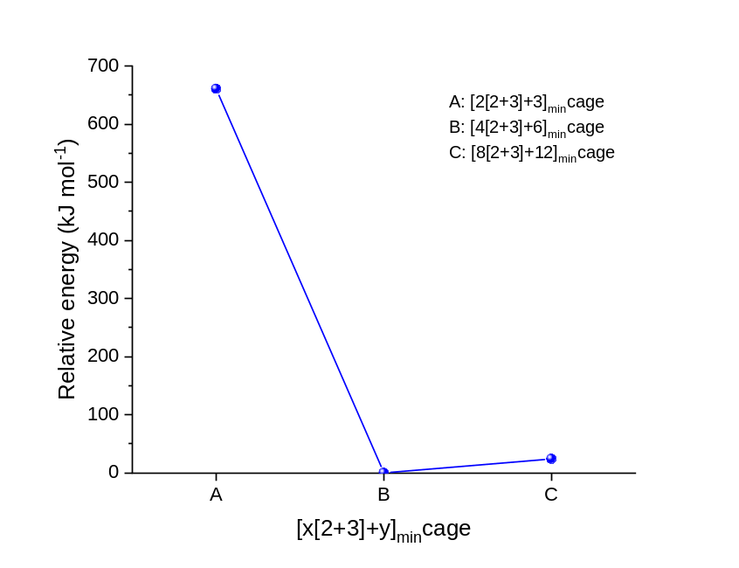

Figure S1 Relative DFT energies for the minimum energy configurations for the [x[2+3]+y]cages.
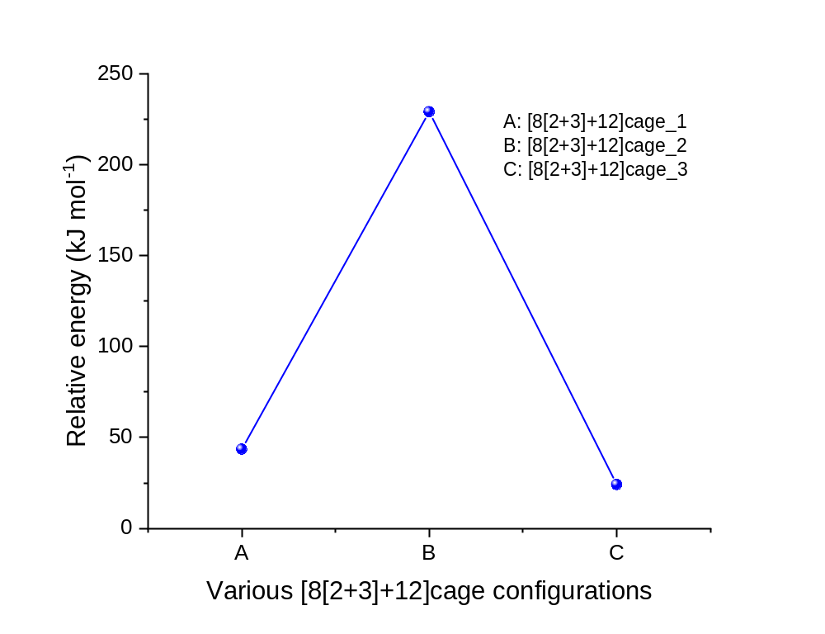

Figure S2 Relative energy values for randomly sampled ether cis-trans configurations for the [8[2+3]+12]cages.
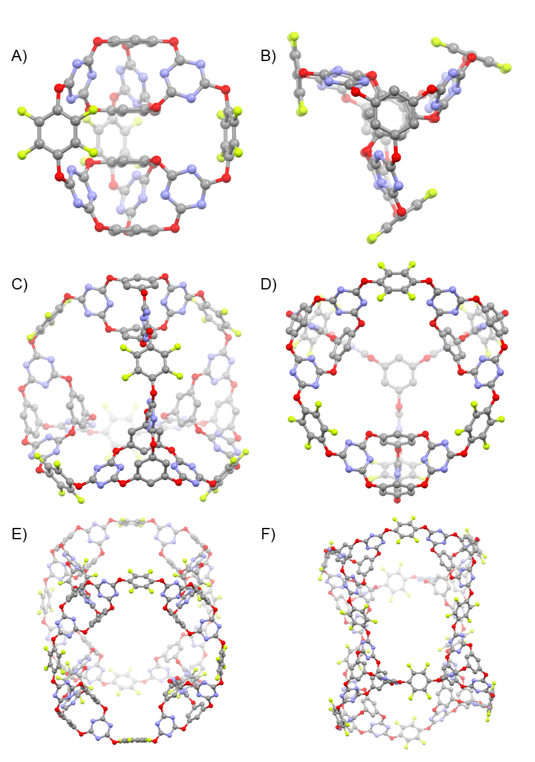

Figure S3 Structural representations of hypothetical [2[3+2]+3]cage (A, B), [4[3+2]+6]cage (C, D), and hypothetical [8[3+2]+12]cage (E, F). Atoms colour, C: grey; N: blue; O: red and F: green.

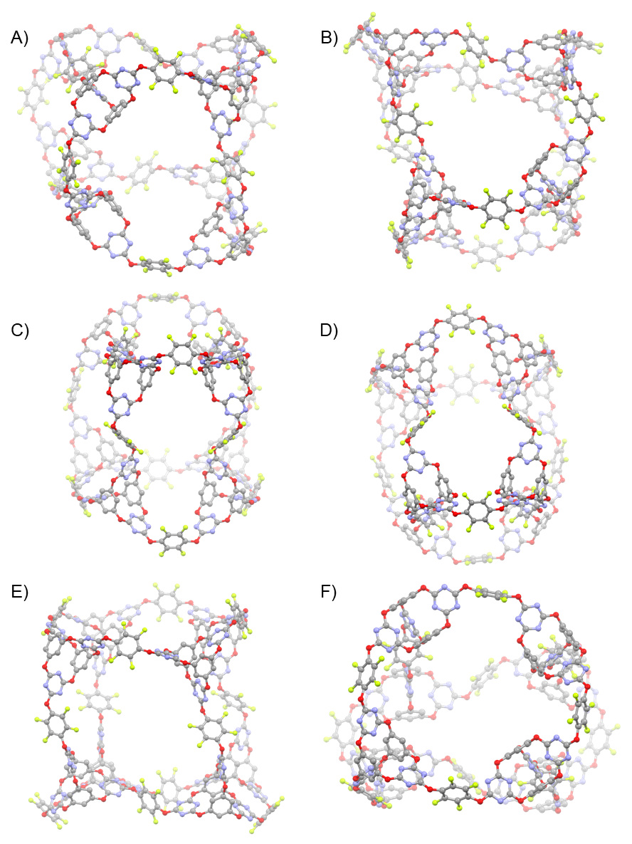

Figure S4 Structural conformer representations of the [8[3+2]+12]cage_1 (A, B), [8[3+2]+12]cage_2 (C, D), and [8[3+2]+12]cage_3 retrieved from random snapshots within [8[3+2]+12]cage MD simulation trajectories (E, F). Atoms colour, C: grey; N: blue; O: red and F: green.

Section 3 Synthetic procedure
Synthesis of [4[2+3]+6]cage
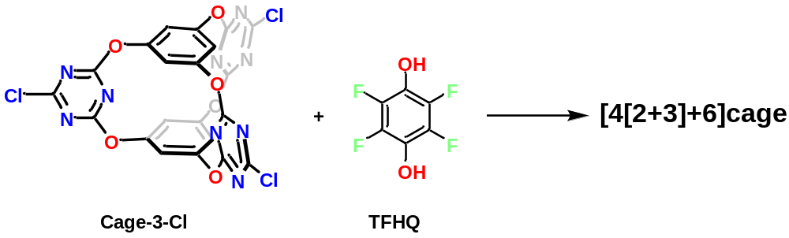

Scheme S1 Synthetic route for [4[2+3]+6]cage.

Cage-3-Cl was first synthesized according to previous methods.¹⁴

DIPEA (61 uL, 0.35 mmol) was dissolved in acetone (25 mL) and purged with N₂ flow for 10 min. To the above solution, a mixture of Cage-3-Cl (58.7 mg, 0.1 mmol) and tetrafluorohydroquinone (TFHQ, 27.3 mg, 0.15 mmol) in acetone (6 mL) was added dropwise over 3 h under a nitrogen atmosphere. After the addition was complete, the reaction was stirred at room temperature for 36 h. The solvent was then removed by rotary evaporation, and the crude product was purified by chromatography using acetone/CH₂Cl₂ (10% acetone) as eluent to afford [4[2+3]+6]cage as a white solid in 53% isolated yield (40 mg, 0.013 mmol).
¹H NMR (400 MHz, acetone-d₆): δ 7.09 (s, 12H_{b}), 6.85 (12H_{a}); ¹⁹F NMR (376 MHz, acetone-d₆): δ -155.62; ¹³C NMR (100 MHz, dioxane-d₈): δ 174.5, 173.5, 173.1, 153.2, 152.8, 142.5, 140.1, 140.0, 128.3, 115.2, 114.8.

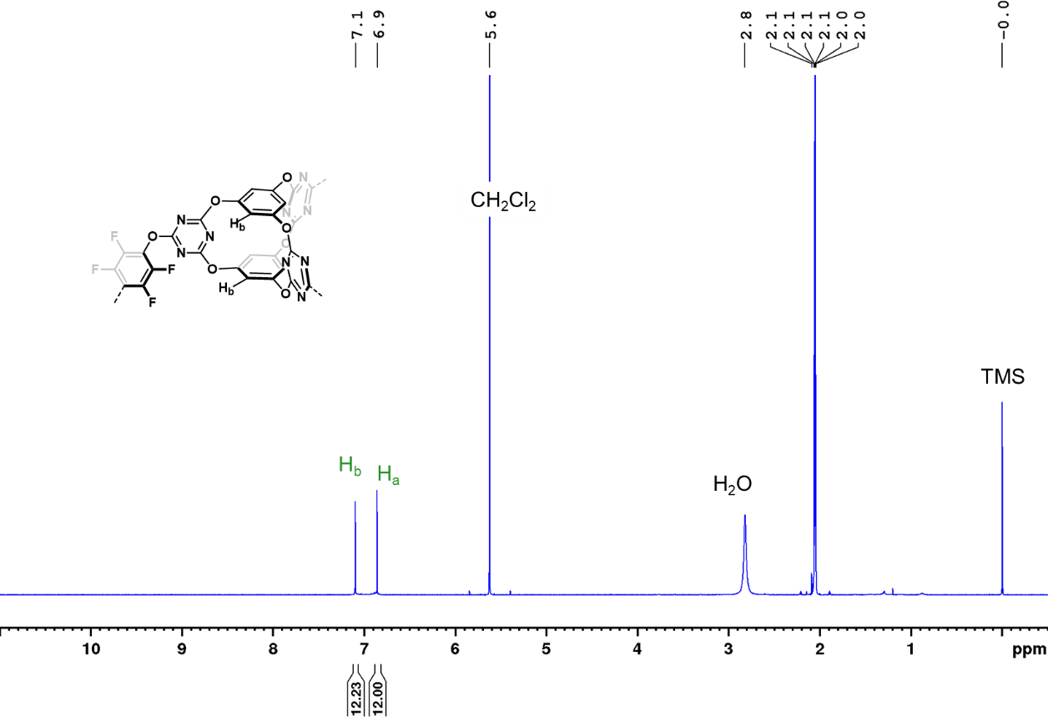

Figure S5 ¹H NMR (400 MHz, acetone-d₆) spectrum of [4[2+3]+6]cage.

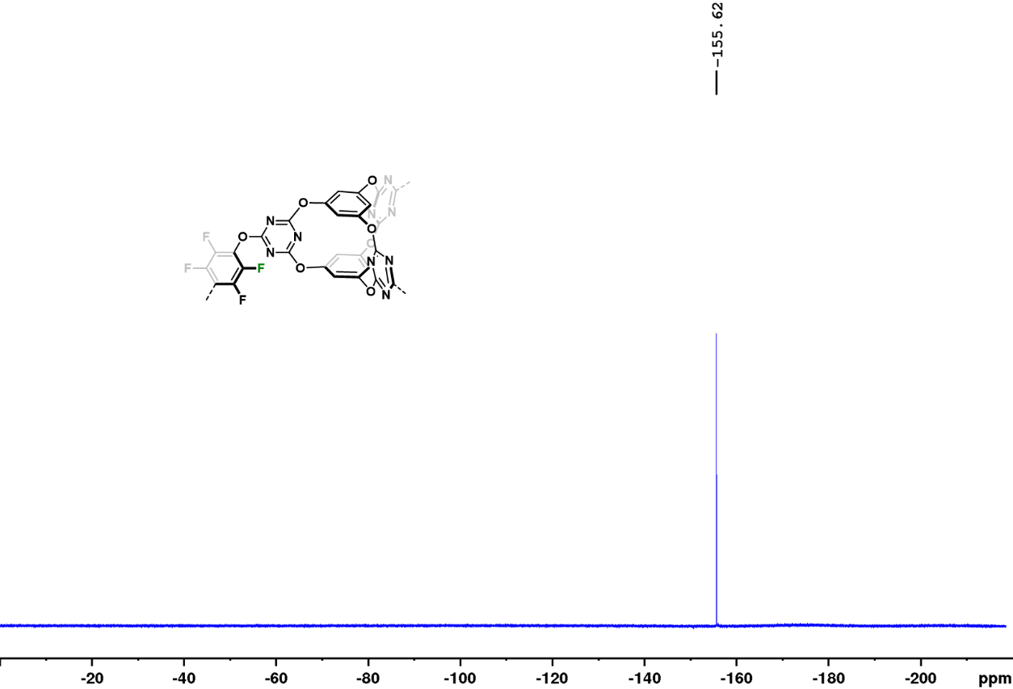

Figure S6 ¹⁹F NMR (376 MHz, acetone-d₆) spectrum of [4[2+3]+6]cage.

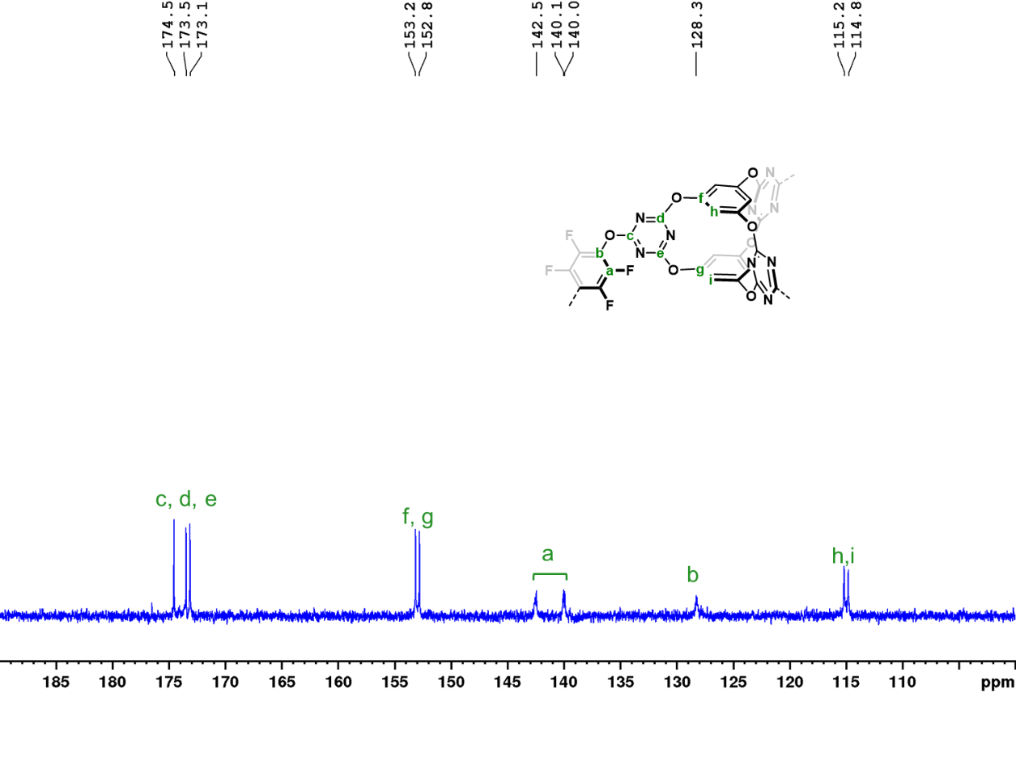

Figure S7 ¹³C NMR (400 MHz, dioxane-d₈) spectrum of [4[2+3]+6]cage.
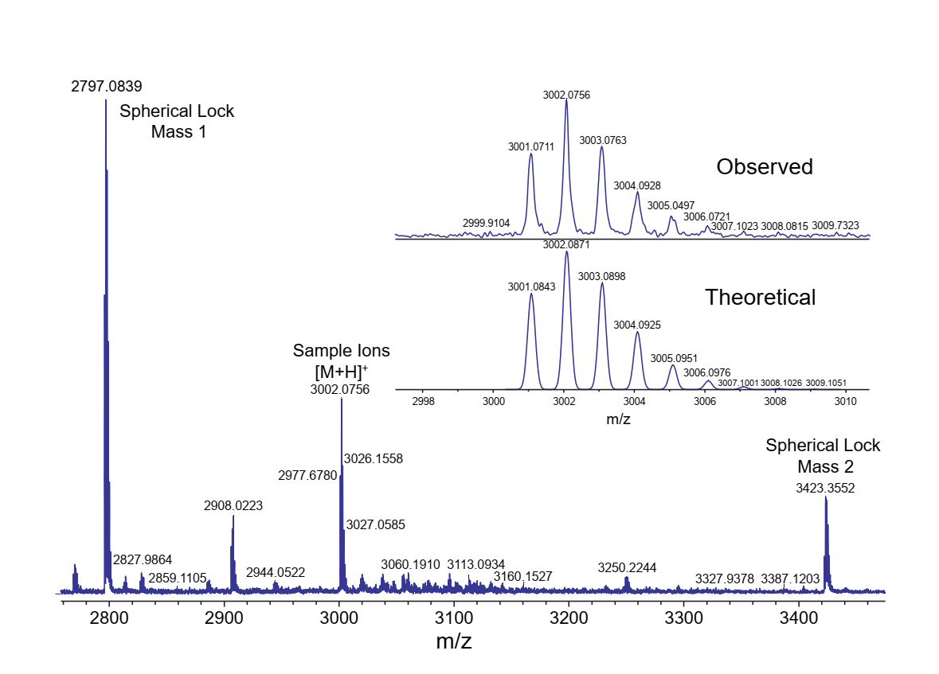

Figure S8 High-resolution MALDI-TOF spectrum of [4[2+3]+6]cage. A linear calibration method using two internal lock masses of the calibrant SphericalTM that bracketed the ions of interest (at m/z 2979 and m/z 3423) was used with m/z error limits of +/- 5ppm.

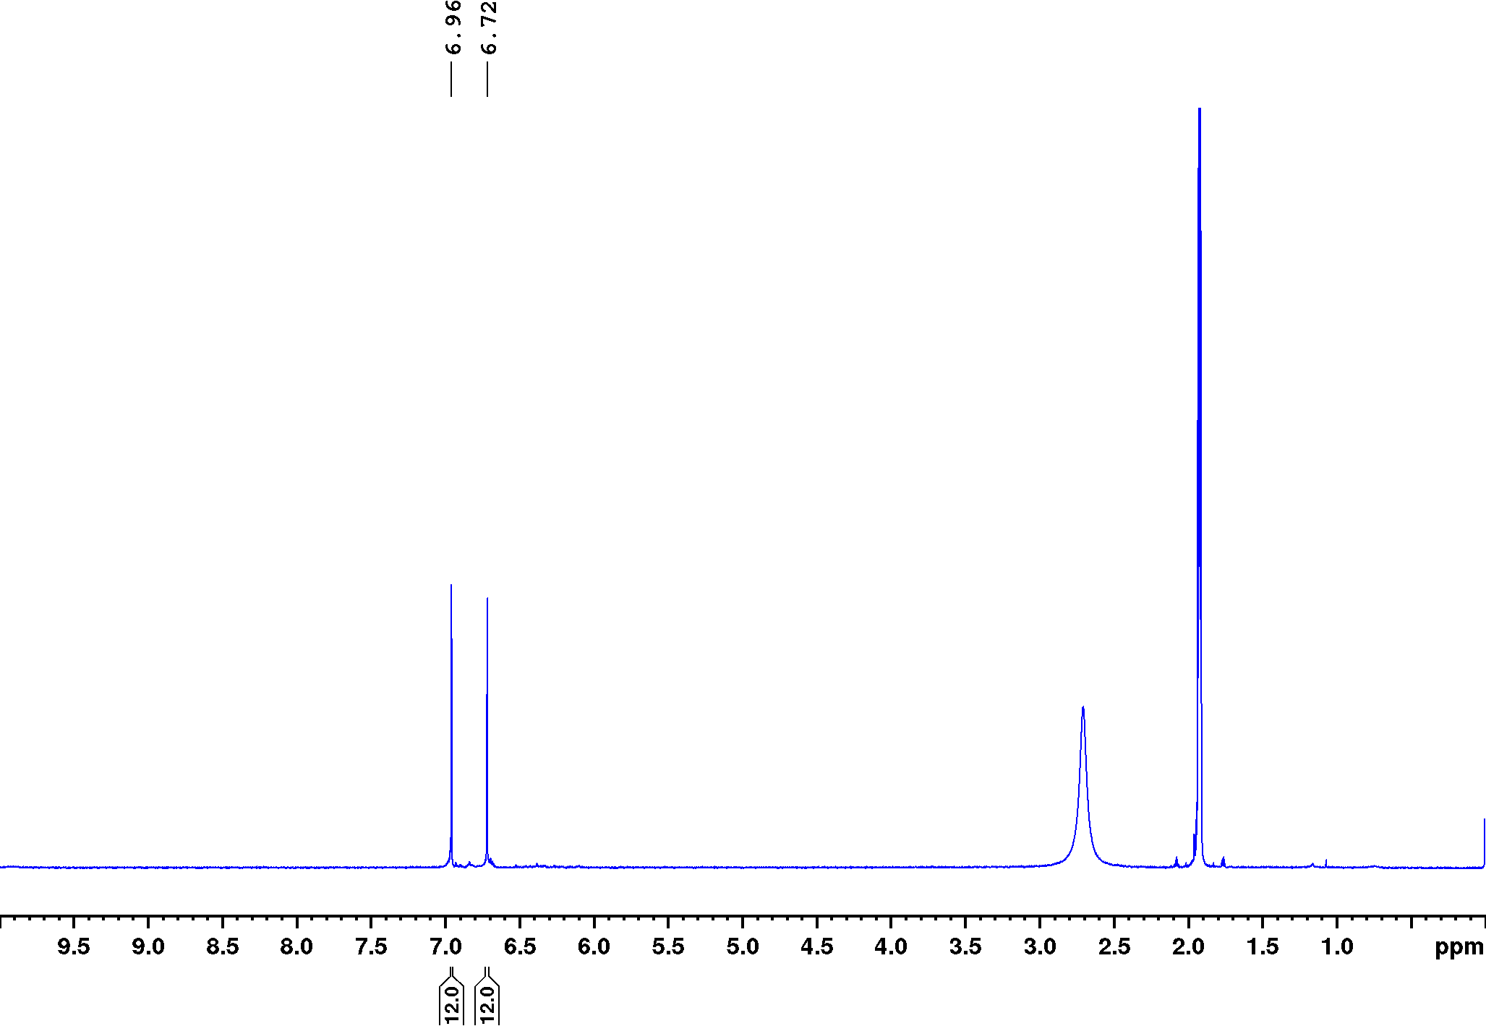

Figure S9 ¹H NMR (400 MHz, acetone-d₆) spectrum of [4[2+3]+6]cage recorded after the sample had been immersed in water for 12 days.

Crystallisation of [4[2+3]+6]cage
[4[2+3]+6]cage (4 mg) was dissolved in acetone (4 mL). The solution was filtered into a 14 mL vial through a 0.2 um syringe filter and layered by EtOH (1 mL). The vial was covered with a cap, which has a small hole on the top, and placed at room temperature, affording rhombic crystals suitable for single crystal X-ray diffraction analysis.

Section 4 Gas sorption analysis
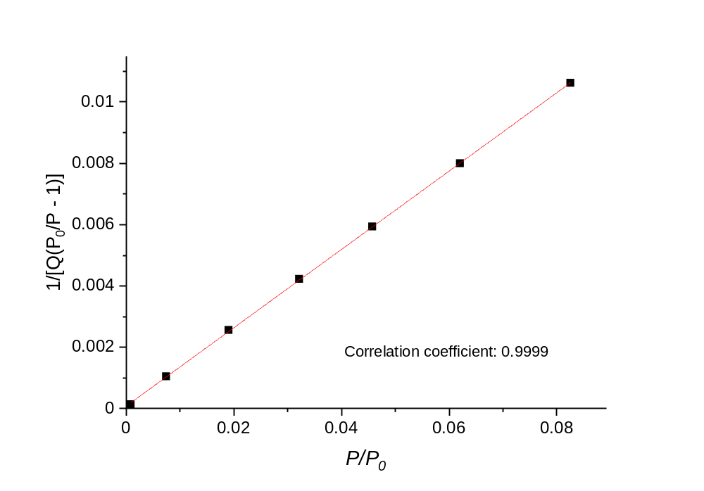

Figure S10. t-Plot for BET surface area calculation. The sample was activated by the solvent exchange with pentane ten times prior to evacuation and sorption analysis.

Table S1. Summary of CO₂ uptakes in various porous organic cages.

Entry | POCs | linkage | SA_{BET} (m² g⁻¹) | CO₂ uptake (mmol g⁻¹)ª | References
1 | cage 2 | imine to quinoline | 698 | 1.15 | ¹⁵
2 | CC15α | imine | 2.7 | 1.30 | ¹⁶
3 | Fe-PB | imine | 409^{b} | 1.33 | ¹⁷
4 | CC14α | imine | 320 | 1.57 | ¹⁶
5 | PB-1 | imine | 1370 | 1.66 | ¹⁸
7 | CC3-S/CC15-R cocrystal | imine | 13 | 1.84 | ¹⁶
8 | 3-Et-Et | imine | 71 | 1.87 | ¹⁹
9 | BTPOC | imine | 605^{b} | 1.96 | ²⁰
10 | CC3α | imine | 409 | 2.01 | ¹⁶
10 | CC3-RS | imine | 598 | 2.01 | ²¹
12 | cage 9 | amide | 102 | 2.05 | ²²
12 | cage 7 | amide | 398 | 2.05 | ²²
14 | cage 8 | amide | 260 | 2.07 | ²²
15 | cage 2 | imine | 1375 | 2.1 | ²³
16 | cage 4 | amide | 275 | 2.14 | ²²
17 | CC3-RScore/CC19-  RSshell – 3 um | imine | 539 | 2.26 | ²¹
18 | CC19-RS | imine | 500 | 2.39 | ²¹
19 | CC3 | imine | 624 | 2.47 | ²⁴
20 | CC19-RScore/CC3-  RSshell – 3 um | imine | 523 | 2.55 | ²¹
21 | cage 1 | ether | 432 | 2.8 | ²⁵
22 | CC2 | imine | 533 | 3 | ²⁴
23 | 3-Et-H | imine | 443 | 3.14 | ¹⁹
24 | PB-2 | imine | 935^{b} | 3.31 | ¹⁸
25 | [4[2+3]+6]cage | ether | 763 | 3.47 | This work
26 | FC1 | imine | 536 | 4.2 | ²⁶

ª All CO₂ uptake data here were collected at 273 K, 1 bar.
^{b} Apparent BET surface area was calculated based on the CO₂ sorption isotherm at 195 K, rather than a nitrogen isotherm at 77 K.
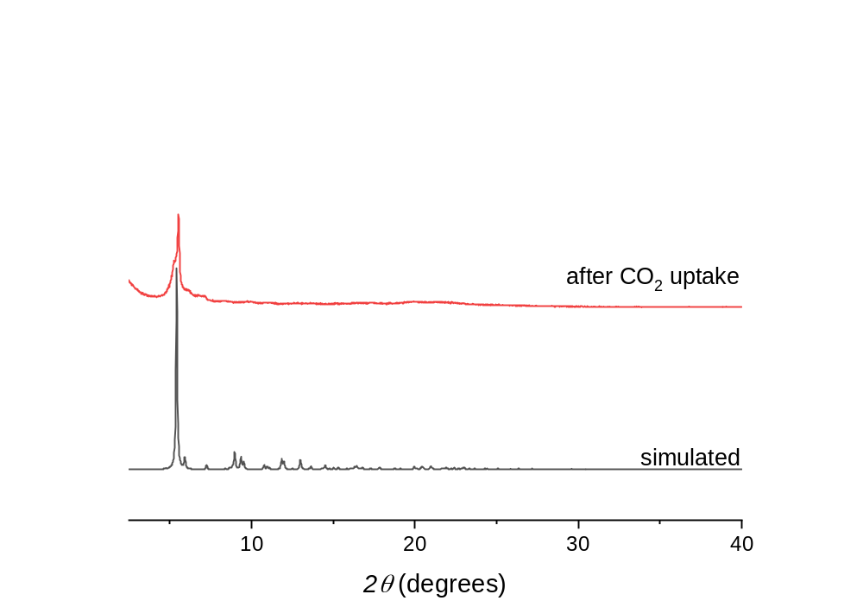

Figure S11. PXRD profile for [4[2+3]+6]cage recorded after the CO₂ sorption / desorption.

Section 5 Crystal structure information
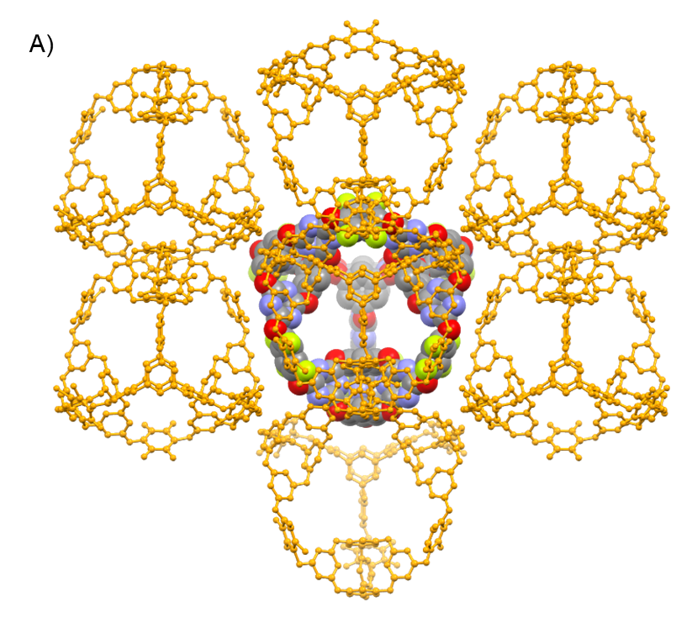
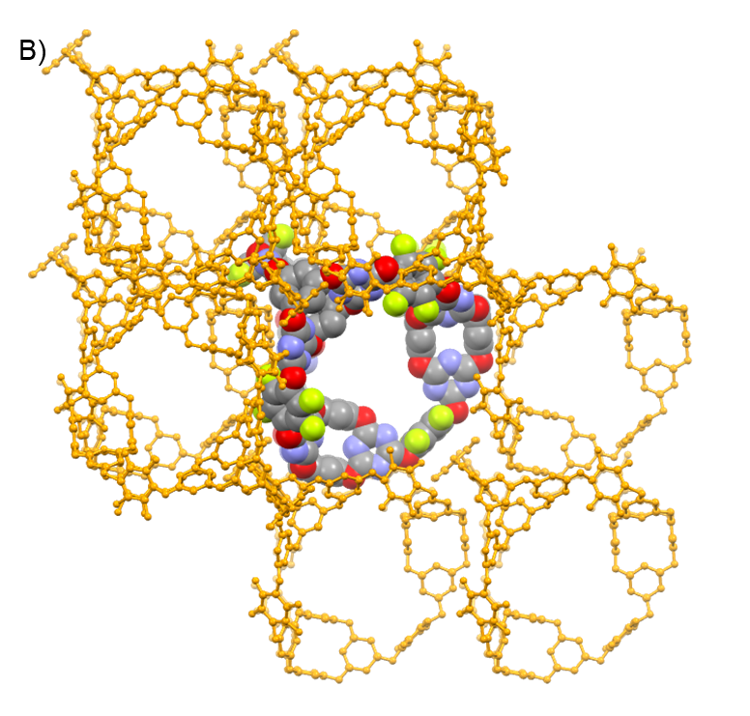

Figure S12. Crystal packing of [4[2+3]+6]cage viewed along the a-axis (A) and the b-axis (B).

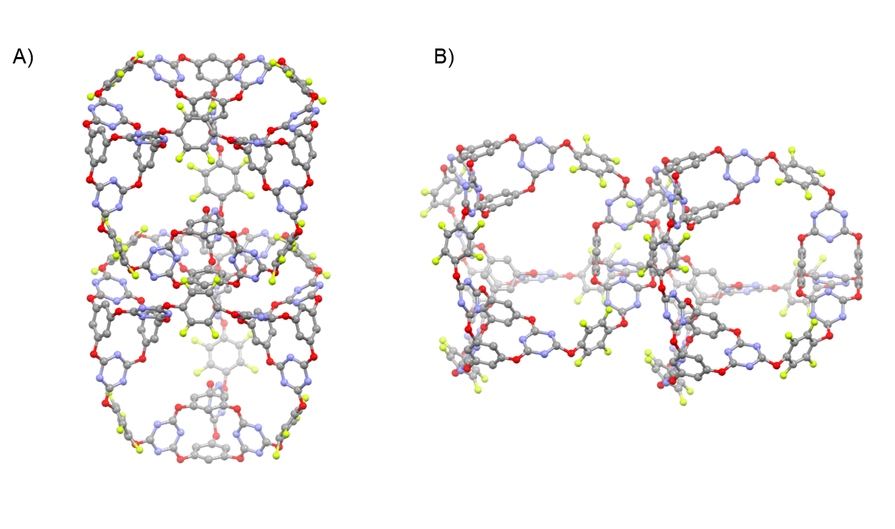

Figure S13. Illustration of the cage window splitting by neighbouring [4[2+3]+6]cage molecules, as viewed along the a-axis (A) and the b-axis (B).

Table S2. Single crystal refinement details for [4[2+3]+6]cage.

Name | [4[2+3]+6]cage
Crystallization solvent | Acetone-Ethanol
Wavelength/ Å | Synchrotron, 0.6889
Formula | C₁₂₀ H₂₄ F₂₄ N₃₆ O₃₆
Weight | 3001.75
Crystal system | monoclinic
Space group | P2₁
a (Å) | 16.2851(7)
b (Å) | 37.1746(17)
c (Å) | 16.5847(10)
α (°) | 90
β (°) | 93.767(5)
γ (°) | 90
V (Å³) | 10018.6(9)
ρ _{calcd} (g cm⁻¹) | 0.995
Z | 2
T (K) | 100
μ (mm⁻¹) | 0.084
F(000) | 3000
2θ range (°) | 2.124 – 45.002
Reflections collected | 38701
Independent reflections | 24380
Data / restraints / parameters | 24380 / 2127 / 1633
Final R₁ values (I > 2σ(I)) | 0.1041
Final R₁ values (all data) | 0.1491
wR₂ (all data) | 0.2895
Goodness-of-fit on |F|² | 1.088
CCDC | 2303319

References
1. Turcani, L. et al. stk: A python toolkit for supramolecular assembly. J. Comput. Chem. 39, 1931–1942 (2018).
2. Lu, C. et al. OPLS4: Improving force field accuracy on challenging regimes of chemical space. J. Chem. Theory Comput. 17, 4291–4300 (2021).
3. Kühne, T. D. et al. CP2K: An electronic structure and molecular dynamics software package - Quickstep: Efficient and accurate electronic structure calculations. J. Chem. Phys. 152, (2020).
4. Perdew, J. P. et al. Generalized gradient approximation made simple. Phys. Rev. Lett. 77, 3865–3868 (1996).
5. VandeVondele, J. & Hutter, J. Gaussian basis sets for accurate calculations on molecular systems in gas and condensed phases. J. Chem. Phys. 127, (2007).
6. Grimme, S. et al. A consistent and accurate ab initio parametrization of density functional dispersion correction (DFT-D) for the 94 elements H-Pu. J. Chem. Phys. 132, (2010).
7. Zhao, Y. & Truhlar, D. G. The M06 suite of density functionals for main group thermochemistry, thermochemical kinetics, noncovalent interactions, excited states, and transition elements: Two new functionals and systematic testing of four M06-class functionals and 12 other function. Theor. Chem. Acc. 120, 215–241 (2008).
8. Frisch, M. J. et al. Gaussian 16 revision a. 03. 2016; gaussian inc. Wallingford CT 2, 4 (2016).
9. Weigend, F. & Ahlrichs, R. Balanced basis sets of split valence, triple zeta valence and quadruple zeta valence quality for H to Rn: design and assessment of accuracy. Phys. Chem. Chem. Phys. 7, 3297–3305 (2005).
10. Weigend, F. Accurate Coulomb-fitting basis sets for H to Rn. Phys. Chem. Chem. Phys. 8, 1057–1065 (2006).
11. Sheldrick, G. SHELXT. Acta Cryst. A71, 3–8 (2015).
12. Sheldrick, G. SHELXL. Acta Cryst. C71, 3–8 (2015).
13. Dolomanov O. V. et al. OLEX2. J. Appl. Cryst. 42, 339–341 (2009).
14. Zhu, Q. et al. Analogy powered by prediction and structural invariants: computationally led discovery of a mesoporous hydrogen-bonded organic cage crystal. J. Am. Chem. Soc. 144, 9893–9901 (2022).
15. Alexandre, P. E. et al. A robust porous quinoline cage: transformation of a [4+6] salicylimine cage by povarov cyclization. Angew. Chem. Int. Ed. 59, 19675–19679 (2020).
16. Slater, A. G. et al. Computationally-guided synthetic control over pore size in isostructural porous organic cages. ACS Cent. Sci. 3, 734–742 (2017).
17. Smith, P. T. et al. Iron porphyrins embedded into a supramolecular porous organic cage for electrochemical co2 reduction in water. Angew. Chem. Int. Ed. 57, 9684–9688 (2018).
18. Hong, S. et al. Porphyrin boxes: rationally designed porous organic cages. Angew. Chem. Int. Ed. 54, 13241–13244 (2015).
19. Lauer, J. C. et al. Shape-persistent [4+4] imine cages with a truncated tetrahedral geometry. Chem. - A Eur. J. 24, 1816–1820 (2018).
20. Liu, C. et al. Porous organic cages for efficient gas selective separation and iodine capture. Chem. Eng. J. 428, 131129 (2022).
21. Jiang, S. et al. Core–shell crystals of porous organic cages. Angew. Chem. Int. Ed. 57, 11228–11232 (2018).
22. Bhat, A. S. et al. Transformation of a [4+6] salicylbisimine cage to chemically robust amide cages. Angew. Chem. Int. Ed. 58, 8819–8823 (2019).
23. Mastalerz, M. et al. A salicylbisimine cage compound with high surface area and selective CO₂/CH₄ adsorption. Angew. Chem. Int. Ed. 50, 1046–1051 (2011).
24. Tozawa, T. et al. Porous organic cages. Nat. Mater. 8, 973–978 (2009).
25. Zhang, C. et al. A porous Tricyclooxacalixarene cage based on tetraphenylethylene. Angew. Chem. Int. Ed. 54, 9244–9248 (2015).
26. Kunde, T. et al. A porous fluorinated organic [4+4] imine cage showing CO₂ and H₂ adsorption. Chem. Commun. 56, 4761–4764 (2020).

