Supplemental Information

Supplemental Methods

Animal keeping and phenotype measurements
Male and female C57BL/6NTac mice (transferred to the Institute for Laboratory Animal Breeding, Leipzig, Germany, in 2007) were purchased from Taconic (Taconic, Denmark). This inbred stock is characterized by a black appearance, and high success of diet induced obesity. Mice were maintained under specific pathogen-free conditions in the closed barrier facility of the Institute in Leipzig at 23 °C, 50% humidity and with a 12 h light/dark cycle (lights on at 6 AM). All animals had free access to their specific rodent diet and water ad libitum.

Transcriptome data acquisition
We isolated total RNA from frozen tissue using guanidinium thiocyanate and phenol (TRIzol, Life Technologies, Grand Island, NY, USA) according to the manufacturer’s instructions. Expression levels of over 20 000 genes were then assessed in transcriptome-wide gene-level expression profiling using Clariom S mouse assays (Applied Biosystems, Thermo Fisher Scientific, Waltham, MS, USA). After sequencing, we background-corrected and quantile-normalized expression data using the Robust Multichip Average provided by R package oligo (v1.60.0)^{24,25}. Control samples were removed, and genes expressed below a threshold of four in at least as many arrays as the smallest experimental group, based on their transcript median intensities, were excluded from the normalized data⁷¹. Packages Biobase (v2.56.0)²⁶, oligo and arrayQualityMetrics (v3.52.0)²⁷ were used for quality control of raw and normalized data.

Phenotype changes and obesity
To define obesity among F0 and F1 female mice and F1 male mice, we initially modelled body-weight-over-time-trajectories using second order polynomials to obtain growth curves. Subsequently, we calculated the second derivatives of the obtained growth curves across all weight measurement time points. We then used the sum of those derivatives to determine of growth curve steepness – the higher the sum the steeper upward the growth curve of a particular individual. Next, we plotted the distribution of these “steepness values” for each F0 and F1, and split F0 and F1 animals in high and low weight gain individuals based on being above or below 0 across collective steepness values (sums of all second derivatives of weight gain curves per individual). Among the F0 we then considered all animals obese which exhibited a high weight gain (Fig. 2 main text), which were all F0 females fed on HFD. Furthermore, among the F0 we considered all males fed with HFD obese, since weight data wasn’t available. Among the F1 we considered all animals, regardless of sex, regardless of diet (all F0 fed with CD) to have had a high weight gain, when their growth curve trajectories were as steep as observed among F0 females, and among those individuals all those with high weight gain would have been considered obese (see SI Fig.1). Among the data describing the F1 generation, we the noted the F1 individuals’ obesity status as a factor (obese or not obese), alongside its parent’s obesity status as a factor (mother obese, father obese, both parents obese, no obese parents). We used these two obesity-related variables (i.e., parental obesity encoded by four-factor variables – mother, father obese, both parents obese, no parent obese; and own obesity encoded by a two-factor variable – true or false) among the F1 for all subsequent analysis.
For guidance on logistic regression and general additive modelling (GAM) and we consulted Wieling (2018), Pedersen et al. (2019), and Zuur et al. (2009)^{72–74}. In each modelling case we determined significance of relevant model coefficients by comparison to adequate null models. We assessed model qualities using the conditional AIC, plotted model predictions, evaluated confidence intervals, and used R package gratia⁷⁵ for model evaluation. If any of the F1 would have been obese, as tested during analysis design, in logistic regression we would have tested for a phenotypical effect indicating inheritance of obesity from F0 to F1. Likewise, we would have tested whether any or both parents’ obesity affected the obesity status of offspring regardless of their sex. Furthermore, using logistic regression, we would have tested for a sex-specific effect among the parents in passing on obesity to their offspring regardless of the sex of the offspring. While implementing logistic regression with test data, we did not apply them to the analysis presented here, as none of the offspring were defined as obese by our final growth curve analysis, and consequently no F1 offspring was considered obese by a factor variable. To move beyond analysis of factor variables and logistic regression, we additionally investigated whether an offspring-specific sex effect of inheriting obesity could be detected using general additive modelling, during which we minded F1’s weight gain trajectories over time, rather than encoding obesity as a logical factor. Model formulae, modelling results and encoding of input factors are available in the supplemental online materials (SOM).

Transcriptome changes and obesity
To increase signal-to-noise ratios we considered array weights in limma’s linear models. Thresholds for identification of differentially expressed genes (DEGs) were parametrized with a false discovery rate (FDR, Benjamini and Hochberg, 1995) < 0.05 and a |log₂-fold change (FC) | ≥ 1.
The evaluated 18 contrasts described among methods included “MotherFatherObese versus MotherObese”, “MotherFatherObese versus FatherObese”, “MotherFatherObese versus FatherObese and MotherObese”, “MotherFatherObese versus MotherFatherNotObese", “MotherFatherObese versus MotherFatherNotObese and MotherObese”, “MotherFatherObese versus MotherFatherNotObese and FatherObese”, “MotherFatherObese versus MotherFatherNotObese and FatherObese and MotherObese”, “MotherFatherNotObese versus MotherObese”, “MotherFatherNotObese versus FatherObese", “MotherFatherNotObese versus FatherObese and MotherObese”, “MotherFatherNotObese versus MotherFatherObese and MotherObese”, “MotherFatherNotObese versus MotherFatherObese and FatherObese”, “MotherFatherNotObese versus MotherFatherObese and FatherObese and MotherObese”, “FatherObese versus MotherObese”, “MotherObese versus MotherFatherNotObese and FatherObese”, “FatherObese versus MotherFatherObese and MotherObese”, “FatherObese versus MotherFatherNotObese and MotherFatherObese”, and “MotherObese versus MotherFatherNotObese and MotherFatherObese”.

Supplemental Results

Animal rearing and data acquisition
SI Table 1: Individuals used for RNA sequencing, including grouping variables for feeding, and derived obesity status from modelling.
Animal | Sex | ObesityLgcl | ObeseParents | Mother  Diet | Father  Diet | MotherId | FatherId
A285 | m | FALSE | MotherObese | HFD | CD | 8993 | 8345
A298 | m | FALSE | FatherObese | CD | HFD | 8986 | 8005
A299 | m | FALSE | FatherObese | CD | HFD | 8986 | 8005
A300 | m | FALSE | FatherObese | CD | HFD | 8986 | 8005
A305 | m | FALSE | FatherObese | CD | HFD | 8987 | 8005
A312 | m | FALSE | MotherFatherObese | HFD | HFD | 8990 | 8335
A313 | m | FALSE | MotherFatherObese | HFD | HFD | 8990 | 8335
A320 | m | FALSE | MotherFatherObese | HFD | HFD | 8991 | 8335
A321 | m | FALSE | MotherFatherObese | HFD | HFD | 8991 | 8335
A339 | m | FALSE | MotherFatherNotObese | CD | CD | 8988 | 8344
A340 | m | FALSE | MotherFatherNotObese | CD | CD | 8988 | 8344
A342 | m | FALSE | MotherFatherNotObese | CD | CD | 8988 | 8344
A346 | m | FALSE | MotherFatherNotObese | HFD | CD | 8992 | 8345
A347 | m | FALSE | MotherFatherNotObese | HFD | CD | 8992 | 8345
A349 | m | FALSE | MotherFatherNotObese | HFD | CD | 8992 | 8345

SI Table 2: Individuals used for RNA sequencing, including grouping variables for feeding, and derived obesity status from modelling.
 | Obesity Parents
Obesity | MotherFatherNotObese | FatherObese | MotherFatherObese | MotherObese
FALSE | 6 | 4 | 4 | 1

Phenotype changes and obesity

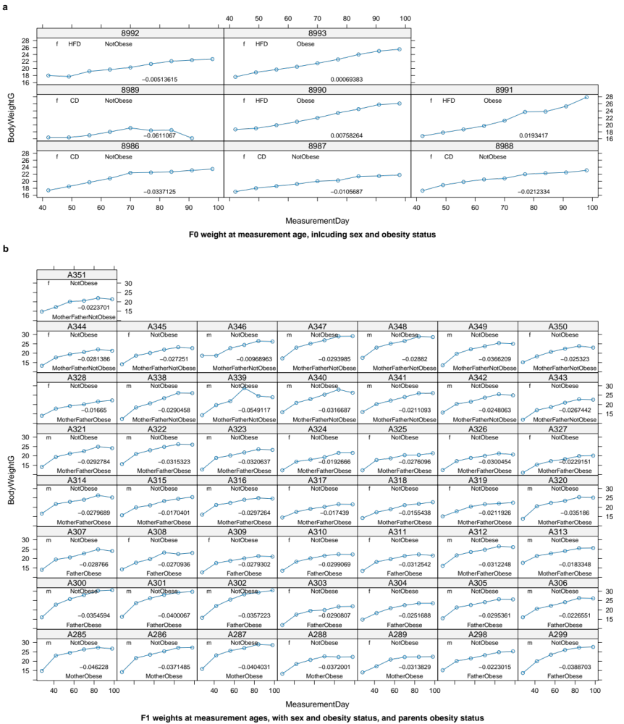
SI Figure 1: Definition of weight gain following growth curve analysis, sex and diet of mice used to define obesity factor variable. Shown are weight gain trajectories (in grams [g]) for (a) female F0 (male F0 on HFD all were assumed to be obese) and (b) all F1 mice, over the course of measurements (in days [d]). Curve annotations for (a) F0 inform about sex, diet, and assigned obesity status in F0 generation, information also accompanying the F1 mice for analysis. Curve annotations in (b) for the F1 generation were used to for modelling of phenotypical characters and to define contrasts for transcriptome analysis. F1 were always fed CD. Shown are sex, obesity status, and obesity status of parents. Numbers indicate sums of second derivatives along the weight gain trajectory used to assigned weight gain and obesity factor variables – the more positive the number, the steeper the growth curve. For resulting variables also see Fig.1 main text and SI Table 1.
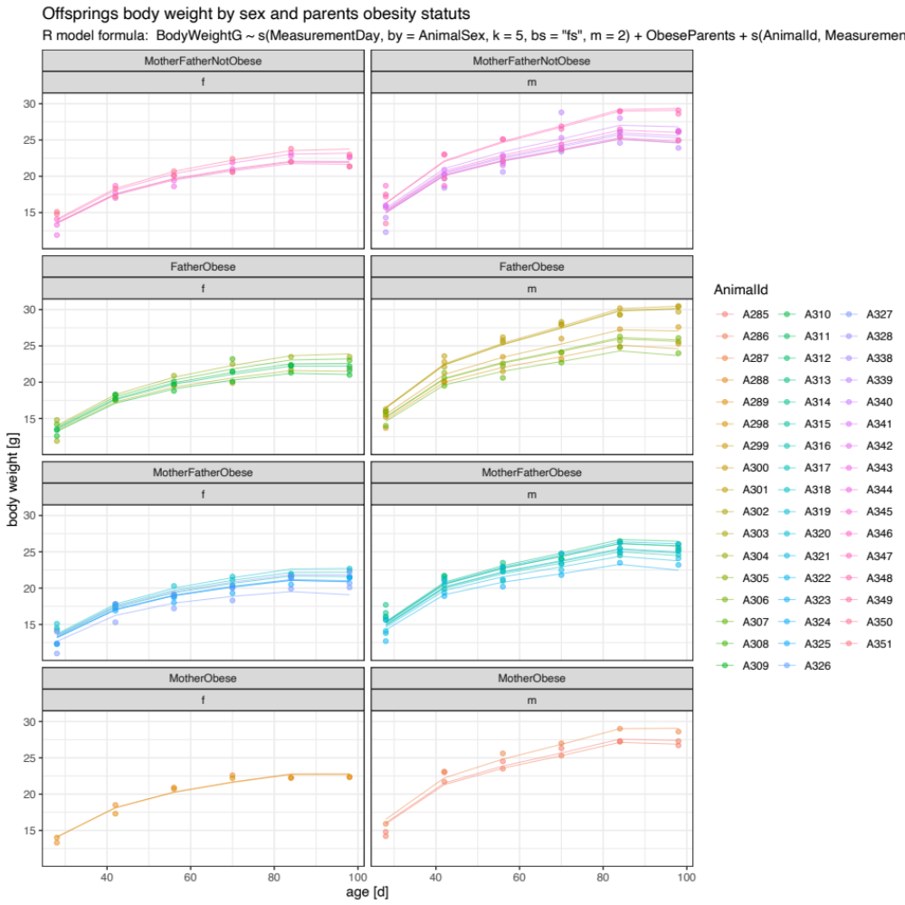
SI Figure 2: F1 weight gain trajectories used in general additive modelling (GAM) to gauge the effect of various parental-sex-specific (F0) combinations of obesity and non-obesity on weight gain of the F1 generation (see main and supplemental text).

Transcriptome changes and obesity
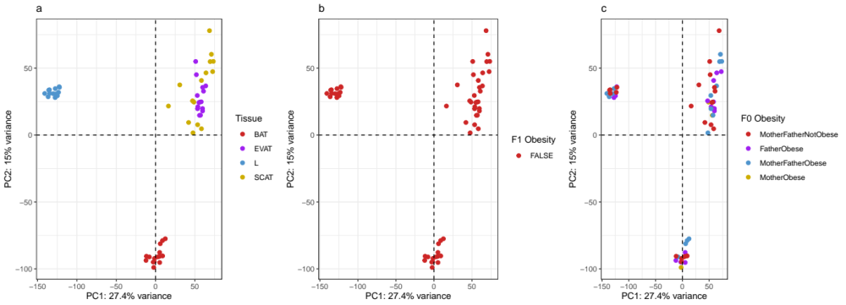
SI Figure 3: Principal components analysis (PCA) of combined F1 expression data for four tissue types (epigonal visceral, EVAT; inguinal subcutaneous, SCAT; liver, L; and interscapular brown adipose tissue, BAT). (a) Coloured by tissue type, (b) by F1 obesity status after F1 growth curve analysis, and (c) by parental obesity status after F0 growth curve analysis. Shown are the most-loaded first two PCs expressing 42.4% of total variation.
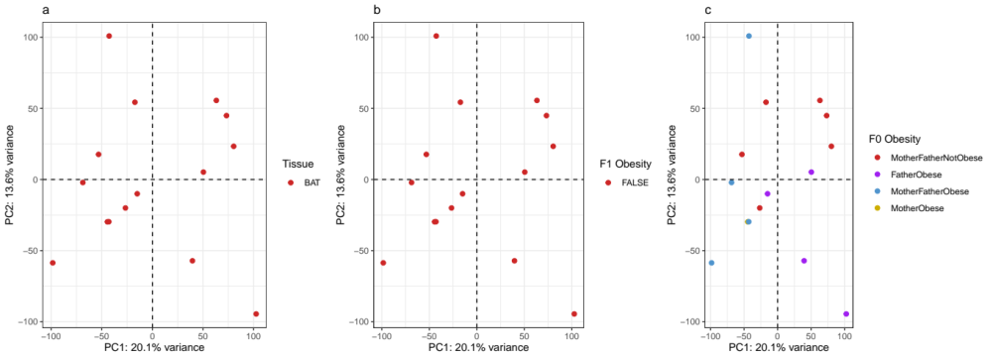
SI Figure 4: Principal components analysis of F1 interscapular brown adipose tissue (BAT) expression data (a) highlighted for obesity status among F1 offspring (b), and parental obesity status (c), as assigned by growth curve analysis. 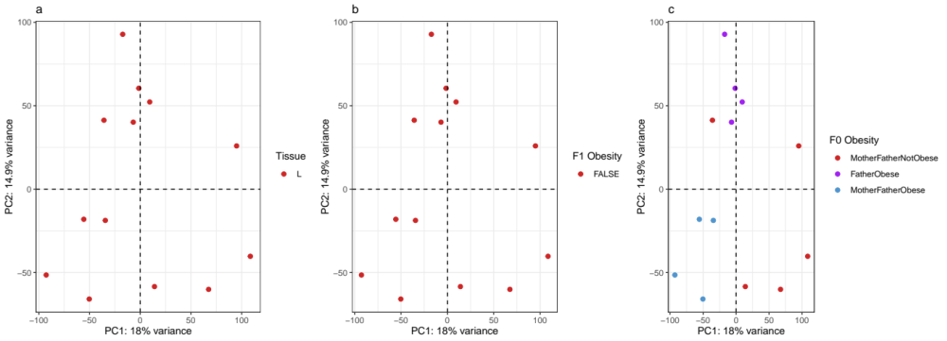
SI Figure 5: Principal components analysis of F1 liver (L) expression data (a) highlighted for obesity status among F1 offspring (b), and parental obesity status (c), as assigned by growth curve analysis.
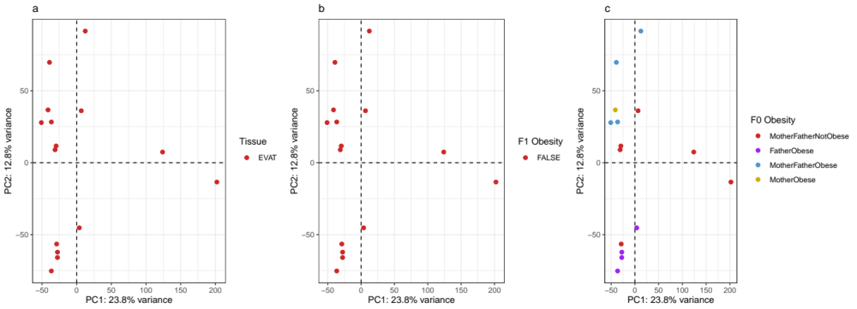
SI Figure 6: Principal components analysis of F1 epigonal visceral (EVAT) expression data (a) highlighted for obesity status among F1 offspring (b), and parental obesity status (c), as assigned by growth curve analysis.
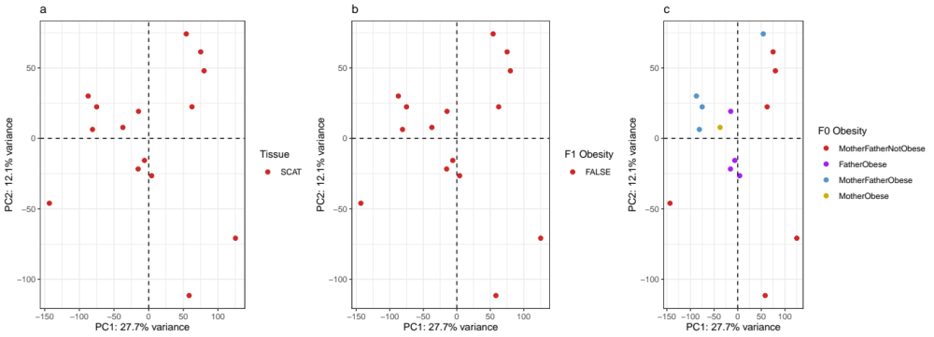SI Figure 7: Principal components analysis of F1 inguinal subcutaneous (SCAT) expression data (a) highlighted for obesity status among F1 offspring (b), and parental obesity status (c), as assigned by growth curve analysis.

