Supplementary Materials.
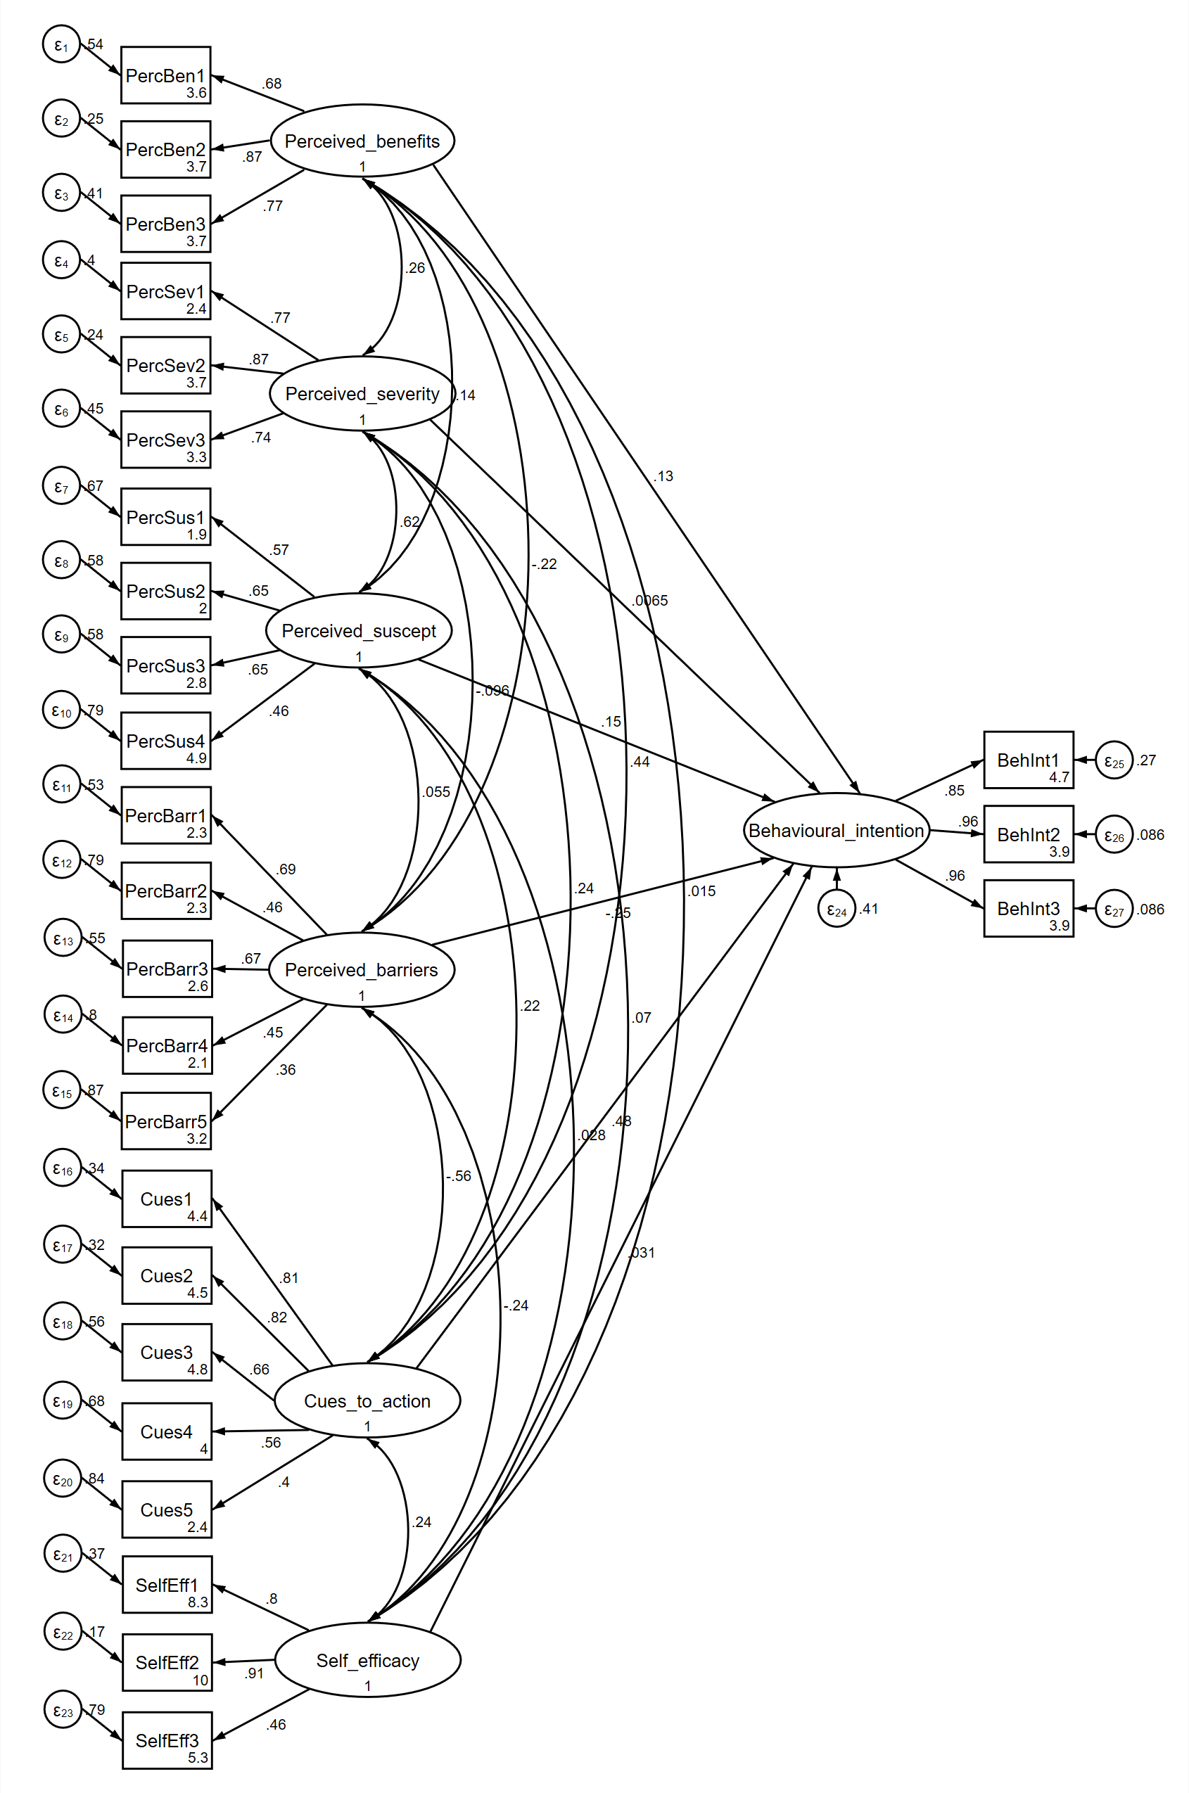
Figure 1. Model schema of HBM constructs predicting intention to use an app for mental health (including all covariates)

