APPENDICES
ANOVA TABLEs
The ANOVA table for the first experiment with seven treatments and three replications was as follows:
Table 2. ANOVA table for analysis
sources of variation | Degree of freedom | SS | MS | F-calculated | F-tabulated
 |  |  |  |  | 0.05 | 0.01
Treatments | t-1=10-1= 9 | SS1 | MS₁ | MS₁/MS₂
Replication | r-1= 3-= 2 | SS₂ | MS₂
Total | r(t-1)=3×10-1=29

Appendix 1. Mean square ANOVA for height of plant at 25 Days
SOV | df | SS | MSS | F value | Pr(>F)
Treatment | 9 | 3.9086 | 0.43429 | 0.7143 | 0.68974
Replication | 2 | 4.8370 | 2.41849 | 3.9780 | 0.03709 *
Error | 18 | 10.9434 | 0.60796

Appendix 2. Mean square ANOVA for height of plant at 40 Days
SOV | df | SS | MSS | F value | Pr(>F)
Treatment | 9 | 43.112 | 4.7902 | 1.1978 | 0.35407
Replication | 2 | 22.999 | 11.4993 | 2.8755 | 0.08247
Error | 18 | 71.983 | 3.9990

Appendix 3. Mean square ANOVA for height of plant at 55 Days
SOV | df | SS | MSS | F value | Pr(>F)
Treatment | 9 | 541.93 | 60.215 | 5.7067 | 0.0008564 ***
Replication | 2 | 45.44 | 22.721 | 2.1533 | 0.1450579
Error | 18 | 189.93 | 10.552

Appendix 4. Mean square ANOVA for height of plant at 40 Days
SOV | df | SS | MSS | F value | Pr(>F)
Treatment | 9 | 280.00 | 31.1110 | 1.5764 | 0.1964
Replication | 2 | 2.30 | 1.1507 | 0.0583 | 0.9435
Error | 18 | 355.23 | 19.7352

Appendix 5. Mean square ANOVA for number of leaves at 25 Days
SOV | df | SS | MSS | F value | Pr(>F)
Treatment | 9 | 0.85368 | 0.09485 | 0.6160 | 0.7684
Replication | 2 | 1.18953 | 0.59476 | 3.8627 | 0.0402 *
Error | 18 | 2.77154 | 0.15397

Appendix 6. Mean square ANOVA for number of leaves at 40 Days
SOV | df | SS | MSS | F value | Pr(>F)
Treatment | 9 | 7.0510 | 0.7834 | 0.4476 | 0.8906
Replication | 2 | 8.2237 | 4.1118 | 2.3493 | 0.1240
Error | 18 | 31.5041

Appendix 7. Mean square ANOVA for number of leaves at 55 Days
SOV | df | SS | MSS | F value | Pr(>F)
Treatment | 9 | 68.911 | 7.6568 | 2.1283 | 0.0825
Replication | 2 | 2.174 | 1.0871 | 0.3022 | 0.7429
Error | 18 | 64.756 | 3.5976

Appendix 8. Mean square ANOVA for number of leaves at 80 Days
SOV | df | SS | MSS | F value | Pr(>F)
Treatment | 9 | 1126.42 | 125.158 | 1.6789 | 0.1670
Replication | 2 | 148.63 | 74.316 | 0.9969 | 0.3885
Error | 18 | 1341.82 | 74.545

Appendix 9. Mean square ANOVA for chlorophyll content at 55 days
SOV | df | SS | MSS | F value | Pr(>F)
Treatment | 9 | 629.94 | 69.993 | 2.8351 | 0.02861 *
Replication | 2 | 119.06 | 59.530 | 2.4113 | 0.11808
Error | 18 | 444.39 | 24.688

Appendix 10. Mean square ANOVA harvested leaves weight at 55 days
SOV | df | SS | MSS | F value | Pr(>F)
Treatment | 9 | 280.0 | 31.111 | 1.5764 | 0.1964
Replication | 2 | 2.30 | 1.1507 | 0.0583 | 0.9435
Error | 18 | 355.23 | 19.7352

Appendix 11. Mean square ANOVA harvested leaves weight at 80 days
SOV | df | SS | MSS | F value | Pr(>F)
Treatment | 9 | 1242.23 | 138.025 | 3.658 | 0.009229 **
Replication | 2 | 35.50 | 17.752 | 0.4705 | 0.632154
Error | 18 | 679.14 | 37.730

Appendix 12. Mean square ANOVA of yield (tonha⁻¹)
SOV | df | SS | MSS | F value | Pr(>F)
Treatment | 9 | 17.499 | 1.9444 | 1.5764 | 0.1964
Replication | 2 | 0.144 | 0.0719 | 0.0583 | 0.9435
Error | 18 | 22.202 | 1.2334

Figure . Effect of different sources of nitrogen on harvested leaf weight at Rampur, Chitwan, 2020

Table . Effect of different sources of nitrogen on harvested leaf weight at Rampur, Chitwan, 2020
Treatments | Harvested leaf weight (g per plant)
Treatments | 55 DAS | 80 DAS
T1 | 16.80ª | 20.80^{ab}
T2 | 11.85^{ab} | 6.40^{d}
T3 | 7.933^{b} | 7.866^{cd}
T4 | 16.066^{ab} | 12.066^{bcd}
T5 | 13.866^{ab} | 11.466^{bcd}
T6 | 17.133ª | 15.00^{bcd}
T7 | 15.400^{ab} | 27.8666ª
T8 | 14.666^{ab} | 13.600^{bcd}
T9 | 15.80^{ab} | 22.10^{ab}
T10 | 19.73ª | 19.60^{abc}
CV% | 29.76 | 39.18
LSD at 5% | 7.62 | 10.53
F value | 1.576^{ns} | 3.65**
SEM | 1.48 | 2.047
Grand mean | 14.925 | 15.676
Means within the same column followed by same letter do not differ significantly at 1%,5 % , and 10% level by DMRT, Significance level 0 ‘***’ 0.001 ‘**’ 0.01 ‘*’ 0.05 ‘.’ 0.1 ‘ ’ 1

Figure . Effect of sources of nitrogen on yield of spinach at Rampur, Chitwan, 2020

Figure . Effect of different sources of nitrogen on leaf chlorophyll content at Rampur, Chitwan, 2020

Table . Effect of different sources of nitrogen on leaf chlorophyll content at Rampur, Chitwan, 2020

Treatments | Chlorophyll content mean value 55 DAS
T1 | 42.80ª
T2 | 27.266^{c}
T3 | 33.33^{abc}
T4 | 32.166^{bc}
T5 | 31.90^{bc}
T6 | 34.70^{abc}
T7 | 39.733^{ab}
T8 | 38.766^{ab}
T9 | 37.30^{ab}
T10 | 40.90^{ab}
LSD at 5% | 8.523
CV,% | 13.84
F value | 2.8351*
SEM | 1.656
Grand mean | 35.886
Means within the same column followed by same letter do not differ significantly at 1%,5 % , and 10% level by DMRT, Significance level 0 ‘***’ 0.001 ‘**’ 0.01 ‘*’ 0.05 ‘.’ 0.1 ‘ ’ 1

 | Rep I |  | Rep II |  | Rep III
 | 2.0 m
1.0m | N2 | 1.0m | N4 |  | N9
 | 0.5m
 | N9 |  | N7 |  | N3
 | N6 |  | N1 |  | N8
 | N3 |  | N8 |  | N10
 | N10 |  | N5 |  | N1
 | N7 |  | N2 |  | N4
 | N5 |  | N9 |  | N7
 | N1 |  | N6 |  | N2
 | N8 |  | N3 |  | N6
 | N4 |  | N10 |  | N5
Figure . Layout of experiment

Graphical Abstract:
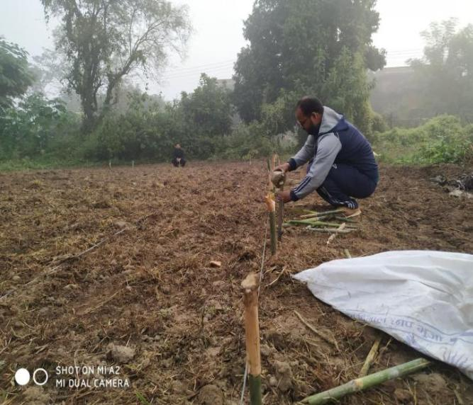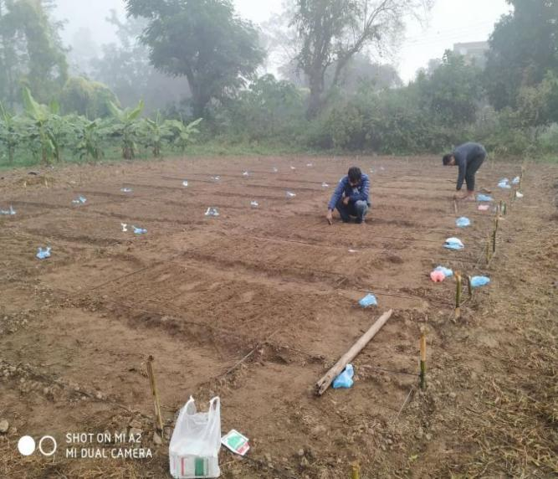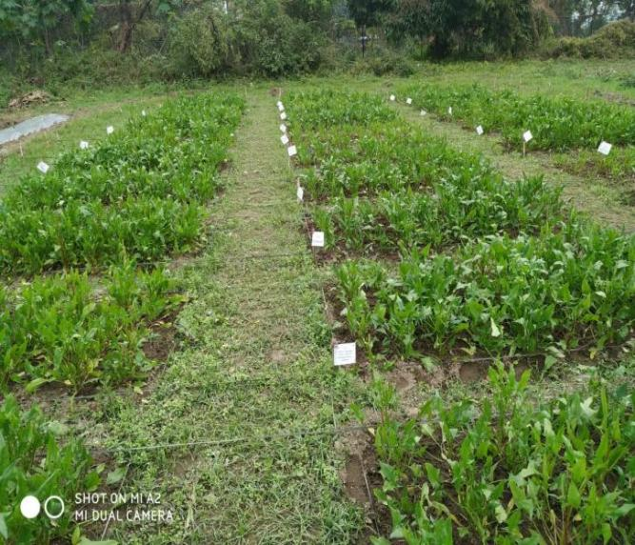
Organic fertilizer application
Ready to harvest
Field ready and Pegging

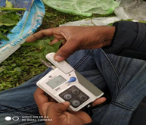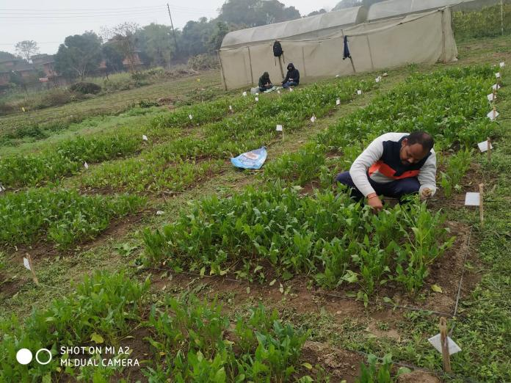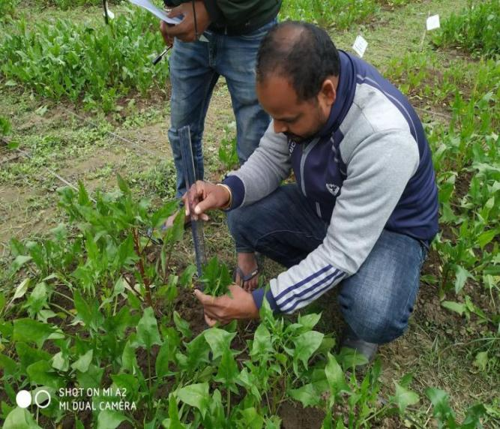
Measuring plant height

Leaf harvesting
Chlorophyll measuring using SPAD

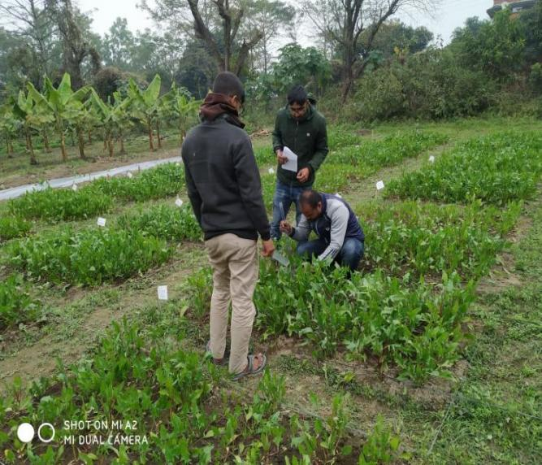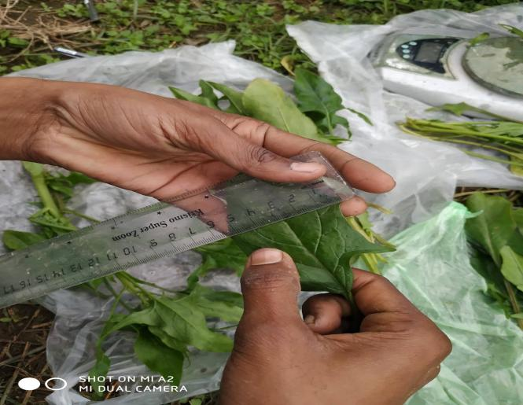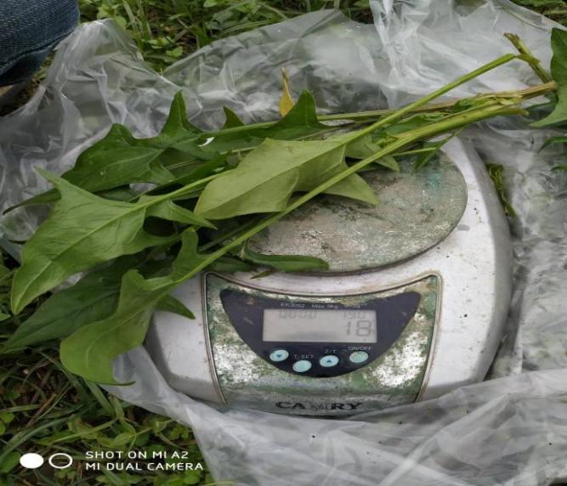
Measuring weight of leaf
Measuring leaf diameter

Measuring data

