Supplementary Materials
Causal associations between socioeconomic status and Alzheimer’s disease: a Mendelian randomization and Mediation Analysis
Chaofan Geng^{1†}, Ke Meng ^{1†}, Yi Tang^{1,2}
¹Department of Neurology & Innovation Center for Neurological Disorders, Xuanwu Hospital, Capital Medical University, National Center for Neurological Disorders, Beijing, China
²Neurodegenerative Laboratory of Ministry of Education of the People’s Republic of China, Beijing, China
*Correspondence Yi Tang, Department of Neurology & Innovation Center for Neurological Disorders, Xuanwu Hospital, Capital Medical University, National Center for Neurological Disorders, 45 Changchun Street, Beijing 100053, China. Email: tangyi@xwhosp.org
†These authors have contributed equally to this work.

Figure s1: The result of MR study illustrated by forest plot.
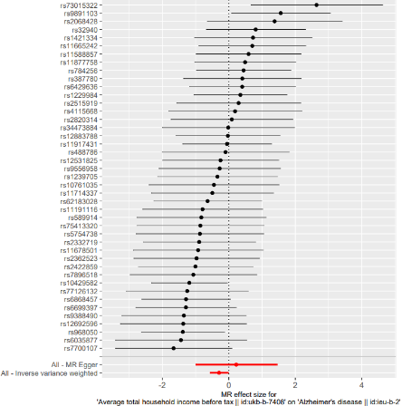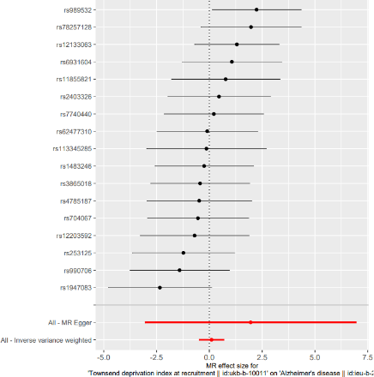
income and AD TDI and AD

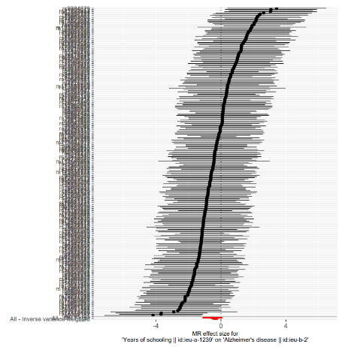
Education and AD

Figure S2. The result of reverse MR study illustrated by forest plot
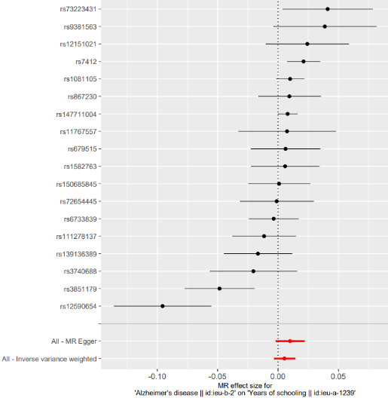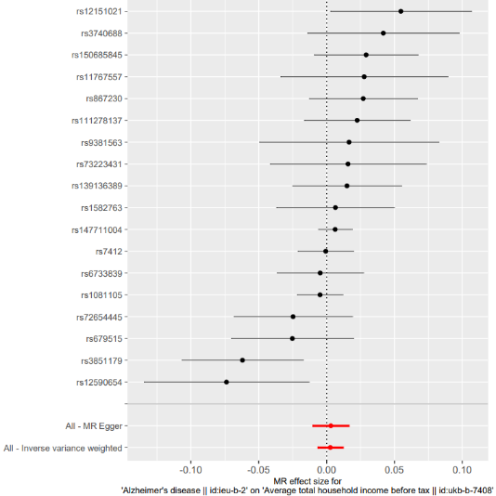
AD-education AD-income
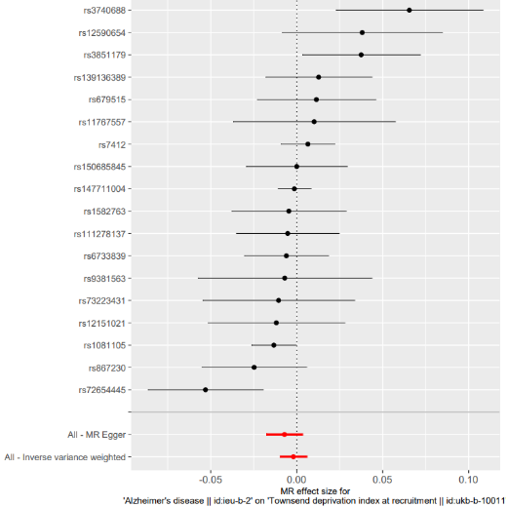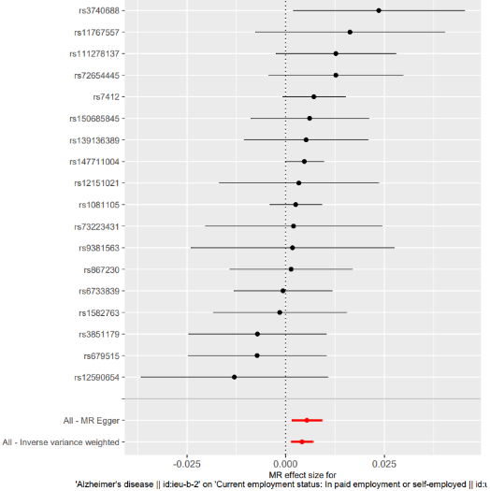
AD-TDI AD-work

