Supplementary material
Deciphering the complex clonal heterogeneity of polycythemia vera and the response to interferon alpha

Milena Kalmer^{1,2,5}, Martin Grasshoff^{3,5}, Tiago Maie³, Kristina Pannen^{1,2}, Marcelo A. S. Toledo^{1,2}, Margherita Vieri^{1,2}, Kathrin Olschok^{1,2}, Rebecca Lemanzyk^{1,2}, Jelena Lazarevic^{1,2} Julian Baumeister^{1,2}, Angela Maurer^{1,2}, Joelle Schifflers^{1,2}, Kim Kricheldorf^{1,2}, Mirle Schemionek^{1,2}, Tim H. Brümmendorf^{1,2}, Ralf Weiskirchen⁴, Martin Zenke^{1,2}, Nicolas Chatain^{1,2,6}, Ivan G. Costa^{3,6}, Steffen Koschmieder^{1,2,6}

¹ Department of Hematology, Oncology, Hemostaseology, and Stem Cell Transplantation, Faculty of Medicine, RWTH Aachen University, Pauwelsstraße 30, 52074 Aachen, Germany
² Center for Integrated Oncology Aachen Bonn Cologne Düsseldorf (CIO ABCD), Aachen, Germany
³ Institute for Computational Genomics, RWTH Aachen University, Aachen, Germany
⁴ Institute of Molecular Pathobiochemistry, Experimental Gene Therapy and Clinical Chemistry (IFMPEGKC), Faculty of Medicine, RWTH Aachen University, Pauwelsstraße 30, 52074 Aachen, Germany
⁵ shared first authors
⁶ shared senior authors

Corresponding Author:
Univ.-Prof. Dr. med. Steffen Koschmieder, Department of Hematology, Oncology, Hemostaseology, and Stem Cell Transplantation, Faculty of Medicine, RWTH Aachen University, Pauwelsstr. 30, D-52074 Aachen, Germany, Phone: +49-241-8036102; E-mail: skoschmieder@ukaachen.de

Supplementary Figures
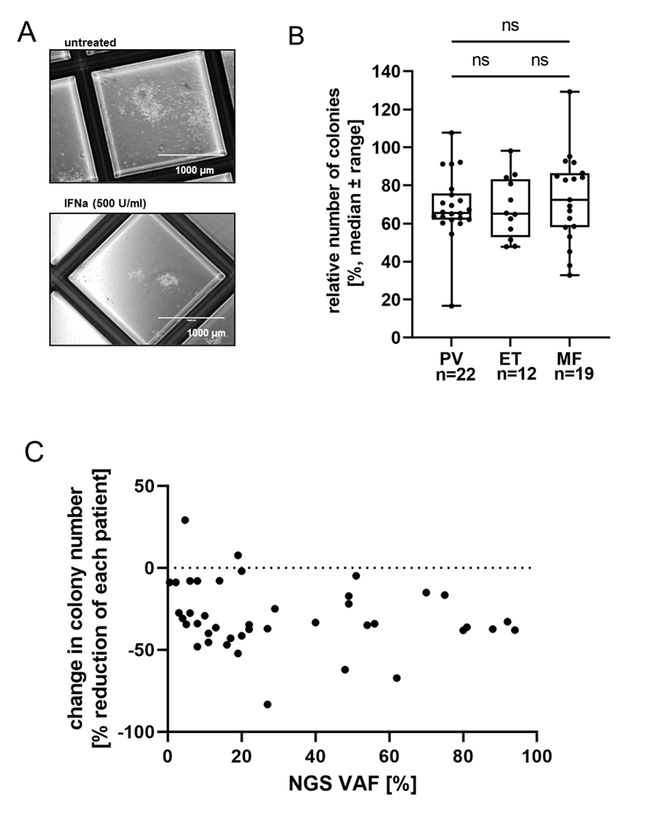
Supplementary Figure S1: A Representative images of colonies are shown. PBMCs were isolated and seeded in methylcellulose without treatment and with 500 U/ml IFNa. It is shown here what the colonies looked like on day 10. These colonies are derived from a PMF patient. B Relative number of remaining colonies was calculated using untreated sample as control. The MF group includes PMF, post-PV-MF and post-ET-MF patients. Data was analyzed using Kruskal Wallis Test and Dunn’s Multiple Comparisons test. C Relative drop in colony number compared to untreated control was not correlated to mutant variant allele frequency (VAF). Mutant VAF was determined using next generation sequencing (NGS). Correlation was analyzed using Pearson r test after passing test for normality, p=0.2375.
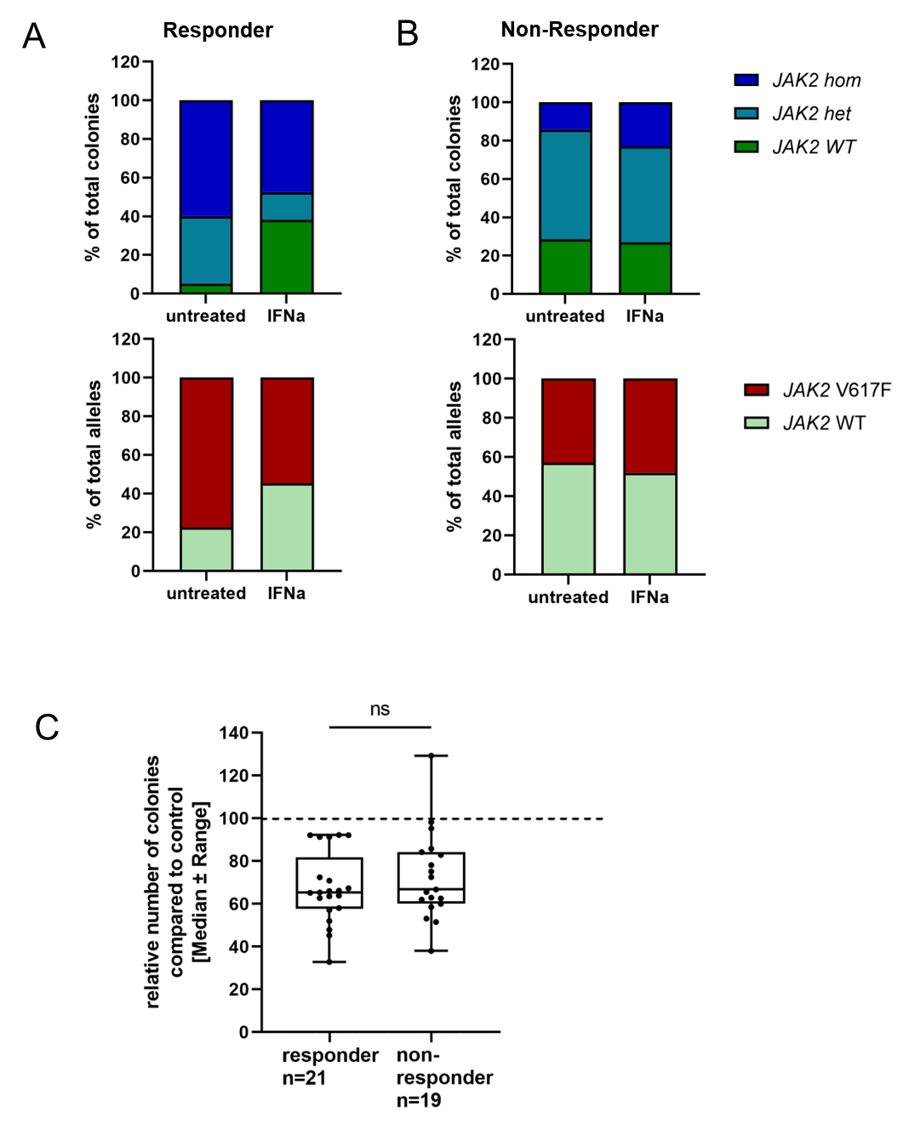
Supplementary Figure S2: A and B One example of a responder (A) and one example of a non-responder (B) is shown. In the upper part the relative distribution of the zygosity of the genotyped colonies (25-30 colonies per patient and condition) is displayed. This ratio was then used to calculate the mutated fraction of alleles (red, lower graph) and wildtype (wt) alleles (green, lower graph). Patients were grouped into responders and non-responders depending on the de- or increase in the fraction of mutated alleles upon IFNa treatment. C The number of colonies in the IFNa treated condition was compared to the untreated condition to calculate the relative number of colonies. Responders and non-responders were compared. Significance was analyzed using Mann-Whitney-Test.
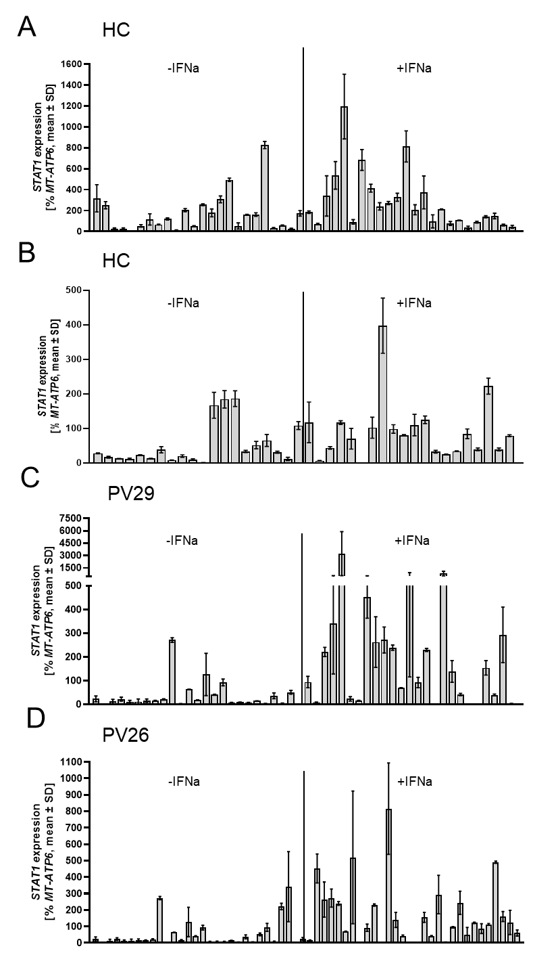
Supplementary Figure S3: Heterogeneity between single colonies was found in HC and PV patients. A and B STAT1 expression of 20-24 colonies per HC and condition were analyzed. Both additional HC support the heterogeneity found in Figure 2A. C and D STAT1 expression of 25-30 colonies per PV patient and condition were analyzed. Both additional patients support the heterogeneity found in Figure 2A.
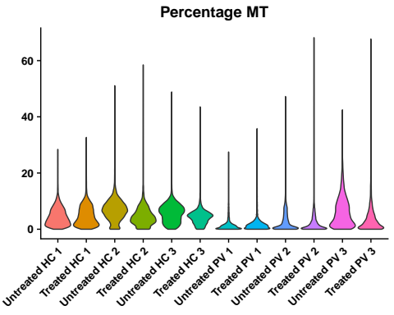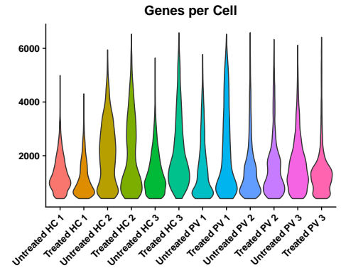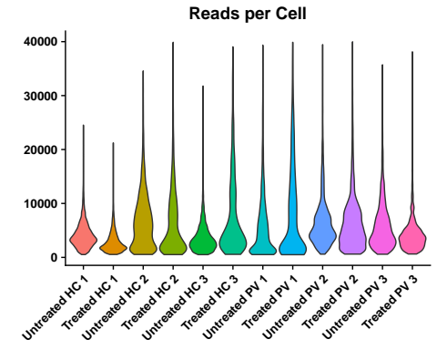
A
B
C
Supplementary Figure S4: Standard quality control metrics for the 10x Genomics data. A The number of expressed genes per cell. B The number of reads per cell. C The percentage of mitochondrial reads per cell.
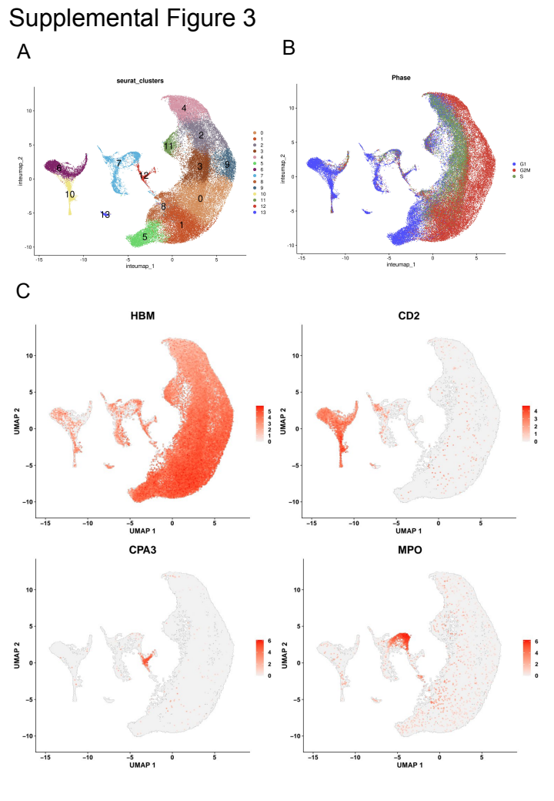
Supplementary Figure S5: UMAP plots from scRNAseq data. PBMCs from PV patients and HC were seeded in a CFU assay and all cells were harvested after 10 days of incubation. Single cells were analyzed using the 10x Genomics system. A Seurat clustering was applied to all analyzed cells. 13 (0-12) clusters were identified at a resolution of 0.3, which were used for the annotation of the cell types in the next step. B UMAP shows different cell cycle phases of the cells. C Expression of genes that were used for the annotation is shown. HBM was used as a marker for erythrocytic differentiation, CD2 as a marker for T cells, CPA3 as a gene typically expressed in Mast cells and MPO as a marker for granulocytes.
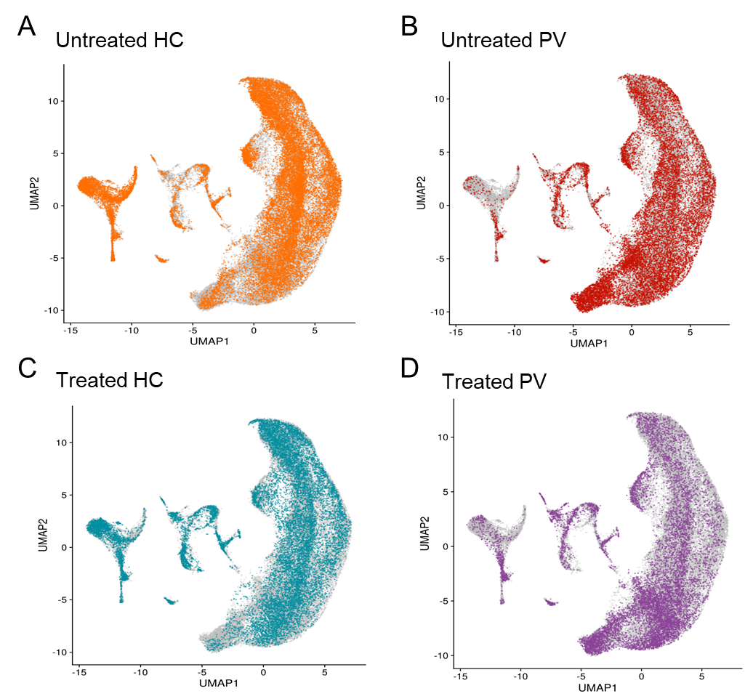
Supplementary Figure S6: UMAP plot of the distribution of the different samples. Cells of the different groups are highlighted in different colors. A Orange – untreated HC cells; B red – untreated PV cells; C teal – treated HC cells; D violet – treated PV cells.

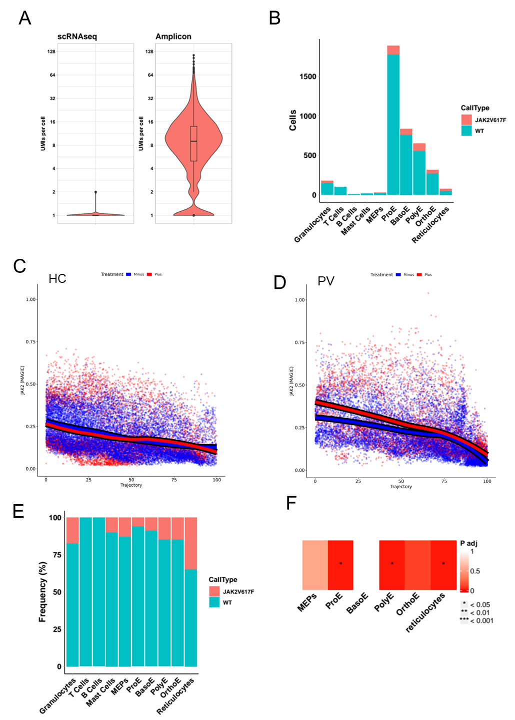
Supplementary Figure S7: Cellular genotyping depends on JAK2 expression even after locus specific amplification A The number of UMIs per cell covering the JAK2V617F locus by technology. B frequency of called cells decreased in the more mature cell types. C and D Pseudotime analysis of JAK2 expression during erythropoiesis in HC (C) and PV (D) derived cells. The frequency of JAK2V617F cells per cell type E and F Fisher test results for the enrichment of JAK2V617F cells per cell type.
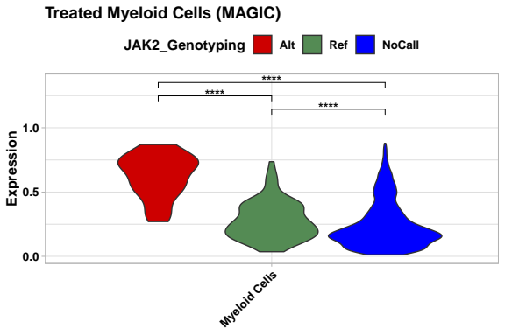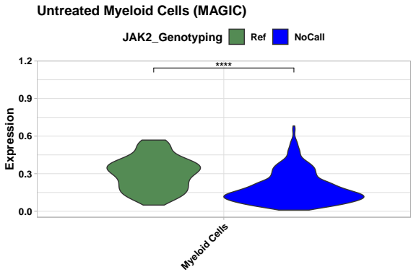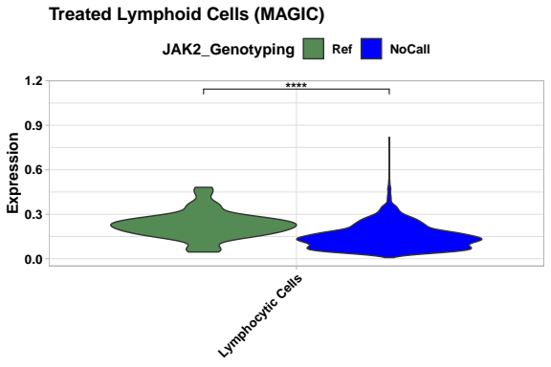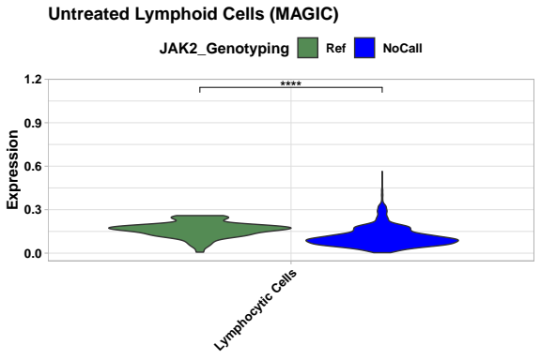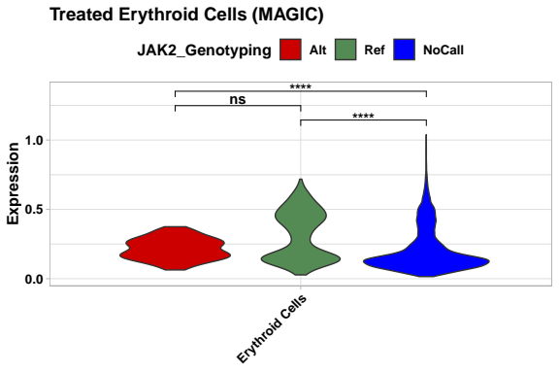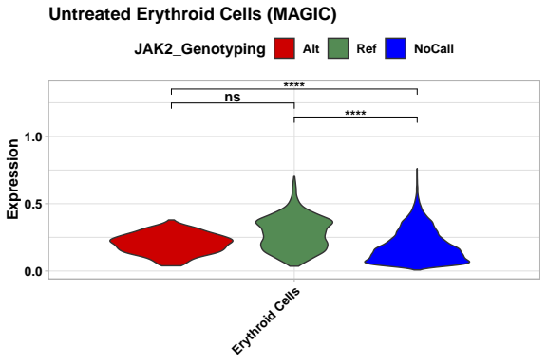
Supplementary Figure S8: Violin plots showing the JAK2 expression in the different cell types per genotyping status. Each violin plot shows the JAK2 expression in the individual cell types split by genotype status.
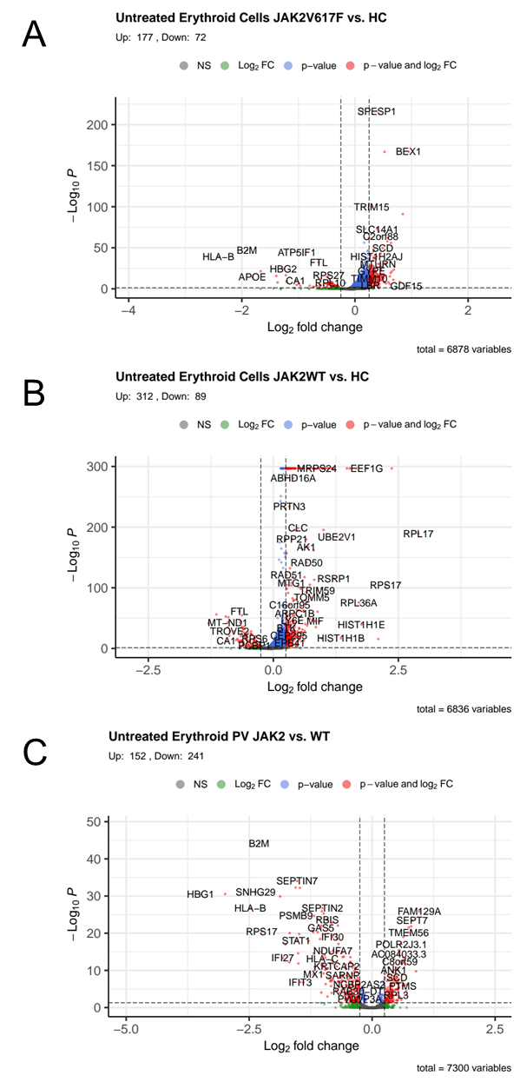
Supplementary Figure S9: Volcano plots showing the differentially expressed genes between different genotypes in the untreated erythroid cells. Each plot shows the results from differentially expression analysis for A JAK2V617F mutated PV vs. HC cells, B JAK2 wild type PV vs. HC cells and C JAK2V617F mutated PV vs. HC cells
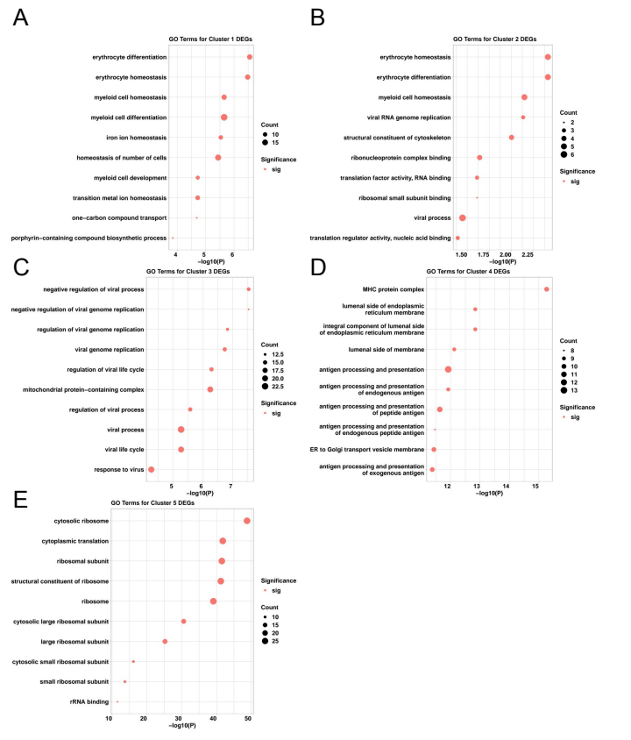
Supplementary Figure S10: Top 10 significant GO terms for the clusters of Differentially Expressed Genes. Each plot shows the top 10 significant GO terms for the clusters 1 to 5 from Figure 2F. The GO Terms are ordered according to their adjusted P value. We used all genes in a specific cluster with an adjusted p value cut off of 0.05 for the GO analysis. p values were adjusted using the Benjamini-Hochberg method.

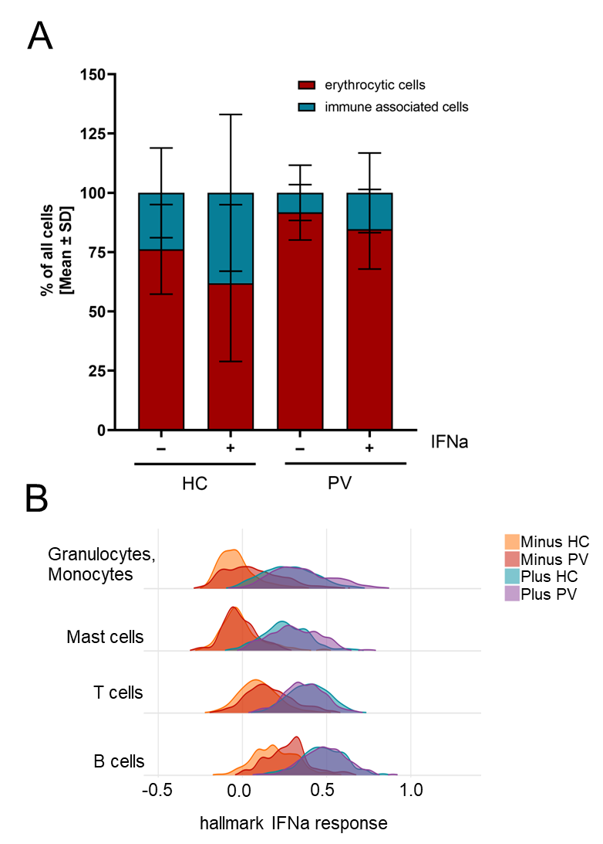
Supplementary Figure S11: Ratio of immune-associated cells increases upon IFNa stimulation and IFNa pathway is clearly stimulated in all cell types. A Relative number of cells was calculated for each sample. Different maturation stages of erythrocytic cells were combined as erythrocytic cells. All other cell types were summarized as immune-associated cells. B Ridges-plot of IFNa response in the immune associated cell clusters, divided into 4 groups, HC untreated (orange), HC IFNa treated (teal), PV untreated (red), PV IFNa treated (violet).

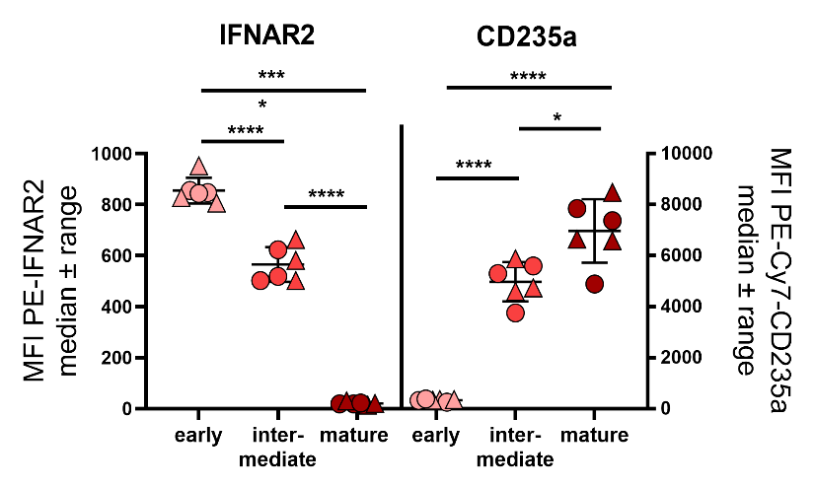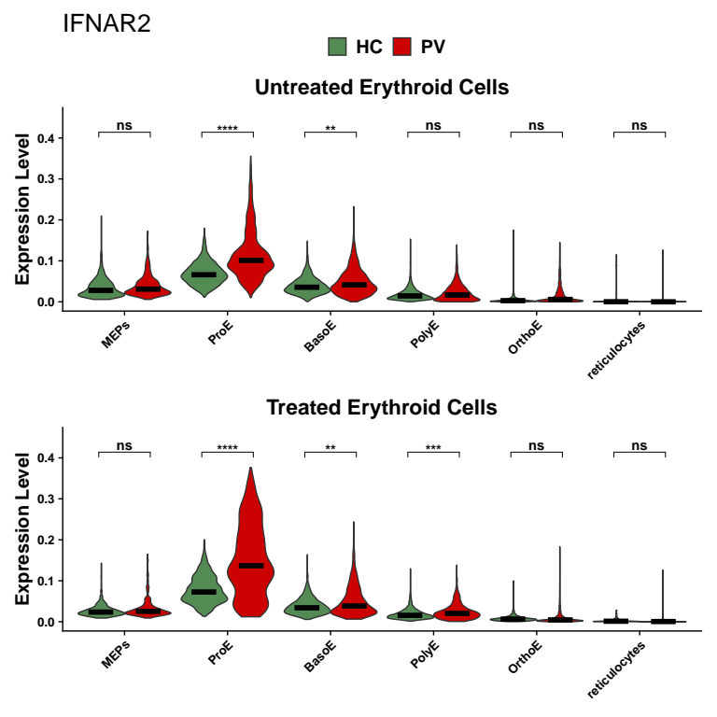Supplementary Figure S12: IFNAR2 expression is downregulated during erythrocytic differentiation. A Expression of IFNAR2 in scRNAseq data was analyzed. Violin plots showing expression in PV cells (red) and HC cells (green) per cell type. Statistics were analyzed using raw values and MAGIC imputation was only used for visualization. B Surface expression of IFNAR2 via flow cytometry. Whole blood after short lysis of erythrocytes was used. Statistics were analyzed using a row-matched one-way ANOVA with subsequent Tukey’s multiple comparisons test.
A
B
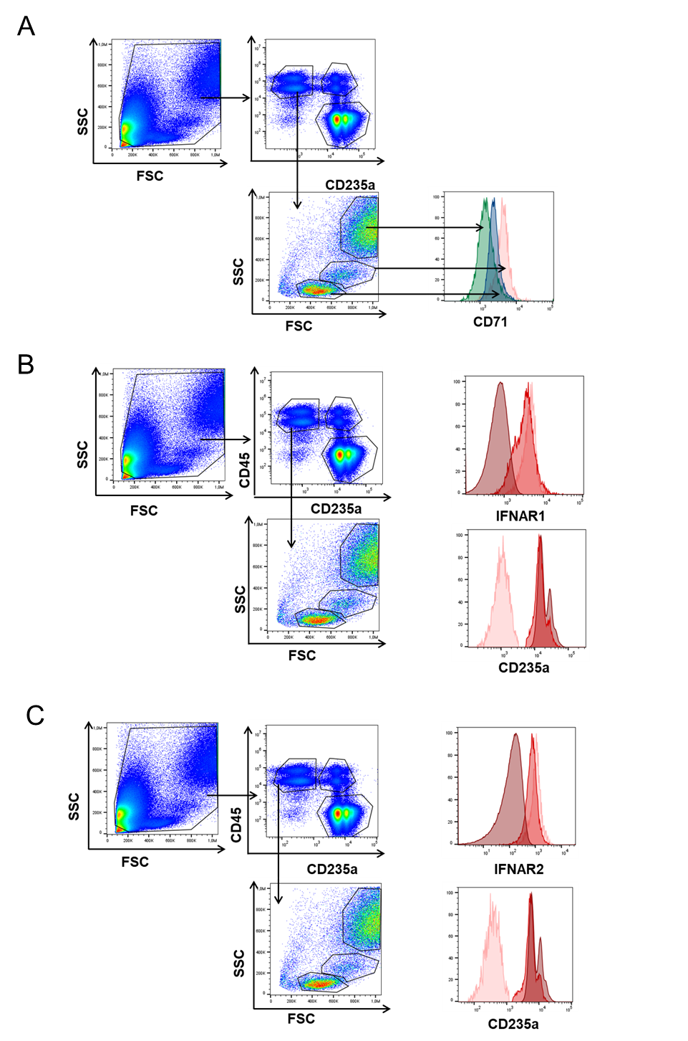
Supplementary Figure S13: Gating strategy for the analysis of IFNAR1 and IFNAR2 expression in flow cytometry. A Whole blood was treated with short erythrocytic lysis buffer to enrich non mature erythrocytic cells. First gate was adjusted to all living cells and CD45 and CD235a were analyzed in this population. One population, being clearly positive for CD235a and negative for CD45 was counted as mature erythrocytes. CD45+ but CD235a-neg cells were further analyzed in FSC-SSC. Three clear populations were visible. Analysis of CD71 surface expression showed medium height SSC population as CD71 positive. These cells were considered as immature erythrocytes. B Same samples as in A were stained with CD45, CD235a and IFNAR1 antibodies. With the help of CD235a, CD45 and FSC-SSC populations were determined as described in A. Histogram of IFNAR1 surface expression of the different populations is shown. C Same samples as in A were stained with CD45, CD235a and IFNAR2 antibodies. With the help of CD235a, CD45 and FSC-SSC populations were determined as described in A. Histogram of IFNAR2 surface expression of the different populations is shown.

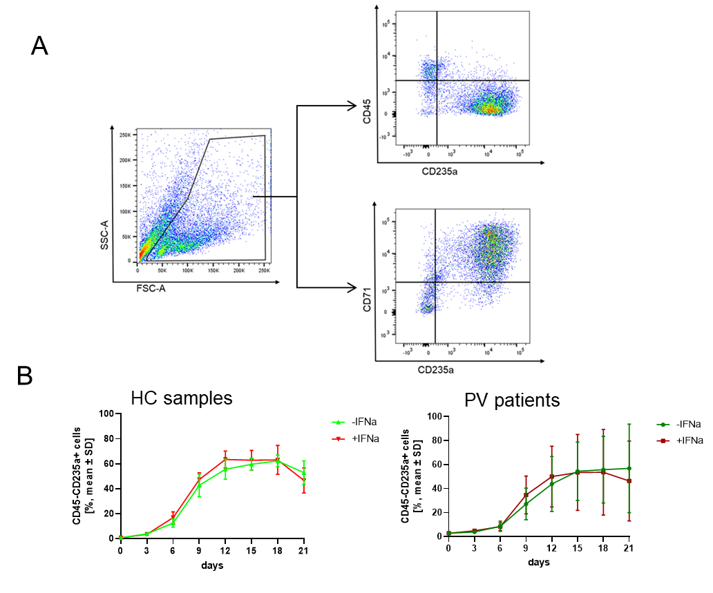
Supplementary Figure S14: A Gating strategy for in vitro erythrocytic differentiation. CD34+ cells were isolated from PBMC fraction of PV patients and HC. To analyze progression of differentiation CD235a and CD45 surface expression were analyzed every 3 days via flow cytometry. Living cells were gated and in this population CD45, CD71 and CD235a surface expression analyzed as shown. B IFNa does not change differentiation kinetics in early erythroid differentiation.

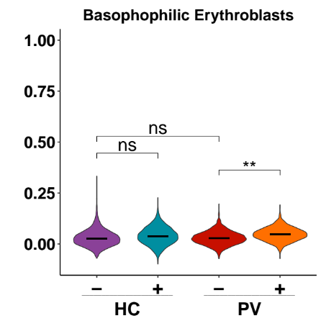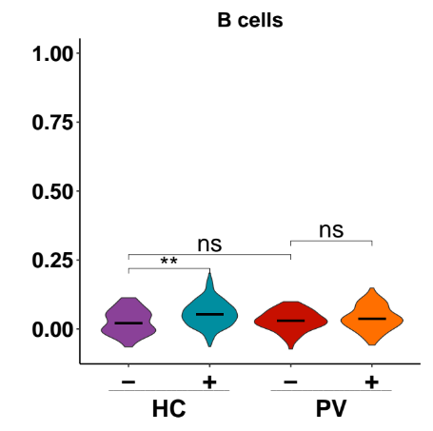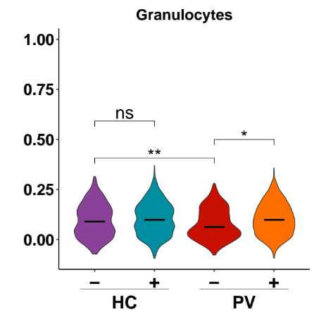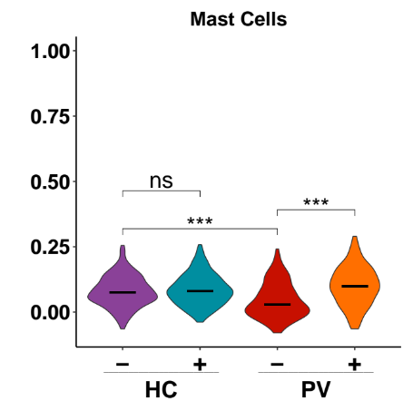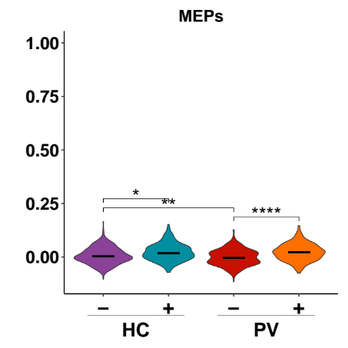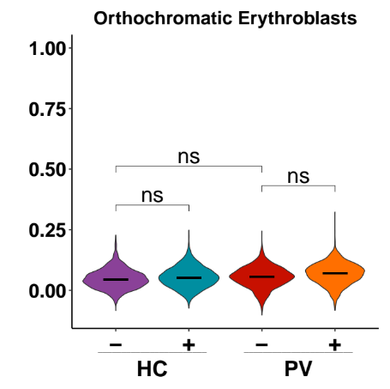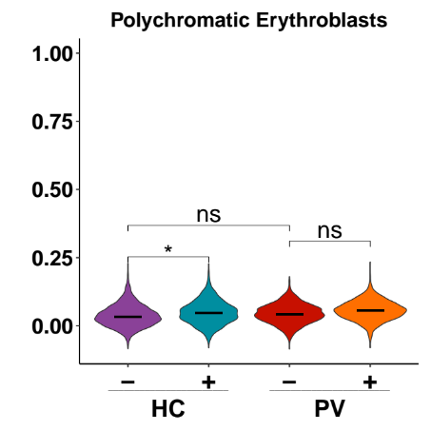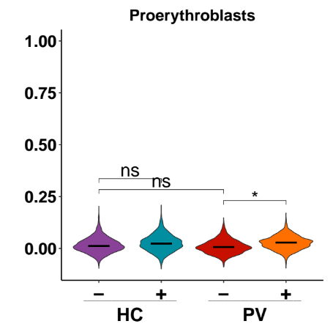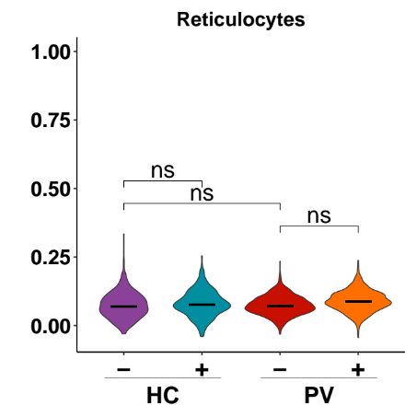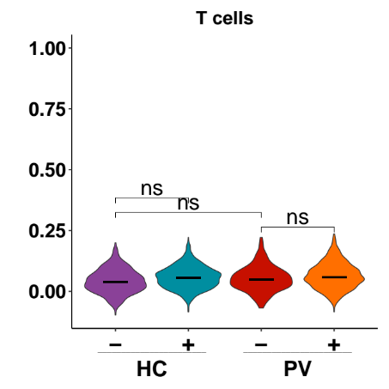
Supplementary Figure S15: Apoptosis hallmark module scores per cell type for the different conditions are shown in violin plots. P-values for the comparison between the conditions were calculated using Gene Set Enrichment Analysis.

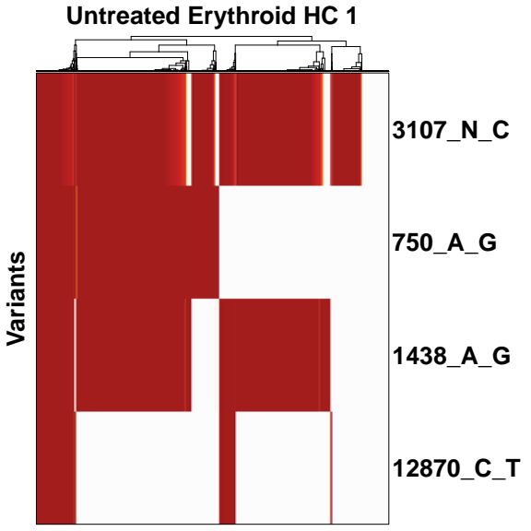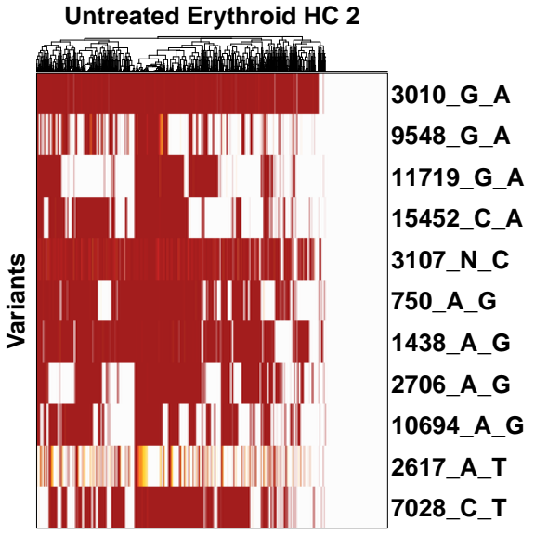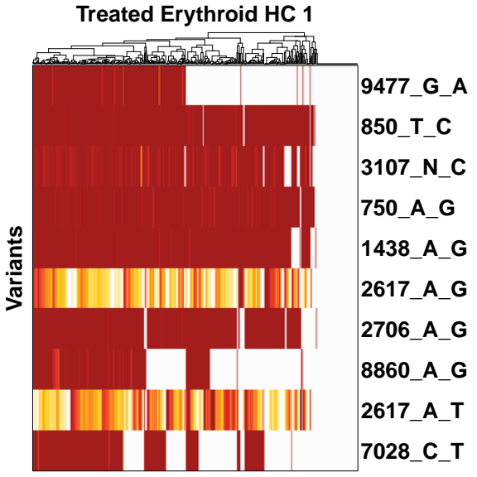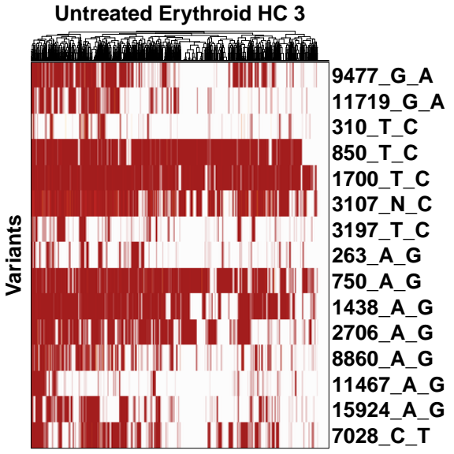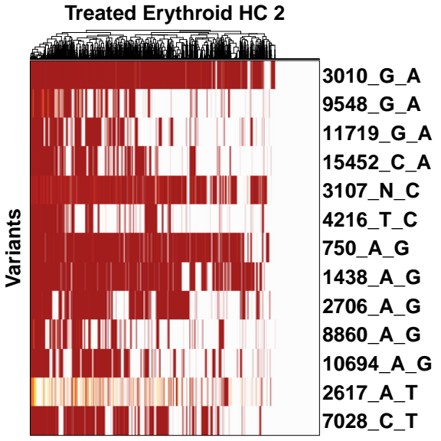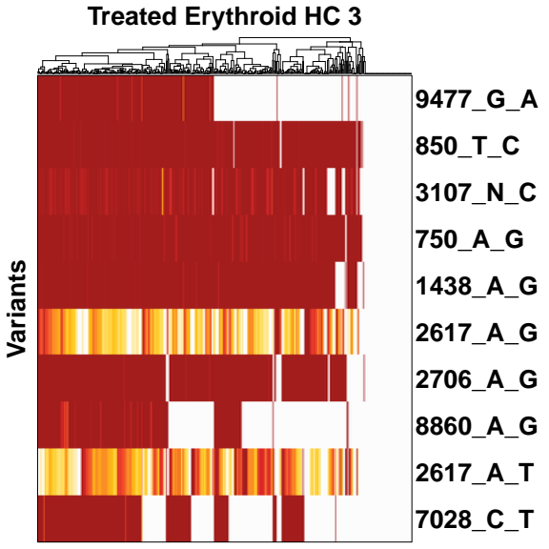
Supplementary Figure S16: Mitochondrial variants of interest for the HC samples. Each heat map shows the VOIs of a sample. For each HC the VOIs for the untreated and the treated sample are shown.

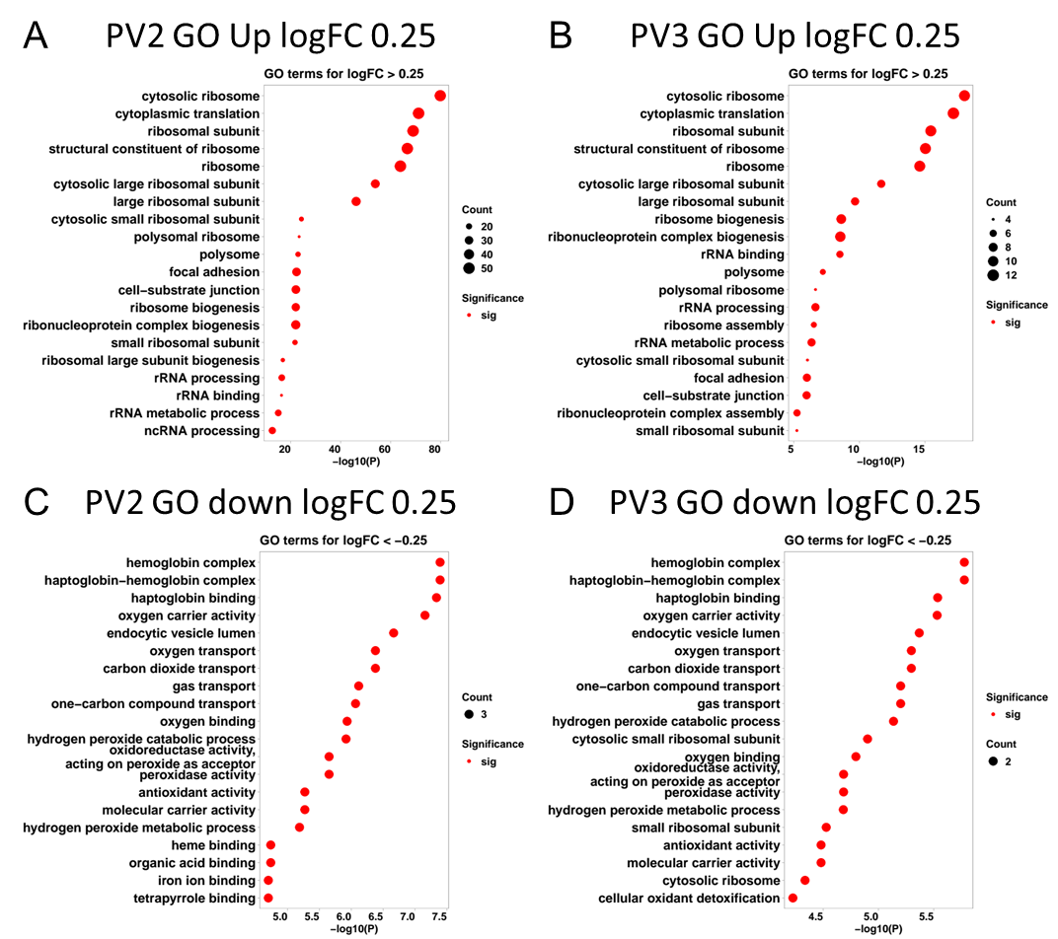
Supplementary Figure S17: Top 10 GO terms for differentially expressed genes between cells with a vanishing variant of interest and cells without. A and B GO terms for up regulated genes for PV02 and PV03 respectively. C and D GO terms for down-regulated genes for PV02 and PV03 respectively.

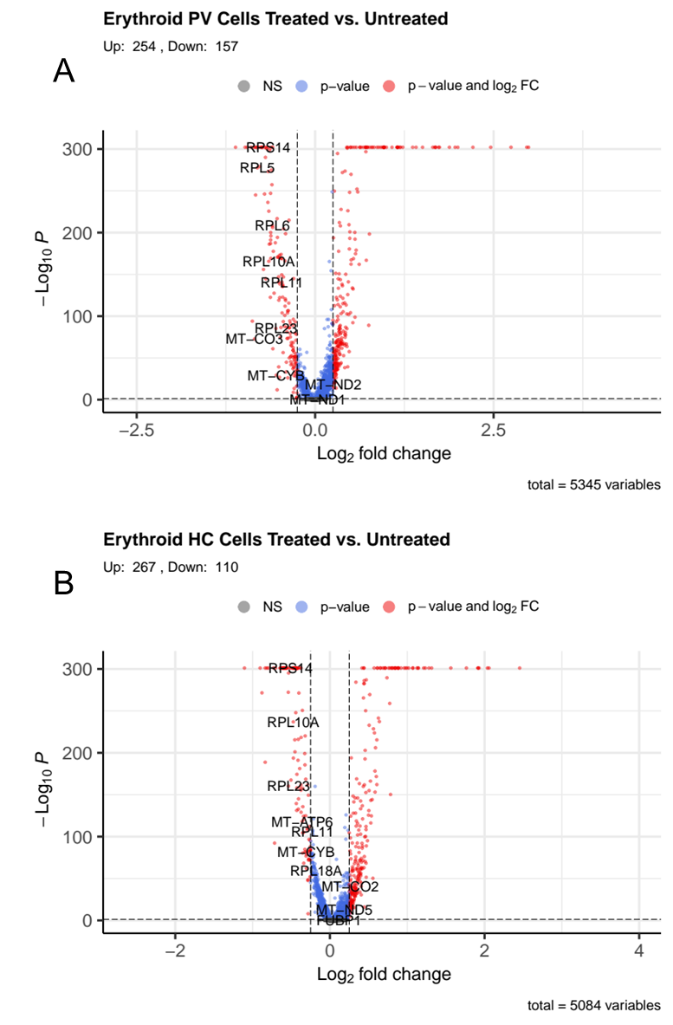
Supplementary Figure S18: Differentially expressed genes between treated erythroid cells for the different conditions. A DEGs for PV cells B DEGs for HC cells.
Supplementary Tables
Table S1 List of all patient samples used
Table S2 List of all primers used
Table S3 List of all antibodies used for flow cytometry
Table S4: Number of cells covering JAK2 in 10X and JAK2V617F in amplicon.

Table S1 List of all patient samples used
patient# | diagnosis | driver mutation | mutant VAF [%] | therapy | additional mutations | HR in CFU | MR in CFU | qPCR from CFU | scRNA  seq | ery differen  tiation | IFNAR surface expression | STAT1 in single colonies | single clone analysis
PV01 | PV | JAK2V617F | 7 | no cytoreductive treatment | - | x |  |  | x
PV02 | PV | JAK2V617F | 54 | no cytoreductive treatment | - | x |  |  | x
PV03 | PV | JAK2V617F | 91 | no cytoreductive treatment | - | x |  |  | x
PV04 | PV | JAK2V617F | 78 | HU | - |  |  |  |  |  | x
PV05 | PV | JAK2V617F | 5.3 | IFNa | - |  |  |  |  |  | x
PV06 | PV | JAK2V617F | 78 | HU | 40% TET2 Q876* |  |  |  |  |  | x
PV07 | PV | JAK2V617F | 56 | RUX | - |  |  |  |  | x
PV08 | PV | JAK2V617F | 62 | IFNa | - |  |  |  |  | x
PV09 | PV | JAK2V617F | 91 | no cytoreductive treatment | - |  |  |  |  | x
PV10 | PV | JAK2V617F | 50 | HU | - |  |  |  |  |  |  |  | x
PV11 | PV | JAK2V617F | 25 | no cytoreductive treatment | 24% JAK2 C618R; 52% IDH2 V147G |  |  |  |  |  |  |  | x
PV12 | PV | JAK2V617F | 25 | HU | - |  |  |  |  |  |  |  | x
PV13 | PV | JAK2V617F | 11 | RUX | - | x | x | x
PV14 | PV | JAK2V617F | 49 | HU | 32% TET2 H974fs | x | x |  |  |  |  | x
PV15 | PV | JAK2V617F | 22 | RUX | - | x | x | x
PV16 | PV | JAK2V617F | 13 | IFNa | - | x | x | x
PV17 | PV | JAK2V617F | 80 | RUX | - | x | x | x
PV18 | PV | JAK2V617F | 0.59 | no cytoreductive treatment | - | x | x | x
PV19 | PV | JAK2V617F | 56 | RUX | - | x | x
PV20 | PV | JAK2V617F | 29 | IFNa | - | x | x | x
PV21 | PV | JAK2V617F | 19 | HU | - | x
PV22 | PV | JAK2V617F | 10 | no cytoreductive treatment | - | x | x
PV23 | PV | JAK2V617F | 94 | HU | 32% TET2 T1397I | x
PV24 | PV | JAK2V617F | 14 | no cytoreductive treatment | - | x | x
PV25 | PV | JAK2V617F | 2.2 | RUX | - | x | x | x
PV26 | PV | JAK2V617F | 92 | no cytoreductive treatment | - | x | x | x |  |  |  | x
PV27 | PV | JAK2V617F | 54 | no cytoreductive treatment | - | x | x | x
PV28 | PV | JAK2V617F | 11 | IFNa | - | x
PV29 | PV | JAK2V617F | 81 | RUX | - | x | x |  |  |  |  | x
PV30 | PV | JAK2V617F | 27 | no cytoreductive treatment | - | x | x | x
PV31 | PV | JAK2V617F | 27 | no cytoreductive treatment | - | x
pPVMF01 | Post-PV-MF | JAK2V617F | 51 | RUX | - | x | x | x
pPVMF02 | Post PV MF (03/18) | JAK2V617F | 88 | no cytoreductive treatment | - | x | x | x
pPVMF03 | Post PV MF | JAK2V617F | n.a. | RUX | DNMT3A R882C | x | x | x
PMF01 | PMF | JAK2V617F | 48 | RUX | 48% ASXL1 T880fs; 47% U2AF1 Q157R; 62% KRAS T58I, 47% TET2 E1470fs | x | x | x
PMF02 | PMF | JAK2V617F | 45 | no cytoreductive treatment | 20% SRSF2 P95L, 43% TET2 C1221Y, 25% TET2 L1322R, 8.2% TP53 R248W | x
PMF03 | PMF | JAK2V617F | 2.5 | no cytoreductive treatment | 81% SRSF2 P95_R102del, 41% TET2 T443fs | x
PMF04 | PMF | JAK2V617F | 43 | no cytoreductive treatment | - | x
PMF05 | PMF | JAK2V617F | 3 | HU | - | x | x | x
PMF06 | PMF | JAK2V617F | 3 | HU | - | x | x
PMF07 | PMF | JAK2V617F | 40 | RUX | - | x | x | x
PMF08 | PMF | JAK2V617F | 20 | RUX | 17% NFE2 P236A, 14% TET2 G876*, 25% TET2 C1378Y | x | x | x
PMF09 | PMF | JAK2V617F | 4.7 | others | - | x | x | x
PMF10 | PMF | JAK2V617F | 49 | RUX | 48% ASXL1 C856*, 97% CBL C416Y, 53% DNMT3A R882H, 44% U2AF1 Q157R | x | x
PMF11 | PMF | JAK2V617F | 4 | no cytoreductive treatment | - | x
PMF12 | PMF | JAK2V617F | 6 | HU | - | x | x | x
PMF13 | PMF | JAK2V617F | 75 | HU | 29% ASXL G646fs | x
PMF14 | PMF | JAK2V617F | 70 | others | 51%SRSF2 P95_R102del | x
PMF15 | PMF | JAK2V617F | 16 | no cytoreductive treatment | - | x | x | x
PMF16 | PMF | JAK2V617F | 62 | HU | - | x | x
MPN-u01 | MPN-u | JAK2V617F | 8 | others | - | x | x
MPN-u02 | MPN-u | JAK2V617F | 8 | others | - | x | x | x
MPN-u03 | MPN-u | JAK2V617F | 8 | others | - | x | x | x
ET01 | ET | JAK2V617F | 22 | no cytoreductive treatment | - | x
ET02 | ET | JAK2V617F | 14 | no cytoreductive treatment | - | x
ET03 | ET | JAK2V617F | 88 | no cytoreductive treatment | - | x
ET04 | ET | JAK2V617F | 20 | IFNa | - | x | x | x
ET05 | ET | JAK2V617F | 5 | no cytoreductive treatment | - | x | x | x
ET06 | ET | JAK2V617F | 81 | no cytoreductive treatment | - | x | x | x
ET07 | ET | JAK2V617F | 17 | HU | - | x | x
ET08 | ET | JAK2V617F | 21 | others | - | x | x | x
ET09 | ET | JAK2V617F | 6 | HU | - | x | x | x
ET10 | ET | JAK2V617F | 19 | IFNa | - | x | x | x
ET11 | ET | JAK2V617F | n.a. | no cytoreductive treatment | - | x | x | x
ET12 | ET | JAK2V617F | 22 | no cytoreductive treatment | - | x | x

Primer | Sequence | Experiment
JAK2 forward * | TCCTCAGAACGTTGATGGCAG | JAK2 genotyping
JAK2 reverse * | ATTGCTTTCCTTTTTCACAAGAT | JAK2 genotyping
JAK2 mut * | GTTTTACTTACTCTCGTCTCCACAAAA | JAK2 genotyping
JAK2 WT * | GCATTTGGTTTTAAATTATGGAGTATATG | JAK2 genotyping
MT-ATP6 for | CGTACGCCTAACCGCTAACA | qPCR
MT-ATP6 rev | AGGCGACAGCGATTTCTAGG | qPCR
STAT1 for | TGTATGCCATCCTCGAGAGC | qPCR
STAT1 rev | AGACATCCTGCCACCTTGTG | qPCR
STAT2 for | CCGGGACATTCAGCCCTTTT | qPCR
STAT2 rev | CTCATGTTGCTGGCTCTCCA | qPCR
IFIT2 for | AGCGAAGGTGGCTTTGAGA | qPCR
IFIT2 rev | GAGGGTCAATGGCGTTCTGA | qPCR
IFIT3 for | TGACCTCACTCATGACTGCCC | qPCR
IFIT3 rev | TGAAGAACAAATCAGCCTGGTCAC | qPCR
INTERNAL_  FORWARD ** | AATGATACGGCGACCACCGAGATCTACACTCTTTCCCTACACGACGCTC | locus-specific amplification
SHORT_INT_FOR ** | AATGATACGGCGACCACCGAGATCT | locus-specific amplification
JAK2_PRIMER1 ** | ACCAACCTCACCAACATTACAGAGGCCT | locus-specific amplification
JAK2_PRIMER2 ** | AGGAGACTACGGTCAACTGCATGAAACAGA | locus-specific amplification
JAK2_PRIMER3 ** | GCAGCAAGTATGATGAGCAAGCTTTCTCACA | locus-specific amplification
JAK2_PRIMER4 ** | GTGACTGGAGTTCAGACGTGTGCTCTTCCGATCTGCAGCAAGTATGATGAGCAA | locus-specific amplification
Table S2: List of all primers used

Sequences were taken from:
* Kalmer, M., et al., Clonogenic assays improve determination of variant allele frequency of driver mutations in myeloproliferative neoplasms. Ann Hematol, 2022. 101(12): p. 2655-2663.
** Liu, S., M. Nguyen, and S. Hormoz, Integrating readout of somatic mutations in individual cells with single-cell transcriptional profiling. STAR Protoc, 2021. 2(3): p. 100673.

Table S3: List of all antibodies used for flow cytometry
Antibody, clone | Company | Dilution
CD235a-PC7, 11E4B | Beckman Coulter | 1:50
CD34-FITC, 581 | Beckman Coulter | 1:50
CD45-APC, J33 | Beckman Coulter | 1:50
CD45-PB, J33 | Beckman Coulter | 1:50
CD71-FITC, M-A712 | BD Pharmingen | 1:50
IFNAR1-FITC, MMHAR-1 | PBL Assay Science | 1:25
IFNAR2-PE, REA124 | Miltenyi Biotec | 1:25

Table S4: Number of cells covering JAK2 in 10X and JAK2V617F in amplicon.
Patient | Treatment | JAK2 10X | JAK2 Amplicon
HC01 | Untreated | 728 | 671
HC01 | Treated | 602 | 557
HC02 | Untreated | 1148 | 683
HC02 | Treated | 1293 | 626
HC03 | Untreated | 744 | 639
HC03 | Treated | 443 | 98
PV01 | Untreated | 1358 | 332
PV01 | Treated | 1384 | 32
PV02 | Untreated | 643 | 238
PV02 | Treated | 652 | 152
PV03 | Untreated | 624 | 186
PV03 | Treated | 402 | 110

